Policy Number | SRP 118
Policy Name | Surveillance Colonoscopy
Status | Group Prior Approval
Effective Date | 1 November 2025
Next Review Date | 31 October 2028

Colorectal Cancer (CRC) is one of the most common cancers in the UK with more than 40,000 new cases diagnosed each year. An estimated 35% of CRC is due to heritable factors. The vast majority of CRCs arise from premalignant polyps. As polyps can recur, some patients are recommended endoscopic follow-up post-polypectomy with surveillance colonoscopy to prevent future CRC.

The greatest benefit in terms of CRC prevention and CRC mortality reduction is derived from the initial polypectomy, rather than from subsequent surveillance, and it is recommended that surveillance is restricted to patients with clearly defined, high-risk criteria. Similarly, individuals who have had treatment for colorectal carcinoma or who have hereditary risk factors can be stratified for future surveillance requirements.

MSE ICB commissions surveillance colonoscopy on a restricted basis in-line with British Society of Gastroenterology (BSG) Guidelines for post-polypectomy, post-cancer-resection, and hereditary CRC surveillance.

Note this policy does not cover the role of Faecal immunochemical testing (FIT) in the diagnostic pathway for patients with signs or symptoms of a suspected diagnosis of CRC.

Post-Polypectomy and Post-Cancer-Resection Surveillance

Colonoscopy surveillance post-polypectomy or post-cancer resection should be offered in line with the British Society for Gastroenterology guidelines, as summarised in Figure 1 below.

Post-Polypectomy

Individuals at high-risk post-polypectomy should be offered one-off surveillance colonoscopy at 3 years. For individuals with no high-risk findings, no colonoscopic surveillance should be undertaken, but individuals should be strongly encouraged to participate in their national bowel screening programme when invited.

Either of the following put individuals at high-risk:

- ≥ 2 premalignant polyps including ≥ 1 advanced colorectal polyp
OR
- ≥ 5 premalignant polyps

Figure 1: Post-Polypectomy/Cancer-Resection Surveillance Guidance (Ref: BSG)
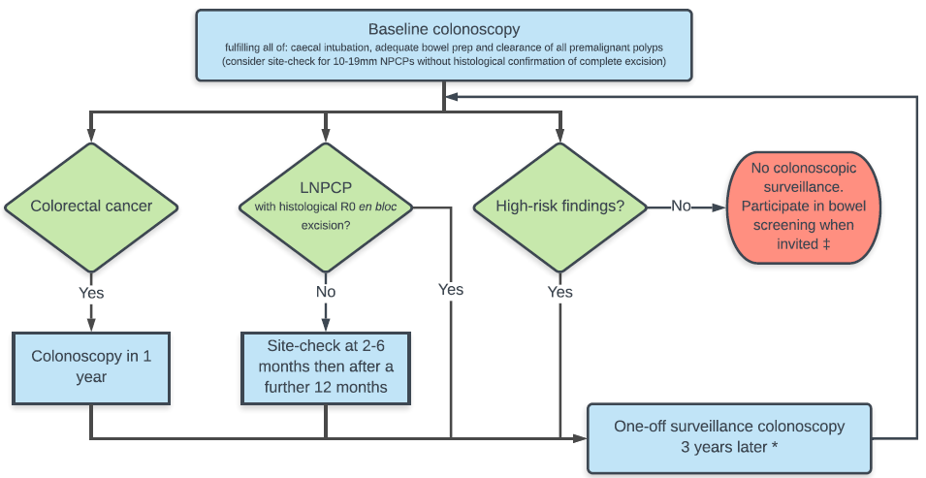
*In general, no surveillance is recommended if life-expectancy < 10 years or in individuals >75 years.

+⁺If patient is >10 years younger than lower screening age and has polyps but no high-risk findings, colonoscopy should be considered at 5 or 10 years, individual to age and other risk factors

Post- CRC Resection

After a potentially curative CRC resection, patients should be offered a clearance colonoscopy within a year after initial surgical resection, and another after a further 3 years. Further surveillance colonoscopies should be determined in accordance with the post-polypectomy high-risk criteria.

Large Non-Pedunculated Colorectal Polyps (LNPCPs)

Following pathologically en bloc R0 endoscopic mucosal resection (EMR) or endoscopic submucosal dissection (ESD) of LNPCPs or early polyp cancers, patients should be offered surveillance colonoscopy after 3 years.

Following piecemeal EMR or ESD of LNPCPs (at least 20mm in size), site checks should be performed at 2-6 months and again at 18 months from the original resection. Once no recurrence is confirmed, patients should undergo colonoscopy surveillance after 3 years.

Further surveillance colonoscopy should be determined in accordance with post-polypectomy high-risk criteria.

.

Surveillance Colonoscopy in the Management of Hereditary CRC

Colonoscopy surveillance for patients with heritable risk factors should be offered in line with the British Society for Gastroenterology guidelines as summarised in Figure 2 below.

Figure 2: Colonoscopy surveillance in the management of hereditary CRC (Ref BSG)

Category | Age to commence (years) | Colonoscopy Surveillance  Interval
Family History of CRC
Average Risk | n/a | Routine surveillance not recommended National bowel screening when invited.
Moderate risk  (1x FDR<50 or 2 x FDRs any age) | 55 | One-off and then as per post-polypectomy guidelines
High risk  (3 x FDRs across >1 generation) | 40 | 5 yearly until age 75 years*
Lynch Syndrome MMR Gene Pathogenic Variant Carriers
MLH1 and MSH2 gene carriers | 25 | 2 yearly until age 75 years
MSH6 and PMS2 gene carriers | 35 | 2 yearly until age 75 years
Lynch-like Syndrome
Individuals with deficient MMR tumours without hypermethylation/BRAF pathogenic variant and no pathogenic constitutional pathogenic variant in MMR genes, and no evidence of biallelic somatic MMR gene inactivation. | 25 | 2 yearly until age 75 years
Serrated Polyposis Syndrome (SPS)
Affected individuals | From age of diagnosis | 1–2 yearly until age 75 years
FDRs of affected individuals with SPS | 40 (or 10 years earlier than the index case) | 5 yearly until age 75 years (unless polyp burden indicates an examination is required earlier)
Multiple Colorectal Adenomas (MCRAs)
10 or more adenomas without constitutive pathogenic variants in APC or MUTYH | From age of diagnosis | 1–2 yearly until age 75 years
Familial Adenomatous Polyposis (FAP)
APC pathogenic variant carriers | 12 to 14 | 1–3 yearly depending on phenotype
Individuals with an FDR with a clinical diagnosis of FAP (i.e. “at-risk”) and in whom a constitutional pathogenic variant has not been identified | 12 to 14 | 5 yearly until either a clinical diagnosis is made, and management as FAP, or the national screening age is reached
MUTYH-Associated Polyposis (MAP)
MUTYH gene pathogenic variant carriers | 18 to 20 | Annually
Monoallelic MUTYH pathogenic variant carriers | n/a | Routine surveillance not recommended
Peutz-Jeghers Syndrome (PJS)
STK11 gene pathogenic variant carriers | 8 | 3 yearly. If baseline colonoscopy is normal, defer until 18 years.
Juvenile Polyposis Syndrome (JPS)
SMAD4 and BMPR1A pathogenic variant carriers | 15 | 1–3 yearly depending on phenotype
*Amsterdam criteria families where MMR testing is not possible may be offered surveillance as per Lynch syndrome families and/or additional constitutional testing.

Patients not meeting the above criteria will not be funded unless there are clinically exceptional circumstances.

Individual funding requests should only be made where the patient demonstrates clinical exceptionality.

Further information on applying for funding in exceptional clinical circumstances can be found on the ICB’s website.

defined as a serrated polyp of at least 10mm in size or containing any grade of dysplasia, or an adenoma of at least 10mm in size or containing high-grade dysplasia
R0 No cancer cells are seen microscopically at the resection margins
FDR, first degree relative
MMR, mismatch repair

