Health Inequalities Information Statement - Annual report 2024/25

# Document Control:

Date: 21/05/25  
Version: v1.7

# Contents

Introduction 2

Executive Summary 3

Health inequalities Tackling Health Inequalities in Mid and South Essex 5

Working with our most deprived communities – CORE20 7

PLUS groups 9

Inclusive Elective Recovery 11

Maternity 14

Children and Young People 15

Adult Mental Health 18

Learning Disabilities 21

Respiratory 23

Cancer 26

Cardiovascular 27

Diabetes 31

Risk factors; Smoking and Obesity 33

Conclusion 35

## Introduction

Health inequalities are preventable, unfair and unjust differences in health across the population and between groups within society. These include how long people are likely to live, the health conditions they may experience and the care that is available to them.

The conditions in which we are born, grow, live, work and age can impact health and wellbeing. These are sometimes referred to as the wider determinants of health. For example, people living in areas of high deprivation, with low educational attainment and in poor quality work would be at even greater risk of experiencing health inequalities. Healthcare inequalities are part of wider inequalities and relate to inequalities in the access people have to health services and in their experiences of and outcomes from healthcare.

NHS organisations have a legal duty to collect, analyse and publish information on health inequalities every year. NHS England’s Statement on Information on Health Inequalities sets out how organisations should exercise this duty and what information should be published[1]. This includes a list of indicators which organisations should report against. The indicators are aligned to key health inequalities priorities for the NHS, which includes the five priority areas for addressing healthcare inequalities and the Core20PLUS5 approach to reducing inequalities for adults and children and young people[2].

This is the second year NHS bodies have been required to publish this information. In line with the guidance in the statement, NHS Mid and South Essex will continue to take a proportionate and phased approach to gathering and making use of available information on health inequalities. This report presents a summary of new and existing analyses of the health and care areas within the statement. The report will evolve and change over time as we improve data collection and reporting locally and as indicators within the statement are updated nationally.

The report has a section focused on each health condition or group of conditions covered within the statement. Each section opens with a brief description of the condition and key health inequalities issues and provides a summary of the information and data relating to that indicator. We highlight where inequalities may exist in relation to deprivation, gender, age and ethnicity where the data is available.

This report should be read in conjunction with our annual report that sets out how the ICB meets its legal duty regarding the need to reduce health inequalities that includes:

* Taking a population health improvement approach to understanding health needs and designing interventions that reduce health inequalities.
* Implementation of the Equality Delivery System within MSE.
* Ensuring that that health inequalities are properly considered when we make commissioning decisions for our population.

## *Executive Summary*

There are 1.3 million people living in mid and south Essex (MSE). Around 10.5% of population live in areas of higher deprivation where we tend to see greater health inequalities and poorer health outcomes.

Focused initiatives and targeted interventions have led to tangible improvements in reducing health inequalities in access, outcomes, and equity for several key health indicators.

* ***Preventative Health checks*** Health check uptake among people with learning disabilities and severe mental illness increased to 77.8% and 67.9%, exceeding national targets of 75% and 60% respectively.
* ***Access Equality*** Waiting time disparities across ethnic and socio-economic groups for outpatients (non-admitted) acute care have significantly reduced.
* ***Oral Health*** A marked decrease in childhood tooth extractions among deprived populations has narrowed the inequality gap.
* ***Mental Health Recovery*** Outcomes from Talking Therapies for people from global majority background improved and are now in line with White British individuals.
* ***Inpatient Mental Health*** Considerable reduction in the number of people with learning disabilities or autism receiving inpatient mental health care between 2023/24 and 2024/25.
* ***Vaccinations*** Improved flu vaccination rates in high-risk, deprived groups with respiratory conditions, although overall MSE remains lower than the national average.
* ***Cardiovascular Health*** Fewer admissions for heart attacks among the most deprived groups and statin prescribing in the most ethnic diverse and deprived populations is higher than the national average.
* ***Maternal Health*** A drop in Smoking status at time of delivery (child birth) rate, now below 6% meeting the national target.
* ***Weight management*** Increased referrals to the NHS Digital Weigh Management Programme from deprived and global majority background, with rising male engagement.

Despite progress, there remains several challenging areas where health inequalities continue to persist which are subject to ongoing actions to address:

* ***Maternity*** Higher preterm birth rates among Asian and Black women, although MSE rates are lower than the national average.
* ***Mental health inpatients*** Disproportionate use of the Mental Health Act and rates of restrictive interventions among deprived and ethnically diverse populations.
* ***Vaccinations*** Low Covid and Flu vaccine uptake which remain in deprived groups and non-white British groups.
* ***Cancer screening*** Reduced Breast and Bowel cancer screening rates in deprived areas.
* ***Hypertension*** Inadequate hypertension management among non-white British and young individuals.
* ***Diabetes*** Widening gaps in diabetes care processes for under-40s and those in deprived communities.

These ongoing disparities highlight the need for sustained, tailored efforts to ensure equitable health outcomes for all segments of the MSE population.

## Health inequalities Tackling Health Inequalities in Mid and South Essex

Tackling inequalities in outcomes, experience and access is one of the four key purposes of ICSs and is at the heart of the Mid and South Essex (MSE) 10 year strategy.

There are 1.3 million people living in MSE. Across this area, there are localities of both relative affluence and high deprivation. Around 10.5% of population live in areas of higher deprivation where we tend to see greater health inequalities and poorer health outcomes.

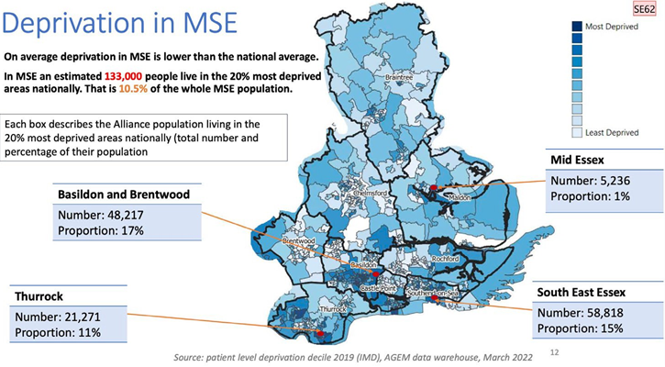

There is a 14.4 year difference in life expectancy for males living in our most and least deprived wards, and 12.7 for females. Those living in our most deprived wards will also live in ill-health for longer.

|  |  |
| --- | --- |
| *Chart showing Years of life expectancy by least deprived and most deprived wards in MSE for Males* | *Chart showing Years of life expectancy by least deprived and most deprived wards in MSE for Males and Females* |

*Source: Fingertips 2021-23*

Within MSE there are over 140,000 registered patients who are from an ethnic minority background, which represents 10.8% of the population. Thurrock has a higher proportion (21.2%) of its population from an ethnic minority background. Those from an ethnic minority background can experience greater health inequalities and for example we see poorer uptake of vaccinations and breast cancer screening uptake in this group.

Within MSE the top three contributors to premature mortality attributable to socioeconomic inequalities are cancer, cardiovascular disease, and respiratory disease. In MSE about 73 in 100,000 people die prematurely from CVD, which is the highest under 75 mortality rate in EoE. Furthermore, within MSE, 124 in 100,000 people die prematurely from **cancer** which is similar to the national average of 122 in 100,000.

The average age of death for people with a **learning disability** in MSE is 57, which is up to 20 years before the rest of the population. Respiratory conditions are by far the leading primary cause of death for people with a Learning Disability.

The Premature mortality in Adults with **Severe Mental Illness (SMI)** per 100,000 is significantly high in Thurrock (130.4 per 100,000). This is more than the national and regional values (110.8 and 95.3 respectively).

***Data intelligence and governance***

MSE ICB works in collaboration with the public health teams across the three Local Authorities, Population Health Management leadership and with Arden & GEM CSU (BI intelligence provider) to strengthen its use of data and insights to understand and respond to population needs through use of:

* Local Authority Joint Strategic Needs Assessments to inform decision making[3]
* Integrated health and social care data and its expansion to include other socioeconomic factors such as housing data, to enable wholistic approaches to care delivery.
* Population segmentation tool that provides insights at Alliance, PCN and Practice level to enable greater understanding of population need.
* Core20plus5 Alliance and PCN packs to inform priority setting and opportunities for addressing local health inequalities.
* Health Inequalities dashboard to track high level impact and inform this annual report
* MSE developed metrics, dashboards and reports now incorporate standard Health Inequalities functionality enabling review by deprivation, ethnicity, sex, and age.

MSE established a Population Health Improvement Board with representation from partners across the system to drive an integrated approach inequalities improvement.

This Board brings together programme of work across:

* Health inequalities
* Population Health Management
* Prevention
* Personalised Care
* Anchor programme

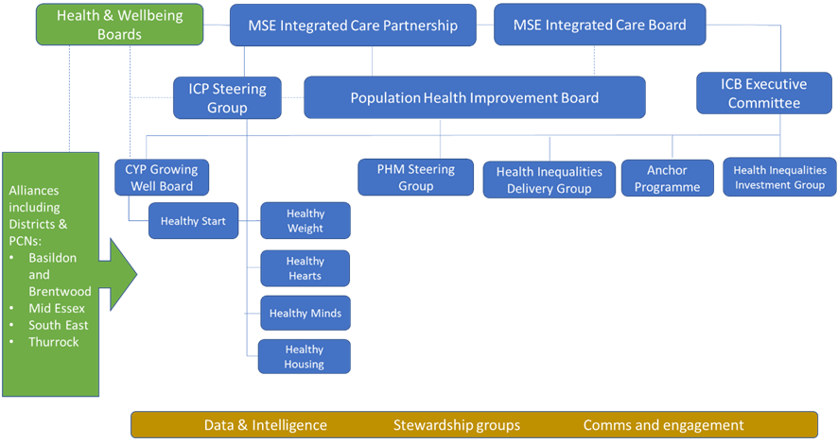

The Population Health Improvement Board reports up to both the MSE Integrated Care Partnership to bring together the work around wider determinants of health and to the Integrated Care Board to drive improvements around specific healthcare priorities.

***Addressing health inequalities in everything we do***

In 2024/25 the MSE health inequalities programme continues to focus on embedding a culture of addressing health inequalities across all our business areas. In support of that ambition, we have:

* Applied the national **Core20PLUS frameworks for Adults and Children and Young People** to prioritise activities both across the system and through the local work delivered by alliance partnerships.
* Ensured **Equality and Health Inequalities Impact Assessments** are undertaken for service change proposals to clearly demonstrate the impact on reducing health inequalities and actions identified to mitigate wherever possible.
* Published the **‘Narrowing the gap’** report that outlines how partners are working collectively across MSE to tackle health inequalities [Narrowing the gap - Mid and South Essex Integrated Care System](https://www.midandsouthessex.ics.nhs.uk/publications/narrowing-the-gap/)[4]
* Developed Health inequalities champions across the system as part of the NHSE **Health Inequalities Ambassador programme**.
* Invested in PCN clinical leadership development to utilise a health creation approach to addressing health inequalities.

## Working with our most deprived communities – CORE20

Narrowing the gap in health inequalities in our most deprived communities is a priority for all our four Alliance partnerships. Each Alliance has tailored their approach and focused on specific areas, groups or conditions based on the needs of their local populations and the engagement work undertaken with their communities. Some highlights include:

**Basildon Alliance**

* Working in partnership with Sport for Confidence to support people with Learning disabilities to access services and make informed decisions about cancer screenings and vaccinations. Resulting in an increase in cervical screening uptake from 53% to 63% over the two year programme.
* Focus on improving physical activity in partnership with Active Essex, in the latest ‘Big Team Challenge’, tracks steps along virtual walking route, 22 teams participated logging 32million steps.
* Learning Disability health checks increasing year on year, with 80.6% achieved in 2023/24 and this year on track to exceed by end of March 2025, which is above national target of 75%.
* Health inequalities funding has supported a range of community based developments to tackle health inequalities including; Hope Community Supermarket that provides community area that can link families into partner agencies across local government, housing, employment and health, family support group for disadvantaged families with complex needs to break down barriers that prevent them from accessing health services.

**Mid Alliance**

* Utilising the Thriving Places index (TPI) and framework to direct investments and grant funding towards priority areas that have included Health housing and economic wellbeing.
* Clinical outreach scheme led by Chelmer PCN in partnership with, amongst others, Sanctus, Chess and Provide to support over 165 individuals experiencing homelessness to develop confidence to engage with statutory services. Of which 43 went on to accept vaccinations and 57 engaged with interventions to improve their physical and mental health including dressings, pain management and medications.

**South East Alliance**

* Active outreach programmes delivered at a neighbourhood level, with partners including public health and community wellbeing services, to provide holistic health and wellbeing services that delivers education, intervention and health promotion to our most vulnerable communities. These events have reached over 2000 patients and residents throughout the area. One event had 464 attendees who received 1229 interventions allowing patients to receive care in one place and negated the need for repeat visits, ensuring that patients who cannot or do not always attend primary care, had access to long term condition education and clinical interventions.
* Focus on increasing identification and effective management of patients with hypertension to reduce the risk of strokes and heart attacks including providing access to lifestyle interventions. Two events identified patients with dangerously high blood pressure who were then transferred to Southend hospital where they were diagnosed and treated with Atrial Fibrillation and therefore avoiding an acute cardiac event.
* Learning Disability health checks increasing year on year, with 81.1% achieved in 2023/24 and this year on track to exceed by end of March 2025, which is above national target of 75%.
* Health inequalities funding has supported a range of community based developments to tackle health inequalities including; provision of family counselling service that provides preventive care approach to health and wellbeing with focus on support for children with ADHD, improving early childhood outcomes through early intervention and prevention sessions that increase health literacy around themes of nutrition, movement, oral health, winter illnesses; we are awaiting evaluation of this project and the other 6 funded projects from 2023/24

**Thurrock Alliance**

* Working in partnership with Sport England to increase physical activity and active travel in most disadvantaged areas of Thurrock and the local CVS to promote free and low cost physical activity.
* Food growing project that incorporates partnership working across 17 primary schools in the most deprived parts of Thurrock to improve childhood obesity.
* Learning Disability health checks increasing year on year, with 79.1% achieved in 2023/24 and this year on track to exceed by end of March 2025, which is above national target of 75%.

## PLUS groups

The ICB PHM team have developed local data and insight for the ‘PLUS’ groups within MSE to identify areas of greatest need and best practice interventions. Together with national insights we continue to undertake programmes of work to address underlying health inequalities in our ‘PLUS’ and inclusion groups including:

**Ethnic Minority Groups**

* Working with Community and voluntary sector partners such as Hope for African communities UK to promote healthy eating and lifestyles
* Changing the way GP practices communicate with patients in BAME community by encouraging face to face meetings to help break down cultural barriers and allay concerns to improve uptake in cancer screening
* Continued focus on improving the data completeness of recording of ethnicity, with 91% completeness in the Primary Care record in 2024/25.

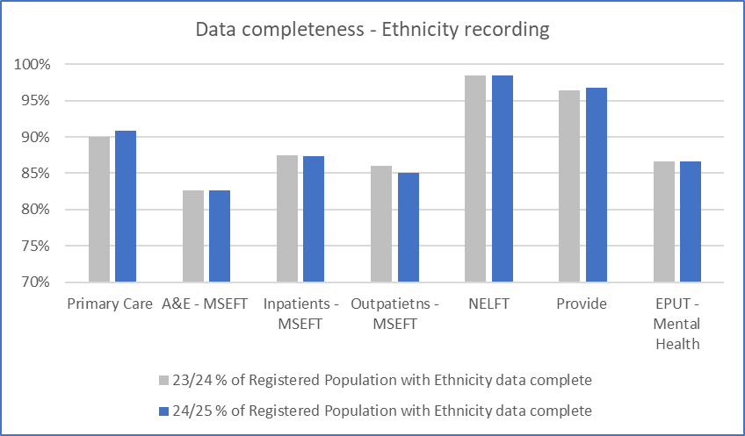

*Source: SystmOne (Primary Care) and local provider SUS submissions (MSEFT, NEFLT, EPUT and Provide) Dec 2024.*

**Veterans**

* Improving the identification and recording of Veterans in primary care and our three hospitals and using Veterans voices to inform how services are delivered utilising research conducted by Healthwatch.
* Every PCN has at least one GP practice that is veteran friendly accredited and MSEFT awarded veteran aware accreditation in 2024.
* Local hubs and community oriented drop in opportunities to raise awareness and support through the Armed Forces Covenant Fund.

**Homeless**

* Homeless Health Needs Assessment commenced, led by the charity Pathway Inclusion Health, to determine health service needs for those experiencing homeless.

**Gypsy, Roma, Traveller Communities**

* Improving access to health services in Basildon and Thurrock through a regular programme of visits to deliver preventive health interventions and facilitate registration with a GP practice.

**Inclusion health groups**

* MSE first ICS in EoE to commission Pride in Practice offering free training and support with 26 accredited practices.

**Research and Engagement network**

The ICB has established a Research and Engagement network to foster sustainable community engagement, enhance research participation, and address health inequalities in underserved populations. There are currently 24 community champions in post across a variety of partner organisations:

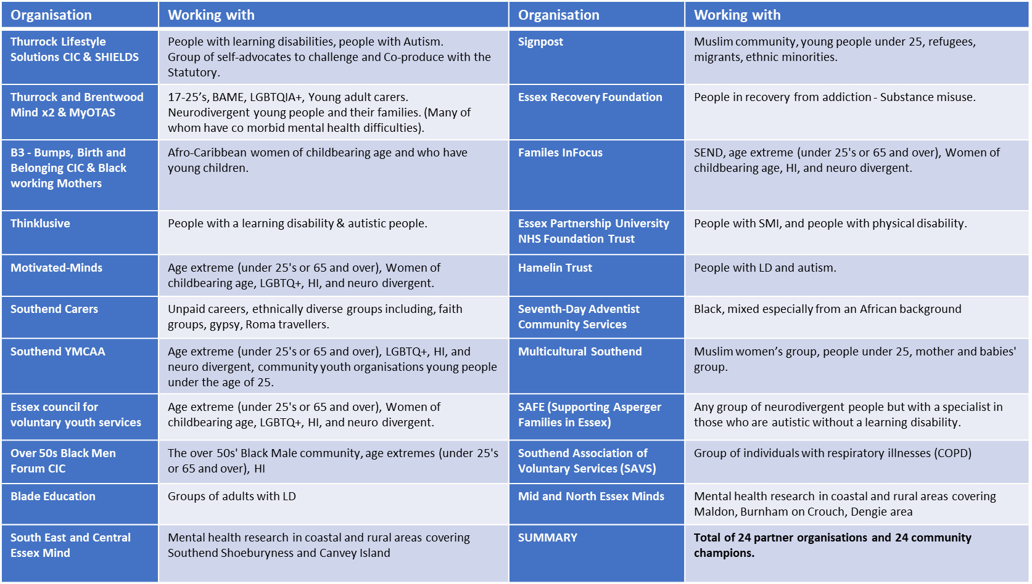

## Inclusive Elective Recovery

**Primary care**

Implementation of the ICB’s Primary Care Access Recovery Programme in 2024/25 has demonstrated improved access, measured via the GP survey. Overall reported experience remains relatively consistent between a large number of demographic indicators including ethnicity, deprivation, gender. There is variation in experience across the age cohorts with a trend that young adults tend to have lower levels of satisfaction compared to older generations. The highest levels of satisfaction are experienced through the oldest part of our population, who equally tend to be the heaviest users of services.

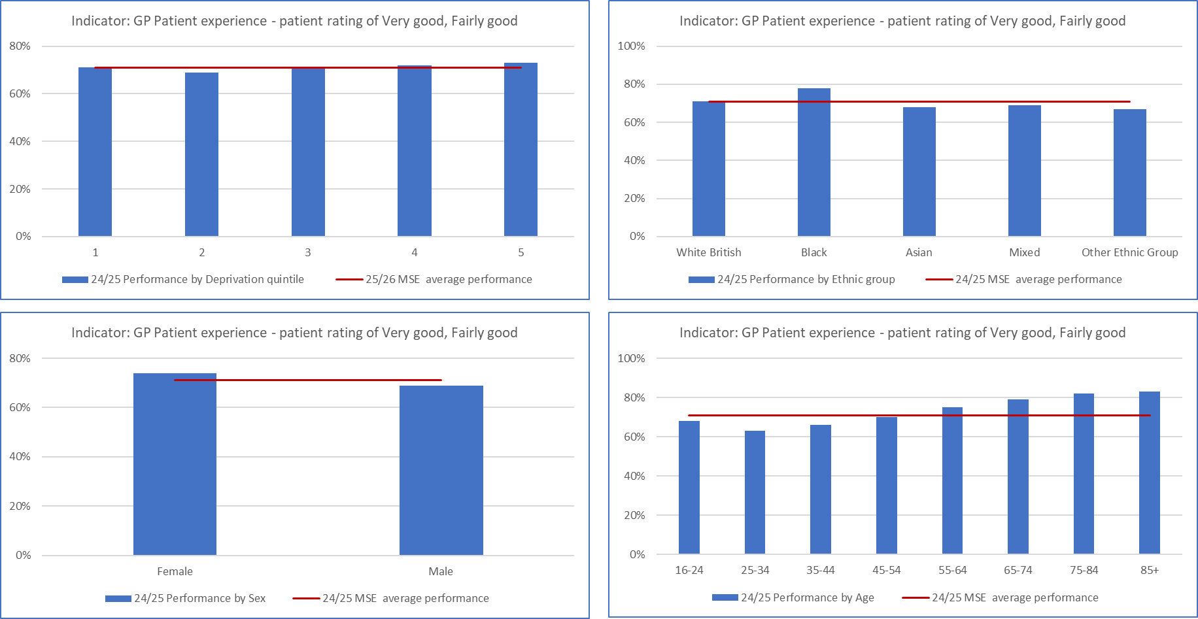

*Source: GP patient survey 2024.*

As part of the local delivery of the Primary Care Access Recovery Plan, there have been multiple changes to primary care service delivery over the past 12 months. Overall capacity has significantly increased, modern general practice has been implemented across a large number of practices in MSE, with patients starting to access a range of services directly rather than via their GP. [Get The Care You Need Quicker - Mid and South Essex Integrated Care System](https://www.midandsouthessex.ics.nhs.uk/health/campaigns/get-the-care-you-need-quicker/)

**Community Collaborative**

The Community Collaborative have focused on inclusive elective recovery through:

* Introduction of four Transfer of Care hubs ensure out of hospital services deliver personalised care and address wider determinants of health through relationships with housing, foodbanks etc.
* Cardiovascular Disease Prevention Programme of work – Blood pressure guidance produced and staff training completed and addressing the co-morbidity of frailty and hypertension
* Co-designed the refreshed patient engagement strategy with communities and Healthwatch
* Health Inequalities Van outreaching to seldom heard groups and improving access to services including Long Covid, Wellbeing and Sexual health services.
* Review of Heart Failure and Diabetes community services as part of the EDS2 2024/25 report incorporating patient engagement to identify actions for improvement. [MSEICB-EDS-2024_25-reporting-v1.0-Feb-2025.docx](https://view.officeapps.live.com/op/view.aspx?src=https%3A%2F%2Fwww.midandsouthessex.ics.nhs.uk%2Fwp-content%2Fuploads%2F2025%2F03%2FMSEICB-EDS-2024_25-reporting-v1.0-Feb-2025.docx&wdOrigin=BROWSELINK)

**Acute services delivered by MSEFT**

MSEFT completed an annual impact report and evaluation of access on the waiting list and patient experience that was presented to their public Board in June 2024. This highlighted a closing of the gap in waiting times between ethnic groups and deprivation variation gap has been closed on the non-admitted waiting list. The gap remains stable on the admitted waiting list at 3 weeks variation.

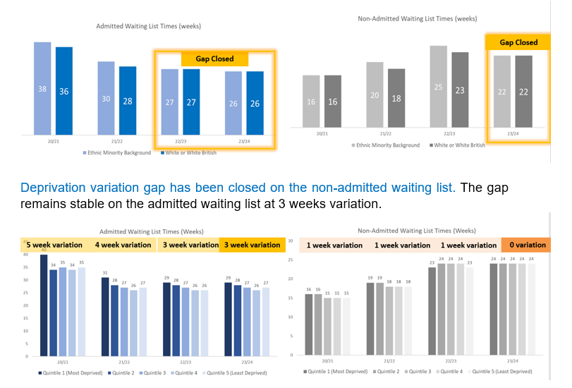

*Source: MSEFT Board report June 2024.*

Mid and South Essex Foundation NHS Trust continues to report bi-monthly to their Board on health inequalities within elective waiting lists as part of the integrated performance report. The waiting list analysis for MSEFT as at December 2024, shows an under-representation in all ethnicities except “other ethnic group” and over-representation of those living in the second most deprived quintile.

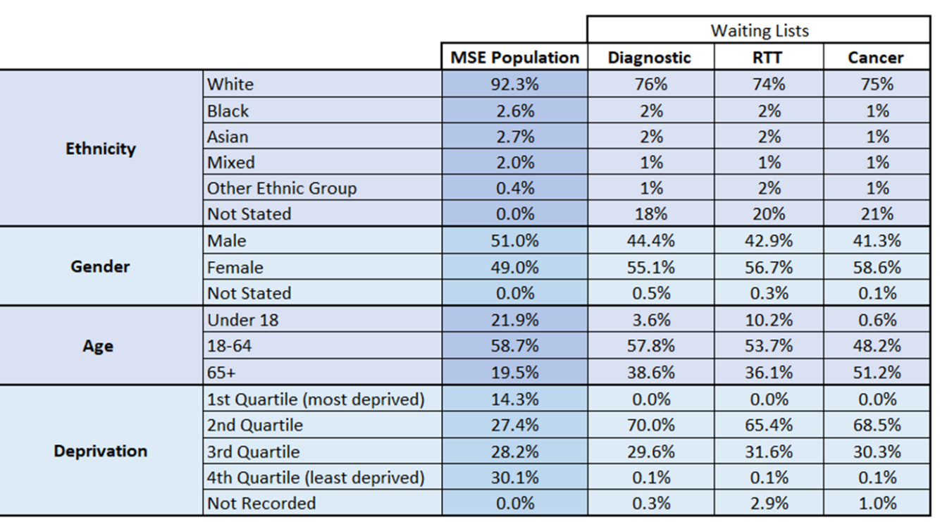

*Source: MSEFT Board report February 2025.*

MSEFT notes the gap in recording of ethnicity data impacts their ability to understand if patients are under-represented. Whilst females are over-represented, meaning they are more likely to appear on MSEFT waiting lists than males. This could be attributed to females living longer than males in mid and south Essex.

There are number health inequalities projects underway within MSEFT:

* Rapid Diagnostic Centre and Endoscopy short films and Easy Read Leaflets supporting patients with LD and/or anxiety etc.
* OVRcome project provides a virtual reality experience to support individuals with learning disabilities or autism to become more comfortable with the hospital environment and procedures. 92% of participants who used oVRcome found the app to be useful, participants saw improvements in how they felt about injections, bright lights and large building sizes.
* Improving Health Literacy working with those with diabetes to improve basic maths skills utilising the Multiply funded government scheme.
* Review of Paediatric services as part of the EDS2 2024/25 report incorporating patient engagement to identify actions for improvement. [MSEICB-EDS-2024_25-reporting-v1.0-Feb-2025.docx](https://view.officeapps.live.com/op/view.aspx?src=https%3A%2F%2Fwww.midandsouthessex.ics.nhs.uk%2Fwp-content%2Fuploads%2F2025%2F03%2FMSEICB-EDS-2024_25-reporting-v1.0-Feb-2025.docx&wdOrigin=BROWSELINK)

## Maternity

MSEFT continue with the implementation of the Maternity Equity and Equality action plan to reduce the risk of preterm births with focus on those from a black ethnic background.

There is an over-representation of preterm births under 37 weeks from non white British women but particularly from women of an Asian or Black ethnic background. However, the rates in MSE of 4.2% and 3.8% are significantly lower than the national averages of 8.1% and 8.7% respectively for Asian or Black women. The over-representation of women from the most deprived areas (first quintile) has reduced in 2024/25 from the previous year. However, the proportion from the second quintile has increased in 2024/25. The MBRRACE (Mothers and Babies: Reducing Risk through Audits and Confident Enquiries across the UK) reported stabilised and adjusted perinatal mortality rates at MSEFT were within an acceptable 5% compared with the group average (2023 data reported in 2025).

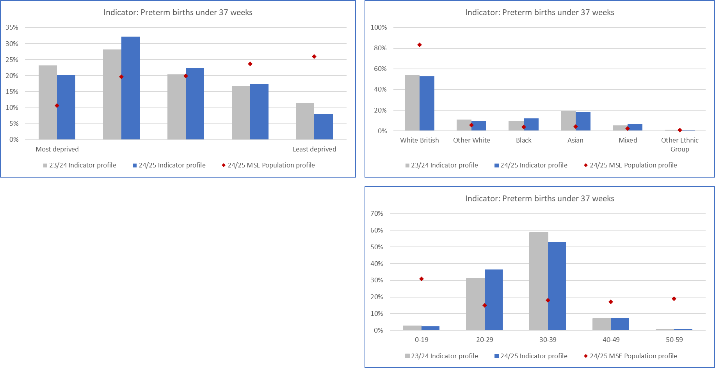

*Source: MSE local dataset Athena taken from SUS extracts*

There are a number of actions being undertaken to address health inequalities in Maternity services including:

* Maternity and Neonatal Voice Partnerships (MNVPs) continue to put service user voices at the heart of service improvement, and they are representative of our communities, with Ethnic Community Leads facilitating feedback from those that may be seldom heard.
* A Maternity and Neonatal Health Inequalities dashboard, aids the identification of themes and trends to inform areas needing further evaluation. This recently included a focus on the timing of access to antenatal care which has identified variation attributed to ethnicity.
* Perineal trauma and ethnicity has been evaluated at Basildon Hospital site and found local variation which is being addressed through staff MSEFT engagement and training.
* Southend maternity booking data specific to the Jewish population has been reviewed and identified cultural norms that may be influencing the timing of engagement with maternity services.
* Implementation of the Smoke Free Pregnancy pathway in MSEFT have seen a reduction in rates of smoking at time of delivery to around 6% which is in line with the national ambition.

## Children and Young People

Childhood and adolescence are key life stages where people face inequalities in health outcomes (such as infant mortality rate and obesity rates) alongside inequalities in accessing services. In MSE, one in eight children live in our most deprived areas and are at risk of experiencing poorer health outcomes. The ICB has adopted the national Core20PLUS5 framework for Babies, Children and Young People. There are a number of transformation programmes that are underway that align with this framework including Asthma, Diabetes and Neurodiversity. The ICB is developing the information analysis to support these programmes and review the health inequalities that exist for children and young people. In 2024/25, this report focuses specifically upon Oral Health and Mental Health.

**Oral Health**

Nationally, children in deprived communities experience poorer oral health with significant inequalities in tooth decay that can impact their overall wellbeing and development. Poor oral health is almost entirely preventable. In MSE there has been a significant reduction in inequalities related to tooth extractions due to decay in children aged 10 years and under. There has been a narrowing of the gap with fewer tooth extractions from those children in our most deprived areas in 2024/25. Although it should be noted that the 2024/25 data represents 9 months up to December 2024 and the small numbers by ethnicity grouping does therefore not allow for a conclusion reached on whether health inequalities have been reduced for non-white British groups. There continues to be an over-representation of boys having tooth extractions.

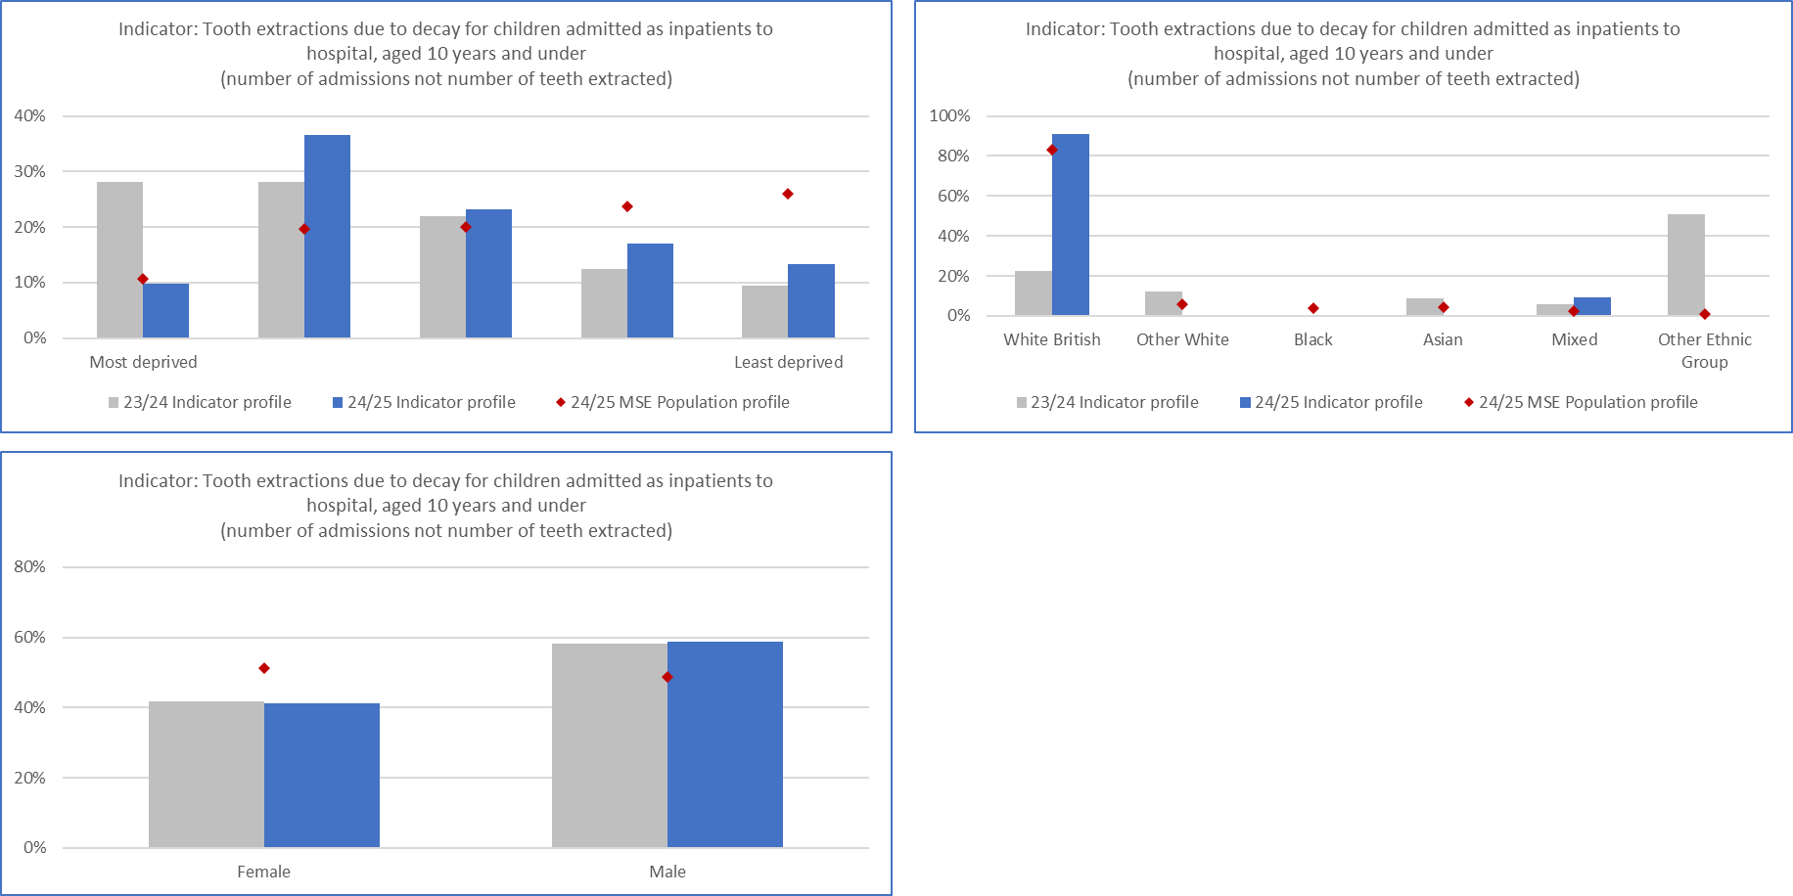

*Source: Local MSE data - Athena from SUS (Note: 23/24 12 months, 24/25 9 months data)*

There are a number of actions being undertaken to prevent the risk of tooth decay that could lead to tooth extractions including:

* MSE Bright Smiles Child Oral health communications campaign rolled out which resulted in positive engagement and feedback.
* Supervised toothbrushing program continued roll out, commissioned by ICB and Local Authorities, with 37 early years and primary schools onboarded.
* Thurrock Early years pilot making good progress with integrated oral health prevention activity within family hub structure and wider community settings. 90 Thurrock based events incorporating Oral Health Promotion: 2062 people directly engaged.
* Improved NHS dental access with dental access pilot allowing over 2700 patients under 16 yrs. to be seen by a dentist since September 2022 and partnering of all 325 MSE primary schools with a dental practice.
* ICB Early Years Oral Health Team have delivered 107 engagement events across MSE, including direct engagement with residents, co-production activities, and Oral Health Training for the Early Years Workforce (attendance by 2178 Children, 1035 Parents/Carers, 764 Members of the Early Years workforce).
* Distribution of over 17,000 toothbrush packages either directly to residents or to partner organisations working with families.
* Development of Oral Health Champion Packages – these are digital and physical packages of resources for Early Years Workforce/ Volunteers with updated oral health information

**Mental Health**

Up to one in five children and young people in England experience a mental health difficulty, and those from socioeconomic deprived areas can be disproportionately affected. Demand for children and young people’s mental health services (CAMHS) significantly increases as a result of the Covid pandemic.

The proportion of patients seen where the ethnic background is not known is significant and therefore doesn’t allow meaningful interpretation of whether inequalities by ethnic groups exist. This is being addressed with the provider of CAMHS.

The trend continues with an increasing number of children being seen in the younger age groups those 10-15 years, with proportionately fewer in those 16 years and above. A significantly higher proportion of individual accessing the service are female, although this is very gradually reducing over time.

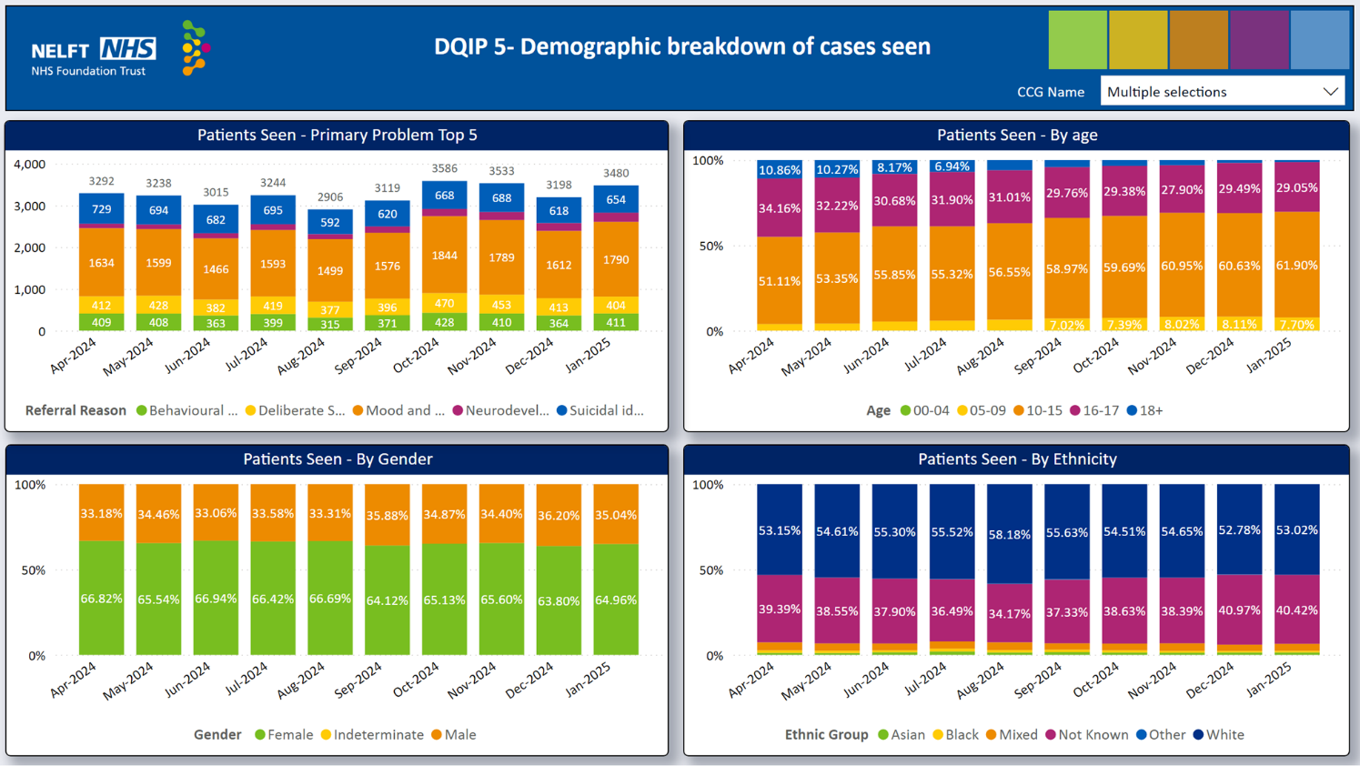

*Source: NELFT data dashboard*

There are a number of actions being undertaken to support children and young people’s mental health and reduce health inequalities including:

* During 2024/25 the ICB has undertaken a procurement for counselling services with a new service specification that will deliver an equitable service across MSE where inequalities are addressed by reducing variation.
* CAMHS nurses are now working a greater proportion of their time in general practice which enables early support children and young people with mental wellbeing concerns.
* Increasing access and choice of support and treatment options for Young people.
* Delivering evidence based interventions for mild to moderate mental health issues across 126 educational settings.

## Adult Mental Health

People with a mental illness such as schizophrenia or bipolar disorder die on average 15-30 years sooner than the general population.

**SMI Health checks**

The ICB continues to focus on reducing premature mortality for those with SMI by ensuring that an annual physical health check is undertaken. The proportion of SMI health checks continues to increase year on year, currently 68% in 2024/25 against the national target of 60%. There has been a notable increase uptake in the last 12 months from those living in our most deprived communities, those from a Black ethnic background and those from aged between 20 and 29 years old.

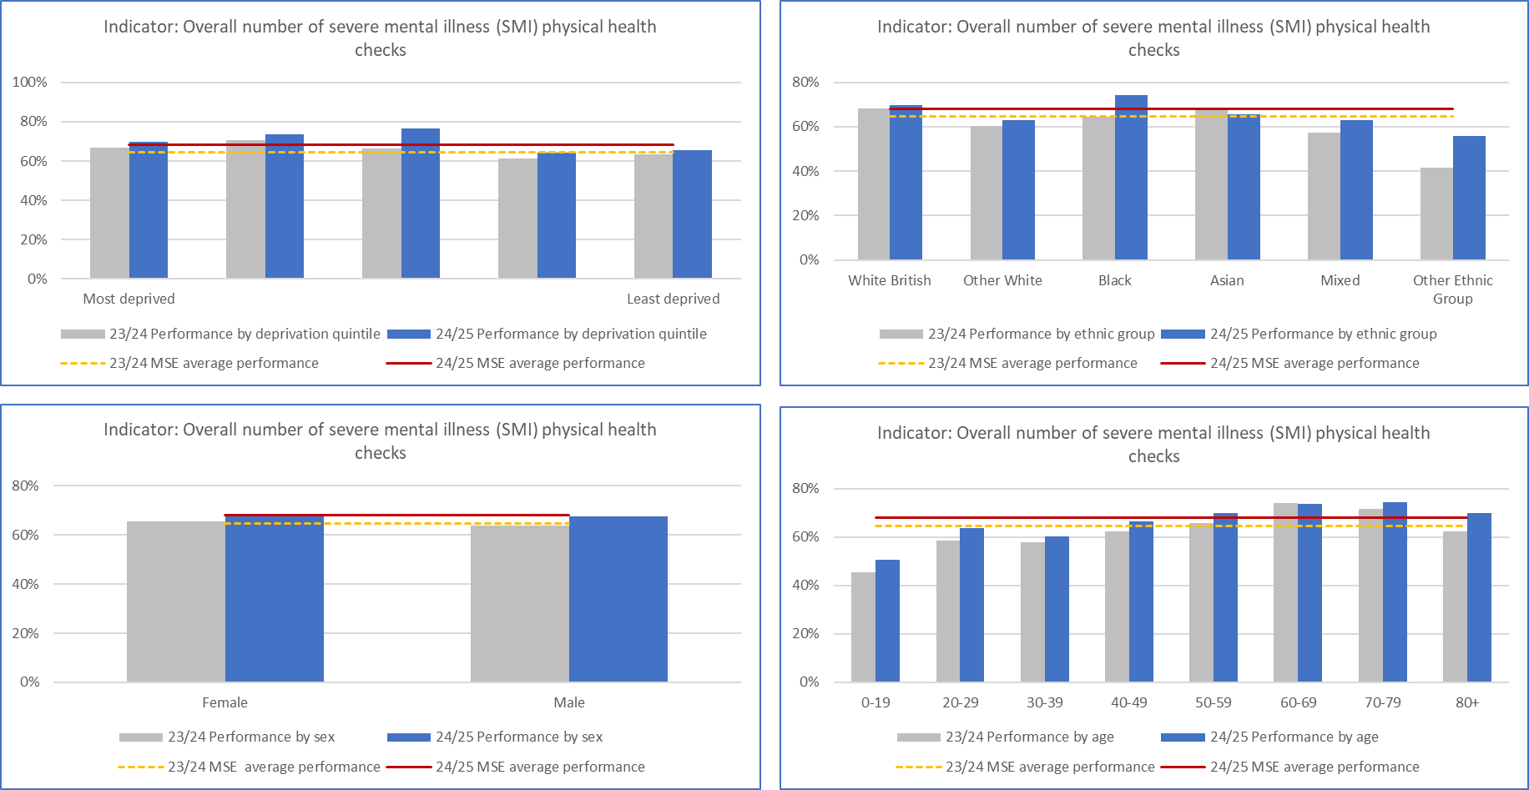

*Source: MSE local dataset February 2025.*

There are a number of actions being undertaken to improve uptake of SMI health checks including:

* Adoption of Standard Operating model including a step-by-step guide implemented across the three providers and General Practice has helped to improve consistency in delivery of health checks. This has reinforced a standardised approach across the ICB, leading to improvement performance and target achievement.
* Co-production of patient leaflets and posters with service users to ensure ‘lived experience’ reflected.
* Focus on principle ‘Don’t just screen, intervene’ and ensuring follow up interventions supporting healthy behaviours and lifestyle changes are accessed.
* Working with VSCEs and other partners on outreach activities to target marginalised communities.

**Talking Therapies**

Nationally evidence has found that those from Black and minoritised ethnic backgrounds have poorer outcomes from NHS talking therapies. In 2024/25, within MSE those from a global majority background have seen improved recovery outcomes that are either in line or exceed those individuals that are White British.

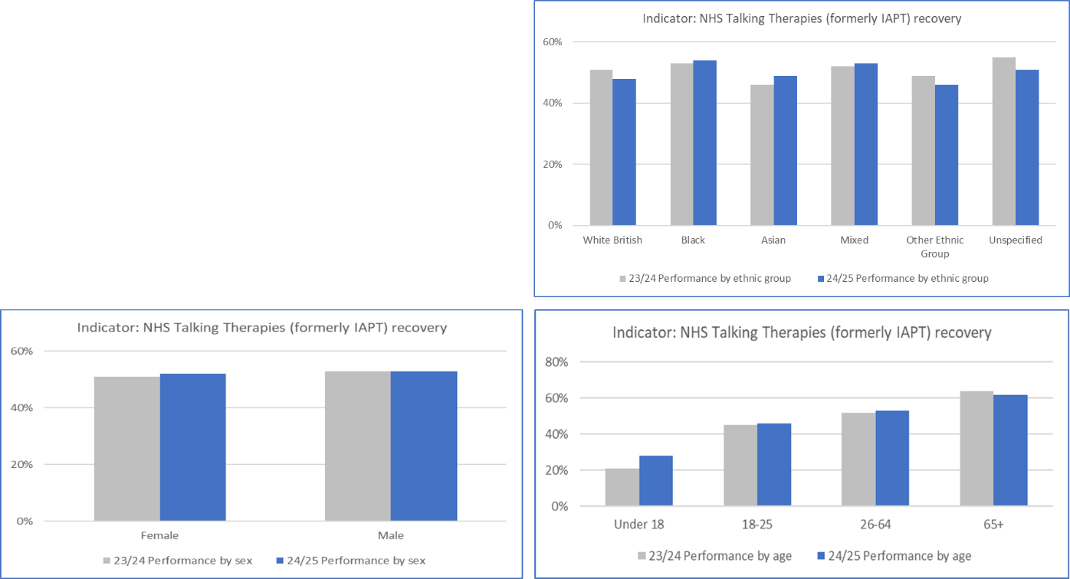

*Source: IAPT dataset, NHS England.*

In 2024/25 the ICB has been focused on the development of a new service specification that underpins the procurement process that is underway. The outcome will be an equitable service across MSE where inequalities are addressed by reducing variation.

**Mental Health Act detentions**

Rates of Mental Health Act detentions and rates of restrictive interventions are shown nationally to be higher for those patients from deprived areas or from global majority background. In MSE the over-representation from the most deprived areas (quintiles one) and the younger age group (those under 40 years) for Mental Health Act detentions increased in 2024/25 from the previous year. There also remains an over-representation from those with a Black ethnicity.

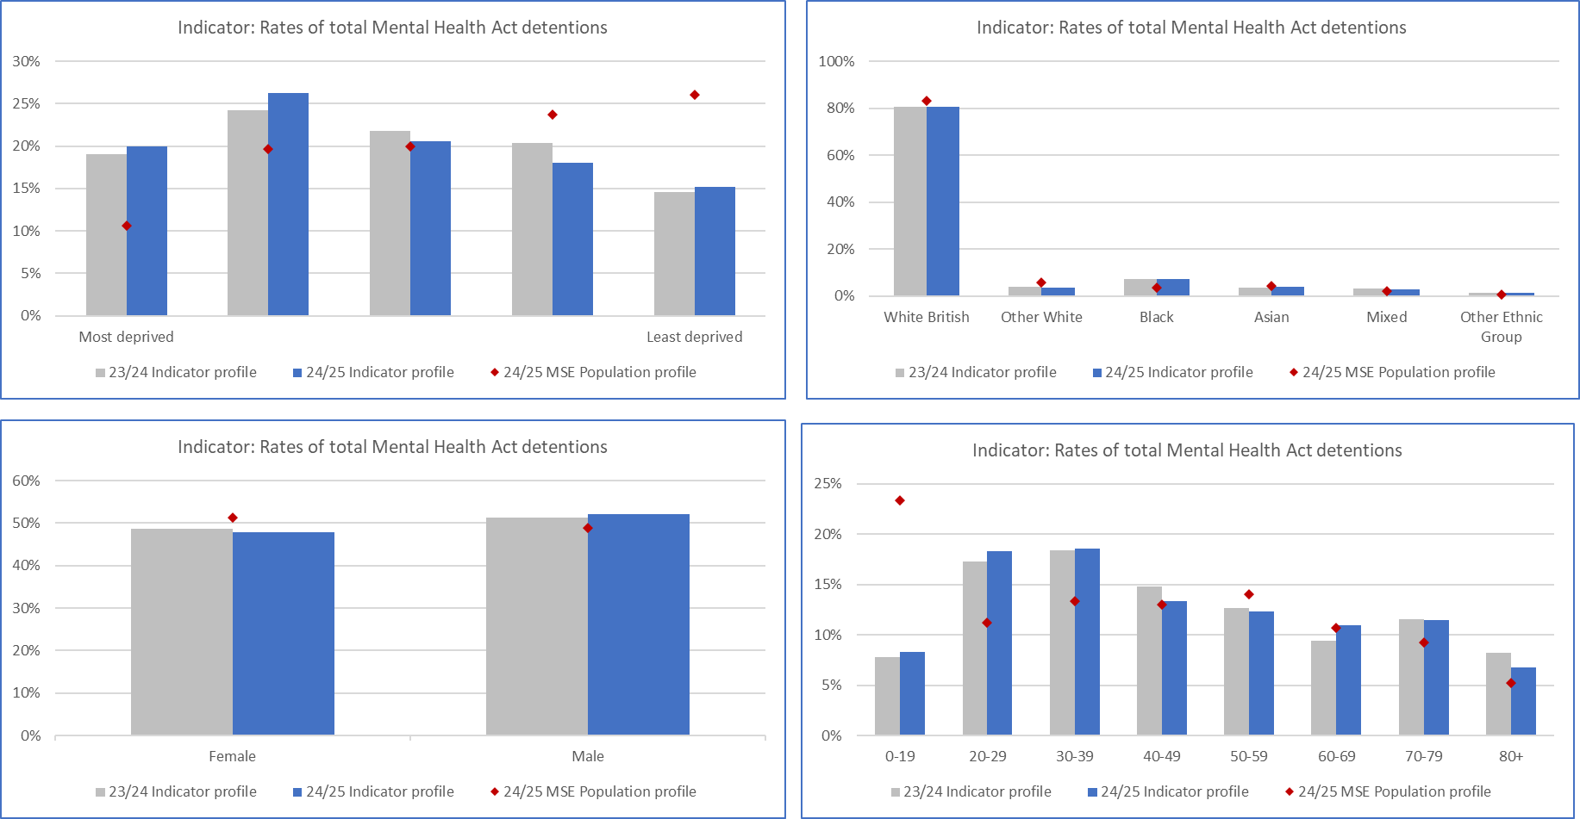

*Source: EPUT local dataset February 2025.*

There are a number of actions being undertaken to reduce health inequalities in Mental Health detentions including:

* MSE has adopted the ***Culture of Care Programme*** that aims to improve the culture of inpatient mental health, learning disability and autism wards for patients and staff so that they are safe, therapeutic and equitable place to be cared for, and fulfilling places to work.
* Cultural change programme includes wards utilising a Quality Improvement methodology to implement changes, training for newly qualified practitioners and development sessions for wards.
* Adoption of patient led care plans by continuing to focus on individuals’ wishes and preferences and giving people as much choice as possible about their care and treatment.

**Restrictive interventions**

In MSE rates of restrictive interventions, the over-representation from the most deprived areas (quintiles one) and the younger age group (those under 40 years) for Mental Health Act detentions increased in 2024/25 from the previous year. The over-representation from those with a Black ethnicity reduced in 2024/25 but there was an increase in the proportion from an Asian background and from the most deprived areas.

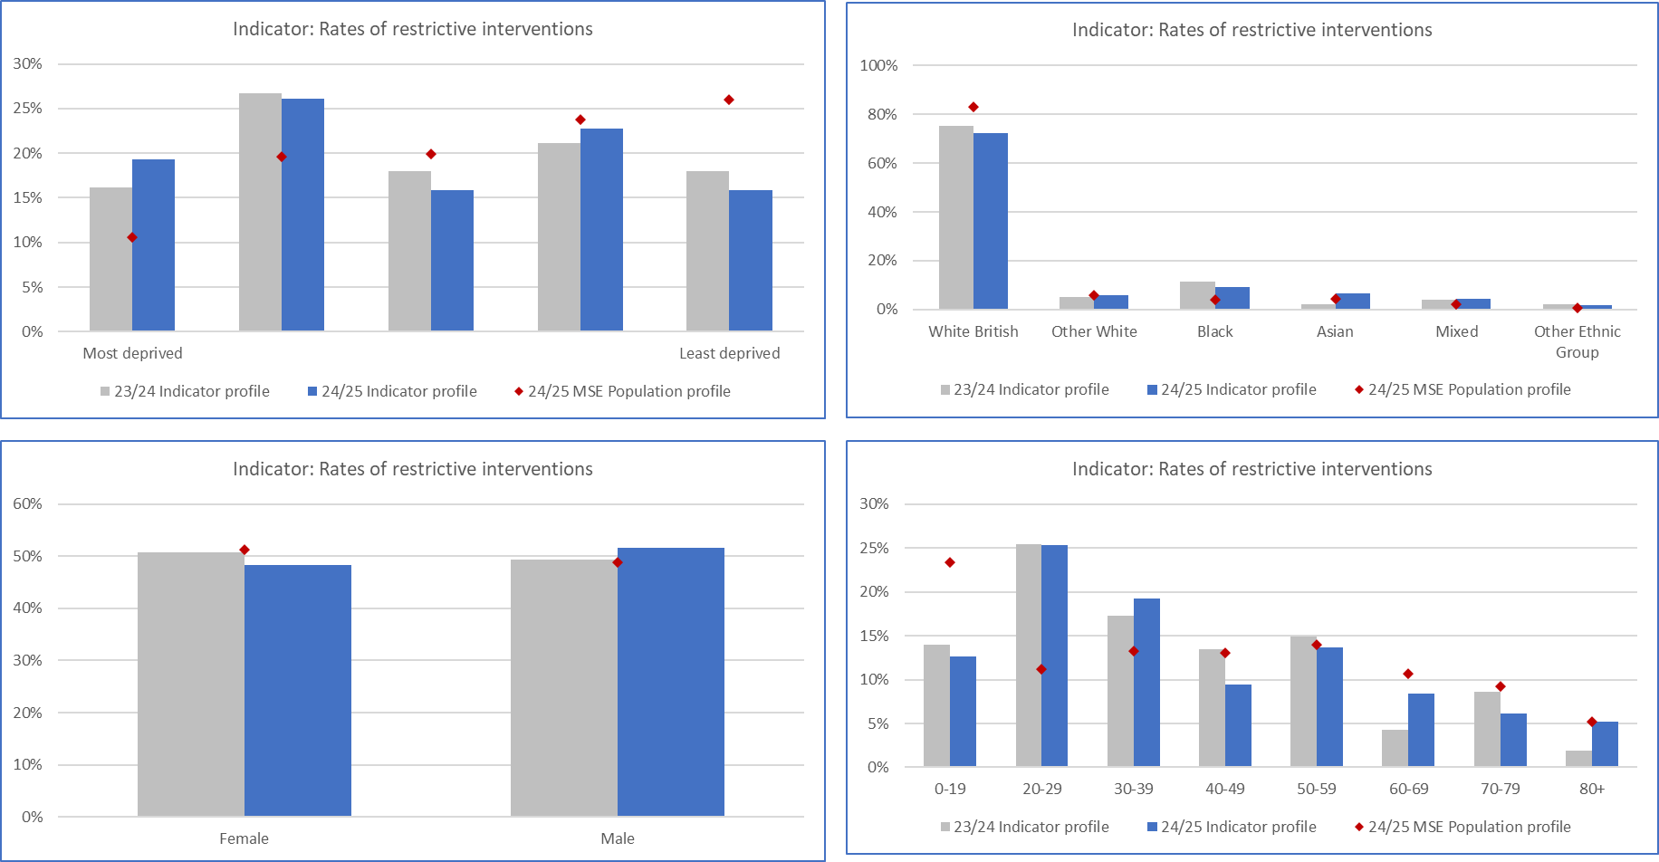

*Source: EPUT local dataset February 2025.*

A new Therapeutic acute inpatient operating model for adults with mental health was launched in 2024/25. This has embedded the principle of personalised care and shared decision making to enable the least restrictive setting and interventions possible. The adoption of a Trauma informed outlook then enables staff to find a way to hear someone’s story and their distress and put in place Positive Behaviour plans. EPUT are supporting staff with training and have invested in new posts including family ambassadors, activity coordinators, Practice Nurse Educators and peer support to deliver the system and cultural change required.

## Learning Disabilities

People with a learning disability and autistic people face significant health inequalities leading to lower life expectancy and more avoidable deaths than the general population.

**Adult mental health for people with a learning disability and autistic people**

The NHS long term plan set out an aim to reduce the number of people with learning disabilities and autism in inpatient mental health care. The NHS long term plan set out an aim to reduce the number of people with learning disabilities and autism in inpatient mental health care.  In MSE there has been some significant work towards a reduction in the number of people with learning disabilities that are in mental health inpatients with some improvements noted between 2023/24 and 2024/25 position.  There has been a reduction in the proportion that are from a non-white British ethnic background and Males over the past 12 months.

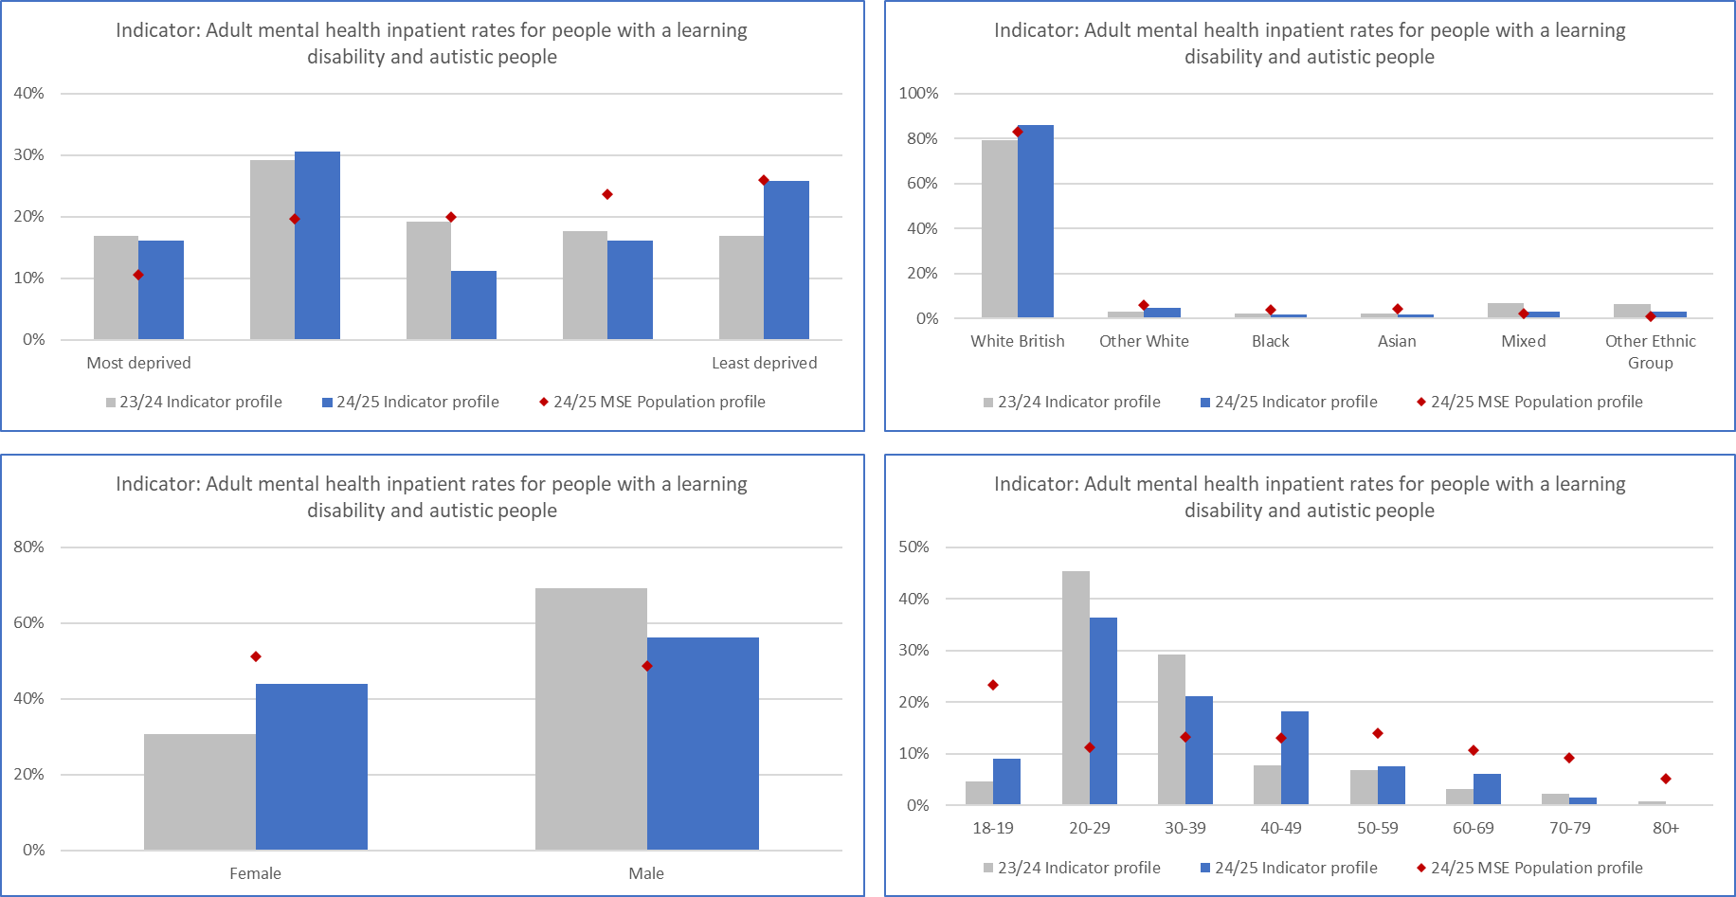

*Source: MSE local dataset February 2025.*

MSE has improved the oversight through the use of the Dynamic Support Register; a list of people with learning disability and autistic people who need support because they are at risk of going into hospital if they do not get the right care and treatment in the community. By regularly reviewing individuals that are at high and medium risk of admission and ensuring that personalised care and treatment plans are implemented. For those that are admitted, the ICB has put in place assurance mechanisms to ensure that regular and robust Care (Education) and Treatment Reviews are in place that set out actions to support discharge to a less restrictive setting.

**Annual health check for people with Learning Disabilities**

Annual health checks for people with learning disabilities are crucial for addressing health inequalities by identifying and managing previously unrecognised health needs. In MSE, there has been a year-on-year increase in percentage of individuals having a health check There has been improved uptake across all demographics in the last year, but it notable to see an increased proportion of people with learning disabilities from a black ethnic background and in the younger cohort those aged 20-29 years.

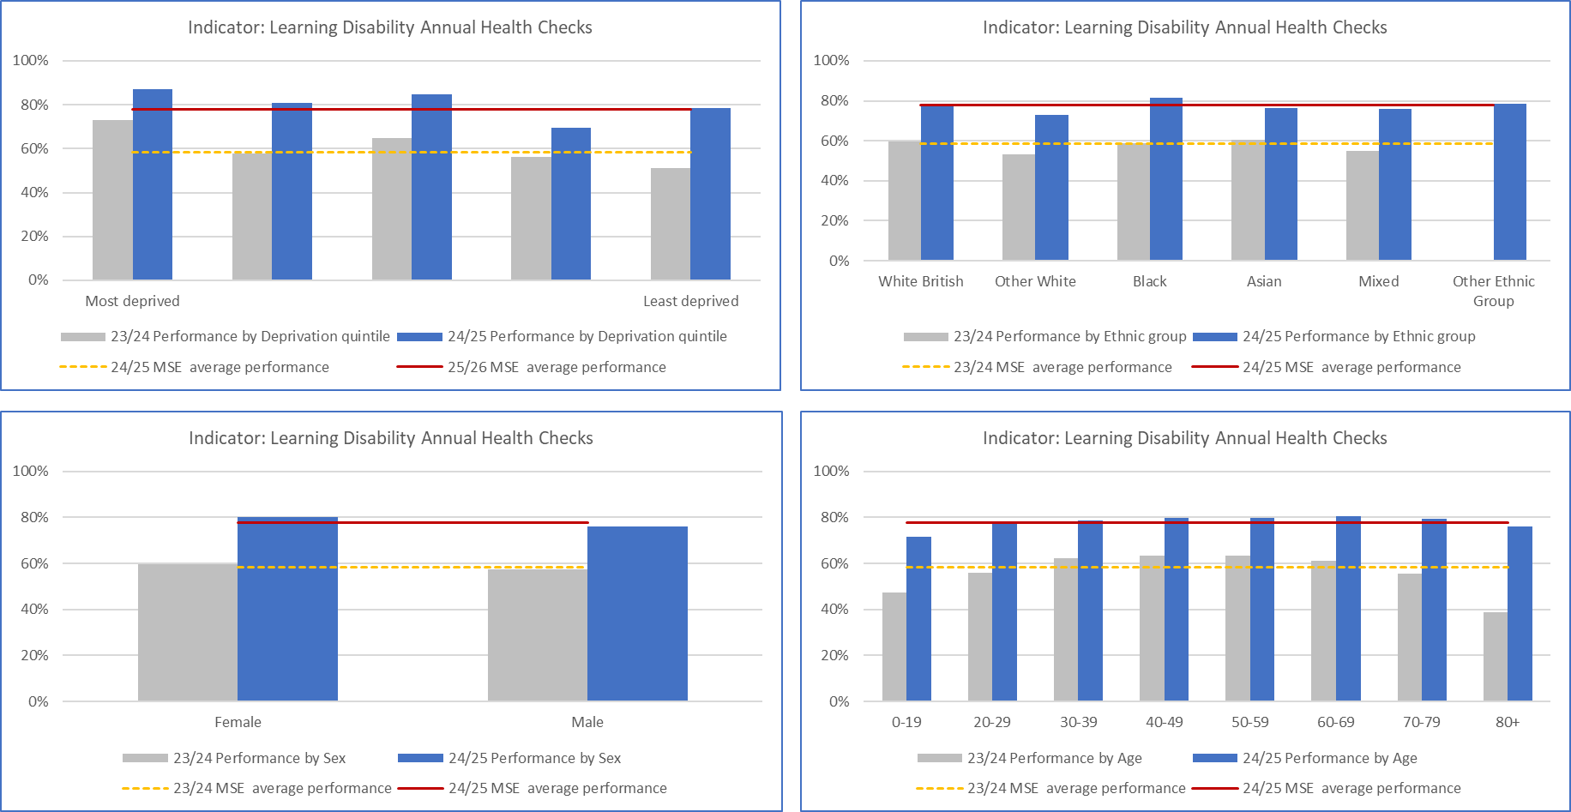

*Source: MSE local dataset Athena extracted from SystmOne January 2025.*

The Southend Essex and Thurrock Learning from Lives and Deaths – People with a learning disability and autistic people (LeDeR) Deliverable Plan 2024-2027 has a priority to ‘Promote Preventative Health’: An improvement plan has been implemented that has improved the uptake and effectiveness of learning disability annual health checks and health action plans. This has been delivered through greater partnership working between the learning disability specialist health team and primary care colleagues.

Our providers within MSE continue to focus on improving the voice and experience of individuals with learning disabilities and/or autism. The [I Have Voice - Learning Disabilities](https://ihaveavoice.co.uk/#/?rmguid=0&rmgmid=0) website sets out the improvement plans with Provide Community.

Work continues to improve the uptake of screening and vaccination programmes by those with learning difficulties. Through the partnership working across Southend Alliance with Lady McAdden Breast Cancer Trust, support has been provided to enable outreach workers support individuals with learning difficulties and autism to access their routine breast screening.

## Respiratory

There has been a focus within MSE to drive up uptake of Covid, Flu and Pneumonia vaccines to reduce Respiratory emergency hospital admissions due to exacerbations.

**Covid vaccinations**

In line with the national picture, MSE has seen a decline in the overall uptake of Covid vaccinations. Higher levels of vaccination are observed in less deprived and older age groups. In addition, ethnicity has an impact on relative rates of vaccination with White British having the higher levels of vaccination and mixed, black and unknown ethnicities having lower levels of vaccination.

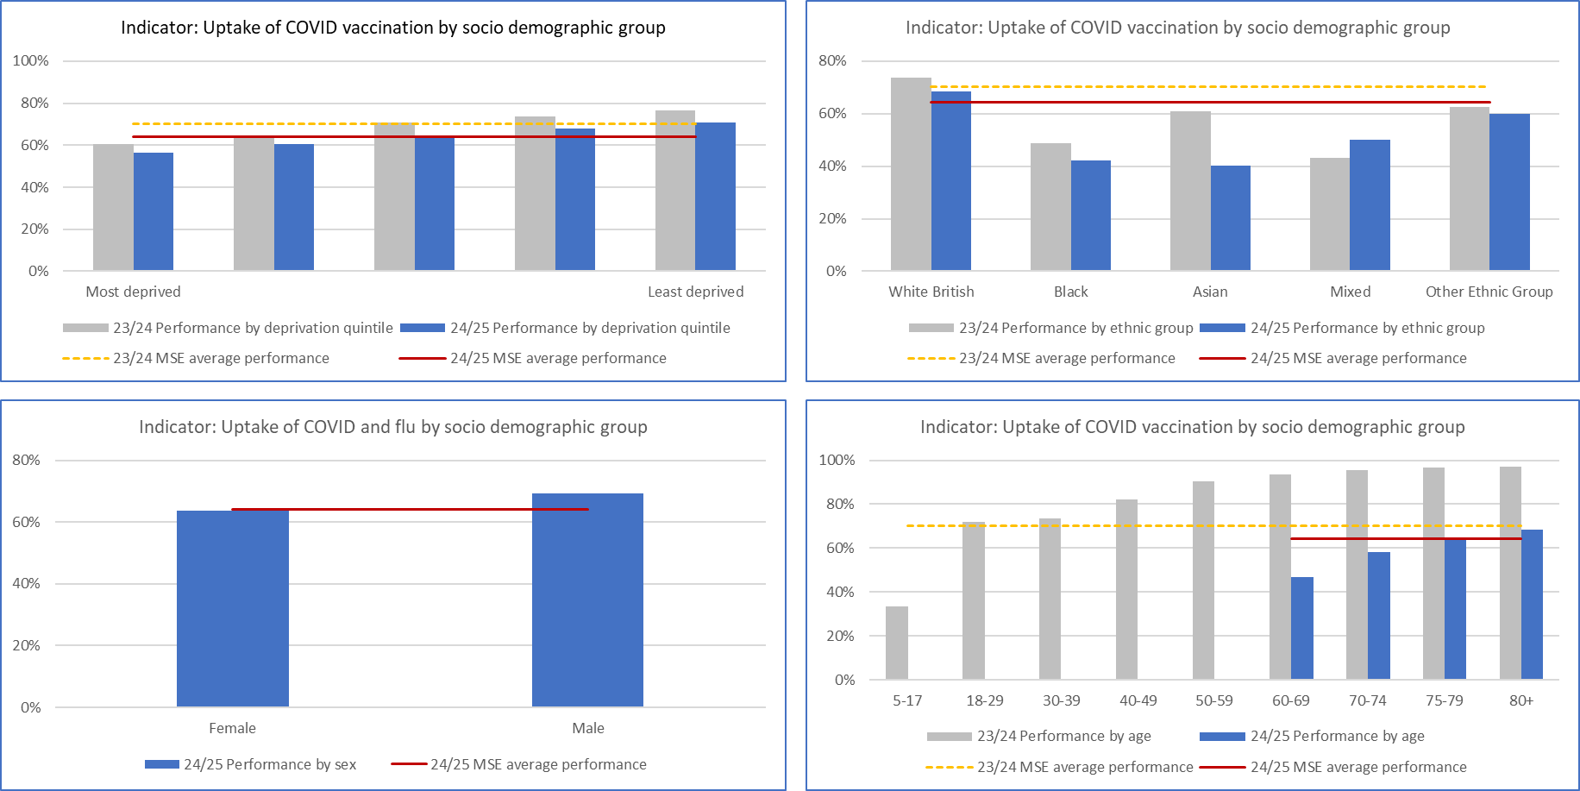

*Source: Foundry February 2025.*

Various programmes were undertaken to target key demographics in particular, targeted promotions in deprived communities. A winter roadshow toured various deprived communities particularly in south Essex. Pop up vaccination clinics in areas such as Thurrock, Basildon and Southend also helped to promote the message, but these events often generated small numbers of vaccinations.

**Flu vaccinations**

The uptake of Flu vaccinations increased in 2024/25 in MSE. However, across the full programme there remains a lower uptake across our most deprived groups, non-white British groups and younger age cohort.

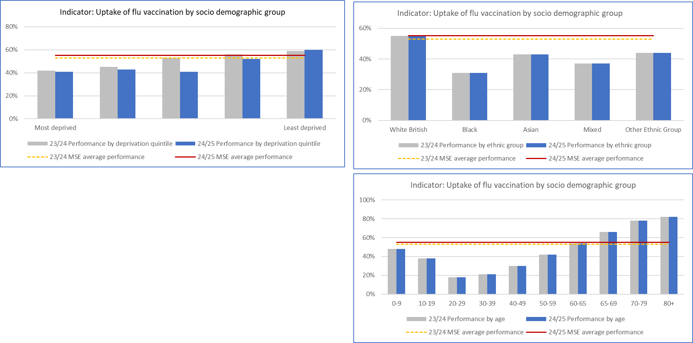

The ICB has undertaken some targeted work to improve the uptake of Flu vaccinations for those most at clinical risk with known respiratory disease, this has resulted in higher vaccination rates in our most deprived groups. However, the uptake within MSE is below the England average of 40.1%.

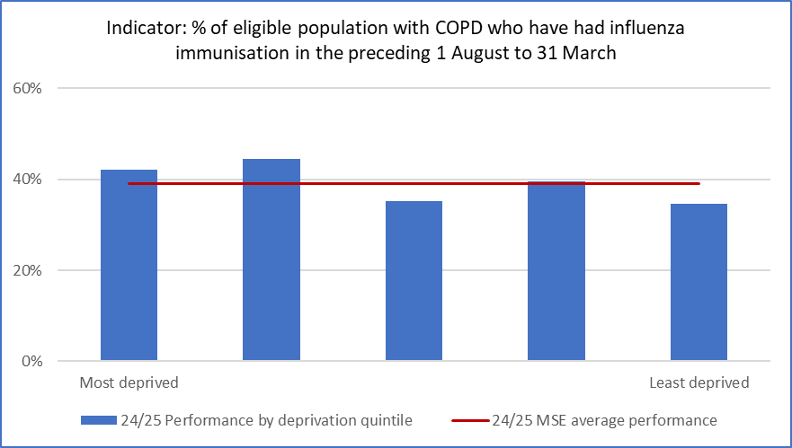

*Source: MSE local dataset Athena February 2025.*

The Flu vaccination continues to be promoted across GP practices, community pharmacy and as part of the targeted winter roadshow in areas of greatest deprivation or poor engagement with primary care.

**Pneumonia vaccinations**

For most adults will need only one dose of the pneumonia vaccine for long term protection. In MSE there remains an under-representation of those from our deprived communities (quintile one and two) and from males.

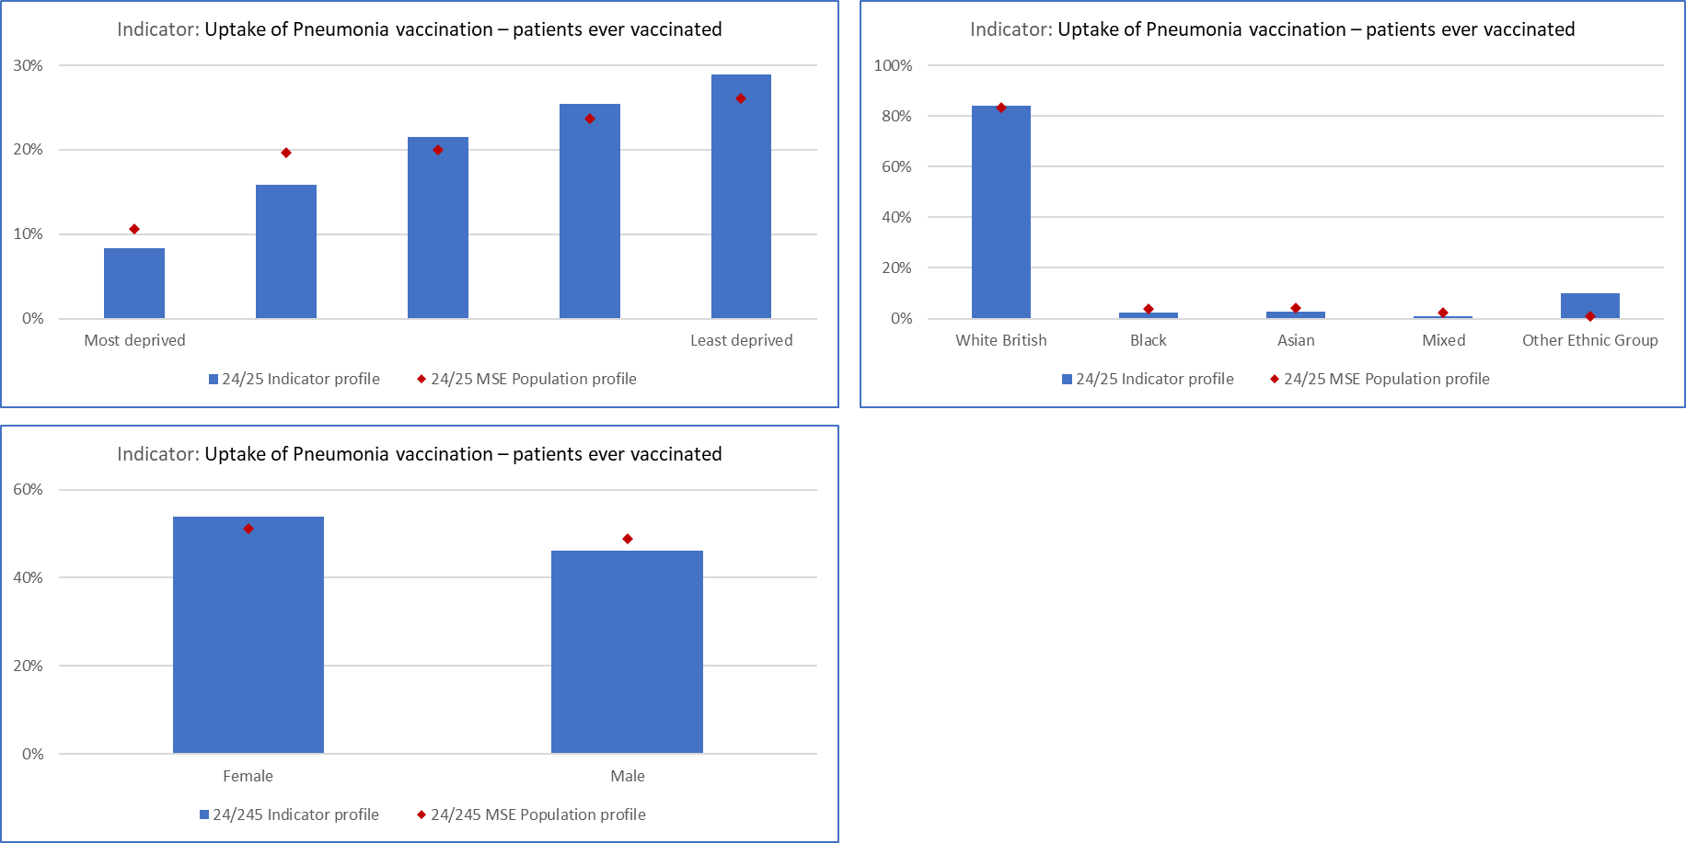

*Source: MSE local dataset Athena February 2025.*

In 2024/25 the ICB launched a communications campaign to raise awareness and encourage eligible individuals to receive the free pneumococcal vaccination. Together with an education campaign, with easy-to read document developed in partnership with voluntary sector groups to increase awareness and uptake among those with learning disabilities. The targeted work through communities and voluntary sector in our most deprived areas has shown good uptake.

## Cancer

Early cancer diagnosis is a specific priority for MSE ICB as part of its adoption of the Core20PLUS5 framework. A collaborative approach has been taken across the ICB, Cancer Alliance, NHSE East of England region, MSEFT, PCNs and GP Practices in reducing health inequalities in Cancer.

**Early Cancer Diagnosis**

A national ambition has been set that 75% of all stageable cancers will be diagnosed as stage 1 and 2 by 2028. The National Disease Registration Service collects and complies the cancer staging data. The latest data available is for 2019-2021. MSE ICB has a lower proportion of cancers diagnosed at stage 1 and 2 in comparison to the England average. There is variation between the localities in MSE with the highest proportion of cancers diagnosed at an early stage in Basildon and Brentwood. The lowest early cancer detection rates are in Castle Point and Rochford

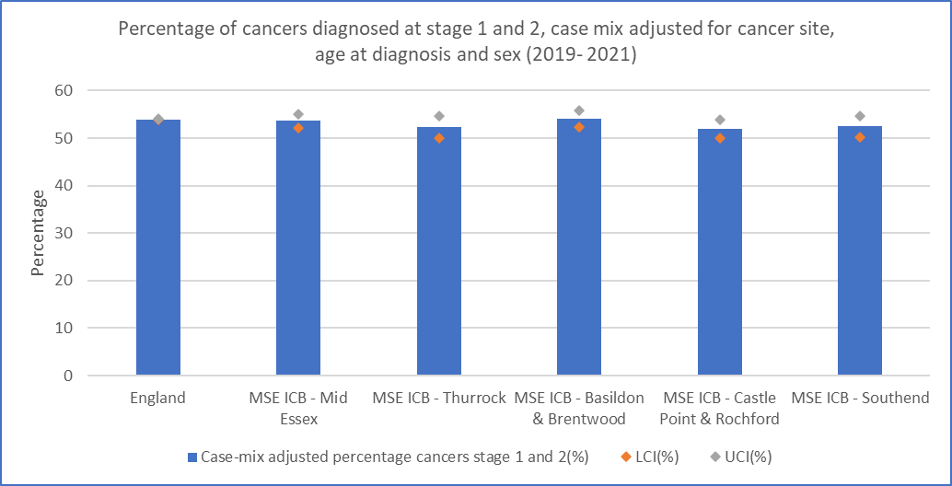

*Source: Cancer Registry staging data from NDRS*

**Cancer Screening**

Nationally 90% of cancers found via screening were diagnosed at an early stage. However, there is lower uptake of cancer screening programmes in adults living in more deprived areas. In MSE there is marginal variation in cervical screening rates by level of deprivation. However, for Breast and Bowel screening the uptake is lower in areas of deprivation (quintile one and two).

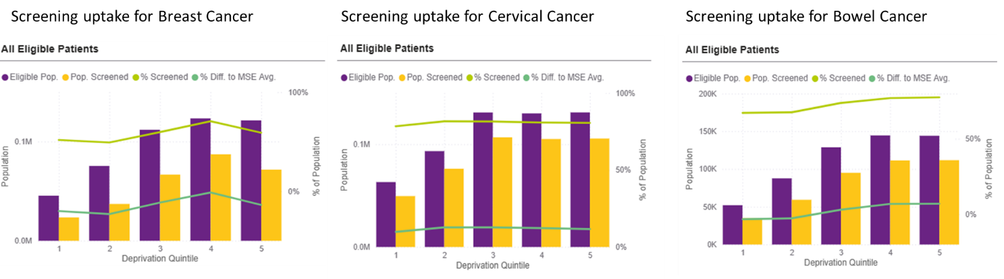

*Source: Local MSE data extracted from SystmOne*

There are a number of actions being undertaken to improve uptake of cancer screening including:

* Monthly PCN data continues to be shared on uptake of cancer screening with follow up by designated Primary care cancer leads to identify and share good practice across MSE.
* Conducting a survey to understand public attitudes, knowledge and experiences relating to breast cancer screening.
* Expansion of culturally competent communication with videos from local doctors about how to recognise signs and symptoms of some of most common cancers.
* Promotion of Essex Frontline as a one-stop shop for cancer care in the community. Offering patients hyper-local support groups that provide advocation for screening programmes.
* Expansion of national Lung Cancer Screening Programme to Castle Point and Rochford with continuation in Thurrock and Southend.

## Cardiovascular

Cardiovascular disease (CVD) causes 1 in 4 deaths in England and is one of the leading causes of morbidity in MSE. CVD and Stroke is largely preventable and therefore has been a priority for the ICB over the last year.

**Stroke and Heart Attack Admissions**

Nationally, there has been an increasing number of people admitted to hospital following a stroke. With people from lower socioeconomic groups experiencing strokes earlier and facing poorer care outcomes. This is borne out in MSE with an over-representation of stroke admissions from more deprived groups, which increased in 2024/25. There is also over-representation from Black and Asian groups and Males, all of which have widened health inequalities in 2024/25.

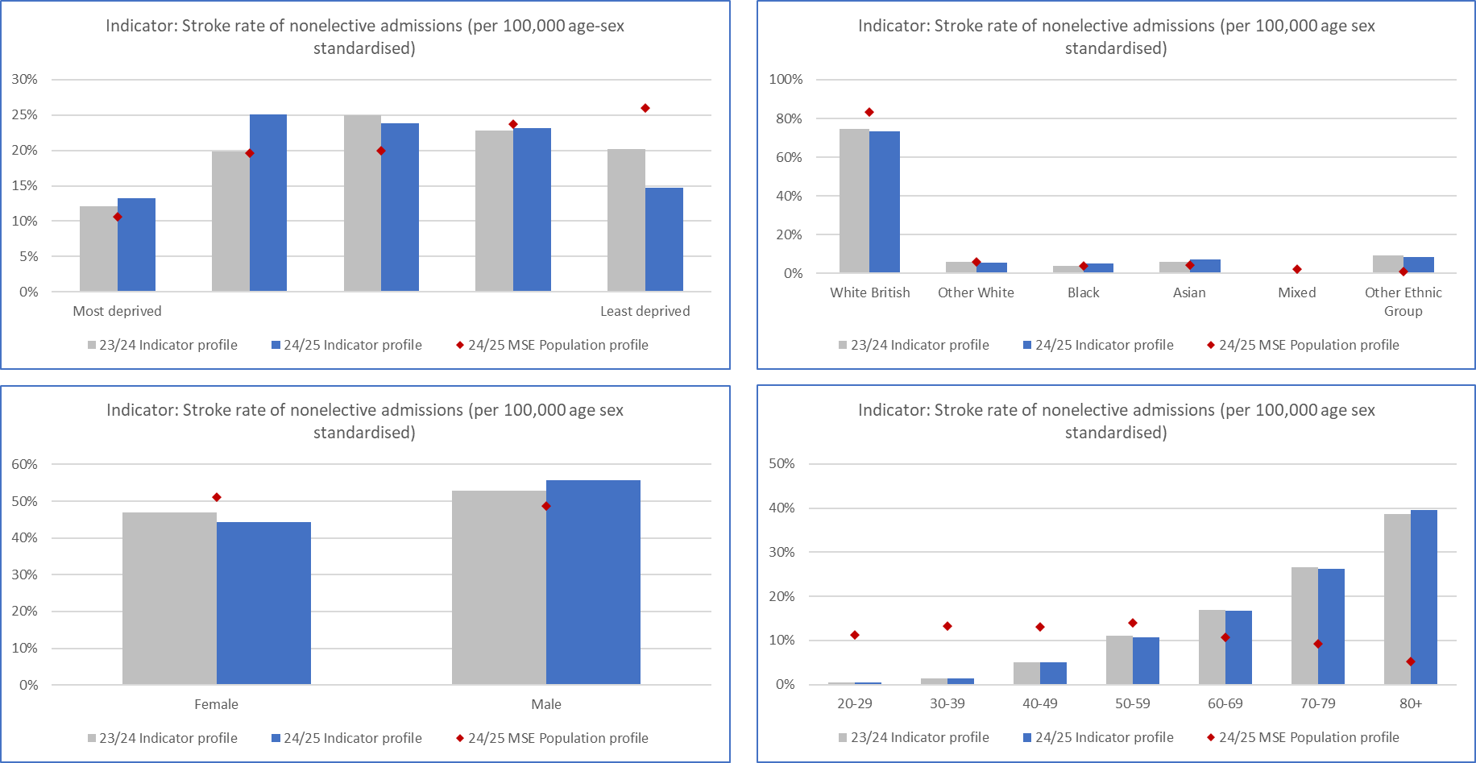

*Source: Local MSE data - Athena from SUS (Note: 23/24 12 months, 24/25 9 months data)*

Heart attacks (Myocardial infarction) is a leading cause of hospital admissions and mortality in the UK. Nationally, the emergency admission rate for heart attacks is higher from lower socio-economic groups and women often face disparities in care and outcomes. In MSE, there is a significant over-representation of Males which has increased in 2024/25. This may indicate potential underdiagnosis in women, due to differences in clinical presentation compared to that of men.

In MSE the inequalities gap due to socioeconomic deprivation closed slightly in 2024/25, with a reduced proportion of admissions for heart attacks from our most deprived groups.

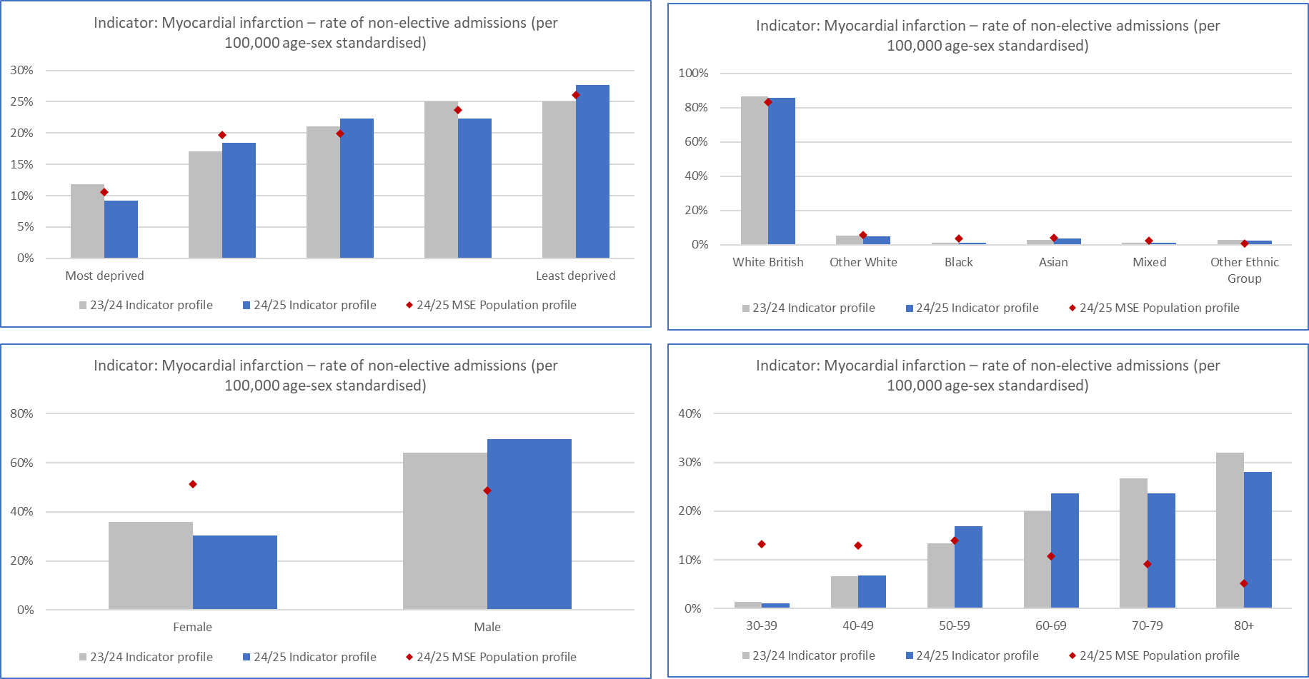

*Source: Local MSE data - Athena from SUS (Note: 23/24 12 months, 24/25 9 months data)*

The ICB has focused on interventions for the prevention and treatment of cardiovascular disease across three main areas (1) Hypertension – diagnosis and treatment of high blood pressure (2) Cholesterol – reduction through prescribing of statins (3) Atrial fibrillation or abnormal heart rate – regulate through prescribing of anticoagulants.

**Hypertension**

Hypertension (high blood pressure) is a key priority within the NHS Long Term Plan and was a National NHS objective for 2024/25. A key measure is the proportion of patients with hypertension that are treated according to NICE guidance. There has been an overall increase in the proportion of patients that are treated to threshold. However, a lower percentage of those from a non-white British background and those in the younger age cohorts (under 60 years) are likely to be treated in accordance with NICE guidance. Although the gap is closing from the previous year for those for Other White and Black ethnic background.

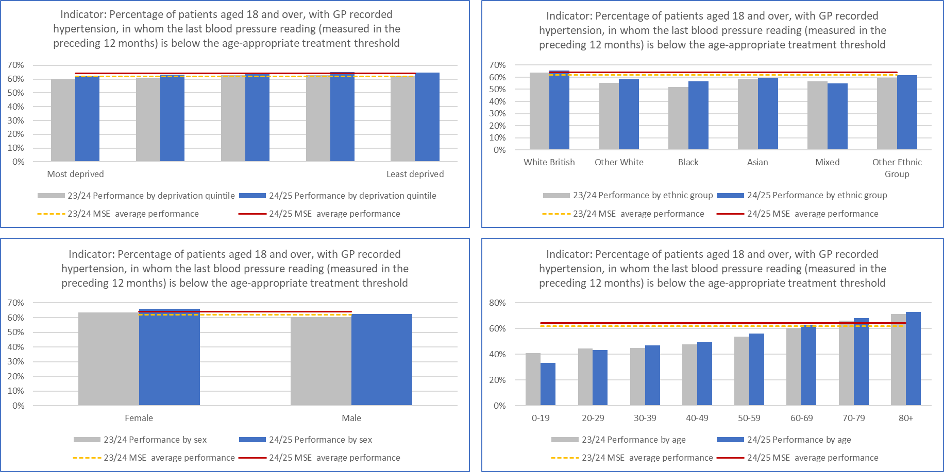

*Source: Local MSE data- Athena extracted from SystmOne*

There are a number of actions being undertaken to improve management of Hypertension including:

* Local Enhanced scheme working with 14 PCNs focused on areas of greater deprivation and the non-white British population providing holistic clinics to optimise management of Hypertension, Atrial Fibrillation and Cholesterol along with providing support for risk factors like smoking and weight management.
* Hypertension Quality Outcomes Framework (QOF) extension scheme, that provides incentives for primary care to effectively management a greater proportion of their patients.
* Outreach clinics undertaken in deprived areas of Southend to improve identification and management of hypertension.
* Working collaboratively with Essex County Council on the pilot of SISU mobile health check machine pilots in MSE to support hypertension case identification targeted at those least engaged with primary care in work place locations.
* Regular public campaigns ‘Know Your Numbers to reduce your risk of heart attacks and strokes’ and ‘Invincible Feeling, Invisible Danger’ encouraging taking regular blood pressure checks.

**Cholesterol**

Raised cholesterol is one of the top three modifiable contributors to risk of cardiovascular death. Stains, a lipid lowering therapies, are the most effective medicines for reducing cholesterol levels for most people. A National NHS objective for 2024/25 was to increase the percentage of patients at the highest risk of CVD on lipid lowering therapy to 65%. In MSE has consistently performed above this level, 77% for 2024/25. There is a greater uptake of lipid lowering therapies in our most deprived areas and from those with global majority background.

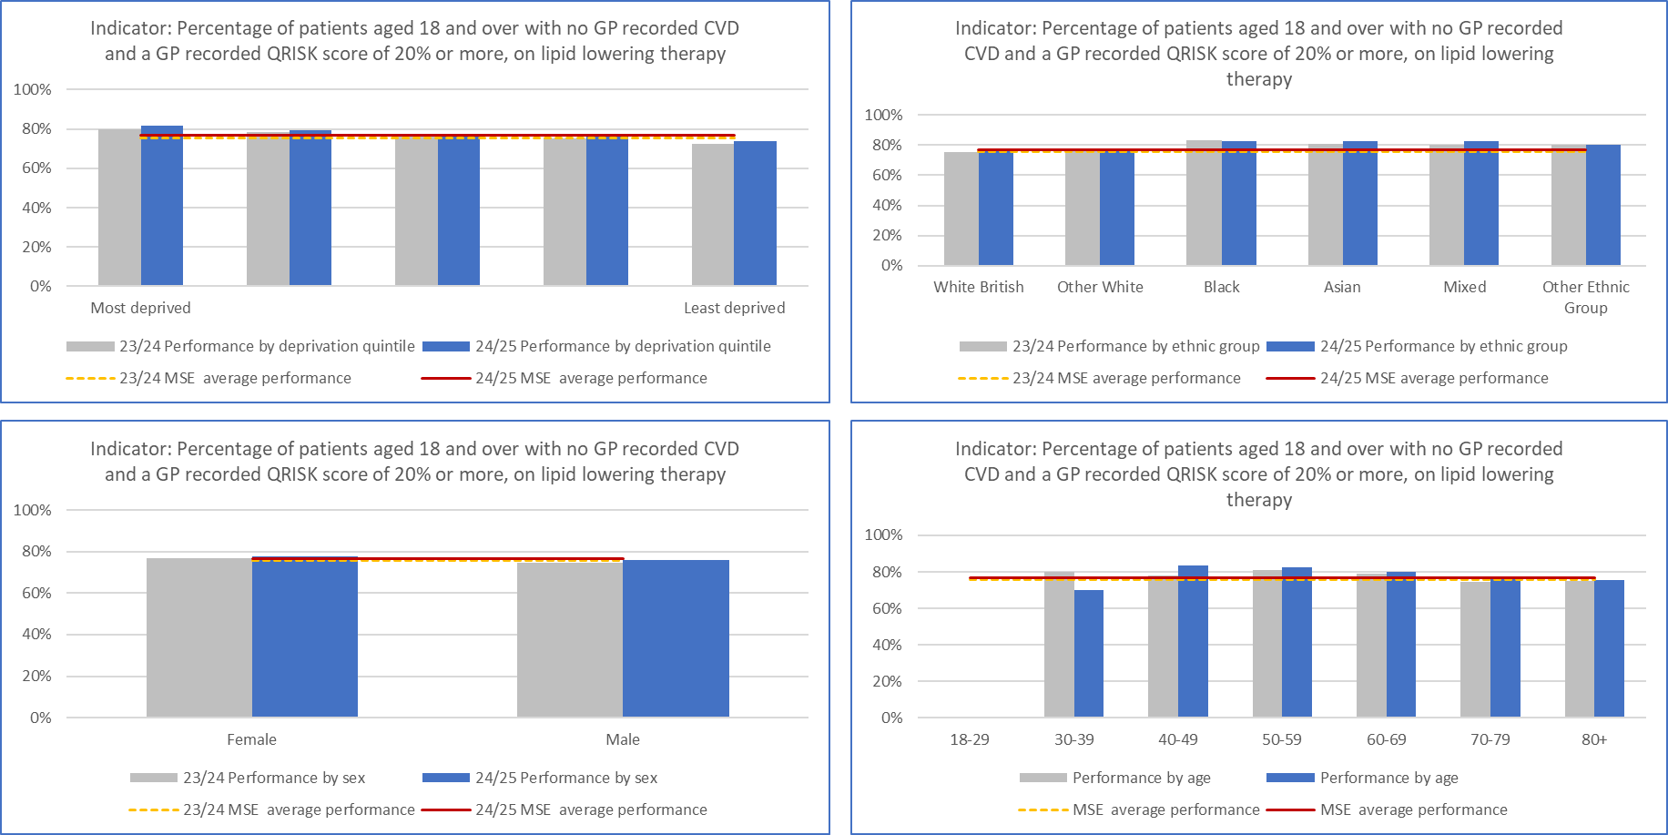

*Source: Local MSE data- Athena extracted from SystmOne*

The ICB has been focused on ensuring that lipid lowering therapies are optimised and the use of high intensity statins are considered along with other medication options. A free e-learning course has been made available to over 550 GP and pharmacy participants.

**Atrial Fibrillation**

Atrial Fibrillation (AF) is the most common form of heart arrhythmia and doubles a person’s risk of stroke. Prescribing anticoagulants for patients with AF are an effective and low risk method of reducing the likelihood of stroke. In MSE, the percentage of patients with AF that currently are on anticoagulants increased from 93.8% in 2023/24 to 94.7% in 2024/25. There remains a lower uptake with those from a Black or Asian ethnic background or aged 40 to 49 years, although the gap is beginning to close.

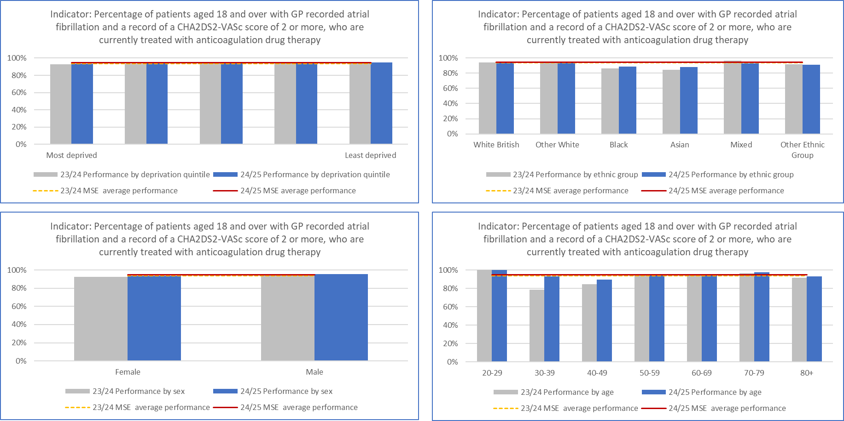

*Source: Local MSE data- Athena extracted from SystmOne*

The Local enhanced CVD scheme, detailed above, not only covers Hypertension but also AF. The outcomes from this scheme will be known in Q1 of 2025/26. In addition the CVD Community Outreach activities being undertaken across 18 PCNs, many are carrying out pulse checks to identify new cases of AF and exploring opportunities of treatment optimisation for existing patients.

## Diabetes

Diabetes does not affect everyone equally, with inequalities in access to service and outcomes along with the risk of developing type 2 diabetes being driven particularly by ethnicity and socioeconomic deprivation.

**Type 1 Diabetes**

For those with Type 1 Diabetes there are eight key care processes that are recommended by NICE that support the prevention of complications associated with diabetes. In MSE it appears there has been a deterioration in the overall percentage of people with Type 1 Diabetes receiving the eight care process. However, it should be noted that the data is recorded up to end of February so doesn’t represent a full year. Many GP practices undertake these checks in the final quarter of year, and therefore the data could be under reporting activity and performance.

Based on the available data, there appears to be a widening of health inequalities based on deprivation, with those from our most deprived areas less likely to have all eight care processes completed. There has also been a widening based on age, with a lesser proportion of patients aged under 40 years having all eight care processes completed. There has however, been a narrowing of the gap with a significantly greater proportion of people from an Asian background receiving the eight care processes.

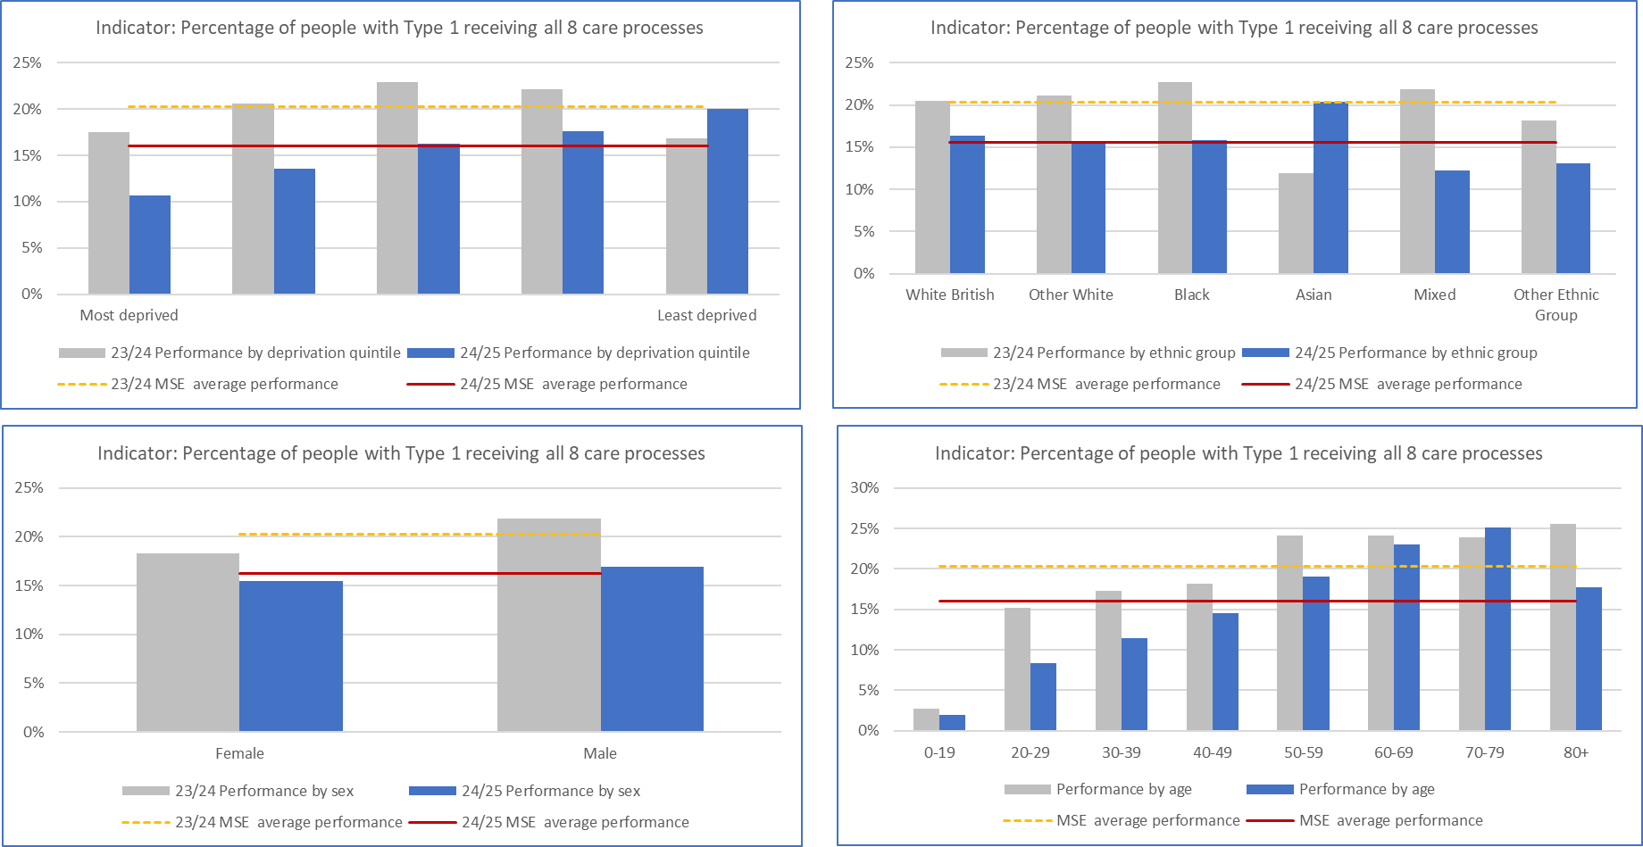

*Source: Local MSE data- Athena extracted from SystmOne*

There are a number of actions being undertaken to improve the effective management of Type 1 diabetes including:

* Implementation of hybrid closed loop system, that automatically adjusts the amount of insulin given through a pump, to reduce variation in care and inequalities for patients. The focus has been initially on areas of greatest deprivation, those who are pregnant and children and young people.
* Patient survey via our engagement platform ‘virtual views’ on their experiences of diabetic care to inform the development of a new service model.
* Training on foot screening delivered to GP practices to increase competency of foot checks to prevent serious foot problems and even amputations.
* Promotional videos developed in multiple languages to highlight the importance of eye screening and used as part of engagement with local ethnic minority communities.

**Type 2 Diabetes**

The eight care processes are also recommended by NICE for those with Type 2 Diabetes. There has been an overall increase in the proportion of people with Type 2 Diabetes receiving all eight care processes. However, it should be noted that the same data limitations apply for Type 2 and described above for Type 1 Diabetes.

It appears that the gap in inequalities due to socioeconomic deprivation has increased, with the greatest increase in people receiving all eight care processes seen in the least deprived group. With under representation from those from a black ethnic background and those aged under 50 years.

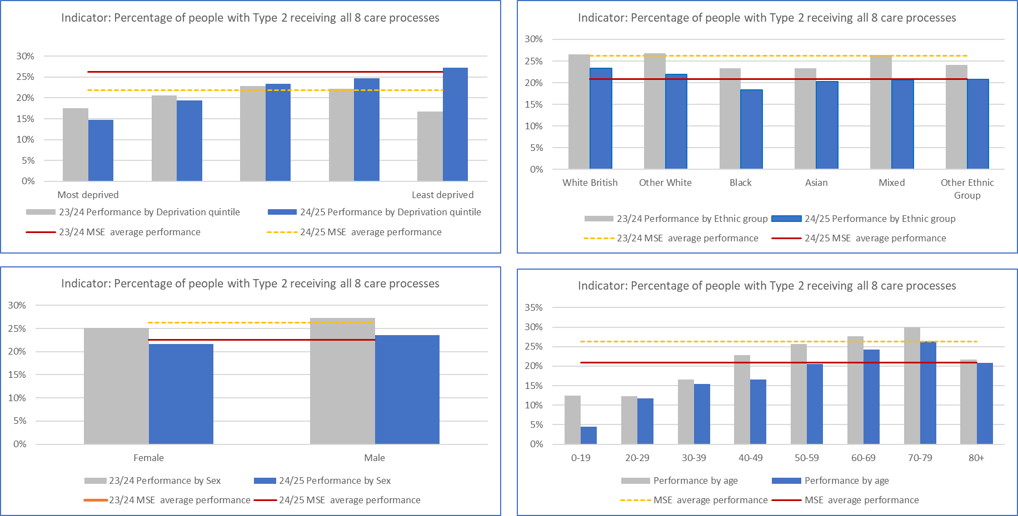

*Source: Local MSE data- Athena extracted from SystmOne*

There are a number of actions being undertaken to improve the effective management of Type 2 diabetes including:

* Targeted PCN Innovation and Recovery Funding to improve uptake of the Care Processes in two PCNs serving our most deprived population. Evening and weekend clinics delivered by Community collaborative and PCN staff have enabled 1200 patients to receive all care process, who had not previous received in the last 2 years.
* Providing support to Primary care though clear Type 2 Diabetes Management Guidelines and promoting awareness through training sessions.
* Working with Diabetes UK and our Research and Engagement champions to promote awareness amongst communities in our most deprived areas or from an ethnic or inclusion background.
* Working with Eye screening provide to locate care closer to local communities to reduce inequalities relating to travel.

## Risk factors; Smoking and Obesity

Smoking and Obesity are the main risk factors that drive premature mortality from cardiovascular disease, lung cancer and chronic lower respiratory diseases. Smoking is the single largest driver of health inequalities in England.

**Smoking**

The MSE Maternity stop smoking pathway launched in February 2024 across the three hospital sites: Basildon, Broomfield, and Southend. Providing women divulge their smoking status, electronic reports are set up to capture the personal details of all birthing people who ‘currently smoke’ and those who have ‘quit since conception.’ All women and birthing people within this category receive a telephone call during the next working day irrespective of their postcode and or deprivation level. The outcome has been a reduction in the Smoking at time of delivery rate from 9% in 2023 to below 6% in December, in line with the national target.

A smoking cessation in-house service is currently available for those patients admitted into wards in Basildon, Broomfield and Southend Hospitals. With a mental health inpatient service launched in December 2024 by EPUT. Whilst some smoking data is currently collected it is incomplete so once there is a comprehensive dataset available in 2025/26 an assessment will be undertaken to identify if there are any inequalities to accessing the service and address as required.

Patients continue to be able to access the Local Authority public health commissioned community smoking cessations services in addition to those above.

**Weight Management**

The ICB supports GP Practices in referring patients to the nationally commissioned NHS Digital Weight Management Programme. The programme supports adults living with obesity who also have a diagnosis of diabetes, hypertension or both, to manage their weight and improve their health.

There is a greater proportion of referrals into the Digital Weight Management Programme from the more deprived areas of MSE, and an over-representation from non-white British ethnic groups, and an increasing proportion from men. These are positive trends that will support the reductions in health inequalities in obesity.

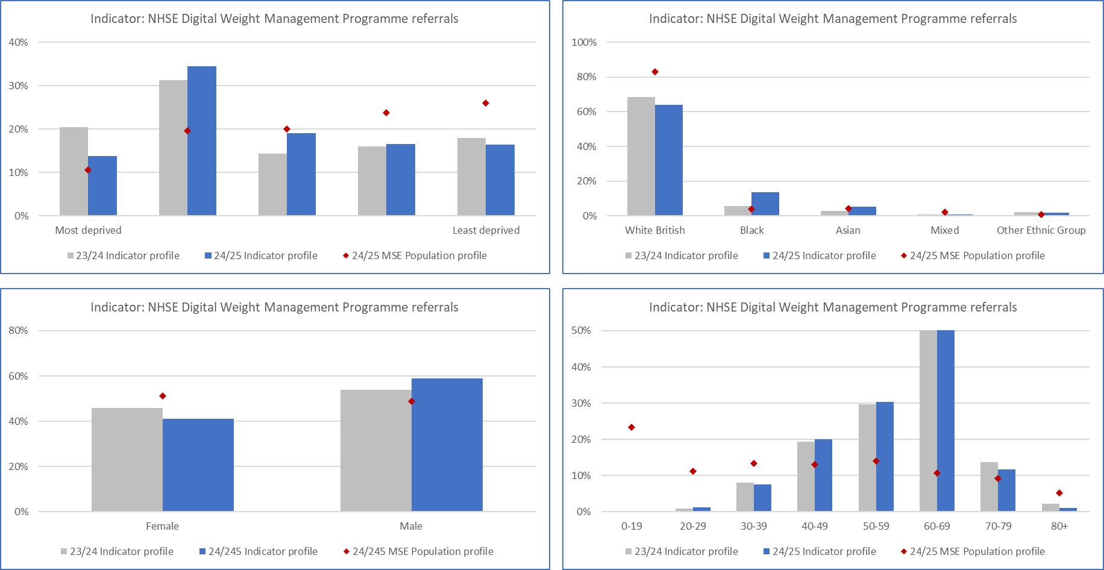

## Conclusion

This is the second health inequalities annual report that NHS Mid and South Essex has published. We have seen an expansion in the number of metrics and quality of data and insights, to facilitate action in reducing health inequalities. Now for the first time we have trend data that enables us to assess whether we are narrowing the gap in health inequalities and areas we need to put more effort and focus.

This report shows our health inequalities gaps are concentrated around our population that live in the most deprived communities and those from diverse ethnic backgrounds. The ICB continues to be committed to embedding prevention, early intervention and tackling health inequalities across all our work and with our partners within the Integrated Care System.

1. [NHS England » NHS England’s statement on information on health inequalities (duty under section 13SA of the National Health Service Act 2006)](https://www.england.nhs.uk/long-read/nhs-englands-statement-on-information-on-health-inequalities-duty/)
2. [NHS England » Core20PLUS5 (adults) – an approach to reducing healthcare inequalities](https://www.england.nhs.uk/about/equality/equality-hub/national-healthcare-inequalities-improvement-programme/core20plus5/), [NHS England » Core20PLUS5 – An approach to reducing health inequalities for children and young people](https://www.england.nhs.uk/about/equality/equality-hub/national-healthcare-inequalities-improvement-programme/core20plus5/core20plus5-cyp/)
3. [Essex’s Joint Strategic Needs Assessment | Essex Open Data](https://data.essex.gov.uk/jsna-home/), [Joint Strategic Needs Assessment (JSNA) – Southend-on-Sea City Council](https://www.southend.gov.uk/health-wellbeing/joint-strategic-needs-assessment), [Joint Strategic Needs Assessment | Public Health | Thurrock Council](https://www.thurrock.gov.uk/public-health/joint-strategic-needs-assessment)
4. [Narrowing the gap - Mid and South Essex Integrated Care System](https://www.midandsouthessex.ics.nhs.uk/publications/narrowing-the-gap/#:~:text=The%20MSE%20ICB%20has%20committed,the%20gap%20in%20health%20inequalities.)