

**NHS Mid and South Essex**

**Joint Forward Plan   
2024-2029**

**Section 1 - April 2025 Refresh**

**NHS Mid and South Essex Joint Forward Plan 2024-2029 (April 2025)**

Contents

About this Document 3

Foreword from our Chair 4

JFP Section 1: Strategic Ambitions 5

1. Introduction 5

2. Our Strategic Ambitions 6

3. Working in Partnership 8

3.1 Let Staff Lead 8

3.2 Mobilising and Supporting our Communities 9

3.3 Developing our system 9

3.4 Improving our NHS oversight framework rating 11

4. Operational Delivery 11

4.1 Improving Quality 11

4.2 Reducing Health Inequalities 13

4.3 Improving population health 15

4.4 Commissioning healthcare services 16

5. Key System Enablers 20

5.1 Supporting our workforce 20

5.2 Data, digital and technology 23

5.3 Financial sustainability 25

5.4 Research and Innovation 26

5.5 Serious Violence and Victims of Abuse 28

Appendix 1 – ICB Statutory Legal Duties 29

# About this Document

This document provides a refresh of Mid and South Essex Integrated Care Board’s (MSE ICB) Joint Forward Plan for 2024-29 (section 1). It recommits the NHS system in MSE to the strategic ambitions set out in the 2023-28 Joint Forward Plan, which were developed in partnership with local stakeholders and approved by the Essex, Southend and Thurrock Health and Wellbeing Boards in June 2023 and by the ICB Board in May 2023.

MSE ICB is a system that is currently facing significant financial challenges. There are challenges to meeting growing and evolving local population needs from the financial position in MSE.

* MSE ICB in-year (2023-24) total healthcare allocation was £2.8 billion.
* We estimate needing a total £247 million in additional recurrent saving by 2029/30.

The ICB’s immediate focus is on recovering a sustainable financial position, delivering on national operational planning requirements, and maintaining a focus on addressing health inequalities as we do those.

The details of how this will be delivered in 2025/26 and beyond have been considered through the delivery NHS system’s 2025/26 Operational Planning requirements and the development of a new system 3-to-5-year Medium Term Plan (MTP). Strategic priorities and refreshed delivery plans are provided in updated sections of this Joint Forward Plan.

This refreshed 2024-29 Joint Forward Plan for MSE ICB includes:

1. A reminder of the strategic ambitions the system has committed to.
2. A summary of some of the commitments the ICB delivered on in 2024/25.
3. A summary of what the ICB will deliver in 2024/25 and beyond *(please refer to section 3 for detailed action plans).*

# Foreword from our Chair

I am delighted to present the Mid and South Essex Integrated Care System Joint Forward Plan for 2024-2029. In this refresh of our Joint Forward Plan, we are recommitting to the strategic ambitions we developed with our partners last year. These ambitions are the foundations for how we will continue to develop and improve our services to better meet the needs of our population and communities. As a priority, we must address our cancer waiting times, which compare poorly with other systems.

We know that we can only deliver on our ambitions by continuing to build on our existing joint work with local government and by listening to our people and communities to deliver change.

As is the case for many Integrated Care Systems, we face a number of significant challenges. The Covid pandemic exacerbated health inequalities in our population and our primary care services are under extreme pressure. Demand on our mental health, urgent and emergency services are significant, we have long waits for planned treatments, and we are not meeting nationally set standards in relation to cancer care. Collectively, our providers are carrying significant vacancies and we over-rely on bank and agency staff to fill rotas – as a result the quality of care we offer can sometimes suffer. Within these many challenges, we are also a system that has high ambitions to improve the health and wellbeing of the population that we serve. During 2024/25 we have delivered impressive and long-lasting improvements and have had many successes.

In addition to recommitting to our strategic ambitions, this revised plan highlights the good progress we have made in 2024/25, a summary of these achievements is included in section 2.

We are committed to continuing to work together across health, local government and with our communities to do all that we can to improve outcomes for our local population.

Our system’s strategic ambitions and plans for this year are set out in this Joint Forward Plan.

**Professor Michael Thorne CBE**

**Chair**

**NHS Mid and South Essex Integrated Care Board**

# JFP Section 1: Strategic Ambitions

## 1. Introduction

Mid and South Essex Integrated Care Board (MSE ICB) oversees the NHS budget for the 1.2 million people that live and work in mid and south Essex. In 2025/26 that budget is £2.8 billion. The ICB is responsible for developing a plan for how to invest and spend this money to deliver care and support services that will help improve people’s health, deliver high quality care that meets their needs and that offers value for money.

Figure 1 shows the shape of our partnership across MSE, which includes 144 GP practices working across 26 Primary Care Networks, three community and mental health providers, one acute hospital trust working across three large hospitals, one ambulance trust, three upper tier local authorities and seven district and borough councils, three Healthwatch organisations and many community, voluntary, faith and social enterprise sector organisations.

Throughout 2024/25 the financial and operational context across the NHS in MSE has remained challenging, with the system facing increasing financial challenges as it aims to deliver sustainable services that meet the needs of local residents. At the end of 2024/25 MSE reported a system-wide deficit and is currently working within a ‘triple’ lock, with any unplanned expenditure or requests over £25,000 being scrutinised by NHS England, as well as the ICB.

Despite this, the ICB remains committed to being a health and care partnership working for a better quality of life in a thriving mid and south Essex, with every resident supported to make informed choices in a strengthened health and care system. We want people to live longer, healthy lives, to be able to access the best of care and to experience the best clinical outcomes, and for us to be able to attract good people to work with us, recognising we offer meaningful careers.

This Joint Forward Plan recommits the ICB to the strategic ambitions that were developed by the system in 2023 to align with the [Mid and South Essex Integrated Care Partnership (ICP) Strategy](https://www.midandsouthessex.ics.nhs.uk/about/integrated-care-strategy-2023-33/). These ambitions are supported by the delivery plans set out in section 3 of the Joint Forward Plan, which outline how we will deliver on our ambitions in 2025/26 and beyond.

*Figure 1: Mid and South Essex Integrated Care Partnership*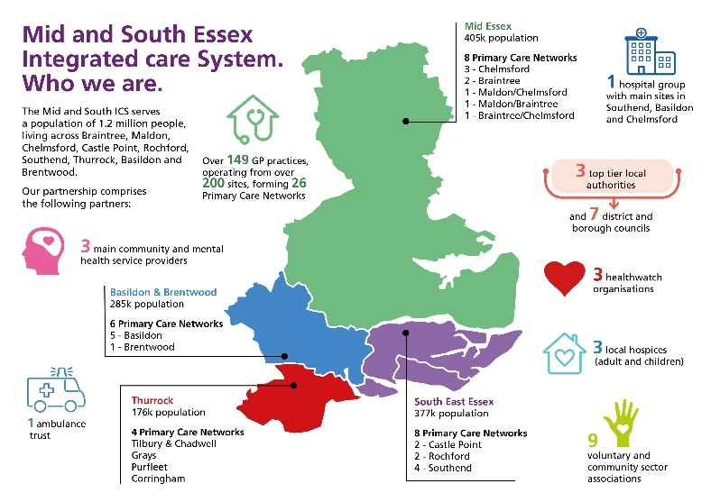

## 2. Our Strategic Ambitions

In 2023, the ICB committed to twelve strategic ambitions for our health and care system. These strategic ambitions inform the system’s operational planning and delivery, ensuring that the ICB can deliver on its statutory duties and maintains a focus on the Triple aim of improving the health of our local population, improving the quality of services we provide and improving the efficiency and sustainability of local services. The ambitions also support the four key aims of Integrated Care Systems to:

* Improve outcomes in population health and healthcare.
* Tackle inequalities in outcomes, experience and access.
* Enhance productivity and value for money; and
* Supporting broader social and economic development.

For the 2024-2029 Joint Forward Plan, the ICB’s strategic ambitions have been grouped under three headings that reflect areas of focus across the ICB:

1. **Partnership:** These ambitions focus on how we work together to develop and deliver our plans and provide collective assurance on the quality and value that services offer to local residents.
2. **Delivery:** These ambitions focus on operational delivery to drive improved quality of care for patients, adjusting how we deliver to address health inequalities and look at upstream delivery to improve the health outcomes across our populations.
3. **Enablers:** These ambitions focus on the critical enablers in our system that are needed to support successful delivery and effective partnership working to improve care outcomes. Those include our workforce, data, digital and technology, financial sustainability and research and innovation.

*Figure 2: Description of 12 strategic ambitions*

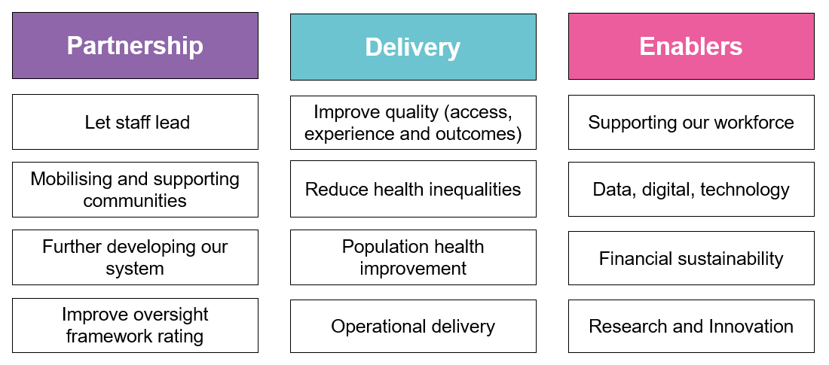

In May 2024 the ICB Board agreed a set of Strategic Priorities that provide focus for how the ICB will deliver on the Strategic Ambitions. These Corporate Objectives are:

1. To ensure that the MSE ICB and ICS deliver good quality health care and services within financial resource limits.
2. To reduce health inequalities across mid and south Essex including access to, experience of, and outcomes of the services we provide.
3. To improve standards of operational delivery, supported by collaborative system working to deliver patient centred care in the right place that the right time and at the right cost to the NHS.
4. To develop and support our workforce through compassionate leadership and inclusion, achieving significant improved by March 2026.
5. To develop effective oversight and assurance of healthcare service delivery across mid and south Essex, ensuing compliance with statutory and regulatory requirements.
6. To embrace service improvement by adopting innovation, applying research and using data to drive delivery, transformation and strategic change.
7. To be an exemplary partner and leader across mid and south Essex ICS, working with our public, patients and partners in the ICP to jointly meet the health and care needs of our people.

Central to these priorities is the need to recover our financial position. The development of a system-wide recovery programme, the Medium-Term Plan (MTP), has been a key priority for 2025/26 and beyond recognising that recovery will require a multi-year approach. This work, led by the Executive Director of System Recovery, provides a structured approach to overseeing both organisational and system level recovery projects and programmes. The governance that oversees this work, and how it feeds into the ICB’s overall governance, are set out at the start of Section 3 of the Joint Forward Plan.

Looking more broadly across mid and south Essex, in March 2024 the Integrated Care Partnership agreed a set of joint priorities to focus on in 2024. These priorities focus on wider determinants of health and focus on areas where there is value in partners coming together to improve services for the local population. Between January and March 2024 an initial set of priorities was identified by drawing on priorities in the three local Health and Wellbeing Strategies and local health priorities.

This initial ‘long list’ was tested with community partners through the Community Assembly, with an updated list proposed back to the ICP Delivery Group that was overseeing the work. This led to an agreed set of five priorities for a ‘Healthy MSE’ were developed across the partnership through a Steering Group which drew on priorities identified from the three local Health and Wellbeing Strategies, as well as the local health priorities.

The five priorities for a Healthy MSE, which are reporting into the Integrated Care Partnership, are:

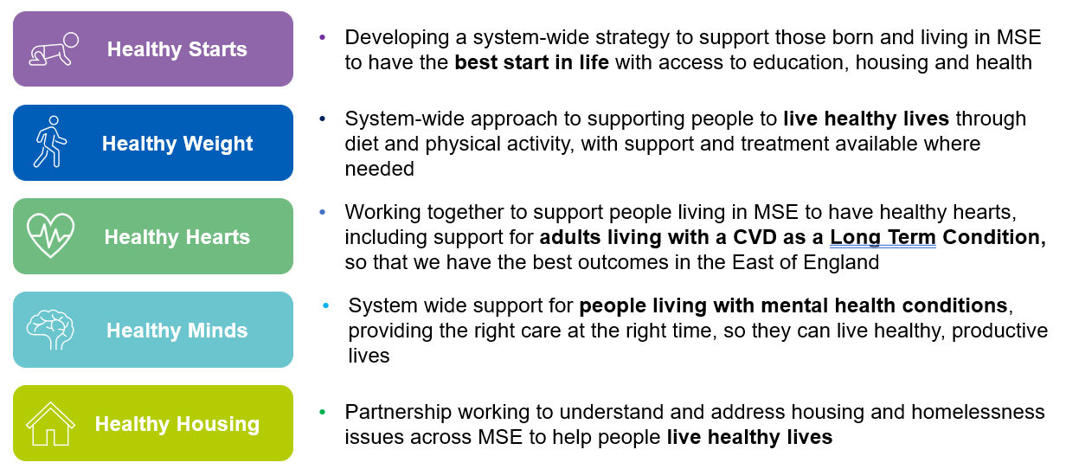

*Figure 3: Description of five healthy MSE priorities*

In 2025/26, this will be extended with two further priorities; of ‘Healthy work’ by supporting individuals into employment and ‘Healthy living’ supporting people to make and maintain healthy lifestyle choices.

## 3. Working in Partnership

### 3.1 Let Staff Lead

Our workforce are our biggest investment and our greatest asset. An engaged and empowered workforce is more likely to deliver high quality care and support the transformation that is needed in our system.

*Working with our stewards and clinical leaders*

The ‘Stewardship’ programme in MSE is putting clinical and operational leaders at the centre of work to drive the transformational change that is needed in our system. Stewardship offers staff the chance to receive training and development that will help them engage with data, information and evidence to help them identify and address challenges in the services they are working in. Our stewards also ensure that we have access to the expert advice that we need to inform the development of clinical and operational pathways to support the ongoing improvement of care.

We are supporting our Stewards to lead clinical change through regular leadership and development opportunities, including our Summits. As the programme evolves, we will be bringing the Stewards closer to our overall Financial Recovery programme and considering how they can help us drive improved productivity alongside improved outcomes and experience for patients.

Alongside our Stewardship programme, we have reviewed our System Clinical Leadership to ensure resource efficiency, system value and a focus on quality improvement. This work is being supported by the Clinical Leadership and Innovation Directorate and is underpinned by the national principles that will see clinical leaders better connected, developed and supported in our system. Our clinical leadership development programme ‘Leading Better Together’ will support those stepping up to lead in our system.

Staff are often best placed to identify opportunities to improve our services. The ICB is committed to developing a model for Quality Improvement that will help equip and support staff to speak up and step up in suggesting ways that they can improve the quality and value of care offered to patients.

*Supporting NHS net zero ambitions*

As the ICB has re-ignited its Greener NHS programme, we have sought Green Champions within our organisation to join those who have already come forward in other organisations. These champions are invited to join others across the system in the MSE Sustainability Forum to share ideas and insights and help lead action to support the system to deliver on its Net Zero ambitions. We aim to publish our greener NHS strategy during summer 2025.

### 3.2 Mobilising and Supporting our Communities

It is important to acknowledge the breadth of assets that exist across our communities in MSE. We recognise that there is more that we can do to work with communities to acknowledge, draw on and support those assets to support our residents. This is central to the work we are undertaking in our Alliances, including the development of local Integrated Neighbourhood Teams.

We are committed to continuing to listen to and work with individuals, groups and communities to ensure that we both understand local challenges and develop asset-based responses to local need. MSE [Virtual Views](https://virtualviews.midandsouthessex.ics.nhs.uk/) has been established as an online community for local people to share their views, experiences and ideals about local health and care services. In addition, we will continue to develop our approach for engaging our people and communities through our placed-based Alliances and the development of our Community Assembly.

### 3.3 Developing our system

The ICB is continuing to develop as both as organisation and as a system. Investing in our collective development and partnership working is critical to enabling our success as an integrated care system. As we continue to mature as a system, we will continue to support and develop our leaders as individuals and our teams so that they are equipped to help lead effective decision making and delivery across our system.

*Commitment to working with Local Authorities*

We are continuing to strengthen our partnership working with local authorities across mid and south Essex at all levels, including our district and borough councils. We recognise the importance of collaborating in how we plan and deliver health and care services for the benefit of local residents, and the ICB and ICP continue to align with and support the priorities identified by the three upper tier Health and Wellbeing Boards and our local placed-based partnerships, our Alliances.

*Our Alliances and local place-based partnerships*

A core part of our system development is our place-based Alliances. We will continue to develop and mature these partnerships so that they can better understand the needs of local communities and support delivery of integrated services that support improve population health outcomes, quality of care, experience and value. Alliances will develop delivery plans around shared local outcomes that contribute to our priorities as an ICB and ICP.

They will use an asset-based approach to community development to drive transformation and focus on the wider determinants of health to improve health outcomes, particularly through the vehicle of integrated neighbourhood working. As Alliances continue to mature and develop, they will look for opportunities to make best use of the collective resource to deliver sustainable change.

*Commissioning and Supporting our Primary Care Partners*

The ICB is now responsible for commissioning all primary care services, including community pharmacy, optometry and dental services. This provides us with a further opportunity to strengthen primary care services in our system and consider new ways of delivering care and treatment to meet local need. MSE is one of the first systems in the country to receive delegated responsibility for commissioning specialised services. We are excited about the opportunity this provides us to review how we commission services to best meet the needs of our local population.

The ICB is also supporting the development with providers and provider collaboratives across our system, including:

* The **Primary Care Collaborative** for Mid and South Essex, including a focus on supporting the sustainability of general practice and implementing the recommendations from the Fuller review.
* The **Community Collaborative**, which brings together Essex Partnership NHS Foundation Trust (EPUT), North East London NHS Foundation Trust (NEFLT) and Provide Community Interest Company (CIC).
* The **NHS Specialist Mental Health, Learning Disability and Autism Provider Collaborative** across East of England with MSE participation.
* **Mid and South Essex NHS Foundation Trust** (MSEFT) to reduce variation and increase the quality and value of care offered across its acute and community hospitals.

*Supporting wider social and economic development through Anchor Programmes*

The NHS in MSE remains committed to being an anchor in our community. With a budget of over £2 billion and a workforce of over 23,000 we are a huge contributor to our local economy. Through the MSE Anchor programme the ICB continues to explore ways that we can contribute to wider social and economic development through:

* **Our workforce:** helping local people to gain jobs in the NHS through the Anchor Ambition programme, anchor youth programme, apprenticeships and then ongoing career development. We will also continue to focus on the wellbeing of our workforce and their families as potential users of our health and care services.
* **Our purchasing:** the NHS is committed to ensuring social value remains an important consideration in our procurements. This includes including requirements around ethical and labour standards, including net zero and modern slavery requirements, in all our procurements and contracts.
* **Our buildings and spaces:** we are currently developing our infrastructure strategy, which will consider how we can make better use of the buildings, spaces and assets we have across MSE to better serve our patients and the wider community.
* **Our environmental impact:** MSE has established and new Greener NHS Programme Board to oversee system progress in supporting our Net Zero ambitions. This Board will support the refresh of the MSE Greener NHS plan for the system to ensure that we are taking appropriate action to reduce NHS emissions, including reducing carbon and air pollutants. The plan will also consider what adaptations health and care services will need to take to respond to the challenges climate change is presenting today and in the future.
* **Our partnerships:** we remain committed to working with and learning from others, both in our communities and beyond. We want to be a learning system, working to make best use of the assets and resource that we have access to so that we can best serve the people living in MSE.

### 3.4 Improving our NHS oversight framework rating

The NHS oversight framework looks at how local NHS partners are aligning with wider system partners and aims to identify areas where systems might require additional support.

MSE ICB remains committed to improving its oversight framework ratings, recognising that this is a system facing significant financial and quality challenges and is currently failing to recover care in line with the national targets.

To support the system in its financial recovery, an Executive Director of System Recovery has started working across the ICB and MSEFT.

## 4. Operational Delivery

### 4.1 Improving Quality

Whilst the NHS in MSE been working hard to address known quality issues, several challenges remain in the system, including the delivery of sustained improvements in mental health, perinatal/maternity care, and supporting our children and young people with Special Educational Needs and Disabilities (SEND). These are evident from current CQC ratings and Ofsted Inspection findings, as well as patient experience indicators and inquiries into local services, specifically in mental health provision. We are working in partnership across the system to continue to address these issues and improve the quality of services available to residents.

The system’s response to the Ofsted and CQC visit to Thurrock is an example of how system partners are collaborating effectively to both understand opportunities for improvement and working together to drive improvements. The ICB is committed to supporting all providers to improve the quality of care they provide, including working across the system to deliver the CQC ‘should do’ and ‘must do’ recommendations, and Ofsted Inspection recommendations, through evidence assurance and triangulation of improvements across the system.

*Ensuring quality oversight and system governance*

This work will be overseen by the Quality, Contract, Performance Review meeting, which is a formal sub-committee of the ICB Board, which remains a focus on ensuring it continues to listen to patient voices around areas of concern, improving patient experience and outcomes.

Work is further supported by quality groups and forums such as the MSE System Quality Group, the Harm Free Care forum and a system Learning from Deaths group. The system also remains committed to participating in national work streams, including the national Maternity and Neonatal Safety Improvement Programme and will be looking at mental health pathway reconfiguration in line with the wider Essex All Age Mental Health Strategy and national standards.

This work will be supported through the development of an updated ICB Quality Strategy for 2024/27 which will align with the National Quality Board principles. This new ICB quality strategy will build on a review of the previous 2021/23 Quality Strategy and Implementation plan. It will contain a set of quality objectives which will use quality information and data to provide a clear understanding that reflects our local system intelligence. The ICB will develop robust system quality dashboards which will align quality metrics on processes and patient outcomes. This will evidence ongoing sustainable and equitable improvement. The ICB Quality strategy will articulate our quality priorities and will go beyond performance metrics and include outcomes and preventing ill-health and use the Core20PLUS5 approach to ensure inequalities are considered.

*Safeguarding in partnership*

The ICB maintains its statutory functions relating to safeguarding, forming partnerships with local authority and police partners to ensure that the system safeguards children and adults at risk of abuse as part of its collective responsibility. Safeguarding responsibilities are led by the ICB’s Executive Chief Nursing Officer, supported by clinical leads to ensure that the partnerships focus on prevention of abuse. The ICB Safeguarding Team will be working with system partners to ensure that the updated Working Together to Safeguard Children (2023) guidance will be implemented across the system.

During 2025/26 the ICB will be focussed on ensuring that quality data is synthesised and delivered in a way that is consistent, and in line with Data for Improvement. Data dashboards which focus on key clinical quality improvement priorities are being designed at the current time to enhance an understanding of variation in outcomes across populations, in order to focus resources on addressing where greatest need is identified.

Furthermore, the ICB team will consider how it can link with the NHS IMPACT (Improving Patient Care Together) team in order to support organisations maximise quality improvement opportunities. NHS IMPACT is a single improvement approach to support organisations, systems and providers to shape their strategy underpinning this with continuous improvement, and to share best practice and learn from one another.

### 4.2 Reducing Health Inequalities

Reducing health inequalities for the population who live and work in mid and south Essex is the Common Endeavour that sits at the centre of the system’s Integrated Care Strategy. We know that existing health inequalities have been exacerbated by Covid and we must continue to listen to the experience of individuals and communities regarding their experiences, and work with them to help us design support, together. On average, deprivation in MSE is lower than the national average.

However, an estimated 133,000 people, or 10.5% of the population of MSE live in the 20% most deprived areas nationally. Figure 4 shows the number of people across each Alliance living in the 20% most deprived area nationally.

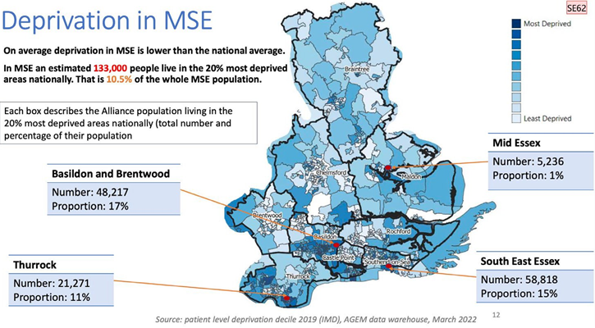

*Figure 4: Deprivation in MSE*

Looking across MSE, there is variation in life expectancy at birth. Those living in Essex generally have a higher life expectancy than the English average, men living in Southend have a higher life expectancy than English males, but women in Southend and all those living in Thurrock have a lower life expectancy than the English average (see figure 5).

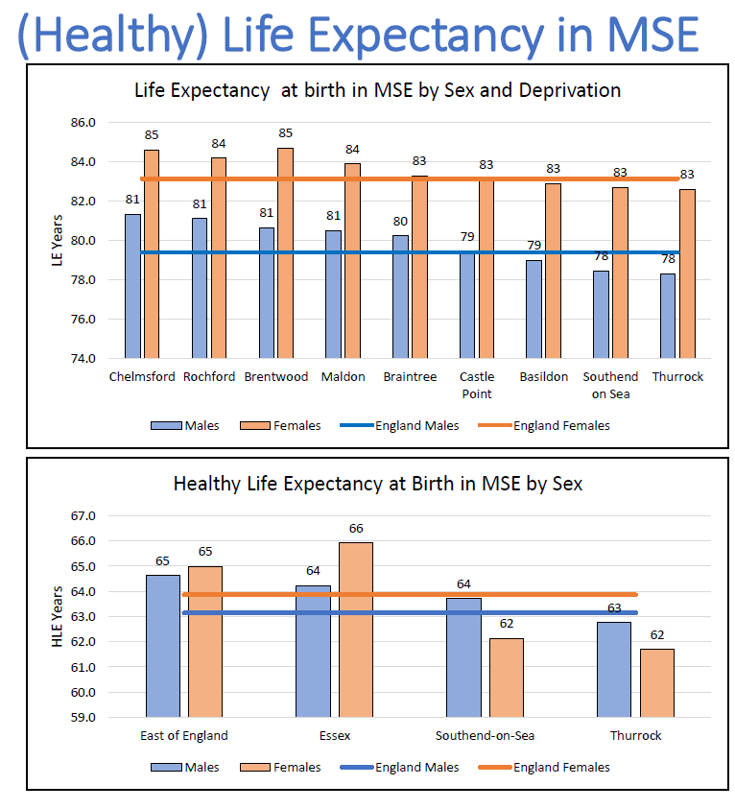

*Figure 5: Life Expectancy at Birth in MSE*

The areas that have a lower life expectancy overall, also tend to have greater inequality of life expectancy within their populations. The inequality gaps are greatest across Basildon, Southend and Thurrock, with the inequality gap across Chelmsford, Braintree, Maldon, Castle Point and Rochford being significantly lower, and lower than the national average (see figure 6).

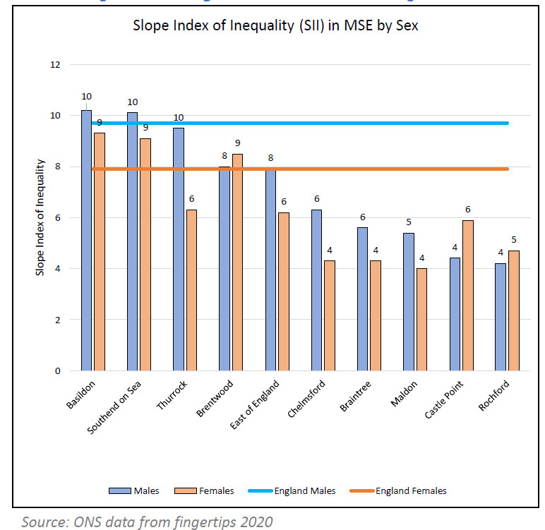

*Figure 6: Slope Index of Inequality in MSE*

Using data, both quantitative and qualitative, to better understand the specific drivers of health inequalities experienced by local residents is key to developing our services and to overcoming potential barriers to access, outcomes or experience.

MSE is committed to using the ‘core20PLUS5’ frameworks developed by NHS England to help us understand and address health inequalities in our communities. This includes both the ‘core20PLUS5’ for adults and for children (See figure 7). 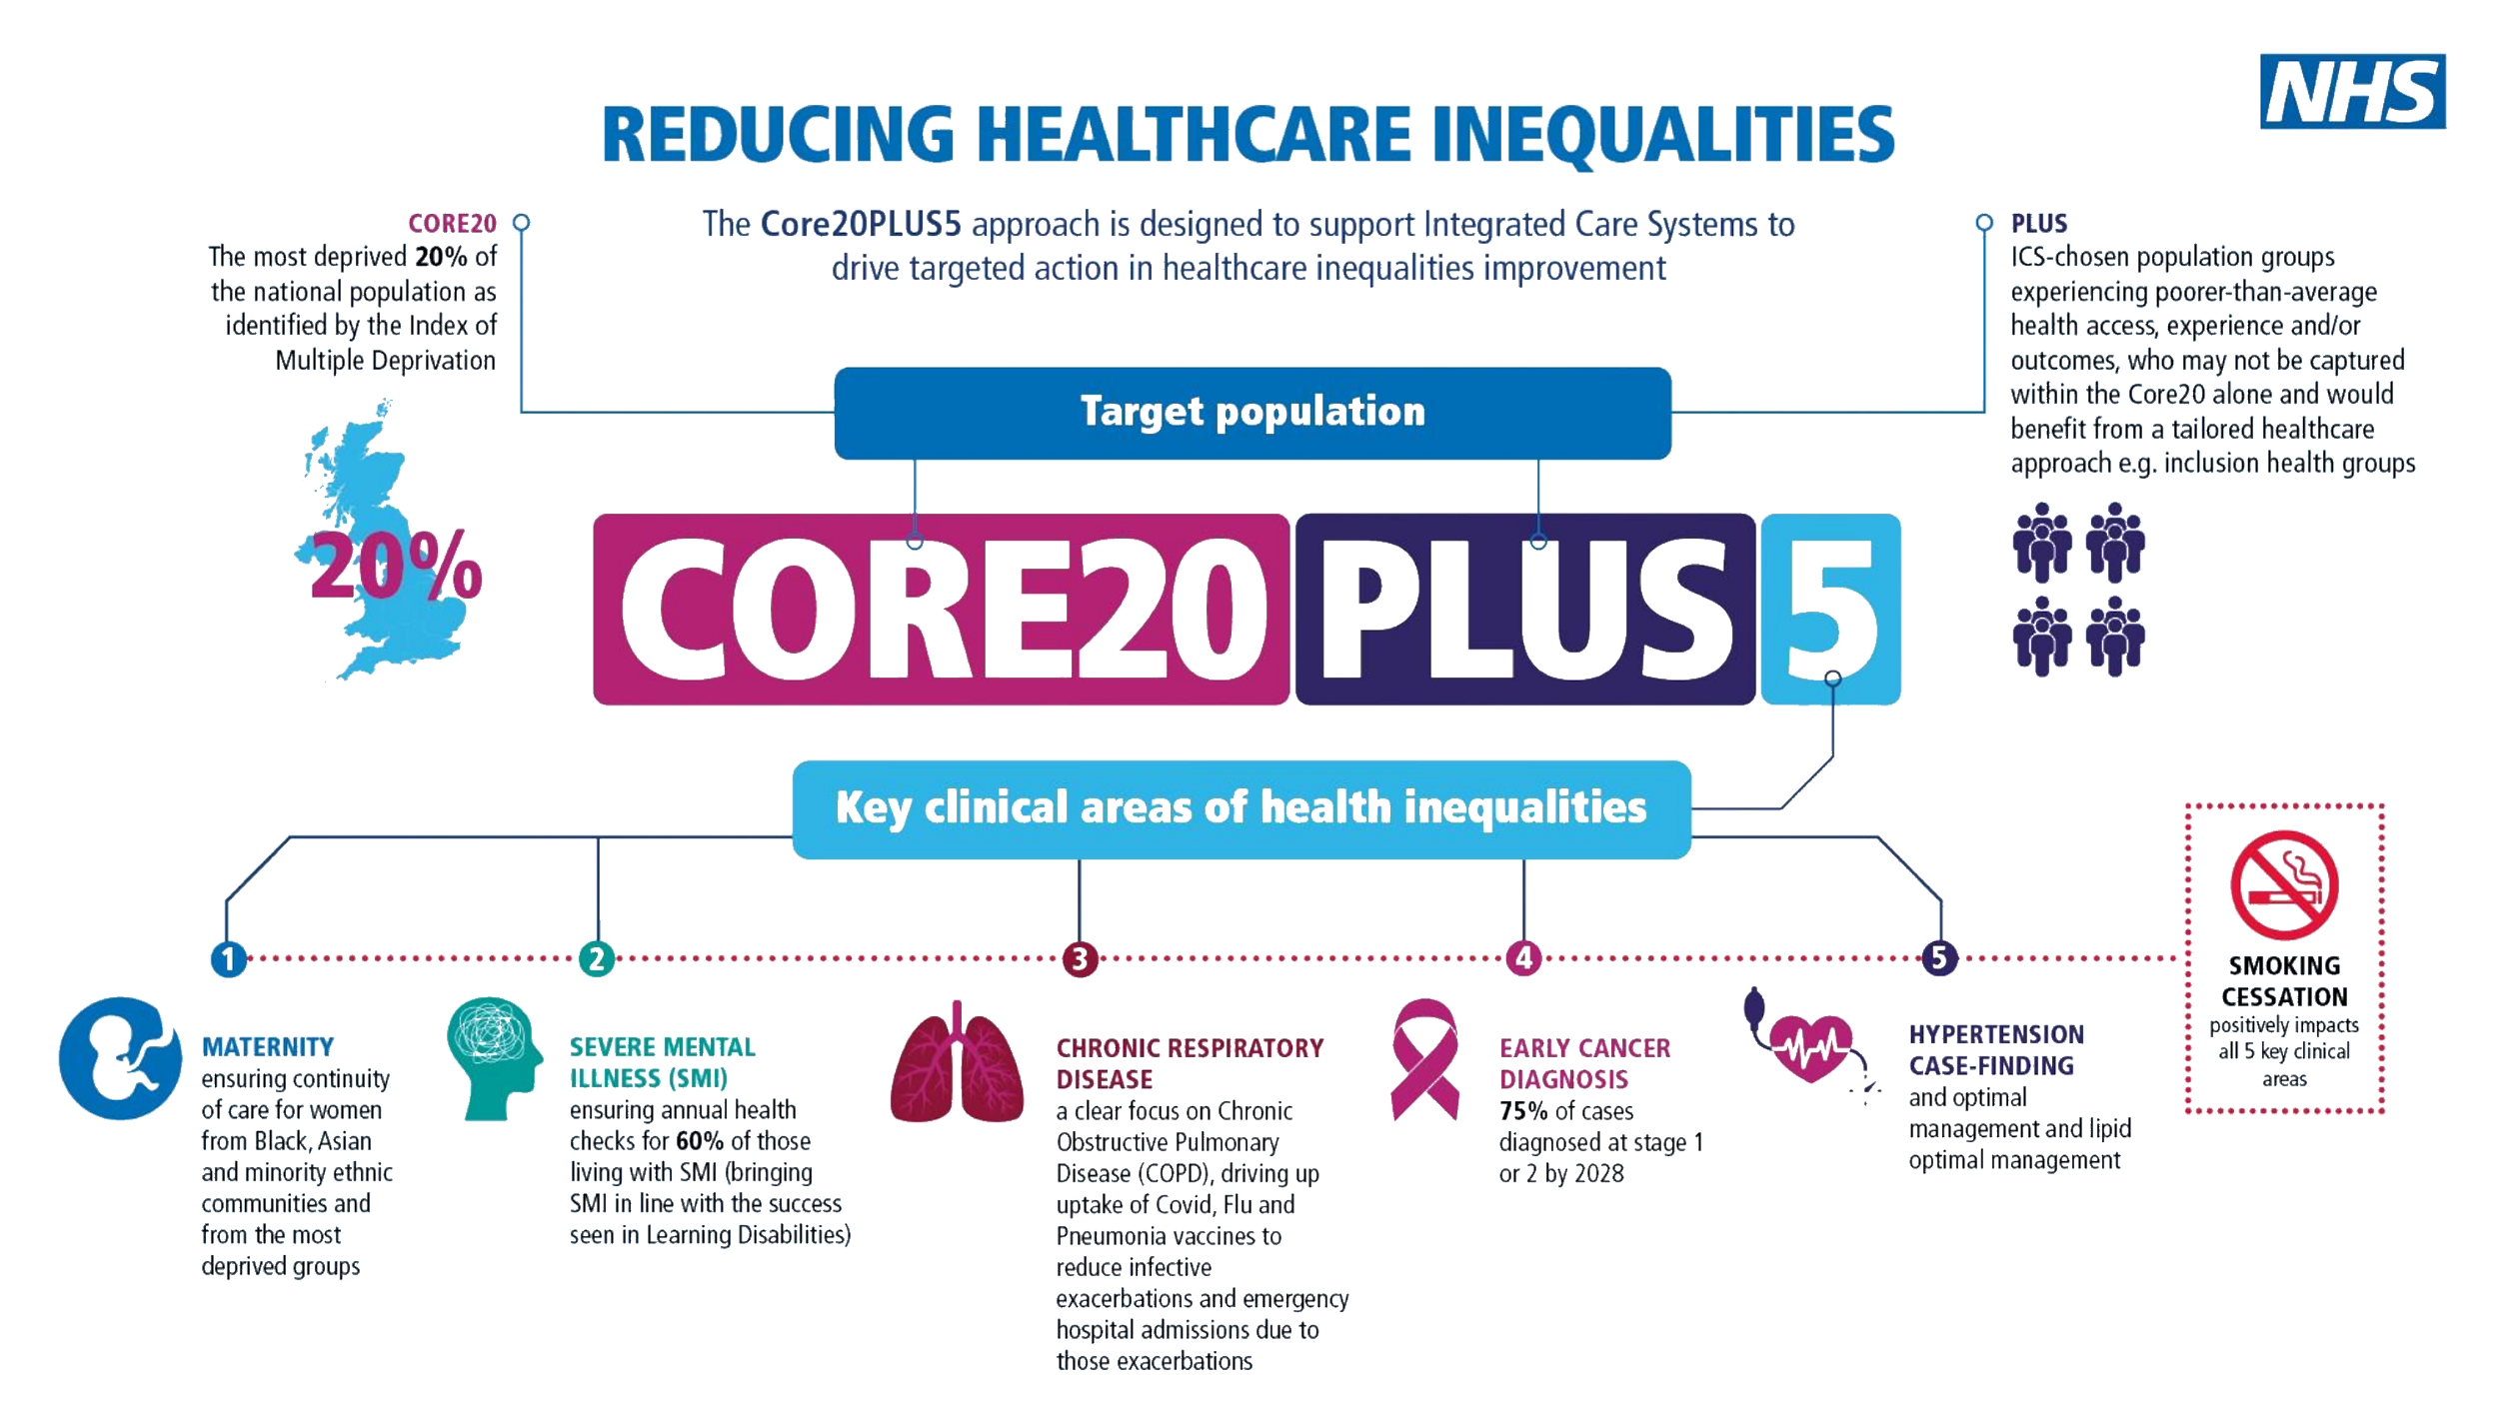

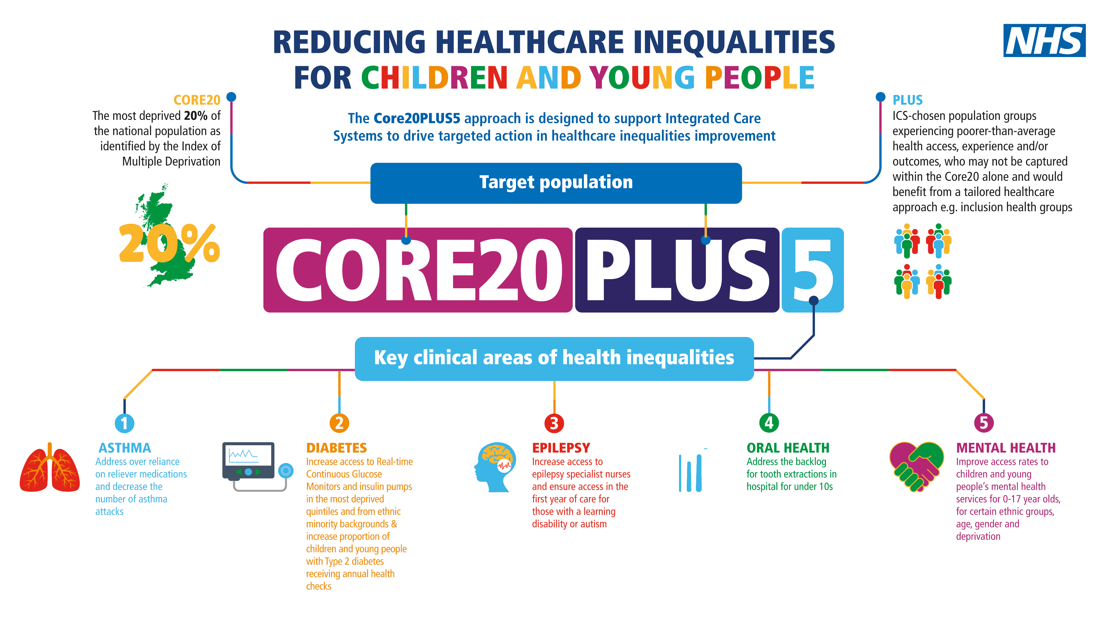

*Figure 7: Core20PLUS5 frameworks*

In addition to focusing on the needs of the communities that live in our most deprived areas, we have identified a number of local ‘PLUS’ groups for adults and children who live and work in mid and south Essex and are committed to working with partners and communities to develop plans for how we can address the barriers they experience in engaging with health and care services.

The adult groups that have been identified as being at risk of experiencing poorer health outcomes in MSE are:

* Black and Minority Ethnic groups
* Carers
* People with Learning Disabilities
* People experiencing Homelessness
* Gypsy, Roma, and Traveller communities.
* Veterans

The groups of children and young people that have been identified as being at risk of experiencing poorer health outcomes in MSE are:

* Young Carers,
* Ethnic minorities
* Roma, Gypsy, Travellers,
* Looked After Children, Care Givers
* Learning Disability
* Special Educational Needs and Disabilities (SEND),
* Neurodiversity (ASD and ADHD, Tics and Tourette’s)
* Young people in the criminal justice system
* Families in Temporary Accommodation,
* Emotionally Based School Avoidance (EBSA),
* Unaccompanied asylum seekers, migrants
* CYP affected by Domestic Abuse

We remain committed to progressing this work through Alliance-level health inequalities funding and targeted system supporting priority areas.

As a Core20PLUS5 accelerator, with clinical, financial and programme ambassadors, we remain committed to embedding a focus on addressing health in equalities in all that the ICB does. This will include having a focus on ensuring that any recovery plans take account of the need to identify and address health inequalities alongside our drive to improve financial sustainability.

### 4.3 Improving population health

Traditionally the NHS has focused on treatment and curative activities. While we have, more recently concentrated on early identification and intervention, we recognise that we must play a full part, with our public health teams and wider partners, on prevention. As we seek to do this, we must recognise the importance of supporting more personalised care that responds to an individual’s needs and situation. Empowering patients to make informed choices and enabling a more personalised approach to managing their health and any treatment they may need should be embedded in how we offer care across mid and south Essex.

The importance of focusing on improving health overall was reinforced through engagement with our Community Assembly in February 2024. When considering the components of the Integrated Care Strategy’s ‘[Plan on a Page](https://www.midandsouthessex.ics.nhs.uk/about/integrated-care-strategy-2023-33/what-is-important/)’, those who were in the discussion highlighted prevention and early intervention as being the things they considered to be most important for the system to focus on.

*Supporting system wide public health improvement*

Delivering on these ambitions is a core focus of MSE’s Population Health Improvement Board (PHIB). PHIB brings together stakeholders from across health, public health, local governance, alliances and community and voluntary partners to identify, develop and oversee delivery of plans to improve overall population health, prevention and reducing health inequalities.

The PHIB is committed to focusing on joint prevention priorities relating to smoking cessation, supporting healthy weight, addressing wider determinants of health such as employment; and to using population health management approaches to support targeted programmes to improve health outcomes and tackle health inequalities. This PHIB will also support the five priorities for a Healthy MSE that have been identified by the ICP, working to support collaborative progress in prevention and action to tackle the wider determinants of health.

*Integrated Neighbourhood Teams supporting population health improvement*

Improving the health of our populations is also a core focus of our place-based alliances which bring together and integrate services across a wide range of local partners in health, care and beyond. Central to this is the development of our Integrated Neighbourhood Teams and the development of our Primary Care Networks.

This local approach supports delivery of personalised care, supporting patients to more involved in the decisions about their own care and their right to choose. Alliances are also lead local decision making on the best use of the Better Care Fund to support patients to access the care and support that they need as close to home as possible.

### 4.4 Commissioning healthcare services

The NHS in MSE needs to do more to ensure that patients can access high quality care at the right time, first time. The ICB remains committed to improving access to and experience of care for local patients and ensuring that patients can exercise their rights to choose which provider they receive consultant-led care from

The NHS is working to continuously improve how we offer care to our patients across all settings of care. In MSE we still have a long way to go to recover care in line with national targets in areas including urgent and emergency care, planned care and cancer.

We remain focused on using data, insights and benchmarking in relation to our activity, outcomes and experience to understand the areas where we are doing well, and the areas where we are falling short. Through our alliances and provider collaboratives we want to share learning and best practice and ensure a targeted focus on improving care for those who find care hard to access or are having a poor experience, specifically those who have identified health inequalities.

*Improving primary care access*

The longer-term ambitions for primary care in MSE will be updated through the primary care strategy, due for publication later in 2025. This will be the first integrated primary care strategy covering primary medical services, community pharmacy, optometry and dental services that has been produced by the local system. This will build upon “The Fuller Stocktake” (the development of Integrated Neighbourhood Teams), the local response to the Primary Care Access Recovery Plan and the Dental Plan. This strategy will be developed in dialogue with provider representation and wider stakeholders.

The ICB recognises the importance of good access to primary care services as, for most people, this is where the majority of NHS provision is delivered. Sustainable and effective primary care will have a stabilising effect across the wider health and care system.

Whilst the strategy will provide a long-term direction of travel, the ICB will maintain momentum with the transformation of primary care services. We will:

* Continue to make changes in line with our Primary Care Access Recovery Plan.
* Expand the number of self-referral pathways that our patients can utilise and promote these through social media, practice websites and other outlets.
* Promote access into community pharmacy, optometry and dental services who are best placed to support patients with a range of issues that currently present to general practice.
* Support practices to use digital tools and new triage approaches to ensure that patient need is consistently assessed and managed in the most appropriate way and avoid the current 8am rush on phones where despite best efforts, need is often managed on a first come first served basis rather than being based on clinical need.
* Work with dental providers to better support our population through increasing capacity in contracts, piloting innovative approaches to address specific needs and encouraging retention through career development linked to new services.
* Improve collaboration between general practice and community pharmacy to support both providers with their long-term sustainability.

*Transforming community care through our collaboratives*

MSE is working closely with its Community Collaborative to explore ways that we can support more patients to receive care in the community where it is appropriate to do so. The introduction of Virtual Wards has supported more patients to receive more care at home, avoiding time in hospitals that can lead to greater deconditioning and greater cost to the system. Use of these digital solutions can also help reduce health system emissions and contribute to net zero ambitions.

A review of Discharge to Assess pathways is underway to support more patients to return to their primary place of residence as fast as possible. Cross-system working throughout 2025 will support a shift to more ‘home first’ approaches that will improve outcomes for patients and help reduce demand on acute beds.

*Increasing community diagnostic capacity*

Further shifts from acute hospitals into the community will be supported by the opening of Community Diagnostic Centres (CDC) in MSE. Construction work is well underway on the Thurrock CDC (opening in summer 25) with further centres scheduled for Southend (late Spring 25), Braintree (Dec 25) and Pitsea (Winter 26). Modalities within the centres include Endoscopy, MRI, CT Ultrasound, heart scans, lung checks, blood tests, and X-rays. Once fully operational the centres will provide 320,000 diagnostic activities annually.

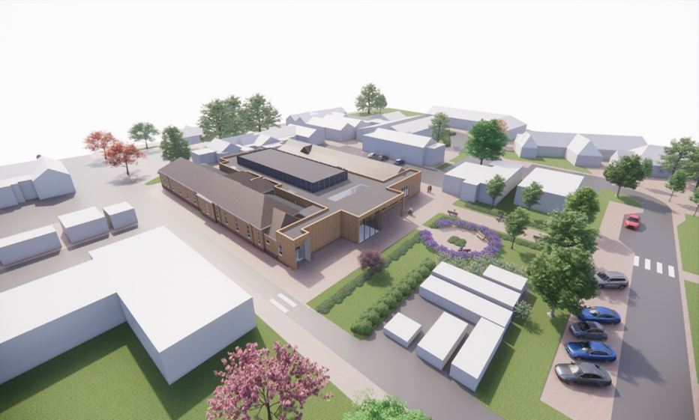

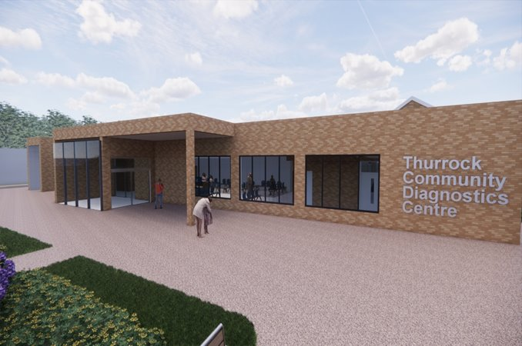

*Figure 8: Artist impression of Thurrock CDC*

*Transforming mental health services*

To support improvements in Mental Health across our system we have developed a Southend, Essex and Thurrock All Age Mental Health Strategy in partnerships with our providers, local government colleagues, partnering ICPs and Essex Police.

The vision that underpins this strategy is to promote good emotional and mental health for everyone, reduce health inequalities and to improve life outcomes for those with mental ill health, enabling them to recover and live well.

Our work to improve mental health services must cover all ages, recognising the increased pressure facing today’s Children and Young People and the associated impact that is have on demand for services.

*Supporting patients with learning disabilities and autism*

Working in partnership with education and the voluntary sector, we will be looking to find ways to increase support through prevention and early intervention initiatives that also address the health inequalities facing children support people of all ages with Learning Disabilities, Autism and others with neurodiversity in our community.

We will review our support and develop a more sustainable model of provision for patients across Southend, Essex and Thurrock, with the aim of improving access and experience of support to all people who need it. This will also include a focus on ensuring that the ICB responds to the expected assent of the Downs Syndrome Act.

This work will be overseen by the Southend, Essex and Thurrock Strategic Implementation Group, who will also ensure that activities support the broader ICP priority ‘Healthy Minds’.

*Improving care for babies, children and young people*

MSE’s Growing Well Programme Board is being refreshed and will look to develop a strategy to improve care and support available to babies, children and young people in our system. This work, which considers both physical and mental health needs, will build on existing plans to improve care for children in areas such as: special educational needs and disabilities (SEND), asthma, diabetes, epilepsy, urgent and emergency care, oral health and end of life care. This work will support the ICP’s ‘Healthy Start’ priority.

*Optimising medicines and reducing waste*

Medicines optimisation looks at the value which medicines deliver, making sure they are clinically and cost-effective. MSE is working to reduce overprescribing to make patient care better and safer, support the NHS, and reduce carbon emissions. Work to reduce medicines waste, unnecessary prescribing and shift to lower-carbon inhalers will deliver both financial and carbon savings that can contribute to the NHS’ Net Zero ambitions.

We are maintaining a focus on achieving antimicrobial resistance prescribing metrics and reducing risk of medicines-related harm from high-risk drugs through improved monitoring. Central to this is embedding shared decision making when prescribing and making better use of clinical decision support tools to reduce variation across MSE.

Community pharmacists support patient care through delivery of a number of clinical services including New Medicines, Discharge Medicines, Blood Pressure Check and Oral Contraceptive Services, and most recently ‘Pharmacy First’ which launched in January 2024. Digital integration of community pharmacies with general practice and PCN Community Pharmacy Lead roles will support implementation of these initiatives.

*Improving productivity*

Over the period of this Joint Forward Plan, the Integrated Care System will increase its focus on improving productivity across all parts of the system. We need to ensure that we are maximising the use of the resources that we have to ensure that people are being seen as quickly as possible in the setting that best suits their needs. We will continue to innovate and test new ways of supporting people to access care in the best way for their current needs, whether that is an urgent or planned care need.

*Developing our system ensuring corporate governance and decision making*

To support the delivery of these operational objectives, we are continuing to review and strengthen how we govern our system through partnership working, but also effective oversight and assurance.

Following the restructure of the ICB, completed in January 2024, we have undertaken a Corporate Review which has supported strengthened approaches across our Operating Model, Decision Making and Organisational Development, all of which are enabling our approach to recovery.

Through this work we have strengthened our risk management, with the introduction of Datix and a review of the Board’s risk appetite, along with agreed new strategic objectives.

We have also refreshed our governance following the annual committee effectiveness reviews ensuring effective and integrated decision making, continued access to appropriate advice and developed an Organisational Development programme that specifically responds to the challenges identified through our staff survey results.

## 5. Key System Enablers

### 5.1 Supporting our workforce

We want people to see the NHS in mid and south Essex as a place they want to work and build a career in. We want to attract a diverse workforce and support people from mid and south Essex to work and progress in our system. We want to train and maintain the best clinical and non-clinical talent and are aware that to do that, we need to create environments and opportunities that will appeal to all.

Developing our workforce to be able to deliver the care models of the future requires effective workforce planning. Attracting and Training clinical staff takes years, so we need to strengthen our workforce planning processes mapping out our long-term workforce needs and supporting people through training and placements in our system. We want to keep building on exciting developments in medical and nursing training through local university and college partnerships with Anglia Ruskin University, the University of Essex, local FE colleges and other education providers to create life-long careers for both those leaving school and those looking to retrain. We will also continue to develop our Healthcare Assistant Academy to attract, develop and retain Healthcare Assistants across the MSE Workforce.

We will continue to develop our system careers website Our People Your Future. This website gives our local population one platform to access information about the different careers within the NHS including entry routes in and work experience opportunities.

*Recruitment and retention*

We have made significant strides in our work to provide recruitment, retention and development support to our Primary Care workforce. The MSE Training Hub, supported by the ICB People Directorate and led by a team of clinical leads and ambassadors, is highly regarded across the region for its best practice work in supporting primary care transformation and developing the current and new workforce required to deliver world-class patient care.

The hub supports our PCNs with their breadth of workforce planning, including the embedding of new roles through the Additional Roles Reimbursement Scheme (ARRS). It develops, delivers and procures education and training for GPs and primary care teams. It supports educational placements in PCNs and practices and career support to staff from new to practice, mid and late career. The hub delivers clinical practice specialty and refresher training, development for clinical supervisors and educators, CPD and training in management and administration.

*Our continued commitment to equality, diversity, and inclusion*

The ICB is fully committed to the implementation of the comprehensive NHS Equality Diversity and Inclusion Action Plan with its six high priority actions:

1. Measurable objectives on Equality Diversity and Inclusion for Chairs Chief Executives and Board members.
2. Overhaul recruitment processes and embed talent management processes.
3. Eliminate total pay gaps with respect to race, disability and gender.
4. Address Health Inequalities within their workforce.
5. Comprehensive Induction and onboarding programme for International recruited staff.
6. Eliminate conditions and environment in which bullying, harassment and physical harassment exist.

This plan provides specific actions that we know from evidence and data will make a real difference to our ambition to be a highly inclusive organisation, but the plan always shows how we can learn and respond to lived experiences.

*Our People Board leading workforce changes*

Our Mid and South Essex People Board is leading the development and oversight of the systemwide plans to support all this work and help us ensure that we attract, train and retain staff to help us deliver high quality and high value care to our patients. Below are some of the initiatives we plan to implement or develop further to meet our NHS workforce challenges in Mid and South Essex:

**Initiative 1: Train**

This initiative focuses on Identifying hot spots where targeted recruitment and retention is critical and highlighting where enduring unfilled vacancies can be addressed with new skill mixes and new ways of working. New innovations regarding recruitment and apprenticeship offers are included.

Over the next 12 months we will further develop programmes through the Health & Care Academy that respond to areas of short supply whilst also working with higher education linking long term workforce plans to 2037. Mapping will be a key part of this.

By the next academic year, we will expand our College Enrichment Programmes to engage with and develop Health and Social Care Further Education Students, providing a clear understanding of the Healthcare Assistant role, work experience and an early recruitment pathway into health and social care careers.

By Summer 2025 we will implement a local Supply Delivery Group which will report into NHSE Train Board. This group will oversee delivery on attraction strategy and widening participation, recruitment and entry level supply. Bringing all supply initiatives into one place.

Implementation of a new Centralised Placement Management Platform across MSE will increase the transparency regarding placement capacity and utilisation. The platform will also encourage the use of a variety of different clinical learning environments, to ensure learners are provided with a diversity of learning experiences. While improving the visibility of and access to placement experiences it will also aid the understanding of undergraduate student numbers and allow for early engagement and proactive recruitment.

**Initiative 2: Retain**

This initiative focuses on developing system-wide legacy practitioner vision. Building awareness and understanding of the value of this role in supporting the recruitment and ongoing workplace support (and therefore retention) for Nursing Associates, newly qualified practitioners, Trainee Nurse Associates, and other students. A similar advocacy/sponsorship approach will be taken to healthcare assistant champions, Physician Associate leads and Advanced Clinical Practitioner Leads across organisations (and recognising those roles in permanent Establishments).

To continue to develop and expand the learning opportunities available to our MSE workforce via ‘My Learning Platform’ – our free virtual learning environment. We will increase the diversity of courses available to ensure our workforce have the right skills and knowledge.

Ambition in MSE continues to be a workforce strategy that is clinically led, and work will continue in 2025/26 to secure the sponsorship of clinical leaders to the adoption of new roles and increase their receptiveness to new skill mixes.

To help support the retain agenda we will further develop the work undertaken in the Colleague Engagement, Wellbeing and Retention workstream which focuses on several retention initiatives across MSE. We will work in partnership to support an improvement for staff in areas of health and wellbeing, personal and professional development, and flexible working. Our health and wellbeing strategy will focus on mental health, one of the current leading causes of sickness related absences across all system partners.

We continue to create a culture and environment where people feel safe and supported to work and through system engagement groups organisations have been able focus on attracting and retaining talent.

We must take the time to understand and address the issues highlighted in staff attitude surveys creating a culture and environment that people want to and feel safe and supported to work in. This is particularly true in the acute hospital, where high vacancy rates continue to drive the use of more expensive temporary staffing which can also impact on the quality of care offered to patients. Having said this there has been a reduction in temporary staffing, through the recruitment of permanent staff which improves the support to staff and quality of care offered to patients.

**Initiative 3: Reform**

Given significant financial deficits relating to workforce, financial improvement plans are in place to support urgent reduction in temporary staffing. In the Acute, the cost drivers are urgent and emergency care, elective care and cancer care. In Mental Health Trust they are increased acuity, observation and engagement.

*Essex Partnership University NHS Foundation Trust:*

The Trust is working hard to eliminate long term agency placements, tightening rostering practice, increasing Direct Engagement uptake for medics and AHPs; potential transfer to NHS Professionals Secondary Bank and re-negotiating rates with preferred suppliers.

Targeted work on staff groups with high temporary staffing spend (especially Community nursing), while maintaining Time to Care safe staffing levels.

Establishment Control panels are in place for all care units and corporate services as well as recruitment strategies for consultant posts and active establishment controls.

*Mid and South Essex NHS Foundation Trust:*

The Trust continues to support service changes with particular focus on:

* Nursing, Medical and Corporate Assurance - senior leader approvals on resourcing.
* Improved rostering processes in train (now need to be scaled, including all medics onto e roster)
* Regular audit of most costly locums, alongside clear recruitment plans to fill posts. Maternity and paediatrics areas of particular challenge, due to sickness levels and vacancy gaps.
* Improved accuracy of staffing categories – specifically ‘unique post identifiers’
* Upskilling and training for off framework and booking approach.
* Review of doctor’s bank booking platform with view to more robust controls
* Push to move staff from temporary to substantive.
* Active establishment controls.

### 5.2 Data, digital and technology

We know that healthcare is lagging behind many sectors when it comes to making best use of both its data and the potential that technology has to offer. The ICB is committed to working collectively to improve both the data and intelligence that we have and use in our system, and the use of digital and technology solutions that will improve the staff experience of delivering care and the patient experience of receiving it.

*Delivering a system wide electronic patient record system*

MSE is the first system in the country to commit to implementing a Unified Electronic Patient Record (UEPR) across our local providers. Mid and South Essex NHS Foundation Trust (MSEFT) and Essex Partnership University NHS Foundation Trust have jointly procured a technology partner that will see them have the same Electronic Patient Record system in place. The trusts are targeting quarter two of 2026, which is subject to investment case approvals and contractual agreements. This joint approach will allow for more integrated care pathways across our acute, mental health and community pathways, offering a better experience for patients and staff.

In implementing the UEPR it is expected to deliver significant cash releasing and non-cash releasing benefits. Detailed benefits scoping has identified opportunities around reduced agency, local and temporary staffing costs. A reduced need for managing paper and consumables. From a clinical and operational perspective, the UEPR will drive standardised care pathways reducing unwarranted clinical variation. It will enable the trusts to optimise care services improving productivity across the organisation. Using new technology the UEPR will also improve system compliance and resilience for cyber security.

*Implementing a shared care record*

Across our Health and Care partners have gone live with our Shared Care Record. We have a role out programme in place with partners that will enable more partner access to the shared care record and improve the level of information shared. We have seen over four thousand documents being viewed since our go live in August 2024.

The shared care record enables information to be shared across health and care partners and provides capabilities that can support joint ways of working, helping to underpin the transformation needed to deliver on our operational and clinical priorities.

*Developing a Patient Engagement Portal*

Our digital patient interface, Patients Know Best (PKB), is now live across MSEFT and EPUT. It integrates with the NHS App, providing our patients with a digital front door to access their records, view appointments and corresponding documentation. Further enhancements are planned over the coming year we are working with our clinical specialities to create bespoke spaces within PKB that can offer patients access to a library of information relevant to care, the ability to receive questionnaires, develop care plans jointly or send and receive messages with their clinician.

*New technologies supporting service transformation*

The success of Virtual Wards in MSE demonstrates how effective use of technology can transform how we deliver care and deliver broad benefits across the health system, such as reducing emissions. We must continue to build on these successes to implement proven technologies that will allow us to transform and improve how we deliver care at all stages of the pathway.

As we do this, we will continue to support our staff, partners and patients to receive the training needed to help them improve their digital literacy and use of emerging tools. An example of this is our primary care ‘tiger teams’ that are working to help local practices maximise the use of new technologies and data that is available to them.

*Continuously improving our data capture and data technologies*

Work is ongoing to establish a virtual Business Intelligence (BI) hub and its overarching vision to have a single way of managing information, which can be manipulated and collated to provide a single source of truth. This enables better planning at an integrated care system level, to provide evidence-based decision making and the ability to focus on improving services and the health and wellbeing needs for the 1.2m population in MSE.

We have built interactive dashboards on our strategic data platform, Athena, to provide insights and support action lead interventions that underpin service transformation across our stewardship groups.

As we improve our ability to collect data and integrate our data, we must continue to work on our supporting data and digital infrastructure so that we can generate and use insights to inform improvements in planning and operational delivery. Alongside the technical platform that will allow greater integration and data reporting, we will continue to train and develop our staff to draw out and use the insights that such solutions provide. As part of this work the ICB and its partners are exploring how best to utilise the opportunities of the nationally provided Federated Data Platform.

Engaging patients and communities in how we are developing our data, digital and technologies across the NHS is key. It is important that we ensure that digital solutions enable the provision of care, and don’t increase digital exclusion or become a barrier to access. We must recognise the differential needs of our population and ensure that we are listening to where technology can help, as well as being transparent in our plans to use data to improve how and what care we provide.

### 5.3 Financial sustainability

MSE ICB remains committed to delivering high quality care that offers value to the taxpayer. As the system enters another year facing a significant financial deficit, there is a significant challenge ahead to develop and deliver plans that will allow us to live within our means and meet the needs of residents.

As the financial challenges in the system increase, the financial scrutiny and oversight also increases. In April 2024, MSEFT was placed in segment 4 of the NHS Oversight Framework (NOF4), meaning that the Trust will now be receiving additional recovery support and additional scrutiny from NHS England. In addition, the whole system has entered ‘triple lock’, with more financial decisions being reviewed by both the ICB and NHS England. Collectively, this is increasing the focus on how we are managing all components of our financial plans. This includes the significant pay costs across our NHS providers, which still includes a high volume of temporary staffing, as well as non-pay and non-healthcare service costs.

Alongside this review of spend, it is important that we consider where we have made investments that have not added value. In a system that supports innovation and improvement it is important that we continue to test ways to improve our services. However, it is equally important that we evaluate those investments and review the impact that they have had. If things are not delivering the expected impact, we must commit to stopping them and considering alternative uses for that investment.

To further support our commitment to achieving financial sustainability, the system has committed to a review of corporate functions and areas which might drive efficiency and savings by consolidating our ‘back office’ functions across multiple system partners. A system-wide NHS infrastructure strategy is also being developed to explore opportunities to make better use of the physical assets we have to support patient care and improve the health of our local communities.

Through the newly appointed Executive Director of System Recovery, the system will continue to interrogate its costs and activities to identify opportunities for efficiency and productivity in how we work. In addition to using available tools, to benchmark opportunities for improvement, the system will continue to look at how it can transform care to offer better outcomes for better value.

We have worked cross system to develop and agree strategic priorities over the next 3 to 5 years to support financial recovery and deliver a more sustainable NHS. Our Medium Term Plan sets out the key proposed changes across the system, and within Mid and South Essex NHS Foundation Trust that will result in both the Trust and the wider integrated care system achieving financial, operational and clinical sustainability. This plan, attached in section 3 of the Joint Forward Plan sets out the key actions and timelines for delivery.

### 5.4 Research and Innovation

Research and innovation are integral parts of the NHS constitution and key enablers in driving improvements in clinical care. They can help attract additional investment into the local system and broader economy, can provide greater opportunities for staff to expand their experience and career opportunities and offer benefit to patients and the public through opportunities both participation and improved outcomes. As our ICB continues to mature, we will develop our strategies for both research and innovation.

*Supporting NHS research*

MSE aims to publish an updated research strategy during summer 2025 that will draw on organisational strategies and plans that are already in place across MSEFT, EPUT and our university partners. The strategy will ensure that we are supporting research across all settings of care, increasing our focus on research in primary and community care and the wider determinants of health. This will be aligned with the work of the newly established Greater Essex Health Determinants Research Collaboration (HDRC).

The strategy will help increase the system’s overall awareness of the value research offers in relation to improving patient care, partnership working between organisations and with patients and the public and funding opportunities. The research strategy will also be informed by the work we are currently undertaken through our Research Engagement Network project, which is looking to increase engagement from groups that are traditionally under-represented in research.

*A system commitment to innovation*

In developing an innovation strategy, MSE will continue to build on its established track record of innovation, including its local Innovation Fellowship programme for staff working in our health and care system, hosted by MSEFT, who also host a number of national innovation schemes. These schemes demonstrate the value we place on supporting our staff to innovate, test and learn.

Our innovation strategy will draw on the organisational strategies that already exist across the system, such as the EPUT Innovation Strategy for 2023-2026 which focuses on opportunities to optimise physical infrastructure and digitally connected things, quality improvement and innovation in working practice and digital and technology innovation.

As we do this, we will explore options to expand our innovation programmes and not only test new ideas, but also focus on scaling proven innovations that can improve outcomes and value in our system. We will remain open to new and evolving technology innovations, including the potential AI has to transform not only care delivery, but also efficiency and effectiveness in clinical and corporate support services.

MSE is part of the University College London Partners (UCLP) Academic Health and Science Network, which reaches into North East and North Central London. We will continue to work with UCLP in implementing proven innovations and practices that will help us improve the health of our local population. We will focus our adoption of innovation in areas of strategic and operational clinical priority such as cardiovascular disease, frailty and cancer care.

Alongside these strategies, we will continue to evaluate and report on the impact investment in research and innovation is having in our system and our broader economy. It will be important to recognise that not all research and innovations will deliver the expected benefits, but reporting on and learning from work that doesn’t succeed is as important as continuing to invest and scale what works so that we remain a learning system.

### 5.5 Serious Violence and Victims of Abuse

The ICB is a member of the Southend Essex Thurrock wide Strategic Violence & Vulnerability Partnerships (VVP), which work across Southend, Essex, and Thurrock (SET) to provide a co-ordinated approach to address particular violence issues, partnership include the: Violence and Vulnerability (VVU) Operational Board and Round Table, Southend Essex and Thurrock Domestic Abuse Board and Violence Against Women and Girls meetings.​

Serious Violence Strategic Needs Assessment (SNA) - Gathering this intelligence on violence into one place ensures a multi-agency lens approach which allows the VVP to better understand the levels of violence in the community across Essex.

This insight feeds into the integrated system wide action plan, allowing strategic and operational activities to be targeted towards the key drivers of serious violence within the county, as part of a preventative approach to reducing serious violence.

The insight within the SNA endorses the current approach of the VVP – that the Partnership is on the right course, delivering interventions which are having an impact and making a difference to communities.

# Appendix 1 – ICB Statutory Legal Duties

As an ICB we have a number of statutory duties that it is required to fulfil by law. This Joint Forward Plan includes details as to how these duties will be delivered. We will exercise our statutory duties with the aim of:

1. **Duty to promote integration** improving quality, reducing inequalities and delivering collaboration. See sections 3.3, 4.1 and 4.2 for further details.
2. **Describing the health services for which the ICB proposes to make arrangements** meeting population needs and arrangements for provision of healthcare services. See section 4.4 for further details.
3. **Duty to consider wider effects of decisions** delivering on the triple aim and approach to decision making. See section 2 for further details.
4. **Implementing any JLHWS** setting out steps the ICB is taking to work in partnership to deliver shared ambitions and outcomes. See section 2 for further details.
5. **Financial duties** explaining how the ICB intends to discharge its financial duties. See section 5.3 and JFP section 3 (NHS Operational Planning Guidance 2025/26) for further details.
6. **Duty to improve quality of services** focus on continuous improvement including outcomes, safety and patient experience. See section 4.1 for further details.
7. **Duty to reduce inequalities** of both access to services and inequalities between patient groups. See section 4.2 for further details.
8. **Duty to promote involvement of each patient** including decisions relating to their diagnosis or illness as well as their care or treatment. See sections 3.2 and 3.3 for further details.
9. **Duty to involve the public** ensuring both people and communities are involved in planning, development of commissioned services. See section 3.2 for further details.
10. **Duty to patient choice** enabling patients to make choices with respect to aspects of health services provided to them. See JFP section 3 (elective reform plan) for further details.
11. **Duty to obtain appropriate advice** for any expert advice from partners or third parties relating to discharging its functions. See sections 2 and 3.3 for further details.
12. **Duty to promote innovation** in the provision of health services. See section 5.4 for further details.
13. **Duty in respect of research** facilitating orpromoting research matters relevant to health services and the use of health service evidence. See section 5.4 for further details.
14. **Duty to promote education and training** in support of national directives as well as responding to changes in service change models. See section 5.1 for further details.
15. **Duty as to climate change** reducing emissions and supporting the drive to deliver Net Zero. See section 3.1 for further details.
16. **Addressing the particular needs of victims of abuse** having due regard to the Domestic Abuse Act 2021. See section 5.5 for further details.
17. **Addressing the particular needs of children and young persons** setting out proposals to address needs of those under 25. See section 4.4 for further details.

***Other content includes:***

* Workforce - See section 5.1 for further details.
* Performance - See JFP section 3 (NHS Operational Planning Guidance 2025/26) for further details.
* Digital / Data - See section 5.2 for further details.
* Estates - See JFP section 3 (MTP Delivery plan) for further details.
* Procurement / Supply Chain - See JFP section 3 (MTP Delivery plan) for further details.
* Population health management - See section 4.3 for further details.
* System development - See section 3.3 for further details.
* Supporting wider social and economic development - See sections 2 and 3.3 for further details.