

**NHS Mid and South Essex**

**Joint Forward Plan   
2024-2029**

**Section 2 - April 2025 Refresh**

**NHS Mid and South Essex Joint Forward Plan 2024-2029 (April 2025)**

Contents

About this Document 4

JFP Section 2: A Review of Our Progress 5

Delivering our 2024/25 Ambitions 5

Improving Quality – Access, Experience and Outcomes 5

Discharge Cell 5

Diagnostic Hubs 5

Hospice Rapid Access Service 5

Primary Care Dental Pilots 6

Improving Access to General Practice 6

NHS Primary Care Access Recovery Plan 6

Community Diagnostics Improved Access 7

Emergency Department Expansion – Improving Patient Care 7

Reducing Health Inequalities 7

Holistic Approach to Residents Wellbeing 8

Pedal Power 8

Smoking Cessation 8

Weight Management Service 9

Targeting Lung Health Checks 9

Child Oral Health 9

Supporting Health and work 10

Outreach into communities 10

Delivering Financial Sustainability 10

2024/25 Year End Position 10

System Financial Recovery Collaboration 10

Supporting our Workforce 11

Recruiting and Retaining Staff 11

Healthcare Assistant Academy 11

Letting Staff Lead 11

Our Stewardship Programme 11

Ageing Well Stewards - Frailty Hotline 12

Ageing Well Stewards - FrEDA and e-FraCCS 13

Cancer Stewards – Prostate Case Finding Pilot 13

Cancer Stewards – Colorectal Cancer Referrals 13

Cancer Stewards – Teledermatology 14

Cancer Stewards – Breast Pain 14

Cancer Stewards – Breast Screening 15

Cancer Stewards – Ardens Cancer Template 15

Cancer Stewards – Prehab / Rehab 15

Cancer Stewards – Cancer Summits 15

Diabetes Stewards – Type 2 Remission Programme 16

Eye Care Stewards – Childrens School Vision Screening 16

Eye Care Stewards – Certificate of Visual Impairment (CVI) 17

Musculoskeletal Stewards – Community Appointment Day 17

Musculoskeletal Stewards – Fracture Liaison Service (FLS) 18

Musculoskeletal Stewards – Mental Health/ MSK Employment Advisor (EA) service 18

Musculoskeletal Stewards – Get U Better App 18

Musculoskeletal Stewards – ARU Magnetic Resonance Imaging (MRI) research 19

Musculoskeletal Stewards – Lower Back Pain Pathways 19

Stroke Stewards – Stroke Rehabilitation Capacity 19

Urgent Emergency Care (UEC) Stewards – UCCH 19

Population Health 20

Pneumococcal Vaccination uptake 20

Moving Towards Net Zero 20

Climate Action Packs 20

Gloves off Campaign 20

Reusing Equipment 20

Reusing Equipment 20

Digital, Data and Technology 21

System Digital Enablement 21

Electronic Palliative Care Coordinating Systems (EPaCCS) 22

Mobilising and Supporting Communities 23

Community Initiatives 23

Specialist Bereavement Service 23

Slipper Swap 24

Vaccination Bus 24

# About this Document

This document, section 2 of the Joint Forward Plan (JFP) 2024-29, sets out some of the things that Mid and South Essex Integrated Care Board (MSE ICB) has delivered in 2024/25 against the strategic ambitions that we set for our system.

# 

# JFP Section 2: A Review of Our Progress

## Delivering our 2024/25 Ambitions

With support of system partners Mid and South Essex Integrated Care Board (MSE ICB) identified 403 actions against several initiatives to be delivered between 2024-2029.

During 2024/25 quarterly reviews have been completed to demonstrate progress with delivering the agreed activities with the latest in December 2024. The current status is:

* 98 actions have been delivered – 24.3% of total actions.
* 162 actions remain on track – 40.2% of total actions.
* 84 actions are under review – 20.8% of total actions.
* 59 actions are considered at risk against the initial outline timeline – 14.6%.

As described in section 1 of the refreshed Joint Forward Plan, April 2025, the mid and south Essex (MSE) health and care is currently facing significant financial challenges. There are challenges to meeting growing and evolving local population needs from the financial position in MSE.

NHS Operational planning guidance 2025/26 has been revised along with the system outlining additional strategic priorities as described within the new Medium-Term Plan (MTP). The requirements to deliver a financially sustainable NHS as described in section 3 of the Joint Forward Plan may delay, or change the actions and timescales published in the 2024/25 Mid and South Essex Joint Forward Plan. All agreed actions will continue to be monitored considering these developments.

The below provides a brief overview of some of the key areas of progress that have been made during 2024/25.

## Improving Quality – Access, Experience and Outcomes

### Discharge Cell

During November 2024 MSE ICS established a system-wide discharge cell with tactical / strategic overview of commissioned beds (acute, intermediate, stroke rehab, hospice, mental health and virtual wards). Since inception the Discharge Cell has seen a 30% reduction in hospital discharge delays.

### Diagnostic Hubs

In August 2024 two nurse / technician led diagnostic hubs were established to provide rapid diagnostic tests in a 45 minute appointments.

### Hospice Rapid Access Service

A finalist in the Health Service Journal (HSJ) Partnership Awards, this is a quicker, more effective service that can assess, provide care (inpatients or packages) for patients and supports capacity with our Integrated Care Board All Age Continuing Care (CHC) service. The ICB has worked with the three Mid and South Essex hospices (Havens, St Lukes and Farleigh) on the development and implementation of this service.

### Primary Care Dental Pilots

Dental pilots have led to improved access to care for residents of all ages.

Over 20,000 patients have been able to access dental appointments during evenings, weekends, and bank holidays thanks to additional appointment capacity we’ve created.

All of the 8,424 care home beds in mid and south Essex are also now covered by a dental practice, and over 4,000 courses of treatment have been delivered to residents.

We’re establishing a new school’s programme to give reception and year three students access to oral health education and assessments in school.

Click here for oral health website: <https://www.midandsouthessex.ics.nhs.uk/work/primary-care/dental-access-initiatives>

### Improving Access to General Practice

Latest figures reveal that GP teams across mid and south Essex delivered almost seven million appointments in 2024, a 5% increase in appointment activity compared to 2023.

Alongside this increase, last year more patients had a face-to-face appointment than the national average (75% compared to 66%), while just over half of all appointments in mid and south Essex were delivered within the same or next day of request.

We’ve recruited 56 additional staff since Sept 23, increasing our GP practice workforce to over 4,300.

We are investing in digital tools and improved Cloud Based Telephony systems to enhance patient care and ease of contact with their practice.

### NHS Primary Care Access Recovery Plan

Work is taking place locally to help residents across mid and south Essex to access primary care services in support of the NHS Primary Care Access Recovery Plan, the aim is to:

* Tackle the 8am rush and reduce the number of people struggling to contact their practice​.
* For patients to know on the day they contact their practice how their request will be managed.



*Above image of Get the care you need quicker campaign.*

In support of the national plan, we have launched a local multimedia campaign ‘Get the Care You Need Quicker’ to raise awareness of ways patients can access the care they need and help free up GP appointments for those that need them most.

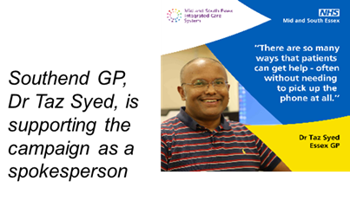

*Above image of quote from Dr Taz Syed in support of campaign*

### Community Diagnostics Improved Access

Continued progress in delivering plans for four Community Diagnostics Centres (CDCs) in Southend, Thurrock, Braintree, and Pitsea already in the building phases.

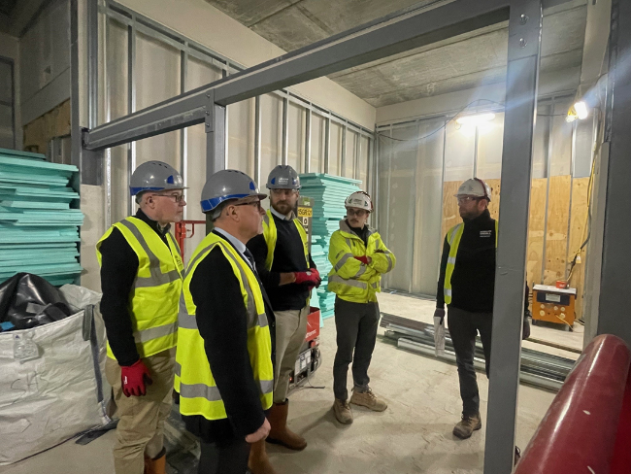

*Above image of building phase for diagnostic hubs.*

These centres will mean patients will receive quicker diagnosis and treatment from the NHS in line with the government’s focus on reducing elective waiting lists.

We know people sometimes are waiting far longer for treatment than they should so in addition we are working hard to fix this, supporting the hospital trust to put on extra theatre sessions and improving our outpatient bookings so fewer people miss their appointments.

### Emergency Department Expansion – Improving Patient Care

In August 2024 an £8.5 million expansion of Southend Hospital’s Emergency Department commenced.



*Above image of Southend Hospital emergency department expansion*

Improvements will include a dedicated paediatrics area, linking it to the existing children’s ward and creating a better experience and calmer environment for children coming into hospital.

Treatment areas, waiting rooms and resuscitation areas will be redesigned to improve flow through the hospital, meaning those coming to emergency departments get the urgent care they need, faster and allowing ambulances to handover patients as quickly as possible.

## Reducing Health Inequalities

Ensuring deliver of our common endeavour of reducing health inequality has and remains a guiding principle that underpins all our work.

The ICB has adopted the NHS Core20PLUS5 frameworks for both adults and children and young people to prioritise activities both across the system and through the local work delivered by alliance partnerships. The ‘Narrowing the gap’ report outlines how partners are working collectively across MSE to tackle health inequalities - [Narrowing the gap Report- Mid and South Essex Integrated Care System](https://www.midandsouthessex.ics.nhs.uk/publications/narrowing-the-gap/)

In 2024/25 the ICB continued to support investment of £2.2m into health inequalities transformation schemes. The funding was utilised to support innovative partnership solutions to reduce health inequalities at an Alliance level based on their local population needs. The funding also contributed towards resourcing the ICB capacity to address health inequalities including the PHM function, alongside system delivery against Core20PLUS5 priorities such as improved Hypertension case management. The ICB continues to evaluate the outcomes from this investment and learn lessons for future scale and spread of the work.

The information statement on health inequalities provides a more extensive overview of the programme of work and outcomes about the Core20PLUS5 framework, the five operational planning priorities and health inequalities funding investments and outcomes.

[Health Inequalities Information Statement 2023/24 - Mid and South Essex Integrated Care System](https://www.midandsouthessex.ics.nhs.uk/publications/health-inequalities-annual-report-2023-24/)

### Holistic Approach to Residents Wellbeing

Benfleet Primary Care Network is taking a holistic approach to residents’ wellbeing to prevent more severe conditions in the future. The initiative is focusing on 63 residents aged 60–74 with multiple complex health issues such as depression, hypertension and diabetes.

The team supports residents to explore their personal goals, financial constraints and social support networks and then direct them to support such as weight-loss classes or therapy.

### Pedal Power

Essex Pedal Power provides free bikes to encourage residents in disadvantaged communities to become more active. It also improves access to employment, training, educational opportunities and local services.

The project, run by Active Essex with Essex County Council and others, includes cycle and bike maintenance training. By January 2024 more than 1,000 people had received bikes, cycling 224,987km.

### Smoking Cessation

A stay in hospital can be hard to manage for someone with a smoking habit. The acute trust is now offering patients staying overnight behavioural support, nicotine replacement therapy or other pharmacotherapy during their stay.

After they return home, they receive follow up and referral to community services. The maternity service is also delivering a programme to reduce smoking during pregnancy.

### Weight Management Service

During 2024-25 MSE ICS have seen an increase of referrals into the national Digital Weight Management Service to 15%, above the national target of 13%.

### Targeting Lung Health Checks

As part of our work to address health inequalities, the Targeted Lung Health Checks programme is helping identify cancer earlier in areas with higher rates of smoking and incidences of lung cancer.

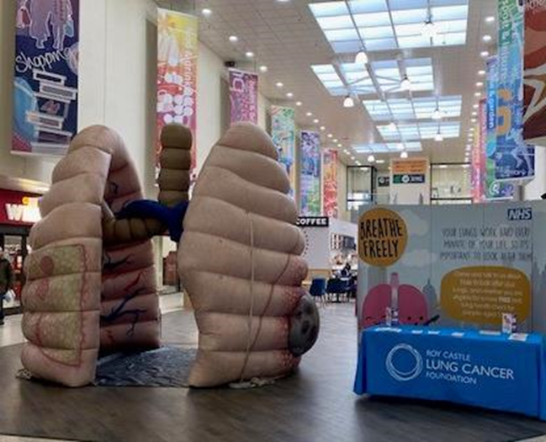

*Above image of lung health check promotions in the community*

The checks began in Thurrock in 2020, followed by Southend, Rochford, Basildon and will be starting shortly in Brentwood.

As of October 2024, over 24,000 lung health checks have taken place in the region.

This has led to over 11,300 CT scans for people at the highest risk. As a result, 163 lung cancers have been found of which 70% were stage 1 or 2.

Click here for lung health website: <https://www.midandsouthessex.ics.nhs.uk/news/saving-lives-by-finding-lung-cancer-early-targeted-lung-health-checks-programme/>

### Child Oral Health

We launched the Thurrock Early Year Oral Health (EYOH) Improvement program at the end of January 2024.

Tooth decay is almost entirely preventable yet, it is the number one cause of admission to hospital for five to nine-year-old children. The ICB is working in partnership with local partners across Thurrock to deliver targeted interventions to promote and embed positive oral health of children and young people within Thurrock.

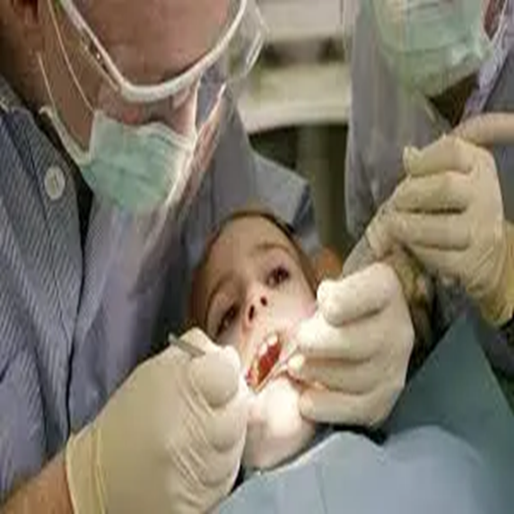

*Above image of child dental health procedure*

The Thurrock EYOH program aims to address the causes of poor child oral health, which has resulted in children and young people in Thurrock experiencing:

* High prevalence of dental decay in five-year-olds, with the highest prevalence seen in areas of less affluence.
* High incidence of admissions to hospital for dental extractions under general anaesthetic.
* Low rates of accessing dental services.

### Supporting Health and work

A system wide collaborative approach has been taken, working with local authorities, the Department for Work and Pensions (DWP), and the voluntary sector to support individuals with physical and mental health conditions, including neurodiverse individuals, in their journey back into employment. Our latest event in Southend, over 250 people received specialist employment support and information, advice and guidance from wellbeing and health services and the opportunity to engage with prospective employers.

### Outreach into communities

The Health Inequalities funding secured the use of an outreach vehicle to deliver a holistic health and wellbeing service in community settings engaging with over 500 users from our most deprived areas to offers services including health checks, smoking cessation Long Covid, sexual health and weight management support.

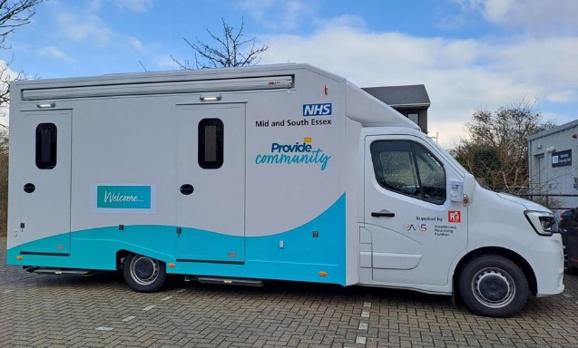

*Above image of outreach vehicle delivering holistic health and wellbeing service in community settings*

## Delivering Financial Sustainability

### System Financial Recovery Collaboration

Collaborative programmes have helped us release better value, reduce waste, and ensure more effective use of resources.

While system-wide focus is yielding results, unanticipated cost pressures, driven by surging demand and rising expenses, have made it challenging to stay on track with our original plans. Rising drug costs continue to affect financial forecasts across primary care, hospital services, and end-of-life care.

Clear plans are in place to address these pressures, with ongoing scrutiny from regional and national bodies to ensure we meet our agreed financial position for 2024/25 and into 2025/26.

## Supporting our Workforce

### Recruiting and Retaining Staff

A system-wide approach to workforce planning that is closely aligned to finance and activity planning is now in place and work is taking place to continue to strengthen these arrangements into 2025/26 and beyond.

We have delivered a system-wide platform ‘Our People Your Future’ to support our workforce through online courses, apprenticeship information, careers advice and job opportunities.

Click here for our people your future website: [Our People Your Future | Be the future of health and care in Essex](https://www.ourpeopleyourfuture.co.uk/).

In June 2024 MSE ICS promoted Allyship in the workplace. Allyship is a critical component of creating an inclusive and supportive workplace for LGBTQ+ colleagues, knowing they have allies can make a significant difference in their experience at work. Allies help advocate for and support LGBTQ+ individuals, ensuring their voices are heard and respected.

In December 2024, Basildon and Brentwood Alliance were honoured with the Active Employer of the year Award at the Basildon Activity Awards 2024.

### Healthcare Assistant Academy

July 2024 saw the first group of newly hired Health Care Assistants (HCAs) attend their induction with the HCA Academy. The induction built on a foundation of great work from Mid and South Essex Foundation Trust (MSEFT) to bring industry- leading training to HCAs who are set to join services across Essex.



*Above image of new HCA Academy members*

Newly hired HCAs from both Essex Partnership University NHS Foundation Trust (EPUT) and MSEFT are automatically enrolled to the HCA Academy upon successful appointment.

They will receive additional support from the Academy during their onboarding process and continued guidance throughout their first few months with their Trust.

The centralised induction across the two Trusts prepares them for roles in both mental and physical health, offering a comprehensive understanding of the various patient and healthcare scenarios they may encounter.

## Letting Staff Lead

### Our Stewardship Programme

MSE ICS Stewardship programme has been running since 2021. There are currently ten stewardship groups in place and four that have been running since the start of the programme.

Clinical Leads appointed for a number of specialist areas including Dermatology, Maternity, Musculoskeletal, Mental Health, Cancer, Children and Young People, Inequalities, Personal and Public Engagement, End of Life, Medicines Optimisation, Service Restriction Policy, Covid, Outpatients, Population Health Management and Ophthalmology and support programme in place.

Our stewardship programme is leading the way in whole system clinical redesign and well regarded in its innovative approach.

Professor Tim Briggs commented: *“You're lucky in mid and south Essex to have stewards”*

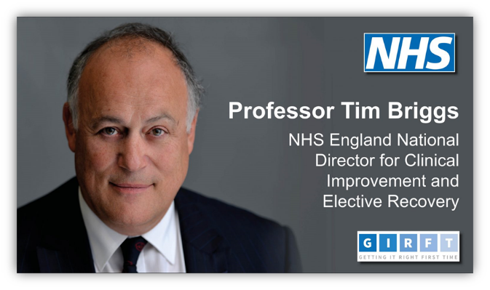

*Above image of Professor Tim Briggs, NHS England National Director for Clinical Improvement and Elective Recovery.*

Matthew Taylor commented:

*“I’m a big fan of the approach the system is taking”*

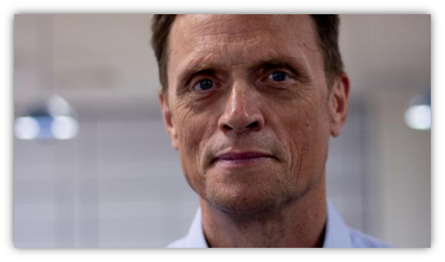

*Above image of MatthewTaylor, Chief Executive, NHS Confederation*

### Ageing Well Stewards - Frailty Hotline

Ageing Well Stewards have been instrumental in embedding a more sustainable approach that is helping those living with frailty / dementia and those at end of life to access the right care and in the right place.

Significant Activity Levels: Currently receiving 400-600 calls per month - a vital enabler for improving clinical outcomes and experience of care to this population.

Integration into Urgent Care Pathways: Data shows 86% of calls originate from the Urgent Community Response Team (UCRT) and East of England Ambulance Service NHS Trust (EEAST) paramedics on scene.

Access to Expert Advice: Embedding the consultant frailty hotline into the UCRT, Single Point of Access (SPoA) and Unscheduled Care Coordination Hub (UCCH) work has provided clinicians with real-time access to expert advice, improving care coordination and reducing unnecessary delays for patients.

Reduced admissions: 81% of calls avoided hospital admissions within the first 7 days, and 64% of patients still avoid hospital admission 90 days later.

National Attention: (Getting it Right First Time (GIRFT) experts, national Frailty Clinical Leads & NHS Elect Improvement team have endorsed the Mid and South Essex hotline model.

### Ageing Well Stewards - FrEDA and e-FraCCS

The Frailty, End of Life and Dementia Assessment (FrEDA) and Electronic Frailty Care Co-ordination System (e-FraCCS).

We identified the challenge of incorrect data and limited tools available for staff to ensure that patients were receiving best practice within Frailty services.

The Ageing Well Stewards co-designed a common assessment tool to deliver and capture best practice within Frailty focusing on the use of 7 high impact pro-active personalised actions, known as FrEDA assessment this launched across PCNs, Community Teams, Hospices, Dementia Teams, Virtual Wards and more.

Implementation of FrEDA across MSE has had a significant impact, with key highlights below:

>12,000 new people with frailty, dementia or EOL needs identified in 1st year.

>50% reduction in older people with >3 unplanned hospital admissions in their last 90 days of life.

5% reduction in 30-day hospital readmission rates (ICS wide).

70% reduction in 30-day readmission rates in Integrated Neighbourhood Teams with highest FrEDA usage.

There have been benefits for staff too. Uniting colleagues under a whole person culture, using integrated tools so partners seamlessly collaborate for better patient outcomes, as opposed to siloed organisational practice.

### Cancer Stewards – Prostate Case Finding Pilot

We designed a phased approach with 11 Primary Care Networks (PCNs) participating in the programme and 1841 patients offered the chance to participate.

As a result, we have seen:

* 865 patients seen in prostate initial clinics, 287 seen in follow up clinics.
* 768 patients had normal results with 32 patients discharged and fast tracked into the Acute Trust.
* Many cases were identified for diagnostic follow up.

### Cancer Stewards – Colorectal Cancer Referrals

A FIT (Faecal Immunochemical Test) is a test that looks for blood in a sample of your faeces. It looks for tiny traces of blood which could be a sign of cancer.

in people with possible colorectal cancer, there was significant variation in referral practice from primary and secondary care, and confusion about best practice.

GPs in MSE were being asked to request and wait for the patient’s FIT result before sending an ‘Urgent Suspected Cancer’ referral to MSE FT. We identified that many referrals had no FIT test were being sent and rejected in secondary care.

If the FIT was <10, and the patient had no other concerning symptoms, they were asked not to refer.

However, some consultants were also still scoping patients with a FIT <10, which was sending mixed messages to the GPs.

In order to improve this, the Cancer Stewards organised a number of educational webinars including at the MSE Cancer Summit to facilitate discussions around the FIT pathway.

In 2022, 33% of all colorectal referrals received into secondary care had a FIT result attached.

In 2024, 73% of all colorectal referrals have a FIT result attached.

### Cancer Stewards – Teledermatology

Teledermatology refers to the use of digital images to triage, diagnose, monitor or assess skin conditions without the patient being physically present.

The skin cancer pathway had below nationally expected patient experience, lengthy diagnosis and treatment times, accompanied with poor performance and variation in pathways.

The Cancer Stewards invested in relationship-building, attending dermatology outpatient meetings and Primary Care ‘time to learn’ education sessions. They shared the improvement that the interim teledermatology pathway had made, including improving relationships between key stakeholders. They challenged some of the norms and existing ways of working, enabling a system approach to support the introduction of the teledermatology pathway.

Over six months, the interim teledermatology service triaged over 9,500 patients.

A 4-week snapshot period showed a 68% reduction in skin cancer referrals through to MSEFT specialists.

Many more people are now receiving a timely diagnosis, improving from 22% to 76% of people who wait no more than 28 days between referral and diagnosis (Faster Diagnostic Standard).

More people are also starting timely treatment (within 62 days of referral), increasing from 23% to 53.6%.

### Cancer Stewards – Breast Pain

The Cancer Stewards coordinated and facilitated a breast cancer workshop for primary and secondary care across MSE, we also included the Women’s Health Hub lead to ensure we were engaging all key colleagues.

We successfully agreed a new Urgent Suspected Cancer Referral (USCR) form and a digital approach to allow the patient questionnaire (which is essential for the Trust to triage) to be initiated by primary care.

Currently, it is too early to evidence the results and impact.

This did bring the primary and secondary care interface together to work more collaboratively. This work will also be the starting point for the Cancer stewards to start developing Community Breast Pain Clinics in the future.

### Cancer Stewards – Breast Screening

Concerns were raised to the Stewardship group by primary care.

We had discussed these issues with East Suffolk and North Essex NHS Trust and South Essex Breast Screening Services (providers of breast screening services across MSE), we also involved Alliance delivery and transformation managers to ensure everyone was included.

A number of positive outcomes were shared including:

1. Agreement on how to communicate with patients.
2. The two screening service providers to share how patient lists can be obtained.
3. Development of a Standard Operating Procedure (SOP) for primary care with coding advice.
4. An educational event to follow the agreement on the SOP.

### Cancer Stewards – Ardens Cancer Template

Improving ease of primary care referrals of suspected cancer has been a key development during 2024/25. We have worked with primary and secondary acre partners as a group to support earlier and faster diagnosis as it was identified as a key area that would support the patient pathway.

We undertook an audit of 50 referrals across four specific tumour sites within certain metrics in place and used audit data to help develop this. This was important as the Ardens cancer template will be designed for primary care to help support them.

### Cancer Stewards – Prehab / Rehab

Two programmes of work have been funded by the Cancer Alliance through Active Essex & Health Inequalities budget.

These were the ‘Digital Health Optimisation Plan (Alvie)’ and ‘Living well with Cancer exercise programme’.

This programme of work aims to support patients in completing their cancer treatment, improve their outcomes and reduce length of inpatient stay post prehabilitation across MSE.

In the first six months of the Digital Health Optimisation programme, there have been 540 referrals of which 56% are from our most deprived communities.

### Cancer Stewards – Cancer Summits

On 7th November 2023, Cancer stewards had organised a MSE cancer summit for primary and secondary care colleagues for influencing partnerships and pathways. This was a whole day event which was supported by national keynote speakers such as Professor Peter Johnson.

There were 4 breakout workshops throughout the day that enabled networking and troubleshooting of key issues that we face across the system within Cancer. Outcomes from this event were improved understanding of cancer pathways, primary care involvement, troubleshooting issues resolved and shared learning.

On 18th September 2024, our Stewardship Group were asked to run a regional workshop on the stewardship approach to addressing the skin cancer issue within MSE, 36 attendees were at the event. The workshop highlighted key successes in implementing the stewardship model across MSE system, with a particular focus on Teledermatology.

Several strategic opportunities were identified during the workshop for the region, including replication of the stewardship model to allow for region-wide improvements and broadening Teledermatology access as the current infrastructure provides a solid foundation to expand these services.

### Diabetes Stewards – Type 2 Remission Programme

The stewards worked to address low referrals to the national low calorie diet programme (the NHS Type 2 diabetes path to remission programme).

Research has shown this national programme helps people to lose over 10kg in weight, improve their blood sugar levels, reduce diabetes-related medication and, in almost half of participants, put their type 2 diabetes into remission.

However, prior to stewards’ involvement, there were less than 40 referrals per month from across the system. The stewards identified several barriers to referrals including, lack of awareness of programme, workload, workforce capability, patient factors, the ICB restructure and change in providers.

The stewards worked to increase referrals through engagement with patients, providers, and Diabetes UK. They supported training, and most significantly used digital tools as an enabler by putting prompts onto the clinical systems that flagged patients who would be eligible for the programme.

Eligible participants are offered low calorie total diet replacement products including soups and shakes consisting of 800 to 900 kilocalories a day for 12 weeks.

*Below image of Mid and south Essex Referrals to T2 Path to Remission Programme.*

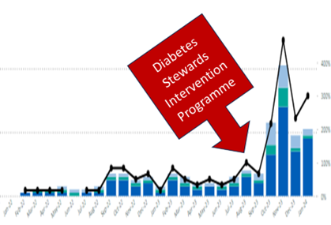

Since the stewardship interventions, referrals have increased from less than 40 to over 100 per month (peaking at 200+ in November 23). MSE ICS now has the highest referrals in the region, and the second highest nationally.

### Eye Care Stewards – Childrens School Vision Screening

The Eye Care Stewards mapped the School vision screening programme pathway across all schools, including Independent, Special Education Needs and Disabilities (SEND) and home-schooled children.

In Southend, 600 out of 2300 (26%) four- to five-year-olds failed their screening test, with 382 (64%) children unaccounted for, who could go on to develop permanent vision problems. This figure is 265 children (91% of those failing their screening test) in Thurrock, and 381 children (51%) across Essex.

Across MSE, there was no mechanism is in place to ascertain if a child had attended an optical practice for further tests following a failed school vision screening test.

The Eye Care Stewards worked to establish partnerships and collaborate with key stakeholders i.e. School Screening Teams, local councils and Primary Eye Care Services. They also identified inequalities e.g. SEND, home schooled children in service provision across MSE and an agreed plan established to address issues.

Southend Council have agreed to screen all Independent Schools and commission OPERA (an IT platform) to ensure children have had a follow-up sight test, closing the loop and addressing safeguarding issues. List of neurodiverse accredited Optometrists shared with school screening teams. Further results will be shared during 2025/26.

### Eye Care Stewards – Certificate of Visual Impairment (CVI)

Eye Care Stewards were instrumental in developing the model and mobilising the Single Point of Access for Eyecare Referrals, and particularly the recent inclusion of the cataract pathway.

The key reasons for this were to provide a clinical triage to direct patients to the most appropriate services, ensure patients are offered informed choice where appropriate, to streamline the existing referral processes, and to provide a robust data set on Eyecare Activity to inform future planning.

Patients now have access to data regarding all hospitals including quality and waiting times to help them choose where they want to have their hospital procedures carried out.

### Musculoskeletal Stewards – Community Appointment Day

We identified we had a large number of people waiting in the community for physiotherapy appointments in south west Essex. Patients had long waiting times, complex needs and care was felt to be disjointed.

A one day event, led by South West Essex MSK service with MSK stewards was held involving 21 community health and social care providers at Basildon Sporting village Community Centre. We aimed to provide a personalised approach which also focused on the wider determinants of health.

139 patients signed up to the day, 99 attended and out of these 56% discharged with Patient Initiated Follow-up.

92% of patients reported finding the day helpful in helping them manage their MSK condition.

100% of stakeholders who responded to the post event questionnaire reported enjoying the day and would participate in another event in future.

As a result of this event we identified a 3.5 week reduction in average waiting times for MSK physiotherapy services in south west Essex.

### Musculoskeletal Stewards – Fracture Liaison Service (FLS)

The burden of preventable fractures on the NHS is enormous. A million acute hospital bed days are taken up by hip fracture patients and £2bn is spent annually on hip fracture care. Hip fractures are ‘heart attack-level’ events, which impose major burdens on hospitals, ambulances, and social care.

Data showed in 2020 there were an estimated 8-10,000 fragility fractures each year in MSE in adults >50 years. At this time <20% were seen in the Fracture Prevention and Osteoporosis clinics, often with a long delay between date of fracture, first assessment and treatment.

FLS identify, assess and treat osteoporosis in people over the age of 50 with a fracture.

The MSK (and Ageing Well) group supported the FLS project implementation, with the Clinical Lead from MSE FT, bringing providers and professions together to help remove barriers and facilitate the left shift to community care. This included supporting pathway design across sectors, including identification and initial treatment in acute settings, and in the community.

The FLS service has been mobilised at Southend Hospital as the first go-live phase, with Basildon and then Broomfield Hospitals to follow by the end of 2024.

At Southend Hospital identification of patients experiencing a fracture exceeded the national average within four months of mobilisation (see below), identifying and assessing over 220 people at risk.

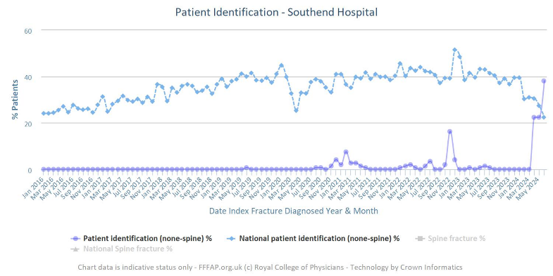

*Above image of patients identified and assessed for FLS service.*

### Musculoskeletal Stewards – Mental Health/ MSK Employment Advisor (EA) service

Stewards have supported the Essex Partnership University NHS Trust (EPUT) by identifying relevant stakeholders and facilitating an increase in awareness of the service.

### Musculoskeletal Stewards – Get U Better App

We have supported the contract review and are now facilitating the ongoing role out/ use of the app therefore ensuring equity of access and value for money.

### Musculoskeletal Stewards – ARU Magnetic Resonance Imaging (MRI) research

In partnership with Anglia Ruskin University supported with advice and guidance on planned research into how MRI results are communicated and how this can have a positive/negative image on patient outcomes.

### Musculoskeletal Stewards – Lower Back Pain Pathways

Initially linked to NHS England, focus on bringing the current tier 1 and 2 providers together to understand our current situation and how we can work together to reduce inequity across the patch, delivering high quality care.

### Stroke Stewards – Stroke Rehabilitation Capacity

In support of the redesign of community stroke rehabilitation capacity stroke stewards have undertaken comprehensive demand and capacity modelling.

A pre consultation business case (PCBC) has been consulted with further work planned during 2025/26 to deliver the Decision-making Business Case (DMBC) for Board consideration.

### Urgent Emergency Care (UEC) Stewards – UCCH

Emergency Departments (ED) in MSE were failing to meet national waiting time standards and an opportunity to reduce the number of ambulance arrivals was identified.

The UEC stewards developed the Unscheduled Care Co-ordination Hub (UCCH) model which encouraged all ambulance crews to contact the UCCH prior to conveying a patient to ED. The UCCH multi-disciplinary team consists of Emergency Department Consultant, Urgent Community Response Team (UCRT) nurses, East of England Ambulance Service Trust (EEAST) clinicians and administrative support.

This team would speak to the ambulance crew and together they would decide whether there was a more suitable option than ED for the patient.

As a result 50% of patients were not conveyed to ED following a discussion with UCCH – with an estimated 140 ambulance conveyances per month avoided. UCCH coincided with a 50% increase in referrals to UCRT.

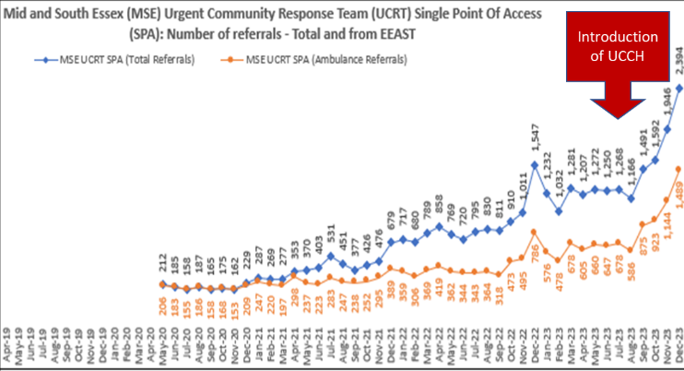

*Above chart indicating increase in referrals to new service.*

Further opportunities are being consider into 2025/26 with the plan to move into a phase 2 and 3 model deployment across Mid & South Essex inviting other partners, including General Practices, Care Homes and Mental Health to utilise the Unscheduled Care Co-ordination.

## Population Health

### Pneumococcal Vaccination uptake

We launched a communications campaign to raise awareness and encourage eligible individuals to receive the free pneumococcal vaccination. ​



*Above image of* *pneumococcal vaccination awareness campaign.*

We promoted benefits of the vaccine and promoted its uptake among over 65s and individuals with chronic long-term conditions. Reducing the risk of meningitis, pneumonia, and sepsis

Most areas saw an increase in uptake among their populations. The largest increase was in Basildon and Brentwood with a 60% rise, followed by Castle Point and Rochford with a 29.3% increase, Mid Essex with a 15% increase, and Southend with an 8% increase.

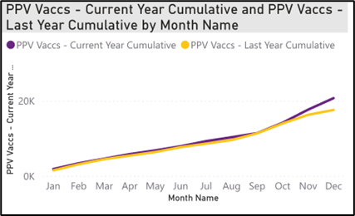

*Above image showing vaccination rates increase.*

## Moving Towards Net Zero

### Climate Action Packs

During 2024 Essex County Council created free climate action packs to help residents and businesses reduce their carbon footprint.

The packs, originally launched in 2022, have been updated with new information as well as a fresh look and feel. This includes funding and volunteering opportunities. The residents pack has also been produced in an accessible easy-read version.

### Gloves off Campaign

The ‘Gloves Off’ campaign has now been fully implemented across all providers including primary care. The ‘Gloves Off’ campaign utilises the work undertaken within our provider organisations, to stop wearing gloves where appropriate.

### Reusing Equipment

Providers across MSE are ensuring that they reuse equipment in accordance with infection prevention control procedures and community equipment teams in south east Essex have confirmed that the only items that they do not refurbish are cutlery.

### Reusing Equipment

Basildon and Brentwood Alliance received an e-bike donated from Ford Motor Company as part of the Electric Bike Loan Workplace Pilot organised by the Find Your Active Basildon partnership. The partnership aims to improve the health and mobility of our frontline primary care support staff. This significant contribution will support their team in delivering essential one-to-one care across the community.

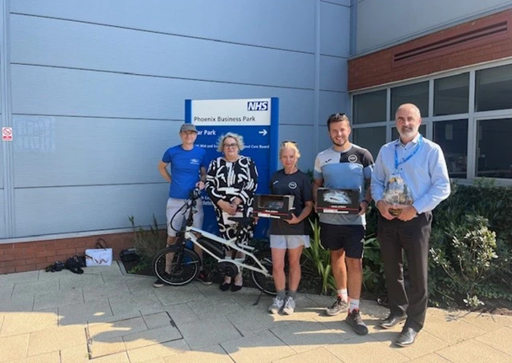

*Above image of Ford Motor Company donating e-bike.*

Kelly Herring, a dedicated Social Prescriber from the West Basildon Primary Care Network, was the first recipient of an e-bike. As a non-driver, Kelly faces unique challenges in her role, and this new addition has greatly improved her ability to efficiently reach patients and community projects.

## Digital, Data and Technology

### System Digital Enablement

In August 2024 Mid and South Essex ICS successfully launched the Shared Care Record, making a significant step forward in our journey towards more integrated and person-centred care across our system and beyond. The launch was a key milestone in our commitment to delivering better, more joined-up care between local health and social care organisations.

With quicker access to more comprehensive and accurate records, this digital tool allows professionals to focus more of their time on direct care rather than administrative tasks. This efficiency gain is projected to deliver £1.7 million in annual savings across MSE ICS, underscoring our commitment to a cost-effective, digitally transformed system that is future ready.

The Shared Care Record is integrated into the existing systems used by our providers. When professionals open a person’s care record in their regular system, they can then directly access the individual’s information within the Shared Care Record, without the need for additional logins. This streamlined, secure access allows professionals to quickly view and use vital information, ensuring more seamless care without any disruptions to their workflow. To understand what data is currently accessible and what will be added in the future.

Our Nova Electronic Patient Record (EPR) programme is a ground-breaking digital transformation programme that is a first in type in the UK. Essex Partnership University NHS Foundation Trust (EPUT) and Mid and South Essex NHS Foundation Trust (MSEFT) are united in an ambitious partnership programme driving substantial improvements in quality, safety, and patient-centred care.

In a healthcare landscape burdened by fragmented information systems and disjointed care pathways, patients and clinicians struggle to navigate a maze of data silos and inefficiencies, our Nova EPR Programme illuminates a path towards seamless, unified care delivery where healthcare information flows effortlessly across boundaries, empowering patients and clinicians alike.

The Patient Engagement Portal is being implemented across Mid and South Essex Foundation Trust (MSEFT) and Essex Partnership University Trust (EPUT). Patients Know Best (known as PKB) was procured in February 2023 as the Patient Portal for the Mid and South Essex system.

PKB provides patients with access to their information held within our hospital systems. It is accessible anywhere, integrated with the NHS App and enables patients to share their information with friends, family and/or carers.

Our strategic data platform Athena allows partner organisations within local authority, primary and secondary care to access systemwide, linked data. Since February 2023 we have loaded over 1 billion rows of data that is now available via subject specific dashboards or for analytical research. From this we are able to make data-driven decisions and enable impactful interventions that can change lives.

### Electronic Palliative Care Coordinating Systems (EPaCCS)

At its core, the main purpose of EPaCCS is to improve the quality of care for adults near the end of life. The registers achieve this by making sure that the person’s needs, wishes, and preferences are properly recorded and easily accessed by professionals involved in their care.



*Above image of holding hands.*

As data sharing platforms, EPaCCS increase the visibility of people with palliative and end of life care (PEoLC) needs. They allow for valuable information about a person’s care needs and wishes to be shared across multiple organisations, whether it is a care home, primary care, a community service, or emergency services.

People that benefit most from EPaCCS are those within their last year(s) of life. As they are living with a severe, life-limiting condition, they are likely to have contact with multiple care providers. Having their personal choices, priorities and goals for care recorded and easily accessible means they can get the most appropriate care in line with their wishes. The information recorded might include details like current palliative medication being taken, preferred place for care and personal decisions on resuscitation.

 Having access to this information helps professionals improve the end-of-life experiences of people in their care. It can help prevent delays in care or avoid unplanned and unwanted urgent care or hospital admission, and it helps ensure patients’ wishes are respected.

## Mobilising and Supporting Communities

### Community Initiatives

A number of community initiatives have been implemented during 2024/25 so support our communities.

In April 2024, Thurrock Council launched a free health lifestyle programme to provide services across the Borough. The programme helps Thurrock families improve their health and wellbeing, through engaging children with health eating and healthy habits.

In September 2024, organisations, people and communities in mid and south Essex joined together to light up buildings and landmarks green, as part of the ‘Creating hope through light’ event. The joint initiative between Mid and South Essex Integrated Care System and Thurrock and Brentwood Mind, and is part of their #LetsTalkAboutSuicide campaign which aims to raise awareness of suicide prevention and reducing the stigma around talking about suicide and challenge residents to take the suicide prevention training available. Click link for suicide prevention training: [www.letstalkaboutsuicide.co.uk](http://www.letstalkaboutsuicide.co.uk).

In October 2024 Healthwatch Essex hosted in partnership with the Trauma Ambassador Group an exhibition illustrating personal experience of trauma, and how people use creative outlets to express themselves. The exhibition, created to raise empathy and awareness of trauma and the effects it has, will feature art covering sensitive themes including bereavement, abuse, chronic pain, and forced adoption, amongst others.

Exhibitors have shared a range of multi-media pieces, with poetry and audio played throughout the exhibition, alongside interactive art pieces, paintings, textiles, photography, and more.

### Specialist Bereavement Service



*Above image of caring hands held out in support.*

During September 2024 a free Specialist Bereavement Service was launched, delivered by Amparo for residents in mid and south Essex, provides emotional and practical support for anyone who has felt the impact of suicide at any time (recent or historical).

The service is completely confidential and can provide short-term or longer-term support. It is also available to bereaved children (Aged between 4 and 11 with agreed appropriate adult) and young adults (Age 11 upwards).

Suicide has a far-reaching impact, leaving questions and concerns on many levels. Those directly affected are left with bereavement and loss, so it is important that help is on hand.

 Experienced Liaison Workers, aim to make initial contact within 24 hours of a referral being received, offer residents:

* Support in their homes or wherever is most comfortable to the resident.
* One to one individual support.
* Help with any media enquiries.
* Practical support when liaising with the Police or Coroners including preparing for and attending inquest.
* Help overcoming feelings of isolation.
* Appropriate contact with other local services that can help.

### Slipper Swap

During 2024-25 a series of slipper swap events have been held across MSE ICS to support older residents and people with frailty, to swap their old slippers for a free pair of new NHS approved slippers. The slippers have secure fastenings and robust soles to help prevent falls.

### Vaccination Bus

In October 2024, members of our Alliances and Communication and Engagement Teams were joined by local community pharmacists on board the vaccination bus to provide information on winter vaccinations including flu, COVID-19 and the new RSV vaccination.

Eligible residents were able to have their flu and/or COVID-19 vaccinations onboard the bus and residents were also offered free blood pressure checks and practical health advice from our community health and wellbeing teams.