

**Equality Diversity, Inclusion**

**and Belonging Strategy**

2024 - 2028

**CONTENTS**

Foreword 3

Introduction 4

Background 4

Vision and Context 5

The Mid and South Essex ICS 6

Understanding the population we serve 7

Understanding our Workforce 11

Our Equality Objectives 14

How We Will Deliver on Our Objectives - Commissioning 20

How We Will Deliver on Our Objectives - Workforce 27

How We Will Track Progress 33

# Foreword

I am pleased to introduce the Mid and South Essex (MSE) Integrated Care Board (ICB) Equality Diversity, Inclusion and Belonging (EDIB) Strategy, approved by our Board on 14 November 2024.

Central to the vision set out in our Joint Forward Plan is our desire to come together in a broad and equal partnership of individuals, organisations, and agencies to serve the people living and working in mid and south Essex, including our own staff. Working together, our shared focus will be on fairness, prevention, early support and providing high quality integrated health and social care services when and where people need them. This will create an environment where everyone: our patients and our workforce alike are treated with respect, ensuring equity of access to our health service and equity of access to opportunity for our staff. Fundamental to this is ensuring we fully understand the health needs of our population as well as any barriers that exist to those needs being met; and understanding our workforce as well as any barriers that exist to us being an employer of choice.

This document sets out our commitment to taking equality, diversity, and human rights into account in everything we do whether commissioning services, employing people, developing policies, communicating with, or engaging local people in our work.

This strategy and associated plans will help the ICB tackle health inequalities, promote equality and fairness, and establish a culture of inclusiveness that will enable the ICB to best meet the needs of all our residents and staff within our given financial envelope.

Our Board commits to monitoring our progress and reporting regularly and openly on the developments in this strategy. We acknowledge and accept our roles in supporting the strategy and will play our full part in making its aims a reality.

The ICB gives its absolute commitment to equality and diversity in respect of the services that we commission for the population of our local area and for our own staff. Indeed, I am committed to Board Members actively participating in and promoting the reciprocal mentoring programme for ICB Non-Executive Members (NEMs) and Associate NEMs driving our culture at the top of our organisation.

Prof. Michael Thorne

**Chair, MSE ICB**

# Introduction

The ICB is committed to ensuring that our local population and all those we serve have equity in access to care, a positive experience of care and improved health and wellbeing. To do that we need to fully understand the inequalities that exist within our health system and actively work to eliminate them.

We are also committed to becoming an employer of choice, as set out within our People Management Strategy. To that end we are creating a sustained and transparent employee pathway that recognises the diversity of our workforce, embracing inclusion, and developing an organisational culture of belonging.

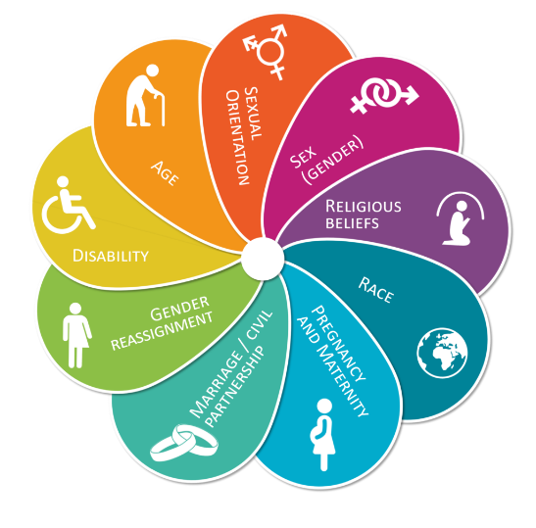

**Figure 1: Protected Characteristics**

# Background

The ICB is committed to ensuring that all our activities, as a commissioner, an employer, and as a partner in the wider health system, always meet the needs of our population and staff in an equitable and fair manner ensuring kindness always. In doing so we will also ensure we meet the requirements in the Equality Act 2010 (the Act).

The Act legally protects people from discrimination in the workplace and in wider society. It replaced previous anti-discrimination laws with a single Act, meaning that discrimination or unfair treatment based on certain personal characteristics is now against the law.

The nine protected characteristics include age, disability, sex, gender reassignment, race, religion or belief, sexual orientation, marriage and civil partnership, pregnancy, and maternity (see figure 1).

The Act also established the Public Sector Equality Duty (PSED). The PSED is made up of a general equality duty and specific equality duties (SEDs). The former is set out in primary legislation as section 149(1) of the Act, and the latter is supported by secondary legislation in the form of statutory regulations. The PSED is supported by non-statutory guidance and technical guidance issued by the Equality and Human Rights Commission (EHRC).

The ICB is committed to the principal objective of the PSED to have ‘due regard’ or proper consideration of the need to address three equality aims:

* **Equality aim 1:** eliminate discrimination, harassment, victimisation, and any other conduct that is prohibited by or under this Act.
* **Equality aim 2:** advance equality of opportunity between persons who share a relevant protected characteristic and persons who do not share it.
* **Equality aim 3:** foster good relations between persons who share a relevant protected characteristic and persons who do not share it.

All three equality aims apply to both our population and our workforce.

# Vision and Context

The ICB recognises and values the diversity of the population we serve, and of our workforce. Having a focus on equality is central to our work, ensuing we commission modern, high quality health services for all. To do that we need a consistent and well-motivated workforce.

Many of our NHS staff are part of the wider population of MSE and are therefore subject to the same health inequality challenges.

Our vision, within our Joint Forward Plan, is for a health and care partnership working for a better quality of life in a thriving mid and south Essex, with every resident enabled to make informed choices in a strengthened health and care system. This means that:

* Members of the public have the right to expect the care and treatment they receive to be provided in an environment free from unlawful discrimination or harassment.
* We will tackle health inequalities and ensure there are no barriers to health and wellbeing.
* We will actively seek to understand the barriers experienced through the lens of the diverse populations we serve and making access to health services equitable.
* We will ensure our health providers also meet their legal requirements around equality and human rights.
* Our staff have the right to work in an environment that is free from discrimination, victimisation, and harassment (policies to safeguard staff are included on our staff intranet).

The ICB’s equality and diversity strategy is based on:

* The Principles of the NHS Constitution
* The Equality Act 2010 and the requirements of the Public Sector Equality Duty under that Act
* The Human Rights Act 1983
* The requirements within the Health and Care Act 2022 to reduce health inequalities, promote patient involvement, and involve and consult the public.

Our approach to equality and diversity includes working closely with our upper tier Local Authorities: Essex County Council, Thurrock Council and Southend City Council; alongside our Essex, Thurrock and Southend Health and Wellbeing Boards in agreeing local needs assessments specific to those areas and developing the strategy to address these needs. We use Joint Strategic Needs Assessments (JSNAs) and population health management data to inform our commissioning intentions and decision-making. The JSNAs are a collection of research about the local people, places, and communities to which the ICB and our partners deliver services. We use the JSNA’s to try to understand what needs to be done in collaboration with local knowledge and community feedback.

In developing this strategy, the ICB has considered the impact of other characteristics outside of the nine statutory protected characteristics for example the ICB feels that neurodiversity and implications for carers should have an equal focus in terms of the role of the ICB as an employer and commissioner.

This strategy sets out our equality objectives and the associated plan that places equality at the centre of all we do both for our staff and for our population. It also sets out how we will monitor and review our progress at least annually.

# The Mid and South Essex Integrated Care System (ICS)

In MSE, our ICS is made up of a wide range of partners, supporting our population of 1.2 million people. The Integrated Care Partnership (ICP) is a statutory committee jointly formed between the ICB and all upper-tier local authorities (named above, page 5). It also brings together a broad alliance of partners concerned with improving the care, health, and wellbeing of our population. Our system includes:

* Three top tier local authorities and seven district, borough and city councils.
* Three healthwatch organisations.
* One hospital Trust with main sites in Southend, Basildon and Chelmsford (Mid and South Essex NHS Foundation Trust (MSEFT)).
* Three main community and mental health service providers (Essex Partnership University NHS Foundation Trust (EPUT), North East London NHS Foundation Trust (NELFT), Provide Community Interest Company)
* One ambulance Trust.
* Over 144 GP Practices, forming 26 Primary Care Networks.
* Other partners including Essex Police, local universities, Optometrists, Dentists, Pharmacists and nine voluntary and community sector associations.

The ICP is responsible for setting the Integrated Care Strategy and holds to account the partners for delivering that strategy. The ICB facilitates ICP meetings and works with all partners in a collaborative approach to achieving the strategy.

The ICB is specifically focussed on the health element of the strategy and in its role as an ICB holds to account the health partners for the delivery of health and care in accordance with the strategy.

Central to the system’s strategy is its commitment to reducng inequalities together. Collaborative working through our Population Health Improvement Board sets the strategy for how we can do this for the population we serve in MSE.

The ICB employs a system clinical lead for Health Inequalities who supports collaborative working to address inequality across the ICS. This is supported by partnership working on the Equality Delivery System 2022 which is completed in partnership on an annual basis (see also page 32).

Similarly, the ICB’s People Board brings together healthcare partners to ensure people strategies have an EDI focus and are delivering improvements for our staff. Working closely with NHS England, we maintain oversight of compliance with statutory and mandatory requirements placed on health organisations in relation to equality.

The ICB is committed to working with its partners across the ICS to further strengthen compliance with EDI requirements and to create an inclusive culture across MSE.

This strategy brings together the ICB’s vision and action to deliver improvements in addressing the EDI that face our population and out workforce and supports the broader system strategies. Partner organisations will also have their own strategies and delivery processes to achieve and demonstrate their commitment to and statutory compliance with EDI.

# Understanding the population we serve in MSE

The ICB serves a population of 1.2 million people. The total population size of mid and south Essex is projected to increase by 14.7% over the next 20 years. By 2034 the largest increases are forecast for the 90+ years population.

We have undertaken an in-depth review of health inequality data, gathered from the JSNAs and population health management data published by our three upper tier local authorities and the Population Health Management teams, which we use to inform our strategy and commissioning process and summarised below. Further information can be found at ‘Essex Open Data’ [[Home | Essex Open Data](https://data.essex.gov.uk/)].

*Life Expectancy* is a key metric for assessing a population’s health. The inequality in life expectancy, measures how much life expectancy varies with deprivation from most to least deprived. During Covid, there was a drop in life expectancy that has now recovered. Across MSE, females have a higher life expectancy than males.

In reviewing our individual districts within MSE we further understand some of our equality gaps and how those gaps differ across our geography. For example, Basildon and Southend-on-Sea have a life expectancy inequality gap that is greater than the average for England (which is 9.7 years for men and 7.9 years for women greater than the England average). Brentwood has a greater inequality gap than average for women. Chelmsford, Braintree, Maldon, Castle Point and Rochford have an inequality gap within their populations that is lower than England average. The areas that have a lower life expectancy overall (Thurrock, Southend-on-Sea, and Basildon) also have a greater inequality of life expectancy within their populations.

*Healthy life expectancy* indicates how long a population is expected to experience good health. Male healthy life expectancy in MSE is higher than the regional (East of England) average, but in Thurrock it is lower than the National average. Female healthy life expectancy is higher in Essex than that of the England average. However, in Southend-on-Sea and Thurrock Female healthy life expectancy is much lower than the England average and is also lower than male healthy life expectancy in these areas (see figure 2).

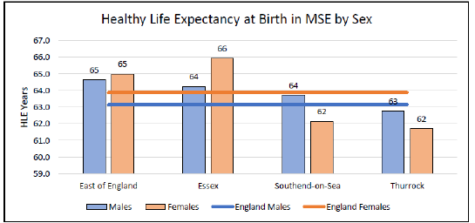**Figure 2: Healthy Life expectancy at birth in MSE by sex**

*Ethnicity.* Based on ethnicity data from the 2021 census, 83% of the population of MSE is White British. This is a higher proportion compared to England as a whole (73.5%). The second largest ethnic group is ‘Other white’. Basildon, Southend, and Thurrock have the greatest groups with ethnic diversity (sometimes referred to as Global Majority). 3.2% of the MSE Population speak a primary language that is not English. The full breakdown of ethnicity within MSE is included within the health inequalities annual statement.

*Other population groups*

* 16.2% of the population reside in areas of rurality.
* 19% (139,500 residents) of the MSE population aged 16-64 have a recorded disability.

**Health Behaviours & Outcomes**

*Disease drivers.* Mortality attributable to socioeconomic inequality (MASI) relates to the excess number of deaths compared to the least deprived areas in England. In 2020, there were over 14,500 excess deaths in mid and south Essex relating to socioeconomic inequality. All districts in mid and south Essex have cancer, circulatory disease, and respiratory disease in their top three contributors to MASI. Further information can be found within the MSE health inequalities annual statement.

Some areas have high and increasing rates of Coronary Heart Disease, Hypertension, Stroke, Diabetes and Chronic Obstructive Pulmonary Disease (COPD).

The number of people diagnosed with Dementia in MSE has increased from 9,314 to 10,627 in 2024. Mental health conditions are increasing in adults and children. The number of people in contact with NHS funded secondary mental health, learning disabilities and autism services in MSE increased from 49,230 in 2020/21 to 53,510 in 2023/24.

Tobacco, high blood pressure and dietary risks are the top 3 cross-cutting risks that have been identified in MSE populations. These are the factors that will have the greatest impact on population health outcomes and health inequalities.

*Overweight and obesity* is currently the fastest rising behavioural risk factor in England. There are high and increasing proportions of overweight or obese adults - in all but one district (Chelmsford) more than 60% of adults are overweight or obese. This is as high as 76% in Thurrock. Likewise, there are increasing numbers of overweight or obese children in early years schooling - 20-26% of children in MSE are already overweight or obese when they arrive at primary school in reception year (age 4).

*Smoking* impacts on quality of life and increases the risk of premature death. Smoking prevalence in adults in MSE is 11.1% compared to England average (11.6%) (2023 annual population survey). Smoking prevalence amongst adults is particularly high in Basildon (14.2%) and Thurrock (14.6%).

**Neurodiversity and our carer community**

Data recording the neurodiversity of our community is being collated, however it is likely under reported given the potential for those on the lower scale of neurodiversity who have not sought diagnosis and the current waiting lists for ADHD and ASD services.

Similarly, 37,100 of the population within MSE is recorded as having a carer status for someone with a disability or long-term condition. This is also likely understated where carers have not registered their status. We work at neighbourhood, Alliance, and system level with all partners to improve the identification, experience, support and health and wellbeing of unpaid carers in MSE and have identified carers as one of our local ‘Plus 5’ groups in the CORE20PLUS5 approach to reducing health inequalities. We have committed to continue to develop and improve our offer to carers as outlined within our Joint Forward Plan.

**Education, Employment & Prosperity**

Deprivation has increased across the 1.2m population within MSE.

On average deprivation in MSE is lower than the national average. In MSE an estimated 133,000 people live in the 20% most deprived areas nationally. That is 10.5% of the whole MSE population (see figure 3 below).

**Figure 3: Distribution of MSE residents living in the most deprived areas.**

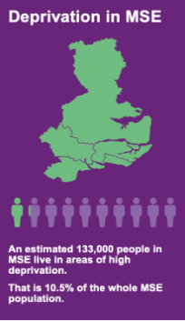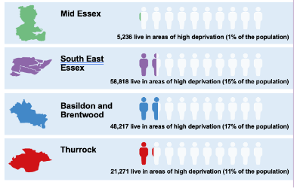

The child population for MSE accounts for approximately 10.7% of the total population, 12% of the child population live in the 20% most deprived areas.

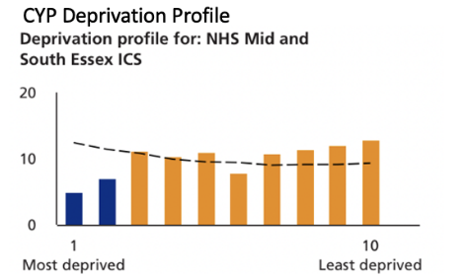

**Figure 4: Children and Young People Deprivation Profile for mid and south Essex**

Overall, Essex (data excludes Southend) is performing worse than national comparisons for proportion achieving GCSE pass (Grade 9-4) in English and maths creating a disadvantage for future schooling and future skills for work. The productivity gap is increasing between mid and south Essex and national comparators.

Homes have become up to 58% less affordable over the last decade.

More details on the health inequalities experienced in the MSE population can be found in the [Health Inequalities Information Statement 2023/24 - Mid and South Essex Integrated Care System](https://www.midandsouthessex.ics.nhs.uk/publications/health-inequalities-annual-report-2023-24/) [hyperlinks]

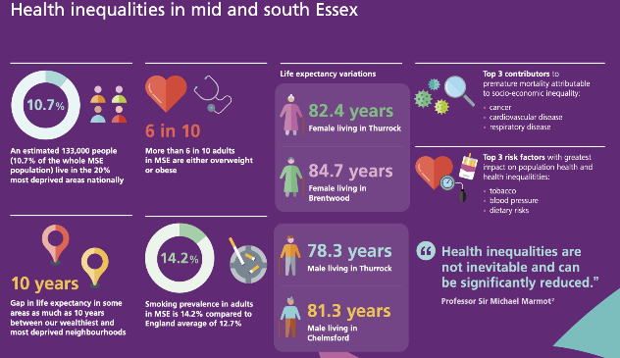

**Figure 5: Overview of Health Inequalities within mid and south Essex**

# Understanding our Workforce

The ICB has a diverse workforce that includes people of different sex, age, race, sexual orientation, religion or belief, disability, and marital status. We are committed to encouraging and supporting these diversities in all we do.

Based on our corporate workforce data, MSE ICB’s workforce is made up of a majority of female employees (80%) (see figure 6). Whereas the gender split of the MSE population is 51% female, 49% male.

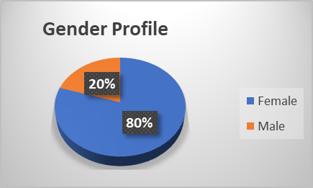

**Figure 6: Distribution of MSE employees by sex**

The majority of the ICB’s workforce is aged between 36-60 (73%), with a fairly equal split between the age ranges 36-40 (11%), 46-50 (15%), 51-55 (14%) and 56-60 (13%). The larger element is 19% of our workforce being 41-45 years, as shown in figure 7.

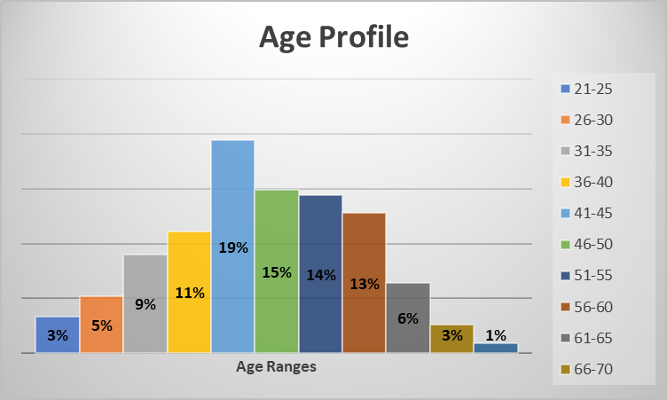

**Figure 7: Distribution of MSE employees by age**

A high level of ICB staff feel comfortable reporting their race, with 2% unknown (see figure 8). Much like the racial diversity across the population of MSE, the majority of our workforce are white. 81% of our workforce, compared to 83% of our population in MSE are white. Of the 17% of ethnically diverse groups, 52% were of Black African and 21% were of Indian origin.

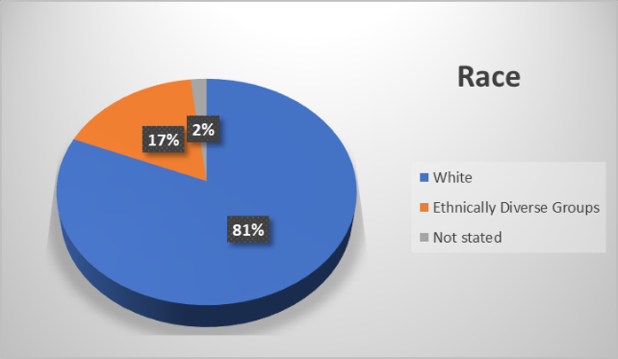

**Figure 8: Distribution of MSE employees by race**

Of the staff who responded to the most recent survey, 84% stated they were heterosexual, with 6% stating they were gay/lesbian/bisexual, 10% preferred not to disclose (see figure 9).

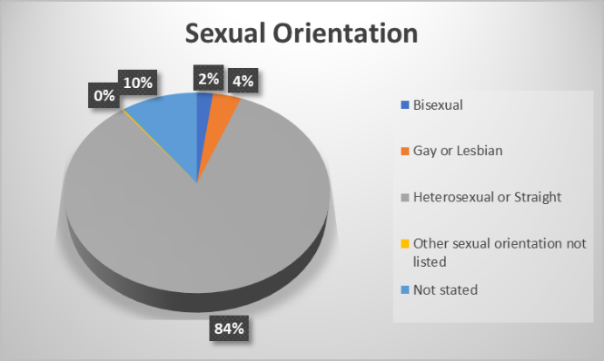

**Figure 9: Distribution of MSE employees by sexual orientation**

Christianity was the majority religion/belief at 49%, with atheism the second at 20% (see figure 10). A proportion (20%) of our workforce preferred not to disclose or left blank the data that records religion or belief.

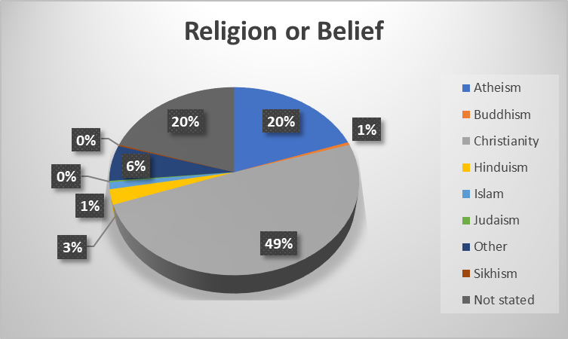

**Figure 10: Distribution of MSE employees by religion or belief**

8% of the ICB workforce stated they had a disability, with 9% recorded as ‘disability unknown’, 83% stated they did not have a disability (see figure 11).

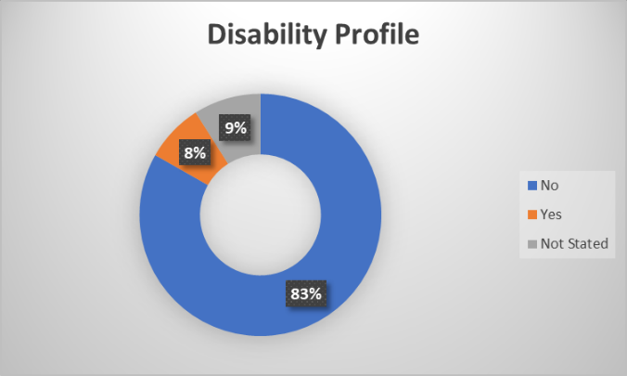

**Figure 11: Distribution of MSE employees by disability**

Supporting people to feel comfortable to declare their disabilities and religion is key to ensure that the ICB delivers effectively on our requirement to make reasonable adjustments to support our colleagues with a disability or need for support in following their faith. The ICB needs to work with staff so that everyone feels comfortable to declare whether they have a disability or not. This will ensure that anyone who has any kind of disability and requires reasonable adjustments can be supported to receive them as an employee of the ICB. The ICB needs to ensure that has truly inclusive recruitment processes and is recognised as an employer of choice for all.

60% of the workforce stated they were married, 26% stated they were single. 2% of our workforce did not provide information relating to their marriage or civil partnership (see figure 12).

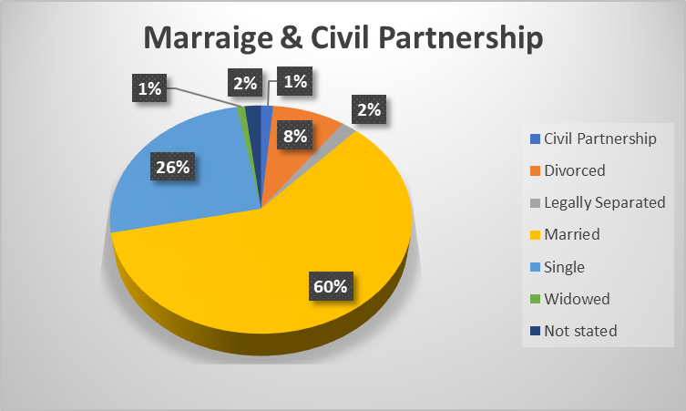

**Figure 12: Distribution of MSE employees by marriage and civil partnership**

The ICB respects individuals right to not disclose information they consider personal to them, but where this inhibits the ICBs ability to support staff with a protected characteristic, we will endeavour to understand why staff did not feel able to disclose such information and consequently what else the ICB could do to improve staff psychological safety to disclose and the ICB ability to support staff.

42% of staff who completed the 2023 staff survey declared that they have dependent children living at home for whom they care and 38% declared that they are a carer for someone with a disability or long-term condition. This is not representative of our full workforce as it was gathered from staff survey data that not all staff completed.

The ICB does not collect data on gender re-assignment or pregnancy and maternity, which includes elements such as parental leave / surrogacy / adoption etc. (which is in line with the NHS generally); which are the remaining two protected characteristics, furthermore it does not collect data on staff who are neurodiverse, but has an ambition to collect data on all protected characteristics by 2028 and to consider the impact of collecting data on the neurodiversity of its staff.

Furthermore, the ICB will look to compare its data to other ICBs across the region and to its partners within MSE to ascertain any insights to support its People Management Strategy. In the meantime, robust human resource policies exist to protect all individuals working for the ICB, but we know there is more to be done for our workforce to feel able to be open and honest about certain protected characteristics.

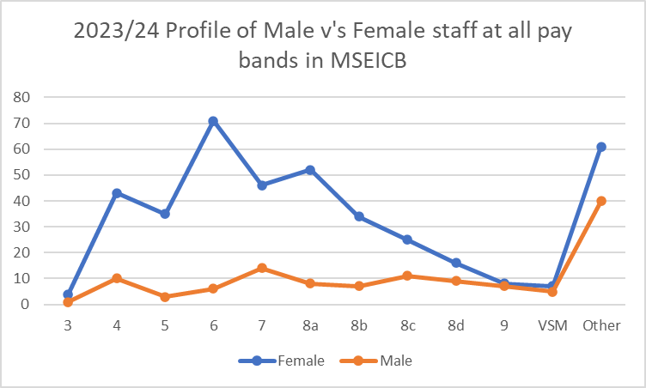

**Figure 13: Gender profile within staff bands.**

Of the senior managers within the ICB (band 8c and above), 56 were female (64%), and 32 male (36%). Data shows that overall, there are a higher proportion of men in higher banded positions in the ICB than in the lower bandings as shown in figure 13. Data further shows that women earn 10.6% less than men overall, according to the median pay gap data and 20% less than men according to the mean pay gap data. The ICB will therefore continue to monitor and take steps to address the gender pay gap (higher proportion of women paid at lower bands), as described in the detailed equality objectives from page 15.

In our endeavours to address the gender pay gap, the ICB will continue to ensure we conduct fair and equitable recruitment processes to senior posts within the ICB and all non-agenda for change pay changes are approved at the Remuneration Committee.

Annually, the ICB reports on the Workforce Race Equality Standards (WRES) the Workforce Disability Equality Standards (WDES) and the Gender Pay Gap; to comply with statutory reporting requirements and to better understand what further actions we may need to take to continue to address identified inequalities. The ICB has performed well in achieving a better representation throughout the ICB. For example, staff with a disability have an equal chance of being appointed but there remains disparity in terms of the appointment of staff from ethnically diverse backgrounds. There is also a new requirement to publish an Ethnicity Pay Gap Report. These will be reported to the ICB Board alongside a detailed action plan outlining the steps that will be undertaken to better understand equality of opportunity and ensure that the ICB takes every possible step to ensure equitable access, such as adjusting our recruitment processes to even up the likelihood of those from non-white heritage applying and being appointed to positions in the ICB.

Our latest published WRES, WDES and Pay gap reporting can be found here [Gender pay gap - Mid and South Essex Integrated Care System (ics.nhs.uk)](https://www.midandsouthessex.ics.nhs.uk/about/corporate/gender-pay-gap/) [hyperlinks]

As part of our strategy, we recognise that we can do more to interpret the data available regarding our staff and consequently, we will be looking at how we assess intersectionality; the experience of staff with more than one protected characteristic and what the ICB can do in the future to support staff in this respect.

# Our Equality Objectives

The equality objectives have been developed in accordance with the mid and south Essex Integrated Care Strategy, which is furthered by our Joint Forward Plan. The objectives are set in the context of the legislation and what we set out to achieve in our strategies as well as our role as an Integrated Care Board.

The ICB has established two overarching equality objectives reflective of its dual role as a commissioner of health services and that of an employer as follows:

1. **To ensure equitable access, excellent experience, and optimal outcomes for all by addressing unwarranted variations in our services and moving towards an integrated health and care system.**
2. **To create an inclusive environment where our staff feel valued and are actively supported to achieve their potential, recognising that our culture values diversity and listens to the voice of our teams.**

These overarching equality objectives have been distilled into further objectives linked to the three equality aims. The detailed objectives (on the next page) are set out in terms of a statement of intent, what the ICB needs to do over the next four years and what success will look like for the ICB to achieve the objectives

Woven into who we are as an ICB, the objectives are also reflected directly in two of the ICB corporate objectives:

* To reduce health inequalities across mid and south Essex including access to, experience of and outcomes of the services we provide, and
* To develop and support our workforce through compassionate leadership and inclusion, achieving significant improvement in staff survey results by March 2026.

Demonstrating ownership at all levels of the ICB we have established equality objectives for each of our Board Members summarised below:

Health Inequalities

* Championing the women’s health board.
* Improved oversight of actions to tackle health inequalities.
* Deliver awareness training to reduce inequality in access to eye health.
* EDI being a prioritised area of focus in Mental Health and Acute services.
* Raising the profile of cultural safety and trust within the primary / secondary care interface work.
* Ensuring visible leadership proactively supporting EDI.

Staff

* Chairing and supporting staff networks, engagement with community groups, and establishing an effective race equality network.
* Stretch assignments, mentoring and coaching to improve the number of ethnically diverse staff in senior roles.
* Mentorship for women from minority ethnic groups in digital health roles.
* Promoting inclusive physical and mental health and wellbeing, with a focus on male mental health.
* Oversight of and supporting HR processes that further the EDI agenda.
* Strengthening freedom to speak up.
* Create and encourage an inclusive environment at committee meetings.
* Reciprocal mentoring for non-executives.

# Detailed Equality Objectives – as an Organisation / Commissioner

| **Equality Objective** | **What does success look like** | **What we need to do** | **Link to Equality Aim** |
| --- | --- | --- | --- |
| 1a. We will develop the organisational culture and governance arrangements within MSE to support embedding the principles of equality and inclusion | Decision making within the ICB will ensure consideration of Equity and Health inequalities, with Equality and Health Inequalities Impact Assessment (EHIIA) included in all relevant processes within the ICB - including financial recovery programme and commissioning and contracting decisions from April 2025. EHIIA will aim to include engagement with those population groups potentially affected and includes each protected characteristic.  ImpactEQ, the digital EHIIA process will be implemented across the ICB by November 2025.  All relevant staff to complete Equality and Health Inequalities Impact Assessment training by March 2026. | * Board and senior managers demonstrate their commitment to promoting equality * Mature our governance arrangements to ensure there is assurance and accountability for securing equity in all that we do. * Develop robust undertaking of equality impact assessments * From publication of this strategy, Board papers will highlight health inequalities impacts and associated mitigating actions. * Establish robust governance processes for reviewing EHIIAs through the Equity and Inclusion Panel | Eliminate discrimination, harassment, victimisation, and any other conduct that is prohibited by or under this Act. |
| 1b. We will monitor and review commissioned services to ensure delivery of an equitable health and care system which seeks to address healthcare disparities and poorer outcomes. | We aim to include within all commissioned services a contractual obligation to consider and reduce gaps in inequity from April 2025.  The ICB will monitor progress against specific equality and health inequalities objectives from April 2025. | * Utilise data intelligence and insights to close gaps in inequitable experience and access * Ensure that the services are equitably commissioned, procured, designed, and delivered to meet the needs of those groups most likely to experience inequalities in access, experience, and outcomes. * Set equality performance goals and develop a measurement framework to evidence how we are progressing in addressing inequalities. | Advance equality of opportunity between persons who share a relevant protected characteristic and persons who do not share it. |
| 1c. We will work with communities as equal partners to develop local solutions and build resilient communities. | Place the voices of our communities and residents particularly those at risk of experiencing inequalities at the centre of how we design and implement services.  As an organisation we can demonstrate how the insight of our residents informs our service commissioning and delivery. | * Utilise local intelligence and community insight (including from those who are digitally excluded) to improve our understanding of the health and social needs of our residents and local communities, ensuring we are better informed of the needs of under-served groups (via focus groups, virtual views, surveys, community alliance groups, Healthwatch and VCFSE partners). * Secure ICB resources to support and sustain community engagement. * Further adoption of Virtual Views as an effective platform to hear from digitally engaged local citizens and patients to inform future services from April 2024.Public and service user engagement is built into all ICB projects, including commissioning and transformation work by March 2025. * Continue to develop local and system-wide relationships with community and VCFSE partners through our Alliance networks from April 2025. Engaging with communities where they live. * Develop and maintain the ICB insight bank to ensure accessible community insights is available to all, to support delivery of equity informed plans from April 2025. | Foster good relations between persons who share a relevant protected characteristic and persons who do not share it. |

# Detailed Equality Objectives – as an Employer

| **Equality Objective** | **What does success look like** | **What we need to do** | **Link to Equality Aim** |
| --- | --- | --- | --- |
| 2a. We will ensure all staff (including our managers and senior leaders) understand their duties and required behaviours in the workplace and have mechanisms in place for staff to raise issues safely and confidently. | Staff will report lower rates of bullying and harassment by managers or colleagues in the workplace via our annual and quarterly staff surveys. This will result in significant improvements in our staff survey results by March 2026.  We aim for mandatory training compliance to be at 75% by 2025, 85% or more by March 2028 and maintained thereafter.  The East of England Anti-Racism Strategy will be delivered by 2028 in MSE.  No bias in the number of suspensions, disciplinaries and dismissals for people with protected characteristics.  Staff report results showing that staff feel confident to speak up about issues that concern them (25% increase in first year. 40% increase from baseline by 2028).  Deliver the actions of the NHS sexual safety charter. | Provide learning opportunities and safe places through our staff networks for staff to feel confident about speaking up.  Implement the East of England Anti-Racism Strategy within MSE.  Better understand intersectionality and the impact on our staff.  Develop and deliver the 10 actions of the sexual safety charter and report to the Executive Committee and raise staff awareness.  All reported incidents of bullying and / or harassment will be investigated and managed using the ICB dignity at work and grievance policies.  Ensure that all HR processes are fair and transparent, panels are appropriately diverse and there is external scrutiny to challenge and check due process.  Make explicit the ICB work and intentions to include carers, neurodiversity, and menopause within its work alongside protected characteristics, raising awareness accordingly. | Eliminate discrimination, harassment, victimisation, and any other conduct that is prohibited by or under this Act. |
| 2b. We will ensure our recruitment processes and promotion processes both internally and externally are inclusive and accessible. | Our WRES and WDES data will show improved statistics in relation to diversity in our workforce by March 2026.  The ICB has a better understanding of neurodiversity within its workforce.  By 2028 people of all races will have an equitable experience and opportunity to be appointed to roles within the ICB.  Our goal is for 40% of staff to have completed (non-mandatory) EDI training programmes by 2026 and 60% of staff by 2028.  Number of staff registered with a mentor / coach or using reciprocal mentoring will increase to 50 by 2028.  60% of staff will have had talent conversation by 2026 and this will have increased to 85% by 2028.  60% of staff will report (in the staff survey) that the organisation acts fairly in relation to career progression by 2026 and this will have increased to 85% by 2028. | Check our language in adverts and promotional materials and adjust our recruitment processes as required (as set out in the ‘de-bias recruitment toolkit’ used across MSE).  Develop system talent pools, including stretch opportunities for staff to develop.  Provide EDI training and support programmes.  Implement succession planning and staff support.  Review and update all relevant HR Policies  Review available data and strengthen existing analysis/dashboards to support action plans to further equality and diversity among those with protected characteristics, including assessing intersectionality, and measures to address pay gaps such as recruiting more male staff into lower band, attracting younger people and supporting people to work longer where appropriate with reasonable adjustments.  Complete training on ethnic diversity in recruitment and managing diverse teams.  Produced a programme of EDI related training supplementary to mandatory training including areas such as unconscious bias, raising awareness through lived experience and build into a training needs analysis.  Ensure that our recruitment processes support individuals with neurodiversity and ensure that reasonable adjustments are made to enable successful recruitment.  To seek views of staff to better understand the profile of the ICB in terms of neurodiversity. | Advance equality of opportunity between persons who share a relevant protected characteristic and persons who do not share it. |
| 2c. We will ensure our staff networks are working together to allow for intersectionality and ensure they are fully supported and part of the ICB accountability structures. | Staff networks are well attended, and the chairs are active participants of the Inclusion and Belonging Group. Staff identifying themselves on ESR improves by 25% by 2028. | Create safe space where staff feel comfortable to bring their whole selves to work. Allow staff time to participate in the networks and the Chairs have dedicated time to undertake their work.  Maintain and further develop staff networks and collaborative working.  In addition to the networks already within our ICB we are creating new staff networks for example on neurodiversity, men’s health and for carers. | Foster good relations between persons who share a relevant protected characteristic and persons who do not share it. |

# How We Will Deliver on Our Objectives - Commissioning

Our vision is of a health and care partnership working for a better quality of life in a thriving mid and south Essex, with every resident making informed choices in a strengthened health and care system. Addressing health inequalities plays a key role in that ambition. We are doing this by understanding and then addressing the drivers of those inequalities and supporting groups to enact a culture change to how services are accessed, for example by groups who struggle to actively engage with services because of their cultural background.

**We will strengthen the organisational culture and maintain governance arrangements within MSE to support embedding the principles of equality and inclusion.**

Governance

The Population Health Improvement Board (PHIB) was established with representation from partners across the system to drive an integrated approach to inequalities improvement. It uses JSNAs and data insights to set priorities and identify health inequalities. It links to Stewardship Groups (bringing teams of health and care staff and managers together to get the best values from our shared health and care resources) via the Health Inequalities Delivery Group that reports into PHIB. The diagram below depicts the complex structure of sub-groups that drive delivery through change. PHIB therefore brings together programmes of work across health inequalities, population health management, prevention, personalised care, and anchor programme. It reports up to both the MSE Integrated Care Partnership (ICP) to bring together the work around wider determinants of health and to the Integrated Care Board to drive improvements around specific healthcare priorities (see figure 14 below).

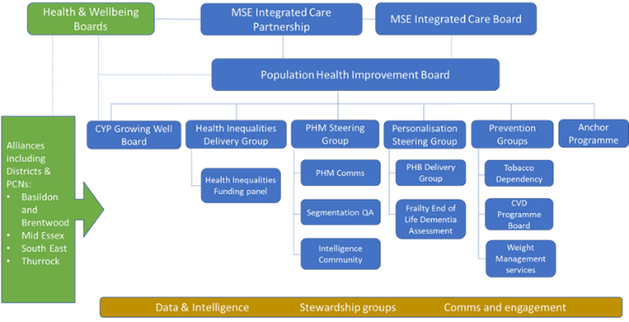

**Figure 14: Population Health Improvement Board governance and reporting**

Strategy and Framework

The Joint Forward Plan [Joint Forward Plan - Mid and South Essex Integrated Care System (ics.nhs.uk)](https://www.midandsouthessex.ics.nhs.uk/publications/joint-forward-plan/) [hyperlinks] sets out the system strategy for addressing health inequalities across mid and south Essex.

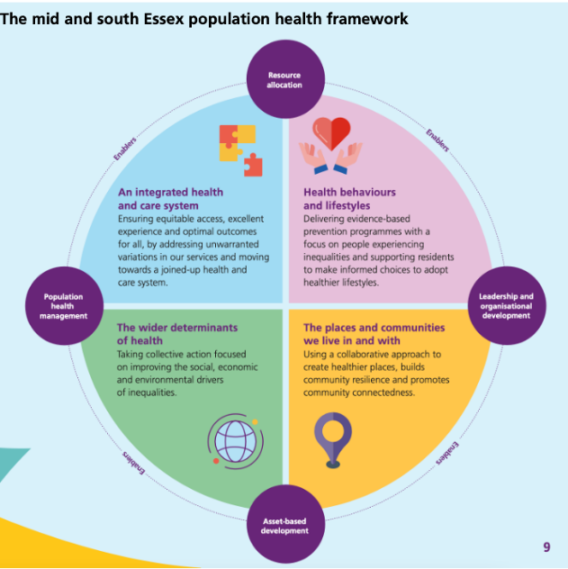This is accompanied by our population health framework which enables us to focus on delivering integrated care and reducing health inequalities. This goes further than treating ill health; moving towards a proactive, preventative model of care to address the causes of poor health outcomes and the wider socio-economic determinants of health (see figure 15 below).

**Figure 15: Mid and South Essex Population Health Framework.**

Our framework helps us ensure that each health inequalities activity, across the system, is:

* focused on a health gain for a defined group that contributes to a shared outcome in the MSE outcomes framework
* using appropriate evidence to identify the group in need, including integrated data, analytics, and intelligence (objective 1b on page 15 focusses the ICB understanding of inequalities in access, experience and outcomes).
* drawing on insight, resource, and commitment to design appropriate interventions.

The four identified enablers to drive improvements are:

1. *Resource allocation.* Developing sustainable funding strategies to address inequalities, allowing investment in transformation at a scale and intensity proportionate to the level of disadvantage.
2. *Population health management.* Accelerate the embedding of a Population Health Management (PHM) approach to help front line services understand current health and care needs and predicting what local people will need for the future.
3. *Leadership and organisational development.*  Developing human learning systems that foster a culture of shared learning and innovation, supported by infrastructure to build capacity and leadership.
4. *Asset-based development.* Working closely alongside communities, using an asset and strength-based approach to develop local solutions and build resilience.

Digital Tools

The implementation of a digital Equality and Health Inequalities Impact Assessment tool ‘ImpactEQ’ alongside organisational training and development, will enable us to ensure high quality assessment are delivered consistently. Organisational development will embed an equity first approach in how we plan and implement services; it will encourage more consistent co-designing of services with residents and engaging those from vulnerable groups.

**We will co-ordinate system planning to deliver an equitable health and care system which seeks to address healthcare disparities and poorer outcomes.**

Operational Planning Guidance

Continued implementation of the five NHSE strategic priorities for tackling health inequalities are set out in the 2024-25 Priorities and Operational Planning Guidance, explained further below:

1. ***Restoring NHS services inclusively.*** Undertaking elective waiting list data analysis by ethnicity, sex, and deprivation will support the development of effective action plans to reduce barriers to access and outcomes. Progress with this action will be reported via the MSE Elective Care Board.
2. ***Mitigating against digital exclusion.*** Ensuring access to primary, secondary and community care continues to be offered via digital, face to face and by telephone for all. Embedding the Digital Inclusion Framework with principles being adopted by all partners within the Integrated Care System (ICS) will support digital infrastructure improvements.
3. ***Ensuring datasets are complete and timely.*** Continuing to make progress on recording and reporting against protected characteristics will enable identification of gap in health inequalities.
4. ***Strengthening leadership and accountability.*** Continuing to ensure there is clear leadership, governance, and accountability for health inequalities through the PHIB reporting to ICB Board and the Integrated Care Partnership that supports the delivery of reductions in health inequalities across all levels with the system.
5. ***Accelerating preventative programmes.*** MSE ICB will continue to accelerate prevention programmes, that includes a major focus on prevention and early intervention across the wider determinants of health, as set via national targets or NHS England funded programmes, through the following actions:

* Improving early cancer diagnosis aiming for 75% of cases diagnosed at stage 1 or 2 by 2028. A focus will be maintained on increasing screening uptake in those groups known to be underrepresented.
* Improving the health outcomes of those with serious mental health illness (SMI) by increasing the uptake and quality of annual SMI health checks.
* Achieving at least 75% uptake of annual Learning Disability (LD) health checks with corresponding health action plans.
* Increasing Flu, Covid and Pneumonia vaccination rates in those groups likely to have poorer uptakes and experience poorer respiratory outcomes. Including increasing vaccination uptake for children and young people year on year towards the World Health Organisation (WHO) recommended levels.
* Increasing referrals into local authority commissioned smoking, weight management and alcohol cessation and other lifestyle and behavioural support programmes.
* Increasing referrals into the nationally commissioned digital weight management programmes and diabetes prevention programmes to support reducing cardiovascular risk, particularly for those most deprived quintiles of the MSE population.
* Supporting people to stop smoking, including through implementing opt-out treatment for patients in hospital and as part of maternity pathways.

Local work on ‘narrowing the gap’

Our work on health inequalities is guided by the national NHS CORE20 PLUS5 frameworks (see figures 16 and 17). Narrowing the gap in health inequalities in our most deprived communities is a priority for all our four Alliance partnerships (Basildon & Brentwood, Mid Essex, South East Essex and Thurrock).

Each Alliance has tailored their approach and focused on specific areas, groups or conditions based on the needs of their local populations and the engagement work undertaken with their communities.

The CORE20PLUS5 frameworks set out five clinical priorities for adults (maternity, serious mental illness, respiratory, cancer and hypertension) and five for children and young people (asthma, diabetes, epilepsy, oral health, and mental health).

A number of core initiatives around cardiovascular disease, smoking cessation and tackling obesity will become enablers for us delivering against the CORE20PLUS5 frameworks.

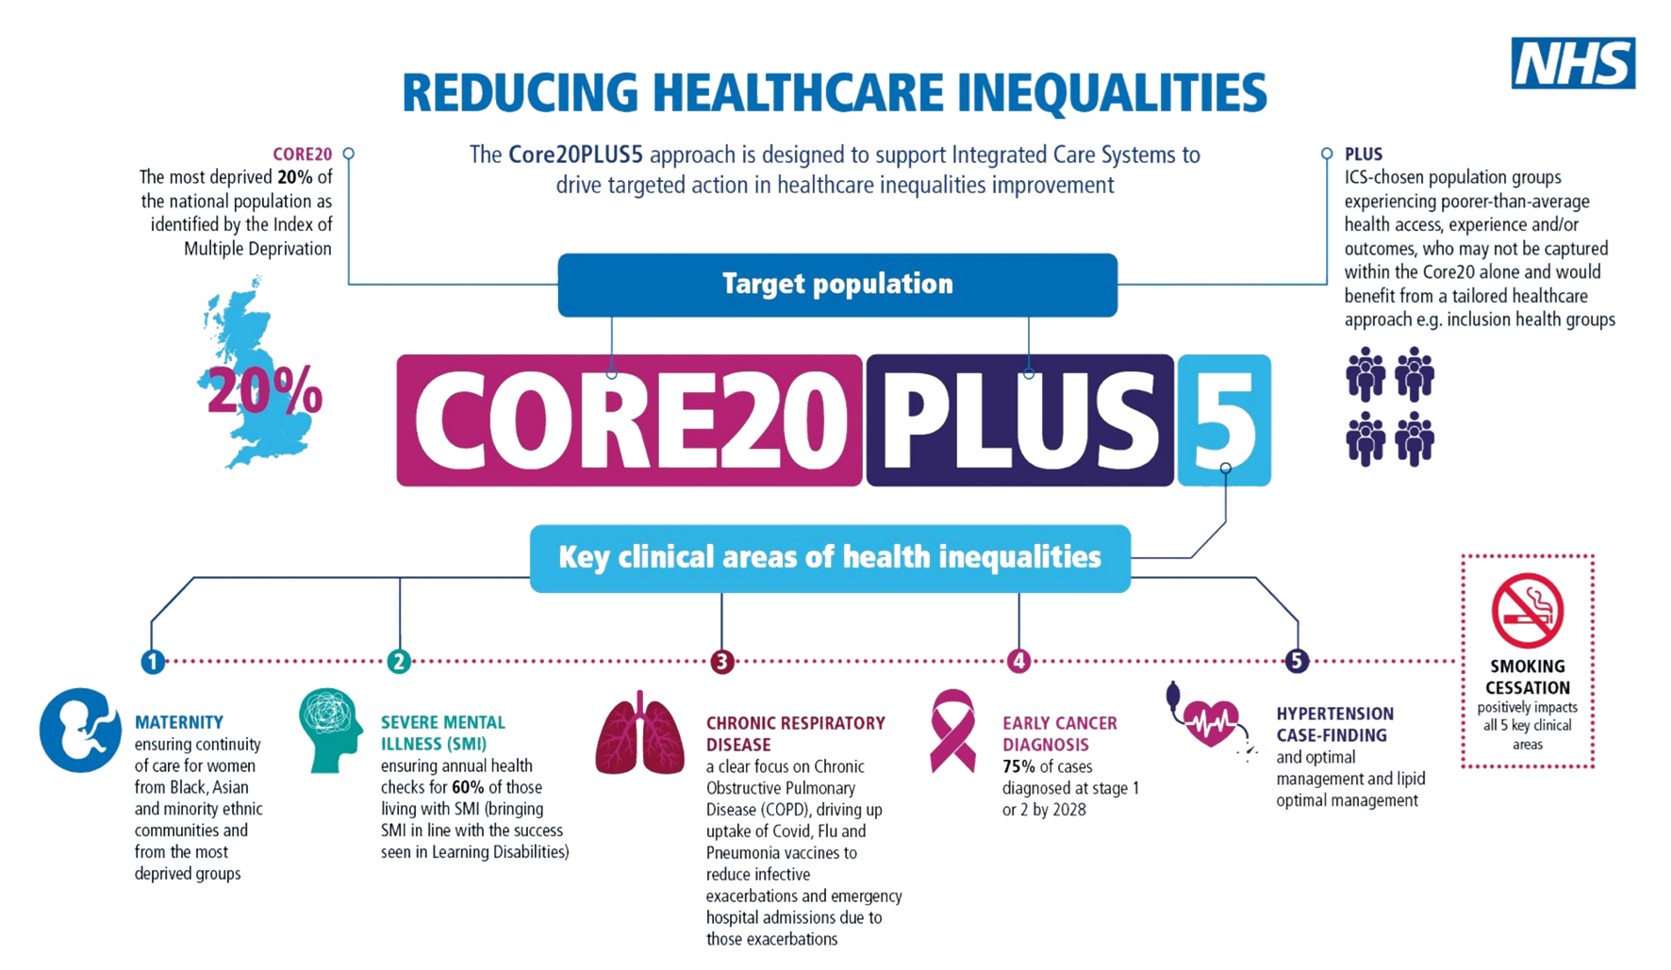

**Figure 16: CORE20 PLUS5 framework for adults in MSE**

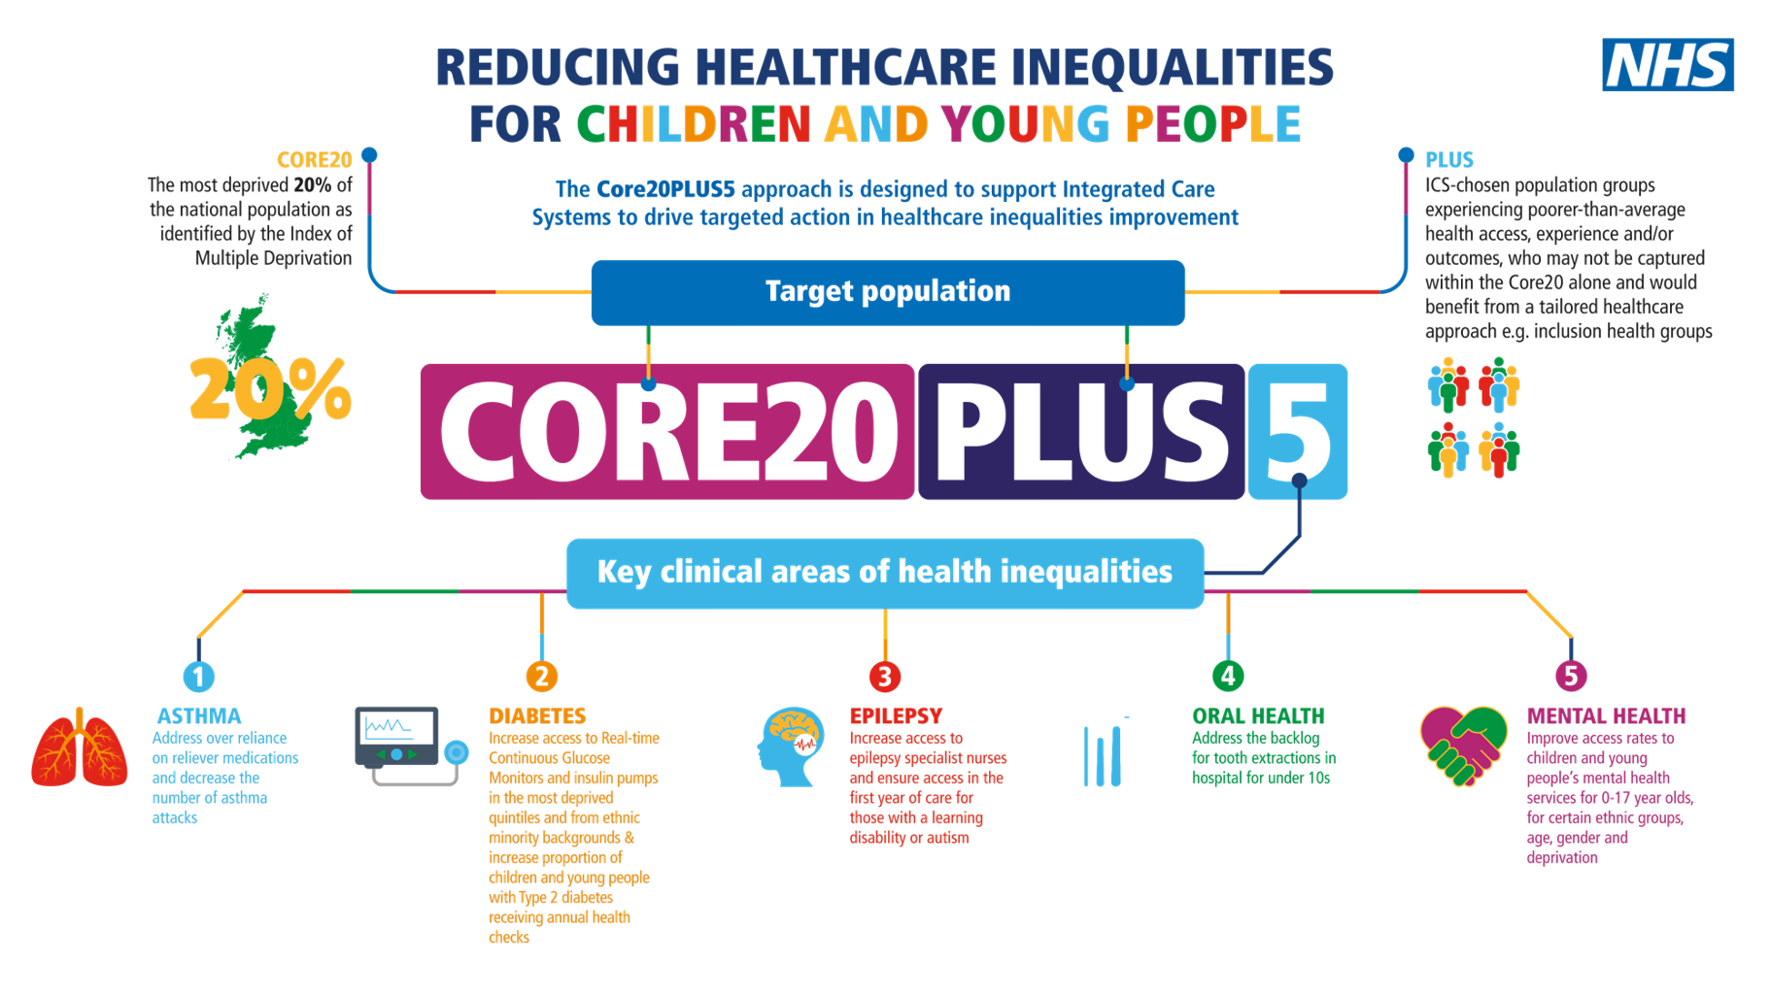

**Figure 17: CORE20 PLUS5 framework for children and young people in MSE**

The **CVD Prevention** programme has been identified as a system priority, with a focus on delivering improvements in hypertension and lipid management.

The ICB work collaboratively with partners towards the ICS commitment of a Smokefree 2030. This includes the launch of **tobacco cessation** programme for inpatient services and pregnant women.

**Tackling increasing rates of overweight and obesity** by taking a system wide approach that includes increasing access to Tier 2 weight management services, tackling the obesogenic environment and supporting children and young people to make health food choices.

**We will work with communities as equal partners to develop local solutions and build resilient communities.**

Our ‘Working with people and communities’ strategy continues to be the foundation of our engagement work to involve the public in developing NHS services. We will continue to deliver two of the core ICB duties of delivering improved services and reducing health inequalities by involving the public, particularly those from groups who experience worse health outcomes, have limited access to care and generally experience poorer quality of care.

**MSE Virtual Views**

Following the launch of our digital engagement platform MSE Virtual Views in November 2023, this web-based platform has developed our approach to public engagement and consultation. It features interactive capabilities like forums, polls, and workshops, accommodating both digital and face-to-face engagement. The platform's analytics enable us to craft engagement strategies that reflect the diverse makeup of our communities.

There is also a function for the participant to choose which language they would like it in, helping us reach those communities where English is not their first language.

Virtual Views allows us not only to target populations via postcode data, but those with specific disclosed health conditions, if they are a carer, or a member of staff for example. We also encourage people who sign up to provide their demographic characteristics, age, ethnicity, the more information provided the better targeted and more suitable our engagement can be.

Virtual Views will continue to play a large part in reaching out to those seldom heard groups so that we can continue to have more targeted conversations.

**Research Engagement Network (REN)**

We established the MSE REN in November 2023 to improve access to health and social care research to underserved groups. By focusing on marginalised groups, the REN project promotes research practices that effectively address health inequalities. Funding from NHS England has enabled us to train and support 18 community champions and their Voluntary, Community, Faith, and Social Enterprise (VCFSE) groups. These champions can now support engagement activity within their communities.

We are planning to expand the number of communities we engage with to include Chinese, Jewish, Eastern European and Gypsy, Roma, and Traveller (GRT) community, as well as expand our outreach into the LGBTQ+ community.

Our four Alliance partnerships (Basildon & Brentwood, Mid Essex, South East Essex, and Thurrock) have a collective purpose to help local people in their own communities and neighbourhoods by developing and championing cross sector collaboration to help transform our approach to the delivery of health and care.  We recognise that inequalities are often rooted in unique cultural and environmental causes within communities and neighbourhoods, and by engaging directly with people and communities we can understand their specific needs.  Working with local partners, approaches to joint working in our neighbourhoods are emerging, creating new and sustainable solutions which are truly reflective of the diverse communities they serve.

Health Inequalities funding has been delegated to each Alliance for local prioritisation, this funding opportunity targeted at the Faith, Voluntary, Community and Social Enterprise Sector endorses the adoption of a multi-year approach to support the development of a rolling programme of locally shaped projects.  Each Alliance has identified a ‘trusted partner’ to manage and administer their Health inequalities funding, ensuring that funding is used effectively and efficiently to meet local needs, fostering transparency, trust, and delivery of the CORE20PLUS5 programmes.

PLUS groups are defined as those locally identified population groups who experience poorer access, experience, and outcomes. Our priority is to better engage and mature our data and intelligence which will allow us to co-design services which are more equitable and answer the needs of our identified PLUS groups. The ICB PHM team are developing local data and insight for the ‘PLUS’ groups within MSE to identify areas of greatest need and best practice interventions. Maturing of the ICB Insight Bank will support programs in accessible insight to PLUS groups to inform planning.

The MSE ICB has committed £3.4 million each year to reduce health inequalities. In each alliance, we are working through trusted partners – either community and voluntary sector infrastructure organisations or local councils – to identify and support projects that narrow the gap in health inequalities. Our funding is focused on the most deprived communities, PLUS groups, clinical priority areas or priority lifestyle behaviours such as smoking and weight management. The aim is to test new, innovative, and collaborative approaches to addressing the underlying causes of health inequalities.

# How We Will Deliver on Our Objectives - Workforce

Through a sense of belonging, we aim to create an inclusive culture which encourages different perspectives and celebrates diversity. The ICB has developed its approach to EDIB in line with the NHS People Plan, NHS People Promise, its corporate objectives and similar plans established for the ICS.

Our approach is therefore consistent with and reflects the NHS EDI Improvement Plan introduced by NHS England in June 2023, which underpins and supports the NHS Long Term Workforce Plan. The improvement plan and indeed this strategy aims to:

* Address discrimination
* Increase accountability of all leaders
* Support the levelling up agenda
* Make opportunities for progression equitable.

This section outlines the governance, strategies, processes and reporting mechanisms in place to deliver our equality objectives for workforce.

Governance

The People Board (a sub-committee of the ICB Board) has representation from the ICB and wider system partners; it has oversight of how we achieve our workforce objectives; as an ICB and system. Sub-groups have been tasked with ensuring the objectives are delivered as shown in figure 18 (page 29).

The ICB website includes the terms of reference of the People Board and the minutes of the meetings are presented to the Board (which are also publicly available within ICB Board papers)

The Executive Committee also reports to the ICB Board and is responsible for oversight of the EDI Objectives.

The ICB has embedded and continues to strengthen inclusion as one of the key principles that runs through everything we do. To begin that journey, the Executive Committee has established a framework of staff networks (figure 19, overleaf), which will help to provide a safe space for colleagues from under-represented groups, as well as developing allies for these groups. The Executive Chief Nursing Officer chairs the ICB Inclusion and Belonging Steering Group to provide a mechanism for the steering groups to provide and link and feed back to the Executive Committee and the ICB Board. Further networks will be developed as we progress on our journey; advised by the steering group who will also revisit the effectiveness of the networks and the support they provide to staff.

At the heart of the workforce objectives is the ambition to become an employer of choice, creating an organisation culture that attracts and retains our workforce.

Strategy and Key Programmes of Work

The **People Management Strategy**, approved by the ICB Board in May 2024 is underpinned by a relevant and accessible set of HR policies and procedures that all embed a culture of EDI. It is centred around supporting four strategic pillars:

1. Culture and Leadership
2. Talent Management and Succession Planning
3. Recruitment and Retention, and
4. Data

The ‘what we need to do’ actions set out within the EDI objectives (page 15) ensure that we are taking actions to strengthen each of the strategic pillars to attract and retain our workforce as an employer of choice.

The ICB has signed up to the **sexual safety at work charter** and is implementing actions to comply fully with the charter.

Our commitment to delivering the **Anti-racism strategy** involves a programme of work to fully deliver the commitments set out by NHS England.

The ICB approach to delivering a programme of work on the **High Impact Actions** set by NHS England is provided in more detail on page 31.

Organisational Development

The ICB Organisational Development Plan sets out how we will achieve this and the key metrics for monitoring progress that are reported to the Executive Committee.

We want to create a working environment where colleagues feel comfortable and empowered to bring their whole selves to work, as this is how our workforce can deliver the very best to the population we service. We are committed to challenging discrimination and want the ICB to be a great place to work for all staff to feel they belong and are equally valued.

The ICB continues to strengthen its processes around Freedom to Speak Up and Allyship.

The Freedom to Speak Up (FTSU) Guardian (Non-Executive Board Member and Audit Committee Chair) is supported by FTSU Champions across the ICB and is linked into the Inclusion and Belonging Steering Group. Monitoring disclosures to the FTSU Guardian and the responses to the Staff Survey and Pulse surveys, the ICB can ensure that staff have avenues they can use to speak up and call out any poor behaviour that affects them and consequently is not reflective of ICB Values.

The ICB staff networks promote and encourage allyship and are supported by a structured programme of how to become an ally and the impact of the programme, which is set out on the ICB intranet ‘connect’.

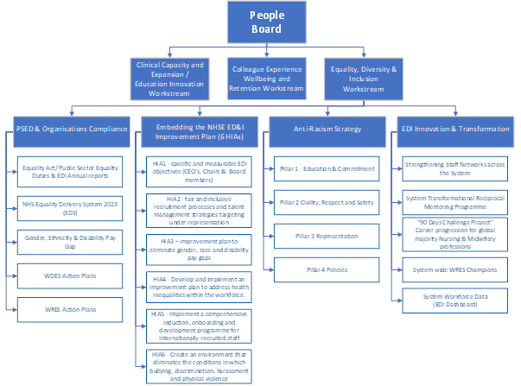

**Figure 18: People Board governance structure.**

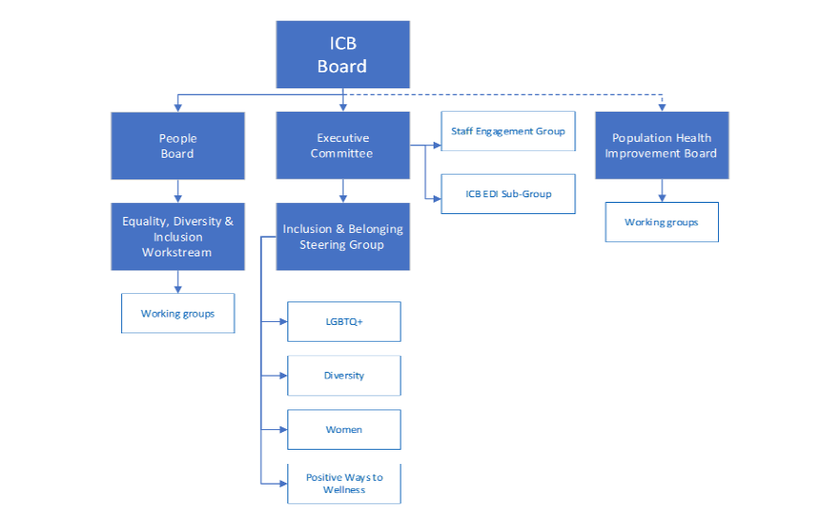

**Figure 19: ICB EDI Governance and Staff Networks**

Culture



**Figure 20: MSE ICB Organisational Values**

The culture of our organisation starts with our organisational values (see figure 20).

Our organisational values and expected behaviours each ensure that we have an inclusive workforce with a sense of belonging that promotes diversity and equality. The values are embedded through our recruitment, induction, and retention processes, how we conduct ourselves, and through our system of performance management and development.

The motivation and well-being of our staff is central to our ability to deliver our corporate and EDI objectives, and the level of recovery required across our system to meet our statutory and constitutional duties. This is measured by the annual staff survey, quarterly pulse surveys, our compliance with mandatory training, our ability to pro-actively manage our talent pool, succession planning and career development.

The 2024 staff survey results [[National results across the NHS in England | NHS Staff Survey (nhsstaffsurveys.com)](https://www.nhsstaffsurveys.com/results/national-results/)] reflected a period of significant organisational change and showed that we have a long journey ahead to become the organisation we want to be. We therefore must focus on equality, diversity and inclusion and use our staff networks to understand what this should look like going forward.

NHS England - Six High Impact Actions

In June 2023, NHS England published the *NHS equality, diversity, and inclusion improvement plan.* The Plan reflected on available data and the asks of the NHS People Plan and People Promise to support the 1.3 million people who work in the NHS and presented six high-impact actions to support equality, diversity, and inclusion. The ICB is committed to delivering these actions:

1. Chief executives, chairs and board members must have specific and measurable EDI objectives to which they will be individually and collectively accountable.
2. Embed fair and inclusive recruitment processes and talent management strategies that target under-representation and lack of diversity.
3. Develop and implement an improvement plan to eliminate pay gaps.
4. Develop and implement an improvement plan to address health inequalities within the workforce.
5. Implement a comprehensive induction, onboarding, and development programme for internationally recruited staff.
6. Create an environment that eliminates the conditions in which bullying, discrimination, harassment and physical violence at work occur.​

We have already made progress in implementing the actions that will be monitored by the Executive Committee and the ICB Board, for example page 14 references the objectives for our Board members. We have also developed reporting dashboards to monitor continued performance and achievement of the actions in accordance with NHS England guidance.

Mandatory Reporting

In 2014, the NHS Equality and Diversity Council announced actions to ensure that employees from ethnically diverse backgrounds had equal access to career opportunities and receive fair treatment in the workplace. Thus, in April 2015 the WRES became a mandatory requirement, followed by the WDES, and GPG reporting and recently (2024) an Ethnicity Pay Gap report.

Each year the ICB completes assessments and publishes the results of the WRES, WDES and GPG alongside action plans to improve performance against the standards in the coming year. Compliance with these standards is included within this strategy to further the development of EDIB within the ICB.

Alongside those standards, NHS organisations (including the ICB and NHS Trusts within mid and south Essex) use the NHS Equality Delivery System 2022 (EDS2). This enables discussion with local partners including local populations, to review and improve performance for people with protected characteristics to deliver the requirements of the PSED.

EDS2 is aligned to NHS England’s Long-Term Plan and its commitment to an inclusive NHS that is fair and accessible to all. It consists of three domains:

* **Domain 1:** Commissioned or provided services
* **Domain 2:** Workforce health and well-being
* **Domain 3:** Inclusive leadership

The ICB, Mid and South Essex NHS Foundation Trust (MSEFT) and Essex Partnership University NHS Foundation Trust (EPUT) work together to assess three services each year (on a cyclical basis). As a group, services are reviewed with patients, public, staff networks, community groups and trade unions, to review and develop our approach in addressing health inequalities through the three domains. The outcome of the assessment and resulting plans are reported to the ICB and Trust Boards and published on our websites [Equality Delivery System 2022 Report for 2023/24 - Mid and South Essex Integrated Care System](https://www.midandsouthessex.ics.nhs.uk/publications/equality-delivery-system-2022-report-for-2023-24/) [hyperlinks].

# How We Will Track Progress on Our Objectives

Working Groups

Within the governance sections of this strategy, we outlined working groups tasked with ensuring our programmes of work to deliver our objectives are achieved. Each working group will track and monitor progress against action plans and report back through the Executive Committee and PHIB where delays or risks to delivery are identified.

The existing staff networks (Staff Engagement Group; LGBTQ+; Diversity; Women; and Positive Ways to Wellness, alongside groups being developed for example for neurodiversity), will also oversee and hold to account the ICB for delivering on this strategy via the ICB Including and Belonging Steering Group (a sub-group of the Executive Committee).

Maturity assessments and mapping the delivery of actions

Through the NHS England [East of England] EDI maturity matrix, the ICB has assessed itself against three key areas of: compliance, the high impact actions, and the anti-racism strategy. This provides an in-depth understanding of how mature the ICB is and a mechanism to track its progress.

A detailed action plan has been established to guide the ICB through its journey of development. Updates of our progress are reported to the ICB Inclusion and Belonging Steering Group.

Reporting

The ICB will track progress on implementation across the actions it has committed to and how that work is contributing to our equality objectives through:

1. Reporting to the PHIB and the ICB Board on Health Inequalities objectives through:

* Updates on Health Inequalities provided to the ICB Board (bi-annually)
* Health Inequalities Information Statement (annual)

1. Reporting to the Executive Committee and ICB Board on workforce objectives through:

* Staff pulse surveys (quarterly)
* NHS staff survey (annual)
* WRES, WDES and EDS2 reporting (annual)
* Snapshot report on six high-impact actions (annual)

1. Annual review of progress against the strategy reported to the ICB Board.

Policy

The EDIB Policy, HR Policies and a suite of associated policies sit alongside this strategy to define the mechanisms by which the ICB complies with the Equalities Act and associated legislation and guidance. Each policy is assigned a sponsoring committee who has oversight of and monitors compliance with the policy.

Engagement & Awareness

The ICB will engage staff through established networks, lunch and learn sessions, through communications channels such as ‘connect’, staff briefings, and via training to raise awareness of the EDI agenda within the ICB and how we are progressing in implementing the various aspects of the strategy.

Culture

The Board will work with senior managers to improve visibility and organisation culture, tracking, scrutinising and monitoring progress against our actions and keeping a sense check on the culture of the ICB.

Oversight

The audit committee also has oversight of the EDI agenda and will receive updates on progress with various aspects of EDI compliance and progress with delivering the strategy. For example, the audit committee will receive reports from the Freedom to Speak Up Guardian on issues raised by staff (as outlined in the ICB Whistleblowing Policy).

Working within the MSE ‘system’

The ICB will continue to work with our regional and local colleagues within the MSE ICS to better understand how we hold each other to account and deliver on the need to address inequalities and create and inclusive culture. The ICB EDIB strategy supports this journey and how we work with our colleagues, but collectively we need to ensure we are all pulling in the same direction.

An invitation to challenge

All staff members are encouraged to participate in the delivery of the EDIB Strategy and to hold themselves and others to account through line management, joining staff networks or through speak up initiatives.

All staff members are also welcome to become EDI Champions for any aspect of the EDI agenda to assist in holding the Executive and ICB Board to account for performance against our EDI objectives. Either a representative of HR or the governance team can guide you in becoming a champion.

**Glossary**

| Acronym | Definition |
| --- | --- |
| The ‘Act’ | Meaning the Equality Act 2010 |
| COPD | Chronic Obstructive Pulmonary Disease |
| CORE20 PLUS5 | Meaning the Core 20 Plus 5 national frameworks for narrowing the gap in health inequalities. |
| CVD | Cardiovascular Disease |
| EDI | Equality, Diversity and Inclusion |
| EDIB | Equality, Diversity, Inclusion and Belonging |
| EDS2 | Equality Delivery System 2022 |
| EHRC | Equality and Human Rights Commission |
| EPUT | Essex Partnership University NHS Foundation Trust |
| Global Majority | Is the collective term for people of Indigenous, African, Asian, or Latin American descent who constitute approximately 85% of the global population. It is increasingly used to replace language such as Black, Asian, Minority Ethnic (BAME). |
| GPG | Gender Pay Gap |
| GRT | Gypsy, Roma, and Traveller community |
| ICB | Integrated Care Board |
| ICP | Integrated Care Partnership |
| ICS | Integrated Care System |
| ImpactEQ | Meaning the digital platform where Equality Impact Assessments are undertaken and recorded. |
| Intersectionality | Refers to the interconnectedness of social categories, such as race, gender, class, sexuality and ability, all of which shape an individual’s experiences and opportunities. |
| JSNA | Joint Strategic Needs Assessment. JSNAs look at the current and future health and care needs of local populations to inform and guide the planning and commissioning (buying) of health, well-being and social care services within a local authority area. |
| LD | Learning Disability |
| LGBTQ+ | Lesbian, Gay, Bisexual, Transgender, queer or questioning or another diverse gender identity |
| MASI | Mortality attributable to socioeconomic inequality [EXPLAIN WHAT THIS ACTUALLY MEANS] |
| MSE | Mid and South Essex |
| MSEFT | Mid and South Essex NHS Foundation Trust |
| NEM | Non-Executive Member of the ICB Board |
| PHIB | Population Health Improvement Board |
| PHM | Population Health Management |
| PSED | Public Sector Equality Duty |
| REN | Research Engagement Network |
| SED | Specific Equality Duties |
| SMI | Serious Mental Health Illness |
| VCFSE | Voluntary, Community, Faith, and Social Enterprise |
| WDES | Workforce Disability Equality Standards |
| WHO | World Health Organisation |
| WRES | Workforce Race Equality Standards |