Accessing the Shared Care Record via Cleo Core System Single Sign On: a quick reference guide

## Introduction

### Purpose of the guide

This guide explains how to access the Mid and South Essex Shared Care Record via Cleo Core system.

### Target audience

Professionals who use the Cleo Core system.

### Prerequisites and requirements

Access to the Cleo Core system and the record displayed will always be that of the patient that you are currently viewing in the clinical system.

### About access to the Shared Care Record

Access to the Shared Care Record is granted via single sign-on when you are signed into your own records system. This means that you do not need any additional login details and will only be able to view the Shared Care Record for the person whose record you are currently viewing.

If you encounter any issues accessing the Shared Care Record, please contact your IT service desk in the usual way.

***Please note that the record shown is a test patient and does not contain any personal identifiable information.***

## Step-by-step instructions

### Launch the Cleo Core application and log in.

### The default view upon logging in is a list of all the cases on the CLEO dashboard:

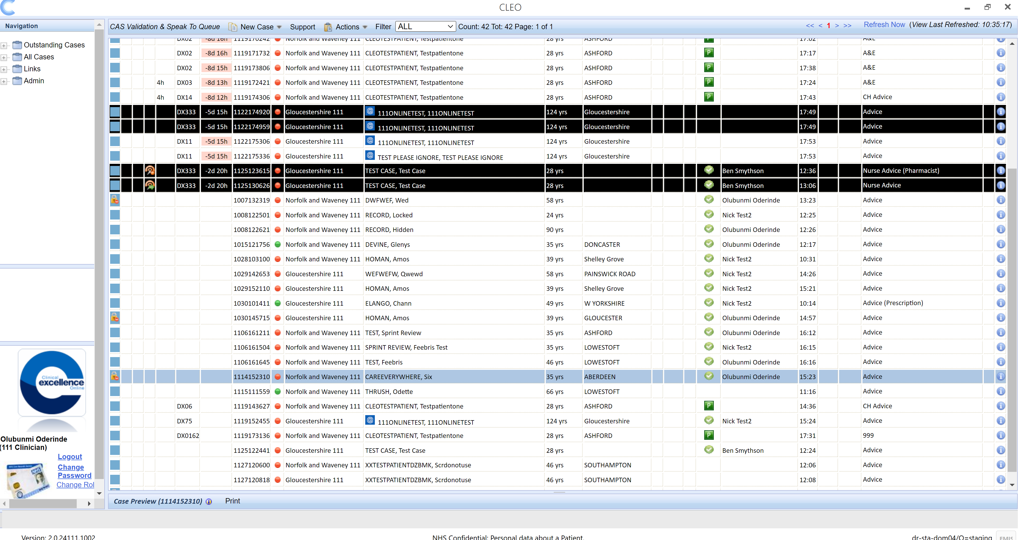

### Select the patient from the list that you wish to view:

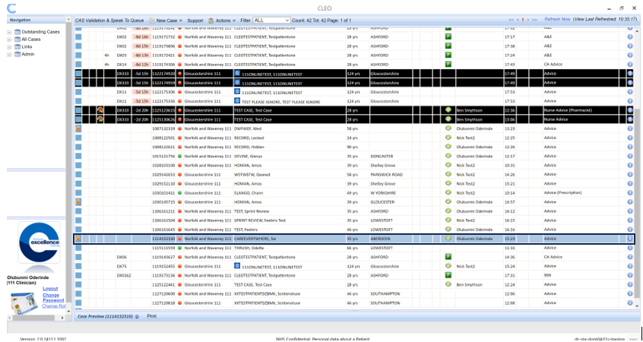

### Click on the Mid and South Essex Shared Care Record label in the patient’s case.

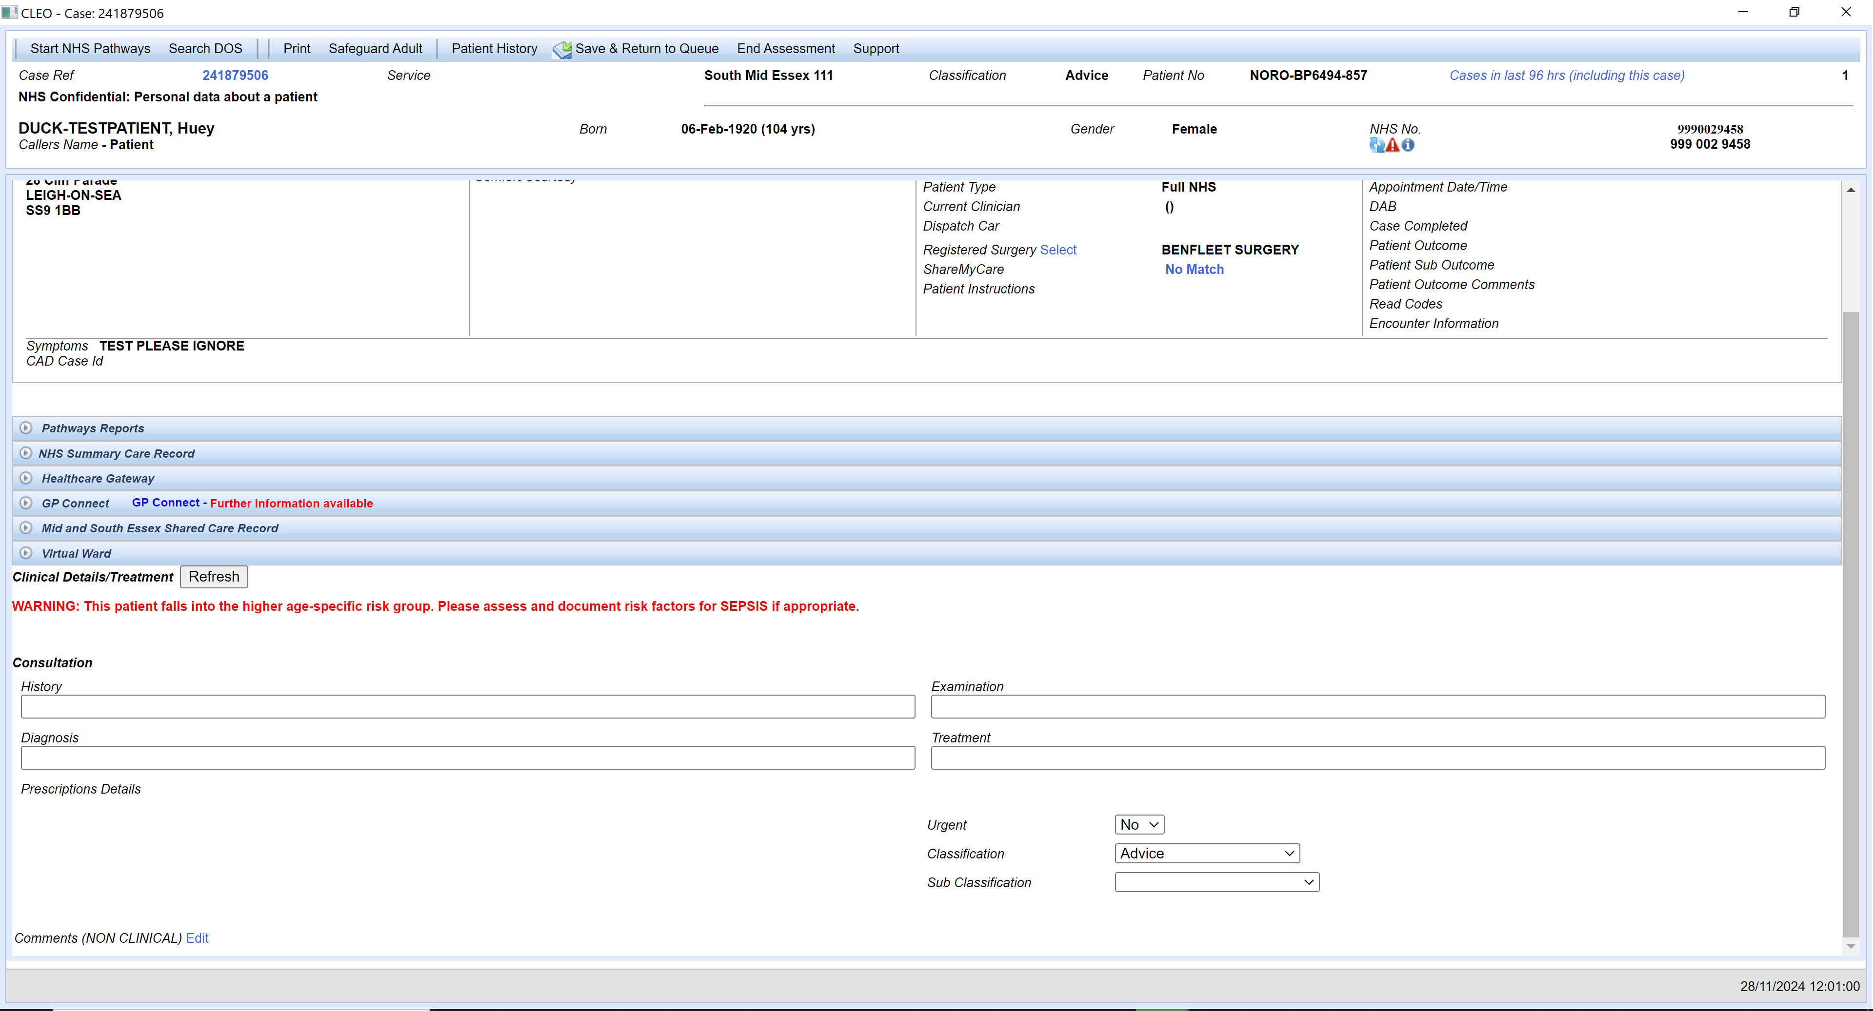

### The person’s shared care record will be displayed.

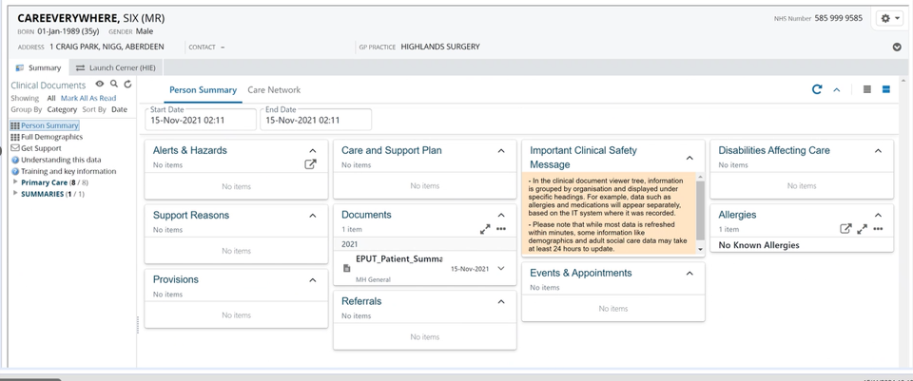

## Launching the Cerner Health Information Exchange (HIE)

### Load an individual’s record in the Shared Care Record.

### Select the Launch Cerner (HIE) option next to the summary tab.

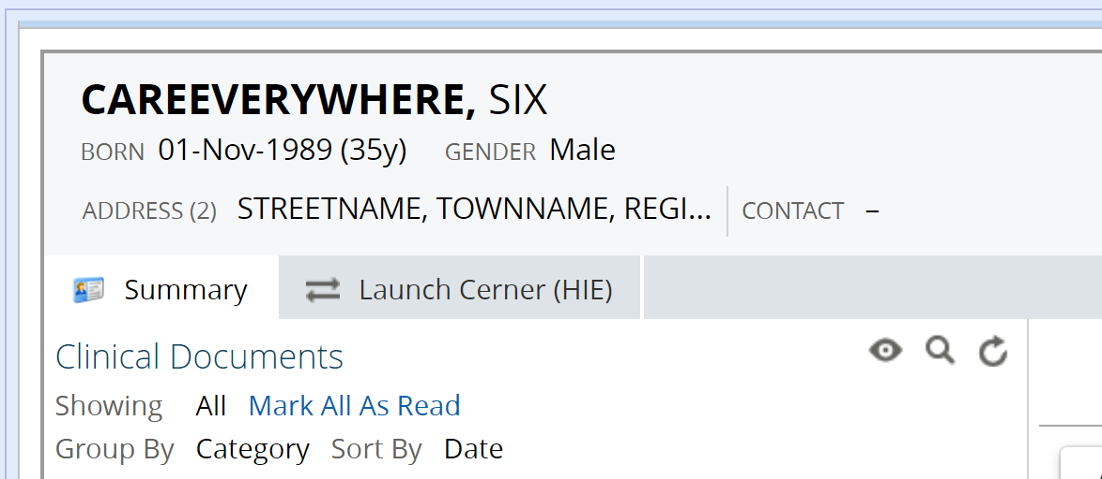

### The Suffolk and North East Essex Cerner Health Information Exchange (HIE) system is launched for the patient in context.

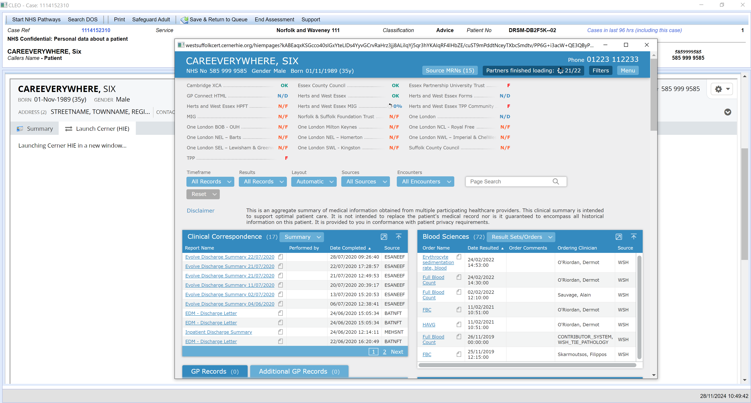

## Additional resources

* **Further information:** <https://midandsouthessex.ics.nhs.uk/sharedcarerecord>
* **Contact information for feedback:** [mse.sharedcarerecord@nhs.net](mailto:mse.sharedcarerecord@nhs.net)