**Electronic Palliative Care Coordination System (EPaCCS) Guidance for professionals**

The **Electronic Palliative Care Coordination System (EPaCCS) registers** aim to ensure that any professional has access to the most up to date information for people nearing the end of life.

## Why do we have EPaCCS registers and how can they help?

At their core, the main purpose of EPaCCS is to **improve the quality of care for people near the end of life**. The registers achieve this by making sure that the person’s needs, wishes, and preferences are properly recorded and easily accessed by professionals involved in their care.

As data sharing platforms, EPaCCS increase the visibility of people with palliative and end of life care (PEoLC) needs. They allow for valuable information about a person’s care needs and wishes to be **shared across multiple organisations**, whether it is a care home, primary care, a community service, or emergency services.

People that benefit most from EPaCCS are those within their last year(s) of life. As they are living with a severe, life-limiting condition, they are likely to have contact with multiple care providers. Having their **personal choices, priorities and goals for care** recorded and easily accessible means they can get the most appropriate care in line with their wishes. The information recorded might include details like current palliative medication being taken, preferred place for care and personal decisions on resuscitation.

Having access to this information helps professionals improve the end-of-life experiences of people in their care. It can help **prevent delays** in care or **avoid unplanned and unwanted urgent care or hospital admission,** and it helps ensure patients’ wishes are respected.

The information recorded on EPaCCS can also be updated at any time and any stage. Preferences and choices can be met early on in a person’s diagnosis and can be adapted to better suit their condition later as it changes with time. This respects a person’s preferences, priorities and personal care choices are relevant at all stages of an illness.

**Principles of good End of life care delivery and benefits of EPaCCS platforms are described here:**

**Identification & Planning**

1. To identify and recognise people likely to be within their last 12 months of life
2. To inform people thought to be within the last 12 months of life and their families of the likelihood of death within the next 12 months sensitively and honestly
3. To elicit and record people's preferences for care during the last 12 months of life
4. To ensure people's preferences for care are accessible to all parts of the health and social care system/end of life care system

**Delivery**

1. All teams are aware of and respect people's preferences for care during the last 12 months of their life
2. To treat people at end of life as individuals, with dignity, compassion, and empathy
3. To control pain and manage symptoms for people during the last 12 months of life
4. To minimise inappropriate/unwanted & futile medical interventions during the last 12 months of people's life
5. To ensure that people at end of life have equitable access to flexible 24/7 end-of-life care services, irrespective of the place of care of the organisation/s providing care
6. To provide support to the families and other carers during and after their loved one's end of life

Please use the following links below for further information on EPaCCS

**EPaCCS guidance**

What are our EPaCCS registers?

Who to consider should be on the register?

Which Professionals can add to the register?

How to add to the register?

[Frequently Asked Questions](#_Frequently_Asked_Questions:(FAQs))

## What are our three local EPaCCS registers here in Mid & South Essex?

We have three electronic Palliative Care Coordination System One (EPaCCS) registers here in mid and south Essex aligned to three geographical regions:

1. **A South-East Essex (SEE) EPaCCS register (hosted by Essex Partnership University Trust) covering residents living in South- East Essex (Southend, Castle Point Rayleigh & Rochford).**
2. **A South-West Essex (SWE) EPaCCS register (hosted by St Lukes Hospice) covering residents living in Basildon, Brentwood & Thurrock.**
3. **A Mid Essex (Mid E) EPaCCS register (hosted by PROVIDE) covering residents living in the Mid Essex area** (*newly launched since March 2024*).

All three registers function the same way and are:

* **Fully integrated** (held in SystmOne) with the following patient record systems used in mid and south Essex:
  + GP practices
  + community provider and community hospital teams
  + community dementia teams
  + 111 Clinical Assessment Service (CAS) teams
  + local hospice provider electronic patient record systems, with read and write access to patient records.
* Available to other care settings and providers including **acute hospital** and **emergency care**.
* Able to provide End of Life (EoL) performance reporting at **Population Health level**. This allows for a system-wide view of our end-of-life care performance, enabling us to drive continuous learning and quality improvement for all teams and providers in our health and social care system.

Each of our EPaCCS register platforms provide easier visibility of people to any team that may access the SystmOne record (in any provider). Professionals can access details of:

* a person’s choices or wishes
* any key documents that may be in place (such as Advance Care Plans - ACP)
* any advanced decisions such as DNACPR status
* A person’s stated preferences for place of care and place of death.

In this way, professionals across multiple teams can better respond to a person’s needs at the **right time and in the right place.** This helps with making for the higher quality, more efficient and more appropriate decisions relevant to the person that respect their choices and their preferred priorities for care.

These features of EPaCCS allow for better coordination of care that is more seamless and efficient between teams. Better coordination between teams allows us to better meet various and often changing needs that more commonly arise in patients near the end of life.

## Who should be on an EPaCCS register:

Our three EPaCCS registers here in mid and south Essex are for adults with **any life-limiting condition(s) or illness(es) who are deemed more likely to be nearing End of life**. This includes any person with life limiting/ incurable progressive diseases, including frailty and dementia. Other people that can be added to the register include those with complex, or highly unstable conditions or patients expressing clear choices and priorities for their care for any reason.

EPaCCS is not necessarily time bound to the final year of living. We all know the last year of life is hard to distinguish and a lot of patients want to plan end of life care in their final years of living. This can help to both live well but also to meet their wishes for how they will die.

EPaCCS should therefore be created at a time that benefits, and respects the person’s wishes, goals, and priorities.

All adult people who wish to record their end-of-life wishes should be encouraged to be on the EPaCCS platform so all health professionals involved with their care can access key information. Ideally people should be uploaded to the EPaCCS register platform at the earliest opportunity.

## Which professionals/staff groups can add a person to an EPaCCS register?

**All professionals/staff across all providers in mid and south Essex can add a person to an EPaCCS register, including**:

* The three acute hospital sites of MSEFT,
* Primary care, community provider nursing and therapies integrated teams
* Community dementia teams, mental health teams,
* Community hospitals, hospices, out of hours 111 providers, emergency services
* Social care professionals and domiciliary care providers including care homes.

*Please note that adding a person to the EPaCCS register is different from a referral to a palliative care service for management.*

In general, any appropriate professional who has had a relationship with the person can add them to the EPaCCS register. The professional adding details to the register will need to be aware of the person’s:

* medical care
* choices for care
* personal priorities/goals

Those professionals responsible for referring a person to the EPaCCS should work in partnership with the person, their next of kin and their named advocates as appropriate.

## How can I add a patient to an EPaCCS register?

### For SystmOne users

You can add a person via a direct referral in SystmOne to the specific EPaCCS register based on where the person is currently living:

* The EPUT EPaCCS register for residents in South-East Essex
* The St Luke’s EPaCCS register for residents in the Basildon Brentwood or Thurrock areas
* The Provide EPaCCS register for residents living in Mid Essex

Many direct quick referral links have already been built into pre-existing SystmOne assessment templates that multiple providers have access to. For example, FrEDA (Frailty End of Life Dementia Assessment SystmOne care coordination template) has a quick referral button to your local EPaCCS register on the End-of-life page and within the electronic referral pages.

Staff in MSEFT Specialist Palliative Care Teams should use their specific Palliative Care SystmOne template which has the quick referral button to all three EPaCCS registers.

### Non-SystmOne users

If you do not have access to SystmOne – then you can add a person to a register by email:

1. South East Essex (EPUT): - [communitypalliative.careservices@nhs.net](mailto:communitypalliative.careservices@nhs.net)
2. Basildon, Brentwood, and Thurrock (St Luke’s): - [stlukes.oneresponse@nhs.net](mailto:stlukes.oneresponse@nhs.net)
3. Mid Essex (Provide): – [provide.ccc@nhs.net](mailto:provide.ccc@nhs.net)

## Procedure for professional /staff roles when adding a person to EPaCCS

1. **Explain to the person the benefits of EPaCCs.** Set out how being added to the register will allow any health professional to access information about their choices, wishes and goals for care. Explain how this information will allow health professionals to better priorities and consider care options best in line with the details recorded on the register.

N.B. *Provision of a MSE EPaCCS leaflet is currently being developed and will be available on the MSE ICB website.*

1. **Add key information on the nature of the person’s life limiting condition(s)**. For example, do they have dementia, frailty, heart failure, respiratory disease, cancer etc.
2. **Include information on the person’s preferences**. At this point you can add any information you have on the personal preferences, choices, and goals of the person. This can include:
   * preferred place of care
   * preferred place of death
   * DNACPR status
   * if an Advance Care Plan ACP (PEACE) document is in place and current estimated GSF (Gold Standard Framework) stage status.

## What will appear on the record after adding someone to an EPaCCS register:

The example below shows how this information appears on the home screen of the person SystmOne record. This information comes under high priority reminders for quicker and easier visibility so that any professional can see it when they open the person’s record. Seeing this denotes that a person is already on an EPaCCS SystmOne register platform.

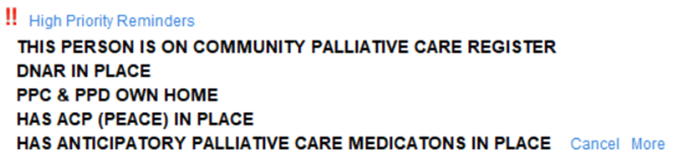

## Frequently Asked Questions:(FAQs)

### If I add someone to the register, does this make a referral to a specific service or team?

**NO –** adding someone to an EPaCCS register is different from referring to a specific team or service. It is simply improving visibility of people’s choices and goals to any teams involved in their care. If you also need to refer to specialist palliative care teams, you can still do this in the usual way as before for your local area.

**South-East Essex** –EPUT Specialist Palliative care nursing teams or services from Havens Hospice

**Mid Essex-** Farleigh Hospice specialist Palliative care teams or services

**South West Essex** (BB & Thurrock) - St Luke’s Hospice Specialist palliative care team or services

1. **I am a professional who uses SystmOne, and I often see this prompt appearing. What does this mean?**

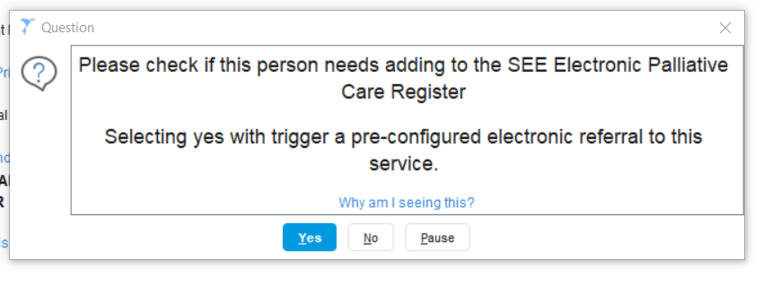

This is an auto-prompt that will appear if you enter data that indicates a person may benefit from being added to an EPaCCS register. For example, if you are adding information on preferred place of care or death, the above prompt should appear.

The prompt will only appear for people who are not already on the EPaCCS register. It can be dismissed (by clicking ‘*No’*) if the professional feels appropriate- but it can be a helpful reminder for staff to consider the benefits of adding the person to the register. Clicking ‘*Yes’* takes you to the EPaCCS register, where it will take just a few seconds to add the person.

### How long will a person remain on the EPaCCS register platform?

A person will usually remain on the EPaCCS register for the rest of their life. The person will should only be removed if they:

* if they die
* move permanently out of the mid and south Essex ICS area
* later choose not to have any part of their health records shared

### Who can access this information about the person?

**Only professionals who are involved in the delivery of care to the person or may become involved in the person’s care, can see this information.**

It is important to highlight that the information visible is no different to how health professionals already view SystmOne records. The register simply makes it easier to instantly view the person’s needs, choices, and preferences.

On the other hand, if they are not on the register, the staff who are caring for them may not see this information as easily. As a result, the person may not get the care that they want. It can also be more challenging for staff responding to needs to coordinate care more efficiently and in line with the person’s wishes.

**Glossary**

|  |  |
| --- | --- |
| **Term** | **Explanation** |
| **PEACE** | Proactive enhanced advance care plan |
| **PEoLC** | Palliative end of life care |
| **EoL** | End of life |
| **PPC** | Preferred place of care |
| **PPD** | Preferred place of death |
| **ACP** | Advance Care Plan |
| **CAS** | Clinical Assessment Service |
| **DNACPR** | Do not attempt cardiopulmonary resuscitation |
| **NOK** | Next of kin |
| **FrEDA** | Frailty End of Life Dementia Assessment |
| **PROVIDE** | PROVIDE Community Interest Company (CIC) |
| **EPUT** | Essex Partnership University Trust |
| **MSE** | Mid and South Essex |
| **MSEFT** | Mid and South Essex NHS Foundation Trust |
| **PCNS** | Primary Care Networks |
| **GSF** | Gold Standard Framework for palliative care |