Decision Making Policy and Procedure

Document Control:
Document Control Information | Details
Policy Name | Decision Making Policy and Procedure
Policy Number | MSEICB 088
Version | 1.0
Status | Final
Author / Lead | Michelle Angell / Nicola Adams
Responsible Executive Director | Director of Resources
Responsible Committee | Finance & Investment Committee
Date Ratified by Responsible Committee | 14 September 2023
Date Approved by ICB Board/Effective Date | 28 September 2023
Next Review Date | September 2025
Target Audience | All MSE ICB Staff
Stakeholders engaged in development of Policy (internal and external) | - Executive Team  - Finance & Investment Committee
Impact Assessments Undertaken  (State if not applicable) | - Equality and Health Inequalities Impact Assessment

Version History
Version | Date | Author (Name and Title) | Summary of amendments made
0.1 | 15/06/2023 | Michelle Angell, Portfolio Director, MSEP, ICB | First draft
0.2 | 15/06/23 | Karen Wesson, Interim Oversight and Assurance Director | Amendments included
0.4 | 21/06/23 | Linda Moncur, Director of Nursing for Safeguarding, ICB | Amendments included
0.4 | 28/06/23 | Janette Joshi, Deputy Director of System Healthcare Purchases  Jenny Davis, Commercial Director, MSEFT | Amendments included
0.5 | 13/07/23 | Nicola Adams, Deputy Director of  Maggie Pacini, Consultant in Public Health | Amendment included – Policy and Procedure
0.6-0.9 | 11/08/23 | Nicola Adams, Deputy Director of Governance and Risk | Amendments included
0.10 | 12/09/23 | ICB Executive Team | Amendments included
0.11 | 14/09/23 | Finance and Investment Committee | Amendments included
1.0 | 28/09/23 | ICB Board | Final version approved.

Contents

1. Introduction 6
2. Purpose / Policy Statement 6
3. Scope 7
4. Definitions 7
5. Roles and Responsibilities 8
5.1. Integrated Care Board (‘the Board') 8
5.2. Chief Executive Officer 8
5.3. ICB Executive Team 8
5.4. ICB Senior Leadership Team (SLT) 8
5.5. Finance and Investment Committee 9
5.6. The Quality Committee 9
5.7. Primary Care Commissioning Committee (PCCC) 9
5.8. Clinical and Multiple-Professional Congress (CLiMP) 9
5.9. System Transformation and Investment Group (STIG) 10
5.10. Stewardship Groups 10
5.11. Central Programme Management Office (CPMO) 10
5.12. System Financial Recovery Working Group 10
5.13. Investment and Disinvestment Committee (IDC) 11
5.14. Chief Executive Officers’ Forum 11
5.15. Director of Resources 11
5.16. Chief Nurse 12
5.17. Identified Operational Lead 12
5.18. Policy Authors 12
5.19. Governance Lead 13
5.20. Line Managers 13
5.21. All Staff 13
6. Policy / Procedure Detail 13
6.1. Commissioned Services 13
Principles of Decision Making 14
6.2. The ICB Planning Cycle 14
6.3. Collaborative Commissioning 16
6.4. Record Keeping 16
6.5. Prioritisation Framework 16
6.6. Prioritisation Criteria 17
Decision-Making 17
6.7. Stages of decision-making 17
6.8. Stage 1 - Planning and Gateway 0 17
6.9. Stage 2 - Business Case Development 18
6.10. Stage 3 - Formal Approval 19
6.11. Stage 4 - Monitoring, Review and Validation 19
6.12. Principles of the Decision-Making Process 19
Decommissioning and Disinvestment 19
6.13. Reasons for decommissioning or disinvesting. 19
6.14. Decommissioning / Disinvestment Principles 20
6.15. Criteria for disinvestment / decommissioning 21
6.16. The Decommissioning or Disinvestment process 21
6.17. Appeals Process 23
6.18. Assessment of Impact 23
6.19. Decommissioning / Disinvestment Assessment 24
7. Monitoring Compliance 24
8. Staff Training 24
9. Arrangements for Review 25
10. Associated Policies, Guidance and Documents 25
11. References 25
12. Equality and Health Inequalities Impact Assessment 25
13. Appendices 25
Appendix A - Equality and Health Inequalities Impact Assessment (EHIIA) 26
Appendix B – Decision Making Flowcharts 28
Appendix C – Decommissioning Process Flow Chart 31
Appendix D – Decommissioning / Disinvestment Assessment 32
Appendix E - Contract Review Checklist 34
Appendix F – Prioritisation Framework 36
Appendix G – Role of Committees in Decision Making 39
Appendix H – Business Case Checklist 41

Introduction

The Mid and South Essex Integrated Care Board (ICB), as part of the Integrated Care System (ICS) receives a fixed budget from NHS England to enable it to fulfil its statutory functions, duties and the health aspect of the Integrated Care Strategy set by the Integrated Care Partnership (ICP). The ICB has a statutory responsibility to maintain financial balance and, as part of discharging this obligation, must decide how and where finite local resources are allocated.

The need for health care is always greater than the resources available to a society to meet demand. Therefore, it is evident that it will not be possible for the ICB to commission all the health care that is needed or wanted by the population it serves and, as a result, it will need to prioritise its commissioning intentions based on the needs of the local population.

In carrying out these functions, the ICB will act with a view to securing health services that are provided in a way which promotes the NHS Constitution among patients, staff, and members of the public. Patients have a right to expect that the ICB will assess and prioritise the health requirements of the local community and commission the services to meet those needs as considered necessary.

Those with the responsibility for health care budgets must make decisions about priorities at three levels: when developing strategic plans (the main priorities), when deciding year on year which investment and disinvestments to make, and at the individual patient level.

The Decision-Making Policy and Procedure is to be applied when making both clinical and non-clinical (e.g., IT) decisions.

The ICB will ensure that procurement decisions in relation to our clinical services are fully informed and based on health outcomes data by utilising all reliable data sources combined with population health data and clinical analysis.

Purpose / Policy Statement

The purpose of this policy is to set out an ethical framework that underpins and applies to the priority setting processes required to enable the ICB to discharge its statutory functions within the financial envelope it is set by NHS England. In particular, providing the basis for decision-making in:
- The development of strategic plans for individual services
- making investment and disinvestment decisions during the annual commissioning cycle
- making in-year decisions about service developments or disinvestments
- management of restricted services, including individual funding requests.

The purpose of setting out the principles and considerations to guide priority setting is to:
- provide a coherent framework for decision-making (both investments, disinvestments, and decommissioning).
- promote fairness and consistency in decision-making.
- ensure that there is a clear and comprehensive rationale for decisions.
- enable the ICB to discharge its functions and deliver the health aspects of the strategy set by the ICP in a safe, fair and transparent manner.

Decommissioning and investment decisions impact on patients and providers therefore requires a formal process, which provides an evidence trail and ratification by a decision-making authority in the face of potential appeals and legal challenge by an affected party. This policy therefore sets out the governance process for decision-making as well as the evaluation criteria used when appraising investment and disinvestment cases.

Scope

This policy and procedure applies to all staff working within MSE Integrated Care Board and covers all contractual agreements utilised by the ICB.

Definitions

For the purpose of this policy the following definitions have been applied:
• Investment: Funding allocated to support service provision across MSE ICS.

- Commissioning: Commissioning is the continual process of planning, agreeing, and monitoring services. Commissioning is not one action but many, ranging from the health-needs assessment for a population, through the clinically based design of patient pathways, to service specification and contract negotiation or procurement, with continuous quality assessment.
There is no single geography across which all services should be commissioned: some local services can be designed and secured for a population of a few thousand, while for rare disorders, services need to be considered and secured nationally.
- Decommissioning: This relates to the withdrawal of funding from a provider organisation that is subsequently re-commissioned in a different format.
• Disinvestment: This relates to the withdrawal of funding from a provider organisation and the subsequent stopping of the service.

In the event that decommissioning, or disinvestment is proposed, the ICB recognises that a number of steps will be required prior to a final decision being taken by the ICB Board. These include consideration as to whether a consultation exercise is required with partner organisations, patients, public and the Health Overview and Scrutiny Committees.

Roles and Responsibilities

Integrated Care Board (‘the Board')
    - The Board retains overarching responsibility for decision-making and sets out is framework for delegating authority for the approval of decisions within the Scheme of Reservation and Delegation
    - The Board will oversee the approval of all investment /disinvestment decisions over £5,000,001 within existing agreed budgets and over £2,500,000 where there is no budgetary provision. The scrutiny of such proposals will generally be held in public, for which supporting papers will be available on the ICB’s website. The ICB Constitution sets out provision for meetings to be held ‘in camera’ where there is a legal requirement to uphold confidentiality, or it is not in the public interest to discuss in a public meeting.
    - The Board is also responsible for ensuring the ICB meets its statutory responsibilities such as involving and engaging with the public over decision-making within the ICB.

Chief Executive Officer
    - As set out in the Scheme of Reservation and Delegation the Chief Executive Officer can approve business cases up to the value of £1,000,000 within existing agreed budgets and between £100,001 and £250,000 with no budgetary provision.
    - Business cases <£250,000 can be approved by the Executive Director identified as the Senior Responsible Officer for the programme.

ICB Executive Team
    - The ICB Executive Team are responsible for the delivery of ICB objectives, including performance, quality, and financial plans. It will delegate activities, tasks, and mitigations of risks to the SLT and receive escalations and responses from SLT in respect of business case proposals.
    - The Executive Team must be sighted and ‘support’ all ideas/projects recommended by the SLT prior to them progressing through to business case development and formal approval.
    - All proposals will need to have and ICB Executive sponsor in order to progress through decision-making.

ICB Senior Leadership Team (SLT)
    - The SLT functions as the operational “engine room” of the ICB. All expenditure exceeding £50k must be ‘supported’ by the SLT before proceeding to any formal approval stages.
    - The SLT includes representatives from Executive Officer direct line reports from all Directorates across ICB, providing insight and guidance to the development of ICB business and achievement of ICB objectives. As such, the SLT facilitates operational delivery as directed by the ICB Executive Team.
    - SLT contributes to the decision-making process by ensuring that any projects/ideas include consideration of all aspects for which the ICB are responsible (i.e. clinical, quality and corporate governance).

Finance and Investment Committee
    - The Finance and Investment Committee will approve all investment / disinvestment decisions between £1,000,000 and £5,000,000 within existing agreed budgets and £250,000 and £2,500,000 where there is no existing budgetary provision.
    - The Finance and Investment Committee is the sponsoring committee responsible for monitoring compliance with the Decision-Making Policy.

The Quality Committee
    - The Quality Committee is responsible for overseeing continued improvement in the quality of services, quality governance and oversight of Equality/Health Inequality Impact Assessments e.g., in support of business cases, ensuring they are adequately governed.
    - The Quality Committee will be made aware of all investment / decommissioning / disinvestment proposals that impact upon clinical services and seek assurance that all concerns have been addressed prior to approval.

Primary Care Commissioning Committee (PCCC)
    - The PCCC is the decision making committee in relation to the ICB’s delegated functions for Primary Care (GP, Pharmaceutical, Ophthalmic and Dental services). Approval of core contractual investments (including Primary Care estate) will be presented to the PCCC for approval in accordance with the ICB Scheme of Reservation and Delegation, and be escalated accordingly where the financial envelope exceeds the authority of PCCC (i.e. exceeding £1,000,000).

Clinical and Multiple-Professional Congress (CLiMP)
    - The Clinical and Multiple-Professional Congress is an advisory Committee responsible for driving the identification and delivery of transformation programmes across the ICS; providing clinical and professional scrutiny; acting as a sounding board of multi professionals across health and care sectors; providing clinical advice to major investment and disinvestment cases and amendments to the Procedure of Limited Clinical Effectiveness (POLCE).
    - All ideas/proposals with a clinical impact should be scrutinised by the CLiMP, or an appropriate clinical expert, who will ensure that decisions are clinically sound, and any resulting impact of service changed identified in impact assessments are appropriately mitigated or managed.

System Transformation and Investment Group (STIG)
    - The STIG provides a gateway for transformation programmes (Business Cases requiring approval of the Finance & Investment Committee or investments that have cross-system implications). The group ensures that there is strategic alignment, cross system outcomes and benefits realisation.
    - Although there is similar representation on the STIG compared to the System Financial Recovery Working Group, the STIG has a more strategic rather that operational / functional role.

Stewardship Groups
    - Stewardship Groups bring together small teams of frontline health and care staff and managers to collaborate as ‘stewards’ using their different perspectives, skills, and knowledge alongside population-level data, to take a fresh look at the value delivered from our shared resources.
    - Stewardship Groups are aligned around ‘care areas’ such as cancer care or stroke and through their innovative work may propose ideas, projects, or changes in care pathways, that will be processed through this policy.
    - Additionally, ideas generated from other forums; impacting on care areas will need to be routed to the Stewardship Groups to ensure there is a cohesive approach to new ways of working for the benefit of our residents.

Central Programme Management Office (CPMO)
    - The CPMO will ensure that all investment / disinvestment proposals have complied with the necessary governance requirements e.g., completed, and approved Equality Health Inequalities Impact Assessment, Quality Impact Assessment, Data Protection Impact Assessment and Digital Technology Assessment Criteria (DTAC) where relevant, prior to submission to the SFRG.
    - The CPMO will maintain a central registry of ideas/proposals as well as projects in progress.

System Financial Recovery Working Group
    - The System Financial Recovery Working Group is responsible for ensuring a collaborative approach to decision making. It will ensure that decisions are in the best interest of the system as a whole and contribute to financial recovery, whilst ensuring that sovereign organisations continue to operate in accordance with their statutory duties. The group will bring together the ICB with system partners to ensure that system partners are sighted on proposals and contribute to ‘system ownership’ in the best interests of our residents. The group will review all proposals for investment/disinvestment/decommissioning, including all relevant Impact Assessments to inform decisions as to whether a project should proceed through ‘gateway 0’ as an idea/project that should progress to formal consideration for approval.

Investment and Disinvestment Committee (IDC)
    - The Investment and Disinvestment Committee will guide the commissioning cycle of the ICB, considering the strategic direction of decision making across the ICB. It will meet twice per annum. Firstly, in March, to consider and guide how commissioning proposals meet the needs of the ICB operational plans. Secondly, in September to consider any in-year changes that reflect the changing needs of residents and regulators.
    - The role of this Committee is to ensure that:
  - Proposals are not considered in silo. A holistic overview will provide a consistent approach to decision-making ensuring that all decisions fully support the achievement of system priorities within the overall financial envelope.
  - Decision-making is fair and equitable throughout the commissioning cycle.
  - The diversion of funds to treatments which are of low priority are prevented, as all cases are considered equitably against the funding available.
  - Investment and disinvestment cases are reviewed alongside population health analytics to ensure that the needs of our population are met.
  - The health economy and local communities are sufficiently aware of or consider opportunity costs.
  - The failure to address disinvestment and redirection of resources is mitigated.
  - Clinical and public engagement is at the centre of ICB planning processes.
    - Formal decision-making groups will check that the IDC has supported the direction of commissioning decisions and where this is not the case (i.e. investment and disinvestment case proposals fall outside of this planning cycle) will be submitted for system-wide review to the Financial Recovery Working Group, prior to the Chief Executive Officers’ Forum, who will act as the IDC where urgent decision making is required that cannot wait until the mid-cycle IDC review.

Chief Executive Officers’ Forum
    - The Chief Executive Officers’ Forum is a meeting of Chief Executive Officers from system Partners who together are accountable for performance improvement across the system.
    - Each Chief Executive Officer is responsible for a portfolio of work to address specific areas of priority e.g. workforce. Together they will act as the IDC where urgent decisions are required and therefore must support decisions that fall outside of the planning cycle for them to progress to formal approval.

Director of Resources
    - The Director of Resources is responsible for ensuring systems are in place to deliver the financial duties of the ICB. Including establishing the annual budget and budget management processes. As such the Director of Resources is responsible for making sure that financial decision-making within the ICB is robust; consequently, they are the Executive Sponsor for this policy.
    - They are also responsible for the development of the Capital Resource Use Plan for approval by the Board and reporting how the ICB has exercised its functions in accordance with the Plan within the Annual Report.
    - As set out in the Scheme of Reservation and Delegation the Director of Resources can approve business cases up to the value of £1,000,000 within existing agreed budgets and between £100,001 and £250,000 with no budgetary provision.

Chief Nurse
    - The Chief Nurse is the Executive Director responsible for ensuring that the required quality and patient safety considerations have been undertaken prior to any investment / decommissioning / disinvestment in a clinical service.
    - The Chief Nurse is the lead Executive Officer ensuring appropriate advice and explanations are provided to the Quality and Safety Committee.

Identified Operational Lead
    - The Operational Lead responsible for the service is required to undertake the following actions when considering investment / disinvestment / decommissioning of a service:
  - Follow the decision-making policy, ensuring that all advice, engagement and due process is followed in progressing a decision and that approvals are sought in accordance with the Scheme of Reservation and Delegation.
  - Seek advice of the governance team to navigate decision-making processes.
  - Be pro-active within the commissioning cycle to ensure that the IDC is sighted on proposals.
  - Develop robust business cases in line with the Decision-Making Policy.
  - Secure legal advice through our legal framework where appropriate.
  - Establish a robust benefits realisation process to assess the potential and realisable benefits to improve the effectiveness of the service.
  - Inform the CPMO and the relevant department of the benefits identified and plan with them how to obtain valid evidence of positive progress.
  - Review, with the CPMO, the monitoring of the benefits realised.
  - Undertake impact analysis assessments.
  - Keep a risk log of issues identified.
  - Prepare a case to be considered by the relevant Committee in respect of investment / disinvestment / decommissioning of a service.
  - Notify the provider of the 10-day appeals process (see point 6.17 below).

Policy Authors
    - The Policy Author and the Quality Committee is responsible for:
  - ensuring that all key stakeholders have been consulted in the development of this policy, adhering to ICB governance arrangements.
  - ensuring that all staff are aware of the purpose and aims of this policy and that the appropriate governance arrangements are in place to support compliance.

Governance Lead
    - The ICB Governance Lead is responsible for ensuring that this policy remains up to date and included within the suite of policies and procedures communicated to all ICB staff.

Line Managers
    - All line managers are responsible for ensuring that their staff are aware of this policy and that this is adhered to when making any investment / decommissioning / disinvestment decisions.

All Staff
    - All ICB staff are responsible for adhering to the content of this policy.

Policy / Procedure Detail

Commissioned Services
    - The ICB commissions services for our population in Primary Care (including GP, Pharmacy, Optometry and Dental services), in our community, in mental health services and in our acute hospitals. There are services the ICB does not commission, which remain the responsibility of NHS England, such as some specialised services.
    - In some cases, the ICB must make the difficult decision to ‘not’ commission a service or only commission a service in certain circumstances. These services are therefore subject to a ‘Service Restriction Policy’ that describes the circumstances under which that service might or might not be provided.
    - Healthcare and the needs of our patients are sometimes complex and exceptional. It is the responsibility of the ICB to ensure consideration is given to those circumstances when making decisions and therefore has established an ‘Individual Funding Request (IFR) Policy’.
    - Both the Service Restriction and Individual Funding Request Policies support the decision-making process within the ICB but sit outside the domain of this policy.
    - There are circumstances in which the ICB may change a previous decision to commission a service; to either decommission or disinvest in a service for example:
  - Where a service is not clinically effective and other services exist to serve the needs of the population, the ICB may disinvest in the service.
  - Where the quality of services of a provider does not meet the standards required of the ICB the service may be decommissioned.
  - Where the innovative work of our Stewardship and other Groups suggests that there may be more benefit from changing the way a service is provided.
  - Where, due to financial constraints, the ICB can no longer afford to provide a service, that is then moved to a ‘restricted service’ or a services that is no longer provided at all (a non-commissioned service).
    - The decommissioning and disinvestment process is subject to this decision-making policy and is described in more detail from section 6.13.

Principles of Decision Making

The ICB Planning Cycle
    - The ICB is responsible for developing a plan for meeting the health needs of our residents (as set out in the Integrated Care Strategy established by the ICP), managing the NHS budget and arranging for the provision of health services in a geographical area. Nationally, the expectation is that the ICB will:
  - Improve outcomes in population health and healthcare.
  - Tackle inequalities in outcomes, experience, and access.
  - Enhance productivity and value for money.
  - Help the NHS support boarder social and economic development.
    - The ICB planning cycle puts patients and the public at the heart of what we do and is the framework that underpins how the ICB will achieve those national expectations, the asks of the Integrated Care Strategy and the collective ambitions and shared commitments of our partners across mid and south Essex.
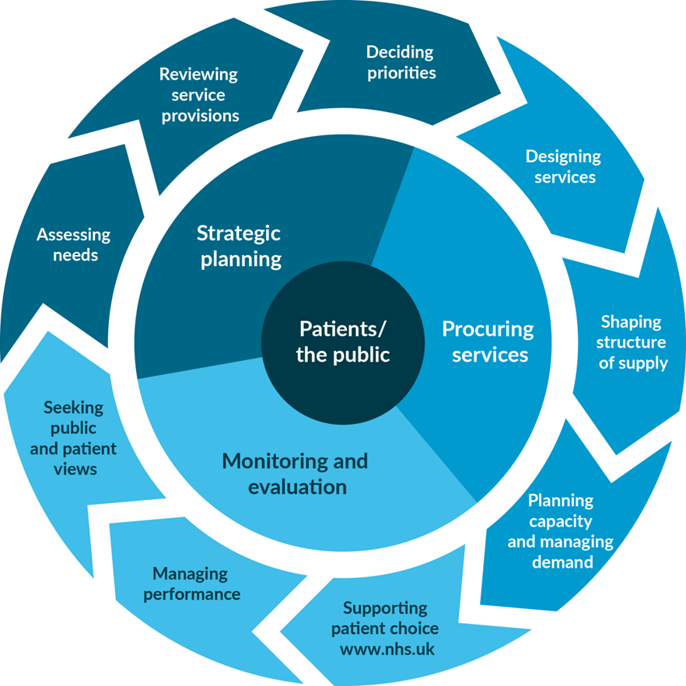
    - The ICB Joint Forward Plan outlines those the joint ambitions, which both responds to, and supports the joint health and wellbeing strategies of our three upper tier local authority partners. Joint Strategic Needs Assessments inform the strategies or our local authority partners and are therefore the starting point by which the needs of our population are assessed.
    - As described in section 1 of this policy, the ICB must plan and prioritise its resources within the financial envelope set by NHS England; a challenging task that has competing asks and opportunity cost.
    - The Investment and Disinvestment Committee (IDC) is responsible for balancing those asks, reviewing service provision and deciding priorities at the outset of the year. As such, groups with responsibility for designing, re-designing and innovating new services must present their proposals and plans to the IDC at the outset of the year. The IDC will then consider how those asks fit with the priorities of the ICB and the wider system and decide how the finite resources of the ICB will be spent.
    - All decisions, throughout the year, will then be made of the basis of the direction set by the IDC. The IDC will meet again mid-year to consider whether priorities, national direction or local need has changed that may require amendment and therefore consideration of further cases mid-year.
    - The business case process (section 6.7 and Appendix B) established within this policy will ensure that the route to designing and procuring services is robust and that informed decisions are made by those with authority set out within the Scheme of Reservation and Delegation.
    - Monitoring and evaluation of services is the primary responsibility of the identified operational lead (at service level) who will ensure that the intended benefits of decisions are realised and where this is not the case, corrective action will be taken to ensure the original need it met. The outcome of this will be overseen by both the Quality Committee and the System Oversight and Assurance Committee, as well as informing the next planning round.

Collaborative Commissioning
    - We will continue to explore opportunities to collaboratively procure services both to achieve value for money and develop markets e.g., NHS, Local Authority and Third Sector partners.

Record Keeping
    - An auditable record/trail of decision making and all communication relating to each decommissioning decision and contract termination must be kept by the identified Operational Lead. This is vital, both to demonstrate that the decision-making process (both investment and decommissioning / disinvestment) was robust and transparent, and as evidence in the event of any challenge, legal or otherwise.

Prioritisation Framework
    - Making good decisions regarding health care priorities involves the exercise of fair and rational judgement and discretion. Although there is no objective or infallible measure on which such decisions can be based, a Prioritisation Framework (see Appendix F) enables decisions to be made within a consistent setting which respects the needs of individuals and the community. The MSE ICB recognises that its discretion will be affected by National Service Frameworks, National Institute for Health and Clinical Excellence (NICE) technology appraisal guidance and Secretary of State Directions to the NHS.
    - The purpose of the Prioritisation Framework is to support and underpin the decision-making processes of the organisation (and decision-making bodies) and to support lawful and consistent commissioning policy.
    - This will be achieved by:
  - Providing a coherent structure for discussion, ensuring all important aspects of each issue are considered prior to decisions being made.
  - Promoting fairness and consistency in decision making from meeting to meeting and with regard to different clinical topics, reducing the potential for inequity.
  - Providing a means of explaining the reasons behind the decisions made.
  - Reducing risk of judicial review by implementation of robust decision-making processes that are based on evidence of clinical and cost effectiveness and an ethical framework so that the decisions are made in a manner which is fair, rational and lawful.
  - Ensuring the values and strategic aspirations of the organisation are reflected in business decisions.
    - Providing a consistent approach for the development of strategy and plans across the whole system.

Prioritisation Criteria
    - Our prioritisation criteria are the means by which the ICB and our officers can assess submitted development proposals in a clear and transparent way. The Prioritisation Framework attached at Appendix F was developed based on our Strategic Plan and the key priorities and outcomes agreed by our Integrated Care Board.

Decision-Making

Stages of decision-making
    - Appendix B sets out the decision-making process. There are four stages:
  - Planning (as described in section x) and ‘Gateway 0’
  - Business Case Development
  - Formal Approval
  - Monitoring, Review and Validation
    - All decisions will follow the decision-making process outlined herein. However, those for decommissioning or disinvestment will be subject to further consideration set out in from section 6.13.

Stage 1 - Planning and Gateway 0
    - Each planning team within the ICB reports into a workstream responsible for either overseeing performance or service transformation. These may be mid and south Essex system groups (e.g., workstreams reporting into portfolio groups led by the system Chief Executives or a stewardship group) or regional groups such as the ‘Cancer Board’.
    - These workstreams are responsible for the generation of proposals for new investment, changing commissioning models or patient pathways or for decommissioning / disinvestment.
    - The System Investment and Disinvestment Committee will consider proposals from the ICB planning teams in terms of their commissioning intentions either at the outset of the year or during the mid-year review meeting.
    - Gateway 0 is a process established to ensure that firstly proposals accord to the approved commissioning intentions set by the IDC, that it is affordable within the financial constraints of the system and that they support a cohesive patient pathway across the system.
    - Groups involved in Gateway 0 are representative of system partners to ensure that there is a collaborative approach to any proposal for investment, decommissioning or disinvestment.

Stage 2 - Business Case Development
    - Business cases must be produced for new proposals or when a change to existing commissioning arrangements is proposed. The ICB template business case is to be followed unless there is a national requirement that a specific template be used e.g. when bidding for NHS England ringfenced funds or Estates related business cases.
    - Business cases are not required for:
  - The re-procurement of an existing service where there is no significant change to the existing model and financial envelope.
  - Use of ringfenced monies obtained via a bidding process.
    - It is important to ensure that all relevant experts (e.g. clinical or technical) are consulted and contribute to the development of a business case to ensure that it is a sound and robust proposal. This may include both the initial development of the case and presenting the case to appropriate forums or ICB advisory or assurance committees/groups. A summary of the groups that may be consulted and their role in decision making is included at Appendix G.
    - To ensure that all proposal comply with governance, legal and technical requirements, each element of the business case checklist must be completed, this will demonstrate:
  - Alignment to the Integrated Care Strategy and strategic priorities (including those relating to health inequalities).
  - Support from the relevant Stewardship Group, Senior Leadership Team, Executive Team, Financial Recovery Working Group, System Transformation and Investment Group and the Investment and Disinvestment Committee.
  - Financial commitment.
  - Engagement and co-production.
  - Equality and Health Inequality Impact Assessments are undertaken and actions to address any impact have been identified.
  - Compliance with legal requirements and procurement regulations.
  - Compliance with digital and information security standards.
  - Clinical, HR, Estates and governance requirements have been met.
  - There is a commitment to the realisation of benefits as part of a cycle of continuous improvement.
    - The ICB has a legal duty to engage, outlined within its communications and engagement strategy, which will be following throughout the development of the business case proposal.

Stage 3 - Formal Approval
    - The Scheme of Reservation and Delegation sets out the roles and decision making that the Board has either retained or delegated to committees or individuals within or outside of the ICB. All cases requiring the commitment or withdrawal of funding must be approved in accordance with that scheme.
    - All cases must be supported by the Executive Team prior to being presented to either an Executive Director, CEO / Director of Resources, the Finance & Investment Committee or the Board (depending on the financial value involved).

Stage 4 - Monitoring, Review and Validation
    - The ICB recognise the need to ensure that we apply best practice performance and contract management principles to all contracts and subsequently reviews whether commissioned services are meeting the needs of the population (as identified through the Joint Forward Plan and demand analysis) ‘and’ are of high quality and best value for money.
    - On-going review of performance and the realisation of proposed benefits will be undertaken as part of a continuous cycle of contract management supporting the principles of continuous improvement and ensuring that services remain clinically relevant and viable.
    - The process for identifying potential services for decommissioning needs to be systematic and there are a number of mechanisms utilised by our staff to evidence the need for review such as benefits analysis working groups, complaints, public health needs assessments etc.

Principles of the Decision-Making Process
    - The Decision-Making Flow Chart is depicted in Appendix B.
    - The ICB acknowledges that all investments involve a degree of risk. In deciding whether to invest, the ICB will take into account the risk and return of the proposed investment.
    - Having made the decision to invest, the ICB will actively monitor and manage its investment to minimise the probability and impact of adverse outcomes.
    - If the ICB decides to approve the project, it will implement controls to minimise the probability and severity of loss associated with the project.

Decommissioning and Disinvestment

Reasons for decommissioning or disinvesting.
    - The drivers for proactively decommissioning a service include:
    - A persistent and serious risk to patient safety.
    - The service represents poor value for money.
    - There is insufficient need/demand to warrant the current volume of service and/or number of providers.
    - The service model is out-dated i.e., the outcomes have not changed but new evidence on the model of delivery has developed which cannot be met via a variation of the existing contract.
    - The service is no longer a clinical priority – reassessment of priorities may mean that investment is required elsewhere and so certain ‘non-essential’ services may be decommissioned.
    - A mismatch between need and the current profile of provided services is identified as one of the outcomes of e.g., Equality Health Inequalities Impact Assessment, and/or Joint Strategic Needs Assessments.
    - The provider is not demonstrably delivering on agreed outcomes following mutually agreed remedial action.
    - As part of a commissioning or market management strategy.
    - The drivers for reactively addressing decommissioning are:
  - Advance mitigation of impact prior to natural expiry of a time-limited contract.
  - Notice of termination of contract from the provider.
  - Breach of contract served due to irreconcilably poor performance, poor patient experience, governance and/or risks to patient safety.
    - As the net impact of both actions is a cessation of a service, the following principles are universal.

Decommissioning / Disinvestment Principles
    - The process outlined below is guided by the following principles.
  - Initiation of a decommissioning proposal must be based on tangible evidence.
  - Appropriate stakeholders must be consulted before the decommissioning decision is made.
  - The provider and commissioner obligations in relation to termination and expiry, resulting from decommissioning, is outlined within the respective contract.
  - Detailed consideration must be given to the broad-ranging adverse impact of the decommissioning decision.
  - The provider must be consulted as early as possible, and in line with contractual notice periods.
  - Where the service is identified as being a requirement / priority area, alternative provision must be available or commissioned before decommissioning is enacted.
  - Once decommissioning is agreed and/or is inevitable, and where adverse impact is anticipated a detailed implementation plan is required which clearly shows the actions and accountabilities including those to mitigate adverse impact.
  - A smooth transition between outgoing and replacement provider (where relevant) is in the best interests of patients. Contractual terms are available to ensure exit arrangements and succession plans (where relevant) are conducted appropriately.

Criteria for disinvestment / decommissioning
    - The following points will be considered when making the decision to disinvest a service.
  - The patient experience and health need must be paramount and gaps in service provision minimised once the service ceases.
  - The potential destabilising effect on other organisations e.g. third sector, of a decision to decommission/disinvest should be considered.
  - Equity of service provision across MSE ICS.

The Decommissioning or Disinvestment process
    - This decommissioning process will be followed unless an event as specified under the terms and conditions of the specific contract requires immediate termination. The decommissioning / disinvestment process is documented in Appendix C.
    - Service Restriction Policy: For a number of commissioned procedures MSE ICB operate a Prior Approvals Scheme setting out criteria for access, based on evidence of effectiveness or relative priority for funding. Those related to procedures are included within the Service Restriction Policy; those relating to prescribing can be found on the commissioner Medicines Optimisation website. Providers must not assume that because a procedure is not included in this document or listed on the Medicines Optimisations website that by default it will be funded. The latest version of the MSE ICB Service Restriction Policy can be accessed at: 1.-JC-FP001-Mid-South-Essex-SRP-v1.3-Updated-March-2023.docx (live.com)
    - Individual Funding Request (IFR) Policy: ICBs are required to have a process for considering funding for individuals who seek NHS commissioned services outside established commissioning policies. There are, in general two types of requests (Category 1 and 2) that come before an Individual Funding Request (IFR) Panel, namely:
Category 1 – Requests for funding treatments for medical conditions where the ICB has no established commissioning policy (commonly called IFR requests), and
Category 2 – Requests for funding treatments for medical conditions where the ICB does have an established commissioning policy for that condition but where the requested individual treatment is not in the ICB policy or does not meet the criteria set out in the policy. The MSE ICB Individual Funding Request Policy can be accessed at: Individual Funding Request Policy - Mid and South Essex Integrated Care System (ics.nhs.uk)
    - The decommissioning process may, on occasion, be triggered by a contract review. These reviews are carried out with a frequency according to the perceived risks of the particular contract, and as set out in the contract. In some cases, decommissioning will be triggered by a significant event, such as a Serious Incident or a ‘Never Event’, failure to provide adequate assurance around policy and procedure documentation and compliance, failure to meet quality requirements within the contract or a failure to sign a contract variation for a change in service.
    - A review will be carried out by a multidisciplinary group constituted by the ICB for this purpose.
    - Using the proforma in Appendix D, a decision will be reached by the team as to whether to decommission or procure this service from an alternative provider. Evidence required at this stage to support the decision must be robust and provided as part of the proforma to enable the decision to be ratified and to provide detailed information for the appeals stage. Should the decision be not to decommission, then corrective action to resolve the issue must be taken.
    - In all cases the identified Operational Lead will complete an Equality Health Inequalities Impact assessment, as in Appendix A. This is to be supported by the prioritisation of resources framework attached at Appendix F.
    - The identified Operational Lead is required to ensure that appropriate consultation has taken place with all relevant stakeholders.
    - Stakeholders will include respective Health and Wellbeing Boards where relevant.
    - Should the decision be to decommission, then the decision must be reviewed by the relevant ICB Committee’s to gain agreement for the decision. If the decision is regarding a service which affects more than one organisation, then approval for decommissioning must be gained from all.
    - Following approval, the decision will be communicated to the identified stakeholders to provide an opportunity for consultation. Stakeholders will include health and wellbeing boards.
    - Fifteen operational days will be allowed for this communication and queries from stakeholders to be dealt with before notice is served on the provider. The responsibility for serving notice on the provider is with the contract manager or as otherwise determined by the Chief Executive.
    - Formal public consultation in line with Health Overview and Scrutiny Committee guidelines must take place where the decommissioning of the service or contract results in a material change to the delivery of a service (except when the service is recommissioned), or where the service will not be recommissioned.
    - Following notification of decision to decommission the Commissioner and Provider (and if appropriate any successor provider) will jointly agree an Exit Plan/Succession Plan, as required under the contract for services, outlining actions required by both parties for smooth service cessation. Where a clinical service, the plan will cover a minimum:
  - Referrals, and patient transfer or discharge
  - Patient continuity of care
  - Patient records
  - Staff
  - Estate
  - Equipment (also need to consider in relation to non-clinical services)
  - Stock (where funded by the ICB)
    - The ICB lead will ensure mechanisms are in place where, in conjunction with the provider, execution of the Exit Plan/Succession Plan is actively managed.

Appeals Process
    - An appeal against a decommissioning decision will be accepted from the provider if the appeal is received within 10 operational days of the notice given, submitted to the following address: Phoenix House, Christopher Martin Road, Basildon SS14 3EZ, or E-mail: E-mail: mseicb.enquiries@nhs.net.
    - The appeal will be dealt with by the ICB within the required timeframe.
    - Evidence to be provided to the governing body or its designated committee or sub-committee will include copies of the relevant Contract Review Checklist and the supplementary evidence supporting this (Appendix E) and the Equality Health Inequalities Impact Assessment (Appendix A).
    - Where a service is decommissioned but the health need for a service remains, and is a priority, this should be recorded in the impact assessment and the funding ring-fenced for ongoing investment in meeting that priority health need.
    - Where decommissioning is the result of insufficient health need the funding should be identified as a financial efficiency saving and any reinvestment in alternative services as per the current investment planning and prioritisation process(es)

Assessment of Impact
    - In the event that a case for change is validated by sufficient supporting evidence, the identified Operational Lead are responsible for carrying out an impact assessment to identify the anticipated or actual impacts of the development intervention on health, social, economic and workforce factors. This impact assessment must be approved by our Quality Lead before decommissioning is undertaken.
    - The impact assessment must include:
  - Health outcomes – the effect on health outcomes will be assessed to identify potential adverse consequences of decommissioning and what might to done to minimise them.
  - Health inequality and equitable access implications - we believe that people should have access to health care on the basis of need. There may also be times when some categories of care are given priority in order to address health inequalities in the community. However, we will not discriminate on grounds of personal characteristics, such as age, gender, sexual orientation, gender identity, race, religion, lifestyle, social position, family or financial status, intelligence, disability, physical or cognitive functioning. However, in some circumstances, these factors may be relevant to the clinical effectiveness of an intervention and the capacity of an individual to benefit from the treatment.
  - Workforce implications.
  - Market implications.
  - Geographic implications e.g. impact on transport links etc.
  - Value for money.
  - Impact on partner organisations.
  - Environmental sustainability including impact on partners.
    - We will also communicate clearly, fully and continuously with ICB stakeholders before, during and following any decision by the ICB to decommission services. Decisions relating to decommissioning will follow the same approval routes as set for investment proposals.

Decommissioning / Disinvestment Assessment
    - The Decommissioning and Disinvestment Assessment document (see Appendix D), forms part of the auditable document trail for the decommissioning decision which may be legally challenged, therefore it must be completed factually, objectively and diligently. Decommissioning a health service will have both positive and negative impact. It is critical that the adverse impact on patients and on the wider health economy are understood and documented.

Monitoring Compliance

The CPMO will monitor compliance with this policy and procedure, ensuring that no service is commissioned / decommissioned without adherence to this.

The Quality and Finance and Investment Committees are responsible for monitoring compliance.

Staff Training

Training will be provided to all staff involved in making investment / decommissioning / disinvestment decisions, through the CPMO.

A Prioritisation Handbook has been developed to support staff to implement this policy and procedure.

Arrangements for Review

This policy and procedure will be reviewed no less frequently than every two years. An earlier review will be carried out in the event of any relevant changes in legislation, national or local policy/guidance, organisational change or other circumstances which mean the policy and procedure needs to be reviewed.

If only minor changes are required, the sponsoring Committee has authority to make these changes without referral to the Integrated Care Board. If more significant or substantial changes are required, the policy and procedure will need to be ratified by the relevant committee before final approval by the Integrated Care Board.

Associated Policies, Guidance and Documents
- ICB Prioritisation Handbook.

Associated Policies
- Individual Funding Request Policy
- Service Restriction Policy

References
  - Castle Point and Rochford CCG Decommissioning and Disinvestment Policy.
  - North East Essex CCG Prioritisation Framework.

Equality and Health Inequalities Impact Assessment

The EHIIA has identified no equality issues with this policy.

Appendices

Appendix A - Equality Impact Assessment (EIA)
Name of policy and version number : Decision Making Policy and Procedure  Version: 1.0 | Directorate/Service: Corporate / Chief Executive’s Office
Assessor’s Name and Job Title:  Nicola Adams, Deputy Director of Governance and Risk | Date: 28/9/23

OUTCOMES
Briefly describe the aim of the policy and state the intended outcomes for staff
The Policy will guide staff on the correct process to be followed for decision making in terms of investment, disinvestment and decommissioning.
EVIDENCE
What data / information have you used to assess how this policy might impact on protected groups?
The policy relates to all decision making and is not associated with any protected groups.
Who have you consulted with to assess possible impact on protected groups? If you have not consulted other people, please explain why?
The policy has been shared with the Corporate Team, Executive Team, Public Health and other relevant ICB staff.

ANALYSIS OF IMPACT ON EQUALITY
The Public Sector Equality Duty requires us to eliminate discrimination, advance equality of opportunity and foster good relations with protected groups. Consider how this policy / service will achieve these aims.
N.B. In some cases it is legal to treat people differently (objective justification).
- Positive outcome – the policy/service eliminates discrimination, advances equality of opportunity and fosters good relations with protected groups
- Negative outcome – protected group(s) could be disadvantaged or discriminated against
- Neutral outcome – there is no effect currently on protected groups
Please tick to show if outcome is likely to be positive, negative or neutral. Consider direct and indirect discrimination, harassment and victimisation.
Protected  Group | Positive  outcome | Negative  outcome | Neutral  outcome | Reason(s) for outcome
Age |  |  | X | The policy sets out a consistent decision making process that will be applied consistently.
Disability  (Physical and Mental/Learning) |  |  | X | As above
Religion or belief |  |  | X | As above
Sex (Gender) |  |  | X | As above
Sexual  Orientation |  |  | X | As above
Transgender / Gender Reassignment |  |  | X | As above
Race and ethnicity |  |  | X | As above
Pregnancy and maternity (including breastfeeding mothers) |  |  | X | As above
Marriage or Civil Partnership |  |  | X | As above

MONITORING OUTCOMES
Monitoring is an ongoing process to check outcomes. It is different from a formal review which takes place at pre-agreed intervals.
What methods will you use to monitor outcomes on protected groups?
The policy requires impact assessments to be carried out on all decision making, which will be monitored by sponsoring/authorising committees.

REVIEW
How often will you review this policy / service?
Every 2 years as a minimum and earlier if there are any significant changes in legislation, policy or good practice.
If a review process is not in place, what plans do you have to establish one?
N/A

Appendix B – Decision Making Flowcharts
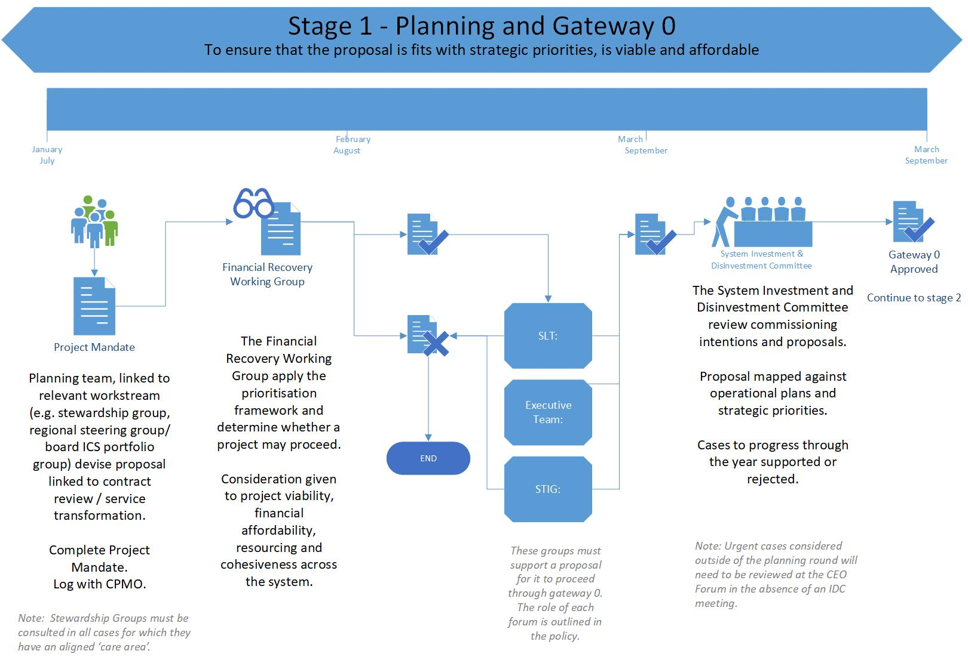

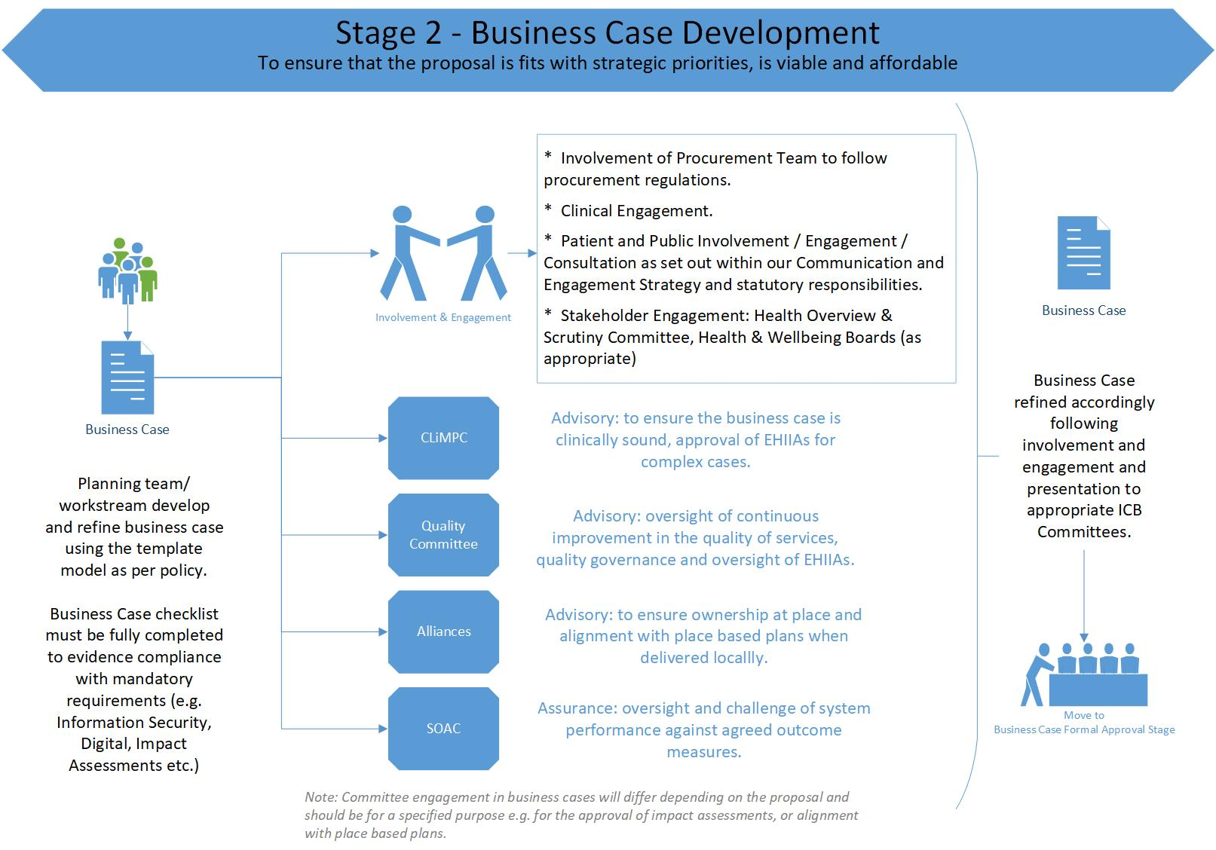

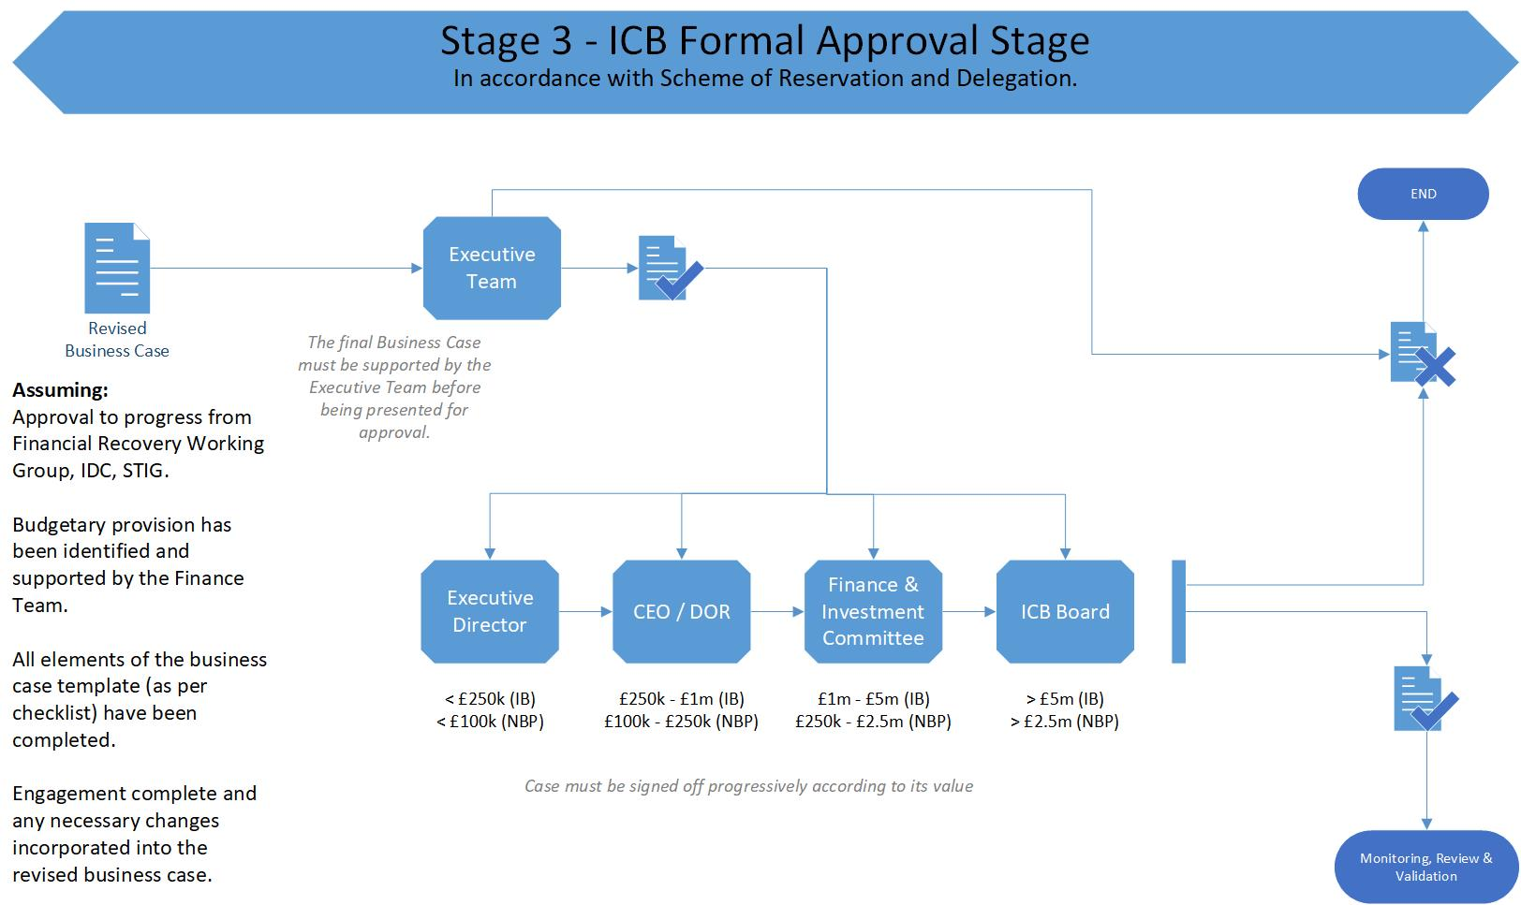

Appendix C – Decommissioning Process Flow Chart

Appendix D – Decommissioning / Disinvestment Assessment
Service Considered for Decommissioning: | Annual Contract Value: | Approx. number of Patients Impacted:
This document forms part of the auditable document trail for the decommissioning decision which may be legally challenged, therefore it must be completed factually, objectively and diligently. Decommissioning a health service will have both positive and negative impact. It is critical that the adverse impact on patients and on the wider health economy are understood and documented.
Background – Information on Service:
Brief notes e.g. what it is, what it does, who provides etc.

Background – Procedure context and/or principle driver for Decommissioning:
DH requires that, if a variation to contract cannot be made, then terminate to enable required intervention. Otherwise, principle driver for considering decommissioning (proactive, reactive, safety, VFM, etc.).

Adverse Impact on the Patient:
Continuity of on-going care for those within service, pathway of care, access, distance travelled, is there another provider representing reasonable choice.

Positive Impact (Benefit) of Decommissioning:
The prime benefit from Decommissioning e.g. improved safety; simplified pathway; better value for money; better outcomes; market improvement; opportunity for reinvestment.

Adverse Impact on ICB including Finance:
Non-recurrent impact / one off decommissioning costs contractually borne by commissioner e.g. TUPE. Non-recurrent impact of replacement service overlapping with decommissioned service. Recurrent gross cost (cost of this service). Recurrent net cost (cost of this service less cost of any replacement or movement in demand). Transactional costs of decommissioning. Likelihood of public outcry at loss or perceived loss. Impact on ICB’s reputation.

Adverse Impact on Provider:
Does the loss of this service/contract element compromise the provider’s economic or physical ability to deliver other services? Fixed cost.

Adverse Impact on Health Market Economy:
Overall supply/demand balance, on upstream and downstream elements of care pathway, knock on to other providers, gap in provision, market diversity, loss of clinical skill, training opportunities etc.

Adverse Impact on Performance:
Does the cessation of service adversely impact any vital sign commitment e.g. cancer access, health inequalities, 18 weeks, access etc. (full list available on request)

Adverse Impact on Equality (Please complete the ICB Equality Impact Assessment proforma prior to completing this section).
[Equality Act 2010] Does cessation of service represent unequal treatment or discrimination or inequality of access on the basis of any of the nine protected characteristics.

Adverse Impact on Quality:
Does cessation of service impact on quality of services / patient care.

Adverse Impact on Rurality:
Does cessation of service represent unequal treatment or a barrier to access to service users in a rural location – if yes, how will this be mitigated.

Health Overview & Scrutiny Committee / Consultation:
Does the recommendation(s) below and the materiality of the change indicate that HOSC will have an interest/what consultation is particularly recommended/has taken place.

Recommendations:
Recommendation to decision making authority e.g. not to be decommissioned, decommission, decommission with stipulated conditions (state them).

Completed By: |  | Date:
Signed off by Financial Recovery Working Group: |  | Date:

Appendix E - Contract Review Checklist

Evidence (to provide | Provider | Conforms? | Data not | Data not
documentary evidence for questions below) | Yes | No | Applicable | Available
Does the provider meet the service specification and specified quality requirements?
Actual activity v. contracted activity is significantly more or less (-/+5%)
Activity cost v. contracted cost is significantly more or less (-/+5%)
Are specified waiting times consistently maintained for more than 6 months.
Does the service cost provide value for money? (if on local tariff, is it within reasonable limits, if block, is the reference cost within regional average? If QOF, within reasonable limits of regional average?)
Have there been any significant patient safety/clinical governance issues? (such as SIs, CRB issues, breaches of policies?)
Does the service meet current national strategy in terms of outcomes and expectations?
Does the service conform with existing patient pathways? (i.e. part of a referral pathway to other services?)
Does the evidence base e.g. NICE etc. identify that the service is clinically effective? (parliamentary enquiries could provide evidence?)
If the service is provided by a single practitioner, has this impacted on service delivery during the practitioners absence?
Does the service reduce activity and costs elsewhere in the pathway?
Was the outcome of the service evaluation positive?
Is there evidence of contractual breach, noting light tough approach in place since COVID, in particular with System Partners
Has the Provider been issued with a performance notice within the current financial year?
Is a Remedial Action Plan currently in place?
Has the service Provider had patient concerns/complaints raised against them?
If yes, have these concerns/ complaints been upheld by internal or external governance processes?
Are there any other data from the review to consider? (please attach with indication below of conclusion following review of this data)

Decision:
Recommission: |  | Decommission:
Signed by ICB Quality Lead: |  | Date:
Signed by Chief Finance Officer: |  | Date:
Approving Committee: |  | Date Approved:

Please list names of attendees ratifying this decision:

Appendix F – Prioritisation Framework
CRITERIA | MEASURE (M) |  |  |  | WEIGHTING | CRITERION SCORE
 | None  (M=0) | Low  (M=1) | High  (M=2) | Maximum  (M=3) | (W) | (M)
- Addresses Health Need  - Addresses a health need identified in Joint Forward View Plan | Does not address a health need identified in the JSNA/HNA | Addresses a health need identified in the JSNA/HNA | Addresses a priority health need identified in the JSNA/HNA | Addresses a priority health need among >10% ICB residents OR multiple health needs | To be agreed
- Patient and Public Acceptability, Expectation and Involvement  - Patient acceptability of treatment  - Public expectation  - Contribution to patient autonomy, responsibility for and involvement in decisions about their health. | Low public acceptability AND/OR no public expectation AND/OR no contribution to patient autonomy | Low public acceptability OR low public expectation OR small contribution to patient autonomy | High public acceptability OR high public expectation OR high contribution to patient autonomy | More than one of high public acceptability, high public expectation, high contribution to patient autonomy
- Impact on Health Inequalities  - Likely contribution to reducing health inequalities | Could increase health inequalities | No impact on health inequalities | Slight reduction in health inequalities | High reduction in health inequalities
- Evidence of Effectiveness  - Strength of evidence of benefit | No evidence of effectiveness, but no evidence of ineffectiveness | Some evidence from case series, cohort studies, unpublished data, or expert opinion. | Some evidence of effectiveness including cohort studies or non-randomised, non-blinded trials | Strong evidence of effectiveness e.g. from meta analyses/ systematic reviews, or randomised, blinded, controlled trials
- Benefit of Intervention  - Magnitude of health improvement for patient, as indicated by evidence on intervention  - Wider benefits to services and society | Lower magnitude of effect AND  No wider benefits | Lower magnitude of effect OR  No wider benefits | Higher magnitude of effect OR  Some wider benefits | Highest magnitude of effect AND/OR  Some wider benefits
- Access  - Provides care closer to home  - Improves access for marginalised groups | Negative impact on access | No impact on Access | Positive impact on access | Strongly positive impact on access
- Strategic Alignment  - With National/Regional/Local strategic priorities  - With UTLA and partners’ priorities; potential for shared resources  - With social, political and technological developments e.g. Sustainability, Public Services (Social Value) Act | Not aligned with any | Some alignment | Reasonable alignment with multiple priorities | Strong alignment with multiple priorities
- Service Quality and Safety  - Contribution to quality improvement e.g. effectiveness, national standards, safety, patient experience, waiting times, integration of care etc | Negative or no impact on quality | Some positive impact on quality | Strong positive impact on one quality dimension | Strong positive impact on multiple quality dimensions
- Patient Choice and Service Supply  - Contribution to improved patient choice e.g. increased choice due to changed opening times, geography, distances travelled  - Contribution to improved supply e.g. facilitates patient switching, increases provider concentration, promotes provider market entry, improves service responsiveness | Negative or no impact on choice AND supply | Positive impact on choice OR supply | Positive impact on choice AND supply | Strongly positive impact on choice AND supply
- Health Economy Impact and Risk  - Risk of not doing to health economy  - Impact of intervention on partners | None | Low | Medium | High
 |  |  |  | TOTAL SCORE

Note: Weightings will be reviewed annually in line with priorities.

Appendix G – Role of Committees in Decision Making

Committee / Group | Type | Purpose
ICB Board | Decision  Statutory | Responsible for overall governance of ICB and maintains responsibility for approving business cases/investment decisions >£5m (within agreed budgets) / >£2.5m (with no budgetary provision).
Finance & Investment Committee (F&IC) | Decision | Responsible for overseeing financial management/performance and for approving business cases/investment decisions between £1m-£5m (within agreed budgets) / £250k-£2.5m (with no budgetary provision).
Quality Committee | Assurance | Responsible for overseeing continued improvement in the quality of services, quality governance and oversight of Equality/Health Inequality Impact Assessments e.g. in support of business cases, ensuring they are adequately governed.
Clinical & Multi-Professional Congress (CLiMP) | Advisory | Advisory committee driving the identification and delivery of transformation programmes across the ICS; providing clinical and professional scrutiny; acting as a sounding Board of multi-professionals across health and care sectors. Clinical advice to major cases.
Primary Care Commissioning Committee (PCCC) | Decision | Decision making committee in relation to the ICB’s delegated functions for Primary Care. Approval of core contractual investments (including Primary Care estate).
Senior Leadership Team (SLT) | Advisory  Endorsement | Executive Officer direct line reports from all Directorates across ICB, providing insight and guidance to development of ICB business and achievement of ICB objectives. Functions as the operational “engine room” of the ICB. All expenditure exceeding £50k must be ‘approved in principle’ by the SLT.
System Transformation and Investment Group (STIG) | Advisory Endorsement | Gateway for transformation programmes (Business cases requiring FIC approval or investments that have cross-system implications). Ensures strategic alignment, cross system outcomes and benefits realisation.
Stewardship Groups | Advisory  Endorsement | Targeted groups overseeing and innovating to ensure the ICB achieves the Triple Aim.  Respiratory, Cardiology, Cancer, Stroke, UEC, Ageing Well – currently established.  Diabetes, Dermatology, Ophthalmology, MSK, CYP, Mental Health – being developed.
Health Overview and Scrutiny Committees (HOSC) | Statutory | Statutory committee with overview / scrutiny of health decisions. To be consulted regarding significant change. Power to refer decisions to the Secretary of State.
Health & Wellbeing Boards (HWB) | Statutory | Overseeing the delivery of the Health and Wellbeing Strategy. To be consulted regarding significant change.
Audit Committee | Assurance  Statutory | No decision making powers, but responsible for overseeing systems of internal control.  All approved waivers must be reported to and scrutinised by the audit committee.
System Oversight & Assurance Committee (SOAC) | Assurance | Providing oversight and challenge on system performance against agreed outcome measures, constitutional standards and associate transformation programmes.
ICB Executive Team | Assurance  Endorsement | Responsible for delivery of ICB objectives, including performance, quality and financial plans. It will delegate activities, tasks and mitigations of risks to the SLT and receive escalations and responses from SLT in respect of business case proposals.
Chief Executives Forum | Assurance  Endorsement | Group of Health System Chief Executives/Leaders accountable for the achievement of system objectives. Will determine and agree system responses to operational, financial and performance challenges.

Appendix H – Business Case Checklist

