

**NHS Mid and South Essex**

**Joint Forward Plan Refresh   
2024-2029**

**NHS Mid and South Essex Joint Forward Plan 2024-2029**

Contents

About this Document 3

Foreword from our Chair 4

Section 1: Strategic Ambitions 5

Introduction 5

Our Strategic Ambitions 7

Partnership 10

Delivery 14

Enablers 24

Section 2: Delivery in 2023/24 33

Partnership 33

Delivery 37

Enablers 44

# About this Document

This document provides a refresh of Mid and South Essex Integrated Care Board’s (MSE ICB) Joint Forward Plan for 2024-29. It recommits the NHS system in MSE to the strategic ambitions set out in the 2023-28 Joint Forward Plan, which were developed in partnership with local stakeholders and approved by the Essex, Southend and Thurrock Health and Wellbeing Boards in June 2023 and by the ICB Board in May 2023.

MSE ICB is a system that is currently facing significant financial challenges. During 2023/24 the system planned to deliver a £40m deficit. Having faced significant financial challenges in year driven by workforce, performance and quality challenges the system revised its forecast in year having been unable to meet the planned figures. The final position for MSE at the end of 24/25 was a £57m deficit. This financial challenge is continuing into 2024/25 and beyond.

The ICB’s immediate focus is on recovering a sustainable financial position, delivering on national operational requirements and maintaining a focus on addressing health inequalities as we do those. The details of how this will be delivered in 2024/25 have been developed through the system’s Operational Plan, with information on our 2024/25 provided in an updated section of this Joint Forward Plan.

The final 2024-29 Joint Forward Plan for MSE ICB includes:

1. A reminder of the strategic ambitions the system has committed to
2. A summary of some of the commitments the ICB delivered on in 2023/24
3. A summary of what the ICB will deliver in 2024/25 and beyond

# Foreword from our Chair

I am delighted to present the Mid and South Essex Integrated Care System Joint Forward Plan for 2024-2029. In this refresh of our Joint Forward Plan, we are recommitting to the strategic ambitions we developed with our partners last year. These ambitions are the foundations for how we will continue to develop and improve our services to better meet the needs of our population and communities. We know that we can only do this successfully by building on our existing joint work with local government and by listening to our people and communities to deliver change.

As is the case for many Integrated Care Systems, we face a number of significant challenges. The Covid pandemic exacerbated health inequalities in our population and our primary care services are under extreme pressure. Demand on our mental health, urgent and emergency services are significant, we have long waits for planned treatments, and we are not meeting nationally set standards in relation to cancer care. Collectively, our providers are carrying significant vacancies and we over-rely on bank and agency staff to fill rotas – as a result the quality of care we offer can sometimes suffer. Within these many challenges, we are also a system that has high ambitions to improve the health and wellbeing of the population that we serve. During 2023/24 we have delivered impressive and long-lasting improvements and have had many successes.

In addition to recommitting to our strategic ambitions, this revised plan highlights the good progress we have made in 2023/24, a number of which have been recognised nationally, for example, our Anchor Programme, virtual hospital, Stewardship and innovations such as Teledermatology and our Happy Hubs and wellbeing cafes that provide a one stop wellness shop within our community. In December 2023, primary care delivered over 7% more consultations than in the same period the year before. This is being supported by new roles, technology and self-referrals pathways that will help residents access the best care to meet their needs.

We are committed to continuing to work together across health, local government and with our communities to do all that we can to improve outcomes for our local population. Our system’s strategic ambitions and plans for this year are set out in this Joint Forward Plan.

**Professor Michael Thorne CBE**

**Chair**

**NHS Mid and South Essex Integrated Care Board**

# Section 1: Strategic Ambitions

## Introduction

Mid and South Essex Integrated Care Board (MSE ICB) oversees the NHS budget for the 1.2 million people that live and work in mid and south Essex. In 2024/25 that budget is £2.7 billion. The ICB is responsible for developing a plan for how to invest and spend this money to deliver care and support services that will help improve people’s health, deliver high quality care that meets their needs and that offers value for money.

Figure 1 shows the shape of our partnership across MSE, which includes 142 GP practices working across 27 Primary Care Networks, three community and mental health providers, one acute hospital trust working across three large hospitals, one ambulance trust, three upper tier local authorities and seven district and borough councils, three Healthwatch organisations and many community, voluntary, faith and social enterprise sector organisations.

Throughout 2023/24 the financial and operational context across the NHS in MSE has remained challenging, with the system facing increasing financial challenges as it aims to deliver sustainable services that meet the needs of local residents. At the end of 2023/24 MSE reported a system-wide deficit of £57 million and is currently working within a ‘triple’ lock, with any unplanned expenditure or requests over £25,000 being scrutinised by NHS England, as well as the ICB.

Despite this, the ICB remains committed to being a health and care partnership working for a better quality of life in a thriving mid and south Essex, with every resident supported to make informed choices in a strengthened health and care system. We want people to live longer, healthy lives, to be able to access the best of care and to experience the best clinical outcomes, and for us to be able to attract good people to work with us, recognising we offer meaningful careers.

This Joint Forward Plan recommits the ICB to the strategic ambitions that were developed by the system in 2023 to align with the [Mid and South Essex Integrated Care Partnership (ICP) Strategy](https://www.midandsouthessex.ics.nhs.uk/about/integrated-care-strategy-2023-33/). These ambitions are supported by the delivery plans set out in section 3 of the Joint Forward Plan, which outline how we will deliver on our ambitions in 2024/25 and beyond.

*Figure 1: Mid and South Essex Integrated Care Partnership*

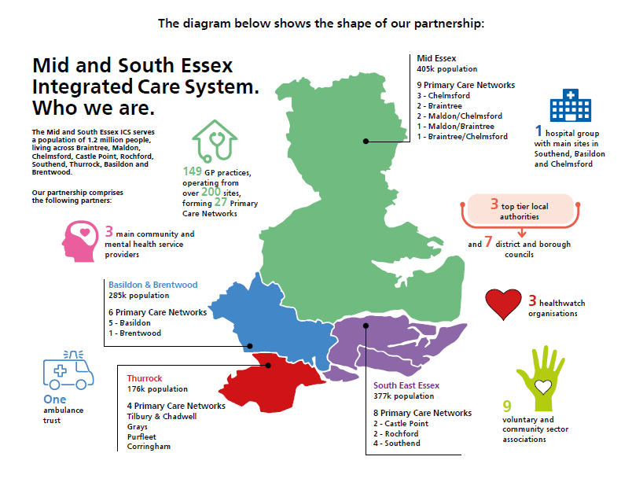

## Our Strategic Ambitions

In 2023, the ICB committed to twelve strategic ambitions for our health and care system. These strategic ambitions inform the system’s operational planning and delivery, ensuring that the ICB can deliver on its statutory duties and maintains a focus on the Triple aim of improving the health of our local population, improving the quality of services we provide and improving the efficiency and sustainability of local services. The ambitions also support the four key aims of Integrated Care Systems to:

* Improve outcomes in population health and healthcare;
* Tackle inequalities in outcomes, experience and access;
* Enhance productivity and value for money; and
* Supporting broader social and economic development.

For the 2024-2029 Joint Forward Plan, the ICB’s strategic ambitions have been grouped under three headings that reflect areas of focus across the ICB:

1. **Partnership:** These ambitions focus on how we work together to develop and deliver our plans and provide collective assurance on the quality and value that services offer to local residents.
2. **Delivery:** These ambitions focus on operational delivery to drive improved quality of care for patients, adjusting how we deliver to address health inequalities and look at upstream delivery to improve the health outcomes across our populations.
3. **Enablers:** These ambitions focus on the critical enablers in our system that are needed to support successful delivery and effective partnership working to improve care outcomes. Those include our workforce, data, digital and technology, financial sustainability and research and innovation.

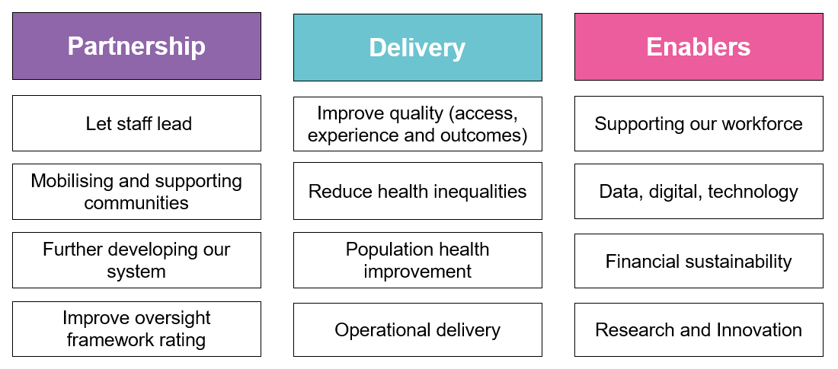

In May 2024 the ICB Board agreed a set of Strategic Priorities that provide focus for how the ICB will deliver on the Strategic Ambitions. These Corporate Objectives are:

1. To ensure that the MSE ICB and ICS deliver good quality health care and services within financial resource limits.
2. To reduce health inequalities across mid and south Essex including access to, experience of, and outcomes of the services we provide.
3. To improve standards of operational delivery, supported by collaborative system working to deliver patient centred care in the right place that the right time and at the right cost to the NHS.
4. To develop and support our workforce through compassionate leadership and inclusion, achieving significant improved by March 2026.
5. To develop effective oversight and assurance of healthcare service delivery across mid and south Essex, ensuing compliance with statutory and regulatory requirements.
6. To embrace service improvement by adopting innovation, applying research and using data to drive delivery, transformation and strategic change.
7. To be an exemplary partner and leader across mid and south Essex ICS, working with our public, patients and partners in the ICP to jointly meet the health and care needs of our people.

Central to these priorities is the need to recover our financial position. The development of a system-wide recovery programme has been a key priority for 2024/25. This work, led by the Director of System Recovery, provides a structured approach to overseeing both organisational and system level recovery projects and programmes. The governance that oversees this work, and how it feeds into the ICB’s overall governance, are set out at the start of Section 3 of the Joint Forward Plan.

Looking more broadly across mid and south Essex, in March 2024 the Integrated Care Partnership agreed a set of joint priorities to focus on in 2024. These priorities focus on wider determinants of health and focus on areas where there is value in partners coming together to improve services for the local population. Between January and March 2024 an initial set of priorities was identified by drawing on priorities in the three local Health and Wellbeing Strategies and local health priorities. This initial ‘long list’ was tested with community partners through the Community Assembly, with an updated list proposed back to the ICP Delivery Group that was overseeing the work. This led to an agreed set of five priorities for a ‘Healthy MSE’ were developed across the partnership through a Steering Group which drew on priorities identified from the three local Health and Wellbeing Strategies, as well as the local health priorities.

The five priorities for a Healthy MSE, which are reporting into the Integrated Care Partnership, are:

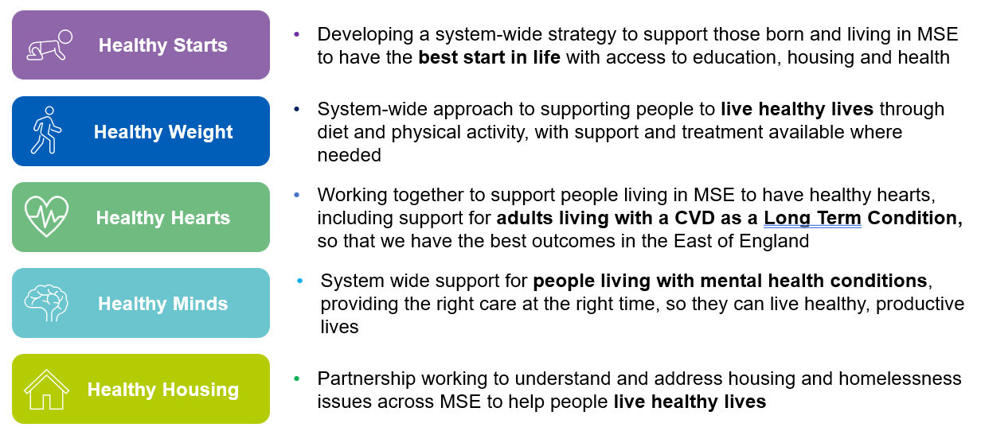

### Partnership

1. **Let Staff Lead**

Our workforce are our biggest investment and our greatest asset. An engaged and empowered workforce is more likely to deliver high quality care and support the transformation that is needed in our system.

The ‘Stewardship’ programme in MSE is putting clinical and operational leaders at the centre of work to drive the transformational change that is needed in our system. Stewardship offers staff the chance to receive training and development that will help them engage with data, information and evidence to help them identify and address challenges in the services they are working in. Our stewards also ensure that we have access to the expert advice that we need to inform the development of clinical and operational pathways to support the ongoing improvement of care.

We are supporting our Stewards to lead clinical change through regular leadership and development opportunities, including our Summits. As the programme evolves, we will be bringing the Stewards closer to our overall Financial Recovery programme and considering how they can help us drive improved productivity alongside improved outcomes and experience for patients.

Alongside our Stewardship programme, we are reviewing our System Clinical Leadership to ensure resource efficiency, system value and a focus on quality improvement. This work is being supported by the Clinical Leadership and Innovation Directorate and is underpinned by the national principles that will see clinical leaders better connected, developed and supported in our system. Our clinical leadership development programme ‘Leading Better Together’ will support those stepping up to lead in our system.

Staff are often best placed to identify opportunities to improve our services. The ICB is committed to developing a model for Quality Improvement that will help equip and support staff to speak up and step up in suggesting ways that they can improve the quality and value of care offered to patients. As the ICB has re-ignited its Greener NHS programme, we have sought Green Champions within our organisation to join those who have already come forward in other organisations. These champions are invited to join others across the system in the MSE Sustainability Forum to share ideas and insights and help lead action to support the system to deliver on its Net Zero ambitions.

1. **Mobilising and supporting our communities**

It is important to acknowledge the breadth of assets that exist across our communities in MSE. We recognise that there is more that we can do to work with communities to acknowledge, draw on and support those assets to support local residents. This is central to the work we are undertaking in our Alliances, including the development of local Integrated Neighbourhood Teams.

We are committed to continuing to listen to and work with individuals, groups and communities to ensure that we both understand local challenges and develop asset-based responses to local need. MSE [Virtual Views](https://virtualviews.midandsouthessex.ics.nhs.uk/) has been established as an online community for local people to share their views, experiences and ideals about local health and care services. In addition, we will continue to develop our approach for engaging our people and communities through our placed-based Alliances and the development of our Community Assembly.

1. **Further developing our system**

The ICB is continuing to develop as both as organisation and as a system. Investing in our collective development and partnership working is critical to enabling our success as an integrated care system. As we continue to mature as a system, we will continue to support and develop our leaders as individuals and our teams so that they are equipped to help lead effective decision making and delivery across our system.

We are continuing to strengthen our partnership working with local authorities across mid and south Essex at all levels, including our district and borough councils. We recognise the importance of collaborating in how we plan and deliver health and care services for the benefit of local residents, and the ICB and ICP continue to align with and support the priorities identified by the three upper tier Health and Wellbeing Boards and our local placed-based partnerships, our Alliances.

A core part of our system development is our place-based Alliances. We will continue to develop and mature these partnerships so that they can better understand the needs of local communities and support delivery of integrated services that support improve population health outcomes, quality of care, experience and value. Alliances will develop delivery plans around shared local outcomes that contribute to our priorities as an ICB and ICP. They will use an asset-based approach to community development to drive transformation and focus on the wider determinants of health to improve health outcomes, particularly through the vehicle of integrated neighbourhood working. As Alliances continue to mature and develop, they will look for opportunities to make best use of the collective resource to deliver sustainable change.

The ICB is now responsible for commissioning all primary care services, including community pharmacy, optometry and dental services. This provides us with a further opportunity to strengthen primary care services in our system and consider new ways of delivering care and treatment to meet local need. MSE is one of the first systems in the country to receive delegated responsibility for commissioning specialised services. We are excited about the opportunity this provides us to review how we commission services to best meet the needs of our local population.

The ICB is also supporting the development with providers and provider collaboratives across our system, including:

* The **Primary Care Collaborative** for mid and south Essex, including a focus on supporting the sustainability of general practice and implementing the recommendations from the Fuller review.
* The **Community Collaborative**, which brings together Essex Partnership NHS Foundation Trust (EPUT), North East London NHS Foundation Trust (NEFLT) and Provide Community Interest Company (CIC).
* The **NHS Specialist Mental Health, Learning Disability and Autism Provider Collaborative** across East of England.
* **Mid and South Essex NHS Foundation Trust** (MSEFT) to reduce variation and increase the quality and value of care offered across its acute and community hospitals.

The NHS in MSE remains committed to being an anchor in our community. With a budget of over £2 billion and a workforce of over 23,000 we are a huge contributor to our local economy. Through the MSE Anchor programme the ICB continues to explore ways that we can contribute to wider social and economic development through:

* **Our workforce:** helping local people to gain jobs in the NHS through the Anchor Ambition programme, anchor youth programme, apprenticeships and then ongoing career development. We will also continue to focus on the wellbeing of our workforce and their families as potential users of our health and care services.
* **Our purchasing:** the NHS is committed to ensuring social value remains an important consideration in our procurements. This includes including requirements around ethical and labour standards, including net zero and modern slavery requirements, in all our procurements and contracts.
* **Our buildings and spaces:** we are currently developing our infrastructure strategy, which will consider how we can make better use of the buildings, spaces and assets we have across MSE to better serve our patients and the wider community.
* **Our environmental impact:** MSE has established and new Greener NHS Programme Board to oversee system progress in supporting our Net Zero ambitions. This Board will support the refresh of the MSE Greener NHS plan for the system to ensure that we are taking appropriate action to reduce NHS emissions, including reducing carbon and air pollutants. The plan will also consider what adaptations health and care services will need to take to respond to the challenges climate change is presenting today and in the future.
* **Our partnerships:** we remain committed to working with and learning from others, both in our communities and beyond. We want to be a learning system, working to make best use of the assets and resource that we have access to so that we can best serve the people living in MSE.

1. **Improving our NHS oversight framework rating**

The NHS oversight framework looks at how local NHS partners are aligning with wider system partners and aims to identify areas where systems might require additional support.

MSE ICB remains committed to improving its oversight framework ratings, recognising that this is a system facing significant financial and quality challenges and is currently failing to recover care in line with the national targets.

To support the system in its financial recovery, an Executive Director of System Recovery has started working across ICB and MSEFT.

### Delivery

1. **Improve quality**

Whilst the NHS in MSE been working hard to address known quality issues, several challenges remain in the system, including the delivery of sustained improvements in mental health, perinatal/maternity care, and supporting our children and young people with Special Educational Needs and Disabilities (SEND). These are evident from current CQC ratings and Ofsted Inspection findings, as well as patient experience indicators and inquiries into local services, specifically in mental health provision. We are working in partnership across the system to continue to address these issues and improve the quality of services available to residents.

The system’s response to the recent Ofsted and CQC visit to Thurrock is an example of how system partners are collaborating effectively to both understand opportunities for improvement and working together to drive improvements. The ICB is committed to supporting all providers to improve the quality of care they provide, including working across the system to deliver the CQC ‘should do’ and ‘must do’ recommendations, and Ofsted Inspection recommendations, through evidence assurance and triangulation of improvements across the system. This work will be overseen by the Quality Committee, which is a formal sub-committee of the ICB Board, which remains a focus on ensuring it continues to listen to patient voices around areas of concern, improving patient experience and outcomes.

Work is further supported by quality groups and forums such as the MSE System Quality Group, the Harm Free Care forum and a system Learning from Deaths group. The system also remains committed to participating in national work streams, including the national Maternity and Neonatal Safety Improvement Programme and will be looking at mental health pathway reconfiguration in line with the wider Essex All Age Mental Health Strategy and national standards.

This work will be supported through the development of an updated ICB Quality Strategy for 2024/27 which will align with the National Quality Board principles. This new ICB quality strategy will build on a review of the previous 2021/23 Quality Strategy and Implementation plan. It will contain a set of quality objectives which will use quality information and data to provide a clear understanding that reflects our local system intelligence. The ICB will develop robust system quality dashboards which will align quality metrics on processes and patient outcomes. This will evidence ongoing sustainable and equitable improvement. The ICB Quality strategy will articulate our quality priorities and will go beyond performance metrics and include outcomes and preventing ill-health and use the Core20PLUS5 approach to ensure inequalities are considered.

The ICB maintains its statutory functions relating to safeguarding, forming partnerships with local authority and police partners in order to ensure that the system safeguards children and adults at risk of abuse as part of its collective responsibility. Safeguarding responsibilities are led by the ICB’s Executive Chief Nursing Officer, supported by clinical leads to ensure that the partnerships focus on prevention of abuse. The ICB Safeguarding Team will be working with system partners to ensure that the updated Working Together to Safeguard Children (2023) guidance will be implemented across the system.

During 2024/25 the ICB will be focussed on ensuring that quality data is synthesised and delivered in a way that is consistent, and in line with Data for Improvement. Data dashboards which focus on key clinical quality improvement priorities are being designed at the current time to enhance an understanding of variation in outcomes across populations, in order to focus resources on addressing where greatest need is identified.

Furthermore, the ICB team will consider how it can link with the NHS IMPACT (Improving Patient Care Together) team in order to support organisations maximise quality improvement opportunities. NHS IMPACT is a single improvement approach to support organisations, systems and providers to shape their strategy underpinning this with continuous improvement, and to share best practice and learn from one another.

1. **Reduce health inequalities**

Reducing health inequalities for the population who live and work in mid and south Essex is the Common Endeavour that sits at the centre of the system’s Integrated Care Strategy. We know that existing health inequalities have been exacerbated by Covid and we must continue to listen to the experience of individuals and communities regarding their experiences, and work with them to help us design support, together. On average, deprivation in MSE is lower than the national average.

However, an estimated 133,000 people, or 10.5% of the population of MSE live in the 20% most deprived areas nationally. Figure 2 shows the number of people across each Alliance living in the 20% most deprived area nationally.

Figure 2: Deprivation in MSE

Looking across MSE, there is variation in life expectancy at birth. Those living in Essex generally have a higher life expectancy than the English average, men living in Southend have a higher life expectancy than English males, but women in Southend and all those living in Thurrock have a lower life expectancy than the English average (see figure 3).

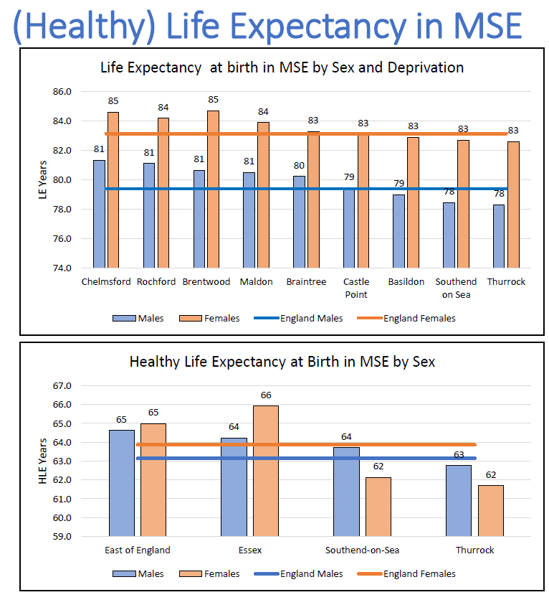

Figure 3: Life Expectancy at Birth in MSE

The areas that have a lower life expectancy overall, also tend to have greater inequality of life expectancy within their populations. The inequality gaps are greatest across Basildon, Southend and Thurrock, with the inequality gap across Chelmsford, Braintree, Maldon, Castle Point and Rochford being significantly lower, and lower than the national average (see figure 4).

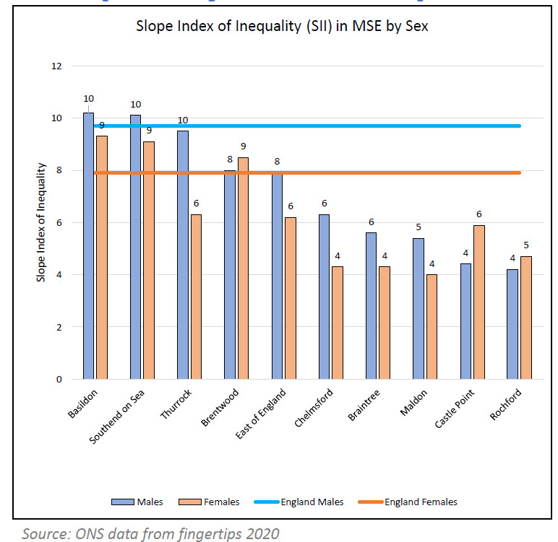

Figure 4: Slope Index of Inequality in MSE

Using data, both quantitative and qualitative, to better understand the specific drivers of health inequalities experienced by local residents is key to developing our services and to overcoming potential barriers to access, outcomes or experience. MSE is committed to using the ‘core20PLUS5’ frameworks developed by NHS England to help us understand and address health inequalities in our communities. This includes both the ‘core20PLUS5’ for adults and for children (See figure 5).

Figure 5: Core20PLUS5 frameworks

In addition to focusing on the needs of the communities that live in our most deprived areas, we have identified a number of local ‘PLUS’ groups for adults and children who live and work in mid and south Essex and are committed to working with partners and communities to develop plans for how we can address the barriers they experience in engaging with health and care services. The adult groups that have been identified as being at risk of experiencing poorer health outcomes in MSE are:

* Black and Minority Ethnic groups
* Carers
* People with Learning Disabilities
* People experiencing Homelessness
* Gypsy, Roma, and Traveller communities.
* Veterans

The groups of children and young people that have been identified as being at risk of experiencing poorer health outcomes in MSE are:

* Young Carers,
* Ethnic minorities
* Roma, Gypsy, Travellers,
* Looked After Children, Care Givers
* Learning Disability
* Special Educational Needs and Disabilities (SEND),
* Neurodiversity (ASD and ADHD, Tics and Tourette’s)
* Young people in the criminal justice system
* Families in Temporary Accommodation,
* Emotionally Based School Avoidance (EBSA),
* Unaccompanied asylum seekers, migrants
* CYP affected by Domestic Abuse

We remain committed to progressing this work through Alliance-level health inequalities funding and targeted system supporting priority areas.

As a Core20PLUS5 accelerator, with clinical, financial and programme ambassadors, we remain committed to embedding a focus on addressing health in equalities in all that the ICB does. This will include having a focus on ensuring that any recovery plans take account of the need to identify and address health inequalities alongside our drive to improve financial sustainability.

1. **Improve population health**

Traditionally the NHS has focused on treatment and curative activities. While we have, more recently concentrated on early identification and intervention, we recognise that we must play a full part, with our public health teams and wider partners, on prevention. As we seek to do this, we must recognise the importance of supporting more personalised care that responds to an individual’s needs and situation. Empowering patients to make informed choices and enabling a more personalised approach to managing their health and any treatment they may need should be embedded in how we offer care across mid and south Essex.

The importance of focusing on improving health overall was reinforced through engagement with our Community Assembly in February 2024. When considering the components of the Integrated Care Strategy’s ‘[Plan on a Page](https://www.midandsouthessex.ics.nhs.uk/about/integrated-care-strategy-2023-33/what-is-important/)’, those who were in the discussion highlighted prevention and early intervention as being the things they considered to be most important for the system to focus on.

Delivering on these ambitions is a core focus of MSE’s Population Health Improvement Board (PHIB). PHIB brings together stakeholders from across health, public health, local governance, alliances and community and voluntary partners to identify, develop and oversee delivery of plans to improve overall population health, prevention and reducing health inequalities. The PHIB is committed to focusing on joint prevention priorities relating to smoking cessation, supporting healthy weight, addressing wider determinants of health such as employment; and to using population health management approaches to support targeted programmes to improve health outcomes and tackle health inequalities. This PHIB will also support the five priorities for a Healthy MSE that have been identified by the ICP, working to support collaborative progress in prevention and action to tackle the wider determinants of health.

Improving the health of our populations is also a core focus of our place-based alliances which bring together and integrate services across a wide range of local partners in health, care and beyond. Central to this is the development of our Integrated Neighbourhood Teams and the development of our Primary Care Networks. This local approach supports delivery of personalised care, supporting patients to more involved in the decisions about their own care and their right to choose. Alliances are also lead local decision making on the best use of the Better Care Fund to support patients to access the care and support that they need as close to home as possible.

1. **Operational delivery**

The NHS in MSE needs to do more to ensure that patients can access high quality care at the right time, first time. The ICB remains committed to improving access to and experience of care for local patients and ensuring that patients can exercise their rights to choose which provider they receive consultant-led care from

The NHS is working to continuously improve how we offer care to our patients across all settings of care. In MSE we still have a long way to go to recover care in line with national targets in areas including: urgent and emergency care, planned care and cancer. We remain focused on using data, insights and benchmarking in relation to our activity, outcomes and experience to understand the areas where we are doing well, and the areas where we are falling short. Through our alliances and provider collaboratives we want to share learning and best practice and ensure a targeted focus on improving care for those who find care hard to access or are having a poor experience, specifically those who have identified health inequalities.

The longer-term ambitions for primary care in MSE will be updated through the primary care strategy, due for publication later in 2024/25. This will be the first integrated primary care strategy covering primary medical services, community pharmacy, optometry and dental services that has been produced by the local system. This will build upon “The Fuller Stocktake” (the development of Integrated Neighbourhood Teams), the local response to the Primary Care Access Recovery Plan and the Dental Plan. This strategy will be developed in dialogue with provider representation and wider stakeholders. The ICB recognises the importance of good access to primary care services as, for most people, this is where the majority of NHS provision is delivered. Sustainable and effective primary care will have a stabilising effect across the wider health and care system.

Whilst the strategy will provide a long-term direction of travel, the ICB will maintain momentum with the transformation of primary care services. We will continue to make changes in line with our Primary Care Access Recovery Plan. By the end of June 2024, all practices in MSE will have access to a cloud-based telephony solution. We will expand the number of self-referral pathways that our patients can utilise and promote these through social media, practice websites and other outlets.

We will promote access into community pharmacy, optometry and dental services who are best placed to support patients with a range of issues that currently present to general practice. We will support practices to use digital tools and new triage approaches to ensure that patient need is consistently assessed and managed in the most appropriate way and avoid the current 8am rush on phones where despite best efforts, need is often managed on a first come first served basis rather than being based on clinical need. We will work with dental providers to better support our population through increasing capacity in contracts, piloting innovative approaches to address specific needs and encouraging retention through career development linked to new services. We will improve collaboration between general practice and community pharmacy to support both providers with their long-term sustainability.

MSE is working closely with its Community Collaborative to explore ways that we can support more patients to receive care in the community where it is appropriate to do so. The introduction of Virtual Wards has supported more patients to receive more care at home, avoiding time in hospitals that can lead to greater deconditioning and greater cost to the system. Use of these digital solutions can also help reduce health system emissions and contribute to net zero ambitions. A review of Discharge to Assess pathways is underway to support more patients to return to their primary place of residence as fast as possible. Cross-system working throughout 2024 will support a shift to more ‘home first’ approaches that will improve outcomes for patients and help reduce demand on acute beds.

Further shifts from acute hospitals into the community will be supported by the development of Community Diagnostic Centres (CDC) in MSE. In January 2024 demolition work started to support the development of the Thurrock CDC, which will create new capacity in Thurrock to enable people to access diagnostic testing in the community. Further centres area also planned for Pitsea and Southend.

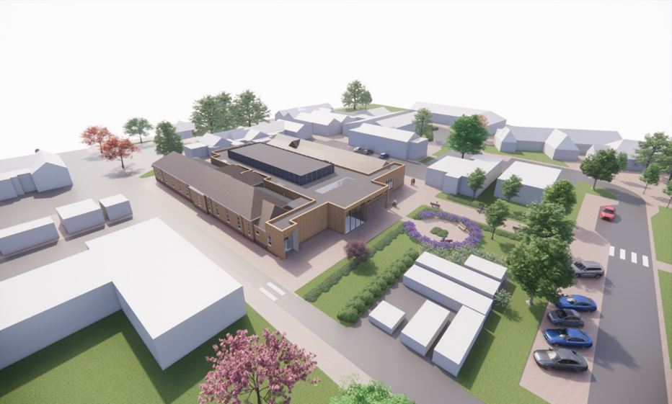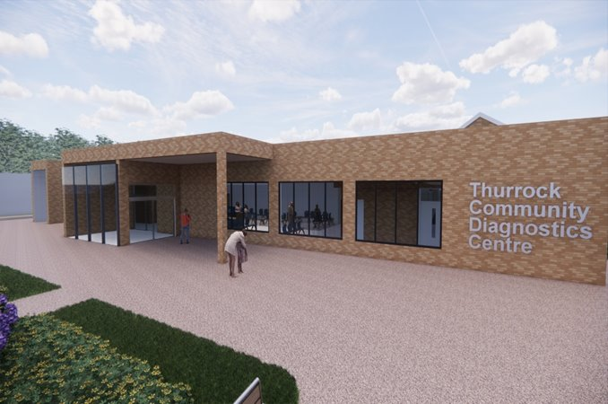

Figure 6: Artist impression of Thurrock CDC

To support improvements in Mental Health across our system we have developed a Southend, Essex and Thurrock All Age Mental Health Strategy in partnerships with our providers, local government colleagues, partnering ICPs and Essex Police. The vision that underpins this strategy is to promote good emotional and mental health for everyone, reduce health inequalities and to improve life outcomes for those with mental ill health, enabling them to recover and live well. Our work to improve mental health services must cover all ages, recognising the increased pressure facing today’s Children and Young People and the associated impact that is have on demand for services.

Working in partnership with education and the voluntary sector, we will be looking to find ways to increase support through prevention and early intervention initiatives that also address the health inequalities facing children support people of all ages with Learning Disabilities, Autism and others with neurodiversity in our community. We will review our support and develop a more sustainable model of provision for patients across Southend, Essex and Thurrock, with the aim of improving access and experience of support to all people who need it. This will also include a focus on ensuring that the ICB responds to the expected assent of the Downs Syndrome Act. This work will be overseen by the Southend, Essex and Thurrock Strategic Implementation Group, who will also ensure that activities support the broader ICP priority ‘Healthy Minds’.

MSE’s Growing Well Programme Board is being refreshed and will look to develop a strategy to improve care and support available to babies, children and young people in our system. This work, which considers both physical and mental health needs, will build on existing plans to improve care for children in areas such as: special educational needs and disabilities (SEND), asthma, diabetes, epilepsy, urgent and emergency care, oral health and end of life care. This work will support the ICP’s ‘Healthy Start’ priority.

Medicines optimisation looks at the value which medicines deliver, making sure they are clinically effective and cost-effective. MSE is working to reduce overprescribing to make patient care better and safer, support the NHS, and reduce carbon emissions. Work to reduce medicines waste, unnecessary prescribing and shift to lower-carbon inhalers will deliver both financial and carbon savings that can contribute to the NHS’ Net Zero ambitions. We are maintaining a focus on achieving antimicrobial resistance prescribing metrics and reducing risk of medicines-related harm from high-risk drugs through improved monitoring. Central to this is embedding shared decision making when prescribing and making better use of clinical decision support tools to reduce variation across MSE. Community pharmacists support patient care through delivery of a number of clinical services including New Medicines, Discharge Medicines, Blood Pressure Check and Oral Contraceptive Services, and most recently ‘Pharmacy First’ which launched in January 2024. Digital integration of community pharmacies with general practice and PCN Community Pharmacy Lead roles will support implementation of these initiatives.

Over the period of this Joint Forward Plan, the Integrated Care System will increase its focus on improving productivity across all parts of the system. We need to ensure that we are maximising the use of the resources that we have to ensure that people are being seen as quickly as possible in the setting that best suits their needs. We will continue to innovate and test new ways of supporting people to access care in the best way for their current needs, whether that is an urgent or planned care need.

To support the delivery of these operational objectives, we are continuing to review and strengthen how we govern our system through partnership working, but also effective oversight and assurance. Following the restructure of the ICB, completed in January 2024, we have undertaken a Corporate Review which has supported strengthened approaches across our Operating Model, Decision Making and Organisational Development, all of which are enabling our approach to Recovery. Through this work we have strengthened our risk management, with the introduction of Datix and a review of the Board’s risk appetite, agreed new strategic objectives, refreshed our governance following the annual committee effectiveness reviews and developed an Organisational Development programme that specifically responds to the challenges identified through our staff survey results.

### Enablers

1. **Supporting our workforce**

We want people to see the NHS in mid and south Essex as a place they want to work and build a career in. We want to attract a diverse workforce and support people from mid and south Essex to work and progress in our system. We want to train and maintain the best clinical and non-clinical talent and are aware that to do that, we need to create environments and opportunities that will appeal to all.

Developing our workforce to be able to deliver the care models of the future requires effective planning. Training clinical staff takes years, so we need to get better at mapping out our long-term workforce needs and supporting people through training and placements in our system. We want to keep building on exciting developments in medical and nursing training through local university partnership with Anglia Ruskin University and the University of Essex to create life-long careers for both those leaving school and those looking to retrain. We will also continue to develop our ‘One Workforce’ initiative to attract, train and maintain Healthcare Support Workers to the MSE NHS Workforce.

The NHS is one of the largest employers in mid and south Essex. Recognising this role as an ‘anchor’ in our community, MSE’s Anchor Ambitions programme continues to provide support for people looking for employment opportunities in the NHS and beyond.

People who work in the NHS in MSE have demonstrated, through their staff survey results, that we have work to do to improve our organisations, with less than 50% of staff working in either the acute trust or the ICB recommending our organisations as good places to work. We must take the time to understand the issues in our organisations and work to address them to attract and retain our talent, creating a culture and environment that people want to and feel safe and supported to work in. This is particularly true in the acute hospital, where high vacancy rates continue to drive use of more expensive temporary staffing which can also impact on the quality of care offered to patients.

We have made significant strides in our work to provide recruitment, retention and development support to our Primary Care workforce. The MSE Training Hub, supported by the ICB People Directorate and led by a team of Clinical Leads and Ambassadors, is highly regarded across the region for its best practice work in supporting primary care transformation and developing the current and new workforce required to deliver world-class patient care. The hub supports our PCNs with their breadth of workforce planning, including the embedding of new roles through the Additional Roles Reimbursement Scheme (ARRS). It develops, delivers and procures education and training for GPs and primary care teams. It supports educational placements in PCNs and practices and career support to staff from new to practice, mid and late career. The hub delivers clinical practice specialty and refresher training, development for clinical supervisors and educators, CPD and training in management and administration.

The ICB is fully committed to the implementation of the comprehensive NHS Equality Diversity and Inclusion Action Plan with its six high priority actions:

1. Measurable objectives on Equality Diversity and Inclusion for Chairs Chief Executives and Board members.
2. Overhaul recruitment processes and embed talent management processes.
3. Eliminate total pay gaps with respect to race, disability and gender.
4. Address Health Inequalities within their workforce
5. Comprehensive Induction and onboarding programme for International recruited staff.
6. Eliminate conditions and environment in which bullying, harassment and physical harassment exist

This plan provides specific actions that we know from evidence and data will make a real difference to our ambition to be a highly inclusive organisation but the plan always shows how we can learn and respond to lived experiences.

Our recently established Mid and South Essex People Board is leading the development and oversight of the systemwide plans to support all this work and help us ensure that we attract, train and retain staff to help us deliver high quality and high value care to our patients. Below are some of the initiatives we will be implementing over the next 12 months, to meet our NHS workforce challenges in Mid and South Essex:

**Train**

* Identifying hot spots where targeted recruitment and retention is critical and highlighting where enduring unfilled vacancies can be addressed with new skill mixes and new ways of working.
* Build on recent success through a ‘grow our own’ approach in hard to fill roles e.g., developing and retaining Clinical Assistant Psychologists (CAPs) and converting long term agency staff to permanent contracts.
* In primary care, strengthening the multi-disciplinary approach and ongoing utilisation of ARRS funding. Targeted action to recruit and retain key primary care roles, including GPs, nurses, community pharmacists, NHS dentists, and dental nurses. Leveraging MSE’s exemplar Primary Care Training Hub and associated Clinical Ambassador roles, to address capability gaps and build peer support and learning networks.
* Develop programmes through the Health and Care Academy that respond to areas of short supply.
* Work with Higher Education Institutions to support clinical expansion linked to long term workforce plan and trajectories to 2037.
* Realistic mapping of potential workforce supply based on current performance, undergraduate trajectories, local demographics, and turnover.
* Healthcare Assistant Academy model to support induction & retention of Health Care Assistants (HCAs) and promote a joined-up approach to recruitment, retention & training/on-boarding.
* HCA academy led centralised induction programme to increase training capacity and quality of induction.
* Increased engagement with HCAs and educational settings providing the Health and Care Certificate to expand outreach.
* Expansion of College Enrichment Programme to engage with and develop Health and Social Care Further Education Students, providing a clear understanding of the Healthcare Support Workers role and an early recruitment pathway into health and social care careers.
* Ongoing development of pre-employments programmes and wrap around provision to aide retention and widen participation, attracting job seekers into careers in health care.
* Exploring innovative recruitment processes (candidate apps, voice activated application forms etc.).
* Expand Apprenticeship offer.
* In MSEFT, establishment of a new leadership faculty to co-create capacity and upskill leaders across the trust.
* Development and implementation of student engagement programmes for nursing students to bolster Registered General Nurse and Registered Mental Health Nurse pipelines and reduce reliance on market-driven supply.
* Analysis of newly qualified nurse’s experience (placements, induction, preceptorship training and first 12 months of employment) to inform improvements.
* Implementation of a new Central Placements Platform across MSE to increase the quality and variety of placements and the efficiency with which they are scheduled. The platform will also improve visibility of and access to undergraduate student numbers and allow for early engagement and proactive recruitment.
* Further develop our system wide clinical capacity and expansion group to meet the demand for an increase in the workforce numbers across all disciplines in the next 9 years.

**Retain**

* Developing system-wide legacy practitioner vision. Building awareness and understanding of the value of this role in supporting the recruitment and ongoing workplace support (and therefore retention) for Nursing Associates, newly qualified practitioners, Trainee Nurse Associates, and other students. Increasing the number of legacy practitioners will be key, as critical mass will help establish and embed the role.
* A similar advocacy/sponsorship approach will be taken to healthcare assistant champions, Physician Associate leads and Advanced Clinical Practitioner Leads across organisations (and recognising those roles in permanent Establishments).
* Ambition in MSE continues to be a workforce strategy that is clinically led, and work will continue in 2024 to secure the sponsorship of clinical leaders to the adoption of new roles and increase their receptiveness to new skill mixes.
* Driving the take-up of internal apprenticeship pathways to bolster staff development and enhance clinical skills.
* Ongoing commitment to the expansion of flexible working policies.
* Focused work on the retention of undergraduates (including those out of area).
* Ensuring a systematic and high-touch approach to the offering of employment to nursing graduates within the system at the beginning of their final year of placement.
* HCA Academy focus on retention of new to care HCAs with a particular focus on the first 12 months.
* Fully embedding the six high impact actions in the NHS Equality, Diversity and Inclusion Improvement Plan into recruitment, onboarding, talent management and Learning and Development initiatives across MSE.
* Further develop the system Wellbeing and Retention Group.
* Implementation of the ICB’s Organisational Development Strategy that responds to challenges from recent restructures and poor staff survey results through:
  1. launching of new core values, prioritisation, and the development of a clear narrative and delivery plan
  2. Focusing on talent management and development, with a particular emphasis on building capabilities and capacity in change, innovation and transformation
  3. Leadership and line manager commitment to developing a compelling vision and roadmap for the future that will encourage staff to stay
  4. Ongoing implementation of Freedom to Speak Up policies, ensure that people feel able to speak up and contribute ideas to improving patient experience and service delivery.
* Implementation of MSEFT’s 2-year improvement programme that responds to its People Survey of 2022 and recently reviewed in light of 2023 survey results. Its ‘Valuing Our People’ programme focuses on 7 areas of improvement: 1. Embedding Zero Tolerance to Bullying, Harassment and Discrimination. 2.Reducing pay errors and Inequity. 3.Improving your Working Environment. 4.Prioritising your Wellbeing and Development. 5.Improving Communication and Engagement. 6.Increasing Recognition and Organisational Pride. 7.Improving Leadership Visibility.

**Reform**

Given significant financial deficits relating to workforce, financial improvement plans are in place to support urgent reduction in temporary staffing. In the Acute, the cost drivers are urgent and emergency care, elective care and cancer care. In the Mental Health Trust they are increased acuity, observation and engagement.

Essex Partnership University NHS Foundation Trust:

* Eliminating long term agency placements, tightening rostering practice, increasing Direct Engagement uptake for medics and AHPs; potential transfer to NHS Professionals Secondary Bank and re-negotiating rates with preferred suppliers.
* Targeted work on staff groups with high temporary staffing spend (especially Community nursing), while maintaining Time to Care safe staffing levels.
* Establishment Control panels in place for all care units and corporate services.
* Recruitment strategy for consultant posts.
* Active establishment controls.

Mid and South Essex NHS Foundation Trust:

* Nursing, Medical and Corporate Assurance - senior leader approvals on resourcing.
* Improved rostering processes in train (now need to be scaled, including all medics onto e roster)
* Regular audit of most costly locums, alongside clear recruitment plans to fill posts. Maternity and paediatrics areas of particular challenge, due to sickness levels and vacancy gaps.
* Improved accuracy of staffing categories – specifically ‘unique post identifiers’
* Upskilling and training for off framework and booking approach.
* Review of doctor’s bank booking platform with view to more robust controls
* Push to move staff from temporary to substantive.
* Active establishment controls.

1. **Data, digital and technology**

We know that healthcare is lagging behind many sectors when it comes to making best use of both its data and the potential that technology has to offer. The ICB is committed to working collectively to improve both the data and intelligence that we have and use in our system, and the use of digital and technology solutions that will improve the staff experience of delivering care and the patient experience of receiving it.

MSE is the first system in the country to commit to implementing a Unified Electronic Patient Record (UEPR) across our local providers. Mid and South Essex NHS Foundation Trust (MSEFT) and Essex Partnership University NHS Foundation Trust have jointly procured a technology partner that will see them have the same Electronic Patient Record system in place. The trusts are targeting quarter two of 2026, which is subject to investment case approvals and contractual agreements. This joint approach will allow for more integrated care pathways across our acute, mental health and community pathways, offering a better experience for patients and staff.

In implementing the UEPR it is expected to deliver significant cash releasing and non-cash releasing benefits. Detailed benefits scoping has identified opportunities around reduced agency, local and temporary staffing costs. A reduced need for managing paper and consumables. From a clinical and operational perspective, the UEPR will drive standardised care pathways reducing unwarranted clinical variation. It will enable the trusts to optimise care services improving productivity across the organisation. Using new technology the UEPR will also improve system compliance and resilience for cyber security.

Across our Health and Care partners we are working to implement a Shared Care Record. This will enable information to be shared across health and care partners and provide capabilities that can support joint ways of working, helping to underpin the transformation needed to deliver on our operational and clinical priorities.

Across MSEFT and EPUT work continues to implement our digital patient interface with appointments and diagnostic information being shared electronically to patients across both organisations by Oct 2024.

The success of Virtual Wards in MSE demonstrates how effective use of technology can transform how we deliver care and deliver broad benefits across the health system, such as reducing emissions. We must continue to build on these successes to implement proven technologies that will allow us to transform and improve how we deliver care at all stages of the pathway. As we do this, we will continue to support our staff, partners and patients to receive the training needed to help them improve their digital literacy and use of emerging tools. An example of this is our primary care ‘tiger teams’ that are working to help local practices maximise the use of new technologies and data that is available to them.

As we improve our ability to collect data and integrate our data, we must continue to work on our supporting data and digital infrastructure so that we can generate and use insights to inform improvements in planning and operational delivery. Alongside the technical platform that will allow greater integration and data reporting, we will continue to train and develop our staff to draw out and use the insights that such solutions provide. As part of this work the ICB and its partners are exploring how best to utilise the opportunities of the nationally provided Federated Data Platform.

Engaging patients and communities in how we are developing our data, digital and technologies across the NHS is key. It is important that we ensure that digital solutions enable the provision of care, and don’t increase digital exclusion or become a barrier to access. We must recognise the differential needs of our population and ensure that we are listening to where technology can help, as well as being transparent in our plans to use data to improve how and what care we provide.

1. **Financial sustainability**

MSE ICB remains committed to delivering high quality care that offers value to the taxpayer. As the system enters another year facing a significant financial deficit, there is a significant challenge ahead to develop and deliver plans that will allow us to live within our means and meet the needs of residents.

As the financial challenges in the system increase, the financial scrutiny and oversight also increases. In April 2024, MSEFT was placed in segment 4 of the NHS Oversight Framework, meaning that the Trust will now be receiving additional recovery support and additional scrutiny from NHS England. In addition, the whole system has entered ‘triple lock’, with more financial decisions being reviewed by both the ICB and NHS England. Collectively, this is increasing the focus on how we are managing all components of our financial plans. This includes the significant pay costs across our NHS providers, which still includes a high volume of temporary staffing, as well as non-pay and non-healthcare service costs.

Alongside this review of spend, it is important that we consider where we have made investments that have not added value. In a system that supports innovation and improvement it is important that we continue to test ways to improve our services. However, it is equally important that we evaluate those investments and review the impact that they have had. If things are not delivering the expected impact, we must commit to stopping them and considering alternative uses for that investment.

To further support our commitment to achieving financial sustainability, the system has committed to a review of corporate functions and areas which might drive efficiency and savings by consolidating our ‘back office’ functions across multiple system partners. A system-wide NHS infrastructure strategy is also being developed to explore opportunities to make better use of the physical assets we have to support patient care and improve the health of our local communities.

Through the newly appointed Executive Director of System Recovery, the system will continue to interrogate its costs and activities to identify opportunities for efficiency and productivity in how we work. In addition to using available tools, to benchmark opportunities for improvement, the system will continue to look at how it can transform care to offer better outcomes for better value.

We are embarking on the development of a medium term plan during the summer of 2024 with the expectation that by early Autumn we will have a system wide medium term financial plan which sets out the key changes across the system, and within Mid and South Essex NHS Foundation Trust that will result in both the Trust and the wider integrated care system achieving financial, operational and clinical sustainability. This plan will set out the key actions and timelines for delivery.

1. **Research and innovation**

Research and innovation are integral parts of the NHS constitution and key enablers in driving improvements in clinical care. They can help attract additional investment into the local system and broader economy, can provide greater opportunities for staff to expand their experience and career opportunities and offer benefit to patients and the public through opportunities both participation and improved outcomes. As our ICB continues to mature, we will develop our strategies for both research and innovation.

**Research:**

MSE aims to publish an updated research strategy later in 2024/25 that will draw on organisational strategies and plans that are already in place across MSEFT, EPUT and our university partners. The strategy will ensure that we are supporting research across all settings of care, increasing our focus on research in primary and community care and the wider determinants of health. This will be aligned with the work of the newly established Greater Essex Health Determinants Research Collaboration (HDRC). The strategy will help increase the system’s overall awareness of the value research offers in relation to improving patient care, partnership working between organisations and with patients and the public and funding opportunities. The research strategy will also be informed by the work we are currently undertaken through our Research Engagement Network project, which is looking to increase engagement from groups that are traditionally under-represented in research.

**Innovation:**

In developing an innovation strategy, MSE will continue to build on its established track record of innovation, including its local Innovation Fellowship programme for staff working in our health and care system, hosted by MSEFT, who also host a number of national innovation schemes. These schemes demonstrate the value we place on supporting our staff to innovate, test and learn.

Our innovation strategy will draw on the organisational strategies that already exist across the system, such as the EPUT Innovation Strategy for 2023-2026 which focuses on opportunities to optimise physical infrastructure and digitally connected things, quality improvement and innovation in working practice and digital and technology innovation. As we do this, we will explore options to expand our innovation programmes and not only test new ideas, but also focus on scaling proven innovations that can improve outcomes and value in our system. We will remain open to new and evolving technology innovations, including the potential AI has to transform not only care delivery, but also efficiency and effectiveness in clinical and corporate support services.

MSE is part of the University College London Partners (UCLP) Academic Health and Science Network, which reaches into North East and North Central London. We will continue to work with UCLP in implementing proven innovations and practices that will help us improve the health of our local population. We will focus our adoption of innovation in areas of strategic and operational clinical priority such as cardiovascular disease, frailty and cancer care.

Alongside these strategies, we will continue to evaluate and report on the impact investment in research and innovation is having in our system and our broader economy. It will be important to recognise that not all research and innovations will deliver the expected benefits, but reporting on and learning from work that doesn’t succeed is as important as continuing to invest and scale what works so that we remain a learning system.

# Section 2: Delivery in 2023/24

This section of the Joint Forward Plan (JFP) sets out some of the things that Mid and South Essex Integrated Care Board (MSE ICB) has delivered in 2023/24 against the strategic ambitions that we set for our system.

### Partnership

1. **Let Staff Lead**

MSE’s Stewardship programme has continued to bring together clinical and operational leaders to focus on how we can best ‘steward’ our resources to improve the care we provide to patients in MSE.

Our Stewardship Expo events, held in October 2023 and April 2024, demonstrated the progress made by our Stewardship groups, including:

* **Urgent and Emergency Care (UEC)**: Our UEC stewards have established and trialled a new Unscheduled Care Co-ordination Hub (UCCH) to test a new way of supporting patients with an urgent need to access the most suitable pathway to meet their needs through a central co-ordinating multi-disciplinary team (MDT). The trial has demonstrated that a coordination hub of this kind is effective in directly people to the pathway most suitable to them, which can reduce pressure on Emergency Departments and reduce Ambulance waiting times. Over 44 active days in 2023/24 the UCCH saw over 1100 patients, with over 560 (51%) of referrals being referred to an alternative urgent care pathway, therefore avoiding an attendance at the Emergency Department.
* **Cancer:** Our multi-disciplinary group of cancer leads are using a new cancer dashboard to better understand where the challenges are across our cancer care pathways and are working to introduce projects that improve patient case finding and offer more personalised care to our patients.
* **Ageing Well**: Our ageing well stewards have focused on how they can support people in MSE to age better through more empowered choices and control over their health and wellbeing, whist offering more efficient care. Through new assessment and reporting tools (FrEDA) and improved use of electronic registers and data they have develop an Ageing Well Dashboard that captures and measures the things that really matter and make a difference for patients. This has allowed them to identify 12,000 new people with frailty, dementia or end of life needs since April 2022. This work has supported a 5% reduction in 30 day hospital readmission rates, a 50% reduction in rates of older people with more than three unplanned hospital admissions in their last 90 days of life, around 10,000 hospital bed days saved through the Frailty consultant hotline that is helping avoid emergency attendances and over 3,000 people supported through Frailty Virtual Wards.
* **Stroke:** Our stroke stewards have supported improved stroke education across our ICS, expanded Level One psychological care for stroke and increased access to rehabilitation assistants in community settings. This has supported an improved Acute Sentinel Stroke National Audit Programme rating to an ‘A’. Stroke Stewards have also supported work on the development of the community rehabilitation stroke pathway, including recommendations on increasing the number of stroke rehabilitation beds across MSE, which is currently was consulted on between January and April 2024.
* **Diabetes:** our diabetes stewards have worked to increase referrals into the NHS Type 2 Diabetes Path to Remission Programme which can help support patients lose weight, improve their blood sugar levels and reduce diabetes-related medication. Their focused approach used digital tools to identify patients eligible for the programme, increasing awareness with both clinicians and patients to increase referrals by over 100 a month since the programme started in November 2023, enabling MSE to deliver the highest referrals in the East of England.

In addition to the Stewardship Programme, we continue to support the development of our clinical leads through our Leading Better Together programme, which has supported over 40 people in 2023/24. Our broader Lunch and Learn sessions, open to all MSE staff who have expressed an interested in developing as a clinical leader, had 160 people undertake leadership development during 2023/24. We also saw 120 aspiring, emergent and established clinical and care leaders (from primary, community, third sector and social care stakeholder organisations) come together at our MSE Leading Better Together 2023 conference with keynote speech by Prof Claire Fuller, NHSE National Medical Director for Primary Care, to underpin and share learning about PCNs, INTs, and the Fuller Stocktake, combined with wellbeing coaching for leaders.

1. **Mobilising and supporting communities**

Work with our community, voluntary, faith and social enterprise sector partners has progressed through our Alliance partnerships and our system-wide Community Assembly. The Community Assembly was established in 2022 but continues to be a work-in-progress as we work with the sector to consider how we can best partner with them to support our local communities through the collective power of our assets.

Our work to engage and involve public and patients has been strengthened through our new [Virtual Views](https://virtualviews.midandsouthessex.ics.nhs.uk/) platform, launched in November 2023, which provides an online community where people can share their views, experiences and ideas about local health and care services. Virtual Views is supporting conversations across the system, within our Alliances and on specific projects and issues, including women’s health services, our Research Engagement Network and proposed changes to local community hospitals.

In November 2023, four Transfer of Care Hubs (TOCHs) were established across MSE, one per Alliance footprint. Each TOCH facilitates “pulling” patients from the acute hospital into the community pathways including the emerging Integrated Neighbourhood Teams (INTs). NHS Alliance Directors are working in collaboration with community health services, emerging INTs and Local Authorities to effectively build on the existing infrastructure. A multi-disciplinary working approach supported by wider partners including housing and Voluntary, Community or Social Enterprise sector (VCSE) enables a targeted focus on enhancing flow, reducing length of stay and improving the experience and outcome for residents.

In 2023/24 nine initial Integrated Neighbourhood Teams (INTs) were established across MSE and have undergone assessment against an agreed framework. The assessment indicates that all INTs are anchored in neighbourhoods acknowledged by the community. Core providers are positioned at the heart of the INT, and incremental transformation is grounded in shared learning and collaborative efforts. To support this, South East Essex Alliance have established a Strategic Integrated Neighbourhood Group (SING) that brings together key voluntary and statutory partners from all eight neighbourhoods to oversee the development of local INTs.

Examples of community initiatives that have been delivered in 2023/24 include;

* **The Langdon Hills Estate Residents Association (LHERA)** created the Duvet Project aiming to distribute duvets to vulnerable residents, to provide warmth due to the escalated cost of the estates uncapped District Heating unit price, which had increased by 201% alongside the impact of the rise on the cost-of-living. In total of 65 duvet sets and duvets, six pillows and six baby blankets were delivered supporting over 80 residents on the estate including: 18 single residents, 21 couples and 13 families with 28 children.
* **Sound and Vision (Sensory) CIC** supports deaf, blind and sensory impaired people to access their community, take part in leisure activities, enjoy positive mental health activities and much more. Through their support, deaf, blind and sensory impaired people are able to access activities they would like to experience to improve their well-being. They have received funds through the MSE ICB Inequalities Microgrant Programme, to introduce new activities into deaf blind people’s lives by providing specialised support at no cost to them.
* During 2023/24 **Neurodivergent Safe Space – Southend** received funding from the Inequalities Microgrants Programme to provide free community mental health support group. The service provides support for neurodivergent (ND), autistic, PDA, attention deficit hyperactivity disorder (ADHD) teens and young adults, between the ages of 13-20 years who are experiencing mental health difficulties.

1. **Further Developing our System**

During 2023/24 we have continued to support the development of our collaboratives across the system, including:

* Continued development of our local place-based Alliances as local partnerships focused on identifying and addressing the needs of our local communities.
* Launch of the new Primary Care Collaborative in February 2024 as a place for us to bring together stakeholders working across the breadth of primary care to discuss how we can continue to develop services to best serve local patients.
* Consolidating our Community Collaborative across Essex Partnership NHS Foundation Trust, North East London NHS Foundation Trust and Provide Community Interest Company. The Collaborative has supported the development of a staff ‘passport’ to allow more flexible working across the Collaborative and is focused on identifying and removing variation in service provision to improve the quality of and access to care across the whole system.
* The development of the Southend, Essex and Thurrock Mental Health Strategy has set a vision, supported by a set of actions that will see improve health and care outcomes for local people.

1. **Improve Oversight Framework Rating**

In 2023/24 the NHS across MSE has demonstrated improvements in a number of areas, including:

* Quality improvements at MSEFT that led to an improved Care Quality Committee (CQC) rating from ‘inadequate’ to ‘requires improvement’
* East of England Ambulance Service NHS Trust (EEAST) coming out of special measures in two areas, with the CQC lifting two additional conditions on its licence

During 2023/24, MSE continued to face significant financial challenges across the system, with both of the providers within our control total ending the year with financial deficits. Given this, the system has been working under a ‘triple lock’ arrangement since February 2024, with all expenditure requests for over £25,000 facing additional assurance from both the ICB and NHS England. Through this process we are starting to realise benefits of collaborative system working through better forward planning in both delivery and procurement.

### Delivery

1. **Improve Quality**

In 2023/24 the ICB has focused on improving its governance and assurance around the quality of care provided for our residents. This has included implementing the Patient Safety Strategy and Patient Safety Incident Framework; establishing the Quality Committee and the System Quality Group; implementing a revised safeguarding structure across the system and reviewing our approach to managing complaints. A key component of each Quality Committee meeting is a deep dive review and the presentation of patient voices around a particular area of concern. This has been particularly successful and impactful and driven real quality improvement in areas such as eating disorder and maternity services. Going forward the Quality Committee aim is to strengthen this process therefore improving patient experience outcomes.

Through the leadership of the Nursing and Quality Team, all providers have had their Patient Safety Incident Response Frameworks and Plans approved, formally ratified by the Executive Chief Nursing Officer in line with national Patient Safety Framework. Through the delegation of oversight to ICB, the Patient Experience team are now overseeing concerns and complaints relating to primary care, pharmacy, optometry, and dental services. The analysis of complaints and concerns will help support identification of emerging risks to service provision across the system and enable the primary care quality team to engage with providers to ensure standards of care delivery and access are sustained and improved across the system.

The Primary Care Quality Team has worked both proactively and reactively with general practices to improve the quality of care we can offered to our patients. The team has supported a number practices who have received poor Care Quality Commission reports to systematically address the issues identified by the CQC. On re-inspection, the majority of practices subsequently achieved good outcomes. Proactively, the team reach out to practices to pre-empt issues and provide guidance and support to avoid deterioration.

1. **Reduce health inequalities**

Each Alliance has a local health inequalities programme which oversees the investment of its health inequalities funding, in partnership with a designated ‘Trusted Partner’. Local activities and investments vary, based on the needs of the community, but examples of successes include:

* Improved Health Check performance across Basildon and Brentwood, with more people with Learning Disabilities having a check in 2024 (61%) compared with 2023 (56.5%) and over 60% of people with serious mental illness having a check.
* Health and wellbeing cafes introduced across Basildon and Brentwood Primary Care Networks to increase engagement with local residents and provide information on key topics, such as winter readiness. The hubs have also supported people attending homeless shelters to register with local GP Practices so they can receive the support they need.
* **Case study: Mobilising communities – Central Basildon INT**

643 patients with high attendances in primary care and A&E amassed 12,000 GP appointments. The approach reduced attendances by 48%. 6,000 GP appointments freed up, with patients being supported through care co-ordination, with a 30% reduction in A&E attendances for this cohort.

Health & Wellbeing Café - Participants noticed positive changes since attending the cafe and talked about feeling happier, calmer, and more centred. There was evidence that feelings of wellbeing were not just during the cafe session, they also seemed to have a positive impact on life beyond the cafe and small healthy lifestyle changes were mentioned with a sense of pride.

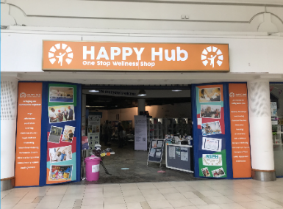

* Achieve Thrive Flourish (ATF) is a strategic partnership for local delivery of a Sport England pilot focused on supporting wellbeing in Basildon. One of our PCNs in Basildon is working in partnership with Active Essex to support the West Basildon Wellbeing café, which is hosting one of the PCN social prescribers. This work is supporting social prescribers to support the local population, including attending homeless shelters to support individuals not yet registered with a local GP practice to register and access the ongoing support they need.
* PCNs in Southend have worked with the Innovations in Healthcare Inequalities Programme (InHIP), delivered through University College London, to use an outreach vehicle to deliver services to communities at high risk of CVD in the heart of Southend.
* MSE ICS teamed up with Ford and local community health leaders to identify and assess the effects of ‘long covid’ by offering a mobile clinic specialising in spirometry, BP and ECG testing in the Ford Transit Van. The Transit houses the equipment, allowing NHS clinicians and health workers to offer a ‘one-stop-shop-service’ to assist residents in the county that may have mobility issues, language barriers or live in more rural areas of the town. Due to the success of this programme of work plans are in place to enhance this model further during 2024/25.
* Thurrock PCNs and Thurrock Public Health designed a new holistic approach to care, setting up and designing their own multiple morbidity clinics and interventions focused on cardio-vascular diseases, supporting the management of existing conditions and lifestyle support services. The clinics are overseen by an advanced nurse practitioner and include social prescribers, community pharmacy, as well as Thurrock Healthy Lifestyle Service for smoking cessation, and weight management.
* A new innovative project called Greening Southend Queensway in working to improve the outdoor green spaces on the Queensway estate and support the improvement of the communities’ health and care. The project, delivered by mental health and wellbeing charity [Trust Links](https://www.trustlinks.org/) and funded by the SEE Alliance Health Inequalities grant funding from 2022/23, will give people living in the Victoria Ward access to green spaces and get them involved in physical activities outside to improve their own communities, while improving residents’ mental and physical health, as well as decreasing social isolation. This is particularly important as population health data about the residents highlights that they often have multi health conditions including, severe mental illness and [chronic obstructive pulmonary disease (COPD)](https://www.nhs.uk/conditions/chronic-obstructive-pulmonary-disease-copd/). It’s also been highlighted as a coastal community with pockets of deprivation hidden amongst relative affluence. In addition, it’s in the top 10% most disadvantaged areas in England according to the [Indices of Multiple Deprivation (IMD) 2019](https://www.gov.uk/government/statistics/english-indices-of-deprivation-2019) and is therefore a target area for the NHS under the [Core20PLUS5](https://www.england.nhs.uk/about/equality/equality-hub/national-healthcare-inequalities-improvement-programme/core20plus5/) inequalities framework.
* **Case study: Population health improvement – greening Southend**

Greening Southend Queensway has been launched to improve outdoor green spaces and support the improvement of the community’s health and care.

The project, delivered by mental health and wellbeing charity [Trust Links](https://www.trustlinks.org/) and funded by the SEE Alliance Health Inequalities grant funding gives people living in the Victoria Ward access to green spaces. As a coastal community it has been identified as having pockets of deprivation hidden amongst relative affluence and data shows residents have multiple health conditions such as severe mental illness and chronic obstructive pulmonary disease.

The project gets residents involved in physical activities outside to improve their own communities, while improving residents’ mental and physical health, as well as decreasing social isolation.



* **Case study: Health inequalities – mental health joint response vehicle**

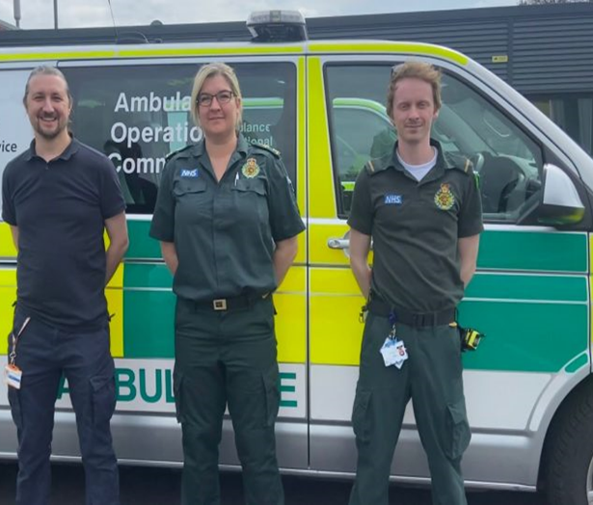

*“Since March 2023, I have been working for the local ambulance service… My role is to help introduce new and better ways of working, to improve access and outcomes for patients suffering with their mental health.  I am also helping to upskill ambulance clinicians and strengthen pathways so that the patients using the 999 system can gain access to the right mental health support early without the need for attendance to an emergency department….* *This now brings mental health care and support to the patient, and in most cases, the patients’ own homes.  The service is now covering mid and south Essex, 7 days a week 13.00hrs to 01.00hrs when we know we usually see the greatest* number of people needing help.”

**Claire Fuller, Mental Health Nurse**

The system’s CVD prevention programme been supported by £80,000 of funding from NHS England, allowing additional focus on health inequalities. The programme has enabled 2,000 monitors to be sent out to 19 PCNs and distributed to 80 practices in areas of high deprivation and has seen an additional 15 PCNs in areas with the greatest CVD needs in areas of greater deprivation of with higher black or Asian ethnic minority groups to sign up to the CVD Locally Enhanced Scheme.

Lung health checks taking place across MSE have helped diagnose 100 new lung cancers in residents.

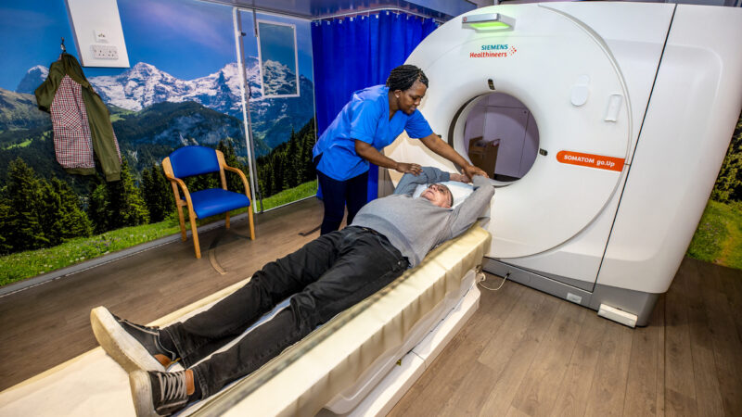**Case study: targeted lung health checks, improving patient care.**

Since 2020, people living in Southend and Thurrock (aged between 55 and 75), were invited to have a free NHS lung health check, which identified people at risk of developing lung cancer. Those at higher risk were offered a scan, then referred for treatment if needed.

More than 100 local people have now had previously undiscovered lung cancer found and treated.

Over 17,000 checks (Feb 2024) have been completed. In addition, nearly 10,000 CT scans and 561 referrals to follow up care, linked to cardio-vascular disease, gallbladder, respiratory, breast, gastro, urology, liver and renal findings.

1. **Population health improvement**

Work to improve the identification and management of cardiovascular disease (CVD) of those living in our community has been a priority for our system in 2023/24. We have continued to roll out the BP@Home programme, with nearly 98,000 people having participated in the scheme since March 2021 and improved GP practice information and patient guides that respond to patient feedback which highlighted, they have a lack of awareness and information on how to monitor their blood pressure at home as part of the scheme. The MSE Lipid QOF Enhanced Service has been introduced across 27 practices with a high percentage of CVD patient and low treatment to threshold performance rates.

Over the last year we have established in-house smoking cessation service for acute inpatients for behavioural support, nicotine replacement therapy or pharmacotherapy. This is supported with follow-up post discharge and referral to community stop smoking services. We have also improved support for individuals who are pregnant, offering smoking cessation support at their first contact with the pregnancy booking line and carbon monoxide monitoring at ante-natal appointments, which offers the opportunity for very brief advice and referral to in-house services.

During 2023/24, MSE has worked towards implementing the principles of a whole system approach to addressing obesity prevalence and supporting residents access to weight management services. To support this, the ICB has developed a weight Management dashboard which will inform future transformation work and has identified potential unmet need of 35,572, adults whose BMI is equal or above 30 or 27.5 for Black or Asian ethnicities and have diabetes or hypertension without a recorded referral into weight management services. We have also worked with local authorities to develop an integrated weight management service pathway and roadmap, commenced an outcomes focused evaluation framework which will continue into 2024/25 and inform Tier 3 re-procurement of specialist weight management services. This work is critical as demand for Tier 3 services continues to rise, with significant waiting lists in place across the system and the potential for new drugs to further drive up demand.

1. **Operational delivery**

In 2023/24, the ICB has continued its upward trajectory on the number of consultations being undertaken in primary care. As of December 2023, primary care in MSE had undertaken 7.1% more consultations than the equivalent period in 2022/23. The Primary Care Access Recovery Programme is supporting the roll out of Cloud Based Telephony to all practices, introduced a ‘total triage’ model across a number of practices and established 11 self-referral pathways into musculoskeletal services, weight management services, community podiatry and wheelchair services.

**Case Study: total triage – reducing the 8am rush**

*Staff said “the quality of contacts has dramatically improved, we are seeing the right patient first time, rather than patients having multiple contacts”.*

*Patients said: “The communication between the administrative staff & me was great. They explained the process clearly via the messaging system and sent me a booking link that morning with appointments at my local surgery.”.*

*“I used to dread being on hold for 40 minutes… [it] takes 30 seconds to use - I had to book to have stitches out and had an appointment within 10 minutes of my request and had to book 2 appointments for my son and he was seen an hour later. Really lovely nurse and doctor in both cases”.*

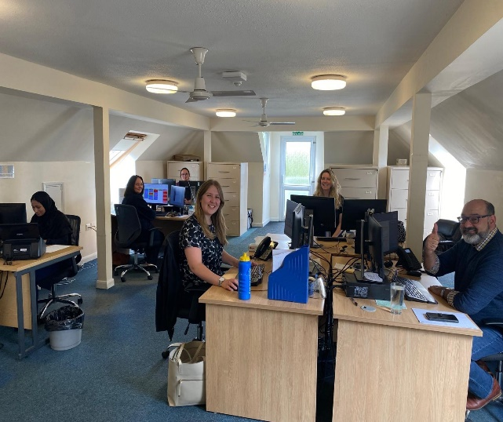

By working in partnership with PCNs, the ICB has made significant progress on the recruitment of the additional roles reimbursement scheme (ARRS). As of Month 9, we are forecasting an 87% utilisation of resource (£24m of £27.5m). This represents a £7.7m increase on 22/23. Whilst the overall satisfaction in general practice reported in the national GP patient survey remains below the national average, MSE’s results have plateaued in 2023/24, despite a national downward trend.

In the first year of delegation, the ICB has taken forward a number of initiatives to improve access to dental services and support the recovery of Units of Dental Activity (UDAs) to pre Covid pandemic levels. The ICB has established an urgent access pilot, care home pilot, allowed a number of contactors to deliver in excess of their contracted activity and recommissioned UDAs from contract hand backs.

Integrated Neighbourhood Teams (INT) have started to demonstrate positive results for patients and the system, with early results from the Central Basildon INT showing that their model has saved around 6,000 GP appointments across 650 patients, as well as reducing A&E attendances within the cohort by 30% and reporting improved staff satisfaction.

MSE has seen an improvement in delivery of Talking Therapy 90 day waiting targets. This will be further supported by a review of opportunities to harmonise services across MSE to both offer improved patient outcomes and value in the services that we commission. MSE has focused on improving delivery of annual health checks for people with severe mental health and the ongoing community care support they receive. We have also been reviewing our model of care for adults with eating disorders to offer an expanded model of care.

MSE is continuing to work to address the backlog of patients waiting to receive planned care treatment across the system. Currently there are still over 2,000 patients that have been waiting over 65 weeks for treatment. The system is also still not meeting the national cancer standards, with only around 62% of people getting a diagnosis or having cancer ruled out within 28 days of referral and only 38% of people having their first definitive treatment within 62 days of receipt of an urgent referral. Over 23% of patients are waiting more than six weeks for a diagnostic test.

The ICB has successfully reduced the rolling 12m antibacterial items /STARPU from 1.143 in April 2023 to 1.108 in December 2023 (latest data available) whilst maintaining proportion of co-amoxiclav, cephalosporins and quinolone items below 10% (8.53% in Dec 2023). It has also reduced overprescribing. In Oct 2022 there were 111,458 (10.87% c.f. 10.79% national average) people taking 8 or more unique medications (range across alliances 8.33% to 11.04%) and the average number of unique medicines prescribed for all patients in MSE was 3.66 compared with 3.53 nationally. In December 2023 figures had reduced to 37,690 (9.30% c.f. 11.15% nationally) and 3.37 compared with 3.58 nationally.

### Enablers

1. **Supporting our workforce**

Understanding our current workforce and planning for the future has been a key focus in 2023/24. The NHS Long Term Workforce Plan released in 2023 is the most comprehensive workforce plan in NHS history and provides a blueprint that can be tailored to the needs of our system. Its ambitious strategy includes three priorities of ‘Recruit, Retain and Reform’ which means retaining existing talent, making the best use of new technology and the biggest drive on recruitment in health service history.

To support this, MSE has been working towards a system-wide approach to workforce planning that is closely aligned to finance and activity planning so that workforce enduring vacancy information is shared across the system and a joint approach established to work to reduce vacancies and bank and agency utilisation. Workforce stratification is being used to understand workforce hotspots by specialty to support focussed intervention on recruitment. Retention, transformation and staff wellbeing.

Throughout the year, we have also been working in partnership across the system to support the introduction of new roles within each organisation which include Training Nurse Associates, Advanced clinical Practitioners Physician Associate, Enhanced Healthcare Support Worker roles and apprenticeships. We have also launched the Healthcare Support Worker academy launched as a ‘one workforce’ initiative.

As part of our ‘One Workforce’ strategy, we have launched a Healthcare Support Worker Academy to ensure a strong pipeline of Healthcare Support Assistants (HSAs). System-wide, the ‘Our People Your Future’ programme is in place, with its ambition to attract those who will ‘Be the future of health and care in Essex’, providing online courses, apprenticeship guidance, careers advice and job opportunities.

Looking forward to future generations of the workforce, Basildon Hospital is working as the pilot site for ‘Generation Medics in Essex’ is an Anchor Programme that connects the NHS in MSE with the local community to provide more opportunities for young people, reduce their environmental impact and create volunteering opportunities. The Programme brings together partners from across the healthcare system to understand how the Trust can be a real force for good and provide high-quality local employment, support staff in their professional development, and reach out to local partners to help them succeed.

**Case study: Anchor Programme – supporting our workforce**

In partnership with health and care (local councils) and the education sector in mid and south Essex, MSEFT (as one of the largest employers in the region) aims to provide more opportunities for young people, reduce their environmental impact and create volunteering opportunities, through the Anchor programme.

The programme brings high-quality local employment, supports staff in their professional development, and reaches out to local partners to help them succeed.

Basildon Hospital is the pilot site, with the programme set to expand to include all three hospital sites and communities across mid and south Essex later this year.

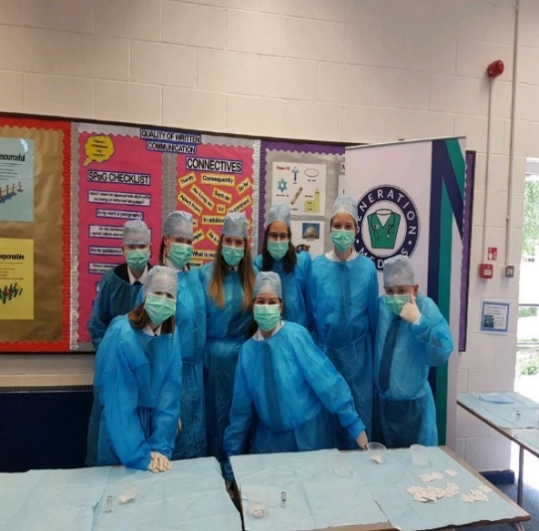

1. **Data, digital and technology**

MSE ICS has implemented Athena its strategic data platform. This platform provides self-service business capability across population health, primary care performance, mental health and UEC. It provides the insight which underpins our stewardship programmes and teams redesign care pathways and interventions. Moving forward the teams are reviewing how the Federated Data Platform can further complement and enhance our capabilities as a system.

Partners across MSE are on track to implement the first release of our Shared Care Record initiative by July 2024. The Shared Care Record will be accessible to our health and care partners across MSE. Future releases will take a clinical use case approach to ensure the Shared Care Record supports a patient centred approach to care provision across our partners.

MSE ICS continue the delivery of their digital patient interface solutions. We are live with demographic information across MSEFT and EPUT. With further releases providing appointment and diagnostic information being phased over July to October 2024. Both trusts are working with their services to support service specific transformation and implementation requirements.

Work to implement a unified Electronic Patient Record (EPR) across MSE, specifically across the two major NHS Trusts (MSEFT and EPUT) has also progressed in 2023/24. A preferred provider has been identified and planning for implementation, which will start post full business case approval and contract signature has begun. The Full Business Case is currently undergoing its national review. Our teams are working towards an approval date at the end of July 2024. The trusts are planning to go live in 2026 where they will aim to realise significant productivity, patient experience and clinical benefits.

The virtual hospital programme continued to progress during 2023/24 with the equivalent of an Emergency Department: the Urgent Community Response Team (UCRT) and at this stage three virtual wards, one for frailty, one for respiratory patients and one for heart failure, in addition to the acute led Hospital@Home service. As at February 2024, virtual wards have been at 100% occupancy with the exception of respiratory. Patient and staff surveys have been undertaken to assess ease of use and overcome any challenges faced. Analysis showed that 60% of patients entering the frailty virtual ward with some level of social care input achieved complete independence at discharge from the frailty virtual ward, requiring no package of care. Avoiding admissions to a physical hospital not only alleviates system bed pressures, it also reduces infection risks on physical hospital wards during a time of high occupancy and has the opportunity to reduce carbon emissions.

**Case study: virtual hospital – digital, data and technology**

* As of February 2024, virtual wards have been at 100% occupancy with the exception of respiratory.
* Avoiding admissions to a physical hospital not only alleviates system bed pressures but reduces infection risks on physical hospital wards during a time of high occupancy.
* The UCRT operates across MSE, with a single point of access offering a two-hour response time. It supports patients in their own homes (including nursing and residential care comes) for up to 48 hours, with others transferred to the virtual wards where clinically appropriate for up to 14 days.
* The virtual wards are multidisciplinary with medical oversight and leadership. The team includes registered nurses, physiotherapists, occupational therapists, rehabilitation assistants and health and care support workers.



The UCRT operates across MSE, with a single point of access offering a two-hour response time. It supports patients in their own homes (including nursing and residential care comes) for up to 48 hours, with others transferred to the virtual wards where clinically appropriate for up to 14 days.

1. **Financial sustainability**

Throughout 2023/24 MSE has continued to have a system-wide financial sustainability programme in place. Within the ICB this has included:

* A significant restructure during 2023/24, reducing running costs by 30% and is on track to reduce to £17.2m by April 2025.
* Closure of historic clinical commissioning group headquarters estates, except for Phoenix Court which remains as the ICB headquarters.
* Leading a system-wide programme to review options for corporate function consolidation and further collaboration, to offer best value to our population.
* Recruiting a new Health Economist to help us better evaluate the impact and value we gain from services to inform future planning and contracting. They have started working on a review of Talking Therapies service provision, Tier three weight management services and intermediate care provision.
* Initiated an NHS system-wide infrastructure strategy, to be completed in 2024 to help us understand our current estate and broader infrastructure, as well as opportunities for improving use and value across the system.
* Work with our procurement provider, Attain, to update internal processes to ensure the ICB is compliant with the new Provider Selection Regime (PSR).
* Appointing a new Executive Director of System Recovery working across the ICB and MSEFT.

Across the system, we have had confirmation of £110 million of capital, to support MSEFT to increase the number of beds, improve capacity in all three emergency departments, improve cancer and planned care by upgrading and expanding surgical theatres.

1. **Research and innovation**

**Research:**

During 2023/24, MSE has continued to draw investment in research and innovation, into the system. As part of that, MSE has secured funding from NHS England to develop a Research Engagement Network (REN) which is being developed in partnership with our main hospitals and members of our Community Assembly. The REN aims to help researchers in MSE provide a better service for groups that have traditionally been under-represented in research.

MSE has been undertaking research across the whole system, including studies in community and primary care such as:

* LISTEN: Long COVID personalised self-management support evaluation where nurses and our CRPs were trained to deliver a coaching-style intervention to those suffering from diverse symptoms of long COVID. We delivered 6 one-hour sessions to each participant, and it was hugely successful. We received positive feedback from our participants and as this was also a community study, not just primary care, we reached a wider population and helped those who were in isolated locations too.
* Chelsea 2: A cluster randomised trial of clinically assisted hydration in patients in the last days of life. We helped a research-naive hospice set up and run this study. Farleigh hospice was randomised to the intervention arm; therefore we evaluated the effects of receiving fluids during EOL. Our nurses and CRPs go over to the hospice to transcribe comprehensive data of the last 2 weeks of life for each participant.
* E-Plays: Enhancing pragmatic language skills for young children with social communication impairment. Evaluation of a computerised intervention to promote communicative development and collaborative skills in children. Many of our Luton schools have participated and the study is one of the biggest research trials on children’s language development ever to take place, which has given schools the opportunity to access a brand-new language programme free of charge.
* Small Business Research Initiative for Healthcare (SBRI): Recognising the unique challenges encountered by LD patients, particularly in healthcare settings, MSEFT collaborated with oVRcome to initiate an innovative project focused on addressing phobias and social anxiety in the comfort of patients' homes. oVRcome, a clinically proven smartphone app utilising virtual reality (VR) and exposure therapy, was tailored to meet the specific needs of LD and autism cohorts, empowering users to acclimatise to hospital environments at their own pace, alleviating associated anxiety and phobias. With funding from SBRI, we have successfully completed phase 1 of this research project which involved a pilot, developing scenarios familiarising patients with our different hospital sites, scenarios with needles and a few other busy environments. Following the success of phase 1, MSEFT applied and won SBRI funding for Phase 2 of the project, and we have committed to focussing on scenarios to tackle needle phobia, primary care environments (annual health checks etc) and diagnostics. So far, co-production sessions have taken place to establish the specific content to be covered, and we will be piloting these with LD participants in Autumn this year.

Across EPUT, work has progressed to provide more capacity to support research within the organisation and strengthen the relationships with academic networks within and beyond Essex. This capacity has supported the Trust to increase the number of clinicians able to act as Principal Investigators, created a forum to support nursing and AHP Masters students in their research, helped increase the volume and participation in trials and increase internal awareness of support for research within the organisation.

**Innovation:**

MSE has strong track record of support innovators and adoption of innovations, both locally and nationally. This is demonstrated through the MSE Innovation Fellowship, which supported 18 innovators within MSE in 2023/24. MSE also has a number of anchor innovation programmes, including:

* **Social Spark** – a Basildon Healthcare social innovation incubator that is exploring innovative ways to tackle healthcare inequality through social and economic solutions by supporting those in and around the Basildon area with great ideas to improve healthcare.
* **Accident and emergency youth project** – which is building on an existing model of youth worker presence in Basildon Hospital A&E between 3pm – 8pm, 5 to 7 days a week to provide a safe space for young people to explore their identity, experience decision-making, increase their confidence, develop inter-personal skills and think through the consequences of their actions.
* **Essex Pedal Power** – which provides free bikes for local NHS staff working at bands 2-4 at Basildon Hospital. The scheme recognises that there are a range of barriers to cycling that go beyond simply having access to a bike. As such, the Essex Pedal Power team will offer free cycle training in a safe environment with trained professionals and support you to maintain your bike. They will also help to create informal cycle groups to create a community of people who all benefit from cycling. Bikes are initially given to recipients as part of a six-month loan. If successful applicants are enjoying having a bike and using it regularly, at the end of the six months they can keep the bike for free. They will also receive a bike helmet, lights, pump, and a D lock free of charge.

Building on their success in supporting the national Clinical Entrepreneur Programme (CEP), in 2023, MSEFT co-developed the NHS CEP InSites Programme as a system capacity-building pilot programme to evaluate innovations supported by NHS England whilst also developing organisational capability and infrastructure in local systems.