Business Intelligence Strategy and Roadmap
27 January 2021

Table of Contents
1. Executive Summary 5
Problem, approach and vision statement for BI 5
A BI strategy with an achievable scope and approach 6
Overview of recommendations 7
Outcomes associated with the recommendations 8
A twin track approach for quick wins and sustainability 10
Alternative options for accelerating benefits realisation 10
2. Introduction 12
Purpose of this document and intended audience 12
Background and context 12
Why are we changing? 13
Our approach 14
Current state analysis 15
POPIT model 15
Interview methodology 16
Questionnaire methodology 17
BI app catalogue methodology 18
Health analytics adoption model (HAAM) 18
HCP-wide interview engagement 19
Questionnaire self assessment results 20
Interview findings - Processes 20
Questionnaire results – Processes 21
Interview findings - Organisation 22
Questionnaire results - Organisation 22
Interview findings – People 23
Questionnaire results - People 24
Interview findings - Information 25
Questionnaire results – Information 25
Interview findings - Technology 26
Questionnaire results - Technology 27
BI app catalogue findings - People 28
BI app catalogue findings – Systems 29
3. MSE HCP’s future vision and BI strategy 33
Future vision and BI strategy 33
3.1 Strategic vision and design principles 34
Captured strategic vision statements for BI 34
Forming the HCP’s strategic vision statement for BI 34
BI design principles and why they are important 35
BI design principles 36
3.2 BI Strategy 38
Recommended changes across POPIT 38
Overview of recommendations by POPIT area 38
Prioritisation of changes through a 3 phase approach 39
Phase 1: Delivering ‘quick wins’ (0-3 months) 40
Headline outcomes and benefits at the end of phase 1 41
Phase 2: Laying the foundations (3-12 months) 41
Headline outcomes and benefits at the end of phase 2 42
Phase 3: Accelerate improvement (13-24 months) 43
Headline outcomes and benefits at the end of phase 3 44
4. What does an advancing HCP look like? 45
4.1 Building a virtual BI hub 46
Mapping recommendations to this focus area 46
What is a virtual BI hub and why use it? 47
Aligning on a virtual BI functional model 48
The pros and cons of current state vs future state 48
What does the hybrid approach mean? 49
Proposed BI hub model 50
How responsibilities are divided between BI hub and organisations 51
Proposed virtual BI hub structure 52
Formation of the BI strategy board 52
Identified BI hub roles 53
Proposed resourcing of the virtual BI hub 54
Resourcing approach 54
How to enable the successful use of BI Hub 55
Business case and aligning on vision and principles 56
4.2 Establishing processes and governance structures 58
Mapping recommendations to this focus area 58
HCP central data governance framework 59
HCP data governance formation 60
Data governance framework 60
Data governance steering group 61
Data governance interaction model 62
Information Sharing Protocol (ISP) 62
Information Sharing Gateway (ISG) 63
Data governance - Process 64
Data governance - Data assets 65
Benefits of improved data governance 66
Reviewing reporting requirements/practices 66
Standardising BI hub service request process 67
BI best practices 68
4.3 Improving the data and establishing an agreed centralised repository 70
Mapping recommendations to this focus area 70
Improving the data - Data quality 71
Proactively managing data quality 71
Ongoing data quality improvement process 72
Formalising a data quality improvement framework 74
Data integrity and timeliness improvement plan 74
Data flows model 75
HCP BI architecture and common data model 76
Selecting the correct pilots to generate early buy-in 77
Potential pilot 1: Urgent and emergency care 77
Potential pilot 2: Population Health Intelligence 79
4.4 Designing and building the technology platform 80
Mapping recommendations to this focus area 80
Data storage and BI tools 81
Establishing an agreed centralised repository 81
HCP level data lake general principles 82
Introducing the components of a data lake 83
Technology architecture 84
Technology architecture in Microsoft Azure 85
Overview of Power BI dashboards 85
Advanced tools for future analytics 86
Developing a service management framework 87
4.5 Creating a data centric culture and workforce 89
Mapping recommendations to this focus area 89
Organisational culture 90
Embedding the right culture and behaviours 90
Creating a data-centric culture 92
Skills and capability 92
Change readiness assessment 93
Change readiness assessment 94
Technical skills gap analysis 95
5 Roadmap to Achieving an Integrated BI Capability 96
A twin track approach for quick wins and sustainability 96
Building the virtual BI Hub 98
Establishing governance structures and processes 100
Improving data and establishing agreed central repository 102
Designing and building the technology platform 103
Creating a data-centric culture and workforce 105
Appendix 1: Detailed breakdown of engagement across the HCP 107
Breakdown of engagement across the HCP 107
Appendix 2: Questionnaire development methodology 109
Appendix 4: Organisation specific primary research results 114
Organisation-level questionnaire results 114
MSE FT primary research results 114
EPUT primary research results 115
Essex County Council primary research results 116
Southend-on-Sea BC primary research results 117
Thurrock Council primary research results 118
CCG primary research results 118
AGEM primary research results 119
EEAST primary research results 120
Provide primary research results 120
NELFT primary research results 121
Appendix5: Questionnaire findings 123
Q12 - In your opinion, what are the main ways of improving information sharing or enriching the data shared across the HCP, if any? 123
Q18 - Are there any example processes in your job that would benefit from automation? Please provide examples 124
Q23 - What role types do you feel are important to sit across the Health and Care Partnership (HCP), to ensure a robust integrated BI capability? 124
Q28 - Are there any ways of improving the data integrity across the HCP or within organisations? 126
Q31 - Are there any ways of improving the data or KPIs produced to impact patient / citizen care? 127
Q32 - Does your organisation or team use cloud based technologies? If so, which solutions are used and how are they used 128
Q37 - Please list any improvement opportunities or ideas on how organisations can collaborate and share data more effectively across the HCP 128
Q38 - Please share any key challenges faced in your role or teams within your organisation that may limit building integrated BI capability across the HCP 129
Q39 - Can you list any use case examples of how your organisation would benefit directly from integrated data sharing HCP 130
Appendix 6: Detailed challenges, recommended changes and potential benefits 131
Processes – Why MSE HCP needs to adapt or change 131
Processes – recommended changes and benefits 133
Organisation – Why MSE HCP needs to adapt or change 134
Organisation – recommended changes and benefits 135
People – Why MSE HCP needs to adapt or change 137
People – recommended changes and benefits 139
Information – Why MSE HCP needs to adapt or change 142
Information – recommended changes and benefits 144
Technology – Why MSE HCP needs to adapt or change 145
Technology – recommended changes and benefits 147

Executive Summary

Problem, approach and vision statement for BI

Defining the problem - Business Drivers - The Why (Internal and External)
The Mid and South Essex (MSE) Health and Care Partnership (HCP) is moving towards becoming an Integrated Care System (ICS) and requires data and business intelligence capability to support its strategy and to apply a system approach to capturing, analysing and using data to better plan and execute its priorities. At present there are separate data sources, flows, and reporting systems between commissioners and providers, and these remain largely unlinked to wider system partners (e.g. local authorities, community and voluntary sector organisations).
There are complexities in data sharing and information governance, and a mixture of internal and external resources that are not aligned around a common set of priorities. There are also separate processes for managing operational performance that are often misaligned.

Our approach
During this 10-week piece of work the first 6-8 weeks were spent gathering information about the as-is BI landscape across the HCP through 22 stakeholder interviews, 3 workshops, 102 questionnaire responses, and 8 BI App Catalogues. Stakeholders from 10 organisations across the HCP were engaged. These findings were then analysed and key themes and challenges were drawn out. A target future state and BI strategy was then designed based on a combination of this analysis and experience from other organisations. A roadmap was then developed detailing activities and timelines required to reach the future state over the next three years. The BI strategy and roadmap was reviewed regularly and fine tuned by the core team.

Vision statement
The following vision statement, as well as a set of supporting design principles, were developed and agreed upon by the core team. The vision statement, alongside the design principles, should act as the anchor point for the BI strategy and set the foundation for accomplishing the HCPs goals. The statement should be reviewed and agreed by the virtual BI hub’s strategic board at the beginning of the roadmap journey.
“The Mid and South Essex Health and Care Partnership will use data to provide insight and enable evidence-based decision making with the aim of improving the health and wellbeing of the local population, reducing inequalities and addressing current and future needs.”

A BI strategy with an achievable scope and approach

Scope of this strategy
The BI Strategy and Roadmap set out in this document is focused on developing a BI capability to support the HCP. This strategy is not designed to transform the internal BAU reporting and BI carried out by each of the organisations that make up the HCP but where BI is required that spans multiple organisations, it will be covered within the remit of this strategy and roadmap.
This strategy proposes the development of a virtual BI hub which will support HCP-wide data and BI initiatives alongside current functions within existing organisations. This virtual BI hub will use a central data repository designed to integrate key datasets from different organisations to be used on HCP level BI services. It is important to note that this BI strategy and roadmap is designed to work independent of the choice of central data repository. The different layers of the future state are depicted in lower left diagram.

Incremental approach
This BI strategy is not recommending a ‘big bang’ approach to developing a HCP BI capability, as there is simply too much to do for this to work. Instead a pragmatic, incremental approach is outlined. This is best described through the example of the central data repository that will be needed to provide the data for the HCP BI services. There is an ambition to develop a data lake to form this repository, but it will take 12 months or more to develop this so, in the meantime, smaller scale repositories need to be used. Examples are given in the lower right diagram. This incremental approach needs to be applied to all elements of this BI strategy and roadmap to ensure it is achievable.
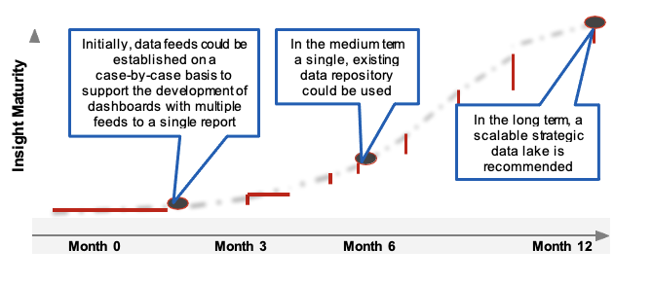

Overview of recommendations
Following extensive engagement, key challenges have been identified across each of the five domains set out below. Based on these challenges, this report makes 29 recommendations to be delivered over a two year period to improve BI provision across the HCP.

Process
- Intra-organisation communication plan
- Communications outreach improvement programme
- Formalised virtual BI Hub service request processes
- Review of HCP reporting requirements & agile approach
- Review the role of the CSU given revised priorities

Organisations
- Central BI oversight and direction
- Centralised BI best practices
- Centralised HCP governance framework
- Data sharing agreements via ISP on ISGs
- Building the virtual BI Hub and filling roles
- Aligning & monitoring against target outcomes for BI hub
- Develop a Programme Business Case

People
- End user assessment & training programme
- Clinical representation at local &a strategic level
- Technical capabilities L&D programme
- Technical capabilities recruitment strategy
- Oversight on BI capacity
- Assigned data stewards in virtual BI hub
- Culture change management plan

Information
- Data integrity & timeliness improvement plan
- Data taxonomy catalogue
- Data quality improvement plan
- Integrate data feeds

Technology
- Single self serve platform with varying access levels
- BI tools & platform alignment
- Leverage economies of scale
- Strategic data lake
- HCP-level technical design principles
- Build pilot use case

Outcomes associated with the recommendations
The recommendations set out in the report have been prioritised into three phases (covering 0-3 months, 4-12 months and 13-24 months), with distinct outcomes targeted at the end of each phase as set out below. Timelines included in this report are indicative at this stage and will be further developed through a Programme Business Case, governed by a BI strategy board.

Phase 1: Delivering ‘quick wins’ (0-3 months)
Fully developed pilot use case(s):
- Key stakeholder involvement at the start so benefits are aligned with wider HCP goals.
- Tangible benefits for all organisations within HCP.
- Providing early impact that supports better care for the population.
Clear, aligned BI strategy, vision and design principles
- Using the BI Strategy and Roadmap report as a starting point for a Programme Business Case which prioritises areas of focus and contains a detailed plan for implementation of later phases.
- Better aligning reporting requirements and actions to drive improved clinical outcomes.
Established governance structures and communications/engagement plan
- Establishment of a BI strategy board to govern the delivery of the Programme Business Case and the virtual BI hub on an ongoing basis.
- Development of a communication/engagement plan for use across the HCP so all organisations are working towards the same strategic objectives for BI.

Phase 2: Laying the foundations (3-12 months)
Centralised BI function acting as a hub of information:
- Bringing governance, best practice and data sharing agreements into a central location enables easy access for users, reduces variation across the HCP, and improves the quality of reporting.
- This will also help reduce time spent on specific agreements or policies, improving efficiency.
Upskilled, analytics/insight focused BI staff:
- Shift of workforce focus from reactive reporting to forward looking, predictive / proactive reporting.
- A development programme, alongside the recruitment strategy, will help provide a better balance of skills.
- A culture change programme to promote data driven insights, shaping provision of care.
Improved data flows and aligned BI operations across the HCP:
- Investing in the right BI tools and platforms, as well as initiating data improvement programmes will help improve data quality.
- This will reduce variability, as well as drive more accurate reporting, reducing validation time.

Phase 3: Accelerate improvement (13-24 months)
Effective Population Health Management function:
- Integrating data feeds from across the HCP will provide BI teams with access to a broader and richer population dataset which along with the additional analytical skills of the BI Hub team allows more population-level insights to be derived, as well as better monitoring of interventions and their impact.
One source of ‘truth’ with a self-serve BI platform:
- Data lake will provide a central source of ‘truth’, reducing the time wasted by organisations trying to interpret data.
- The self-serve BI platform will improve data visualisation and shift the onus onto the end user to understand what exactly they are looking for.
Fully enabled integrated care approach to patient care:
- Better lines of communication and collaboration will support more effective provision of care.
- Central oversight will allow for frequent users of health and care services to be identified up earlier, and organisations can work together to reduce the amount of time these patients spend in care.

A twin track approach for quick wins and sustainability
The size of the challenge facing the HCP in transitioning from the current state to the future state set out in this report can seem overwhelming, especially with each step providing additional challenges. In an industry fraught with failed transformation programmes, it is easy to lose momentum on these large scale projects; it is therefore essential that the HCP get things moving quickly right from the get-go, accelerating the delivery of certain key activities to see some real tangible change early on, leading to some quick wins.
This helps garner support and enthusiasm for the programme, demonstrating the potential of collaborating at the HCP level and crucially, showing people that it’s possible to make an impact quickly. This is important for securing buy-in and commitment both for the people directly involved in the programme doing the doing, and for the external stakeholders.
The way to do this is to employ an agile, twin track approach, whereby certain activities are carried out rapidly to produce the equivalent of a minimum viable product to allow certain quick wins. In parallel, longer term activities are carried out in slower time, guided by the learnings from the accelerated activities.
In practice, this means prioritising specific high impact programmes early on, to get widespread stakeholder buy-in; this is why this report emphasises initial activities in the proposed roadmap, to identify and highlight key outputs to expect within 3 months.

Alternative options for accelerating benefits realisation
Whilst this BI Strategy and Roadmap focuses on the aforementioned twin track approach in order to achieve both short term gains and long term foundational change, there is an inherent challenge relating to the time it will take to deliver certain benefits. This inherent challenge stems from having to write a Programme Business Case for buy-in and funding, then having to bring onboard sufficient resource or upskill people before certain work can begin. There is an alternative approach which could allow benefits to be realised faster, though of course this comes with cost implications.
The HCP could opt to reduce the scope of the in-house work to be carried out by the virtual BI hub, and outsource high priority sections of what is needed. For example this BI strategy is designed to address required improvements in both performance reporting and population health management (PHM) across the system. The HCP could instead outsource the PHM aspect of this to a third party who could use their ready-made resources to perform all data cleansing, data manipulation, and dashboard development necessary in a short time frame to provide substantial benefits within weeks.
Some benefits and risks associated with this approach are set out below.

Benefits
- Rapid realisation of benefits and addressing of immediate high priority problems.
- Less up-front investment required.
- Significantly reduced remit and workload for the virtual BI hub, lowering the risk of failure of the roadmap BI roadmap.
- Spreading of risk. Rather than investing solely on internal development and trusting that it will work, using external resource spreads out the risk.

Risks
- Potentially higher cost over the long term.
- The investment will lead to short-term benefits, but without the necessary in-house expertise to maintain the developed product longevity will be limited.
- Some internal expertise is still required in order to effectively procure and manage outsourced solutions.
While this report is predominantly focused on developing in-house capabilities and solutions, where more detailed design is taking place, outsourced solutions should be considered to identify whether off-the-shelf products can be used in place of larger development projects.

2. Introduction

Purpose of this document and intended audience
The content outlined through this document is the result of a ten week assessment and strategy project commissioned in light of the need for the Mid and South Essex (MSE) Health and Care Partnership (HCP) to develop a system level Business Intelligence (BI) capability to aide its transition to becoming recognised as an Integrated Care System (ICS).

The purpose of this document is to:
- Reflect the as-is state of BI functions across the HCP (as captured through interviews, questionnaires, workshops and a BI app catalogue);
- Identify the current challenges faced by suppliers and customers of BI;
- Outline the gap between the as-is and the required to-be state; and
- Provide a clear BI strategy and roadmap that will allow the HCP over the next 3 years to establish an effective HCP-level BI function.
This document should be considered as a “working” or “living” document which may change or update as the programme progresses and new decisions or requirements emerge.

Scope of this strategy
The BI Strategy and Roadmap set out in this document is focused on developing a BI capability to support the HCP. This strategy is not designed to transform the internal BAU reporting and BI carried out by each of the organisations that make up the HCP but where BI is required that spans multiple organisations, it will be covered within the remit of this strategy and roadmap.

Intended audience
This document is intended for: members of the MSE HCP board, senior members of organisations across the HCP in roles relating to BI, strategy and performance in healthcare, and BI team leads in each of the organisations making up the HCP.

Background and context
The HCP is a partnership of all the NHS organisations and local authorities that are responsible for health and wellbeing for the 1.2m population in MSE. The MSE HCP is moving towards becoming an Integrated Care System (ICS) and it requires data and business intelligence capability to support its strategy and apply a system approach to capturing, analysing and using data to better plan and execute its priorities.
At present there are separate data sources, flows, and reporting systems between commissioners and providers, and these remain largely unlinked to wider system partners (e.g. local authorities, community and voluntary sector organisations). There are complexities in data sharing, information governance and Data Services for Commissioners Regional Offices (DSCRO) requirements, and a mixture of internal and external resources that are not aligned around a common set of priorities. There are also separate processes for managing operational performance that are often misaligned.
As a result there is no “single version of the truth” to underpin evidence-based decision making and this undermines the HCP’s ability to focus on improving services for residents.
The HCP has the ambition to create an integrated BI function across the ICS and commissioned this piece of work to undertake an initial diagnostic that provides a baseline and gap analysis of current information flows, BI tools and workforce capabilities, before then designing a BI strategy and roadmap that presents options for future ICS BI configurations and an implementation plan for delivery.

Why are we changing?
The HCP is moving towards becoming an ICS and it requires integrated data and business intelligence capability to support this transition.

What do the patients/citizens want?
- Data entry once only
- Efficient care and service based on accurate and up to date data
- Safe, transparent and consensual use of personal data

What do the organisations that make up the HCP want?
- HCP-level oversight to identify duplication of effort across organisations and to address this by implementing changes to streamline processes
- To have access to data from other organisations
- Less focus on performance reporting, and more focus on BI that will improve patient/citizen care
- Clear governance and direction at a HCP level to know who to go to for information and access to data

What does the HCP board want?
- To have a data and BI capability to support its strategy and apply a system approach to capturing, analysing and using data to better plan and execute its priorities
- To have a clear future vision of BI which is communicated across the HCP

Quotes:
“Across the HCO we are data rich and information poor”
“We need less focus on performance metrics, more focus on improving patient/citizen care”
“My number on frustration is multiple versions of data”

Our approach
During this ten week piece of work the first 6-8 weeks were spent gathering information about the as-is BI landscape across the HCP through a series of interviews, a questionnaire, and a BI app catalogue. The findings were then reviewed and the strategy and roadmap was developed before being reviewed and fine tuned by the core project team.

Process
Conduct stakeholder interviews; Develop & distribute online questionnaire; Distribute BI app catalougue.
These were reviewed as part of the Strategy and roadmap development.
Roadmap orientation and handover

Engagement across MSE HCP in producing this document
This document has been produced with input from a range of individuals from organisations across the MSE HCP. Further details on the stakeholders engaged in the creation of this document can be found in Appendix 1.
- 41 stakeholders interviewed
- 10 organisations engaged
- 102 questionaire responses
- 8 BI app catalogues collected

Current state analysis
In this section the findings of the as-is state analysis of the BI capability across the HCP are presented. These findings were gathered using three main methodologies:
- Interviews
- Questionnaire
- BI app catalogue

The purpose of this section is to explore:
- The approach and methodologies used when gathering information via the interviews, questionnaire, and BI app catalogue.
- The key themes and challenges gathered through the interviews and questionnaire, categorised by the Process, Organisation, People, Information, Technology (POPIT) model areas.
- The organisational structure and expertise breakdown in the HCP, as well as the systems used, based on the BI app catalogue responses.

POPIT model
The POPIT model was used in designing the questions for both the interviews and the questionnaire, and has been used widely throughout this project to provide a holistic approach in both understanding the as-is landscape and designing the future state. The as-is findings in the subsequent slides are presented categorised by POPIT area.
The POPIT model is a quick and easy approach used consider all business aspects at the outset and throughout any business change. It provides a framework to derive a comprehensive and integrated approach for understanding the dependencies of the proposed change on the hard and soft aspects within the HCP.

Processes
This section looks to better understand how processes are designed and implemented across organisations and the wider HCP

Organisation
This section looks to better understand the governance structures in place across the HCP with specific focus on organisational governance groups established to encourage consistency and strategic oversight

People
This section looks to better understand the people within your organisation, assessing the skills, capabilities and culture in place across the wider HCP

Information
This section looks to understand how data can be better used in your organisation, identifying any inefficiencies or barriers limiting optimal use of data and information across MSE

Technology
This section looks to better understand the technology used across organisations within the wider HCP, particularly looking at the potential uses of advanced technologies

Interview methodology
The aim of the interviews as a whole was to gather an in-depth picture of the as-is BI landscape across the HCP, to get a clear view of the existing challenges, and to gather views on what the future should look like. In order to get sufficient breadth, interviews were held with each of the organisations that make up the MSE HCP (including Arden and GEM Commissioning Support Unit and grouping the five Clinical Commissioning Groups together). Additionally, in order to provide sufficient depth within organisations, two separate interviews were held with each organisation, as described below:

BI team interviews
Interviews with members or leaders of the BI teams in each organisation were held in order to gather in-depth views of the as-is BI tools, processes, skills and the day to day challenges of working in and running the BI team, with a specific focus on interactions with the HCP and other organisations in the area.

Senior interviews
Interviews with senior members of each organisation were also held to gather a more strategic set of views on the current challenges around BI both within their organisation and at a HCP level. These interviews were also used to understand the BI capability of that organisation from an end-user perspective.

Feedback loop approach

Following each interview the key findings were distilled down in terms of the as-is state, key challenges, key opportunities and vision for the future HCP BI capability. The findings of each interview were then used to guide the questions that were asked in future interviews to help increase the amount of useful insight could be captured. Any gaps in the gathered knowledge were then filled by following up with the interviewees with questions and requests for useful documents.

Questionnaire methodology
The interview findings were supplemented with a questionnaire which was used to gather a wider range of views than was possible through the interview process. The questionnaire was filled out by employees from various teams and of different levels of seniority across the ten organisation.

What did the questionnaire cover?
The questionnaire was developed using a process which is explained in Appendix 2. The questions were formed using the health analytics adoption model (HAAM) as a basis; this model is explained initially on page 20 and further in Appendix 3. The questionnaire itself consisted of 39 questions categorised by each of the five POPIT model areas. The questions varied between offering a sliding scale answer (e.g. Strongly Disagree to Strongly Agree), and allowing free text answers when more detail was required or when suggestions & ideas were requested.

Who received the questionnaire?
The questionnaire was distributed to over 100 people across all organisations in the MSE HCP. The recipient list for each organisation was drawn up by the core project team and key stakeholders involved in the project. Recipients ranged from senior leadership positions to teams working on day-to-day BI or operations.

How were the responses interpreted?
The methods for interpreting the questionnaire results were two-fold. Firstly, in a qualitative way, key themes and challenges could be drawn out by reading through the free text responses and by comparing the scores across the various POPIT model areas per organisation. Secondly, the quantitative results were analysed and used to score organisations (and the HCP) on a scale of “Exposed”, “ Viable” or “Future ready”. Finally, the HAAM model and its levels was used to assess the maturity of the organisation as a whole against these defined stages of maturity.

BI app catalogue methodology
The BI App Catalogue is a template for gathering detailed information about systems and team capability.

What information is gathered in the BI app catalogue?
- Technical information - This section gathers detailed information about the applications and systems used by a each organisation that could be relevant to the central HCP BI function. This information provides a useful starting point for developing a picture of what data can be held centrally and reported on. The catalogue also gathers information regarding the costs and contracts of the systems to help identify cost saving opportunities through potential cost savings.
- Team capability information - This section provides an understanding of the size of the BI teams in each organisation as well as showing the spread of BI skills and experience between management roles, technical development roles, and BI analyst roles.

Who completed the BI app catalogue?
The BI app catalogue template was sent to the BI leads from each of the 10 organisations in the HCP to complete. The majority of organisations provided a response, though in some cases resource was not available to complete the template due to increasing pressures of COVID-19 during winter 2020. This was exacerbated by the fact that information about systems and team sizes was often not readily available.

How has the information captured in the BI app catalogue been used?
A high level summary of the results is presented in this report. The information was used to guide the development of the strategy and roadmap with the technical information guiding the timelines for establishing the strategic data lake, and the team capabilities guiding the approach to resourcing the future HCP BI capability.

Health analytics adoption model (HAAM)

What the HAAM model is
The Healthcare Analytics Adoption Model (HAAM), shown to the right, is a framework that provides a systematic assessment of an organisation’s analytics maturity.

Organisations frequently operate at various stages of maturity in each level. In that regard, the model is not necessarily linear in its progression.

How the HAAM model has been used
The full HAAM model criteria (see Appendix 3) were used as a basis for developing the questionnaire so that questions covered a breadth of health analytics topics.

HAAM model
- Level 9 - Direct-to-Consumer Analytics & Artificial Intelligence - Putting member data, analytics & AI in member’s hands so they can own more of their health and healthcare decisions
- Level 8 - Personalized Medicine & Prescriptive Analytics - Tailoring member care based on population outcomes and genetic data
- Level 7 - Clinical Risk Intervention & Predictive Analytics - Organisational processes for intervention are supported with predictive risk models
- Level 6 - Population Health Management & Suggestive Analytics - Tailoring member care based upon population metrics
- Level 5 - Waste & Care Variability Reduction - Reducing variability in care processes, focusing on internal optimisation and waste reduction
- Level 4 - Automated External Reporting - Efficient, consistent production of reports & adaptability to changing requirements
- Level 3 - Automated Internal Reporting - Efficient, consistent production of reports & widespread availability in the organisation
- Level 2 - Standardized Vocabulary & Patient Registries - Relating and organising the core data content
- Level 1 - Enterprise Data Operating System - Collecting and integrating the core data content
- Level 0 - Fragmented Point Solutions - Inefficient, inconsistent versions of the truth; cumbersome internal and external reporting

HCP-wide interview engagement
The spread of people and teams engaged in interviews across the HCP is illustrated below. Overall 22 interviews were held with 41 stakeholders across 14 organisations (although the five CCGs were treated as one for the purposes of engagement).
- CCGs - 13 people interviewed covering each of the five CCGs¹, senior leadership, and the internal BI team
- Provide Community Interest Company - 3 people were interviewed covering the Business Intelligence and Contracts team and senior leadership
- Mid and South Essex NHS Foundation Trust - 4 people interviewed covering the Health Analytics team, Strategy & New care models, and senior leadership
- Essex County Council (ECC) - 7 people interviewed across ECDA², Data Analytics, Population Health Management (PHM), Newton Europe³ and senior leadership
- Thurrock Council - 3 people interviewed covering the PHM team, the Public Health Improvement team and the Health Intelligence team
- NHS Arden and GEM (AGEM) CSU - 4 people interviewed from both the MSE team and the national team.
- North East London NHS FT (NELFT) - 3 people interviewed covering the BI team and senior leadership
- East of England Ambulance Service NHS Trust (EEAST) - One person was interviewed from the EEAST BI team.
- Essex Partnership University NHS Foundation Trust (EPUT) - 2 people interviewed covering the business analysis and reporting team
- Southend-on-Sea Borough Council - 4 people were interviewed covering the Operational Performance & Intelligence Team, and senior leadership

Questionnaire self assessment results
Before presenting the detailed qualitative interview and questionnaire findings, below are the average figures for how respondents from across the HCP rated the current maturity levels against the POPIT model. Further details on findings by organisation can be found in Appendix 4 and a more detailed breakdown of findings from free text responses can be found in Appendix 5
- Process: 2.8/5
- Organisation: 3.1/5
- People: 3.1/5
- Information: 3.1/5
- Technology: 2.2/5

Interview findings - Processes
The below themes were highlighted through interviews as the current challenges faced across the MSE HCP. The quotes on the right are examples comments from the interviews that emphasise the highlighted challenge.

Service requests
The majority of BI teams across the HCP have no formal/structured service request processes in place within their organisation, and rely on ad-hoc processes.
“Service requests tend to come via phone calls or email, then we’ll discuss their requirements with them”

Communication
There are limited processes and forums established linking communications between BI teams across the HCP. Communication and collaboration will need to be addressed to drive progress and HCP BI maturity.
“There are four or five teams working on some form of population health management in the area, probably with quite a lot of overlap”

Duplicative reporting
There are several examples across the HCP of duplicative and inefficient performance reporting processes, an example of which is the lack of standardisation across the five CCGs which currently have different reporting requirements.
“Our life would be a lot easier if the five CCGs could align more on the reporting that is required of providers”

Questionnaire results – Processes
Overall HCP rating: 2.81 (Viable)
The standout figures and key themes from the answers to the process related questionnaire questions are shown below.

Standout figures
- 87% of respondents are unaware of any standardised published processes detailing how to create new HCP BI reports
- 34% of people agreed or strongly agreed that data shared across the HCP is used to improve patient outcomes
- 3.65 - Highest average rating in this section, highlighting over reliance on the knowledge of key individuals within organisations
- 4% of people believed their organisation was completely agile or iterative in their process

Key themes
- Significant amounts of reporting is done via Excel, limiting the amount of automation possible
- People are aligned on the fact automation can improve reporting efficiency & accuracy
- Some automation already takes place, however is reliant on data quality, consistency, format and manual checks
- Level of automation used varies heavily across the HCP

Interview findings - Organisation
The below themes were highlighted through interviews as the current challenges faced across the MSE HCP. The quotes on the right are examples comments from the interviews that emphasise the highlighted challenge.

Central BI oversight
There are several organisations across the HCP with strong internal BI capabilities, which could be better utilised or leveraged for HCP level BI with the right central oversight and direction.
“Each provider tends to provide good BI insights internally but are never asked to provide that externally”

Reporting focus
There is a great deal of focus on arbitrary performance reporting rather than focusing on providing actionable insight to improve the efficiency or quality of care provided.
"We need less focus on performance metrics, and more focus on improving patient/citizen care"

Information governance barriers
Information governance procedures can be viewed as being barriers to sharing data or increasing delays to information sharing.
“98% of GPs use SystmOne but there is still a barrier to using data from it, so simpler data governance around this is needed”

Questionnaire results - Organisation
Overall HCP rating: 3.13 (viable)
The standout figures and key themes from the answers to the organisation related questionnaire questions are shown below.

Standout figures
- 54% are aware of some data governance frameworks, structures, or policies in place across the HCP
- 29% of people agreed or strongly agreed that information is shared freely and readily across the HCP

- 3.40 - Highest average rating in this section, highlighting how data governance can enable data driven decision making
- 6% - Identified current data policies as strongly promoting data centric behaviours and encouraging data sharing across HCP

Key themes
- Only around half respondents were aware of HCP wide data governance; those aware highlighted its usefulness
- Perspectives on data sharing and how well their organisation shares data varied heavily across the HCP
- Many people identified a “single source of truth” dataset as being the key to enriching shared data
- Others highlighted system wide policies and sharing agreements as essential to improving data sharing

Interview findings – People
The below themes were highlighted through interviews as the current challenges faced across the MSE HCP. The quotes on the right are examples comments from the interviews that emphasise the highlighted challenge.

End-user culture
The end-users of BI and reporting across the HCP are often reluctant to move away from legacy bespoke reports and may be particularly resistant to self service solutions.
“There is a lack of appetite for a self serve platform; people are used to being spoon fed the same Excel report by analysts every time”
BI resources
Resources are often working at full capacity on their BAU workload, leaving little time to allocate HCP-level work. This has been exacerbated by an increase in ad-hoc work due to the COVID-19 pandemic.
“We have enough problems meeting our internal reporting demands let alone expanding our remit to working at a HCP level”

Technical skills
Whilst there are many generalists or those with data analysts skills across the HCP organisations, there is a lack of deep technical/specialist data skills which will need to be addressed.
“We sometimes find it hard to bring in the deep technical knowledge because it can be very expensive”

Advanced analytics
Very few teams have the tools and/or capabilities to perform advanced predictive analytics on large population data sets
“Advanced analytics resource is very expensive and it’s hard to make a business case for it at an organisational level”

Questionnaire results - People

Overall HCP rating: 3.07 (Viable)
The standout figures and key themes from the answers to the people related questionnaire questions are shown below.

Standout figures
- 28% of respondents are aware of nominated change leaders / champions which sit across the HCP
- 88% of people are unaware of any data stewards that sit across the HCP are used to improve patient outcomes
- 44% of people disagreed / strongly disagreed, that they had sufficient opportunity to develop their skills and use the latest technologies
- 3.75 - Highest average rating in section, highlighting how data stewards provide an essential service in reviewing data quality

Key themes
- There is a heavy concentration of Excel and SQL capabilities across the HCP, but limited analytical skills
- Only 2 people indicated they had advanced level machine learning and statistical programming skills - no one considered themselves an expert
- In addition to technical staff (i.e. analysts), respondents highlighted the need for clinical input as part of delivering a robust, integrated BI capability
- The role of data stewards in working with IT and internal BI teams to define what data is needed and review data quality, is seen as an essential service

Interview findings - Information
The below themes were highlighted through interviews as the current challenges faced across the MSE HCP. The quotes on the right are examples comments from the interviews that emphasise the highlighted challenge.

Data access
Organisations can be restricted to limited datasets which they have gathered themselves. The sharing of increased datasets between HCP organisations could provide greater benefits and insight.
“Unless someone from our organisation made the diagnosis, we won’t know if a patient has diabetes or not”

Data sharing
Organisations can be reticent to share data with other organisations due to complexities in data sharing or lack of clarity around governance. An Information Sharing Protocol will need to established to improve transparency and speed of data sharing.
“There is a general sense of nervousness across the wider HCP about sharing data, specifically regarding what is permissible to share / distribute”

Data integrity
Lack of data timeliness and integrity can leave contradicting BI/reports between organisations using the same data sets leading to many hours of manual data manipulation/cleansing.
“We spend half of our time trying to work out which data we should use”

Data classification
There is no common data classification approach across the different organisations within the HCP.
“A consistent data taxonomy and approach to data processing is needed in line with the NHS standards, otherwise merging data will just lead to more work for the organisation BI teams”

Questionnaire results – Information
Overall HCP rating: 3.20 (viable)
The standout figures and key themes from the answers to the information related questionnaire questions are shown below.

Standout figures
- 43% of respondents spend at least four hours per week manually reconciling / validating data they receive
- >16 hrs - 11% of respondents spend over 16 hours per week manually reconciling data they receive
- 3.50 - Highest average rating in this section, highlighting that the KPIs in reports produce useful info that improves patient care
- 0 - People strongly agreed that the data received from other organisations in the HCP has high data integrity

Key themes
- There are substantial differences in the amount of PHM activity across MSE; in order to drive PHM effectively, input from across the HCP is needed
- The key themes around improving data integrity all centred around standardising operations
- Standardised templates, processes, taxonomies, data standards are a few of the methods identified
- People highlighted the need for KPIs that are outcome focused in order to drive improved patient care

Interview findings - Technology
The below themes were highlighted through interviews as the current challenges faced across the MSE HCP. The quotes on the right are examples comments from the interviews that emphasise the highlighted challenge.

Mis-aligned BI technology
There are a plethora of BI tools and underlying data infrastructure across organisations within the HCP. A more strategic procurement and rationalised approach will be required at the HCP level.
“It would be helpful for sharing resource if different organisations used the same tools ”

Discrepant systems
Often the same technology has been implemented differently in different organisations. For example SystmOne is used in different ways by different practices.

“There are hundreds of GPs across MSE using SystmOne but every single one uses it in a different way”

Lack of advanced BI tools
Very few BI teams across the HCP have the tools, data architecture and skillset to perform advanced analytics such as predictive analytics, AI and scenario modelling.
“We find it hard to develop advanced BI capabilities because it costs so much and we can’t justify it at an organisation level”

Questionnaire results - Technology
Overall HCP rating: 2.24 (exposed)
The standout figures and key themes from the answers to the technology related questionnaire questions are shown below.

Standout figures
- 30% of respondents identified Microsoft Power BI as their preferred BI and Analytics publishing tool
- 0 people strongly agreed that integrations and data flows are mostly automated with little manual intervention
- 1.96 - Lowest average rating in the questionnaire, highlighting the limited use of AI / ML in organisations as of yet
- 2% of people strongly believed there is sufficient investment on improving the integrated BI capabilities across HCP

Key themes
- Microsoft Power BI and Excel were by far the most popular choices as people’s BI and Analytics publishing tool of choice
- The most common cloud based technologies in use across organisations were Microsoft Azure, Power BI, Tableau, Qlikview and SSRS
- This section received the lowest scores on average across the questionnaire, highlighting a system weakness
- The low score associated with AI / ML uptake highlights the need to improve infrastructure first, in order to enable more advanced uses of the data

BI app catalogue findings - People
The diagram below illustrates the number of resources across each organisation in the HCP in management, technical, and analyst roles. The numbers in each bubble represent the number of FTEs in that organisation in that role, as captured by the BI App Catalogues. Where BI app catalogues were not received or were not fully completed by an organisation, the values have been left blank. Taking into account the partial completion of the BI app catalogue, the relatively low amount of resource supporting technical/development roles across the HCP is stark.

Manager/senior roles: FTE – 29.5
- AGEM - 3.5
- CCG – 1
- ECC – 15
- EEAST –
- EPUT – 3
- MSEFT –
- NELFT – 5.5
- Provide – 0.5
- Southend – 1
- Thurrock –

Technical / Dev roles: FTE - 20.25
- AGEM - 0
- CCG – 2
- ECC – 10
- EEAST –
- EPUT – 3
- MSEFT –
- NELFT – 3.5
- Provide – 0.75
- Southend – 1
- Thurrock –

BI / analyst roles: FTE – 101.15
- AGEM - 8
- CCG – 2
- ECC – 57
- EEAST –
- EPUT – 3
- MSEFT –
- NELFT – 14.4
- Provide – 2.75
- Southend – 14
- Thurrock –

BI app catalogue findings – Systems
A high level summary of the BI app catalogue responses from across the HCP are shown in the table below and on the following slides. Time constraints, partly driven by the Covid-19 response, have meant that not all organisations were able to fill out the app catalogue, and those that did were only able to provide a relatively high level of detail. Further details aggregating full responses to the BI app catalogue have been provided alongside this report.

AGEM
Relevant Applications:
- Data Management Environment
  - System Function: Centralised data warehouse holding national, local and reference datasets according to appropriate Information Governance standards.
  - Data:
    - NHS Digital Datasets
    - Local data flows
    - Reference Data
- GEMIMA BI Portal
  - System Function: Customer facing BI portal
  - Data:
    - NHS Digital Datasets
    - Local data flows
    - Reference Data
- Palantir Foundry
  - System Function: Big data analytics platform
  - Data:
    - National Datasets supporting the COVID-19 response

NELFT
Relevant Applications:
- Power BI:
  - System Function: Deployment of full, in-house BI solution. Automation of reporting procedures.
  - Data:
    - Patient Data
    - Staff Data
    - Incident Data
    - Finance Data
    - PPE data

Southend BC
Relevant Applications:
- SQL
  - System Function: Reporting
  - Data: Unknown
- R
  - System Function: Reporting and data science
  - Data: Unknown
- ESRI
  - System Function: Geospatial
  - Data: Unknown
- LiquidLogic
  - System Function: Case management
  - Data: Client data

EPUT
Relevant Applications:
- Crystal Reports
  - System Function: Operational self service reporting
  - Data:
    - Patient Data
    - Contact Data
    - Activity Data
- SQL Server Reporting Services (SSRS)
  - System Function: Dashboards
  - Data:
    - Patient Data
    - Contact Data
    - Activity Data

ECC
Relevant Applications:
- Microsoft Power BI:
  - System Function: Centralised reporting
  - Data: Collated data for reporting
- SQL Server:
  - System Function: Datamart
  - Data: Various databases
- MOSAIC:
  - System Function: Adults and children's social care case management
  - Data: Case management and procurement data
- Capital One:
  - System Function: Education and additional services
  - Data: Pupil and schools data
- TCS:
  - System Function: Corporate Finance/HR or CSP in which case Oracle Transactional Business Intelligence (OTBI) and Oracle Business Intelligence Publisher (BI Publisher)
  - Data: Finance & Procurement data

Provide
Relevant Applications:
- SQL Server:
  - System Function: Database
  - Data: Not provided
- Microsoft SQL Server Analysis Services (Cubes):
  - System Function: Analytical processing
  - Data: Not provided
- SQL server Reporting Services (SSRS):
  - System Function: Dashboards
  - Data: Not provided
- Microsoft Excel:
  - System Function: Analytical processing
  - Data: Not provided
- Microsoft Access:
  - System Function: Database
  - Data: Not provided
- Power BI:
  - System Function: Data visualisation
  - Data: Not provided

CCGs
Relevant Applications:
- SQL warehouse, Execel, Glasscubes
  - System Function: All three systems are used to produce the Acute Performance Report. Performance reporting of acute constitutional standards and main standards for diagnostics, Cancer and RTT, Ambulance response times and handover delays, ED 4 hour standard, Stroke standards Glasscubes is used for the report distribution.
  - Data: Acute constitutional standards and main standards for diagnostics, Cancer and RTT, Ambulance response times and handover delays, ED 4 hour standard, Stroke standards

MSEFT
Relevant Applications:
- Hospital Insights
  - System Function: Monitoring tool to explore opportunities for improving utilisation and productivity
  - Data: Inpatients, Outpatients, Theatres
- Healthcare Evaluation Data (HED)
  - System Function: Benchmarking tool for comparing data and KPIs across different Trusts
  - Data: Inpatients, outpatients, ED
- QlikView
  - System Function: Data visualisation tool
  - Data: Multiple datasets from Somerset, Medway and Lorenzo
- SSRS
  - System Function: Data visualisation tool
  - Data: Multiple datasets from Somerset, Medway and other operational systems
- Power BI
  - System Function: Data visualisation and analysis tool
  - Data: Multiple datasets from Somerset, Medway and other operational systems

3. MSE HCP’s future vision and BI strategy

Future vision and BI strategy
Having established the as-is BI landscape across the HCP, this section covers the development of a strategic vision statement and design principles in order to align the HCP around a single direction for BI.
The key challenges and themes from Section 2 are then built upon and recommended changes are suggested along with their potential benefits. Finally the various recommended changes are prioritised into three phases, and the benefits that will be realised after each phase are highlighted.
The recommended changes are then expanded upon in Section 4 of the report.

The purpose of this section is to explore:
- The agreed BI strategic vision and design principles for the HCP and the benefits of having these.
- The key themes, challenges, opportunities and associated benefits categorised via the POPIT framework
- Which changes to prioritise in phase 1 (0 - 3 months), phase 2 (4 - 12 months) and phase 3 (12 - 24 months) and the high level benefits that could be realised after each phase.

3.1 Strategic vision and design principles

Captured strategic vision statements for BI
A range of views on the HCP’s strategic vision for BI have been captured throughout the interviews and during the workshops held during the course of this work. There are a diverse range of views presented from senior management across the HCP organisations. It will be important to agree an overarching vision statement before commencing implementation of the HCP BI Strategy.

Emerging vision statements
- Need for clinical input
  - “We need to have clinical [and operational] buy-in, they are the ones using it, so we must have clinicians contribute to the shared vision.”
- One version of the truth
  - “We need a flexible, capable team that is looking at one version of the truth, that we can buy into; with clear scale & scope.”
- Evidence based decision making
  - “We need to have the data, infrastructure, and operating model that allows evidenced based decision making.”
- Joint commitment to a single purpose
  - “Organisational identity needs to come second to overall purpose, and there needs to be commitment from everyone involved”
- Improves patient care
  - “The statement has to be centred around reducing patient harm and improving patient care - core to any data usage.”
- Integrated and efficient use of resource
  - “We have a great deal of resource across the HCP, we just need to use it in a more integrated and efficient way.”
- Flexibility
  - “We need a system that is flexible enough to handle the constant changes in both the HCP structure and the technology used across the system.”
- Population health
  - “The vision statement needs to reflect not only care that we provide but health of residents. It's not always about patients of the system. We need to think about Population Health.”

Forming the HCP’s strategic vision statement for BI
The strategic vision statement below has been agreed by the core team working on the development of the HCP BI Strategy.
The vision statement, alongside the design principles detailed in the following slides, should act as the anchor point for the BI strategy and set the foundation for accomplish the HCP’s goals. The statement should be reviewed and agreed by the virtual BI hub’s strategic board at the beginning of the roadmap journey.

MSE HCP’s Strategic Vision for BI:
The Mid and South Essex Health and Care Partnership will use data to provide insight and enable evidence-based decision making with the aim of improving the health and wellbeing of the local population, reducing inequalities and addressing current and future needs

What are the benefits of a strategic vision statement
- A clear vision statement will act as a unifying force across the HCP, and will have a positive impact on organisational effectiveness. When stakeholders understand and buy-in to the vision statement, it brings them together and focuses and aligns efforts so everyone is working towards the same understood goal.
- A vision statement will act as a guide for HCP actions and decision making. If at any point a decision will clearly contradict the vision statement then either the decision should be changed, or the vision statement should be revisited.
- Finally, a vision statement can be motivating and inspiring. When an individual understands and aligns with the core values and vision of the organisation, they are able to readily commit to, and engage in, the organisation’s efforts. This will be particularly important for the MSE HCP given the number of different organisations involved.

BI design principles and why they are important
In order for the HCP to develop a well-formed centralised BI capability that meets the fundamental needs of the partnership, a clear and agreed set of design principles are required to guide decision making and direction.

What is a design principle?
A design principle is a rule that is applied consistently to initiatives to provide coherence and alignment in the way things are done.
They should align with and expand on the strategy of the organisation, and the vision for the programme. They provide fundamental values
which act as the main parameters or ‘guard rails’ for the detailed design, to support delivery in line with the HCP’s vision and strategy.
The principles form the criteria to judge the best approach to take in a given situation. It is not always straightforward, even with the principles in place, and at times one principle may need to be favoured over another but the design principles provide the guidance to frame the debate and take a considered approach.

Approach to defining the sets of design principles
The design principles on the following page have been drafted based on information and views gathered through the workshops and interviews that have been held and the questionnaire that has been conducted through this piece of work.
One of the first steps on the roadmap will be to agree and ratify a set of design principles which everyone has bought into which will guide the HCP through it’s decision making processes throughout the programme of work.

BI design principles
The BI design principles listed below were developed based on findings from the interviews and questionnaire responses, and ratified by the core project team.
- Data should be used as a strategic asset
  - The rationale: Data is a strategic asset that has value to the HCP and must be managed accordingly to deliver effective insight. The HCP should continuously strive to expand the availability and accessibility of data.
- Work effectively across the HCP to deliver accurate and timely insight
  - The rationale: BI must be delivered against clearly outlined guidelines and processes so that stakeholders have timely information that supports improved decision making.
- Be adaptable to the changing HCP environment
  - The rationale: BI must be flexible and adaptable in light of the continuously evolving technology, tools and services across the different organisations that make up the HCP. Alongside this, knowledge and best practice resulting from new tools and services should be shared across the HCP.
- Eliminate duplicative activity
  - The rationale: The HCP must eliminate activity duplication and overlap across organisation members and support efficient and streamlined processes across the system.
- Define common data definitions and improve data quality
  - The rationale: Data must be defined consistently throughout the HCP, standardised, understandable and distributed, and there must be a continual improvement in data quality.
- Improve decision making and performance of the HCP
  - The rationale: BI should be aligned to a clear business need which supports the realisation of HCP benefits (e.g. improved care, reduced cost or improved performance)
- Data should be processed in a secure and authorised manner
  - The rationale: Data should be protected from unauthorised use and disclosure and must be processed in line with relevant legislation and data sharing agreements.

3.2 BI Strategy

Recommended changes across POPIT
This sub-section sets out recommended changes to address the challenges discovered in the as-is data gathering part of this work. Each of the five key POPIT areas is explored one by one, building on key challenges and themes detailed in the current state analysis section and mapping them to recommended changes that will address the challenges.
Process – Organisation – People – Information – Technology
Further details on the recommended changes can be found in Appendix 6 of this report. This includes the key challenges for each POPIT area, categorised into sub themes, and quotes from the interviews or questionnaire, which bring the challenges to life.
The recommended changes required to address each challenge are then shown, and these changes are explained in further detail for each POPIT area on separate slides along with the benefit of the changes, and the suggested priority.

Overview of recommendations by POPIT area

These are all the proposed change plans and programmes, based on the challenges detailed in Appendix 6. These will provide the basis of our approach on how to achieve the desired future state for the HCP

Process
- Intra-organisation communication plan
- Communications outreach improvement programme
- Formalised virtual BI Hub service request processes
- Review of HCP reporting requirements & agile approach
- Review the role of the CSU given revised priorities

Organisations
- Central BI oversight and direction
- Centralised BI best practices
- Centralised HCP governance framework
- Data sharing agreements via ISP on ISGs
- Building the virtual BI Hub and filling roles
- Aligning & monitoring against target outcomes for BI hub
- Develop a Programme Business Case

People
- End user assessment & training programme
- Clinical representation at local &a strategic level
- Technical capabilities L&D programme
- Technical capabilities recruitment strategy
- Oversight on BI capacity
- Assigned data stewards in virtual BI hub
- Culture change management plan

Information
- Data integrity & timeliness improvement plan
- Data taxonomy catalogue
- Data quality improvement plan
- Integrate data feeds

Technology
- Single self serve platform with varying access levels
- BI tools & platform alignment
- Leverage economies of scale
- Strategic data lake
- HCP-level technical design principles
- Build pilot use case

Prioritisation of changes through a 3 phase approach
A three phase approach is recommended, with the high priority changes (including those that deliver ‘quick wins’ suggested to start in phase 1, medium priorities in phase 2, and long term priorities in phase 3. Timelines included in this report are indicative at this stage and will be further developed through the Programme Business Case, governed by the BI strategy board.

Phase 1
High impact ‘quick win’ changes are recommended for the first phase, designed to garner support and buy-in for wider transformation of BI across the HCP.

Phase 2
Medium impact changes are recommended over the remainder of the first year of the programme.

Phase 3
The longer term changes that have a lower initial impact but are fundamental to a sustainable HCP BI capability are recommended in phase 3.

Phase 1: Delivering ‘quick wins’ (0-3 months)
The highlighted elements below have been identified as priority recommendations to initiate within the first 3 months; they have been selected given the scale of their impact and to drive early buy-in from across the HCP.

Process
- Communications outreach improvement programme
- Review the role of the CSU given revised priorities

Organisations
- Central BI oversight and direction
- Develop a Programme Business Case

People
- Clinical representation at local &a strategic level

Information
- nil

Technology
- HCP-level technical design principles
- Build pilot use case

Headline outcomes and benefits at the end of phase 1
The key headline outcomes expected at the end of the first 3 months (Phase 1) are shown below. These are designed to help highlight the associated benefits of an integrated BI function, as well as drive early stakeholder buy-in and involvement.

Fully developed pilot use case(s)
- Key stakeholder involvement at the start so benefits are aligned with wider HCP goals.
- Tangible benefits for all organisations within HCP.
- Providing early impact that supports better care for the population.

Clear, aligned BI strategy, vision and design principles
- Using the BI Strategy and Roadmap report as a starting point for a Programme Business Case which prioritises areas of focus and contains a detailed plan for implementation of later phases.
- Better aligning reporting requirements and actions to drive improved clinical outcomes.

Established governance structures and communications/engagement plan
- Establishment of a BI strategy board to govern the delivery of the Programme Business Case and the virtual BI hub on an ongoing basis.
- Development of a communication/engagement plan for use across the HCP.

Phase 2: Laying the foundations (3-12 months)
The recommendations below have been highlighted as important foundational plans to initiate within the first 12 months. They have been selected based on aligned HCP priorities, focusing on what is required to establish the foundations for a successful BI capability

Process
- Intra-organisation communication plan
- Formalised virtual BI Hub service request processes
- Review of HCP reporting requirements & agile approach

Organisations
- Centralised BI best practices
- Centralised HCP governance framework
- Data sharing agreements via ISP on ISGs
- Building the virtual BI Hub and filling roles

People
- End user assessment & training programme
- Technical capabilities L&D programme
- Technical capabilities recruitment strategy
- Oversight on BI capacity
- Assigned data stewards in virtual BI hub
- Culture change management plan

Information
- Data integrity & timeliness improvement plan
- Data taxonomy catalogue
- Data quality improvement plan

Technology
- BI tools & platform alignment
- Leverage economies of scale

Headline outcomes and benefits at the end of phase 2
The key headline outcomes expected at the end of the first 12 months (Phase 2) are as follows. These will help set up the foundations for the future, providing an infrastructure to enable the benefits of an integrated BI function. Successful delivery of the outcomes set out below will be important to achieve the outcomes in Phase 3. For example, all three of these outcomes will support Population Health Management in the HCP.

Centralised BI function acting as a hub of information
- Bringing governance, best practice and data sharing agreements into a central location enables easy access for users, reduces variation across the HCP, and improves the quality of reporting.
- This will also help reduce time spent on specific agreements or policies, improving efficiency.

Upskilled, analytics/insight focused BI staff
- Shift of workforce focus from reactive reporting to forward looking, predictive / proactive reporting.
- A development programme, alongside the recruitment strategy, will help provide a better balance of skills.
- A culture change programme to promote data driven insights, shaping healthcare policies and provision of care.

Improved data flows and aligned BI operations across the HCP
- Investing in and aligning on the right BI tools and platforms, as well as initiating data improvement programmes will help improve data quality throughout the process.
- This will reduce variability, as well as drive more accurate reporting, with less time spent on validation activities.

Phase 3: Accelerate improvement (13-24 months)
The recommendations below have been highlighted as essential in driving some of the long term benefits of an integrated BI function, starting after 12 months. They have been selected based on dependencies on the successful implementation of earlier recommendations.

Process
- nil

Organisations
- Aligning & monitoring against target outcomes for BI hub

People
- Oversight on BI capacity

Information
- Integrate data feeds

Technology
- Single self serve platform with varying access levels
- Strategic data lake

Headline outcomes and benefits at the end of phase 3
The key headline outcomes to expect at the end of the first 24 months (Phase 3) are as follows. At this point, the HCP will be able to realise some of the more impactful benefits of an integrated BI function, driving improved care and outcomes for patients.

Effective Population Health Management function
- Integrating data feeds from across the HCP will provide BI teams with access to a broader and richer population dataset which along with the additional analytical skills of the BI Hub team allows more population-level insights to be derived, as well as better monitoring of interventions and their impact.

One source of ‘truth’ with fully implemented self-serve BI platform
- Data lake will provide a central source of ‘truth’, reducing the time wasted by organisations trying to interpret data.
- The self-serve BI platform will improve data visualisation and shift the onus onto the end user to understand what exactly they are looking for.

Fully enabled integrated care approach to patient care
- Better lines of communication and collaboration across the HCP will support more effective provision of care.
- Central oversight will allow for frequent users of health and care services to be identified up earlier, and organisations can work together to reduce the amount of time these patients spend in care.

4. What does an advancing HCP look like?
The recommendations in Section 3 have been aligned to five focus areas upon which the HCP will need to deliver in order to advance its BI function:
- Building a virtual BI hub
- Establishing processes and governance structures
- Improving the data and establishing an agreed central repository
- Designing and building the technology platform
- Creating a data centric culture and workforce
The change plans outlined in the earlier slides have been mapped onto these 5 key areas, which will act as a structure for the content within each pillar.

The purpose of this section is to explore:
- What an advancing HCP could look like, as well as the associated benefits.
- Specific areas to consider and required changes.
- How the future model will operate and what it will require in terms of support.

4.1 Building a virtual BI hub
The purpose of this section is to explore:
- What are the challenges associated with the current localised functional model across MSE HCP?
- What are the advantages of a hybrid hub and spoke model?
- How should the virtual BI hub be structured, and how will it interact with the organisations across the HCP?
- What is the remit of the virtual BI hub?
- What roles will be required in the virtual BI hub and how might these be filled?

Mapping recommendations to this focus area
The change plans that map to the building of the virtual BI hub have been highlighted below:

Process
- Review the role of the CSU given revised priorities

Organisations
- Central BI oversight and direction
- Building the virtual BI Hub and filling roles
- Aligning & monitoring against target outcomes for BI hub
- Develop a Programme Business Case

People
- Clinical representation at local &a strategic level
- Assigned data stewards in virtual BI hub

Information
- Nil

Technology
- HCP-level technical design principles

What is a virtual BI hub and why use it?

What is a virtual BI hub?
- A virtual BI hub is a centralised function that carries out BI activities using data and input from a range of organisations.
- It is not a physical entity, it is more of a central resource that is widely accessible and provides useful insights.
- As well as optimising data use by generating data driven insights, it also acts as a repository for keeping key information and policies.

Why use a virtual BI hub model over alternative models?
- Virtual BI hubs are highly useful for large areas with multiple organisations with differing data sets, ambitions and competencies.
- This is because they help align organisations, reducing variance and siloes without requiring large, structural change which may be disruptive to BAU processes in implementation
- From research and past experience, alternative models, such as embedded analytics teams tend to work better in more localised scenarios

What are the high level benefits?
- Increased alignment of all aspects of BI.
- Improved output through collaboration.
- The ability to manage a central data repository.
- Central oversight leading to more efficient processes and use of resources.

Use case: Worcester Office of Data Analytics
The Worcester Office of Data and Analytics (WODA)¹ is a virtual hub, where in-house analysts within each applicable agency have supported the delivery of pilots. It was recognised as a high quality virtual hub example in a comprehensive study of Offices of Data Analytics (ODAs) in the UK².
The WODA was created in 2017 and, from 2018 onwards, a small team (3.0 FTE) has been recruited to deliver a mix of project management, business analysis, information management and data science skills. Most of the team are part-time and also members of the partner agencies, which helps bring in practical knowledge of working in those organisations. Support from existing in-house individuals or teams is still required for the delivery of some solutions.
1 Worcester Office of Data and Analytics (WODA), ttps://www.worcestershire.gov.uk/woda/
2 State of Offices of Data Analytics (ODA) in the UK, Nesta, December 2018 (https://media.nesta.org.uk/documents/State_of_Offices_of_Data_Analytics_ODA_in_the_UK_W EB_v5.pdf)

Aligning on a virtual BI functional model
There is focused but limited data sharing between organisations which make up MSE HCP with the majority operating in a data siloed, organisation-specific capacity. In order to support the movement to an Integrated Care System, an equally integrated Business Intelligence function is required.

Current Approach: Fully Localised BI Model
- Each organisation has their own BI service or equivalent, where it processes organisational specific reports and analysis.
- All decision making on all aspects of BI are driven by the individual function or organisation.
- BI initiatives and goals will be driven based on function or organisation's needs and objectives.
- Some collaboration may exist between organisations although not across the entire HCP.

Future Approach: Hybrid BI Model
- Each organisation will continue with their business as usual BI/Data and Analytics services processing organisational specific reports and analysis.
- BI teams will be supported by a central virtual BI hub which provides HCP-wide BI, improving consistency and avoiding duplication of effort.
- A centralised virtual BI hub function would set policies, standards and methods, and provide a central point for engagement on BI matters where required.

The pros and cons of current state vs future state
Below are the pros and cons of the current state compared to the future hybrid BI model state.

Current Approach: Fully Localised BI Model
Strengths:
- Analytical needs aligned to specific organisation and functional areas.
- Team members in BI roles are close to business, issues and customer groups.
- BI resource is on hand to provide immediate tactical inputs for each service provided.
Weaknesses:
- Incomplete system-wide view due to focus on organisational issues.
- Limited strategic view of pressures across the wider region.
- Duplication, ad-hoc and not scalable across the system.

Future Approach: Hybrid BI Model
Strengths:
- Standardised processes and methods developed in an system-wide approach.
- Independent and strategic viewpoints shared system-wide.
- Direct reporting to executive sponsor allows for faster, better adoption across the system.
- Functional knowledge and experience accessible through federated structure.
Weaknesses:
- Requirement from organisations to commit BI resources, which are often already in high demand performing business as usual roles.
- Blurred lines of responsibility.
- Culture and working practices can be more difficult to develop than moving to a physical BI hub.

What does the hybrid approach mean?
The hybrid approach provides the flexibility to adapt BI services for each organisation which make up the HCP. The strategic drive, management and development should be led centrally, alongside inputs from localised teams which may have personnel sitting across both central and local functions.
Central Function: Core HCP BI services should be delivered from a central function which engages and provides governance to the virtual BI hub, providing guidance and highlighting best practises to deliver high standards of BI and data across the system.
Central Engagement with Local: Central functions engage with local BI teams to advise on best uses of BI technologies and data standards demonstrating best practice and highlighting pockets of excellence to encourage collaboration and knowledge sharing.
Local BI Services: Provide essential analytics and BI services for their organisational and customer needs, whilst providing data and resources towards system-led BI function.

Benefits and value driven from a hybrid approach:
- Provides a flexible approach which can be adapted for each organisation’s capabilities and BI requirements.
- Provides economies of scale as core BI services can be delivered centrally.
- Encourages collaboration across teams bringing together pockets of excellence to create “communities”, and driving innovation rather than disparate pockets of excellence throughout the system. This will lead to more consistency in the data and a reduction of duplicated BI activity as there is a greater understanding of BI analysis which already exists.
- Citizens and Providers have an improved experience as more accurate information is provided due to improved consistency in data and BI standards, enabling organisations to make informed decisions through data driven insights.
- Meets HCP needs while not inhibiting localisation of services across local functions.

Proposed BI hub model
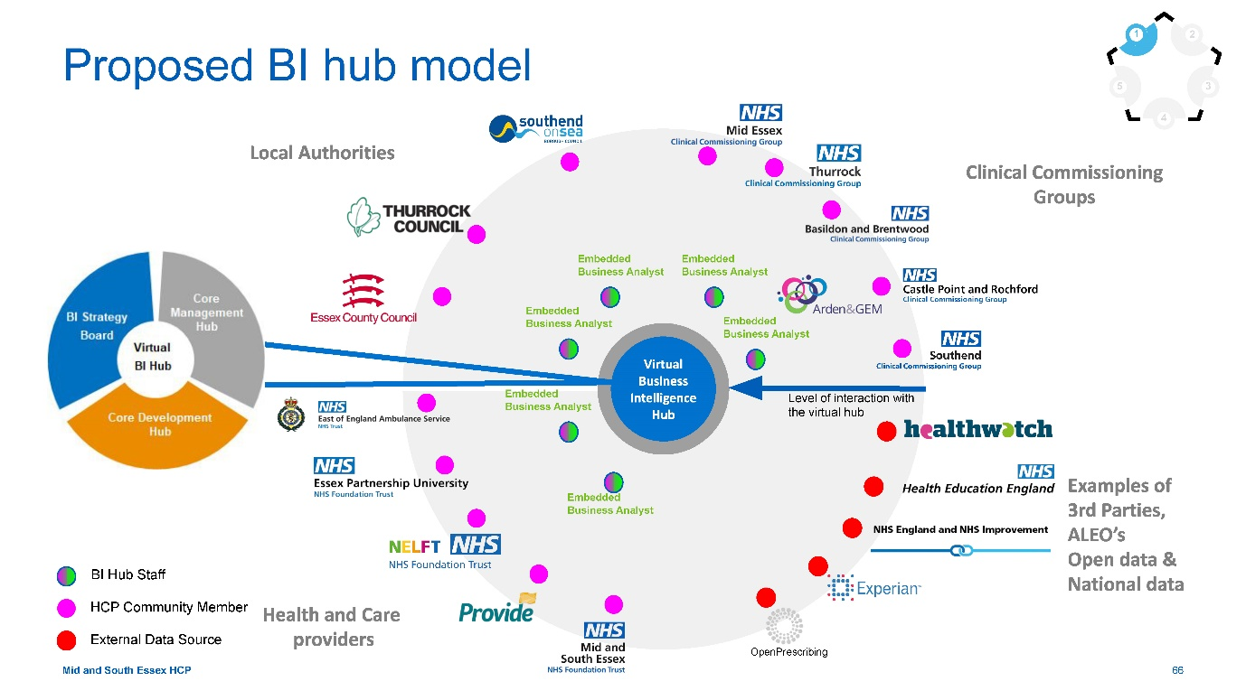

How responsibilities are divided between BI hub and organisations
The table below provides a breakdown of how activities related to BI will be distributed across the management and development parts of the BI hub and the wider HCP organisations.

Org specific
- HCP organisation activities
  - Maintain data quality of inputs to HCP systems.
  - Feed organisational-level data and information through agreed HCP pathways.
  - Responsible for identifying needs or inputs around individual organisational level reports and expressing these to the BI hub.
  - Identify specialist or bespoke reporting requirements not covered by existing tools, and request that the BI hub produce these insights (these requests will be prioritised alongside other requests across the system).

Virtual BI hub
- Core management hub activities
  - Champion the HCP wide BI capabilities used to produce reports and dashboards for the HCP.
  - Use central oversight of BI to identify common issues and opportunities across service areas.
  - Gather requirements and verify data from HCP organisations.
  - Responsible for strategic-level governance of data management, quality and standards.
  - Maintain and update service management processes and tools.
  - Maintain templates for common reusable BI reports, to allow self-serve capabilities.
  - Signpost existing tools and resources to organisational staff.
- Core development hub activities
  - Responsible for all agreed operational/strategic/public health BI development across the HCP.
  - Produce descriptive and qualitative analysis for agreed data sets.
  - Carry out advanced analytics, including scenario modelling, predictive and prescriptive analytics.
  - Create and maintain a set of standard and agreed BI reports.
  - Coordinate service management via the use of case management tools and processes.
  - Create specialist ad-hoc BI insights for organisations, when prioritised by the BI strategy board.

Proposed virtual BI hub structure
5 3
The structure below has been drawn up based on the hybrid Hub and Spoke model design. The virtual BI hub takes its strategic governance and direction from the BI strategy board.
Having the correct size of the ‘Core Development Hub’ team is important in achieve success for the virtual BI hub and it is likely that this size will differ from initial implementation to end state. If a scaled implementation is taken forwards, consideration will need to be given to which of the below roles will be introduced and how many. Due to this, it is important that any proposals are reviewed and refined with the relevant HR business partners and organisational design teams.
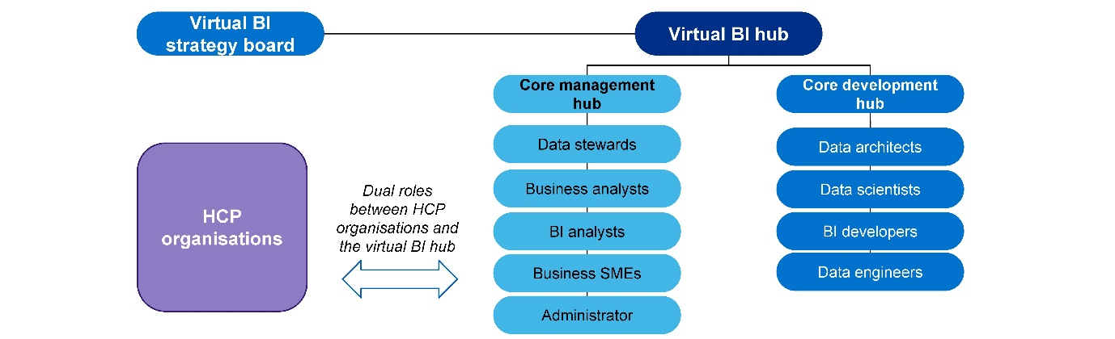

Formation of the BI strategy board
The governance structure for how the Data Analytics and Intelligence Group (DAIG) sits within the wider MSE HCP structure is show on the right.
The DAIG group is made up of around 30 BI leads from the various organisations making up the HCP and is accountable to the Operational Reset Group (ORG). The DAIG is responsible for providing intelligence to specific work stream groups.
It is envisioned that the BI strategy board is formed as an evolution of the DAIG with some more senior membership drawn in from the ORG or the System Leadership Executive Group (SLEG).
It should also be considered whether the BI strategy board should report directly to the SLEG or via other groups such as the ORG.
It is important to note that work is currently underway to review the governance of the HCP’s Digital Programme. The exact placement of the BI strategy board within the HCP’s governance structure should be considered in light of the results of this review.

Identified BI hub roles
Virtual BI hub roles have been defined in line with the capability model and service offering, as well as industry standards. Each role will play an important part in the operation of the virtual BI hub, described in the role summaries below.

Data and BI Lead
Responsible for overseeing the BI hub function and its performance, leading the development, management, and ongoing improvement of BI and data capability within the Hub.

BI Analyst
Responsible for collecting, organising and studying data to provide business insight. This role will be HCP focused.

BI Developer
Responsible for designing and implementing data, reporting, and dashboard solutions.

Data Scientist
Responsible for identifying business problems and leveraging data value to address these problems. Likewise this could be a health economist role.

Data Architect
Responsible for designing, developing and implementing data models and other data architecture components.

Data Engineer
Responsible for finding trends in data sets and developing algorithms to help make raw data more useful to the enterprise

Administrator
Responsible for administrative tasks relating to the BI hub such as incident logs, setting up committees, meetings and minutes etc.
Whilst these are the proposed roles, this is not a comprehensive list and other data and BI-related roles could be considered dependent on the direction the HCP wishes to take the virtual BI hub. Further considerations related to roles include: dependencies for each role (e.g. a data scientist requires high quality data to perform their job), the phasing (at what phase will each role be brought in), feasibility of redeploying/recruiting into these roles, the cost/benefit of each role, whether varying levels of seniority are required (e.g. Junior BI Analyst), and lines of reporting.

Proposed resourcing of the virtual BI hub
The structure and roles below are proposed as a starting point to resource into the virtual BI hub. They are split between management / business led activities and technical/data focussed activities. The process of how to recruit and fill the roles (either internally across the HCP or with external appointments) and implications on job roles, accountability, contracts, etc, needs to be addressed within the highlighted roadmap activity. It’s proposed that to begin with each organisation provides the equivalent of one FTE, half to a technical role and half to a business role. There is also scope to explore how to best use AGEM to support the development of the virtual BI hub.

Core Management Hub team – 5.5 FTE
- Data & Bi lead – 0.5 FTE
- Data Stewards (1 per org, 2 hrs per week)
- Business Analysts – 2 FTE
- BI Analysts – 2 FTE
- Business SMEs (as required from orgs)
- Administrator – 1 FTE

Core Development Hub team – 4FTE
- Technical PM/Lead– 0.5 FTE
- Data Engineer– 0.5 FTE
- Data Architect– 0.5 FTE
- Data Scientist – 0.5 FTE
- BI Developers – 2 FTE

Resourcing approach
Below are series of activities that ought to be performed by in-house resource, and various activities that may lend themselves to external support, alongside the reasoning behind this categorisation.

Additional long term resources recommended
- Virtual BI hub data engineer
- Virtual BI hub data architect
- Virtual BI hub data scientist
There are a number of roles proposed within the virtual BI hub where the HCP is known to have limited internal resource. For these roles, it may be necessary to explore external recruitment directly to the virtual BI hub in the medium term. Ahead of this, it may be necessary to utilise external resource in the short term.

Internal or external resources for project-based activities
- Data lake development and implementation
- Integration of data feeds
- Implementation of PHM dashboards
- End user assessment and training programme
- Culture change programme
- Data quality assessment and improvement plan
These resources could lend themselves to being resourced externally for one of two reasons; the expertise required to perform the work is highly specialised and therefore would cost a lot to hire as permanent resource or would involve a lot of upskilling of existing HCP resource, or because the piece of work could be relatively self contained and carried out once.
When resourcing these activities, they should be considered in parallel with the workload of the virtual BI hub.

How to enable the successful use of BI Hub
To deliver a successful hybrid model organisations must work closely with both core management and development layers of the virtual BI hub. This interdependency is demonstrated in the diagram to the right, which highlights organisational responsibilities in the outside arrows and BI hub responsibilities in the centre.

Key factors related to the operation of the BI hub are:
- Inputs: Organisations must provide specific data inputs (alongside external data) that are managed for quality and communicate needs effectively.
- Outputs: BI hub staff must generate accurate insight and foresight. These outputs will align with agreed HCP vision and BI strategy for the HCP.
- Standardisation: Staff within the Hub will generate templates and communicate best practice; organisational D&A staff will be encouraged adopt these practices.
- Service specific knowledge and expertise: Staff within organisations will need to coordinate knowledge transfer to the hub, to increase the accuracy of outputs.
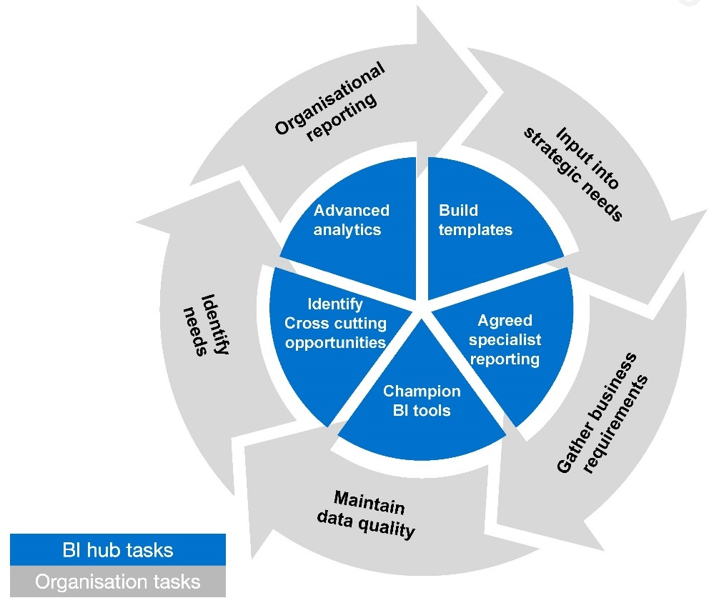

Business case and aligning on vision and principles

A Programme Business Case may be required early on to secure the appropriate senior buy-in and support
In order to achieve a successful implementation of the BI hub, it’s important to get HCP alignment and buy in. In order to secure senior buy-in and support for the resourcing and funding of the virtual BI hub it may be necessary to develop a Programme Business Case. The content of this report can be used as the foundation of the business case. A separate business case is being developed that will cover the funding for the build of strategic data lake.

The strategic vision statement and BI design principles should be agreed by all key stakeholders at the outset
A crucial way to secure early alignment and buy-in is to agree on the strategic BI vision statement for the HCP, which should be backed up by a set of clear design principles. As highlighted earlier in the report, an initial vision statement and set of design principles have been agreed by the core project team, but one of the first steps on the roadmap is to get agreement from all key stakeholders across all of the organisations that make up the HCP

MSE HCP’s Strategic Vision for BI
The Mid and South Essex Health and Care Partnership will use data to provide insight and enable evidence-based decision making with the aim of improving the health and wellbeing of the local population, reducing inequalities and addressing current and future needs.

Principles:
- Ensure data is used as a strategic asset
- Work effectively across the HCP to deliver accurate and timely insight
- Be adaptable to the changing HCP environment
- Eliminate duplicate activity
- Define common data definitions and improve data quality
- Improve decision making and performance of the HCP
- Ensure data is processed in a secure and authorised manner

Next steps framework
- Identify - Those in charge of monitoring and running the virtual BI hub should identify key e.g. need for HCP wide alignment on vision areas to align on to deliver continued success and progression statement and design principles
- Engage - Once identified, there is a need to engage and align on the way forward with e.g. hold workshops to agree on vision representation (including clinical representation) from across the HCP statement and design principles
- Action - Using organisation leaders, as well as a comms programme, to drive changes; e.g. send out details of aligned vision and recruiting local clinical champions will help drive sustained change from within principles in HCP wide newsletter

4.2 Establishing processes and governance structures
The purpose of this section is to explore:
- What governance structures currently exist across the HCP?
- What governance structures will need to be in place in the future state and functions will be required?
- What roles will need to be filled?
- How will the virtual hub governance fit in with existing
- How could an information sharing gateway be used?

Mapping recommendations to this focus area
The change plans that map to the establishing processes and governance structures have been highlighted below:

Process
- Intra-organisation communication plan
- Communications outreach improvement programme
- Formalised virtual BI Hub service request processes
- Review of HCP reporting requirements & agile approach

Organisations
- Centralised BI best practices
- Centralised HCP governance framework
- Data sharing agreements via ISP on ISGs

People
- Oversight on BI capacity

Information
- Nil

Technology
- Nil

HCP central data governance framework
The development of the virtual BI hub lends itself to the development of a central governance framework which will help to address many of the challenges identified in this report regarding governance across the HCP.

The HCP governance framework will define an infrastructure that will support HCP goals and allow it to evolve the direction and the value of BI. The framework will provide clearly defined roles and responsibilities, along with policies that deliver accountability and ownership where needed. This in turn facilitates decision making, compliance, and issue resolution all in line with the HCP’s vision and design principles.

Use case: Suffolk Office of Data and Analytics (SODA)

SODA utilises an Information Sharing Assurance Gateway (ISAG), which describes the set of interconnected processes in eight stages that are required before data is to be shared by partner organisations and utilised for SODA purposes, as well as ongoing actions to maintain the agreed level of security and privacy.

The overarching SODA Data Sharing Charter makes clear that Suffolk partners will safeguard the safety and privacy of people and businesses and comply with all Data Protection legislation. The ISA Gateway is there to make sure that all the commitments in the charter are upheld, including the need to balance public benefit with privacy.
SODA ISAG Flow Diagram
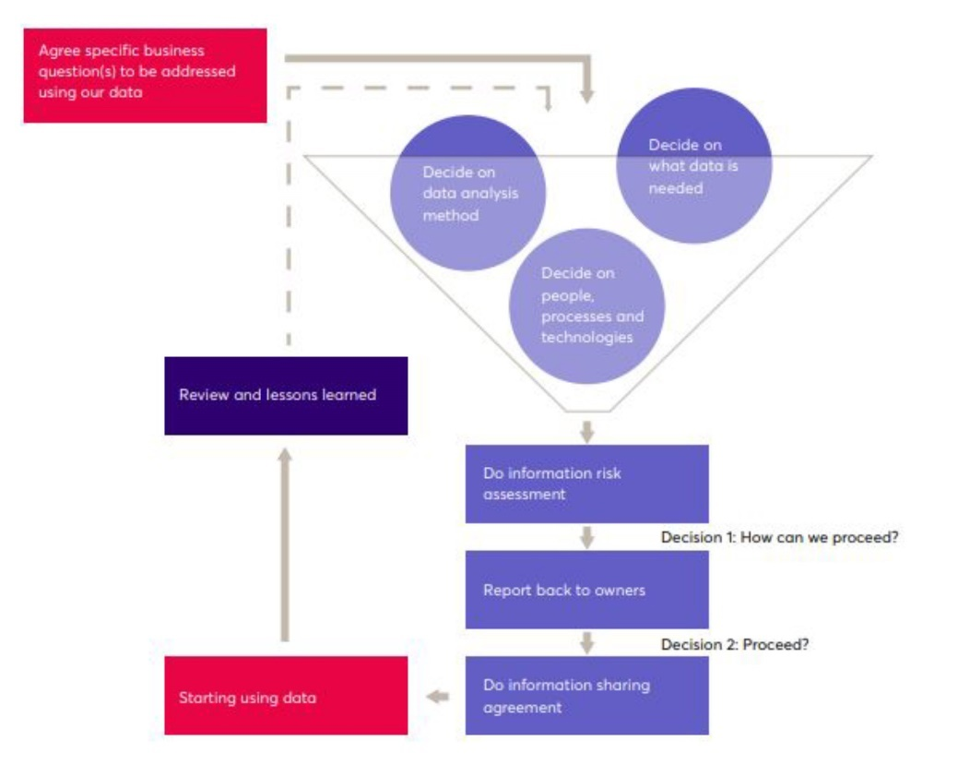

HCP data governance formation
Empowering the right people to look after information is a simple, low cost step that will provide structure and reduce deviation across organisations within the HCP. It can be light touch and seen as an enabler to improving performance across the HCP.
It starts with the right organisation (data literate business people), then defining simple policies around ownership, accountability and standards, before implementing some processes to apply the policies.
This governance formation approach should be the remit of the Data Governance Steering Group which will be responsible for the right integration with existing governance bodies / frameworks across the HCP.
Data governance must be considered across 3 key components:
- Governance
- Process
- Data Asset

Data governance framework
The suggested data governance framework is shown in the diagram below along with descriptions of the functions that make up the framework.
Executive sponsor - A HCP board leadership team member who authorises funding and resources for data governance and management processes, supports the implementation of the data strategy and assists in achieving its business objectives.
Data governance steering group - The steering group is responsible for developing and implementing strategies, policies and standards in relation to data governance and management. Furthermore, the steering group puts measures in place to monitor compliance with the standards. Individuals that make up the group must be knowledgeable in GDPR requirements, data protection laws and HCP’s future vision for data governance and management. This group might be part of or be a sub-committee of the virtual BI strategy board. The members of this group will supplement local organisation data governance structures (including Caldicott Guardians) rather than replacing them.
HCP organisations/localised data owners - The localised data owners (within individual HCP organisations) are responsible for defining and providing a specific type of dataset (e.g. patient record), determining the required data quality levels and setting the privacy, retention and security policies. The localised data owners are required to make decisions, design and control the processes surrounding data in order to improve its reusability, accessibility and quality. The relationships these organisations have with ‘core management hub data stewards’ is key.

Data governance steering group
The data governance steering group is the foundational component of the data governance framework as it defines the scope of data governance, processes, ownership of information assets, policies and standards, and the mechanism to enforce and monitor the policies and standards established by the data governance function.
- Organisational design: The data governance steering group should comprise of constituent stakeholder entities across leadership, business functions and data domains. The need to collaboratively structure, manage and execute will facilitate execution with specific functions, roles, responsibilities and shared accountability.
- Roles and responsibilities: Various roles exist within the governance steering group which need to be distinctly defined along with responsibilities. Typical roles may include; Chief Data Officer, legal and data protection expertise, business subject matter experts, data stewards, business data owners and data custodians.
- Decision rights: Based on roles and responsibilities within the governance steering group, clear guidelines have to established on how decisions will be made and what is the escalation structure based on certain scenarios.
- Interaction model: (see next page)
- Policies and standards: The primary way through which the data governance steering group manages the HCP’s data as an asset is through defining and issuing set of policies, standards and processes that manage the quality, consistency, usability, security, and availability of information across the HCP.

Strategic Data Lake Governance
It should be noted that initially the governance for the development of the strategic data lake will be separate to governance for the virtual BI hub, and will be provided by the digital board. There should be close collaboration between both governance groups to ensure the data lake is built to provide the necessary business requirements. Once the data lake is up and running, it is recommended that governance should be handed over to the BI strategy board.

Data governance interaction model
Once governance organisation design and roles and responsibilities are defined, the ‘interaction model’ needs to be defined as to how the governance organisation will interact with rest of the organisation.
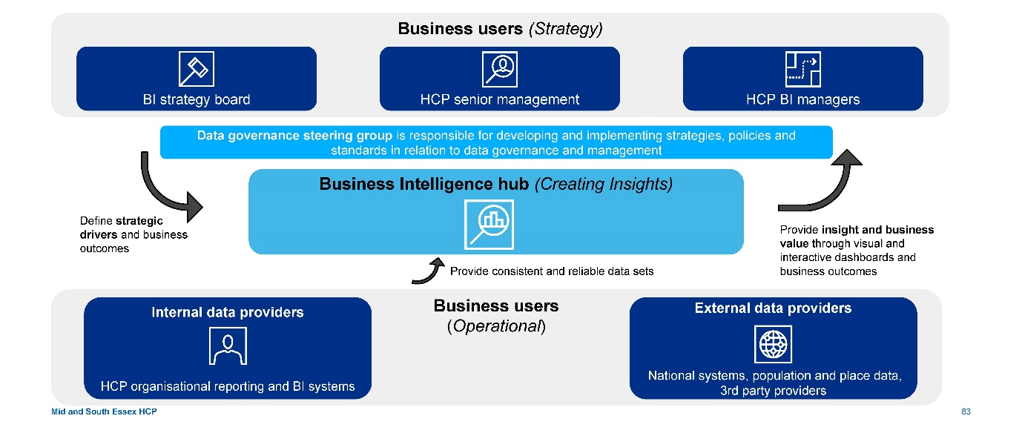

Information Sharing Protocol (ISP)

Key insights
When sharing data among organisations across the HCP, a common set of rules and conditions should be developed. This will typically start with the BI strategy board outlining its intentions in an information sharing strategy or charter, to which all partners sign up.

Many similar system-led programmes have signed a data sharing charter that recognises and respects the underlying principle of ‘a duty to share data unless there is a legal or ethical reason that prevents sharing’. This helps to standardise the information sharing approach upfront and uses it as a starting point for setting up the Information Sharing Protocol (ISP).
The mechanism to then share information for any given data initiative will be made more specific and measurable in the form of a data sharing agreement.

Essential elements to be covered in ISP
- Purpose of sharing
- Potential recipients and the circumstances in which they will have access
- Exact data to be shared
- Data quality - Accuracy, relevance, usability, etc
- Data security
- Retention of shared data
- Individuals’ rights - Procedures for dealing with access requests, queries and complaints
- Review of effectiveness / termination of the sharing agreement
- Sanctions for failure to comply with the agreement or breaches by individual staff

Information Sharing Gateway (ISG)
One of the key priorities highlighted from the interview data gathering sessions faced by organisation’s is for the HCP to identify a space where all information sharing agreements could be stored, providing information not only for a given dataset (who it is shared with and under what terms), but also for a given organisation (what are the datasets already shared and with whom).
Best practice is to use an Information Sharing Gateway (ISG), an online tool that helps create, manage, sign and store data sharing agreements.
The ISG has legal gateways and privacy screening questions directly built into the tool, meaning that information sharing protocols can be completed and signed off much more rapidly and securely. In addition, it includes a sign-off request option, which allows the sending of information sharing agreements to signatories and includes a system to archive agreements and flag those that need a review.
The HCP should develop an ISG to avoid delays or barriers to sharing data which are often described through information governance obstacles, an example of good practice is WEISF already established in Essex.

Good local practice: Whole Essex Information Sharing Framework
The Whole Essex Information Sharing Framework (WEISF) provides members with access to advice, guidance, good practice, networking and tools to support the development of local information sharing. It is a key foundation for the the Essex Centre for Data Analytics. The WEISF provides:
- An overview of all active information sharing protocols submitted to WEISF, allowing practitioners to identify existing sharing, find examples of protocols and provide transparency for citizens
- A list of agencies which are partners in the framework, linking through to their websites
- Advice and guidance sourced from the ICO as regulators.
- Templates to simplify and standardise the completion of ISPs, flexible enough to meet partners’ needs.
- Tools and guidance to assist in increasing data management maturity
This good practice could be built upon for use by the HCP.

Data governance - Process
The data governance steering group should define and monitor the processes that operationalise the policies and standards to maintain data quality, consistency, usability, security, and availability of information across the HCP.
- Data definition and data lineage: The common understanding of data elements across the various systems of the HCP including business rules and calculations derived certain data elements (data dictionaries). The tractability of each data element from the time it was created, through maintenance/enhancement, until analytics and reporting.
- Onboarding new data assets: The processes around data definition, data/process mapping, data quality requirements, change management, and access and security.
- Issue management: The process to track issues (or cases) as a result of monitoring of various data governance program effectiveness measures.
- Change management: The process of changing any of the components within the governance framework ranging from organisation design, roles and responsibilities to specific policy or standard related to specific data processes or data sets.
- Compliance monitoring: The reporting structure to manage compliance with policies and measure overall data governance effectiveness.
- Data quality: This is detailed in subsection 3 - Improving the data and establishing an agreed centralised repository

Data governance - Data assets
The data asset layer establishes scope of what is under the governance of the HCP and the difference in governance between structured and unstructured data.

Structured data
Information that has pre-defined data model and is organized. Structured data typically can take the shape of ‘rows and columns’ or is easily interpreted as such.
- Transactions: Transactional data is data describing events against a customer account for example, which repeats for single customer account multiple times.
- Reference: Reference data is any data that is used as a ‘reference’ to complete or process another set of data. At times this data can be static such as product or customer data, which changes when a change event happens but it can also be live data such as market data.
- Patient/citizen and pathway: Structured patient/citizen and pathway data is at the centre of any data asset held by organisations in the HCP. This can have complex relationships with one person represented across multiple pathways.
- External data: All data outside the HCP is considered external data. This can be reference, transactional and at times patient/citizen and pathway data as well.

Unstructured data
Information that does not have a pre-defined data model and is not organised in a pre-defined manner. It may be text heavy and has ambiguous or unpredictable patterns in which data is laid out. Unstructured data typically requires complex tools and techniques to be converted into structured data. Governance around such data is organized by the type of unstructured data, its usability, and its organisation/storage that is easily searchable.
- Records: Information regarding other activities sometimes to prove the existence of an activity but not necessarily the activity itself.
- Documents: Electronic or manual information that does not follow a specific data model pattern and is stored as a document file rather than a structured data file. For example Microsoft Word files, Powerpoint presentations, Visio, PDFs, etc.
- Web Content: Contents of web pages (displayed or hidden) that can be textual, documents, visual, audio, or animations.
- Multimedia: All other types of unstructured data such as pictures, audio, videos etc.

Benefits of improved data governance
A robust data governance framework with an executive sponsor encourages the use of data as an asset and provides the following benefits:

Enhanced data quality
Data quality is protected and maintained by teams directly responsible to the executive sponsor. Overall, staff spend less time on data quality activities such as cleansing and verifying data for accuracy and spend more time on analysing and interpreting the data.

Value of data
The value of data is understood culturally and becomes synonymous with HCP objectives. Data is seen as an asset across the HCP, however the real value comes from the analysis and deriving of insights.

Better decision making
A clear governance structure allows better decision making through the enhanced data quality. Well-governed data is also more discoverable, making it easier for the relevant parties to find useful insights. It also means decisions will be based on the right data, providing greater accuracy and trust.

Standardised data/processes
Data governance gives the HCP a way to standardise approaches to data use and to promote consistency across the organisations.

Reviewing reporting requirements/practices

Current situation:
- The majority of BI teams across the HCP do not have a formalised service request processes in place within their organisation, and rely on ad-hoc processes; this leads to a large number of ad-hoc requests, which are time consuming and not prioritised correctly.
- There are a number of duplicative and inefficient reporting processes across the HCP, the most obvious being the lack of standardisation across the five CCGs, which have different reporting requirements; this leads to inefficient duplication of time and effort.
- Finally, there is a lack of drive to identify labour intensive processes and look at possible solutions to reduce their burden on capacity, for example by automating certain processes.

Immediate next steps:
- Streamline HCP reporting requests through formalised pathway (detailed in subsequent slides).
- Highlight best practices and recommendations (detailed in subsequent slides) for widespread adoption.

Long term agile strategy:
This should be run in regular intervals (~6 months), with one assigned staff member per organisation responsible for driving this agile approach:
- Identify: BI staff dealing with requests should break down all reporting requirements, highlighting timeframes, requestor and bottlenecks/areas for improvement. e.g. Bed occupancy report takes ~8 working hours, most of which is spent processing data
- Engage: Workshops should then be run with BI staff, requesters and clinical input, discussing potential solutions (using best practice examples highlighted by the virtual BI hub) to implement going forward. e.g. Potentially looking to automate manual parts of the data processing pathway or reducing/refining the size of the report
- Action: These changes should then be implemented on a pilot basis, with a review session scheduled for 3 months to discuss the benefits/challenges faced. e.g. 1 hour is saved on the report, however automation attempts did not work successfully

Standardising BI hub service request process
Requirements should come to the virtual BI hub through various means including the front of house function performed by business analysts, standard reporting requirements from the performance and other corporate dashboards and ad-hoc requests. The requirements should all be documented in an information model; a service desk tool used to demonstrate the demand signal for management information (MI) through the business.
As information requirements are captured they should be categorised in order to appropriately prioritise delivery. The key criteria for such categorisation and prioritisation are:
- Business need: What is the priority of the business need and what are the likely benefits?
- Existence: Is the data currently collected, will new data collection need to be established?
- Availability (access): Does the HCP currently have direct access to the data, is it held by a local organisation or is it held by a third party?
- Quality: What is the quality of the data in terms of integrity, authenticity, and accuracy?
- Confidentiality: What are the confidentiality requirements associated with the data?
- Customer (external/internal): Who is the end customer? Is this a high-profile request?
- Effort: How much effort will be required to deliver the requirement through the data phase, build phase and test phase?
Not only will this help streamline ad-hoc requests for the virtual BI hub, it will also act as a best practice template for organisations to adopt for themselves, helping reduce the burden of ad-hoc reporting requests on their BI teams.

BI best practices
BI best practices will be driven across the HCP in two main ways:

Using the virtual BI hub as an exemplar by adopting best practices centrally and providing detailed information and support to help BI staff replicate these in their own organisations
- This would entail the virtual BI hub piloting recommended best practices, having looked at other exemplar systems/organisations elsewhere in the UK.
- Once pilots have been successfully implemented, the BI hub will highlight these as use cases in the regular communications sent out across the HCP, as well as detailing how to implement the same best practices in individual organisations, with direct help and steer from the initial champion/driver within the virtual BI hub.

Understanding and highlighting best practices being used across HCP, detailing how they implemented it and how to achieve similar in
- This would require an initial landscaping of the HCP, with specific people responsible for identifying the organisation (within MSE) with the best practices in certain areas.
- Once identified, they will be highlighted as being ‘local exemplars’, and be asked to share the details of their practices. For example the Bristol, North Somerset and South Gloucestershire system does this through a regular newsletter.
- This will be highlighted in the regular communications, emphasising the benefits this organisation is realising, as well highlighting the local team for the excellent work and processes.
- Other organisations will be encouraged to adopt similar practices, with local leaders providing steer and teaching to help bring others up to speed.

Examples of best practices areas to share:
- Data governance policies
- Dashboard design
- Data capture processes
- BI tools and platforms
- Data quality improvement
- Data cleaning
- Learning and development programmes
- PHM

4.3 Improving the data and establishing an agreed centralised repository
The purpose of this section is to explore:
- The need for a data quality assessment.
- The need for a data quality improvement programme.
- How to maintain data quality going forwards.
- Understanding future data flows
- Pilot options

Mapping recommendations to this focus area
The change plans that map to the improving data and establishing a central repository have been highlighted below:

Process
- Nil

Organisations
- Nil

People
- Nil

Information
- Data integrity & timeliness improvement plan
- Data taxonomy catalogue
- Data quality improvement plan
- Integrate data feeds

Technology
- Strategic data lake
- HCP-level technical design principles

Improving the data - Data quality
The HCP needs to commence - and sustain - a data improvement programme on all data that will be useful at the HCP level, to deliver high quality data that is available to perform accurate BI and support decision making. This directly meets the data design principle of treating data as a strategic asset.
Data quality can be defined as “The existence of the right data in the right format at the right place and time to meet the needs of business processes”. Any relevant item of data across the HCP should have a required level of quality associated with it, driven from by the needs of the services that use it. Once the required level is determined, data can be measured to determine whether the right level of quality is being achieved.
A phased approach is required to address and enhance the data across the HCP in order to realise the benefit of using data as an asset. A formalised data quality improvement framework allows formation of a single agile repository which can leverage the power of Azure Data Services and BI visualisation tools.

How to drive improved data quality
- Ongoing, proactive data quality management
Embedding a proactive culture and mindset into the staff across the HCP to encourage there is continual, iterative improvement on data quality.
- Early risk identification and mitigation
Creating an easy to use risk/issue log, accessible to everyone, to drive earlier mitigation of risks, limiting their impact.
- Implementing a data quality improvement framework
Implementing a data quality improvement framework establishes a framework to improve data, allowing the HCP to leverage information and decision making. A continuous data improvement approach should be embedded across the HCP and driven by the data stewards.

Proactively managing data quality

Proactively manage data quality and drive its improvement
Once the HCP understands the data demand and underlying data quality (derived from data quality assessment) it can move towards a proactive and continual data quality improvement process on datasets that are used at the HCP level. All individuals working within the virtual BI hub should have a good working knowledge of data quality principles and apply these whilst completing work. The principles include being more open to displaying pre-adjusted figures from source systems despite poor data quality and challenging post extraction adjustments. Data stewards and data owners should be responsible and held accountable, for fixing these issues. This encourages issues to be raised, tracked and fixed at source. Data can also be certified, once tested, to mark a particular source or dataset as being recognised of set quality and reliability.

What are the data quality principles?
The main two principles for teams to follow are completeness and accuracy. By the automation of reporting processes testing to check that key or flagged fields are complete should always occur. Once this first assessment has taken place, subject matter experts can be engaged to confirm that data contained within those complete records is accurate.

Where should issues be tracked and logged?
Data quality issues should be logged and monitored via a formalised process. All such issues should be tracked in a central place known as a DQIR (Data Quality Issues Register) and be maintained by the virtual BI hub core management team, which allows them to be accessed, prioritised, fixed and monitored. There are two normal entry routes for an issue to appear on the register:
- Business as usual operations find a difference in a report or continuous monitoring, where a figure does not align with to the business rule or check total; or
- A data quality audit makes a finding that requires a fix to be completed.

Ongoing data quality improvement process
Outlined below is the proposed ongoing iterative data quality process aimed at driving sustained data quality improvement across HCP:
- Log - Issues must be logged in order to start the data quality process, which could be a simple email or the filling in of a form for the team to pick up. Issues could be formed of bulk findings from a data quality audit that might need splitting into multiple issues.
- Triage - The issue is assessed to see whether it is a duplication, whether it is a data quality issue and whether there are any very quick fixes required prior to moving on to the next stage. This could simply involve forwarding the request on to the correct person or requesting more information. Triage would also look at evidence from business rules to check whether the issue is genuine or allowed within the policy.
- Initial prioritisation - The BI development team will assign an issue a first priority based on the information entered into the DQIR. Timelines for a non-priority long term issue will be different to those for an urgent request. Once the issue is formalised it may necessitate a return to the initiator to populate the detailed template. Key metadata such as dates, department raised, detailed description and processes affected will allow for better judgement. Good communication throughout this process will be important on order to agree on matters such as severity, timelines for fix, current impact and to move forwards towards a resolution target date.
- Root cause analysis - This step is required to check whether the issue raised is a symptom of any greater issue. If someone’s age entry was wrong, does this mean that their personal record as a whole is wrong, and is it the data entry process or has a migration and corruption event occurred?
- Split, merge or continue - Following root cause it may be possible to close issues, merge them with other existing issues or split them up. Genuine new issues will be entered into the DQIR ready for treatment.
- Assess and confirm priority - The data quality issues team use the data from the DQIR to balance the costs and benefits of completing the change and will confirm these with the original initiator. Moving to a confirmed status will allow the team to investigate options for fixing.
- Options for fix - Earlier steps often cause issues to be broken up into parts, or allow them to merge with other issues allowing for different types of remediation. With data quality, it may be a bulk change to a source system following a new survey. Fixes should always aim to be completed with minimal impact to business as usual, and the team manager should liaise with all relevant teams to deliver this outcome.
- Approval - Once the type of fix has been agreed it is important to gain approval. System changes or limitations will often need an impact assessment in order to understand how any change might affect other users. For small projects within a single project team this should be easy to complete. For larger issues, formal approval will be required by core management hub or BI strategy board.
- Manage fix (or group to larger fix) - Where the fix itself has become a project, such as a large data cleansing exercise, it is important to carefully manage the process. Communication of the ways in which users will be affected, for example the schedule of work and any down time of services, will be vital.
- Establish programme of work (e.g. adjust policy / standards) - A fix may require changes to a process, policy or standard for an outside organisation. In this case the team should refer to the data governance steering group.
At the end of the process, the cycle restarts - driving the iterative data quality improvement cycle.

Formalising a data quality improvement framework

Step 1 - Data Quality Assessment
Systems need to be assessed for data quality. Key factors such as data completeness, integrity, timeliness, etc. will be used to assess the data entities and attributes thresholds to prioritise data sets which require the largest effort to improve quality. This assessment activity will define the scope and volume of effort required to effectively improve data quality across the HCP’s IT landscape.

Step 2 - Data Quality Enhancement
The data quality issues identified in the assessment will be documented, and prioritised with recommendations used to inform a data quality improvement plan. This improvement plan will then be executed to enhance data quality across the HCP.

Step 3 - Data Quality Co-ordination
For data quality enhancements, the virtual BI hub should act as a coordination center for resolution and owners of the quality enhancement plan but would not necessarily deliver such resolutions directly.
Similarly, data requirements and quality issues would come to virtual BI hub by various means including central bodies (e.g. NHS England), standard reporting requirements and ad-hoc requests. A prioritisation framework for data quality issues would need to be drafted and agreed in order to support these processes alongside the more strategic framework of data quality improvements across the HCP.

Data integrity and timeliness improvement plan

Data integrity plan
There are a number of potential steps that can be taken to improve data integrity throughout the HCP:
- Use a single source of data
- Data entry training and literature
- Data validation processes
- Automating processes
- Standardised data taxonomy
- Remove duplicate data
- Selective access management
Many of these steps will be covered in other areas of the roadmap but can be accelerated if the data integrity is highlighted as a priority.

Data timeliness improvement plan
There are a number of potential steps that can be taken to address poor data timeliness throughout the HCP:
- Single source of truth
- Automating highly manual, time consuming tasks
- Improve data capture tools
- Train clinicians to improve data completeness
- Driving best practices across the HCP
- Complete data cleaning via virtual BI hub
Many of these steps will be covered in other areas of the roadmap but can be accelerated if the data timeliness is highlighted as a priority.

Data flows model
An indicative data flow model for the HCP’s central data repository has been set out to the right.
There will be two key data stores: one for individual records for direct care and one for secondary usage (i.e. commissioning/planning).
One and two-way data flows will need to be established from local organisations into and out of these flows. It is recommended that an early prioritisation exercise is undertaken to determine the order in which these data flows are established
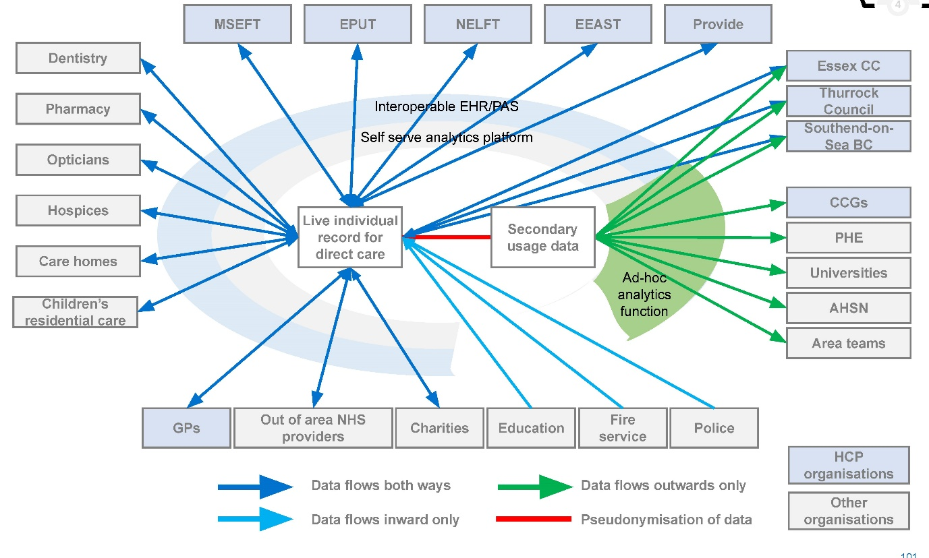

HCP BI architecture and common data model
These data flows will be structured within a BI architecture and will have a common data model (CDM). It has been assumed (in line with the Strategic Data Lake work) that this will be a Microsoft Azure environment. However this is by no means the only option and is shown in this report for example purposes only. Further details on the technology to support this are in the next subsection.
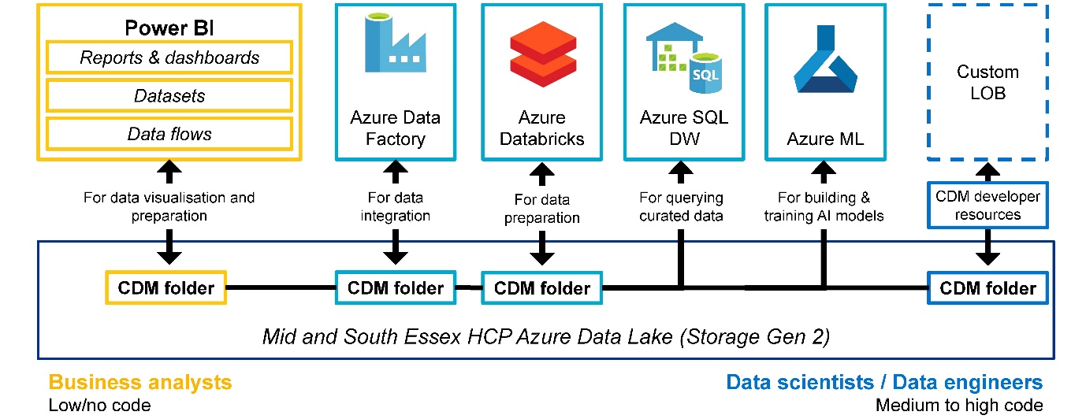

Selecting the correct pilots to generate early buy-in
Choosing the right early pilot(s) for dashboard development will be key to establishing support for an integrated BI approach across the HCP, getting the commitment of leadership teams, and securing the time and resource investment needed.
The leadership team should consider how to have the largest possible impact across the HCP, whilst requiring potentially restricted resources. In order to impact the whole HCP, the following broad topic areas (used by the Dorset Intelligence and Insights Service) may be considered:
- Actionable Insight: Workforce (e.g. staff absences), capacity (e.g. available beds), patient flow (e.g. admissions/discharges).
- ICS Intelligence: Overview, planned care/referrals, unplanned care, mental health, community, workforce.
- Population Health Intelligence: Population segmentation, risk stratification, intervention KPIs.
Given that the insights derived from a Population Health Intelligence dashboard are likely to take longer to deliver benefits, it is recommended that two pilot dashboards are developed, including one from the Actionable Insight or ICS Intelligence categories. Through discussions with the Project Group, one potential area for early consideration for this second dashboard is system-wide urgent and emergency care.

Good local practice: Essex Centre of Data Analytics pilot
The initial pilot for the Essex Centre of Data Analytics (ECDA) set out to reduce the threat, risk and harm to potential victims of modern slavery through creating a predictive model using business inspections data. During the discovery phase, it was highlighted that before any predictive algorithm was attempted, a wider problem was the lack of any consistent sharing of business inspections data between agencies.Therefore, the first outcome of the pilot produced a multi-agency picture of business inspections to identify a broader range of risk factors that could improve business practices. This also helped reduce vulnerability further down the line by laying the foundations for building the predictive product originally envisaged, with much higher chances of success.

Potential pilot 1: Urgent and emergency care
Urgent and emergency care has been suggested as a potential area for development of a pilot dashboard. This has been selected as:
- Urgent and emergency care flow is a system-wide problem so the dashboard will provide insight to a large proportion of the organisations within the HCP.
- Due to local pressures associated with the COVID-19 pandemic (in additional to winter pressures), there is an immediate need for performance improvement.
- Improved insight can provide short term benefits, i.e supporting greater visibility of blockages in patient flow.
Potential metrics for consideration include the following. These are a combination of existing performance metrics, metrics proposed through the Transformation of Urgent and Emergency Care consultation1 and other system-wide metrics that impact on urgent and emergency care flow.
Further COVID-specific metrics (i.e. segmenting the below by COVID/non-COVID patients) may also be useful in the short term.

Existing metrics
- Ambulance category 2 response times
- Percentage of patients spending more than 4 hours in the Emergency Department
- Number and proportion of unoccupied acute beds

Additional metrics currently under consultation
- Conveyance rates to Emergency Departments by ambulance
- Proportion of contacts via NHS 111 that receive clinical input
- Percentage of ambulance handovers within 15 minutes
- Percentage of patients receiving an initial assessment in Emergency Departments within 15 minutes
- Mean time in Emergency Departments for non-admitted patients
- Mean time in Emergency Department for admitted patients
- Percentage of patients spending more than 12 hours in the Emergency Department

Other system-wide flow metrics
- Number of stranded/super-stranded patients
- Number of delayed transfers of care by type
- Number and proportion of unoccupied community beds
- Number and proportion of unoccupied care home beds
- Number of people awaiting packages of care at home by current location

Potential pilot 2: Population Health Intelligence
A Population Health Intelligence dashboard could be used as a second pilot as this will build upon the strong foundations that already exist within the HCP when it comes to PHM.
An effective Population Health Intelligence dashboard should help the HCP to:
- Understand the specific needs of the local population and to explore gaps in care and unwarranted variation through segmentation.
- Identify high and emerging risk groups most amenable to interventions and target them through tools such as risk stratification and impactability models.
- Size the opportunity to understand the impact (both on outcomes and finances).
The specific areas of focus within the Population Health Intelligence dashboard should be agreed with the PHM Steering Group but these require a clear understanding of how population need will be identified and the outcome measures that will be used for the defined population. They should also build upon population health needs assessments that have already been undertaken.
The FutureNHS Population Health Management Academy provides a wide range of good practice examples of Population Health Intelligence dashboards: https://future.nhs.uk/populationhealth/grouphome

Good practice example: Behaviour PredictorTM
While Population Health Management tools often focus purely on characteristics of a population, i.e. demographics, disease prevalence, etc to make recommendations of proposed interventions, PwC’s Behaviour Predictor is a virtual laboratory of social determinants of health and individual motivators that allows for prediction of behaviours that drive health outcomes.
Through use of a synthetic population that accurately resembles demographics, neighbourhood characteristics, individual motivators and behaviours within target neighbourhoods, Behaviour Predictor generates cohorts to show patterns in preferences, behaviours and the key drivers of the target population. It then predicts population health behaviour in response to interventions and projects, showing the potential impact on outcomes and financial return on investment.
Often these influential social/environmental determinants of health and individual motivators can be key to the effective management of costly chronic conditions.
https://www.pwc.com/us/en/industries/health-industries/library/doubl ejump/behavior-predictor.html

4.4 Designing and building the technology platform
The purpose of this section is to explore:
- The options for hosting the data repository
- HCP data lake principles
- The high-level design of the technology platform
- Details of the analytics tools likely to be required over time
It is important to note that work is underway to further develop this requirement as part of the strategic data lake business case and therefore it is subject to change.

Mapping recommendations to this focus area
The change plans that map to the designing and building the technology platform have been highlighted below:

Process
- Nil

Organisations
- Nil

People
- Nil

Information
- Integrate data feeds

Technology
- Single self serve platform with varying access levels
- BI tools & platform alignment
- Leverage economies of scale
- HCP-level technical design principles
- Build pilot use case

Data storage and BI tools

Data storage and technology architecture
In order for the virtual BI hub to be able to manipulate the data and link the data flows described earlier in this report, a single data store is required for use across the HCP.
It is recommended that the HCP adopts a cloud based storage model and, based on the previously completed Strategic Data Lake work, it is recommended that a Microsoft Azure architecture is used. This has the advantage over physical storage solutions that it can be more easily scaled up and down as the requirements of the HCP change over time.
Access to the services will take place through cloud computing platforms, through applications that use Application Programming Interfaces (APIs), such as cloud desktop storage, gateway or Web-based content management systems, or through APIs themselves.

BI tools
Alongside the data storage solution, the tools through which users can access this data are equally important, particularly given the finding earlier in this report that the most common tool used within the HCP is Microsoft Excel. Three of the most used tools currently on the market are Qlik, Power BI and Tableau but given the prior recommendation to use an Azure architecture, it is recommended that Microsoft Power BI is used for this purpose.
Further details on the recommended technology architecture and visualisation tool can be found on the following pages.

Establishing an agreed centralised repository
A centralised data repository will be required, bringing together and integrating various data feeds from the organisations making up the HCP. This data, in time will be supplemented with external data sets from other organisations both in and outside of the MSE HCP and with national datasets.
A separate programme of work is being carried out to develop a strategic data lake platform which, in time, should be used as the data repository for the virtual BI hub. The strategic data lake will however take a substantial amount of time to build, and therefore it is proposed that initially the virtual BI hub utilises existing data processing and data storage capabilities such as those provided by AGEM.
In the long run, the HCP will need to agree where the strategic data lake will be hosted and who it will be managed by. This will require a thorough analysis of the options to be reviewed by all key stakeholders before an option can be chosen. Below are several options along with high level pros and cons of each.

OPTION 1 - Hosted by a shared BI function
Pros
- Best option for equally representing all parties’ interests
- Easiest to distribute costs
Cons
- Requires setting up and resourcing a new team from scratch

OPTION 2 - Hosted by an NHS provider
Pros
- Best placed from a process perspective as NHS providers are closer to more of the data sources
Cons
- There is a danger this would be seen as an NHS focused project and would lose wider engagement

OPTION 3 - Hosted by a council
Pros
- Best placed for driving public health
Cons
- Integrating data from the NHS providers would be a challenge

HCP level data lake general principles
HCP level data lake principles were developed during the piece of work developing the strategy and roadmap for the strategic data lake. These are shown below, and should be used to guide the design and build of the technology platform.
- The data lake will support the LHCR and Population Health Management Strategy
  - Rationale: The data lake will need to support the long term strategic aims of the HCP, so that ultimately all data can sit within one technical solution.
- Data should be accessible 24x7
  - Rationale: Data is required operationally for clinicians and care workers to be able to provide effective care; therefore this data will need to be available 24x7, and there should be failsafe measures in place to avoid downtime during maintenance periods. This raises the total cost of ownership.
- Data needs to flow at different rates through the architecture
  - Rationale: Data flows of different rates need to be permitted so that it supports both the Shared Care Record and the population health management requirements, which must include both real time and batch data flows.
- Iterative ways of working
  - Rationale: Building data lake components iteratively to build up the data sets and components over time, so that business benefits are realised earlier for both individual organisations and the wider HCP.
- The data lake will be a repository, and will not write back
  - Rationale: The Data Lake will be a slave repository where data can only be cleansed, enriched, and merged. It will not write back merged or enriched information into the master data sources. However, it will be possible to use data quality reporting to highlight inconsistencies for correction in master sources and a process will need to be set up to perform this activity.
- The data lake will support the BI roadmap
  - Rationale: The data lake will need to support the long term strategic aims of this BI Strategy and Roadmap, as well as the Shared Care Record, so that ultimately all data can sit within one technical solution. Data flows once from the appropriate data sources into the organise component, so data can be extracted as required into the Standardise Data Marts.

Introducing the components of a data lake
Data lakes and data warehouses are both widely used for storing big data, but they are not interchangeable terms. A data warehouse is a repository for structured, filtered data that has already been processed for a specific purpose, and may have a series of data marts held within it to hold information structured in a specific way for different business functions to access.
A data lake is a vast pool of raw data, the purpose of which is not yet defined. An enterprise data lake architecture will provide a flexible ‘base’ architecture, which can be built on with specific components and technology tools to meet current and future needs of the HCP. It will support the different types of analytics, dashboards, population health management, real time alerting, notifications and flexible messaging to provide integrated patient management models that the HCP want to develop. The diagram below shows the core components of an enterprise data lake.
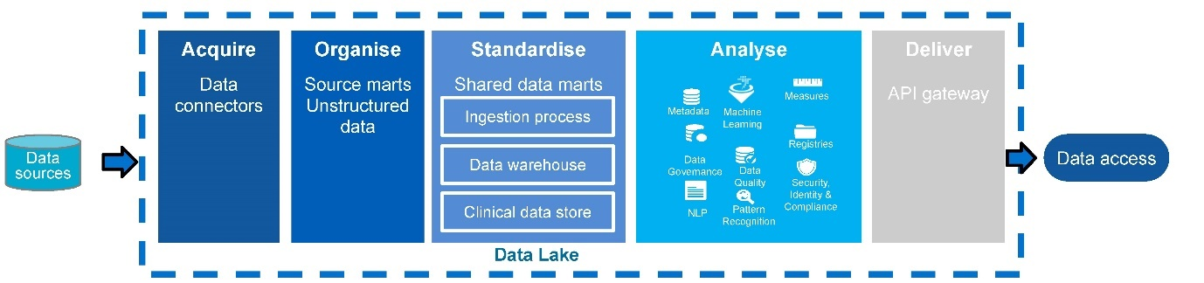

Data source
Source systems contribute target data. These can be both organisational and HCP systems.

Acquire
Integrating information from the data sources into the data lake.

Standardise
The ingestion process takes raw messages and populates the appropriate data mart/warehouse.

Analyse
Uses different tools to combine and enrich the data to allow extraction of maximum insight.

Deliver
This layer ensures data can be visualised, accessed or transferred to systems.

Data access
Users and systems can consume the data and retrieve data sets.

Technology architecture
The diagram below illustrates the key components of the data lake architecture which would enable HCP integrated BI capabilities. This architecture aligns to the recommendations of the Strategic Data Lake work previously undertaken. It is important to note that the blocks on the left of this diagram may represent either existing data warehouses or, in the long term, direct feeds from data collection systems.

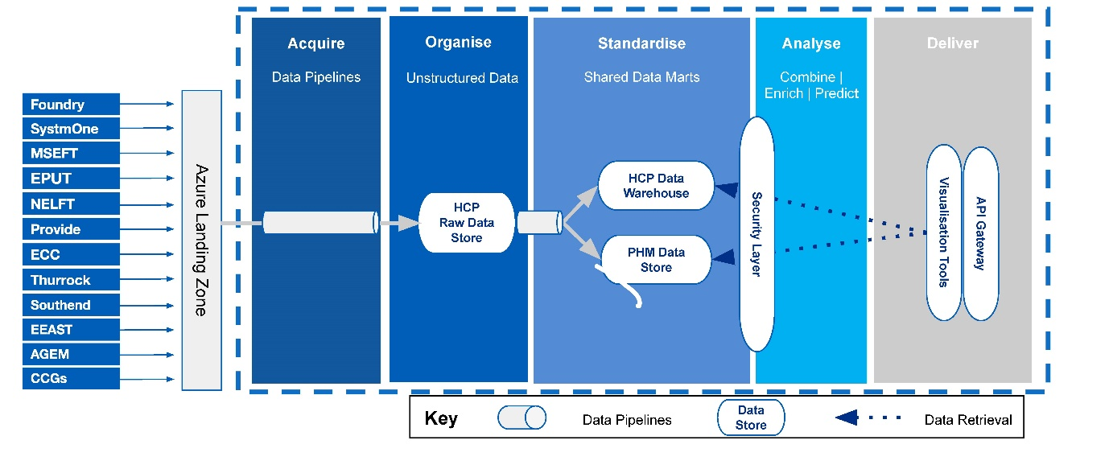

Technology architecture in Microsoft Azure
This requirement has then been mapped to the standard building blocks of an Azure architecture in the diagram below.
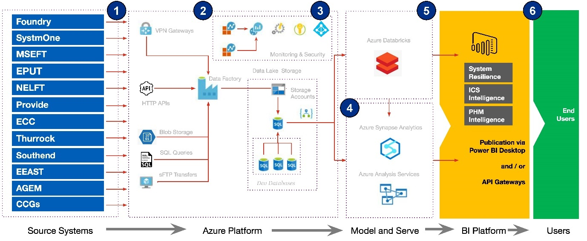

Overview of Power BI dashboards
It is recommended that the HCP adopts greater utilisation of visualisation tools such as Microsoft Power BI.
Power BI has a number of features that make it suitable for use within the HCP. Core features that promote usability from a BI developer perspective include:

- A drag-and-drop user interface that allows for the rapid creation of interactive dashboards with real-time feeds of data. This first benefit is critical as the real-time, interactive nature of the dashboards will allow the HCP to move away from the large number of spreadsheet reports that are currently being produced and to a self-serve model for accessing data.
- Support for a wide range of data sources including linking directly to SQL databases, text files (e.g. XML) or existing Excel reports. The latter is particularly useful as a short term solution when creating new dashboards where the formal data flows do not yet exist.
- Links to geospatial tools, such as Esri ArcGIS, which can allow for more advanced map-based representations of data than may currently be possible.
- A simple API for integration with other applications.
Through the Power Query functionality, Power BI additionally has the ability to undertake more complex data preparation and discovery activities (although for published dashboards it may be more computationally efficient to move these earlier in the process, i.e. coding them in SQL).
There are also a wide range of ways that these reports can be consumed by users, including web, desktop and mobile platform support. Integration with Microsoft Azure, as detailed on the previous page, will allow for management of security and accessibility for users across the HCP.

Example Power BI dashboard: MSEFT elective performance dashboard
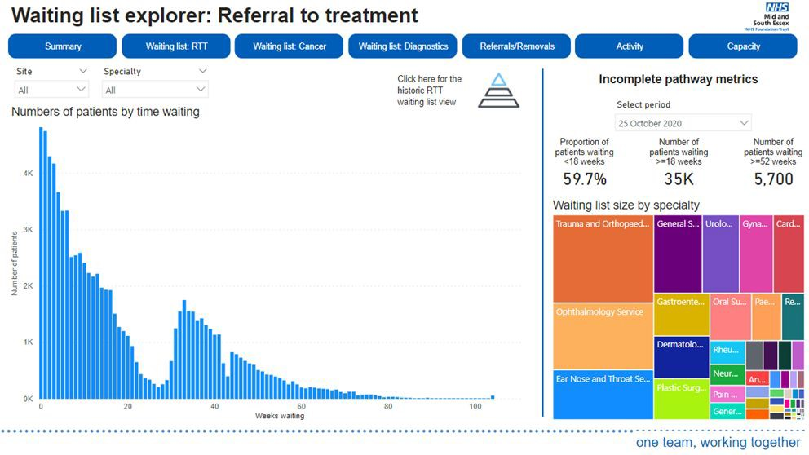

Advanced tools for future analytics
In the short term it is likely that the data lake will supply access to aggregated data either via API gateways or through front end visualisation tools such as Microsoft Power BI. To begin with relatively basic data analytics tools such as PowerBI and Alteryx (which supports data manipulation) will be sufficient to meet demands, but over time as more data is available more powerful tools will be required such as those offered by the cloud providers of the data repository, e.g. Azure. In the longer term there are a number of more advanced and highly flexible tools that could be used by the virtual BI hub in the Azure platform, particularly for population health management.
For some of these tools there exist NHS communities which the virtual hub should utilise. One such example is the NHS R Community (https://nhsrcommunity.com).
The timing of which of these tools will be needed when will depend on the prioritised pipeline of work for the BI hub. It will also depend on the central data repository and the data sitting within it.

Basic tools (Powerr BI, alteryx)
Initially the virtual BI hub will rely upon relatively basic data analytics tools capable of data processing and analysis on small to medium sized datasets.

Data lake tools – (databricks, Azure Synapse Analytics)
As the data lake is set up and the amount of data to work with grows, more powerful data analytics tools will be required capable of transforming and exploring massive quantities of data.

Advanced tools – (R, Python)
In the long term, and once the available datasets are mature and rich enough, the BI hub are likely to need to use more flexible tools with advanced capabilities, such as AI packages.

Developing a service management framework
Initially the virtual BI hub will be able to manage service requests and maintenance of the BI services (e.g. dashboards) developed by the hub relatively easily, because the number of services and end-users will be small.
In time however, the number of ongoing BI services will grow into a large portfolio, the maintenance and management of which will become considerable for the BI hub. There may well be large numbers of people across the HCP relying heavily upon services provided by the BI hub. At this point a formal service management framework will be required, defining how and what level of service will be provided.
It is recommended that the virtual BI hub develop a framework based on ITIL (Information Technology Infrastructure Library) best practices. ITIL is a set of detailed practices for IT service management that focuses on aligning IT services with the needs of business. The diagram on the right illustrates the key areas covered by a service management framework.

The virtual BI hub may also be able to draw upon good examples of service management already used in organisations in the MSE HCP.
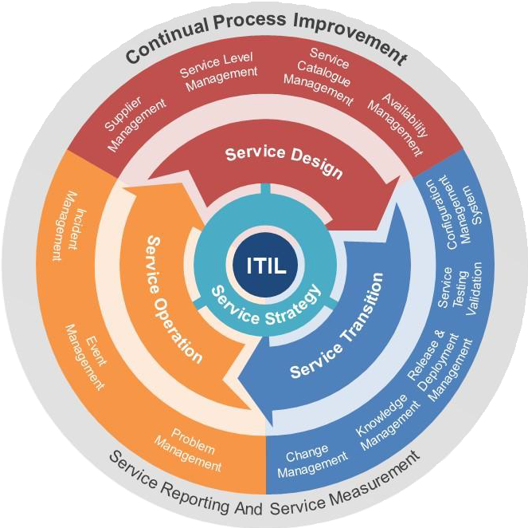

4.5 Creating a data centric culture and workforce
The purpose of this section is to explore:
- Challenges with organisational culture
- Embedding the right culture and behaviours
- Skills gap analysis for the resourcing of the virtual BI hub

Mapping recommendations to this focus area
The change plans that map to the creation of a data centric culture and workforce have been highlighted below:

Process
- Intra-organisation communication plan
- Communications outreach improvement programme

Organisations
- Nil

People
- End user assessment & training programme
- Clinical representation at local &a strategic level
- Technical capabilities L&D programme
- Technical capabilities recruitment strategy
- Culture change management plan

Information
- Data taxonomy catalogue
- Data quality improvement plan

Technology
- HCP-level technical design principles

Organisational culture

HCP barriers
Although there is often a desire for sharing data amongst services, it can be challenging in reality. Some of the challenges will be deeply rooted in a particular service, its culture and staff, and will take time to change. Other barriers, such as information governance, technology or finance can be more quickly overcome by being well informed and learning from others.

What’s the challenge?
Many data leads report having difficulties in even getting into initial conversations about data sharing and analytical capability in their organisation. Partly, this is due to organisational cultures that struggle to keep pace with innovation. In some cases, data and digital capabilities are looked at as desirable options rather than essential and effective investment of resources. It is not always understood at all levels of the organisation how these can be used to achieve better outcomes in decision making and healthcare delivery.

How can this be managed?
Communication is key to this, primarily being able to adapt the information and explanations to different audiences.
One of the qualities of a good data scientist is being able to explain his or her analysis and findings to a non-data literate audience, being able to deliver insights rather than describing statistics. The same principles apply here. For example, using plain English, leaving out the jargon or acronyms can help. If people do not understand it, they will not engage with it, or may feel threatened by it. Explaining it simply, identifying tangible benefits and sharing information in a digestible way is key.
It is not just about having senior executives on board but the support of analytical teams is also crucial. For example, this could be keeping them up to date with policy changes or through regular training. Keeping engagement high with the wider workforce is also important.
Explaining the benefits of the approach, how it will make the organisation better and what has worked well elsewhere (perhaps by giving examples of other areas doing it well) will all contribute to adopting a good culture around data sharing.

Embedding the right culture and behaviours
Sustained business value comes from embedding the right culture and behaviours to deliver insight from trusted data.
Often overlooked, data needs to be seen as an asset like any other asset the organisation owns and manages.
Organisations are now including data as an asset on the balance sheet and are building data culture into employee performance management.
However, shifting culture is not a short journey and needs senior sponsorship. When people have been used to doing something in a certain way, it’s a challenge that entails a lot of change.
Getting everybody to understand the value of making decisions using data-driven insight rather than gut feel is something most organisations seem to struggle with.
Continual communication and proactive leadership action are required to reinforce and embed culture and behaviours.
Questions to ask:
- How can I deliver change which is meaningful and consistent across the HCP?
- How do I address traditional ways of working which are now acting as an obstacle?
- How can I empower my workforce with the right data at the right time?
- How do I connect strategy to operations in a way that is meaningful?
- How can I increase ‘trust in the source’?
- How can I align the business to consistent principles and policies, for data and reporting?
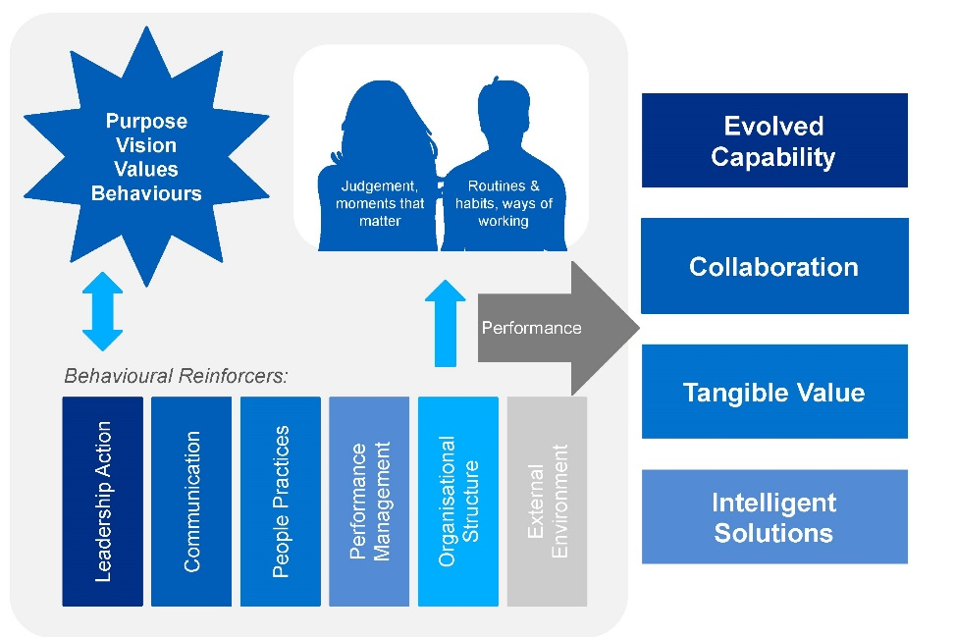
- Clear milestones delivering capability that is truly sustainable, through an
- empowered workforce
- Benefit that is felt ‘on the ground; Data that is trusted; Faster and more effective decision making
- Change that is understood and bought into by the business; from strategy and leadership, to functions and operations
- Solutions which make a difference and leverage what the HCP already has

Creating a data-centric culture
Several key things need to be in place in order to create a data-centric culture and skilled workforce.

Data availability
Data should be available to people who need it, when they need, in a way they can use it in order to improve the services delivered to their patients or citizens. The questionnaire responses collected through this programme identified several instances where people struggle to access data, which in turn creates frustration or inefficiency, particularly in delivery of key front-line services.

Openness to data sharing
The culture of limited data sharing and limited accountability for data improvement needs to change in order for organisations across the HCP to exploit fully the benefits that could come with the development of a central data repository and collaborative HCP BI capability. As a supporting factor, workforce skills and business change initiatives are vitally important.

Alignment to wider communications
Alignment to a wider business change and training needs plan: In order to deliver cultural change a draft proposal should be prepared which outlines staff training on new ways of working, behaviours and responsibilities. The introduction of a HCP-wide handbook could also help outline the vision and the type of organisational behaviours necessary to become the data-centred HCP it aspires to be.

Skills and capability

What is the challenge?
In addition to changing the culture, having the right mindset and increasing the appetite for innovative ways of working; having the skills and capability is also a crucial aspect to consider.
Capability may become a barrier due to current organisational structures. Structures may not align to a collaborative BI model, meaning it is difficult to identify who takes the lead and how. It is for the strategic board to decide the details of what that core team should look like; however, effective BI hubs do not just hire a crack team of data experts. Data scientists are key, but it’s also vital to have access to the necessary legal, technical, evaluation and comms expertise too.

How can this be managed?
For this, the collaborative nature of a virtual BI hub becomes very useful. Partners could include local authorities, public sector bodies, tech firms, data science SMEs, academic institutions, think tanks, civic hacker groups, and so on, all of which could provide bespoke expertise that the HCP would not otherwise have access to. Some of the roles required in setting up and running could also be secured on a voluntary basis (there are plenty of organisations willing to work on projects that could benefit the community), or through simplified procurement frameworks, put in place by the virtual BI hub.
There are a number of opportunities to work with private sector businesses and academic institutions to create attractive opportunities for skilled individuals. Catalyst projects are a good example of collaborations between counties and universities.
There also exist external communities which should be used by the BI hub for building links with wider NHS communities. One such example is the Association of Professional Healthcare Analysts (https://www.aphanalysts.org/).

Change readiness assessment

What is a change readiness assessment
Readiness assessments tap into stakeholders’ unspoken opinions and attitudes regarding a change – revealing their readiness to adopt the change. It also uncovers business related aspects that need to be in place to support making the change happen. A change readiness assessment is thus a formal process for understanding the organisation’s ability to support the desired changes as well as a tool to uncover and manage related people and business risks. The readiness assessment can be conducted through interviews, focus groups and/or surveys based on available time, resources and budget.

Why is it important?
In order to realise expected benefits of a change, we need to uncover and understand stakeholder opinions and attitudes, and to identify and understand the organisations ability to support the change. This decreases the risks associated with the implementation of the
change. Given the number of change plans suggested, as well as the commented on change fatigue that some organisations across the HCP are suffering from, it is essential to gauge the appetite and opinions of stakeholders, allowing for more tailored approaches to drive sustained change.

How ready are staff for change?
Typically, stakeholders sit somewhere along the change curve (outlined on the right); it is essential to understand where the organisation sits, to better understand the amount of effort required to drive change.

Change readiness assessment

What activities will be key to success
Throughout the cycle of change, activities must address three areas of focus - leadership, engagement, and skills and behaviors - to enable your people to change.

Engagement
People need a positive experience to embrace change. In implementing this strategy, engagement will be required to:
- Connect their role to the vision
- Build a sense of team
- Co-create solutions
- Celebrate successes and learn from their experience

Leadership
People need leaders to set the tone for success. Leaders in the system should:
- Align with and advocate the vision
- Work as a team to make decisions
- Be accountable for their role and actions
- Build capability and role model behaviors

Skills & Behaviours
People need support to change. In implementing the strategy, teams should be supported to:
- Understand the rationale for doing things differently
- Acquire new skills and capabilities
- Experience a positive response to their new behavior
- Overcome obstacles to adoption

Technical skills gap analysis
A technical skills gap analysis will identify areas of expertise which are lacking or non-existent across the HCP. An investment in training to
address the gaps will be required which will also include training to business users who will self-serve their reporting needs through self-service BI.
The HCP needs to invest in a BI Hub team with people who are skilled and can work closely with the various organisations to identify and develop BI and reporting capabilities, which will ultimately improve the overall BI maturity across the HCP. An initial review conducted as part of the development of this BI Strategy and Roadmap has identified Data Architect, Data Engineer and Data Scientist skill sets as being in particularly short supply across the HCP. Therefore these might form an initial area of focus for any investment.
Each organisation should identify a data steward and data architect with the correct skills to help maintain and continually improve data management across the organisations services in line with the principle of using their underlying data as an asset.
For the HCP to build a virtual BI hub team with the correct skills, the following key activities are proposed as part of a future activity in the strategic roadmap. The skills required in the BI Hub and services teams must include the ability to:
- Identify and manage data quality issues
- Maintain data models of organisation systems and complete data migration tasks
- Develop and maintain Azure data services including data warehouse skills
- Complete data science statistical analysis activities
- Develop and maintain BI and visualisation reporting technologies such as Power BI

5 Roadmap to Achieving an Integrated BI Capability
This section focuses on providing next steps and associated timeframes, centred around the five key pillars identified in the last chapter, to achieving an integrated BI capability
- Building a virtual BI hub
- Establishing processes and governance structures
- Improving the data and establishing an agreed central repository
- Designing and building the technology platform
- Creating a data centric culture and workforce

The purpose of this section is to explore:
- Detailed next steps to achieving an integrated BI capability in the HCP.
- Associated timeframes and dependencies.
- Effort and impact levels of each activity within the roadmap.

A twin track approach for quick wins and sustainability
The size of the challenge facing the HCP in transitioning from the current state to the future state set out in this report can seem overwhelming, especially with each step providing additional challenges. In an industry fraught with failed transformation programmes, it is easy to lose momentum on these large scale projects; it is therefore essential that the HCP get things moving quickly right from the get-go, accelerating the delivery of certain key activities to see some real tangible change early on, leading to some quick wins.
This helps garner support and enthusiasm for the programme, demonstrating the potential of collaborating at the HCP level and crucially, showing people that it’s possible to make an impact quickly. This is important for securing buy-in and commitment both for the people directly involved in the programme doing the doing, and for the external stakeholders.
The way to do this is to employ an agile, twin track approach, whereby certain activities are carried out rapidly to produce the equivalent of a minimum viable product to allow certain quick wins. In parallel, longer term activities are carried out in slower time, guided by the learnings from the accelerated activities.
In practice, this means prioritising specific high impact programmes early on, to get widespread stakeholder buy-in; this is why this report emphasises initial activities in the proposed roadmap, to identify and highlight key outputs to expect within 3 months.
Alternative options for accelerating benefits realisation
Whilst this BI Strategy and Roadmap focuses on the aforementioned twin track approach in order to achieve both short term gains and long term foundational change, there is an inherent challenge relating to the time it will take to deliver certain benefits. This inherent challenge stems from having to write a Programme Business Case for buy-in and funding, then having to bring onboard sufficient resource or upskill people before certain work can begin. There is an alternative approach which could allow benefits to be realised faster, though of course this comes with cost implications.
The HCP could opt to reduce the scope of the in-house work to be carried out by the virtual BI hub, and outsource high priority sections of what is needed. For example this BI strategy is designed to address required improvements in both performance reporting and population health management (PHM) across the system. The HCP could instead outsource the PHM aspect of this to a third party who could use their ready-made resources to perform all data cleansing, data manipulation, and dashboard development necessary in a short time frame to provide substantial benefits within weeks.
Some benefits and risks associated with this approach are set out below.

Benefits
- Rapid realisation of benefits and addressing of immediate high priority problems.
- Less up-front investment required.
- Significantly reduced remit and workload for the virtual BI hub, lowering the risk of failure of the roadmap BI roadmap.
- Spreading of risk. Rather than investing solely on internal development and trusting that it will work, using external resource spreads out the risk.

Risks
- Potentially higher cost over the long term.
- The investment will lead to short-term benefits, but without the necessary in-house expertise to maintain the developed product longevity will be limited.
- Some internal expertise is still required in order to effectively procure and manage outsourced solutions.
While this report is predominantly focused on developing in-house capabilities and solutions, where more detailed design is taking place, outsourced solutions should be considered to identify whether off-the-shelf products can be used in place of larger development projects.
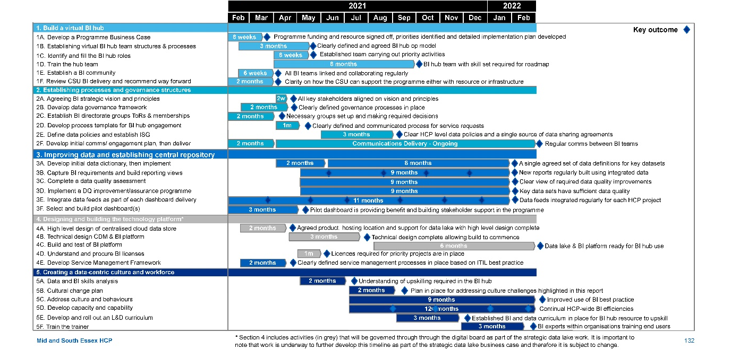

Building the virtual BI Hub

1A. Develop a Programme Business Case
A Programme Business Case for the MSE BI Strategy investment implementation may need to be written, reviewed and signed-off. This will be separate to the business case for the development of the strategic data lake.
Effort Low, Impact High

1B. Establishing virtual BI hub team structures, processes and ways of working
The key processes and governance structure for the virtual BI hub must be designed and approved, including a quality assurance framework for BI work and a triage process for receiving, prioritising and delivering incoming requests.
Effort Med, Impact Med

1C. Identify and fill the BI hub roles
A project team will need to be assigned to move initial roadmap activities forward, utilising CSU and/or contractor support as required. Over the longer term, HCP organisational staff with appropriate skills will be re-aligned to replace contractors. In a limited number of cases an external recruitment campaign could be used.
Effort Med, Impact Med

1D. Train the hub team
The data-centric workforce and culture workstream should be used to establish where the biggest skill gaps exist across the HCP. These gaps, in conjunction with the estimated requirement, would help define the recruitment and training strategy for the virtual BI hub.
Effort Med, Impact Med

1E. Establish a BI community
In order to connect the Business Intelligence community; the identified teams across the organisation should be connected through knowledge-sharing forums and regular communications.
Effort Low, Impact Low

1F. Review CSU BI delivery
The role of AGEM should be reviewed to understand what contributions they could make to the HCP BI capability, either through resource or infrastructure.
Effort Med, Impact Med

Building the virtual BI hub - High level 12 month plan

1A. Develop a Programme Business Case
6 weeks from February 21 to March 1 - Programme funding and resource signed off, priorities identified and detailed implementation plan developed

1B. Establishing virtual BI hub team structures, processes and ways of working
3 months from February 21 to May 21 - Clearly defined and agreed BI hub op model

1C. Identify and fill the BI hub roles
6 weeks from April 21 to May 21 - Established team carrying out priority activities

1D. Train the hub team
6 months from April 21 to Oct 21 - BI hub team with skill set required for roadmap

1E. Establish a BI community
6 weeks from February 21 to March 21 - All BI teams linked and collaborating regularly

1F. Review CSU BI delivery
2 months from Feb 21 to March 21 - Clarity on how the CSU can support the programme either with resource or infrastructure

Establishing governance structures and processes

2A. Agreeing BI strategic vision and principles
Building on vision statements/principles captured in BI strategy, the BI strategy board need to ratify and communicate the vision to the wider HCP.
Effort Low, Impact Med

2B. Develop data governance framework
The data governance steering group will review existing data governance policies across organisations, before establishing a set of governance policies, standards and processes that deliver higher consistency across the HCP.
Effort Med, Impact Med

2C. Establish BI directorate groups ToRs and memberships
There is a need to align on Terms of Reference (ToR) for the BI directorate and assign membership roles. This will be driven predominantly by the steering group, but also requires BI strategy board input, as well as steer from executive sponsor.
Effort Low, Impact Med

2D. Develop process templates for BI hub engagement
Provide standardised routes for communications and request templates to streamline BI hub engagement.
Effort Low, Impact Med

2E. Define data policies and establish ISG
The steering group will define data policies to enable better use of reporting, as well as using an Information Sharing Gateway (ISG), an online tool that helps create and manage data sharing agreements
Effort High, Impact High

2F. Communications plan to wider HCP community
Initial communications should be developed concurrently with a Communications and Engagement Plan designed to improve communication between the different BI teams across the HCP, as well as between BI teams and service users. This plan should then be implemented.
Effort Low, Impact med

Establishing governance structures and processes High level 12 month plan

2A. Agreeing BI strategic vision and principles
2 weeks in April 21 - All key stakeholders aligned on vision and principles

2B. Develop data governance framework
2 months from February 21 to April 21 - Clearly defined governance processes in place

2C. Establish BI directorate groups ToRs and memberships
2 months from February 21 to April 21 - Necessary groups set up and making required decisions

2D. Develop process templates for BI hub engagement
1 month in April 21 - Clearly defined and communicated process for service requests

2E. Define data policies and establish ISG
3 months from June 21 to August 21 - Clear HCP data policies and one source of data agreements

2F. Communications plan to wider HCP community
2 months from February 21 to April 21 + ongoing delivery – regular comms between BI teams

Improving data and establishing agreed central repository

3A. Complete a data quality assessment
Data quality issues across all HCP data sources associated with the BI development pipeline should be measured and documented. This assessment will define scope, volume and root cause of issues.
Effort Med, Impact Med

3B. Implement a DQ improvement / assurance programme
Data quality improvement plan should be implemented against assessment outcomes and prioritised in conjunction with BI pipeline
Effort High, Impact High

3C. Develop an initial HCP data dictionary, followed by a full implementation
Develop data definitions, business glossaries and taxonomies to profile data, create consistency across the HCP and contribute to the common data model. This work should build upon national standards.
Effort Med, Impact High.

3D. Integrate data feeds
Complete a data architecture and integration design of key data sources across the HCP’s structured and unstructured sources enabling mapping to Azure and Common Data Model.
Effort High, Impact High

3E. Capture BI requirements and build reporting views
Identify business use cases and BI requirements across HCP which will be used to design and build front end visualisations and create a BI development pipeline
Effort High, Impact High

3F. Select and build pilot dashboard(s)
Prototype dashboard(s) should be piloted as soon as possible to demonstrate value from the BI strategy. These may need to utilise an organisation’s existing architecture.
Effort Low, Impact High

Improving data and establishing agreed central repository High level 12 month plan

3A. Complete a data quality assessment
2 months from April to May 21 – a single agreed set of data definitions for datasets key to the HCP

3B. Implement a DQ improvement / assurance programme
9 months from May 21 to February 22 - New reports regularly built using integrated data

3C. Develop an initial HCP data dictionary, followed by a full implementation
9 months from May 21 to February 22 - Clear view of what data quality improvements are needed for initial projects

3D. Integrate data feeds
9 months from May 21 to February 22 - Key data sets have sufficient data quality for priority projects

3E. Capture BI requirements and build reporting views
11 months from February 21 to February 22 - Data feeds integrated regularly for each HCP project

3F. Select and build pilot dashboard(s)
3 months from February 21 to May 21 - Pilot dashboard is providing benefit and building stakeholder support in the programme

Designing and building the technology platform

4A. Confirmation of hosting environment
Complete options analysis and confirmation of hosting of data lake infrastructure.
Effort Low, Impact Low

4B. Technical design CDM and BI platform
Technical Design of the BI platform based on the strategic ADLS, Common Data Model and Azure Analytics Services and Power BI data flows
Effort Med, Impact High

4C. Build and test of BI platform
Implementation of technology infrastructure and BI Platform core build and test.
Effort High, Impact High

4D. Understand and procure BI licenses
Analysis of existing BI user licenses followed by the procurement of licenses to fill any gaps that exist.
Effort Med, Impact Med

4E. Develop service management framework
Develop clearly defined service management processes based on ITIL best practice
Effort Med, Impact Med

Designing and building the technology platform High level 12 month plan

4A. Confirmation of hosting environment
2 months from March 21 to May 21 - Agreed product, hosting location and support for data lake with high level design complete

4B. Technical design CDM and BI platform
3 months from May 21 to August 21 - Technical design complete allowing build to commence

4C. Build and test of BI platform
6 months from September 21 to Feb 21 - Data lake & BI platform ready for BI hub use

4D. Understand and procure BI licenses
1 month in May 21 - Licences required for priority projects are in place

4E. Develop service management framework
2 months from March 21 to April 21 - Clearly defined service management processes in place based on ITIL best practice

Creating a data-centric culture and workforce

5A. Data and BI Skills analysis
Identify capability gaps within the virtual BI hub by comparing the BI and data requirements with the capabilities of the people taking on the BI hub roles
Effort Low, Impact Low

5B. Cultural change plan
Develop a plan for addressing the culture challenges highlighted in this report.
Effort Med, Impact Med

5C. Address culture and behaviours
Re-affirm BI Directorate level support and sponsorship around the data and BI agenda. This should be accompanied by a schedule of communications to encourage good practice and direct any activity around BI and data through the correct governance routes.
Effort Med, Impact High

5D. Develop capacity and capability
In order to successfully deliver change, HCP should increase capacity by augmenting the current BI development resources from across the partner organisations to create more bandwidth.
Effort High, Impact High

5E. Build an L&D curriculum
Create a curriculum around BI and data to allow virtual BI hub development resource to upskill and become professionally recognised.
Effort Med, Impact Med

5F. Train the trainer
Train-the-trainer should be employed as an approach to embed BI experts within organisations to enable them to train other people.
Effort Low, Impact Low

Creating a data-centric culture and workforce High level 12 month plan

5A. Data and BI Skills analysis
2 months from May 21 to July 21 - Understanding of upskilling required in the BI hub

5B. Cultural change plan
2 months from July 21 to September 21 - Plan in place for addressing culture challenges highlighted in this report

5C. Address culture and behaviours
9 months from July 21 - Senior commitment to BI and improved use of BI best practice

5D. Develop capacity and capability
12+ months from July 21 - Continual HCP-wide BI efficiencies

5E. Build an L&D curriculum
3 months from September 21 to December 21 - Established BI and data curriculum in place for BI hub resource to upskill

5F. Train the trainer
3 months from December 21 to February 22 - Embedded BI experts within organisations training end users

Appendix 1: Detailed breakdown of engagement across the HCP

Breakdown of engagement across the HCP
Thank you to the 52 individuals from across the HCP who engaged with this programme of work through interviews and workshops. These people are listed below and on the following slides. In addition to this, thank you to the 101 people who completed the questionnaire.
Name | Group | Interviewed | Attended Kick-off workshop | Attended strategy workshop | Attended final review workshop
Brian Hughes | AGEM | Yes | Yes | Yes | No
Ayub Bhayat | AGEM | Yes | No | No | No
Gail Savage | AGEM | Yes | No | No | No
Sheila Etcuban | AGEM | Yes | Yes | No | No
Emma Smith | AGEM | Yes | Yes | Yes | No
Laura Browne | AGEM | No | No | Yes | No
Carol Machin | AGEM | No | No | Yes | No
Anthony McKeever | CCGs | Yes | No | No | No
Ashley King | CCGs | Yes | No | No | No
Patricia Dorsi | CCGs | Yes | No | No | No
Rachel Hearn | CCGs | Yes | No | No | No
Jennifer Speller | CCGs | Yes | No | No | No
James Wilson | CCGs | Yes | No | No | No
Dan Doherty | CCGs | Yes | No | No | No
Emma Timpson | CCGs | Yes | Yes | Yes | Yes
Jo Cripps | CCGs | Yes | No | No | Yes
Alison Birch | CCGs | No | No | Yes | No
James Buschor | CCGs | Yes | Yes | Yes | No
Sarah Hurst | CCGs | No | Yes | No | No
Peter Fairley | ECC | Yes | No | No | No
Colin Seward | ECC | Yes | Yes | Yes | Yes
Alastair Gordon | ECC | Yes | No | No | No
Nicola Mallet | ECC | Yes | No | No | No
David Caplan | ECC | Yes | No | No | No
Zoe Collis | EEAST | Yes | No | No | No
Paul Scott | EPUT | No | No | No | Yes
Jan Leonard | EPUT | Yes | Yes | No | Yes
Yes | EPUT | Yes | No | No | No
Andrew Pike | MSEFT | Yes | No | No | No
Tom Abell | MSEFT | Yes | No | No | No
Charlotte Williams | MSEFT | Yes | Yes | No | No
Ian Harrison | MSEFT | Yes | Yes | Yes | No
Martin Callingham | MSEFT | No | No | No | Yes
Dawn Scrafield | MSEFT | No | No | No | Yes
Josie Harding | MSEFT | Yes | Yes | No | No
Charlotte Sturges | MSEFT | No | Yes | No | No
Brid Johnson | NELFT | Yes | No | No | No
Keith Apperley | NELFT | Yes | No | Yes | No
Barry Plewa | NELFT | Yes | Yes | No | No
David McMullan | Newton | Yes | No | No | No
Frank Wilkinson | Newton | No | Yes | Yes | No
Barry Frostick | NHSE | No | No | No | Yes
Vicky Waldon | Provide | Yes | No | No | No
Andrew Brown | Provide | Yes | No | Yes | Yes
Deepak Pulikkottil | Provide | Yes | No | No | No
Kaiser Chowdhury | Provide | No | Yes | No | No
Tandra Forster | Southend | Yes | No | No | No
Tom Dowler | Southend | Yes | No | No | No
Richard Warren | Southend | Yes | No | No | No
Monica Scrobotovici | Thurrock | Yes | No | Yes | Yes
Emma Sanford | Thurrock | Yes | No | Yes | No
Maria Payne | Thurrock | Yes | No | No | No

Appendix 2: Questionnaire development methodology
The process used for developing the questionnaire is illustrated below. In order to ensure the questionnaire was comprehensive, thorough and up-to-date, material from a range of sources was used:

Understanding the landscape
Past engagements with the NHS, primary research and our SME network enabled us to develop a high level understanding of how organisations are assessed from a BI maturity perspective

Developing question longlist
Separating into 5 core themes, we began compiling questions, tailoring questions from the HAAM model, primary research and previous work

Refining question list
Understanding what exactly we want to know and how to ensure the questions address this; we also shortened the questionnaire at this point to improve accessibility

Iterating on feedback
Based on feedback, we further reduced the length of the questionnaire, standardised answer options and clarified definitions to reduce confusion, as well as using MS Forms to ensure accessibility

Distributing questionnaire
Through designated organisation specific leads, we distributed the questionnaire to the relevant parties

Appendix 3: Detailed healthcare analytics adoption model scoring
The table below shows the first five levels of the HAAM model and the detailed requirements that need to be met for an organisation to be classed as at that level. Requirements are highlight black where this is not found anywhere in the HCP, orange where it is found in some organisations, and green where it is found across the HCP. The remaining five levels are shown on the next slide.

Level 4 - Automated External Reporting
- Analytic motive is focused on consistent, efficient production of reports required for regulatory and accreditation requirements (e.g. CMS, Joint Commission, tumor registry, communicable diseases); payer incentives (e.g. MU, PQRS, VBP, readmission reduction); and specialty society databases (e.g. STS, NRMI, Vermont-Oxford).
- Adherence to industry-standard vocabularies is required.
- Clinical text data content is available for simple key word searches.
- Centralized data governance exists for review and approval of externally released data.

Level 3 - Automated Internal Reporting
- Analytic motive is focused on consistent, efficient production of reports supporting basic management and operation of the healthcare organization.
- Key performance indicators are easily accessible from the executive level to the front-line manager.
- Corporate and business unit data analysts meet regularly to collaborate and steer the EDW.
- Data governance expands to raise the data literacy of the organization and develop a data acquisition strategy for Levels 4 and above.

Level 2 - Standardized Vocabulary & Patient Registries
- Master vocabulary and reference data identified and standardized across disparate source system content in the data warehouse.
- Naming, definition, and data types are consistent with local standards.
- Patient registries are defined solely on ICD billing data.
- Data governance forms around the definition and evolution of patient registries and master data management.

Level 1 - Enterprise Data Operating System
- At a minimum, the following data are co-located in a single data warehouse, locally or hosted: HIMSS EMR Stage 3 data, Revenue Cycle, Financial, Costing, Supply Chain, and Patient Experience.
- Searchable metadata repository is available across the enterprise.
- Data content includes insurance claims, if possible.
- Data warehouse is updated within one month of source system changes.
- Data governance is forming around the data quality of source systems.
- The EDW reports organizationally to the CIO.

Level 0 - Fragmented Point Solutions
- Vendor-based and internally developed applications are used to address specific analytic needs as they arise.
- The fragmented point solutions are neither co-located in a data warehouse nor otherwise architecturally integrated with one another.
- Overlapping data content leads to multiple versions of analytic truth.
- Reports are labor intensive and inconsistent.
- Data governance is non-existent.

Level 9 - Direct-to-Consumer Analytics & Artificial Intelligence
- Direct-to-patient analytics and AI are used in a collaborative decision making environment between patients and healthcare providers.
- Patients have the ability to port and analyze their complete healthcare data ecosystem, independent of healthcare providers.
- Treatment and health maintenance protocols are enabled using AI-based digital twins– “Patients Like This” and “Patients Like Me” pattern recognition.

Level 8 - Personalized Medicine & Prescriptive Analytics
- Analytic motive expands to wellness management, physical and behavioral functional health, and mass customization of care.
- Analytics expands to include NLP of text, prescriptive analytics, and interventional decision support.
- Prescriptive analytics are available at the point of care to improve patient specific outcomes based upon population outcomes.
- Data content expands to include 7×24 biometrics data, genomic data and familial data.
- The EDW is updated within a few minutes of changes in the source systems.

Level 7 - Clinical Risk Intervention & Predictive Analytics
- Analytic motive expands to address diagnosis-based, fixed-fee per capita reimbursement models.
- Focus expands from management of cases to collaboration with clinician and payer partners to manage episodes of care, using predictive modeling, forecasting, and risk stratification to support outreach, triage, escalation and referrals.
- Physicians, hospitals, employers, payers and members/patients collaborate to share risk and reward (e.g., financial reward to patients for healthy behavior).
- Patients are flagged in registries who are unable or unwilling to participate in care protocols.
- Data content expands to include home monitoring data, long term care facility data, and protocol-specific patient reported outcomes.
- On average, the EDW is updated within one hour or less of source system changes.

Level 6 - Population Health Management & Suggestive Analytics
- The “accountable care organization” shares in the financial risk and reward that is tied to clinical outcomes.
- At least 50% of acute care cases are managed under bundled payments.
- Analytics are available at the point of care to support the Triple Aim of maximizing the quality of individual patient care, population management, and the economics of care.
- Data content expands to include bedside devices, home monitoring data, external pharmacy data, and detailed activity based costing.
- Data governance plays a major role in the accuracy of metrics supporting quality-based compensation plans for clinicians and executives.
- On average, the EDW is updated within one day of source system changes.
- The EDW reports organizationally to a C-level executive who is accountable for balancing cost of care and quality of care.

Level 5 - Waste & Care Variability Reduction
- Analytic motive is focused on measuring adherence to clinical best practices, minimizing waste, and reducing variability.
- Data governance expands to support care management teams that are focused on improving the health of patient populations.
- Population-based analytics are used to suggest improvements to individual patient care.
- Permanent multidisciplinary teams are in-place that continuously monitor opportunities to improve quality, and reduce risk and cost, across acute care processes, chronic diseases, patient safety scenarios, and internal workflows.
- Precision of registries is improved by including data from lab, pharmacy, and clinical observations in the definition of the patient cohorts.
- EDW content is organized into evidence-based, standardized data marts that combine clinical and cost data associated with patient registries.
- Data content expands to include insurance claims (if not already included) and HIE data feeds.
- On average, the EDW is updated within one week of source system changes.

Appendix 4: Organisation specific primary research results

Organisation-level questionnaire results
Organisation | No. respondents | Process | Organisation | People | Information | Technology
AGEM | 7 | 3.43 | 3.08 | 3.60 | 3.07 | 2.33
CCG | 19 | 2.67 | 3.04 | 2.81 | 2.82 | 2.05
ECC | 6 | 2.44 | 2.70 | 3.57 | 3.00 | 2.06
EEAST* | 1 | 2.00 | 4.00 | 4.00 | 4.50 | 2.33
EPUT | 27 | 2.86 | 3.38 | 3.05 | 3.41 | 2.49
MSEFT | 26 | 2.67 | 3.16 | 2.81 | 3.21 | 2.03
Other | 1 | 3.33 | 3.00 | 3.00 | 3.50 | 3.00
Provide | 4 | 2.75 | 2.75 | 3.40 | 3.13 | 2.50
Southend BC | 3 | 2.89 | 3.00 | 3.33 | 3.50 | 2.44
Thurrock | 2 | 3.50 | 3.43 | 2.80 | 3.00 | 1.83
NELFT | 6 | 3.28 | 2.71 | 4.00 | 3.50 | 2.44
HCP | 102 | 2.82 | 3.13 | 3.07 | 3.20 | 2.24
* It should be noted that the East of England Ambulance Service results are based on a single questionnaire response so may not represent the range of opinions collected from other organisations.

MSE FT primary research results

Interview findings
- End-users often have no time for self service BI
- It is hard to hire analytics resources at a high enough pay band
- It is possible to get data from across the HCP but it takes a lot of time and effort
- Having three PAS systems and three sets of ways of working is a blocker
- Short notice urgent turnaround requests coming in are never ending
- MSE are one of the top 10 biggest Trusts in the country which presents its own challenges

Questionnaire results
- Process AR: 2.67 - viable
- Organisation AR: 3.16 - viable
- People AR: 2.81 - viable
- Information AR: 3.21 - viable
- Technology AR: 2.03 - Exposed

BI App Catalogue - People/ Team
Total number of people: not provided

BI App Catalogue - Applications / Data Sources
- Hospital Insights
- Healthcare Evaluation Data (HED)
- QlikView
- SSRS
- Power BI

EPUT primary research results

Interview findings
- The team struggle to keep up with BAU reporting and ad-hoc requests, and have no time for BI development
- EPUT cannot have confidence in their data until 21 days after the end of the month due to data validation
- EPUT have to produce around 600 KPIs on a regular basis, many of which are not necessary
- There has been a culture of needing the most up to date data possible, when all that is needed is trend data
- The technical infrastructure and internal reporting tools are relatively mature
- It would help EPUT if there was a DSCRO with most of the data in it so others in the HCP could self-serve

Questionnaire results
- Process AR: 2.86 - viable
- Organisation AR: 3.38 - viable
- People AR: 3.05 - viable
- Information AR: 3.41 - viable
- Technology AR: 2.49 - Exposed

BI App Catalogue - People/ Team
Total number of people: 9
- 3 Management staff
- 3 Technical staff
- 3 BI staff

BI App Catalogue - Applications / Data Sources
- Crystal Reports
- SSRS

Essex County Council primary research results

Interview findings
- ECC has a good level of resources, capability and technology across several teams for reporting and PHM
- There are cultural challenges to address around appetite for sharing information at a HCP level
- Greater support is needed on IG and IT as the internal resources are stretched thin
- Data quality as a result of poor data entry is an issue and a barrier to utilising predictive analytics
- The future state has to be interoperable with other Essex STPs
- ECC have the capability to contribute to BI best practices documentation at the HCP level

Questionnaire results
- Process AR: 2.44 - Viable
- Organisation AR: 2.70 - Viable
- People AR: 3.57 – Future ready
- Information AR: 3.00 - Viable
- Technology AR: 2.06 - Exposed

BI App Catalogue - People/ Team
Total number of people:5
- 1 Management staff
- 2 Technical staff
- 2 BI staff

BI App Catalogue - Applications / Data Sources
- Microsoft Power BI
- SQL Server
- MOSAIC
- Capital One
- TCS

Southend-on-Sea BC primary research results

Interview findings
- The team is stretched working on BAU reporting
- Data sharing can be an issue, as often the necessary contracts or structure are not in place
- There is low priority placed on BI work outside of Southend BC
- Each LA has their own priorities which can lead to resource problems or political issues
- Access to integrated healthcare / NHS data would help enormously with both operations and PHM

Questionnaire results
- Process AR: 2.89 - viable
- Organisation AR: 3.00 - viable
- People AR: 3.33 - viable
- Information AR: 3.50 - viable
- Technology AR: 2.44 - Exposed

BI App Catalogue - People/ Team
Total number of FTE: 14
- 1 Management staff
- 1 Technical staff
- 14 BI staff

BI App Catalogue - Applications / Data Sources
- SQL
- R
- ESRI
- Liquid Logic

Thurrock Council primary research results

Interview findings
- The Thurrock Integrated Care Partnership is a good example of intra-organisation collaboration
- Challenges lie in linking what the HCP are doing compared to what Thurrock are doing
- At times it feels like there is a bit of a barrier around the HCP from a Local Authority perspective
- Information governance can be a real challenge, both trying to access data within the HCP and externally
- Thurrock have done lots of good work in PHM and other BI areas but these are Thurrock focused
- Thurrock have very recently set up a small HCP PHM team funded by the HCP

Questionnaire results
- Process AR: 3.50 - viable
- Organisation AR: 3.43 - viable
- People AR: 2.80- - viable
- Information AR: 3.00 - viable
- Technology AR: 1.83 - exposed

BI App Catalogue - People/ Team
- No BI App Catalogue provided

BI App Catalogue - Applications / Data Sources
- No BI App Catalogue provided

CCG primary research results

Interview findings
- Sometimes receive different data sets from trusts which contradict each other
- There is often a disconnect between those sending the data and those receiving it
- The absence of good data means that people are less invested in developing insights
- Providers can be very guarded with their data, with significant internal politics around what data is shared
- There is a culture of reliance on bespoke BI and a resistance to self-service
- Any future system will need to be interoperable with organisations outside of the HCP

Questionnaire results
- Process AR: 2.67 - viable
- Organisation AR: 3.04 - viable
- People AR: 2.81 - viable
- Information AR: 2.81 - viable
- Technology AR: 2.05 – exposed

BI App Catalogue - People/ Team
- To be completed on receipt of BI app catalogue

BI App Catalogue - Applications / Data Sources
- To be completed on receipt of BI app catalogue

AGEM primary research results

Interview findings
- AGEM have the capability to provide more BI services required by the CCG
- There is some duplication between the work AGEM do and the work done by the in-house CCG BI team
- Data completeness and quality is a major issue
- There is a high reliance on key individuals in MSE
- More strategic vision, governance and drive for change at a HCP level will help things
- Education for end-users on the value of data and analytics will help to foster a collaborative approach

Questionnaire results
- Process AR: 3.43 - viable
- Organisation AR: 3.08 - viable
- People AR: 3.60 – future ready
- Information AR: 3.07 - viable
- Technology AR: 2.33 – exposed

BI App Catalogue - People/ Team
Total number of people: 11.5
- 3.5 Management staff
- 0 Technical staff
- 8 BI staff

BI App Catalogue - Applications / Data Sources
- Data management environment
- GEMIMA BI portal
- Palantir foundry

EEAST primary research results

Interview findings
- EEAST are primarily a data provider to the HCP and do not currently receive any data from the HCP
- EEAST’s technical infrastructure and internal reporting tools are relatively mature
- A data lake is being developed which in future could link to a HCP data lake

Questionnaire results
- Process AR: 2.00 - exposed
- Organisation AR: 4.00 – future ready
- People AR: 4.00 – future ready
- Information AR: 4.50 – future ready
- Technology AR: 2.33 - exposed

BI App Catalogue - People/ Team

No BI App Catalogue provided

BI App Catalogue - Applications / Data Sources

No BI App Catalogue provided

Provide primary research results

Interview findings
- Data quality and data availability are two key issues
- Provide have driven a self-serve BI model but some support for service users is still required
- A more collaborative and holistic approach to data sharing across the HCP is required
- Better access to primary care data would be a huge benefit to Provide
- Risk stratification would be useful for Provide - incorporating aspects of AI to help identify risks earlier on

Questionnaire results
- Process AR: 2.75 - viable
- Organisation AR: 2.75 - viable
- People AR: 3.40 - viable
- Information AR: 3.13 - viable
- Technology AR: 2.50 - exposed

BI App Catalogue - People/ Team
Total number of people:4
- 0.5 Management staff
- 0.75 Technical staff
- 2.75 BI staff

BI App Catalogue - Applications / Data Sources
- SQL Server (Database)
- Cubes
- SSRS
- Excel
- Microsoft Access database
- Power BI

NELFT primary research results

Interview findings
- There is a lack of transparency and transferability of data from SystmOne
- Simpler data governance is needed, particularly regarding SystmOne
- CCGs focus too much on requesting data in order to meet targets when this is often not the best use of time
- NELFT have a relatively mature BI team in terms of resource, tools and infrastructure
- More alignment across the different CCGs is required in terms of required reporting
- NELFT and other providers will want to continue their own processes and sign off data shared with the HCP

Questionnaire results
- Process AR: 3.28 - viable
- Organisation AR: 2.71 - viable
- People AR: 4 – future ready
- Information AR: 3.5 - viable
- Technology AR: 2.44 – exposed

BI App Catalogue - People/ Team
Total number of people: 23.5
  - Management staff
  - Technical staff
- 14.4 BI staff

BI App Catalogue - Applications / Data Sources
- Power BI

Appendix5: Questionnaire findings

Q12 - In your opinion, what are the main ways of improving information sharing or enriching the data shared across the HCP, if any?

Key themes (including frequency of responses)
- Standardised data set across HCP / one source of (verified) truth x10
- Change policies / culture / legislation / governance to drive collaborative HCP and encourage data sharing (system wide sharing agreements / structures) x8
- Ensuring only collect data that drives insights and decision making x5
- Better interoperability across HCP (standardisation of systems) x5
- More investment spent (time, money and capacity) improving data quality before sharing x4
- Single Sign On platform to access all site systems and permissions to view reporting across HCP x4
- Consistent approach / protocol to data management (turning data into insights that drive clinical outcomes) and sharing x3
- Clear, transparent communication across the HCP x3
- Better data timeliness x2
- Central data warehouse that covers all HCP x2
- Email updates / newsletters x2
- Faster uploading of patient records and pseudonymising of data
- Shared goals across HCP
- Unified patient record across HCP
- More emphasis on working with service users (e.g. doctors and nurses)
- Better documentation of data
- Easy access to key data sets
- Clear direction, steer and input from senior leadership in HCP
- Real time data flows, dashboards and updates
- Allowing the STP/CCG to access our self-service reporting at a summarised level

Q18 - Are there any example processes in your job that would benefit from automation? Please provide examples

Key themes (including frequency of responses)
- Specific examples of use cases x10
- Lots of Excel reports can be automated (cultural and technical barriers) – requires centralised reporting platform and data warehouse that can be used by the whole HCP to ensure consistency of info x3
- Daily NHSI Sitrep returns x3
- One source of the truth (with a understanding of how that source is built) is required to enable automation x2
- Automation will reduce intervention time, manual effort and risk of errors x2
- Consistent reporting formats from providers required
- Report tracking for failed reports
- Robust data warehouse and risk stratification support is required to drive automation
- Automation can lead to missed data errors / trends; manual checks reduce missed data errors / trends
- Automating process from data extraction to processing (Excel) to reporting (dashboards)
- Automation is likely to require significant investment (time and money) to develop and maintain
- Use Sharepoint instead of email attachments
- Access to the relevant, correct data

Q23 - What role types do you feel are important to sit across the Health and Care Partnership (HCP), to ensure a robust integrated BI capability?

Key themes (including frequency of responses)
- Business / information analyst x9
- Information governance (leads) x8
- Data quality (leads) x7
- Clinical change manager / Clinical information officer x5
- Clinical staff champions (that have a good understanding of data & how it can be used to improve patient care) x5
- Senior BI strategic lead (ideally with past analyst experience in the Trust) x5
- CIO x4
- BI developers x4
- Data integrity x2
- Data scientist x2
- Database admins x2
- PHM / Public health specialists x2
- Data Warehouse management / developer / architect x2
- Data security officer
- Reporting Solutions Management
- Analysis & Reporting management
- Request/project coordinator
- Information promoters to operational staff
- Service manager
- Accountable officer
- Self serve platform developers / analysts
- Data visualisation
- Health economists

Q26 - PHM is the critical building block for an integrated care system, describe how your organisation has been involved in any PHM initiatives to date?

Key themes and quotes (including frequency of responses)
- Segmentation tool using PHM; AGEM have produced Segmentation models x2
- Reporting activities at trust level provides commissioners with insight to make wider planning for the local population
- Working with GPs and CCGs to access data
- GEMIMA is being rolled out within the HCP
- The HCP is aligned to public health leads and working with information analysts to build population health management initiatives.
- We have attended many meetings and conferences on PHM. We have also produced reports, showing segmentation of patients.
- PHM has been one of the areas where a lack of focus or understanding has hampered its adoption. A lack of defined approach at both system and organisational level has hindered PHM initiatives.
- We have used Eclipse for population management of conditions and identification of prescribing patterns.
- The CCG has participated in the STP wide PHM group. This has largely been in its developmental stages at this point in time.
- PHM lost its way and became more focused on a needs analysis in line with Council processes (JSNAs). Focus was not on risk stratification at locality level or indeed PCN
- AGEM are developing a tool, it is currently acute data driven. It should include MH data, Primary Care and Community Data
- Dashboards have been built to plot data LSOA information and layering across geographical regions
- PHM work at Anglia University that I know the organisation was looped into in the past.
- ECDA - data sharing to support early identification and prevention of issues before they arise. 1 health project with Basildon hospital predicting unnecessary admissions to A&E.
- The CCG has engaged AGEM to be able to use the GEMIMA system and is currently expressing an interest to be a wave 3 site for the national PHM programme (working with Optum)
- Supply of normal statutory reporting e.g. SUS
- Supply of national audit programmes
- Supply of ad hoc data sets to key partners
- We have established a Population Health Management, PCN service model in South East Essex
- Thurrock Council have been leading this on behalf of MSE

Q28 - Are there any ways of improving the data integrity across the HCP or within organisations?

Key themes (including frequency of responses)
- Standardised templates / formats / approach x4
- Aligned, interoperable better systems x4
- Compulsory fields in the front end of systems with user training as to the importance of what is recorded x4
- Standardised operational processes x3
- Consistent data standards across HCP x3
- Standardised taxonomy / definitions x2
- Sufficient time provided for validation and triangulation of data x2
- Centralised database of core data sets x2
- Secure file transfer servers with other organisations in HCP so we can automate data coming in & going out
- More priority needs from senior leadership
- Formalised processes for resolving data quality issues
- Data quality teams
- Transparency of metrics with well defined specifications
- Reduce reporting burden for front end service users
- Automatic sharing of records from all parties in the HCP would help
- Employ a data quality ("DQ") officer.
- Daily monitoring of overnight DQ reporting.
- Feedback of errors to data entry personnel.
- Reporting and logging of DQ problems by all staff including information analysts.
- Design all BI data extracts in a way which highlights any DQ errors.
- Greater availability of data to staff within organizations to change and improve practices
- Data assurance and Data Quality rating attached to each report
- A single source of the truth, elimination of duplicative data/monitoring systems
- Data Quality Improvement Plan - a basic principle of a this plan would be that Data Quality Improves through sharing with the person responsible for generating the data for a meaningful purpose.

Q31 - Are there any ways of improving the data or KPIs produced to impact patient / citizen care?

Key themes (including frequency of responses)
- Outcome focused / clear link to patient care outcomes KPIs x13
- Reduction / simplification in total number of KPIs requested x4
- Monitoring reports and staff responsible - held accountable x3
- Automation of our reports and data flows required for KPI reports (enables more time to provide insight and analysis); too much ‘handleturning’ x3
- Focus on quality of care, rather than quantity x3
- Definition of data needed behind KPI x2
- KPIs developed in line with clinical system capabilities x2
- Shouldn’t be a tick box exercise x2
- KPIs aligned with HCP vision / strategy x2
- Dedicated data quality team
- Regular reviews of KPIs
- Consistent presentation of information, with clear explanation of measures, benchmarks and targets
- Data validation
- Standardised report design
- Training for those entering the data
- Clinical input feeding into KPI generation
- Easy access to data for front end service users
- Closer working between commissioners, contract leads and analysts
- Access to validated baseline data
- More accurate and regular reporting makes the wider planning more robust and reliable
- Dashboard for inpatient services where staff will be able to see what paperwork, physical health checks, etc. has been done for the patient from admission to discharge. This will facilitate the staff to identify any gaps and reviews overdue so that they can be addressed promptly. Effective in the community services as well.

Q32 - Does your organisation or team use cloud based technologies? If so, which solutions are used and how are they used

Key themes (including frequency of responses)
- MS Azure x18
- PowerBI x12
- Tableau x6 (GEMIMA)
- Qlikview x5
- SSRS x3
- Sharepoint x2
- MS Teams x2
- SQL x2
- R
- Excel
- PARIS
- OneDrive
- ESRI
- RShiny
- Slam Cloud
- Allocate product suite
- Medeanalytics
- S1

Q37 - Please list any improvement opportunities or ideas on how organisations can collaborate and share data more effectively across the HCP

Key themes (including frequency of responses)
- Integrated central BI team (sharing of skills and resources within HCP) x6
- Develop aligned vision, strategy, objectives, priorities and goals that drive the BI capability for the HCP x5
- Central self service platform (with one version of truth) that can be accessed (different user access permissions) across HCP x5
- Interoperable systems across HCP x5
- Agreed upon data sharing agreements across the HCP x4
- Strong information governance x3
- More training opportunities (and certificates) x3
- Better, open communication across HCP x3
- Standardise the definitions, taxonomy and standards across the HCP x3
- Standardise processes / protocols (e.g reporting, requesting & prioritising work, necessity for individuals to override the planned workload) x3
- Support to help organisations improve data quality before data is shared (e.g. Better data capture systems) x2
- Secure file transfers for transfer of data
- Linking clinical systems to EPR systems (Lorenzo and Medway)
- Standardise reporting formats
- Greater focus on analytical skills (to pull insights to guide outcomes)
- Use pilots / use cases to highlight benefits early on
- Better data visualisation (using tools like QlikSense or Tableau)

Q38 - Please share any key challenges faced in your role or teams within your organisation that may limit building integrated BI capability across the HCP

Key themes (including frequency of responses)
- Limited time / capacity / resources (to do extra HCP wide work or support DW, etc) x14
- Outdated legacy software (e.g. Excel 2010) and hardware x9
- Lack of expertise / experience / knowledge in BI x5
- Missing data (No SLAM data from the MSE trust in FY 2020/21, No waiting list data from the MSE Trust) / data sharing x5
- Different EPR / systems across HCP x4
- Little / no (time for) training (or best practices / protocol) on how to use new systems x4
- Data access x4
- Data quality x3
- Lack of automation x3
- Lack of communication between all levels across HCP x3
- Lack of roadmap / overall strategy / shared priorities across HCP x3
- Misaligned expectations regarding time required for work x3
- Different data / reporting formats / styles x2
- Culture change required x2
- Lack of opportunities to share ideas for improvement
- Data timeliness
- No unique identifiable ID on case management systems, preventing linking
- Lack of investment
- COVID

Q39 - Can you list any use case examples of how your organisation would benefit directly from integrated data sharing HCP

Key themes (including frequency of responses)
- Better PHM driving better health outcomes x10
- Better resource allocation / demand / forward planning x6
- Better patient care / experience / outcomes x5
- Track full patient pathway across systems (identify frequent fliers, intervene earlier) x5
- Linking more patient data sets (shared records etc) across org / HCP x5
- More efficient patient flows x4
- Time saved by reducing duplications (e.g. emails, finding data, etc) and reducing manual work x3
- Enables use of predictive analytics / data modelling x3
- Data driven decision making x2
- Drives more integration with PCNs x2
- Best practices are easy to identify and replicate
- Linking waiting list data to primary care to see how patients might be deteriorating due to long waits for elective surgery.
- Aligned / integrated systems (e.g. EPRs) would enable easier sharing of data

Appendix 6: Detailed challenges, recommended changes and potential benefits

Processes – Why MSE HCP needs to adapt or change

Sub theme: Communications
- Challenge: Lack of established channels between BI teams within HCP
  - Description: There are limited processes and forums established linking communications between BI teams across the HCP. Communication and collaboration will need to be addressed to drive progress and HCP BI maturity.
  - Use case / quote: “There are four or five teams working on some form of population health management in the area, probably with quite a lot of overlap”
  - Recommended change: Intra-organisation communication plan
- Challenge: Sub-optimal end user report use
  - Description: There is often a disconnect between the BI teams sending the data/reports and the end-users receiving them, leading to misunderstanding and ineffective use of the developed reports.
  - Recommended change: Intra-organisation communication plan
- Challenge: Lack of updates from senior leadership
  - Description: Ground level staff are often left in the dark about board level decisions, with information trickling through slowly across the organisation.
  - Recommended change: Communications outreach improvement programme
- Challenge: Limited scope to drive change from bottom up
  - Description: No opportunities to share ideas / advise on the way forward - skilled staff with experience in other areas are not able to contribute to wider policies / discussions.
  - Use case / quote: “I've been involved in data modelling tasks / Data Warehouse business cases / setting strategic objectives with senior teams, but I would love to be able to contribute to overall strategy”
  - Recommended change: Communications outreach improvement programme
- Challenge: Lack of awareness of the ‘Power of the collective’
  - Description: Lack of collaborative drive stems from staff within organisations being unaware of the direct benefits a collaborative HCP can provide to their organisation.
  - Recommended change: Communications outreach improvement programme

Sub theme: Service requests and reporting
- Challenge: High volume processes are manual and bespoke
  - Description: High volume and repeat requests/processes (e.g. freedom of information requests) produce an unnecessary strain on BI teams who are struggling with capacity across their teams. The tracking and reporting of these should be improved, standardised and automated (where possible) through tools and ways of working, thus leading to reduced strain on requests impacting BI and reporting teams.
  - Use case / quote: “Both manual and automated processes should be reviewed as there is a possibility there may be redundancies. Once streamlined move it into automation.”
  - Recommended change: Review of HCP reporting requirements & agile approach
- Challenge: Ad-hoc, unstructured reporting processes leading to inefficiencies and capacity constraints
  - Description: Many data or reporting requests across the HCP are completed in an ad-hoc manner via unstructured communications. Although at certain times, these tactical requests may be needed, a more strategic and documented process of BI and reporting requests needs to be developed and adhered to within the HCP structure.
  - The sheer diversity of organisations and volume of requests will not be handled efficiently by a centralised virtual team without a robust process and methodology for BI development and publishing.
  - Use case / quote: “Service requests tend to come via phone calls or email, then we’ll discuss their requirements with them”
  - Recommended change: Formalised virtual BI Hub service request processes
- Challenge: Duplicative reporting
  - Description: There are several examples across the HCP of duplicative and inefficient performance reporting processes, the prime example could be the lack of standardisation across the five CCGs which require different reporting requirements.
  - Use case / quote: “Our life would be a lot easier if the five CCGs could align more on the reporting that is required of providers”
  - Recommended change: Review of HCP reporting requirements & agile approach
- Challenge: Sub-optimal use of AGEM
  - Description: AGEM has strong capabilities, particularly with regards to data processing using the DSCRO, but are not currently used as effectively as possible, as significant amounts of their time is spent dealing with ad-hoc requests
  - Recommended change: Review the role of the CSU given revised priorities

Processes – recommended changes and benefits

Recommended change: Intra-organisation communication plan
- Description: Well defined communication channels between the different BI teams across the HCP, as well as between BI teams and service users, will be set up or improved where certain forums exist. This should be driven by the virtual BI hub.
- Benefits:
  - Increased opportunities for collaboration
  - Better sharing of knowledge and resource
  - More effective use of reports
  - More service user input into report creation
- Phase / priority: Phase 1 (Communications)

Recommended change: Communications outreach improvement programme
- Description: Regular newsletter highlighting any strategic level changes distributed across the BI teams within the HCP, as well as to clinical champions. In addition, clear routes for suggesting improvements and driving change at the ground level
- Benefits:
  - Better dissemination of information
  - More aligned HCP
  - Change being driven from both top and bottom
- Phase / priority: Phase 1 (Communications)

Recommended change: Formalised virtual BI Hub service request processes
- Description: The HCP virtual BI hub should develop a set of standardised processes/templates for organisations across the HCP to request a report creation, amendment, and/or deletion. These processes should be efficient, simple to follow, and compulsory for engagement with the core BI Hub development team. This best practice standardised process could then be adopted by organisations for internal use.
- Benefits:
  - Greater efficiency in processes
  - Reduction in variability of processes across HCP
  - Frees up capacity
- Phase / priority: Phase 1 (Standards & policies)

Recommended change: Review of HCP reporting requirements & agile approach
- Description: Understanding the current reporting requirements for the HCP, assessing where duplications lie and identifying opportunities for automation. Going forward, a more iterative and agile approach to BI development will be used to improve existing reports. This approach will be employed by the virtual BI hub and driven as best practice across the HCP organisations.
- Benefits:
  - Reduced time spent on manual processes or duplications
  - Iterative improvement on reporting
- Phase / priority: Phase 1 (Standards & policies)

Recommended change: Review the role of the CSU given revised priorities
- Description: Optimising AGEM’s role, particularly with regards to data processing using the DSCRO, looking to use them as effectively as possible. Adjusting AGEMs focus from contract management and ad-hoc data requests to supporting the initial formation of the virtual BI hub with data processing and development. Regular reviews of how to proceed with AGEM going forward will help to achieve maximum value.
- Benefits:
  - Cost effective use of AGEM
  - Better data processing improves data quality
- Phase / priority: Phase 1 (Standards & Policies)

Organisation – Why MSE HCP needs to adapt or change

Sub theme: Central BI function
- Challenge: Poor central resource allocation
  - Description: There are several organisations across the HCP with strong internal BI capabilities, which could be better utilised or leveraged for HCP level BI with the right central oversight and direction. Resources could be allocated more efficiently and effectively across the HCP based on need / demand – currently no redistribution.
  - Recommended change: Central BI oversight and direction
- Challenge: Low visibility on BI best practices or use cases
  - Description: There is very little alignment in the approach taken to providing BI, in particular, there is no way of highlighting example use cases across the HCP, or sharing best practices in an effective, easily accessible way.
  - Recommended change: Centralised BI best practices

Sub theme: Information governance
- Challenge: Lack of governance framework leads to barriers to data sharing
  - Description: There is currently a lack of an established central governance framework with identified groups, roles and responsibilities and terms of reference. Information governance procedures can be viewed as being barriers to sharing data or increasing delays to information sharing.
  - Use case / quote: “98% of GPs use SystmOne but there is still a barrier to using data from it, so simpler data governance around this is needed”
  - Recommended change: Centralised HCP governance framework

Sub theme: Data sharing agreements
- Challenge: Lack of awareness of data sharing agreements
  - Description: BI teams across the HCP often do not have a clear and comprehensive view of existing data sharing agreements, which acts as a barrier to expanding inter-organisation data sharing.
  - Use case / quote: “No SLAM data from the MSE trust in FY 2020/21, No waiting list data from the MSE Trust”
  - Recommended change: Data sharing agreements via ISP on ISGs
- Challenge: Limited GP data sharing agreements in place
  - Description: There is a general lack of access to primary care data across the HCP, driven by limited data sharing agreements. As the holders of the registered list GPs are the only group of contractors that have data on the full population. Without this data the HCP only ever see part of the picture.
  - Use case / quote: “Linking waiting list data to primary care to see how patients might be deteriorating due to long waits for elective surgery”
  - Recommended change: Data sharing agreements via ISP on ISGs

Organisation – recommended changes and benefits

Recommended change: Central BI oversight and direction
- Description: The virtual BI hub should have a clear big picture view of BI across the HCP, with a holistic understanding of the different BI teams that exist and the work they’re doing. With this oversight the hub can direct the various teams in working together on HCP level BI work, identifying common issues and opportunities.
- Benefits:
  - Better resource allocation
  - Greater scope for wide scale impact
  - Aligned HCP driving towards common goal
  - Opportunity identification
- Phase / priority: Phase 1 (Performance management)

Recommended change: Centralised BI best practices
- Description: The virtual hub should set BI best practices, policies, standards and methods, and provide consultation where required, as well as highlighting use cases and best practices adopted by organisations within the HCP.
- Benefits:
  - Reduced variability across HCP
  - Improved staff morale through identification and promotion of exemplar practices

Recommended change: Centralised HCP governance framework
- Description: A centralised governance framework should be established to drive responsibility and direction for data use at the HCP level. There should be clear and regular communications around governance and data sharing agreements disseminated to all stakeholders.
- Benefits:
  - Increased visibility on governance
  - Easy to access
  - Less time spent looking for governance
- Phase / priority: Phase 1 (Data governance)

Recommended change: Data sharing agreements via ISP on ISGs
- Description: Details of data sharing agreements that are either planned or currently in place should be collated and made easily available to BI teams across the HCP, ideally via Information Sharing Protocol (ISP), which can be kept externally on Information Sharing Gateways (ISGs) This can be furthered by the HCP looking to improve or set up new sharing agreements where gaps exist. There is a cultural aspect to this as well, requiring senior buy in to drive improved data sharing culture across HCP.
- Benefits:
  - Increased visibility on governance
  - Easy to access
  - Less time spent looking for governance
- Phase / priority: Phase 2

Recommended change: Building the virtual BI hub and filling roles
- Description: A virtual BI hub should be set up and staffed to coordinate and drive HCP level BI. The hub should be responsible for driving the change plans in this report. Further details are set out in section 4 of this report.
- Benefits:
  - Accountability for driving forward all other change plans
- Phase / priority: Phase 2

Recommended change: Aligning & monitoring against target outcomes for BI hub
- Description: At the outset of this change programme the strategic board of the virtual BI hub should agree a set of measurable target outcomes, progress against which will be reviewed at a regular intervals.
- Benefits:
  - Maintained focus on tangible outcomes
  - Awareness of impact of BI hub
  - Constant drive for progress
- Phase / priority: Phase 3

Recommended change: Develop a Programme Business Case
- Description: The Programme Business Case for the MSE BI Strategy implementation needs to be written, reviewed and signed-off. This business case will need to identify initial priorities for future work (i.e. dashboards to be developed) as well as a detailed implementation plan for delivery of Phases 2 and 3.
- Benefits:
  - Organisations across HCP are aligned and in agreement on what they are aspiring towards
  - Allows easy referencing to agreed principles
- Phase / priority: Phase 1

People – Why MSE HCP needs to adapt or change

Sub theme: Culture
- Challenge: End user culture of being opposed to change and not data centric
  - Description: The end-users of BI and reporting across the HCP are often reluctant to move away from legacy bespoke reports and may be particularly resistant to self service solutions. Staff throughout organisations do not have a cultural focus on data, therefore limiting its uptake / use to drive better practice.
  - Use case / quote: “There is a lack of appetite for a self serve platform; people are used to being spoon fed the same Excel report by analysts every time”
  - Recommended change: End user assessment & training programme
- Challenge: Individual organisation focus rather than wider HCP
  - Description: There exists a culture in some organisations in the HCP of being guarded with their data, with internal politics often existing around what data can and cannot be shared. This means that when data requests are sent from one organisation to another the data may not be supplied, or if it is it may be incomplete. This fosters a culture across the wider HCP of relying solely upon data collected by that individual organisation and public datasets.
  - Recommended changes:
    - Communications outreach improvement programme
    - Data sharing agreements via ISP on ISGs
    - Build pilot use case
    - Culture change management plan

Sub theme: Clinical staff
- Challenge: Lack of buy-in from clinical staff
  - Description: There is a distinct lack of clinical involvement or buy in across the HCP, limiting the level of input clinical staff have on BI development or refinement. In addition, this low engagement makes it difficult to drive improvement at a ground level (e.g. improving data capture).
  - Recommended changes:
    - Communications outreach improvement programme
    - Clinical representation at local and strategic level

Sub theme: Technical capabilities
- Challenge: Poor distribution of skill sets across HCP
  - Description: Whilst there are many generalists or those with data analysts skills across the HCP organisations, there is a lack of deep technical, data scientist or data architecture skills. The data analysts are brought in year on year to deal with the increased BI workload brought about by the ubiquitous increase in data, but these resources are just ‘keeping the lights on’, whereas more technical resource capable of developing new more efficient BI approaches and data architectures could reduce the BAU workload.
  - Recommended changes:
    - End user assessment & training programme
    - Technical capabilities L&D programme
    - Technical capabilities recruitment strategy
- Challenge: Limited budget to invest in new resources
  - Description: The hiring process and pay structure of certain organisations can make it difficult to hire staff with sufficient technical experience, as these resources are more costly than general data analysts.
  - Use case / quote: “We sometimes find it hard to bring in the deep technical knowledge because it can be very expensive”
  - Recommended change:
    - Technical capabilities L&D programme
    - Technical capabilities recruitment strategy
- Challenge: Lack of advanced analytics capabilities within HCP
  - Description: Very few teams have the tools and/or capabilities to perform advanced predictive analytics on large population datasets.
  - Use case / quote: “Advanced analytics resource is very expensive and it’s hard to make a business case for it at an organisational level”
  - Recommended change:
    - Technical capabilities L&D programme
    - Technical capabilities recruitment strategy

Sub theme: Capacity
- Challenge: Already at full capacity, no room for additional support
  - Description: Resources are often working at full capacity on their BAU workload, leaving little time to allocate HCP-level work. This has been exacerbated by an increase in ad-hoc work due to the COVID-19 pandemic.
  - Use case / quote: “We have enough problems meeting our internal reporting demands let alone expanding our remit to working at a HCP level”
  - Recommended change:
    - Technical capabilities recruitment strategy
    - Oversight on BI capacity
- Challenge: Misaligned expectations from report requestors
  - Description: Misaligned expectations regarding time required for work leads to delays and over-working.
  - Recommended change: Oversight on BI capacity

Sub theme: Data stewards
- Challenge: Lack of accountability and ownership around data
  - Description: Across the HCP there is a general lack of accountability and ownership of data, with few data stewards assigned. This can negatively impact data quality, data integrity, and data sharing.
  - Recommended change: Assigned data stewards in virtual BI hub

People – recommended changes and benefits

Recommended change: End user assessment & training programme
- Description: Carry out a skills and culture assessment across the HCP organisations and then design and run a campaign to improve the data literacy and data culture of end users, encouraging them to embrace and get the best out of self service BI technologies. This training should make it as easy as possible for end users to transition to the new way of working, and should emphasise how self-serve BI can make their life easier in the long term. Embed change champions to encourage continued support.
- Benefits:
  - Better retainment of staff due to upskilling opportunities
  - Better use of technologies leads to efficiency savings
  - Improved data culture and literacy drives more usable data, improving insights
- Phase / priority: Phase 2 (L&D)

Recommended change: Clinical representation at local & strategic level
- Description: Drive clinical representation by including a clinical lead at a board level (e.g. CMO) to help directly link BI outputs to improving clinical outcomes or patient care. Recruit clinical champions within organisations to improve clinical involvement and buy in, as well as help highlight the use case for BI work
- Benefits:
  - Improved alignment of BI outputs with better clinical outcomes
  - Improved patient care
  - Wider buy-in and drive for BI
- Phase / priority: Phase 2 (Insight & assurance)

Recommended change:
- Description: Organisations across the HCP can increase their technical capability by upskilling existing data analysts in data engineering and data architecture. A structured L&D programme should therefore be developed, using input from existing capabilities in the HCP. This will allow BI teams to develop new architectures, tools and processes to achieve efficiency savings and make sure the HCP is ‘future ready’. These efficiency savings will to more time to focus on BI rather than standard BAU reporting.
- Benefits:
  - Improved technical capabilities across HCP
  - Enables better use / more focus on BI
  - Helps drive data insights, therefore improving patient care / outcomes
  - More opportunities for staff to upskill will improve retention rates
  - Efficiency savings
- Phase / priority: Phase 2 (L&D)

Recommended change: Technical capabilities recruitment strategy
- Description: Organisations across the HCP can increase their technical capability by recruiting new data analysts in data engineering and data architecture. A detailed recruitment strategy should be developed, with clearly defined specifications, as well funding routes/options. This will help develop new architectures, tools and processes (as well as enabling advanced analytics) to achieve efficiency savings and make sure the HCP is ‘future ready’.
- Efficiency savings enable more time to focus on BI rather than standard BAU reporting.
- Benefits:
  - Improved technical capabilities across HCP
  - Enables better use / more focus on BI
  - Helps drive data insights, therefore improving patient care / outcomes
  - Efficiency savings

Recommended change: Oversight on BI capacity
- Description: Central oversight on BI capability can be enabled by tying rough timeframes for completion of reports, helping better align expectations. If this information is reported and assessed centrally, it will help drive better allocation of reporting requirements across the HCP, as well as monitoring where significant amounts of time and effort are being spent.
- Benefits:
  - Improved resource allocation
  - Less extra requests overstretching resources
  - Better oversight on capacity constraints and time occupying tasks

Recommended change: Assigned data stewards in virtual BI hub
- Description: As part of the setting up of the virtual BI hub, data stewards will be assigned from each organisation who will be responsible and accountable for their organisations data at a HCP level.
- Benefits:
  - Single point of contact for queries regarding and organisations data
  - Improved data quality
  - Improved data integrity
  - Increased data sharing

Recommended change: Culture change management plan
- Description: An as-is culture assessment should be performed across the organisations in the HCP, with the findings guiding the development and implementation of a culture change management plan. This should address two key culture challenges; firstly the need for a more collaborative HCP-focused culture rather than prioritising individual organisations, secondly the need for a more data centric culture and for everyone to start using data to drive more decisions.
- Benefits:
  - Increased collaboration across the HCP
  - More effective use of data by end-users
- Phase / priority: Phase 2

Information – Why MSE HCP needs to adapt or change

Sub theme: Data access
- Challenge: Lack of access to the right data
  - Description: Organisations often only have access to data they themselves have collected and publicly available datasets, rather than having useful data feeds from other organisations in the HCP. There is a particular lack of access to primary care data across the HCP.
  - Use case / quote: “Access is a big issue. I still do not have access to certain servers/BI platforms due to what Site my account is under. Once we all have an MSE account I hope this will fix it”
  - Recommended change: Single self serve platform with varying access levels

Sub theme: Data sharing
- Challenge: Lack of awareness and clarity over data sharing policies
  - Description: Organisations can be reticent to share data with other organisations due to complexities in data sharing or lack of clarity around governance. An Information Sharing Protocol will need to established to improve transparency and speed of data sharing.
  - Use case / quote: “As organisations we need to be clear as to why we would be sharing data, which doesn't need to be all data.”
  - Recommended change: Data sharing agreements via ISP on ISGs
- Challenge: Concerns over data security limiting data sharing
  - Description: Organisations, in particular GPs, can be guarded about sharing their data for security reason; this limits data sharing within the HCP and therefore restricts opportunity to drive programmes such as PHM.
  - Recommended change:
    - Data sharing agreements via ISP on ISGs
    - Centralised HCP governance framework

Sub theme: Data integrity
- Challenge: Poor data integrity
  - Description: Lack of data integrity can leave contradicting BI/reports between organisations using the same data sets leading to many hours of manual data manipulation/cleansing.
  - Use case / quote: “We spend half of our time trying to work out which data we should use”
  - Recommended change: Data integrity & timeliness improvement plan

Sub theme: Data taxonomy / classification
- Challenge: Inconsistent definitions across HCP
  - Description There is no common data classification approach across the different organisations within the HCP.
  - Use case / quote: “A consistent data taxonomy and approach to data processing is needed in line with the NHS standards, otherwise merging data will just lead to more work for the organisation BI teams”
  - Recommended change: Data taxonomy catalogue

Sub theme: Data quality
- Challenge: Poor data quality
  - Description: Data quality is an issue throughout most organisations in the HCP and is largely due to poor and untimely data entry by end-users, which is often the result of time pressures and inefficient data entry processes. These data quality issues lead to; barriers to effective and accurate data analysis, difficulties in employee distrust of critical technology, decreases in efficiency and increases in bottlenecks, poor and ineffective operational decisions and ultimately patient frustration and a sub-optimal experience.
  - Use case / quote: “Organisations need support to improve their data quality before data can be shared.”
  - Recommended change:
    - End user assessment & training programme
    - Data quality improvement plan
- Challenge: Lack of consistent patient identifiable data
  - Description: This limits the amount MSE can track a patient journey and therefore restricts the ability to identify frequent fliers and extract insights from PHM
  - Use case / quote: “Receiving non identifiable patient information can leave data useless as we're unable to cross reference the info to gain insight into patient pathways.”
  - Recommended change:
    - Data quality improvement plan
    - Integrate data feeds

Sub theme: Data timeliness
- Challenge: Inconsistent, late data feeds
  - Description: There are widespread challenges around data timeliness across the HCP, often due to long periods of data being in a flex status until data entry and data quality issues have been corrected. This means that in many cases data cannot be relied upon until several weeks after an event the data is describing took place. This naturally provides a challenge when BI requires the data to be near-real time. Also, because this flex period is different from one dataset to another, and from one organisation to another, it can be hard to know at what point data is reliable, and therefore good communication about datasets is vital.
  - Recommended change:
    - Data integrity & timeliness improvement plan
    - End user assessment & training programme
    - Assigned data stewards in virtual BI hub

Sub theme: Data driven insights
- Challenge: Lack of outcomes driven KPIs
  - Description: KPIs are not driving outcomes; there is too much focus on arbitrary performance reporting, particularly in the CCGs, rather than focusing on actionable insight to improve the level of care provided.
  - Use case / quote: "We need less focus on performance metrics, and more focus on improving patient/citizen care”
  - Recommended change:
    - Clinical representation at local & strategic level
    - Review of HCP reporting requirements & agile approach

Information – recommended changes and benefits

Recommended change: Data integrity & timeliness improvement plan
- Description: There should be a drive by the HCP to improve data integrity through; the development of more standardised operational processes, the creation of the centralised data repository, the assigning of data quality and data integrity officers, service user training and easy error reporting.
- Benefits:
  - Reduced variation in reporting
  - Less time spent accessing data and on other manual tasks
  - Better error reporting

Recommended change: Data taxonomy catalogue
- Description: The HCP should develop a data catalogue taxonomy which aligns different data sources and interpretations between organisations in order to help develop a Common Data Model. This will lower the barrier to data aggregation.
- Benefits:
  - Aligned HCP with opportunity to aggregate and compare data
  - Less misunderstandings between organisations
- Phase / priority: Phase 1 (standards & policies)

Recommended change: Data quality improvement plan
- Description: The HCP should carry out a data maturity assessment of the relevant data held across the HCP, details of which have been gathered in the BI App Catalogue, and should follow this up with a data quality improvement programme.
- Benefits:
  - Improved data quality
  - Improved insight development from data set
- Phase / priority: Phase 1 (Data quality improvement)

Recommended change: Integrate data feeds
- Description: In the shorter term, the virtual BI hub should prioritise and sequentially integrate key datasets from organisations across the HCP in central data repository. In the long term these datasets should be integrated with external datasets. These could be from organisations in surrounding STPs, or other local services such as police forces and fire services. Additionally 3rd party datasets should be incorporated such as data from Healthwatch. This additional data will be particularly useful for population health analysis.
- Benefits:
  - Enables broader uses of data (i.e. PHM)
  - Allows for better central oversight and steer
- Phase / priority: Phase 1 (data integration)

Technology – Why MSE HCP needs to adapt or change

Sub theme: BI Tools
- Challenge: Misaligned BI tools
  - Description: There is little alignment in the BI and data architecture tools used by organisations across the HCP, with some organisations using Excel and others using Power BI, and some using on premise data repositories and others using cloud based services. This creates barriers to
  - inter-organisational collaboration and sharing of resources.
  - Use case / quote: “It would be helpful for sharing resource if different organisations used the same tools ”
  - Recommended change:
    - BI tools & platform alignment
    - Technical capabilities L&D programme
- Challenge: Basic, limited tools used and favoured
  - Description: Across the HCP regular reports are often created in Excel and sent via email, when a dashboard in a tool such as Power BI could be made available persistently to end-users.
  - Recommended change:
    - BI tools & platform alignment
    - Single self serve platform with varying access levels
- Challenge: Poor data visualisation
  - Description: Limited reporting tools (e.g. Excel) are unable to provide clear visualisation of data,leading to difficult to interpret info and therefore trends / patterns are difficult to identify
  - Recommended change: BI tools & platform alignment
- Challenge: Lack of advanced analytics tools
  - Description: Very few BI teams across the HCP have the tools, data architecture and skillset to perform advanced analytics such as predictive analytics, AI and scenario modelling.
  - Use case / quote: “Data modelling is something sorely lacking. We're constantly looking back, we're never looking ahead.”
  - Recommended change:
    - BI tools & platform alignment
    - Technical capabilities recruitment strategy
    - Leverage economies of scale

Sub theme: Systems
- Challenge: Incompatible , discrepant systems
  - Description: Often the same technology has been implemented differently in different organisations. For example SystmOne is used in different ways by each GP service, leading to poor data integrity when trying to aggregate the data.
  - Use case / quote: “It would be helpful for sharing resource if different organisations used the same tools”
  - Recommended change:
    - Strategic data lake
    - HCP-level technical design principles
    - Leverage economies of scale
- Challenge: Legacy software and hardware
  - Description: People are having to use outdated systems and hardware – limiting productivity.
  - Use case / quote: “I am an analyst running Microsoft Excel 2010 in 2020. Legacy issues with this version are affecting my productivity”
  - Recommended change:
    - Strategic data lake
    - HCP-level technical design principles
    - Leverage economies of scale

Sub theme: Data storage
- Challenge: Lack of central repository
  - Description: Each organisation uses separate data sources, with no flows between organisations and very little aggregation of HCP level data. This leads to substantial barriers to any HCP level BI work.
  - Recommended change:
    - Integrate data feeds
    - Strategic data lake

Technology – recommended changes and benefits

Recommended change: Single self serve platform with varying access levels
- Description: Align on one self serve platform to use, with multiple access levels, to allow for reports to be agile, flexible and dynamic.
- Benefits:
  - Able to compare data sets from across HCP
  - Less time wasted on finding the right data
  - Reduces barriers to data sharing
- Phase / priority: Phase 3 (data storage platform)

Recommended change: BI tools & platform alignment
- Description: There is an opportunity in many organisations to transition to using new BI tools that allow more efficient and effective ways of working (e.g. Power BI). It is important to align on the right tools and platforms to enable future growth, rather than limit it.
- Benefits:
  - Better visualisation of data
  - Enables more advanced analytics to be performed
  - Improves efficiency
- Phase / priority: Phase 1 (Data architecture)

Recommended change: Leverage economies of scale
- Description: There is an opportunity once the HCP is aligned on BI technologies to leverage economies of scale to reduce costs and duplication.
- Benefits:
  - Align HCP going forward
  - Financial savings to be realised

Recommended change: Strategic data lake
- Description: The HCP needs to develop a strategic data lake to act as a central data repository to feed HCP level BI. The aggregated data in this central repository should then be made available to BI teams across the HCP using role based access.
- Benefits:
  - Enables central oversight and steer
  - Easier to access the right data sets
  - Drives PHM and other large scale interventions
- Phase / priority: Phase 3 (master data management)

Recommended change: HCP-level technical design principles
- Description: A set of HCP-level technical design principles and best practices documentation should be agreed to facilitate alignment on open architectures and system interoperability across the HCP.
- Benefits:
  - Aligned HCP leading to reduced variance
  - Better interoperability between organisations driving improved patient care and outcomes

Recommended change: Build pilot use case
- Description: The pilot use case is an extremely important component of the BI strategy, as it will be used to tangibly demonstrate the value associated with an integrated HCP. Using input from key stakeholders, a pilot use case should be selected to have the maximum impact and highlight examples of where it has been done effectively (elsewhere in the UK). The use case needs to show demonstrable benefits to all organisations across the HCP (e.g. PHM).
- Benefits:
  - Highlights the benefits associated with building a virtual BI hub and having an integrated HCP
  - Provides tangible example people can easily refer to
  - Use case will benefit all organisations within HCP, improving buy-in and awareness
- Phase / priority: Phase 1

