Health and Safety Policy

(Including Fire Safety, First Aid and Manual Handling)

# Document Control:

|  |  |
| --- | --- |
| Policy Name | Health & Safety Policy |
| Policy Number | MSEICB 021 |
| Version | V1.2 |
| Status | Final |
| Author / Lead | Sara O’Connor, Head of Corporate Governance Mid Essex CCG |
| Responsible Executive Director | The Chief Executive has delegated responsibility for Health and Safety to the Director of Resources |
| Responsible Committee | Audit Committee |
| Date Ratified by Responsible Committee | 20 May 2022 |
| Date Approved by Board/Effective Date | 1 July 2022 |
| Next Review Date | 31 December 2023 (review date extended by Audit Committee, 20 June 2023) |
| Target Audience | * Mid and South Essex (MSE) Integrated Care Board (ICB) members and staff (including temporary/locum/bank/agency/voluntary/work experience staff). * Contractors engaged by the ICB. * Staff from other MSE Integrated Care Partnership (ICP) organisations who are members of ICB Committees/Sub-Committees and other groups. * Visitors to ICB premises. |
| Stakeholders engaged in development of Policy (internal and external) | * Mid and South Essex CCG Governance Leads * Human Resources * MSE CCG Audit Committees meeting in common reviewed and supported the draft policy on 20 May 2022, subject to minor amendments. * Staff Engagement Group |
| Impact Assessments Undertaken | * Equality and Health Inequalities Impact Assessment |

# Version History

| Version | Date | Author (Name and Title) | Summary of amendments made |
| --- | --- | --- | --- |
| 0.1 | 27/04/22 | Sara O’Connor | Draft ICB Policy |
| 0.2 | 03/05/22 | Viv Barnes | Review of first draft. |
| 0.3 | 09/05/22 | Sara O’Connor | Comments from D Triggs, R Stinson and additional section re incident reporting/RIDDOR. |
| 0.4 | 12/05/22 | Nicola Adams | Review of Version 0.3, minor amendments and addition of Mental Health First Aiders. |
| 0.5 | 20/05/22 | Sara O’Connor | Minor updates following comments from Mark Barker, Kerry Harding and Audit Committees in common (20/05/22), plus addition of evacuation assembly points. V.05 also reviewed by Staff Engagement Group – no suggested amendments made. |
| 1.0 | 04/0722 | Sara O’Connor | Final version. |
| 1.1 | 29/12/22 | Sara O’Connor | Responsible Director and Health and Safety Lead details updated. |
| 1.2 | 20/06/23 | Helen Chasney, Governance Officer | Review date amended to 31 December 2023 as agreed by Audit Committee (20 June 2023). |

# Contents

1. Introduction 5

2. Statement of Intent 5

3. Scope 7

4. Definitions 7

5. Roles and Responsibilities 10

5.1. Chief Executive 10

5.2. ICB Board 10

5.3. Director of Resources 10

5.4. Audit Committee 10

5.5. Health & Safety Sub-Committee / Staff Engagement Group 10

5.6. Policy Author 11

5.7. Health & Safety Lead 11

5.8. Directors and Managers 11

5.9. All Staff 11

5.10. Safety Representatives and Staff Representatives 12

6. Arrangements for Health & Safety 13

6.1. Risk Assessment and Inspections 13

6.2. Information and Training 14

6.3. The Workplace 14

6.4. Alcohol, Drugs and other Substance Abuse 15

6.5. Occupational Health Referrals 15

6.6. Security 15

6.7. Violence and Aggression 16

6.8. Lone Working 16

6.9. Work Equipment 16

6.10. Electrical, Mechanical (including Lifts), Heating/Air Conditioning, Gas and Water Installations 17

6.11. Control of Substances Hazardous to Health (COSHH) 17

6.12. First Aid 18

6.13. Smoking and use of E-cigarettes / Vaping 19

6.14. Fire Safety 19

6.15. Manual Handling 21

6.16. Driving Vehicles 22

6.17. Display Screen Equipment (DSE) 23

6.18. Working Time Regulations 1998 24

6.19. Mental Health including Stress Management 25

6.20. Pregnant Workers 25

6.21. Personal Protective Equipment (PPE) 26

6.22. Incident Reporting (including reporting under the Reporting of Incidents, Diseases and Dangerous Occurrences Regulations (RIDDOR) 2013. 26

7. Monitoring Compliance 27

8. Staff Training 27

9. Arrangements For Review 28

10. Associated Policies, Guidance and Documents 28

11. References 28

12. Equality Impact Assessment 29

Appendix A - Equality Impact Assessment 30

Appendix B – Action to be taken on discovering a fire or hearing the fire alarm sound 33

Appendix C – Fire Evacuation Assembly Points 34

Appendix D – General Fire Safety Requirements 37

Appendix E – Fire Alarm System Testing and Information 38

## Introduction

Mid and South Essex Integrated Care Board (‘the ICB’) is committed to meeting its legal obligations to protect the health, safety and welfare of its Board members and staff whilst at work, including whilst working from home, and that of all others using ICB premises.

This policy has been developed in accordance with the Health and Safety at Work Act 1974 and associated Acts, Regulations and guidance to address the main health and safety risks and issues that have been identified as being relevant to the ICB’s business and will be updated should additional issues be identified.

The policy includes a Statement of Intent setting out the ICB’s commitment to managing health and safety; defines the main functions and responsibilities of those involved in implementing the policy; and the main arrangements for managing health, safety and welfare.

The policy will be supplemented with guidance, processes, risk assessment forms and other documentation which will be reviewed and updated as required.

## Statement of Intent

The Chief Executive and the Board of the ICB, recognise the need to develop and implement effective health, safety and welfare arrangements.

It is the ICB’s policy to comply with relevant legislation as a minimum, and exceed this where possible, to improve the health, safety and wellbeing of any person who might be affected by the ICB’s activities.

The ICB recognises that reducing the risk of work related accidents and incidents, which result in injury, illness or damage to premises, other assets or the environment will contribute to the effectiveness and efficiency of the organisation’s performance and achievement of its objectives.

Systems will be put in place that will allow the ICB to maintain, monitor and, where necessary, improve its safety performance.

A robust health and safety culture and operational system will be maintained by ensuring that, in so far as is reasonably practicable:

* Adequate resources to maintain and improve health (both physical and mental) and safety are provided, including appropriately trained staff or contractors and financial or other resources.
* Activities are risk assessed and those assessments are regularly reviewed/updated and shared with relevant employees or other stakeholders, with additional controls implemented as necessary.
* Systems of work are safe and without unnecessary risks to health and safety.
* Systems of work for the safe use, handling, storage and transportation of articles and substances are provided and maintained.
* Suitable and sufficient information, training, instruction and supervision are provided for all staff, which are updated when legislation, circumstances or procedures/processes change.
* A safe working environment is provided with adequate and hygienic welfare arrangements and facilities that are regularly inspected and remedial action is taken to address any defects as required.

Ensuring that any action taken to comply with health and safety legislation will not amount to discrimination because of protected characteristics as set out in the Equality Act 2010, although there may be limited circumstances where discrimination might be justified to ensure the health and safety of the individual concerned or someone else’s health and safety.

* Employees, Union and Staff Representatives are regularly consulted on matters affecting their health, safety and welfare and are encouraged to identify workplace hazards or ways in which the working environment can improve.
* Contractors undertaking work on behalf of the ICB are competent to do so and are briefed on relevant ICB health and safety arrangements.
* Encouraging the reporting and investigation of incidents (accidents and near misses) to enable learning to be identified and appropriate remedial action to be taken to prevent recurrence.
* Arrangements are in place to deal with any emergency situations that might compromise the health, safety and welfare of staff and visitors.
* Health, safety and welfare advice, guidance and support is readily available across the ICB, including proactive and reactive support for staff via a range of methods including Occupational Health, health surveillance, vaccination, health promotion initiatives and employee assistance programmes.
* Identifying a main ICB committee with responsibility for oversight of health, safety and welfare arrangements, which will receive regular reports and escalate any significant concerns to the ICB Board.

The ICB recognises that organisations can be found guilty of corporate manslaughter as a result of serious management failures resulting in a gross breach of a duty of care under the Corporate Manslaughter and Corporate Homicide Act 2007 and acknowledges the liabilities of directors, Board members or other individuals under health and safety law or general criminal law, as highlighted within [Leading Health and Safety at Work: Leadership Actions for Directors and Board Members (INDG417)](https://www.hse.gov.uk/pubns/indg417.pdf).

This policy and other associated policies, guidance and procedures, will be brought to the attention of all employees upon recruitment and made available to contractors, the general public and regulatory authorities via the ICB’s intranet and website.

Anthony McKeever Date: 1 July 2022

Chief Executive

## Scope

This policy applies to the following (collectively known as members of staff):

* Mid and South Essex (MSE) Integrated Care Board (ICB) members.
* Members of staff (including temporary/bank/agency/voluntary/work experience staff).
* Contractors engaged by the ICB.
* Members of staff from other MSE Integrated Care Partnership (ICP) organisations who are members of ICB Committees/Sub-Committees, advisory groups/other groups or otherwise involved in ICB business.

The policy applies to all areas of the ICB’s responsibilities and activities, all ICB premises, equipment and other assets, as well as the ICB’s responsibilities towards its staff who work from home.

## Definitions

* **Accident -** a distinct, identifiable, unintended incident that results in physical injury or ill‑health.
* **Controls** - measures implemented in a hierarchical way to eradicate or reduce risk and prevent harm. These include design of systems and structures, processes, policies, guidelines, professional practice, equipment, training and personal protective equipment.
* **Danger Occurrences** – certain specified near-miss events, as defined by the Reporting of Injuries, Diseases and Dangerous Occurrences Regulations (RIDDOR) 2013.
* **Display Screen Equipment (DSE) –** Equipment such as personal computers (PCs), laptops, tablets and smartphones.
* **Display Screen Equipment (DSE) User** - The Health and Safety (Display Screen Equipment) Regulations 1992 apply to workers who use DSE daily, for continuous periods of an hour or more (the regulations do not apply to workers who use DSE infrequently or for a short time). The Health & Safety Executive describes these workers as 'DSE users'. For the purposes of this policy, all ICB employees are DSE Users, unless there is a reason why this definition should not apply.
* **Enforcing Authority** – the two main agencies in the United Kingdom with responsibility for enforcing, regulating and encouraging businesses to follow health and safety legislation are the [Health and Safety Executive (HSE)](https://www.hse.gov.uk/) and Local Authorities.

The [Care Quality Commission (CQC)](https://www.cqc.org.uk/) is also an enforcing authority in relation to the care of patients and users of health and care services as well as the [General Medical Council (GMC)](https://www.gmc-uk.org/) and [Nursing and Midwifery Council](http://www.nmc.org.uk/) regarding concerns about patient safety involving doctors and nurses respectively.

[Other enforcing authorities](https://www.hse.gov.uk/contact/authority.htm) have specific responsibilities depending on the nature of the work being undertaken.

* **Fire Marshals** - members of staff appointed to assist in the evacuation of ICB premises in the event of the fire alarm sounding. They also help to identify potential fire safety hazards and assist in the lockdown of ICB premises as set out in the ICB Security and Lockdown Policy. Their role is set out in more detail in section 6.14.
* **Hazard** -any source (incident/event/circumstances) of potential damage, harm or adverse effect on someone, something, the organisation or the environment.
* **Health, Safety and Welfare –** a term generally used to describe arrangements implemented to prevent accidents and ill-health to employees and others who may be affected by the activities of an organisation.
* **Incident** – collective name for an accident or near miss including ‘dangerous occurrences’ (see above).
* **Load –** when referred to in relation to manual handling operations, a load is an object, person or animal.Although the weight of a load is important, the law does not set specific weight limits.
* **Manual Handling** -The transporting or supporting of a load, including lifting, putting down, pushing, pulling, carrying or moving a load by hand or by bodily force.
* **Near Miss** - an event/incident not causing harm but has the potential to cause injury or ill health if action is not taken to prevent recurrence.
* **Personal Emergency Evacuation Plan (PEEP) –** a plan for a person who may need assistance (e.g. a person whose mobility is affected by a disability, pregnancy or health condition) to evacuate a building or reach a place of safety in the event of an emergency.
* **Refuge Area –** a place identified within a building where individuals should remain during a fire safety incident if they are unable to leave the building (e.g. due to mobility issues or because fire/smoke/debris is impeding their exit) whilst they await rescue. These areas will be identified due to their location and ability to provide greater/longer fire protection and noted within fire risk assessments, fire safety procedures, PEEPs and notified to staff during induction and other training.
* **Risk** – the potential of a situation or event to impact on the achievement of specific objectives. Risks can arise in many ways and include clinical, non-clinical, financial, environmental, workforce, equality and diversity and reputational risks. The Orange Book: Management of Risk – Principles and Concepts (2020) defines risk as the “uncertainty of outcome, whether positive opportunity or negative threat, of actions and events”.

Risk is characterised by two factors, being a combination of the

* + **consequences/impact** of a hazard and the
  + associated **likelihood** of occurrence.

The ICB will use a 5 x 5 risk rating matrix and impact assessment table to assess the level of risk as set out in the Risk Management Policy.

* **Risk Management -** a proactive and integral approach to the management of those risks that might affect the achievement of an organisation’s objectives.
* **Safety Representatives** - ICB employees who are designated and appointed by a Trade Union in accordance with their respective membership regulations and the Safety Representatives and Safety Committees Regulations (SRSCR) 1977.
* **Staff Representatives** - ICB employees who are not Union appointed but are designated to represent staff regarding Health & Safety issues in accordance with the Health & Safety (Consultation with Employees) Regulations (HSCER) 1996.

## Roles and Responsibilities

### Chief Executive

* + 1. The Chief Executive of the ICB has overall accountability for effective health, safety and welfare management within the ICB in line with relevant legislation and guidance issued by the Health and Safety Executive and other enforcing authorities.

### ICB Board

* + 1. The ICB Board is accountable and responsible for ensuring that the ICB has effective arrangements for managing the health, safety and welfare of its staff and others affected by its activities. The Board will lead by example and seek regular assurance from its committees, and other sources regarding the effectiveness of health, safety and welfare controls and will ensure further mitigating action is taken where necessary.

### Director of Resources

The Chief Executive has delegated responsibility for health, safety and welfare to the Director of Resources.

### Audit Committee

* + 1. The Audit Committee has responsibility for monitoring the ICB’s compliance with this policy and is the ‘sponsoring committee’ referred to in Section 9 below.
    2. The Audit Committee will seek assurance that health, safety and welfare and any associated risks are being appropriately and robustly managed via receipt of regular reports or ad-hoc reports on specific issues requested by the committee and will escalate any areas of significant concern to the ICB Board.

### Health & Safety Sub-Committee / Staff Engagement Group

* + 1. The ICB acknowledges that if two or more union-appointed health and safety representatives request in writing that a Health and Safety Sub‑Committee is set-up, that this must be done within three months of the request. The sub-committee will report to the Audit Committee.
    2. In the absence of a Health and Safety Sub-committee, oversight of health and safety arrangements will be overseen by the Audit Committee and ICB staff will be consulted on health and safety matters via the Staff Engagement Group.

### Policy Author

* + 1. The policy author will be the Health & Safety Lead who will have responsibility for developing and updating the policy in line with Section 9.

### Health & Safety Lead

* + 1. The Collaboration Hub Programme Lead ([robert.hunt1@nhs.net](mailto:robert.hunt1@nhs.net)) is the Health and Safety Lead, who has operational responsibility for managing health, safety and welfare arrangements, including liaising with other managers, contractors or other organisations with specific relevant areas of responsibility, including fire safety, to ensure that arrangements are maintained, regularly reviewed and updated as required. Their role is referred to in more detail throughout this policy.

### Directors and Managers

* + 1. Directors and managers are responsible for ensuring that appropriate and effective health, safety and welfare arrangements are in place and followed within their scope of responsibility and that any concerns are notified to the Health and Safety Lead and/or other relevant managers.
    2. Directors and managers are also responsible for ensuring that all members of their staff are aware of arrangements relevant to their area of work, including their personal responsibilities as set out in section 5.9 of this policy.
    3. Directors and managers must ensure that any member(s) of their staff requiring a Personal Emergency Evacuation Plan (PEEP) is immediately notified (i.e. upon recruitment or when the individual suffers an injury or condition affecting their mobility/ability to evacuate) to the Health and Safety Lead who will liaise with the individual concerned and Fire Marshals on the details and implementation of the PEEP.
    4. Directors and managers must ensure their staff receive appropriate information, instruction and training, including participation in fire and lockdown drills, to enable them to undertake their roles effectively and safely and monitor uptake of mandatory and other training on a regular basis.

### All Staff

All members of staff must:

* + 1. Be aware of their duty under legislation to take care of their own health and safety and that of people who may be affected by what they do (or do not do) and that breaches of this policy can lead to disciplinary action.
    2. Co-operate with others on health and safety, and not interfere with, or misuse, anything provided for health, safety or welfare.
    3. Undertake relevant mandatory training or specific training relevant to their role and follow the training or instruction received when using any work items provided by the ICB.
    4. Familiarise themselves with the content of this policy and associated procedures, guidance or risk assessments, including those relating to working from home, and follow these.
    5. Report incidents/accidents and near misses as set out in the Incident Reporting Policy.
    6. Being aware of any emergency procedures relevant to their role and place of work, e.g. fire safety/security/lockdown procedures and participate in evacuation drills.
    7. Identify and escalate any health, safety, welfare and fire risks or concerns to their line manager and/or the Health and Safety Lead.

### Safety Representatives and Staff Representatives

* + 1. The role of representatives is independent of management and aims to provide valuable insight, skills and resources to help the ICB and colleagues comply with health, safety and welfare legislation.
    2. The ICB’s Staff Representatives include, but are not limited to:
* Fire Marshals and
* Members of any established Staff Engagement Forum/Health & Safety Sub‑Committee.

Additional Staff Representatives can be appointed by the ICB or nominated by employees if required.

* + 1. Any ICB employee, including those who are not members of a union, may consult Safety Representatives and/or Staff Representatives in respect of health & safety at work.
    2. All representatives, either appointed by trade unions, by the organisation or elected by employees, can
* Represent the workforce on health and safety generally or make representations on potential hazards and dangers.
* Attend health and safety training courses.
* Have contact with inspectors.
  + 1. Union-appointed health and safety representatives can:
* Represent employees generally and when the ICB consults them about specific matters that will affect their health, safety and welfare.
* Represent employees when Health and Safety Inspectors from the Health and Safety Executive (HSE) or local authorities consult them;
* Investigate accidents, near misses, and other potential hazards and dangerous occurrences in the workplace.
* Investigate complaints made by an employee they represent about their health, safety or welfare in the workplace.
* Present the findings of investigations to the ICB.
* Inspect the workplace.
* With at least one other appointed representative, request in writing that the ICB sets up a Health and Safety Sub-Committee.
* Attend Health and Safety Sub-Committee meetings (if established) as a representative of ICB employees.
  + 1. Safety representatives are entitled to time off with pay for performing the above functions or undergoing relevant/reasonable training in connection with them.

## Arrangements for Health & Safety

### Risk Assessment and Inspections

* + 1. To meet regulatory requirements, the ICB will:
* Appoint or nominate competent persons to lead on health & safety and to undertake risk assessments.
* Provide guidance, training and documentation to enable health, safety and welfare risk assessments to be undertaken.
* Undertake and record in writing appropriate risk assessments to evaluate and adequately control health, safety and welfare hazards.
* Implement preventative and protective measures that follow from the risk assessment.
* Regularly review and update risk assessments to ensure they remain ‘live’ documents in accordance with changes in circumstances, legislative requirements, relevant standards, guidance and codes of practice.
* Communicate the outcome of risk assessments to relevant staff.
  + 1. Directors and/or Managers should regularly review risk assessments for their areas of responsibility in accordance with the relevant ICB Policy.
    2. All risk assessments undertaken (including updates) should be forwarded to the Health and Safety Lead for review and recording.
    3. The Health and Safety Lead will arrange for any significant risks identified to be added to the relevant ICB risk register and reported to the group or committee responsible for health, safety and welfare.
    4. Copies of risk assessments should be retained for at least 5 years unless otherwise specified.
    5. Regular inspections of ICB premises will be undertaken by the Health and Safety Lead and the Corporate Services Manager and remedial action taken promptly.
    6. Annual inspections and risk assessment of ICB premises will be undertaken by the Health and Safety Lead and Corporate Services Manager.

### Information and Training

* + 1. Information and training on health, safety and welfare will be given to staff as follows:
* As part of their induction upon commencement of employment with the ICB.
* Mandatory health and safety related training via the Electronic Staff Record (ESR) system, dependent on their role.
* When specific duties and tasks requiring additional training are allocated to them.
* When they change role or are given increased responsibility.
* When there are changes in work methods/practice, equipment, legislation or guidance which may impact on safe systems of working.
* Where ICB staff are required to work in premises occupied by other organisations.

### The Workplace

* + 1. The ICB is committed to providing a safe and healthy working environment and will ensure that:
* Access to, and egress from, each workplace remains safe, taking account of the condition of floors, pathways, levels of lighting and security of the building and staff.
* Suitable and sufficient heating, ventilation and lighting is provided and maintained.
* Adequate and clean welfare facilities are provided.
* Premises, including lifts, water, heating/air conditioning, security, fire alarm and other systems, are regularly inspected and well maintained.
* Premises are smoke free in line with legislation.
* Emergency procedures and business continuity plans are in place and communicated to all concerned.
* That any concerns health and safety concerns identified within premises used by its employees but owned by other organisations are escalated to the relevant owner/landlord for them to address.
  + 1. The Health and Safety Lead will seek assurances from the ICB’s Landlords that all necessary planned preventative maintenance (PPM) has been undertaken and will ensure that any reactive maintenance required is logged appropriately and actioned within an appropriate period of time.
    2. All staff are asked to report any defects to ICB premises (or other premises in which they work) to the Health & Safety Lead for logging with NHSPS or relevant Landlord/owner.

### Alcohol, Drugs and other Substance Abuse

* + 1. The misuse of alcohol, drugs and other substance abuse can lead to reduced productivity, mistakes or errors, taking time off work, serious ill health and accidents at work.
    2. Staff should not be under the influence of alcohol, drugs or other substances whilst at work, including working from home. If it appears that someone could be under the influence whilst at work Human Resources should be contacted for advice and support.

### Occupational Health Referrals

* + 1. All referrals to the ICB’s Occupational Health services provider must be made in line with the ICB’s Occupational Health referral process.
    2. Following assessment, the Occupational Health service may recommend a variety of treatments, which must also receive prior approval by the line if it is to be funded by the ICB. Line managers may wish to discuss with Human Resources before approving.
    3. The Occupational Health service may also be requested to provide advice on specific issues, e.g. reasonable adjustments required when setting up a workstation for an employee with a disability or specific health condition.

### Security

* + 1. The ICB recognises that a secure and safe environment for the public, visitors and staff is essential to meet the requirements of current legislation and best practice. All employees should help to create a secure environment for themselves and others by following the ICB’s Security and Lockdown Policy.
    2. The security of ICB premises and assets will be reviewed as part of general and specific risk assessments, with remedial action or additional control actions being implemented where necessary.

### Violence and Aggression

* + 1. Staff have a right to work in an environment that is safe and free from violence and aggression and all members of staff have a duty to behave in an acceptable and appropriate manner whilst at work.
    2. The ICB’s arrangements for preventing and managing any incidents of violence and aggression, including assessment of risk, are set out in the Managing Violence, Aggression and Vexatious Behaviour Policy as well as the Lone Working Policy.
    3. Employees must report all incidents of violence and aggression to their line managers and complete an incident report form as per the Incident Reporting Policy.
    4. Staff are encouraged to report incidents of violence and aggression to the police, particularly where an incident of physical assault has occurred. The ICB appreciates that this might be daunting for some people. Therefore, managers, including the Health and Safety Lead and the ICB’s Local Security Management Specialist ([julie.hill2@wmas.nhs.uk](mailto:julie.hill2@wmas.nhs.uk)) will offer and provide support where necessary.

### Lone Working

* + 1. Many ICB staff will be lone workers because they work outside of normal working hours, travel between sites, work from home or have public facing roles requiring them to visit members of the public or patients in their homes.
    2. Further guidance on ensuring the safety of lone workers is set out in the Lone Working Policy and the working from home risk assessment and guidance.

### Work Equipment

* + 1. The ICB will maintain all work equipment in a safe working condition.
    2. Managers are required to ensure that the correct equipment is provided and used, that it is properly maintained, that staff using equipment are properly trained, instructed and where necessary supervised, and that no item of equipment is misused.
    3. The correct operating and safety instructions must be followed by staff. If an item of equipment is suspected of being defective, it should not be used until it has been thoroughly checked/repaired and approved for use by a competent person.
    4. All portable electrical equipment should be given a visual inspection for damage to the casing and wiring before being used. Any defects to be reported as per section 6.9.3 above.
    5. Portable appliance testing will be undertaken at an appropriate frequency to be determined by the Health and Safety Lead.
    6. Staff must not bring their own portable electrical equipment (e.g. portable heaters, fans, coffee machines, kettles etc.) as these will not be tested and therefore pose a potential risk to other staff and property.

### Electrical, Mechanical (including Lifts), Heating/Air Conditioning, Gas and Water Installations

* + 1. The safety of electrical, mechanical, heating/air-conditioning, gas and water installations will be tested and maintained by the ICB’s Landlords and NHS Property Services, who will liaise with the appropriate utility providers if necessary.
    2. The ICB will implement controls to ensure that access to these systems is restricted to authorised persons.
    3. Any defects in these systems must be reported immediately to Corporate Services Manager, who will log a report with NHSPS and/or appropriate contractor/utility company.
    4. Records of inspections of these systems will be retained by the Landlord and in each ICB premises in accordance with the relevant legislation.
    5. If someone using a lift needs to be released as a matter of urgency (e.g. for medical reasons), this should be clearly communicated so that the Fire Service can be summoned to effect a quicker rescue should this be necessary.

### Control of Substances Hazardous to Health (COSHH)

* + 1. Substances hazardous to health include chemicals (which may be toxic, harmful, corrosive or irritant), dusts, fumes, gases and biological agents (bacteria and micro-organisms). They can enter the body by inhalation, ingestion, by injection or injury, or by absorption via the skin or eyes.
    2. The ICB and its staff generally operate in a low risk office environment with very few such substances present. The Health and Safety Lead will review and risk assess the need to use such substances, ensuring that they are replaced with suitable or less harmful substitutes where possible and implementing any other control measures required.
    3. The ICB’s cleaning and other contractor(s) will also be required to undertake their own COSHH risk assessment, replacing products with less harmful substances where possible. Contractors will be required to keep products safely stored (e.g. within the cleaning store) along with their product safety data sheets, access to which will be appropriately restricted.
    4. It is acknowledged that some ICB staff may be at greater risk of exposure to substances hazardous to health, including biological hazards (which include bacteria, viruses, parasites, fungi) as part of their roles. For example, those staff who undertake inspections of provider organisations premises and those required to provide mutual aid to providers as part of business continuity arrangements during major incidents or a pandemic. The ICB will ensure that any such staff are adequately trained in infection, prevention and control procedures and are provided with appropriate PPE, for example via a Memorandum of Understanding with the host organisation when mutual aid is provided.

### First Aid

* + 1. Arrangements will be implemented to minimise the consequence of injury or ill health in the workplace by treating minor injuries and, where necessary, giving help until professional assistance can be obtained.
    2. The ICB will undertake a needs assessment to determine the extent of first aid provision required within its premises, based on [First Aid at Work guidance issued by the Health and Safety Executive](https://www.hse.gov.uk/pubns/priced/l74.pdf).
    3. As a minimum the ICB will appoint an ‘Appointed Person’ to take charge of first-aid arrangements, including ensuring that there are adequately stocked and accessible first aid boxes at identified locations within ICB premises and calling the emergency services when required.
    4. Doctors, nurses and paramedics are exempt from a qualification in first aid provided they can demonstrate current knowledge and skills in first aid. Provided they are competent to do so, such staff employed by the ICB will be expected to provide first aid to their colleagues if required.
    5. Clinical staff employed by the ICB are required to attend Basic Life Support training on an annual basis.
    6. Depending on the availability of staff referred to in 6.12.4, if the first aid needs assessment identifies that additional First Aiders are required, volunteers to perform this role will be sought from staff regularly working at ICB premises, although the ICB might need to nominate staff where insufficient volunteers come forward.
    7. First Aiders will be provided with appropriate HSE approved and accredited training to enable them to gain the relevant qualification, including refresher training as required.
    8. Defibrillators useable by anyone in the event of a situation where a pulse is not detected, will be provided at each ICB premises and kept in an easily accessible and identifiable location. The Defibrillator and its battery will be regularly checked by the reception staff in line with the manufacturer’s guidance.

### Smoking and use of E-cigarettes / Vaping

* + 1. The ICB operates a smoke-free environment in compliance with the Smoke-free (Premises and Enforcement) Regulations 2006 and does not permit the use of e-cigarettes/vaping on its premises.
    2. E-cigarettes/vapes must not be charged or used within ICB premises due to the associated fire/electrical/explosive safety risks associated with this (as per [DHSPS Alert Ref EFA/2014/002)](https://www.health-ni.gov.uk/sites/default/files/publications/dhssps/EFA-2014-002.pdf)
    3. Anyone wishing to smoke or use e-cigarettes/vape during their normal breaks may do so in their own vehicles parked at ICB premises or in designated ‘smoking’ areas, taking care to ensure that cigarette ends or e‑cigarettes/vapes are appropriately disposed of.
    4. Staff are not permitted smoke or use e-cigarettes/vapes when using their own vehicle to transport their ICB colleagues or other persons whilst on ICB business or as part of a car-sharing arrangement.
    5. The ICB will sign-post employees wishing to stop smoking or vaping to appropriate services that can offer advice and support.

### Fire Safety

* + 1. It is the duty of the ICB’s landlord (NHSPS) or their agent to co-ordinate the arrangements and maintenance of fire safety systems within the building. This includes undertaking fire risk assessments, maintenance of means of access and egress, emergency fire safety equipment including extinguishers, signage, emergency lighting and alarm system and the provision of evacuation procedures for public/common areas of the building. The Health and Safety Lead will oversee this process on behalf of the ICB and maintain records for internal assurance purposes.
    2. As a tenant the ICB is required to co-operate with the landlord (and other tenants) in the execution of their statutory duties, develop evacuation procedures for the areas it occupies and ensure that staff are aware of the importance of fire prevention in the workplace.
    3. The Health and Safety Lead has operational responsibility for ensuring that fire safety arrangements are maintained.
    4. Fire safety arrangements will be formally reviewed as part of the annual general workplace health and safety risk assessment undertaken by the Health and Safety Lead.
    5. The ICB will appoint and train a suitable number of Fire Marshals to co‑ordinate the evacuation of ICB premises in the event of the fire alarm sounding. Fire Marshals will be appointed from staff who spend all or most of their working day/week at ICB premises and will be responsible for the following:
* Attending training for Fire Marshals and regular refresher training.
* Act as staff representatives for health and safety, particularly in relation to fire safety.
* Participate in fire / emergency evacuation drills.
* Direct and assist ICB staff/visitors to ensure premises are evacuated safely and quickly (whether during a drill or emergency situation).
* Assist staff with a Personal Emergency Evacuation Procedure (PEEP) in place to evacuate the building or to access a refuge area (those assisted to refuge areas should not be left unattended unless there is a risk to the safety/life of the person providing assistance).
* Liaise with other Fire Marshals and the emergency services during an evacuation to provide information on the evacuation of the building, particularly any staff who are unaccounted for or known to remain in the building.
* Ensure that the building is not entered until safe to do so.
* Assist during Lockdowns of the building to ensure that entry to /exit from the building is restricted (please refer to the Security and Lockdown Policy).
* Attend meetings with the Health and Safety Lead and other Fire Marshals, including debriefs following each fire evacuation drill.
* Advise the Health and Safety Lead of any fire risks they identify.
* Participate in weekly fire alarm testing or other fire safety procedures as necessary.
* Review/comment on draft fire safety related documents/procedures.
  + 1. The names of Fire Marshals will be displayed throughout the building, including at each break glass point.
    2. The Health and Safety Lead will provide Fire Marshals with a fire safety checklist detailing the areas each marshal is required to check when the fire alarm sounds and a list of staff with a PEEP requiring assistance.
    3. The Health and Safety Lead will liaise with the ICB’s landlord, NHS Property Services (NHSPS) and any other building tenants to arrange fire evacuation drills to take place at all ICB premises twice a year.
    4. The most senior person initially present during a fire incident should:
* Attempt to determine the location and extent of the fire (or other cause of the evacuation) if it is safe to do so.
* Implement the evacuation procedure as required.
* Take charge of the situation until the arrival of Fire Marshal(s) or the Fire Authority.
* Handover to Fire Marshals or Fire Authority, including advising of anyone held in ‘refuge areas’ and anyone unaccounted for.
* Provide further assistance as required.
  + 1. All receptionists will be appointed as Fire Marshals and will have specific responsibilities in the event of the fire alarm being activated outside of weekly fire alarm testing, as below:
* Contact the Fire Brigade or other emergency services required by dialling ‘999’ (or 9-999 where necessary to gain an external dial tone) giving additional information if available as to the precise location and any other information provided by other Fire Marshals/Senior Personnel.
* Leave the building taking out the log of visitors to account for all visitors.
* Remain close to the entrance of the building (at a safe distance) to ensure that no one enters the building after the fire alarm has sounded.
  + 1. Visitors (i.e. anyone who does not formally work within the relevant building) are required to sign in and out of the building.
    2. Action for individuals to take during a fire evacuation will be reinforced during training and is detailed at **Appendix B**.
    3. Fire evacuation assembly points for ICB premises are detailed in **Appendix C**. These points must be notified to staff by managers upon their induction and clearly signed within each building.
    4. Additional information on fire safety arrangements to be implemented within each building are provided at **Appendix D.**
    5. Information on the Fire Alarm System is provided at **Appendix E**.

### Manual Handling

* + 1. The ICB has a legal responsibility to
* Avoid hazardous manual handling, so far as reasonably practicable.
* Assess the risk of injury from any hazardous manual handling operations that cannot be avoided.
* Reduce the risk of injury from hazardous manual handling to as low as reasonably practicable.
  + 1. All managers are responsible for ensuring that arrangements made under this policy are implemented properly, including:
* Being aware of manual handling activities, including patient handling, undertaken by their staff within their area of responsibility.
* Assessing any hazardous manual handling operations that cannot be avoided to reduce the risk of injury (see 6.15.3 below). This may need to be done in conjunction with the Health and Safety Lead and/or a specialist Moving and Handling Advisor.
* Ensuring that staff undertake mandatory manual handling training and that those who regularly undertake manual handling duties receive additional training appropriate to their role.
* Ensuring that suitable and sufficient mechanical aids are provided and that these are easily accessible for staff use.
* Ensuring that moving and handling equipment and accessories are thoroughly examined, serviced and maintained in accordance with [The Lifting Operations and Lifting Equipment Regulations 1998 (LOLER](https://www.hse.gov.uk/work-equipment-machinery/loler.htm) and [The Provision and Use of Work Equipment Regulations 1998 (PUWER)](https://www.hse.gov.uk/work-equipment-machinery/puwer.htm).
* Ensuring that any manual handling incidents are reported in line with the Incident Reporting Policy.
  + 1. Manual handing risk assessment forms are available from the Health and Safety Lead and posted on the intranet. Managers should use this form to assess manual handling risks to staff undertaking specific manual handling duties and ensure that it is regularly reviewed in line with the guidance.

### Driving Vehicles

* + 1. All employees who drive vehicles as part of their duties are expected to be in possession of a full, valid and current driving licence for the category of vehicle they are driving.
    2. The ICB expects drivers to observe the Highway Code and all road traffic laws, including the use of mobile phones or other devices whilst driving, and to drive with due consideration and courtesy to other drivers at all times.
    3. Employees must bring to the ICB’s attention any reason why they may not be fit to drive, including conditions that might affect the validity of their driving licence and their ability to drive whilst undertaking ICB business. Where necessary the implementation of reasonable adjustments will be considered.
    4. Drivers must not be under the influence of drugs, alcohol or other substances when driving and must not smoke/vape when transporting other people whilst on ICB business (see paragraph 6.13.3 above).
    5. All vehicles, including employees own vehicles, must be kept in a roadworthy condition and have a current, valid MOT Certificate. All drivers using their vehicles for work purposes should be adequately insured and their cover must include ‘business use’. For more details see the Payment of Travel and Staff Expenses Policy.
    6. Although legislation provides for the use of hands-free devices whilst driving, due to the possibility of distraction whilst making/receiving calls, the ICB requires that whilst an employee is driving on ICB business their mobile telephone is diverted to voicemail or business calls are not made or answered. Managers should not call employees at times they suspect they will be driving.

### Display Screen Equipment (DSE)

* + 1. The DSE Regulations 1992 require every employer to carry out a suitable and sufficient analysis of all workstations used by DSE Users. This includes fixed workstations or ‘hot-desks’ in ICB or other premises; when employees work from home; or if they are mobile workers.
    2. Health problems associated with DSE work, such as musculoskeletal disorders, visual and mental fatigue, can be prevented by good ergonomic design of the equipment, software and workplace, training, consultation with users and where necessary seeking advice from Occupational Health.
    3. ICB employees who work from home (please see the Agile Working Policy) will be required to undertake an assessment of their workstation as part of a ‘Working From Home’ (WFH) assessment, which also provides advice on how to set-up a workstation. Completed WFH assessments must be reviewed and signed off by the employee’s line manager and a copy forwarded to the Health and Safety Lead who will decide if any equipment/action is required, including where necessary, liaising with the Human Resources Department and the ICB’s Occupational Health provider.
    4. Where an ICB employee does not have a suitable working environment or workstation at home and it is not possible for the ICB to implement reasonable measures to facilitate this, the employee will be required to work from ICB premises or at the premises of one of its partner organisations. Where possible, the employee will be allocated a fixed workstation and will be asked to undertake a DSE assessment, which will be signed off by the line manager and reviewed by the Health and Safety Lead as per 6.5.4 above.
    5. Employees who are mobile workers will be provided with suitable equipment to enable them to perform their roles remotely. The WFH assessment includes a section on equipment for mobile workers.
    6. The Health & Safety Lead will be available to provide advice on undertaking assessments, the set-up of workstations and will arrange for any equipment identified following assessments to be ordered.
    7. The ICB will ensure that hot-desks within its premises are set-up appropriately and will make a limited range of different size chairs/desks and other equipment available. Hot-desk users should make the Health and Safety Lead or Corporate Services Manager aware if they have any specific problems or needs.
    8. DSE Users are encouraged to take short and often breaks away from their workstation and managers are expected to support and facilitate this. The WFH / DSE assessments provide additional guidance on taking breaks.
    9. DSE Users are entitled to request reimbursement for eye tests in line with the Payment of Travel and Staff Expenses Policy. The user may choose which optician they wish to attend for the test.
    10. If required, DSE Users can also claim the cost of basic special glasses prescribed for the distance the screen is viewed at (if an ordinary prescription is suitable, the user cannot claim for reimbursement) in line with the Payment of Travel and Staff Expenses Policy.
    11. Claims for eye test and glasses must be supported with a receipt for payment made and, in the case of claims for glasses referred to in 6.17.9 above, an optician’s report confirming they are required. Claims for reimbursement must be made via the Easy Expenses system.

### Working Time Regulations 1998

* + 1. Managers must ensure that they and their staff are aware of the limits on working time and the entitlements provided for in the Working Time Regulations 1998 which mean that (subject to exceptions) employees cannot be asked to work more than 48 hours a week on average (normally averaged over 17 weeks).
    2. Employees over 18 can voluntarily choose to opt-out of the 48-hour week in writing, either for a certain period of indefinitely, and may cancel the opt-out agreement at any time, even if part of the employment contract.
    3. The ICG’s Human Resources department can provide further advice on the Working Time Regulations.

### Mental Health including Stress Management

* + 1. The ICB’s arrangements for managing stress in the workplace are set out in the Stress Management Policy.
    2. The ICB has appointed several staff who are fully trained Mental Health First Aiders (MHFA). Their role is to act as a first point of contact for any employee experiencing emotional distress through to a mental health issue.
    3. Although Mental Health First Aiders are not trained to be therapists, they can offer initial support through non-judgemental listening and guidance and are fully trained to:
* Spot the early signs and symptoms of mental ill health.
* Start a supportive conversation with a colleague who may be experiencing a mental health issue or emotional distress.
* Listen to the person non-judgementally.
* Assess the risk of suicide or self-harm.
* Encourage the person to access appropriate professional support or self-help strategies. This might include encouraging access to internal support systems such as Employee Assistance Programmes or in-house counselling services.
* Escalate to the appropriate emergency services, if necessary.
* Maintain confidentiality as appropriate.
* Complete critical incident documents as and when necessary.
* Protect themselves while performing their role.
  + 1. Members of staff who feel they are in need of some support are encouraged to contact one of the MHFA's whose contact details are posted on Connect, [Mental Wellbeing.](https://nhs.sharepoint.com:443/sites/99F_Connect/SitePages/Mental-Wellbeing.aspx?from=SendByEmail&e=avs3fUpf8EGlmkXsLz9giA&at=9)

### Pregnant Workers

* + 1. The ICB Maternity Policy requires managers to undertake a risk assessment of pregnant workers to identify whether any additional control measures are required. The policy and risk assessment form are available on the staff intranet.

### Personal Protective Equipment (PPE)

* + 1. The use of PPE should be a last resort to protect against risks to health and safety, with elimination, substitution, engineering and changes in the way people work being considered and implemented first.
    2. PPE will be provided free of charge to employees and other workers who generally have a more casual employment relationship and work under a contract for service in line with the PPE Regulations 2022.
    3. PPE must be compatible and effective for the task being undertaken, maintained, correctly stored and used properly, with appropriate and training and instruction on its use being provided to relevant staff.
    4. Religious and cultural considerations must be taken into account when issuing PPE and accommodated where it is reasonably practicable and safe to do so.

### Incident Reporting (including reporting under the Reporting of Incidents, Diseases and Dangerous Occurrences Regulations (RIDDOR) 2013.

* + 1. All health, safety and welfare related incidents (including near misses) must be reported in line with the ICB’s Incident Reporting Policy.
    2. The Health and Safety Lead will review all such incidents and liaise with the person(s) affected, relevant line managers and witnesses to investigate the incident, determine whether additional control measures are required and that action agreed is taken forward.
    3. The Health and Safety Lead will also determine whether an incident is reportable to the Health and Safety Executive, or other Enforcing Authority, under RIDDOR and submit the report within the timescales set out within the Regulations, as follows:
* For accidents resulting in the over-seven-day incapacitation of a worker, **within 15 days of the incident**, using the appropriate [online form](https://www.hse.gov.uk/riddor/report.htm#online).
* **Without delay** where an incident results in the death of any person, specified injuries to workers, non-fatal accidents requiring hospital treatment to non-workers and dangerous occurrences by [reporting online](https://www.hse.gov.uk/riddor/report.htm#online). Alternatively, for fatal accidents or accidents resulting in specified injuries to **workers only**, phone 0345 300 9923).
  + 1. In cases of occupational diseases the Human Resources team will arrange for a report under RIDDOR to be submitted, using the appropriate [online form](https://www.hse.gov.uk/riddor/report.htm#online), as soon as they become aware that a staff member has received a diagnosis. Reportable occupational diseases are as follows:
* **Carpal Tunnel Syndrome**: where the person's work involves regular use of percussive or vibrating tools
* **Cramp of the hand or forearm**: where the person's work involves prolonged periods of repetitive movement of the fingers, hand or arm
* **Occupational dermatitis**: where the person's work involves significant or regular exposure to a known skin sensitiser or irritant
* **Hand Arm Vibration Syndrome**: where the person's work involves regular use of percussive or vibrating tools, or holding materials subject to percussive processes, or processes causing vibration
* **Occupational asthma**: where the person's work involves significant or regular exposure to a known respiratory sensitiser
* **Tendonitis or tenosynovitis**: in the hand or forearm, where the person's work is physically demanding and involves frequent, repetitive movements
  + 1. In the unlikely event of a member of ICB staff being exposed to carcinogens, mutagens or biological agents in the course of their work, the Human Resources and the Health and Safety Lead will liaise to submit the appropriate report under RIDDOR.
    2. The Health and Safety Lead, Human Resources and relevant managers will liaise with the HSE or other Enforcing Authority regarding any investigations undertaken or action required to comply with Improvement or Prohibition Notices issued to the ICB.

## Monitoring Compliance

The Health and Safety Lead is responsible for monitoring the ongoing compliance with this policy and ensuring that an appropriate health, safety and welfare culture is embedded across the ICB.

The Audit Committee is accountable to the Board for ensuring that health, safety and welfare arrangements are effective and will receive regular reports of action taken to implement this policy.

## Staff Training

All staff will be made aware of this policy as part of their local induction by their line manager including their role and the forms of support available to them. Line managers will be responsible for ensuring that employees’ health and safety training needs are assessed during induction and reviewed annually via the staff appraisal process.

The Health and Safety Lead will arrange training to supplement mandatory or other training provided via the e-learning portal where appropriate.

## Arrangements For Review

This policy will be reviewed annually. An earlier review will be carried out in the event of any relevant changes in legislation, national or local policy/guidance, organisational change or other circumstances which mean the policy needs to be reviewed.

If only minor changes are required, the sponsoring Committee has authority to make these changes without referral to the ICB Board. If more significant or substantial changes are required, the policy will need to be ratified by the relevant committee before final approval by the Board.

## Associated Policies, Guidance and Documents

#### Associated Policies

* Agile Working Policy
* Equality and Diversity Policy/Strategy/Guidelines
* Incident Reporting Policy
* Lone Working Policy
* Management of Violence and Aggression Policy
* Maternity Policy
* Payment of Staff Expenses and Travel Policy
* Risk Management Policy
* Security and Lockdown Policy
* Stress Management Policy

**Guidance and other documentation**

General Risk Assessment Form

Display Screen Equipment Risk Assessment Form

Working From Home Risk Assessment and Guidance

## References

**Legislation**

* Corporate Manslaughter and Corporate Homicide Act 2007
* Display Screen Equipment (DSE) Regulations 1992
* Equality Act 2010
* Health & Safety at Work Act 1974.
* Health and Safety (Consultation with Employees) Regulations 1996
* Lifting Operations and Lifting Equipment Regulations 1998 (LOLER)
* Management of Health and Safety at Work Regulations 1999.
* Manual Handling Operations Regulations (MHOR) 1992 (as amended)
* Provision and Use of Work Equipment Regulations (PUWER) 1998
* Personal Protective Equipment at Work (Amendment) Regulations (PPER) 2022
* Regulatory Reform (Fire Safety) Order 2005
* Reporting of Injuries, Diseases and Dangerous Occurrences Regulations (RIDDOR) 2013.
* Safety Representatives and Safety Committees Regulations 1977
* Smoke-free (Premises and Enforcement) Regulations 2006
* Working Time Regulations 1998
* Workplace (Health, Safety and Welfare) Regulations 1992

**Other References**

* The Orange Book: Management of Risk – Principles and Concepts (2020)
* DHSPS Alert Ref EFA/2014/002

## Equality Impact Assessment

The EIA has identified a positive impact and is included as **Appendix A**.

## Appendix A - Equality Impact Assessment

**INITIAL INFORMATION**

|  |  |
| --- | --- |
| **Name of policy:**  Health and Safety Policy (including Fire, First Aid and Manual Handling)  **Version number (if relevant):** 1.0 | **Directorate/Service**:  Corporate Office / Goverance |
| **Assessor’s Name and Job Title:**  Sara O’Connor, Head of Corporate Governance, Mid Essex CCG | **Date:** 27 April 2022 |

|  |
| --- |
| **OUTCOMES** |
| *Briefly describe the aim of the policy and state the intended outcomes for staff* |
| The Health and Safety Policy will support the organisation and its staff to achieve legislative requirements in relation to the effective management of health and safety. |
| **EVIDENCE** |
| *What data / information have you used to assess how this policy might impact on protected groups?* |
| The CCGs regular monitor the make-up of the workforce, including protected groups. |
| *Who have you consulted with to assess possible impact on protected groups? If you have not consulted other people, please explain why?* |
| Mid and South Essex CCG Governance Leads.  MSE CCGs Audit Committees meeting in common.  Human Resources |

**ANALYSIS OF IMPACT ON EQUALITY**

The Public Sector Equality Duty requires us to **eliminate** discrimination, **advance** equality of opportunity and **foster** good relations with protected groups. Consider how this policy / service will achieve these aims.

N.B. In some cases it is legal to treat people differently (objective justification).

* ***Positive outcome*** *– the policy/service eliminates discrimination, advances equality of opportunity and fosters good relations with protected groups*
* ***Negative outcome*** *–**protected group(s) could be disadvantaged or discriminated against*
* ***Neutral outcome***  *–**there is no effect currently on protected groups*

Please tick to show if outcome is likely to be positive, negative or neutral. Consider direct and indirect discrimination, harassment and victimisation.

| Protected  Group | Positive  outcome | Negative  outcome | Neutral  outcome | Reason(s) for outcome |
| --- | --- | --- | --- | --- |
| Age | X |  |  | The policy refers to “ensuring that any action taken to comply with health and safety legislation will not amount to discrimination because of protected characteristics as set out in the Equality Act 2010.” |
| Disability  (Physical and Mental/Learning) | X |  |  | As above. The policy also refers to the need to implement Personal Emergency Evacuation Plans (PEEPs) for those whose mobility is affected by a disability, pregnancy or health condition. It also references the Stress Management Policy. |
| Religion or belief | X |  |  | See first comment as above.  Paragraph 6.21.4. states that “Religious and cultural considerations must be taken into account when issuing PPE and accommodated where it is reasonably practicable and safe to do so”. |
| Sex (Gender) | X |  |  | See first comment as above. |
| Sexual  Orientation | X |  |  | See first comment as above. |
| Transgender / Gender Reassignment | X |  |  | See first comment as above. |
| Race and ethnicity | X |  |  | See first comment as above.  Also See comment regarding Paragraph 6.21.4. |
| Pregnancy and maternity (including breastfeeding mothers) | X |  |  | See first comment as above  See comment above re PEEPs for pregnant women and Section 6.20 |
| Marriage or Civil Partnership | X |  |  | See first comment as above |

|  |
| --- |
| **MONITORING OUTCOMES** |
| Monitoring is an ongoing process to check outcomes. It is different from a formal review which takes place at pre-agreed intervals. |
| *What methods will you use to monitor outcomes on protected groups?* |
| Risk assessment of health and safety hazards, health and safety incident reports |

|  |
| --- |
| **REVIEW** |
| *How often will you review this policy / service?* |
| Annually as recommended by the Health and Safety Executive. |
| *If a review process is not in place, what plans do you have to establish one?* |
| N/A |

## Appendix B – Action to be taken on discovering a fire or hearing the fire alarm sound

It is important to note that the fire alarm may be used to evacuate the building for reasons other than a fire where the safety of ICB staff is at risk. The same evacuation procedure as detailed below should be used.

On discovering a fire or when seeing or smelling smoke, the alarm must be raised. Even if a fire is only suspected and following a swift search you still believe there to be a possible fire, the alarm should be raised by using the nearest break glass point as delaying the actuation of the fire alarm places other staff and visitors at increased risk. It will also delay attendance of the Emergency Services.

The provision of firefighting equipment is mandatory. However, a delay in raising the alarm whilst attempting local firefighting may place persons in danger, both at the fire scene and in adjacent areas. **There is no requirement for you to use firefighting equipment and you should only attempt to use it if you are confident how to use it and that it is safe to do so.**

Process to be followed when discovering or identifying a fire:

* Raise the alarm via the nearest break-glass point (always your first action).
* The receptionist will phone the Fire Service.
* If the evacuation is required for any other reason, e.g. because of a violent intruder, the relevant emergency service must be contacted by a senior manager, receptionist or Fire Marshal.
* Move person(s) from immediate danger where appropriate.
* The Fire Marshals (who will wear a fluorescent tabard) will direct staff to the nearest fire exit and undertake a sweep of the floor to confirm all personnel have evacuated.
* Leave the building via the nearest fire exit – do not return to your desk or office to collect personal belongings – and follow the instructions of the Fire Marshal.
* If possible and safe to do so, close doors and windows as you leave.
* Assist disabled persons, pregnant women and visitors, if asked to do so.
* On leaving the building, make your way to the assembly point.
* Do not attempt to re-enter the building and remain at the assembly point until you are advised that you may return to the building.
* Check that your colleagues have evacuated the building and advise a Fire Marshal or member of the emergency services of anyone unaccounted for.

**DO NOT**

* Return to your desk to collect personal belongings.
* Use lifts.
* Open a door to investigate a fire.
* Enter the building when the alarm is ringing.
* Allow others to enter the building even if they insist.

## Appendix C – Fire Evacuation Assembly Points

Fire evacuation Assembly Points are marked

Additional signage marking their location will be maintained at each site.

**Wren House, Hedgerows Business Park, Colchester Road, Chelmsford, CM2 5PF**

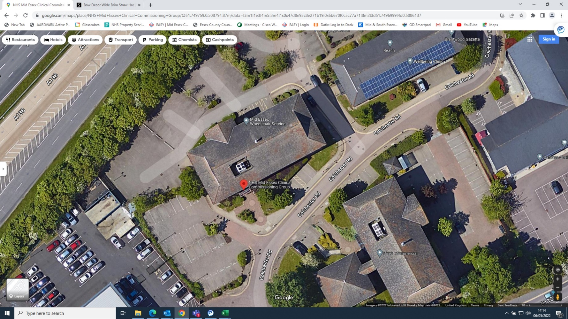

**Phoenix House (2 evacuation assembly points)**

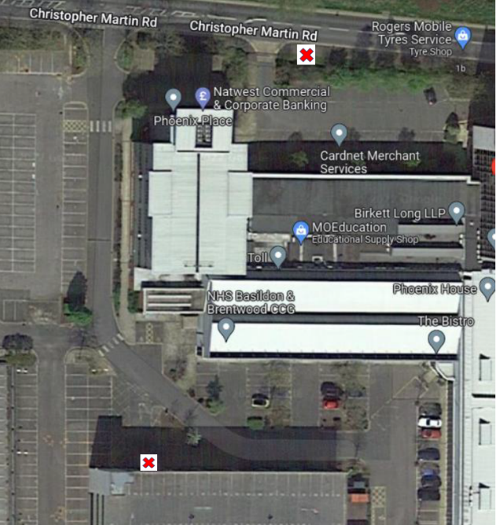

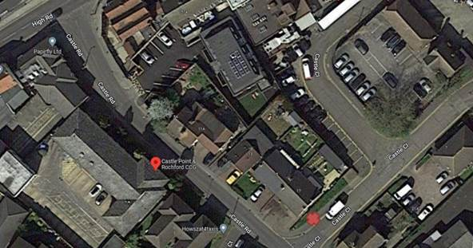**Castle Road**

**Southend Council Offices**

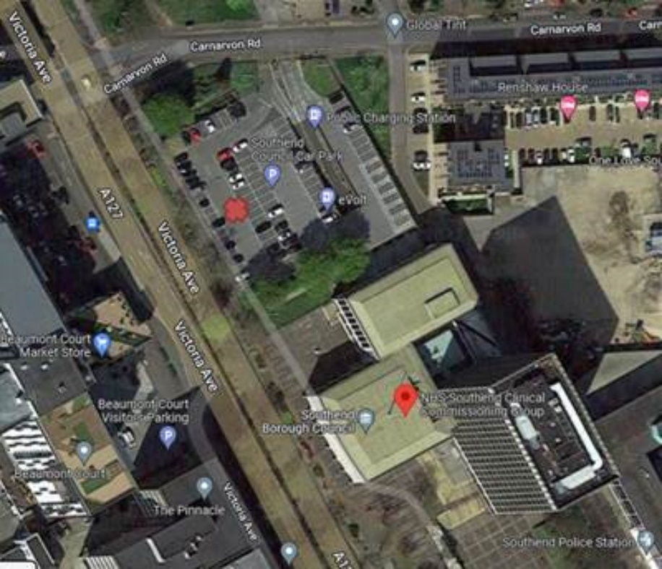

***Thurrock Council Offices***

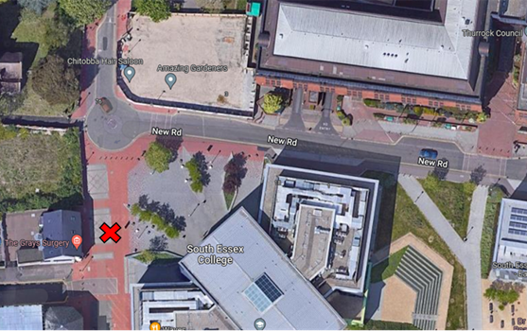

## Appendix D – General Fire Safety Requirements

* No smoking or use of e-cigarettes/vaping is allowed anywhere within ICB premises.
* Charges for e-cigarettes/vapers are not to be used in ICB premises.
* Toasters are not to be used on ICB premises.
* Naked flames are not allowed anywhere in the building, e.g. candles, lighters.
* Staff must not bring their own portable appliances, e.g. heaters and fans, onto ICB premises.
* Escape routes/corridors and walkways must be kept free of obstruction.
* Rubbish must not be allowed to accumulate – good ‘housekeeping’ must be maintained.
* Care should be exercised when using electrical extension sockets to ensure that they do not become overloaded and that any electrical cables are not faulty or can become trapped/damaged.
* Flammable liquids must not be brought on to ICB premises (the exception is liquids brought on to the premises by cleaning/facilities management contractors in exercise of their duties, which should be used with care and stored appropriately)
* With the exception of fire doors which automatically close in the event of a fire alarm, fire doors must not be wedged open or be obstructed. Defects to such doors should be reported immediately to a receptionist or the Corporate Services Manager.
* Any suspicious activity near ICB premises must be reported.
* All fire incidents and false alarms must be reported in accordance with the ICB’s Incident Reporting Policy to the Health and Safety Lead.
* All staff should report any electrical equipment defects, fire hazards or deficiencies in fire safety arrangements to the Health and Safety Lead.

## Appendix E – Fire Alarm System Testing and Information

The fire alarm system comprises of automatic heat and smoke detectors, manual glass call points, with audible siren sounders.

Fire detectors are triggered by either a rise in temperature as with heat detectors or by the detection of particles as in smoke detection.

An alarm of fire can be raised by:

* Actuation of a break glass release call point or
* The detection of the automatic detectors as indicated above.

Once activated, the fire alarm sounds continuously in all areas.

Information with regard to the fire zone is shown on the fire panel situated in the reception area.

The main switchboard is managed by the reception staff on duty, who will confirm actuation of the fire alarm to the fire authority via the ‘999’ system.

A weekly audible test of the fire alarm system is carried out every week by the relevant Landlord as follows:

* Wren House – weekly by NHSPS
* Phoenix Court – Wednesday morning at 10.00 am
* Castle Road – Tuesday by EPUT maintenance team
* Southend Council Offices – weekly by Southend City Council Facilities Team.
* Thurrock Council Offices – Friday at 11.00 by Thurrock Council Security Team

The alarm will sound to confirm the following:

* The system is operational.
* the relevant break glass point is operational (break glass points should be tested on a rotational basis).
* Any automatic fire door release systems are operational (the alarm will sound until this has been confirmed).

Staff should contact the Health & Safety Lead and Corporate Services Manager if they suspect the system is not working correctly, e.g. failure of the fire alarm bell in a particular area, who will report the issue to NHSPS/fire alarm system provider.

If the alarm sounds outside of the testing time (or over 30 seconds at the time that testing is usually carried out), evacuation should commence, as in a real fire situation. **There are no exceptions to this rule.**