Media Policy
Document Control:
Document Control Information: | Details:
Policy Name | Media Policy
Policy Number | ICB001
Version | 1.0
Status | Final
Author / Lead | Elliott Spiteri, Communications Manager/  Claire Hankey, Director of Communications and Engagement
Responsible Executive Director | Jo Cripps, Executive Director of Strategy and Partnerships.
Responsible Committee | Audit Committee
Date Ratified by Responsible Committee | 14 June 2022
Date Approved by Board/Effective Date | 1 July 2022
Next Review Date | February 2024
Target Audience | ICB Staff
Stakeholders engaged in development of Policy (internal and external) | ICB Staff, ICB Communications Team, ICS Communications Teams, ICB Board.
Impact Assessments Undertaken | - Equality Impact Assessment

Version History
Version | Date | Author (Name and Title) | Summary of amendments made
0.1 | Feb 2022 | Elliott Spiteri, Communications Manager | Initial Draft
0.2 | May 2022 | Claire Hankey, Director of Communications | Remit of policy
1.0 | 1 July 22 | Elliott Spiteri, Communications Manager | Final Board approved version.

Contents

1. Introduction 3

2. Purpose / Policy Statement 4

3. Scope 4

4. Definitions 4

5. Roles and Responsibilities 5

6. Policy Detail 6

7. Monitoring Compliance 9

8. Staff Training implications 9

9. Strategy for dealing with the media 10

10. Arrangements for Review 10

11. Associated Policies, Guidance and documentation 11

12. Equality Impact Assessment 11

APPENDIX A Equality Impact Assessment 12

APPENDIX B Taking a media call 15

APPENDIX C Crisis Management Flow Chart 16

APPENDIX D Proactive Press Release 17

APPENDIX E Reactive Press Release 18

Introduction

The purpose of this strategy and policy is to provide an overarching framework for media relations and media and social media management within the Integrated Care Board for mid and south Essex hereafter referred to as “the ICB”) and the Integrated Care System (ICS) (hereafter referred to as “the ICS”).

The Policy seeks to build on the basic elements of the ICS Communications and Engagement Strategy.

The aim of this policy is to establish and maintain a standard operating procedure for media and social media management which:
- Supports the ICB in achieving corporate objectives and realising the significant organisational benefits from minimising risk of inappropriate use of media/social media.
- Ensure processes are based on best practice and national guidance.
- Ensure al staff are aware of their responsibilities with regard to public facing communications.

Background to ICB and Media Policy
    - The ICB is committed to being accountable and responsive to the needs of patients and the local population, ensuring they are well informed about and involved with their local NHS.
    - The ICB is a publicly funded and publicly accountable service. The care and treatment commissioned is subject to public and democratic scrutiny and can attract significant media interest. This policy and procedure outlines the function and role of media relations to provide a practical guide for ICB staff on their role in media interaction. It also seeks to promote positive media coverage and informing the local community how we are leading the local NHS. It is also there to protect staff and to ensure a coordinated approach to media handling internally and externally.
    - Clear internal arrangements for media relations ensure that the right people are conveying the right message, at the right time and to the right audiences. This policy provides a mechanism through which the ICB can be effective in media management. It is the responsibility of the Director of Communications and Engagement to ensure this policy is correctly implemented across the ICB and wider ICS as appropriate.
    - This policy supports a culture of openness and dialogue in the NHS and ensures that the reputation of the ICB and ICS is protected and if possible enhanced and that the chances of misrepresentation by the media are reduced. The ICB believe that clinical and non-clinical staff should have access to expert knowledge to assist and support them in media management and this policy sets out a framework to provide this support.

Purpose / Policy Statement

Developing good relationships with the press and media is essential. This can help to promote a positive image of our services and can be a valuable source of communication for the communities that we serve.

It is in the best interests of the ICB that all representatives of the press and broadcast media are treated with honesty and integrity and in a helpful manner.

In order that our relationships with the press and media are successful, it is vital that our communications are concise, clear, and unambiguous. Staff are required to familiarise themselves with this policy and how it applies.

This policy does not apply to requests for information made under the Freedom of Information Act 2000, to which a separate statutory and local policy applies.

Scope

The policy will apply across all parts of the organisation as a statutory NHS body and includes all ICB staff and those in the wider ICS as appropriate. It relates to all areas of ICB activities as a commissioner of NHS services and persons engaged in business on behalf of the wider ICS.

Definitions
- The Media – refers to journalists, researchers, editors, and others working for the press in all forms (including newspapers, radio, television, and internet sites)
- Social Media – refers to internet-based social media sites that are used by individuals or groups to express opinion, give advice, or share information. This includes but is not limited to: Facebook, Twitter, Instagram, Pinterest, Snapchat, LinkedIn, and YouTube. The ICB Social Media Policy can be accessed here.

Roles and Responsibilities

Integrated Care Board
    - The Integrated Care Board is responsible for ensuring that the ICB have systems and processes in place for effective management of the media and handling enquiries and comments received from bona fide journalists.

Executive Director of Strategy and Partnerships
    - The Executive Director of Strategy and Partnerships has overall responsibility for this policy.

Director of Communications and Engagement
    - The Director of Communications and Engagement is the lead person responsible for all media relations and overseeing of social media and responses where senior sign off is required with delegated authority that does not require Executive approval. Any social media issues will be escalated directly by the social media team. All new responses must be signed off by the Director of Communications or in their absence those with delegated authority to approve as required such as a Head of Communications.

All ICB Employees and Board Members
    - All ICB employees and Board Members are responsible for:
- Familiarising themselves and complying with the ICB Media and Social Media Policy.
- Being aware of any emergency crisis response procedures relevant to their role and place of work.
- Identifying media crisis and cascading information about issues that could affect the ICB and give rise to PR or reputational issues.
- Sharing positive news with the communications team that can build reputation and trust.
    - Contractors and agency staff working for the ICB and ICS as appropriate are expected to be abide by the contents of this policy and strategy.

Partnership Working
    - The ICB works together with partner organisations in proactive and reactive statements to the media, on social media, campaigns, and responses. Key partners include providers of shared services to the ICS, Local authorities, the Police, statutory and voluntary bodies, providers of services and patient representative groups.
    - All joint communications content should be signed off by the ICB Director of Communications or in their absence those with delegated authority such as a Head of Communications to approve as required and in line with policies of partner organisations via relevant communications teams/leads.
    - On occasion, depending on the nature of the circumstance, it may be another lead agency nominated such as Fire or Police. This would especially apply in critical incidents when a Gold command, as detailed in the EPRR Policy, would be appointed and a command-and-control situation would apply for any communications.

Policy Detail

Implementation
    - This policy will be available to all staff, for use in the circumstances described on the title page. All directors and managers are responsible for ensuring that relevant staff within their own directorates and departments have read and understood this document and are competent to carry out their duties in accordance with the procedures described. Partner health and care organisations operating within the NHS Mid and South Essex area such as GP practices and care homes should escalate any concerns or issues internally or with relevant body in the first instance before contacting media to maintain public trust and confidence.

Press and Media Enquiries
    - For the purposes of this policy, a media enquiry will be a request for information received from the following stakeholders:
- Print, broadcast, or online media
- “Citizen Journalists‟ – bloggers
    - This may be in response to a story that the ICB have already published proactively, or an issue that has arisen (called a reactive enquiry).
    - In addition to a response sent directly to any of the above stakeholders, the following channels are also to be considered ‘mass media’ and are subject to these procedures:
- ICS/ICB website.
- Social Media – e.g. Twitter, Facebook, and other social media channels.
    - During normal office hours 9am – 5pm all enquiries from the press or media are to be referred, in the first instance, to the media lead or equivalent. Enquiries should be emailed to msepartnership.comms@nhs.net
    - If approached by the media, ICB staff should not answer any questions on behalf of the ICB and should instead confirm that a member of the communications team will get back to them, as soon as possible. A brief summary of the enquiry, along with contact details should be taken and given to the media lead or equivalent for action and logging.
    - The only exception to this is on an occasion when it is appropriate for the Director of Communications and Engagement, Executive Lead, clinical lead, subject expert, or those with delegated authority to speak directly with the media if required.
    - The media lead will identify a spokesperson on a case-by-case basis. Where appropriate staff will be briefed with respect to the communications strategy by the communications team. The identified spokesperson will be the ONLY authorised point of contact with the media. Any other contact with the media by other staff will be considered as unauthorised and will be treated as such by the ICB and may be subject to disciplinary proceedings.
    - Staff giving interviews to the press or media should ideally have received media training, or otherwise will be/can be fully briefed/coached by the media lead or wider communications team.
    - All staff should ensure they are available as a matter of urgency should information be required by the press or media to avoid a negative reputation from being ‘unavailable for comment’ or worse still ‘refused to comment’. This includes staff who have not been media trained, as they will be required to give information for written press statements or background.
- All newspaper media enquiries should have a written response via email adhering to deadlines. This is particularly important when handling contentious issues, to ensure accurate records are kept for future reference (if required).
- All press statements will be approved by the Director of Communications or Head of Communications in their absence with delegated authority to approve as required, or by a relevant member of staff nominated by the Director of Communications and Engagement. All statements should be issued from the Communications team giving a contact name for any further enquiries; in most cases this will be the media lead.
- A record will be kept of all ICB media enquiries / statements and releases by the communications team. No representative of the media (newspaper or broadcasting) will be allowed access to the ICB for the purposes of filming or interviewing without the permission of the Director of Communications and Engagement or equivalent.
- Media contact must not detract from the primary purpose of care delivery and the duty of care must not be detrimentally affected by media activity.
- Authorised media representatives will be expected to produce proof of identify (i.e. a valid press card) when visiting ICB/ICS premises.

Social Media
    - The ICB/ICS social media channels will be managed by the ICB Digital Communications Team. Please refer to the ICB Social Media Policy for more information on social media use.

Whistleblowing
    - If staff have any concerns, they are expected to adhere to the ICB Whistleblowing Policy and should raise such concerns in accordance with that policy.

Major Incidents
    - The ICB Major Incident Plan will detail the role of communications in the event of a major incident and special arrangements for liaising with the media are detailed in the plan located on the ICB Intranet site.

Out of Hours Enquiries
    - The ICS does not provide a full (24/7) out of hours press office service. This means that staff are generally available to deal with press enquiries Monday to Friday; 8am – 6pm (not including Bank Holidays).
    - Out of hours media enquiries will be routed to the on-call director who, will take responsibility for ensuring they are media trained.
    - On occasion it may be necessary for the media lead or wider communications team to contact nominated Directors/Executive Lead or equivalent director / subject expert with delegated authority to approve as required out of hours if an urgent reaction to a significant media story is needed.

Rights of staff side representatives of recognised Trade Unions or staff associations.
    - This policy does not restrict the right of elected staff side representatives of recognised trade unions or staff associations, to express their views through or to the media directly.
    - Elected staff side representatives of recognised trade unions or staff associates are fully entitled to make comments on behalf of their staff association or trade union. They are not able to make comments on behalf of or represent the views of the ICB or wider ICS.

Serious Incidents
    - The ICB is required to inform NHS England and Improvement (NHSI) if any serious incident (SI) occurs within the organisation that is likely to involve press or media attention. Every SI should be reported in accordance with the ICB SI policy using a standard SI report form which should be completed by the relevant member of staff. The ICB Communications Team should be consulted in response to any reports that may give rise to media responses. Patient confidentiality should be respected at all times particularly in light of any legal proceedings or due process that may be underway.

Monitoring Compliance

It is the responsibility of all staff to ensure that the Media Policy is adhered to and is being embedded within the ICB and wider ICS as appropriate. The Director of Communications and Engagement will ultimately be accountable to the Integrated Care Board for ensuring that the media management process delivers as expected and that the process remains robust and operates effectively and reviewed as necessary.

Staff Training implications

Only staff in senior managerial or director positions, on-call directors, clinical leads, and appropriate subject matter experts will be expected to request media training.

This policy will however be communicated to all staff to ensure it is implemented appropriately and followed; this will be promoted via the staff newsletter and at staff team meetings as appropriate and on the intranet available to all staff.

Strategy for dealing with the media

The ICB has a strategy of openness and accountability when dealing with the media. We will always endeavour to answer questions and proactively engage with media on topics relating to healthcare. The Communications Strategy articulates responsibility of partners leading projects and joint areas or responsibility.

The ICB and wider ICS use media and social media as a vehicle for patient engagement, information provision and promotion of key events. Our strategy is to proactively offer stories of interest to the public and our stakeholders.

Working with partners is a key part of our strategy. It enables us to offer more engaging content and to cement closer working relationships with the partners we collaborate with for campaigns or stories.

The ICB communicates stories that are linked to its key areas of focus and offers opinion and reassurance on reactive stories where healthcare services are not performing as they should.

The media is seen as an important tool in making the ICB accessible to the public and as a window to the work of the organisation.

Arrangements for Review

This policy will be reviewed every year. An earlier review will be carried out in the event of any relevant changes in legislation, national or local policy/guidance. Communication to staff will be via normal internal channels such as the intranet and updates such as bulletins and staff briefings where necessary.

If only minor changes are required, the sponsoring Committee has authority to make these changes without referral to the Integrated Care Board or Executive Lead or those with delegated authority. If more significant or substantial changes are required, the policy will need to be ratified by the relevant committee before final approval by the Integrated Care Board.

If the review results in changes to the document, then the initiator should inform the policy and corporate governance lead who will renew the approval and re-issue under the next “version” number. If, however, the review confirms that no changes are required, the title page should be renewed indicating the date of the review and date for the next review and the title page only should be re-issued.

For ease of reference for reviewers or approval bodies, changes should be noted in the ‘document history’ table on the front page of this document. NB: If the review consists of a change to an appendix or procedure document, approval may be given by the sponsor director and a revised document may be issued. Review to the main body of the policy must always follow the original approval process.

Archived copies of superseded policy documents will be retained in accordance with Records Management: NHS Code of Practice 2009.

Associated Policies, Guidance and documentation
- Emergency Preparedness, Resilience and Response.
- Acceptable Use of Electronic Communications
- Standards of Business Code of Conduct
- Social Media Policy

Equality Impact Assessment

The ICB is committed to carrying out a systematic review of all its existing and proposed policies to determine whether there are any equality implications. The policy applies to all groups. This policy has been assessed using the Equality Impact Assessment framework and identified as having the following impact/s upon equality and diversity issues.

The EIA has been included as Appendix A.

APPENDIX A Equality Impact Assessment

INITIAL INFORMATION
Name of policy and version number:  Media Policy version 1.0 | Directorate/Service:  Communications
Assessor’s Name and Job Title:  Elliot Spiteri, Communications Manager | Date:  27th May 2022

OUTCOMES
Briefly describe the aim of the policy and state the intended outcomes for staff
The Policy is intended to ensure accurate and appropriate media management, reporting and relationships with the media and social media by the appropriate members of staff.
EVIDENCE
What data / information have you used to assess how this policy might impact on protected groups?
The ICB Communications and Engagement team regularly works with our workforce, stakeholders and local population including protected groups.
Who have you consulted with to assess possible impact on protected groups? If you have not consulted other people, please explain why?
Mid and South Essex Communications Team. Healthwatch. Local population, including those from protected groups.

ANALYSIS OF IMPACT ON EQUALITY
The Public Sector Equality Duty requires us to eliminate discrimination, advance equality of opportunity and foster good relations with protected groups. Consider how this policy / service will achieve these aims.
N.B. In some cases it is legal to treat people differently (objective justification).
- Positive outcome – the policy/service eliminates discrimination, advances equality of opportunity and fosters good relations with protected groups
- Negative outcome – protected group(s) could be disadvantaged or discriminated against
- Neutral outcome – there is no effect currently on protected groups
Please tick to show if outcome is likely to be positive, negative or neutral. Consider direct and indirect discrimination, harassment and victimisation.
Protected  Group | Positive  outcome | Negative  outcome | Neutral  outcome | Reason(s) for outcome
Age |  |  |  | Media connects and engages with all sectors of the community, and we tailor content and the profile it is aimed at based on channel and demographic. For example, content for younger people is best via a visual medium such as television and for older people a medium such as radio e.g. BBC Essex would be more appropriate ensuring it is representative of the demographic of MSE.
Disability  (Physical and Mental/Learning) |  |  |  | Using the media is a platform to reflect the representative nature and make-up of the local population for example representing seldom heard groups such as SEND children to ensure representation is far and equitable across MSE and marginalized voices are heard and is representative of the demographic of MSE.
Religion or belief |  |  |  | We ensure our media releases include content using inclusive language, no matter their religion or belief and are sensitive to communities such as travellers and is representative of the demographic of MSE.
Sex (Gender) |  |  |  | We ensure our media content uses inclusive language, no matter their gender status and is representative of the demographic of MSE.
Sexual  Orientation |  |  |  | We ensure our media content uses inclusive language, no matter what a user’s sexual orientation is and is representative of the demographic of MSE.
Transgender / Gender Reassignment |  |  |  | We ensure our media content uses inclusive language and is representative of the demographic of MSE.
Race and ethnicity |  |  |  | We ensure our media content uses inclusive language and is representative of the demographic of MSE.
Pregnancy and maternity (including breastfeeding mothers) |  |  |  | We ensure our media content uses inclusive language and is representative of the demographic of MSE.
Marriage or Civil Partnership |  |  |  | We ensure our media content uses inclusive language and is representative of the demographic of MSE.

MONITORING OUTCOMES
Monitoring is an ongoing process to check outcomes. It is different from a formal review which takes place at pre-agreed intervals.
What methods will you use to monitor outcomes on protected groups?
Our media is regularly monitored to ensure we are using inclusive language for all and that we have a good mix of representation reflected in the channels and content we utilise.
Media is only way in which we communicate with our audiences and inclusion is a priority for the communications and engagement team ensuring we engage as widely and equitably as we can with local people and our partners and stakeholders where appropriate ensure information is disseminated as widely as possible across MSE.
This policy applies equally to all members of staff and contains no negative equality and diversity implications.

REVIEW
How often will you review this policy / service?
Every three years.
If a review process is not in place, what plans do you have to establish one?
N/A

APPENDIX B Taking a media call
What to do if you take a call from a journalist or receive a request for a media interview.
All media enquiries should be notified to the communications team even if you have an existing relationship with the journalist, publication or organisation.
Please do not respond directly to any media request or agree to any interviews without first notifying and seeking advice from the communications team.
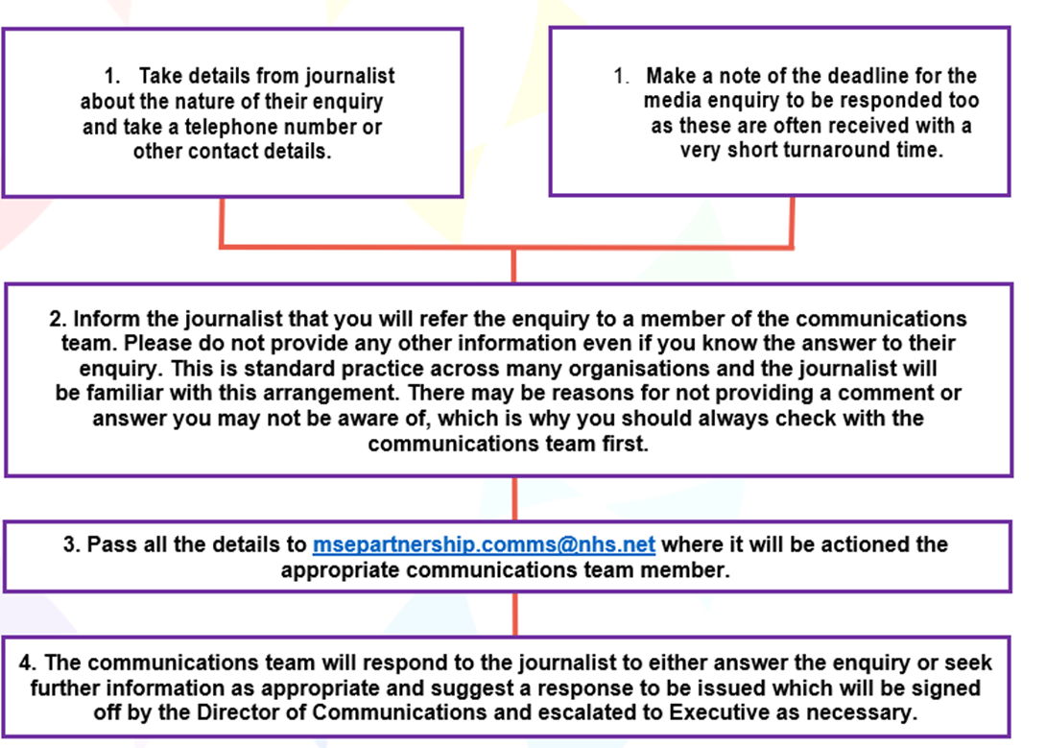
If you take a call from a journalist, radio station or receive a request for a media interview note as many details as possible such as nature of enquiry, publication / media outlet, contact name and telephone / email and most importantly deadline

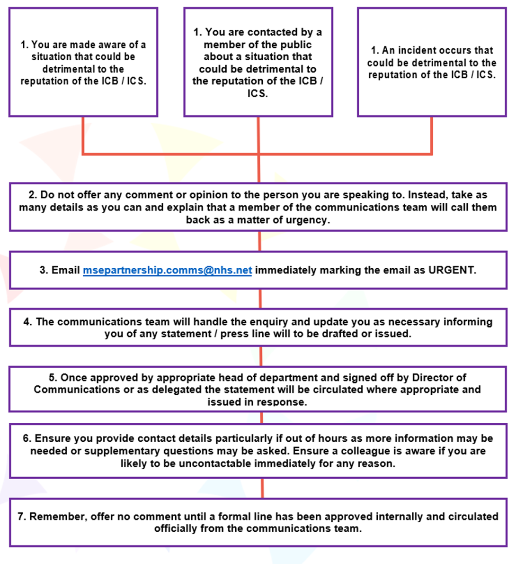
APPENDIX C Crisis Management Flow Chart

APPENDIX D Proactive Press Release
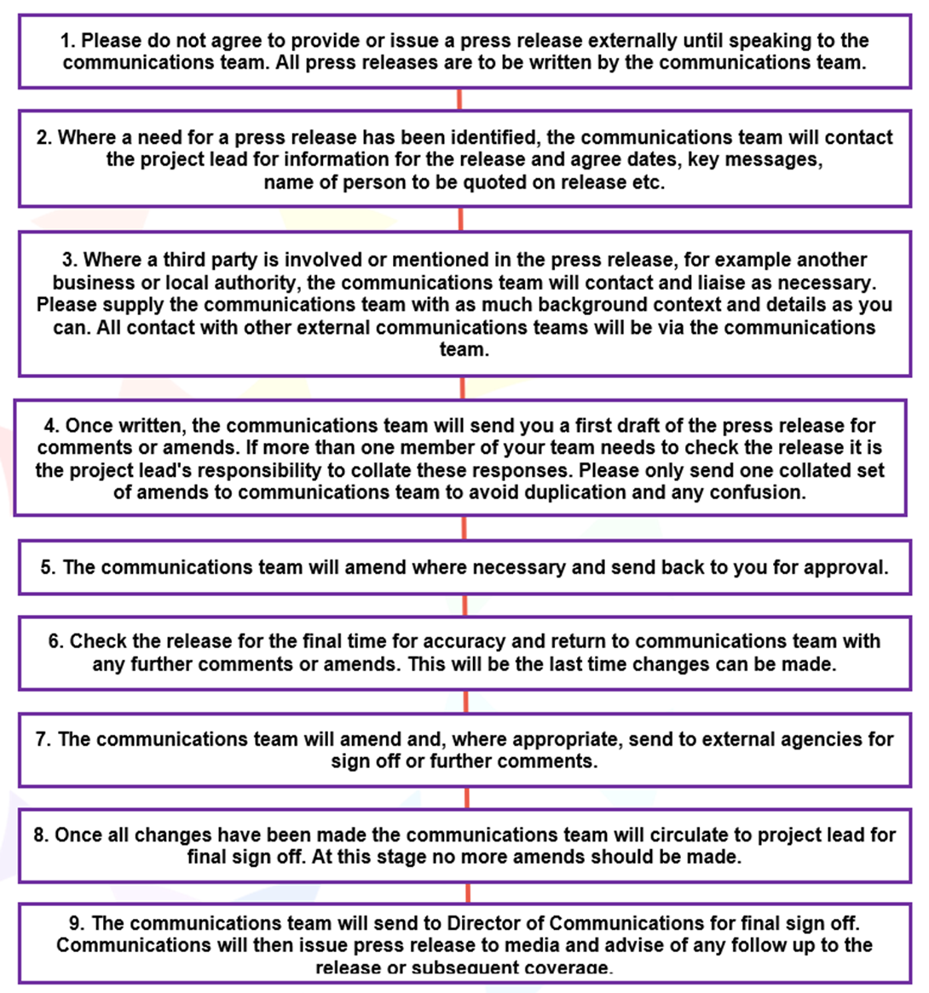
(Where we are making news)

APPENDIX E Reactive Press Release
Reacting to other people’s news or something on the news agenda.
This is often time sensitive and therefore requires fast responses from all involved.
