Basildon and Brentwood CCG Annual Report 2021/22

This document can be provided in alternative formats upon request, such as larger print, easy read, braille, audio format and different languages.

Contents

Chair’s Foreword 5

PERFORMANCE REPORT 8

Performance Overview 8

Accountable Officer’s introduction 8

What Basildon and Brentwood CCG does 10

Our Purpose 10

Our Strategy 11

Mid and South Essex Health and Care Partnership 12

Local Achievements 14

How we have performed 17

Key issues and risks 17

Performance analysis 18

Introduction 18

Performance Summary 18

Improve Quality 21

Reducing health inequality 25

Engagement with people and communities 27

Health and Wellbeing Strategy 29

Financial Review 30

Risks 33

Sustainable Development 34

ACCOUNTABILITY REPORT 37

Corporate Governance Report 37

Members Report 37

Members Profiles 37

Composition of Governing Body 37

Member practices 46

Committees, including Audit Committee 49

Register of Interests 56

Personal data related incidents 56

Statement of Disclosure to Auditors 57

Donations to political parties and charitable organisations 57

Modern Slavery Act 57

Statement of Accountable Officer’s Responsibilities 61

Governance Statement 62

UK Corporate Governance Code 64

Discharge of Statutory Functions 64

Risk management arrangements and effectiveness 64

Capacity to Handle Risk 65

Risk Assessment 67

Other sources of assurance 67

Internal Control Framework 67

Annual audit of conflicts of interest management 68

Data Quality 68

Information Governance 68

Third party assurances 69

Review of economy, efficiency & effectiveness of the use of resources 70

Delegation of functions 71

Counter fraud arrangements 71

Head of Internal Audit Opinion 72

Review of the effectiveness of governance, risk management and internal control 73

Conclusion 74

Remuneration and Staff Report 75

Remuneration Report 75

Remuneration Committee 75

Policy on the remuneration of senior managers 75

Senior managers’ performance-related pay 75

Policy on the duration of contracts, notice periods and termination payments 76

Salary and pension entitlements 76

Compensation on early retirement or for loss of office 85

Payments to past directors 85

Staff Report 87

Staff composition 87

Sickness absence data 87

Staff turnover percentages 88

Staff engagement 88

Staff policies 89

Trade Union Facility Time Reporting Requirements 91

Expenditure on consultancy 91

Off-payroll engagements 91

Exit packages, including special (non-contractual) payments 93

Parliamentary Accountability and Audit Report 94

ANNUAL ACCOUNTS 95

## Chair’s Foreword

In what has been another challenging year for our teams right across the NHS I am proud that we have continued to provide safe and effective patient care. Working together for better lives, we have continued to build on collaborative working between our local authority, the CCG, community providers and voluntary organisations.

This foreword gives me an opportunity to say how proud I am of all my fellow health and care professionals in Basildon and Brentwood and our wider colleagues who support us.

The ongoing vaccination programme continued to dominate our Covid response. I am pleased that the vast majority of people in our area have taken up the opportunity to receive their vaccine. it’s never too late to protect yourself if you haven’t yet had the jab – there are plenty of opportunities to come forward, visit [Essex Covid Vaccine (Hyperlinks)](http://www.essexcovidvaccine.nhs.uk).

I have been inspired by the work we have undertaken to support some of our seldom heard and more remote communities to receive their vaccine closer to home with the Essex Vax Van and mobile vaccination units. Working with our primary care teams, public health and Essex Partnership University Trust, we were able to offer dozens of pop-up vaccine opportunities.

Every effort has also been made to continue providing routine healthcare to the population during the pandemic in a safe way. A robust plan is being developed and following national guidelines to significantly reduce the number of people who are waiting for operations and treatments, as we move into the next year, the momentum on this will build.  Working together, the Mid and South Essex Health and Care Partnership has also supported hundreds of people to receive timely care in their own home or care home.  2021/22 saw the launch of new virtual wards to reduce some of the pressure on our hospitals helping us continue some of our elective work.

During the last year we have seen a wider range of health and care professionals begin to work in our local GP practices.  Professionals such as paramedics, physiotherapists, and mental health workers are now working within local Primary Care Networks (PCNs) to help meet the needs of our local communities.

We continue to utilise new technology in healthcare and our local residents were among the first as part of a national pilot to test out how people can improve their health outcomes through self-monitoring their blood pressure. To date across Essex, it is estimated that this has prevented 250 heart attacks and 375 strokes.

**Place based acknowledgements**

Alongside the rollout of the Covid vaccination programme including the busiest period of the programme so far in the “Booster” campaign before Christmas, NHS Basildon and Brentwood CCG has continued to improve services for our local population.

Our GP practices have provided a 10% increase in the volume of consultations they have provided to our population. This has been partially achieved through the recruitment of 56 new whole time equivalent additional primary care roles. This includes 25 clinical pharmacists, 8 care coordinators and 7 social prescribers. These staff play an increasingly important role in supporting GPs to better address patient need. Our primary care providers have also played a crucial role in trying to reduce health inequality through increasing the number of Learning Disability and Serious Mental Illness Health checks undertaken alongside the crucial role of primary care in supporting some of our most vulnerable patients receive the covid vaccine.

We have made considerable progress on the development of a new mental health model that sees improved integration across the whole health and care system with an increased range of services supporting patients outside of secondary mental health care. This is vital for our communities as we move forward from the pandemic that has impacted on so many people’s wellbeing.

The CCG has actively supported the implementation of a population health management scheme in East and West Basildon. This scheme aims to ensure our approach to improving wellbeing is driven by data and aimed at preventing ill health rather than only treating the consequences of it. The initial pilots have seen a focus on the wellbeing of women aged 20-40 and people with high BMIs.

We have embraced the opportunity to engage with wider system partners to reduce the level of inactivity in our communities. This year we have appointed to a dedicated role that works closely with health providers and our communities to try and encourage people to take more exercise. This includes supporting our own staff to place importance on their own wellbeing. We will continue to build on this for years to come.

The CCG has much to be proud of since its inception in 2013. Our staff have always focussed on trying to improve the health and wellbeing of the population we serve. This work will continue as we move towards the next phase of the NHS and its integration with the care system and with our strong communities.

It was fitting that the conclusion of the Clinical Commissioning Group’s term as the local NHS body coincided with the award of the Freedom of the Borough of Basildon. I was humbled that alongside other NHS organisations, the CCG received this prestigious award from the Mayor of Basildon for the efforts the NHS had made to look after the people of the Borough during the pandemic. This is a testament to all of the people within the NHS and the wider health and care system who have delivered so much during the biggest challenge the NHS has ever faced.

As we move forward, we are met with a number of challenges that have been exacerbated by the pandemic, not least the waiting list backlog which has left many people within our local communities waiting significant time before their complications can be suitably resolved. Our organisation will work tirelessly to address these challenges and make the best use of the resources that have been made available for this purpose. We must also focus on improving our approach to prevention so that the NHS can better manage the ever growing demands placed upon it by the demographic changes of today and the future.

I would like to use this final Annual Report Foreword in my tenure as Chair of NHS Basildon and Brentwood CCG to pay tribute to the members of our communities who both directly, through the NHS, social care and other partners and indirectly, through informal care, support the wellbeing of our local population. Since its inception, the CCG has played an important role in coordinating the provision of healthcare for our population and ensuring effective use of financial and human resource but we have always recognised that our strength is derived from those directly providing care. May we build upon the foundations we have laid and together improve outcomes for all.

**Dr ‘Boye Tayo**

Basildon and Brentwood CCG Chair

29 June 2022

PERFORMANCE REPORT

## Performance Overview

The purpose of the performance report is to provide information on the CCG’s objectives for the 2021/22 financial year, the principal risks to their achievement and how the CCG performed against these objectives. This section provides a precis of the rest of the annual report and accounts.

Accountable Officer’s introduction **– Basildon and Brentwood CCG Annual Report 2021/22**

It has been another extraordinary 12 months. Amid unprecedented world events, the NHS faced new Covid-19 variants and had to respond rapidly by expanding its vaccination programme. All aspects of the system continue to be under unprecedented pressure, whether in primary care, with both urgent demand and the support of patients with long term conditions, in our community services, who have stepped up to the challenge to deliver innovative ways of caring for more people in the community, our mental health services which are seeing a significant rise in demand and acuity of people accessing services, our acute hospitals, who are seeing rising demand on urgent and emergency care services which is affecting flow through the hospital and impacting on its ability to treat cancer and elective patients in a timely manner, our local authority partners, whose services are stretched in a challenging social care market and of course, our community and voluntary sector partners, without whom we could not have risen to the challenges that the Covid pandemic brought.

All this has made 2021/22 a very unsettling time.

Yet despite the pressures, our NHS and other institutions have generally succeeded in helping people get through these unique circumstances. When mid and south Essex residents looked for guidance or essential services, the NHS and its partners from the public and voluntary sectors stepped up, often in new and innovative ways. We were the trusted source of information and support.

Public services depend on trust. Every time the question of trusted professions comes up in Britain, doctors and nurses are near the top of the list. This shows the mutual confidence our residents and healthcare professionals have in one another and in the public services we all rely upon. During difficult times collaboration and confidence in one another can help us deal with difficulties and uncertain futures.

People have trusted the science behind new treatments and the support available from our institutions. In a similar way, our transition to an “integrated care system” – ICS for short – should also inspire confidence. As we restore more normal operations, the new ICS will build on the legacy of the five clinical commissioning groups to show that people’s best interests and improved health outcomes are at the heart of everything we do. Now and in the future.

As well as sharing what this CCG has achieved for Basildon and Brentwood residents through well-planned NHS services and partnership working, this document also reflects the seriousness with which we take our responsibilities as part of an ICS.

Strengthening relationships across the old CCG areas – which are now called “Alliances” – is vital to better health outcomes and the reduction in health inequalities and just one example of the focus we are putting on that is the appointment of our first Head of Engagement. This role will focus on nurturing broadly based relationships with our public and partners, so we can design services, identify health outcomes and set standards *together*.

A part of this work, our “Moments that Matter” campaign, will showcase the best of what coordinated health and social care can do. It celebrates examples of professionalism and personalised care that have stood out for residents and colleagues. Anyone who has worked in or for one of our CCGs will understand how ‘small gestures’ can sometimes make all the difference to those who look to the NHS for help.

As the passage of the Health Bill completes its final stages to create ICS’ on a statutory footing, we can all look to the exciting opportunities that this will bring for our residents. At the same time, it is right that we should mark the passing of a final and tumultuous full year for CCGs by noting the distinct contribution they have recently made in developing alliance-based services and Primary Care Networks of GP practices. That emphasis on delivering health and wellbeing services for and with residents at a local level will go from strength to strength.

So many people have contributed to the CCG’s success - to name them all here would be impossible. I would nevertheless like to pay tribute to CCG colleagues for the continued support they have shown one another – and most importantly, to the 1.2m people we serve – during these uniquely challenging times. CCG staff and Board members can be rightly proud of all that they have achieved - and be assured that the lasting legacy of their work will be seen in the solid foundations they have laid for the ICS.

**Anthony McKeever**

Executive Lead for the Mid and South Essex Health and Care Partnership and Joint Accountable Officer for its five CCGs

29 June 2022

## What Basildon and Brentwood CCG does

### Our Purpose

The Basildon and Brentwood Clinical Commissioning Group was formed on 1 April 2013 following the changes that took place in the NHS as a result of the Health and Social Care Act 2012. The CCG is the statutory health body responsible for commissioning (i.e. planning, designing and buying) local NHS care and services to meet the needs of the local population. We work in partnership with colleagues from GP Practices, community and hospital services, social care and the independent voluntary sector to improve the health and wellbeing of people in our communities.

We aim to commission safe, high quality services with a focus on achieving a sustainable health and care system that improves the health and wellbeing of people in Basildon and Brentwood. Our membership consists of 35 GP Practices which are responsible for a population of 285,655 across Basildon and Brentwood. Our Governing Body (The Board) is principally formed of clinical representatives from the four localities across the CCG.

The key providers from which the CCG buys health services for the residents of Basildon and Brentwood are:

* Mid and South Essex NHS Foundation Trust (MSEFT) is the main provider of acute hospital services from its sites at Basildon, Southend and Broomfield.
* Essex Partnership University NHS Foundation Trust (EPUT) is the main provider of mental health services.
* EPUT and the North East London NHS Foundation Trust (NELFT) are our main providers of community services.
* Emergency health services and transport are provided by the East of England Ambulance Service NHS Trust and urgent care services by IC24.

In addition, the CCG has a range of contracts with other providers of services such as palliative care and end of life services, specialist health services for fertility and termination of pregnancy and community elective care services. We also buy services from a number of Independent Sector providers.

|  |  |
| --- | --- |
| Basildon and Brentwood CCG – facts and figures | |
| CCG Headquarters | Phoenix Court, Christopher Martin Road, Basildon  Essex SS14 3HG |
| Communities covered | The CCG is coterminous with Basildon and Brentwood Borough Councils |
| Population (registered with a GP) at 31 March 2022 | Approx. 285,655 |
| Number of member GP practices at 31 March 2022 | 35 |
| Expenditure for 2021/22 | £431.652m for healthcare services and a further £5.279m for running costs, totalling £436.931m |
| Average number of employees | 77 |

### Our Strategy

The MSE Health & Care Partnership developed its five year strategy in December 2019. The strategy outlines 4 key ambitions, with the underpinning aim to **reduce health inequalities.** The strategy outlines that we would achieve this through:

* **Creating opportunity for our residents** – supporting education, employment and socio-economic improvements for our residents. We have developed this ambition further - for example, extending the successful work led by MSEFT on hospitals as Anchor institutions, and achieving agreement to a system-wide Anchor Charter in 2021.
* **Supporting health and wellbeing** – including a focus on prevention, self-care, lifestyle support.  We have undertaken much work in this area – particularly through the Covid pandemic, where we were able to use targeted engagement techniques to link with different communities, understanding their needs and barriers to accessing care, vaccinations and so on.  We have also continued to work in partnership to target prevention opportunities and we have agreed with public health colleagues to focus particularly on obesity in the coming months
* **Bringing Care Closer to Home** – where this is safe and possible.  Again, we have seen many examples of this, with our Covid vaccination van that has now been transformed to a “long-Covid van”, taking assessment and testing to our communities.  We are progressing with the integrated medical centres in Thurrock, again as a new model of care to bring services closer to home.
* **Improving and Transforming our Services** – we know that our services are under considerable pressure and we are not providing the level or quality of service that we would like. There are several transformation programmes progressing, underpinned by system working on workforce, digital, and finance to bring improvements in primary care, cancer care, elective recovery, urgent care, community diagnostics, flow through the system and care arrangements.   Our Stewardship programme will be key in our future approach to service improvement and transformation.

While the strategy was set in the pre-Covid era, we consider that the key ambitions have stood the test of time and have underpinned our partnership working during the pandemic.

We will therefore take the five year strategy into the new ICS and use the early period of Integrated Care Partnership (ICP) formation to begin work to develop the Integrated Care Strategy – taking our local authority Joint Strategic Needs Assessments (JSNAs) and health and wellbeing strategies to develop a single strategy for Mid & South Essex.

A joint strategic needs assessment (JSNA) looks at the current and future health and care needs of local populations to inform planning and commissioning of health, well-being and social care services.  They are often, but not always, lead by the local authority(ies) of an area but do require participation from all appropriate partners to:

1. Collect, analyse and interpret health and care needs information.
2. Participate in engagement work between partners or with the population.
3. Follow up and implement recommendations.

As a partner in the provision of health and care services to the population PCNs will be expected to fully participate and help shape, where appropriate, in the production of these needs assessments.

The plan for achieving this, by April 2023, will be agreed with the ICP once it is formed. See page 14.

We have been clear that we want the hallmarks of our ICS to be:

* Evidence and data driven
* Have a true partnership with our communities and use their lived experience and insight to help us shape our work
* Ensure clinical and care professionals are leading strategy formation and supporting decision-making

### Mid and South Essex Health and Care Partnership

Key activities in 2021/22and progress towards establishment of an ICB/ICP

Over 2021/22the system has progressed towards establishment of the ICS by:

* Submitting a successful application to be formally designated as an Integrated Care System
* Refreshed our primary care strategy and established PCN support programmes
* Further established our population health management capacity and engaged with a national Population Health Management (PHM) programme to support turning data into intelligence to design interventions through our PCNs
* Our four Alliances have agreed their initial delivery plans to support their local populations, working in partnership with local authority, Healthwatch and community and voluntary sector organisations
* Developing a data and digital roadmap to transform our digital and data capacity and capability – and we have employed a Chief Digital Information Officer to enable the ICS to move forward on this important work that will underpin everything we do
* Agreeing an engagement strategy that defines how we will gain and use insight from our communities in the work that we do.
* Launched the Citizens’ Panel, of 1500 residents, with whom we share ideas and obtain insights to help us design services appropriately.
* Developed and agreed a system wide quality strategy, bringing together all aspects of the health system.
* Further developed our system finance approach through the System Finance Leaders Group
* Embedded joint accountability and assurance through our System Oversight and Assurance Group, co-chaired by the Accountable Officer and the NHSE Regional Director for Strategy and Transformation – and further developed our embedded assurance model with NHSE colleagues so as to reduce traditional transactional assurance processes between the system and NHSE.
* Developed a new approach to clinical and professional leadership, including introducing a new clinical and professional congress to support the ICS to ensure the expertise of clinicians and care professionals is at the heart of our work.
* Launched MSE Partners as a means to supporting innovation and improvement.

**Establishing the ICS**

In terms of preparing for forthcoming legislation to form the ICS on a statutory footing (which has a national target date of 1 July 2022), we have introduced an ICS Transition Programme Board with seven workstreams to manage and oversee the technical aspects for development of the ICS including the disestablishment of CCGs and the commencement of the new Integrated Care Board (ICB) as an organisation. The work streams are:

* Quality and safety
* Finance and resources
* Governance and accountability
* Data and digital
* Communications and engagement
* Workforce
* Future system operating model

**Integrated Care Board**

The ICB will take on all of the functions of current CCGs and, over time, some commissioning functions from NHSE. It will be responsible for the system’s entire NHS finance allocation and will take responsibility for workforce, digital, data and engagement.

Anthony McKeever has been appointed as the Chief Executive Officer (CEO) designate of the new ICB and Professor Mike Thorne CBE, has been appointed as Chair designate of the ICB. Non-executive members for the new ICB Board have been appointed and remaining appointments to the executive team are being finalised.

The Transition Programme Board has overseen the due diligence requirements to establish the ICB and will complete a “Readiness to Operate” statement to enable NHSE to formally establish the new organisation.

**Integrated Care Partnership**

The ICP will be a joint and equal partnership between the NHS and our upper tier local authorities (UTLAs). Together, we have agreed that the ICP will be chaired by Professor Thorne so as to ensure consistency and coherence across the ICS, with the three health and wellbeing board chairs of our upper tier local authorities acting as vice chairs for the ICP. We have agreed membership of the ICP and we are currently progressing discussions to agree its work programme. The first task of the ICP will be to develop a new Integrated Care Strategy for the ICS, and for the population of Mid & South Essex.

### Local Achievements

**Covid vaccinations**

More than 205,000 people within Basildon and Brentwood have received a ***Covid vaccination*** with over 184,000 having their Covid-19 Booster jab. This represents 92% of the population most at risk, those over 50 or people with health conditions, having had a 1st jab and 87% having two jabs and a booster jab. During the year, Covid-19 vaccines were offered across a number of venues including from Towngate Theatre, Brentwood Centre, Basildon Hospital and across four other GP led vaccination centres and at some community pharmacies in the Basildon borough.

To increase the uptake of the Covid vaccine the CCG worked in partnership with Basildon Council, Council for Voluntary Service and faith and communities leaders to deliver a number of outreach events including those at Festival Leisure Centre and housing association venues. In addition, Provide and Red Cross supported by making welfare calls and visits to those individuals most at a risk from Covid-19 including the elderly and those with Learning Disabilities and Serious Mental Health Illness (SMI) to ensure they were able to book a vaccine appointment and access the vaccine clinics.

Further dedicated services were arranged to support individuals including:

* CCG commissioned ***needle phobia service***, from the Vita Health Group, that used Virtual Reality goggles in the comfort of their own home with a therapist guiding them through the techniques and strategies to manage needle fears.
* For those attending an ***antenatal or postnatal clinic*** at the hospitals within Mid and South Essex they could speak to an expert about vaccine safety, the effect on them and their unborn baby and access the vaccine.

**Primary care access**

In response to the pandemic general practice adapted the way they work and how services are provided in order to keep both patients and staff safe. Retaining the total triage and remote consulting during 2021/22, allows vulnerable patients to access their GP without the need to visit a practice and risk contraction or spreading of the disease. During 2021/22 we saw an increase of 10% in appointments with general practice compared to the previous year, of which a fifth were face to face appointments.

During 2021/22, we have expanded our Primary Care workforce to support improving access to general practice. Our six PCNs have utilised the ***Additional Roles Reimbursement Scheme*** to expand their staffing capacity and skill-mix, with 56 new whole time equivalent roles (including 25 additional Clinical Pharmacists, 8 Care Coordinators and 7 Social Prescribing Link Workers) recruited to by end-December 2021, with further recruitment continuing during the final quarter of the year. These staff have provided vital support to the existing practice teams in maintaining patient services despite the challenges created by Covid. They are also key to developing the collaborative working arrangements, both between member practices and other community partners, that will be central to the delivery of integrated community-based services in the coming months.

**Reducing health inequalities**

Leading up to Christmas 2021, GPs were critical in creating the rapid expansion of capacity of the vaccination programme which quadrupled from that previously delivered. However, continued delivery of physical health checks for our most vulnerable populations of Learning Disabilities (LD) and Serious Mental Illness (SMI) remained a high priority alongside the vaccine booster roll out. The number of LD Health checks reached 72% which was a 16% increase from the previous year. It will continue to be a priority during 2022/23.

To support improved uptake in SMI Health checks the CCG commissioned Vita Health Group community provider as part of the wider Integrated Primary Community Care (IPCC) service, this commenced implementation in Quarter 4 of 2021/22.

**Integrated Primary Community Care (IPCC) service**

In line with the Mental Health Long Term Plan, the CCG is committed to deliver Mental Health Transformation which focuses on better whole system integration of mental health services for our population. From Quarter 1 of 2021/22 the CCG has continued to increase its workforce to include Mental Health Practitioners working within PCNs to support primary care as part of the wider mental health integrated team approach. These teams offer improved access to service users requiring mental health, management and support and also play a vital role in ensuring there are seamless transfers of care where required. The integration of mental health services will continue to develop and enhanced in 2022/23 with the emphasis continuing to focus on better mental health outcomes for the people of Basildon and Brentwood.

**Population Health Management**

Two PCNs have established ***Population Health Management pilots***: East Basildon PCN is participating in the third wave NHSE (PHM) Development programme, to develop a multi-organisational approach to improving the wellbeing of women between the ages of 20 to 50, who have a history of obesity, musculo-skeletal pain and depression. West Basildon PCN has initiated a programme, working in collaboration with colleagues from the CCG and Essex Public Health team to identify ways of improving the wellbeing of women aged between 20 and 40, and living in the most deprived areas of west Basildon, who have a BMI > 25 and have experienced gestational diabetes and/or hypertension.

The Covid-19 pandemic has impacted on both IAPT (psychological therapy) services and the populations they serve. At the start of the Covid-19 pandemic in March 2020, all IAPT services moved to a non-face to face delivery of therapy, using telephone or video appointments and webinars. Vita Health Group introduced the Limbic digital ‘Chat-bot’ a digital referral assistant to provide faster access to online treatment options such as Webinars or Online Therapy. There are currently 25 webinars running concurrently with 8 different ones offering alternate start time options each week including four long term condition webinars. Face to face delivery has now recommenced but the digital offers have proved to be popular.

**Yoga4Health**

Basildon and Brentwood CCG successfully secured a Local Delivery Pilot Microgrant through Active Essex that are open for local people to help their community become more active. The Yoga4Health on Prescription 10 week programme was created to support NHS patients to gain self-care skills. It is an evidence based programme that was commissioned by the NHS and created by the Yoga in Health Care Alliance. Practices are very gentle and can be practiced on a mat or in a chair. The course is suitable for people suffering with stress, social isolation, mild anxiety or depression, at risk of Type 2 diabetes or those with cardiovascular issues. It is hoped this programme will introduce patients to a different type of activity, create social groups, help them to become healthier and encourage them to undertake independent activity.

**Workplace Wellbeing**

Basildon and Brentwood CCG work closely with Active Essex and their Workplace Health Programme 2022/23. From this, the CCG was able to successfully secure a Local Delivery Pilot Microgrant to help support and increase the activity of their Colleagues. The CCG has worked on delivery of a year long activity plan, providing Colleagues with access to free classes to try each month such as: Badminton, Rounders, Volleyball, Yoga and Mindfulness, etc. Alongside this, the CCG has encouraged staff to take part in employees’ Active Essex’s March Big Team Challenge – Steps to Japan where Teams contributed their steps in order to try walk around the jewels in Japan.

**Community Engagement & Partnership Officer**

The Community Engagement & Partnership Officer role is jointly funded by the CCG, Active Essex and Basildon Council to work alongside the Local Delivery Pilot supporting and promoting physical activity and health and wellbeing across the patch. This role is developing to help bridge the gap between Active Essex, Healthcare and activity, by linking in with Primary Care Networks, GP’s, Social Prescribers and other Health Care Professionals. This role also engages with Community Services and the voluntary sector to get a real ‘grass roots’ understanding of what is already going on in the community and encouraging them to include activity where possible, to signpost to possible funding opportunities and to offer support where necessary. Examples of projects underway include: Walking Groups, Buggy Walks, Yoga, Workplace Wellbeing and Dance on prescription, etc.

### How we have performed

The CCG monitors health outcomes against a range of NHS Constitutional Standards that are set nationally. Performance across the system has generally been below the set standards due to capacity pressures throughout the health and care system.

The CCG is working with local providers of services and NHS England/Improvement (which is the regulatory organisation for the CCG and providers of services) to agree the system transformation required to support improvements in care for patients.

As seen nationally, performance against the standards has been directly impacted by the Covid-19 pandemic. A key issue experienced nationally is the increase in patients waiting for planned elective care during the Covid-19 pandemic. As directed through national guidance whilst capacity was reduced, non-urgent diagnostic tests together with elective planned appointments and procedures were paused to prioritise emergency, urgent and cancer work.

A key risk that could affect the delivery of future performance and recovery is ensuring workforce is in place to meet the delivery of the increased capacity required to recover from the Covid-19 pandemic and meet demand.

The following is an overview of how the system has performed against the constitutional standards.

### Key issues and risks

The Covid-19 pandemic had a significant impact upon the operation of NHS services across the country, which brought with it several associated risks, firstly in relation to the effects of the virus itself and secondly in relation to the effects that management of the pandemic has had on core services and the achievement of constitutional standards.

The former has been managed well during the year, which is reflected in the lowering of risk in relation to the effects of the virus as a result of the success of the Covid-19 vaccination programme and greater understanding of how to care for patients with the virus. The Mid and South Essex CCGs continue to manage the impact of risks on core services, focusing on restoring performance back to pre-Covid levels.

Further information on the CCG’s key risks and risk profile is provided in the Risks section of the Performance Analysis report.

## Performance analysis

### Introduction

2021/22 has, as outlined within this report, provided challenges to delivery and recovery of performance standards. The below summary shows the performance as reported in March 2022, this is the most up to date information at time of writing this report.

Mid and South Essex continues to work collaboratively with our provider partners to support recovery of performance standards and outcomes for our population. This work is ongoing and continues into 2022/23.

### Performance Summary

The following is an overview of how the system has performed against the constitutional standards.

* **NHS Constitution – Urgent and Emergency Care (UEC)**

For UEC the NHS constitution includes standards for both Ambulance Response Times and Emergency Department (ED) waiting times.

#### Ambulance response times are significantly challenged. This is evident from the latest snapshot position which were for category:

* Category One calls - for life-threatening injuries and illness:
  + Mean: 00:09:32 (standard <=7min)
  + 90th Centile: 00:16:57 (standard <= 15min)
* Category Two calls - for emergencies:
  + Mean: 00:58:37 (standard <= 18min)
  + 90th Centile: 02:06:21 (standard <= 40min)
* Category Three calls - for urgent:
  + 90th Centile: 08:16:21 (standard <= 2 hours)
* Category Four calls - for less urgent:
  + 90th Centile: 10:51:13 (standard <= 3 hours)

ED waiting times are also challenged. For Mid and South Essex NHS Foundation Trust (MSEFT), during 2021/22 (Apr-21 to Jan-22) 77.6% of patients arriving within A&E were seen, treated, and discharged, or admitted to a ward with four hours of arrival (i.e. the standard of >= 95%).

As a system the CCG are working with all partners including MSEFT, Community providers, Local Authorities and East of England Ambulance Service Trust (EEAST) to improve response times and ED waiting times.

All partners are members of the Strategic Partnership Urgent and Emergency Care Board which provides oversight and input into the improvement of the system UEC performance. Daily operational calls are in place with system partners, ensuring plans are in place or reviewed to mitigate presenting pressures across the system.

Mid and South Essex system through collaborative working between partner organisations are working on several initiatives to improve ambulance offload times (for conveyed patients) and flow through ED.

Community providers are supporting for example, through the Urgent Community Response Team (UCRT) working with EEAST to, where appropriate, provide an alternative to conveying patients to acute hospital. The Virtual Wards work is continuing to be developed to support admission and reduce the need for conveyance of frail elderly patients where more appropriate options are available.

Another example of collaborative working between partner organisations is where the EEAST Hospital Ambulance Liaison Officer (HALO) is working within MSEFT Emergency Departments (ED) to facilitate the triaging and handover of patients arriving via ambulance to release EEAST staff.

To facilitate optimal flow through the hospital, Local Authorities ensure continued support for timely discharges from the acute hospital setting.

* **NHS Constitution – Diagnostics**

#### As seen nationally during the Covid-19 pandemic, waiting times for diagnostic tests or procedures have increased significantly with a large increase in the number of patients waiting over the six week and 13 week targets.

During 2021/22, 68% of patients waited less than six weeks (below standard of >= 99%) with circa 14% of patients waiting over 13 weeks (below standard of zero) at MSEFT.

* **NHS Constitution – Cancer waiting times**

As seen nationally during the Covid-19 pandemic, demand in terms of the number of two week wait (2WW) referrals decreased significantly and now, as expected demand on cancer services particularly the 2ww referrals is increasing as the country comes out of the pandemic.

For Mid and South Essex NHS Foundation Trust (MSEFT), during 2021/22 (Apr-21 to Mar-22):

* 69.8% of patients were seen by a specialist within 2 weeks of being booked on a 2WW pathway (below standard of >= 93%).
* 68.8% of patients were informed within 28 days whether they have cancer or not (below standard of >= 75%).
* 85.7% of patients started first definitive treatment for a new primary cancer within 31 days of the decision to treat (below standard of >= 96%).
* 55.3% of patients started first definitive treatment of cancer from receipt of urgent referral for suspected cancer within 62 days (below standard of >= 85%).

Delivery of the 62-day performance continues to be the most challenged cancer standard.

The CCG is working with MSEFT and Cancer Alliance through plans to transform the diagnosis, treatment, and care for cancer patients to recover previous levels of performance for the local population.

* **NHS Constitution – Planned Care**

As seen nationally during the Covid-19 pandemic, waiting times from referral to first definitive consultant led elective (non-urgent) treatment (RTT) has increased significantly with a large increase in the number of patients waiting over 18 and 52 weeks.

#### During 2021/22, 34.5% of patients waited less than 18 weeks (below standard of >= 92%) with circa 4% of patients waiting over 52 weeks (below standard of zero) at MSEFT.

The Mid and South Essex health system through collaborative working between partner organisations including MSEFT, Independent Sector Providers, Community Providers and primary care are working together to ease pressure at the acute trust, ensuring patients with 2ww or urgent referral are prioritised, and available capacity is maximised across the system.

Community providers are working with MSEFT to, where appropriate, provide an alternative place for treatment to waiting and being treated at MSEFT. Local Independent Sector providers are providing additional system capacity for patients waiting at MSEFT facilitated by commissioners and MSEFT. Primary care is supporting with demand management/referral diversion plans.

* **NHS Constitution – Improving Access to Psychological Therapies (IAPT) and waiting times**

The number of people accessing psychological therapies is below target (as at January 2022).

The waiting list for IAPT service is meeting the six and 18 week standards for receiving first treatment as follows:

* 91% of patients received first treatment within six weeks

(above standard of >=75%)

* 96% of patients received first treatment within 18 weeks

(above standard of >= 95%)

Of the people who complete treatment, 51.9% moved into recovery (above the standard of >= 50%).

* **NHS Constitution – Psychosis waiting times.**

#### During 2021/22, 86% of people experiencing first episode psychosis started treatment, with NICE recommended package of care, within two weeks from referral (above the standard of >= 60%).

* **Severe Mental Illness (SMI) Health Checks**

Circa 2,400 people are living with Severe Mental Illness (SMI) within the CCG population. As at March 2022, 41.6% of people living with SMI have received their full physical health assessments (below standard of >= 60%).

The CCG is working closely with primary care GP Practices to increase coverage of people living with SMI receiving their health checks ensuring the 60% standard is met during 2022.

* **NHS Constitution – Children and Young People access to mental health services and eating disorders treatment waiting times.**

The number of Children and Young People accessing Mental Health Services is below national trajectory of 35% at 32.7%. North East London Foundation Trust are working through an agreed recruitment plan for expanding the workforce to improve access.

* **NHS Constitution – Dementia**

The standard is for the number of people on the dementia GP Practice register to be at least 66.7% of the estimated prevalence. The CCG register is at 55.4% (as at March 2022). The CCG is working closely with primary care GP practices to encourage GP referrals into the commissioned Memory Assessment Service to increase dementia diagnosis rate.

### Improve Quality

2021/22 has continued to bring challenges and demands on our services, during which time colleagues from all sectors have done so much to ensure we continue to maintain quality care to thousands of patients across our system.

Mid and South Essex CCGs (MSE) have maintained core quality functions, such as serious incident monitoring and investigation, safeguarding, quality assurance and infection prevention and control, whilst recognising the challenges created by the pandemic. At times having to prioritise our work to flex with the needs of the system and continuing, where able, to work towards the transformation of services and processes in readiness for transition into an Integrated Care System (ICS).

Throughout 2021/22 the Quality team has adopted a continued response to the management of Covid-19 and associated workforce challenges, whilst continuing to influence the provision of safe, clinically effective healthcare locally.

**Care Quality Commission (CQC)**

The ratings of our main providers remain as ‘outstanding’ for Provide Community Interest Company, ‘good’ for Essex Partnership University Trust (EPUT) community services and ‘requires improvement’ for Mid and South Essex Foundation Trust (MSEFT), EPUT Mental Health Services, North East London Foundation Trust community services and East of England Ambulance service.

As part of a new risk-based approach to inspections CQC undertook a formal reinspection of MSEFT Maternity services, and Emergency Departments. In terms of Maternity services, CQC gave an overall rating of ‘Requires Improvement’. This represents an improvement and acknowledges the hard work being undertaken as part of the MSE wide Maternity Improvement Programme. The CQC Section 31 notice for Maternity remains in place, as well as ongoing support as part of the NHSE/I Maternity Safety Support Programme. The Maternity Improvement Programme has been updated to reflect CQC’s most recent recommendations and strengthened to include learning from the Ockenden Report. Both will support and further improve the transformation of Maternity services across MSE.

CQC undertook a review in June 2021 of care for people with a learning disability during the Covid-19 pandemic. The report published looked at how providers worked collaboratively in a system in response to the Covid-19 pandemic and the experiences of people with a learning disability living independently within the community. The report showed positive aspects, that care was provided, and communication was good at the height of the pandemic. Advocacy was also seen as a positive aspect displayed at this time.

**System Quality**

In line with national NHSE guidance the MSE CCGs Executive Director of Nursing and Quality has successfully established the Mid and South Essex System Quality Group. This has significantly strengthened the quality surveillance, oversight and wider system learning from all key providers and partners. This group will be instrumental in developing system strategy leading into the Integrated Care Board and Partnership.

MSE CCGs have also initiated the Patient Safety Specialist meeting as one of the elements from the National Patient Safety Strategy. This meeting aims to share knowledge and learning across our system through the collaboration of all acute and community partners.

MSE Quality teams have also supported MSEFT to undertake deep dive harm reviews on all patients whose care pathways breached cancer standards and those breaching referral to treatment standards. This has enabled the Trust to identify where harm has occurred and for learning to be used to change pathways and processes moving forward.

For Mental Health service provision across the population of Mid and South Essex the Quality teams have been working closely with Essex Partnership University NHS Foundation Trust (EPUT), the newly formed Mental Health Provider Collaborative and other local providers to ensure robust oversight of the quality and safety of care provided. During 2020/21 the CCGs have robustly reviewed their mental health commissioning arrangements through the CCG Mental Health Taskforce and supported the ongoing Parliamentary commissioned Essex Mental Health Independent Investigation.

**Special Educational Needs and Disability (SEND)**

Thurrock - Ofsted and CQC visited Thurrock in December 2021 to assess the levels of progress made by the Council in addressing areas identified as needing focus and development as highlighted through a joint local area SEND Ofsted inspection report in April 2019. The report found sufficient improvements on the storage of accurate records and oversight of the provision for children and young people. The rigorous quality assurance for services provided to 0- to 25-year-olds with SEND, and the quality and reviewing of Education, Health and Care (EHC) plans were also highlighted as key improvements.

Southend - An Ofsted and CQC revisit to special education needs and disabilities (SEND) services in Southend-on-Sea in November 2021 found sufficient progress made in three out of four areas of significant weakness as identified through the 2018 SEND Inspection. The report highlighted improvements to the Local Offer, the multi-agency approach to Education Health and Care (EHC) plans and better evaluation of education needs, as well as commenting on the ‘palpable’ change in culture and greater commitment to joint working for the best outcomes for children and young people with SEND in Southend.

Essex - The SEND team are currently working up their plans prior to the forthcoming inspection due in April and May 2022.

**Infection Prevention and Control**

The Infection Prevention and Control team has been integral to the Covid-19 pandemic system response during 2021/22. They have maintained high levels of oversight and partnership working with local agents such as Public Health to ensure information, advice, and rapid learning has been robustly available.

The team have also maintained oversight of healthcare associated infections such as Meticillin resistant Staphylococcus aureus bacteraemia (MRSAB) and Clostridioides difficile infection (CDI) cases. In the year there were a total of 33 CCG and 9 Acute MRSAB cases and 382 CCG and 221 Acute CDI cases. Learning from these infections has been identified and we will be supporting providers moving forward to ensure this learning is embedded into practice.

With reference to the 2019 Group A Streptococcus (iGAS) outbreak in Mid and West Essex work has continued to ensure that all learning has been taken forward and disseminated regionally and national during 2021.

**Patient Experience**

During 2021/22 as part of the development of the Quality strategy, the Quality teams have strengthened the voice of the patient through ways such as a programme of patient stories which capture authentic lived experiences. This, in turn, is shared with commissioners and has directly influenced commissioning decisions. Furthermore, as part of stakeholder development of the MSE Quality strategy, a key priority highlighted going into 2022/23 is the call for ongoing focus to ensure robust coproduction with patients and services users.

**Care Sector**

The Quality team helped to progress the provision of Enhanced Care in Care Homes. Providing support to homes during the Covid-19 pandemic with training, new technology to support our patients remotely and daily hub calls to rapidly enable support to our homes in a timely way.

**Complaints**

The CCG receives complaints from patients, carers, family members and Members of Parliament. Where the complaint relates directly to a provider the permission of the individual is sought to refer to the relevant provider. The CCG will analyse any trends and themes arising from complaints and works with providers to address these. Complaints relating to primary care services are managed by NHS England.

During 2021/22, there were 98 complaints opened and 90 complaints closed, meaning there are currently 8 complaints under investigation. The main themes for complaints were access to GP appointments, Covid vaccinations queries and Individual Funding Requests.

There were no Parliamentary and Health Service Ombudsman (PHSO) complaints raised in 2021/22.

**Whistleblowing**

The CCG whistleblowing policy was last reviewed in February 2020 with the Audit Chair nominated as the whistleblowing champion. In 2020/21 the CCG has not received any whistleblowing cases.

**Requests under freedom of information rules**

The Freedom of Information (FoI) Act 2000 gives a general right of access to recorded information held by public authorities, subject to certain conditions and exemptions. The CCG received 192 FoI requests during 2020/21. The CCG responded to 99% of these within the statutory timescale of 20 working days.

We certify that we have complied with HM Treasury’s guidance on setting charges for information.

### Reducing health inequality

Health inequalities are the preventable, unfair, and unjust differences in health status between groups, populations or individuals that arise from the unequal distribution of social, environmental, and economic conditions within societies, which determine the risk of people getting ill, their ability to prevent sickness, or opportunities to act and access treatment when ill health occurs.

Addressing health inequalities is a core strategic ambition of the MSE Health & Care Partnership (HCP). The significant increase in collaborative working accelerated by the Covid pandemic has enabled us to tackle these issues across the HCP. The MSE ICS five-year HCP strategy outlines our commitment through working with our partners to reduce inequalities. We aim to achieve this by:

(1) Creating opportunities through education, employment, housing and growth

(2) Supporting health and wellbeing

(3) Bringing care closer to home and

(4) Transforming and improving health and care services.

The Health Inequalities Oversight Group (HIOG) was established to provide oversight, focus, and ensure the delivery of requirements to reduce inequalities. The HIOG group has cross organisational representation from NHS Providers, Local Authority Community and Voluntary Services, Public Health, Primary Care and other NHS organisations. This group reports into the System Leadership Executive and MSE Healthcare Partnership Board.

Dr Sunil Gupta, Chair of Castle Point and Rochford CCG, is the designated Senior Responsible Officer (SRO) for the HCP. Dr Gupta is supported by a Senior Executive Sponsor for Inequalities (Mark Tebbs, Thurrock Alliance Director) and by Senior Clinical Fellow. Dr Sophia Morris, Inequalities Programme Lead has also taken a lead in driving our work and is supported by a secondment role enabled by some non-recurrent seed funding to co-ordinate the work of the HIOG. The work to reduce health inequalities is driven by a maturing network of equity leadership. All system providers have a named Inequalities SRO, and each Alliance has named inequalities leads who will support the incoming Primary Care Network (PCN) Inequalities leads. Development of leadership within inequalities has been proactive and within MSE we have hosted a successful first cohort of five GP Trailblazer Deprivation Fellows with recruitment now open for cohort two.

Progress in health inequalities improvement is established through the use of the System Outcomes Framework which are health inequalities indicative metrics aligned to system ambitions. The system outcomes framework is being collated into an interactive system-wide dashboard. System and Place-based inequalities plans are focused on the amalgamation of Prevention, Population Health Management, Personalised Care, Self-Care and strengthening our community-based approach. A place-based approach to addressing inequalities is being delivered with our four Alliances which sees NHS organisations, Primary Care, Health and Wellbeing Boards, Local Authority Public Health, Social Care and children’s services, voluntary sector organisations working collaboratively through a single, shared “place plan” to address agreed key priorities.

Addressing the wider determinants of inequalities, particularly in our most deprived areas, is crucial in reducing inequality gaps. With an explicit focus on the social determinants of health - at system and place level - partnership working is embedded in our approach to inequalities improvement. This can be seen in areas such as Better Start Southend, which delivers targeted provision to children aged 4 and under in the most deprived wards in Southend, and the Mid and South Essex Foundation Trust (MSEFT) Anchor Programme initiatives that are targeting employment opportunities to young people and adults in most deprived wards.

To realise our ambition to reduce inequalities, we have identified community asset engagement as a core principle within our engagement strategy - which is driven by our aim to ensure local voices are heard, improved local confidence and to be unified to creating changes. Embedding co-production into the equalities workstream has been a key part of the MSE equalities approach. Much co-production was seen within the Covid Inequalities Programme and this will continue as we learn and distill the good practice from this period. Following a co-design initiative for people with Learning Disabilities accessing hospital services in 2021-22, MSE FT will implement a detailed action plan in 2022-23 to improve access for people with Learning Disabilities across hospital sites. We are also working with providers in other parts of Essex to jointly take actions for the benefit of our population.

The latest planning guidance for NHS organisations outlines five priority areas for tackling health inequalities:

* Priority 1: Restore NHS services inclusively
* Priority 2: Mitigate against digital exclusion
* Priority 3: Ensure datasets are complete and timely
* Priority 4: Accelerate preventative programmes that proactively engage those at greatest risk of poor health outcomes
* Priority 5: Strengthen leadership and accountability

The Core20PLUS5 approach to tackle health inequalities was also introduced in 2021. This approach outlines a framework to accelerate health inequalities improvement through focused approaches targeted at the Core20 (the most deprived 20% of the population) PLUS (other inclusion groups) and 5 (clinical areas of focus). This Core20PLUS5 framework has been adopted across the system and health inequalities improvement plans at system and place have been refined to reflect the Core20PLUS 5 approach.

Within Primary Care, the Tackling Neighborhood Inequalities Directed Enhanced Service (DES) has called for a coordinated approach to tackling inequalities within Primary Care. All PCNs are required to nominate a health inequalities lead will be to act as a focal point and champion for this work. PCNs will also work with commissioners and PHM teams to design and deliver inequalities improvement intervention(s) for a selected population group experiencing inequality.

It is expected that an overarching ICS Health Inequalities Strategy will be deployed by July 2022.

### Engagement with people and communities

**Introduction**

We put patients and the public at the heart of our CCG. Working in partnership with patients, carers, families and local people within their own communities brings a different perspective to our understanding and can challenge our view of how we think services are received and should be delivered in the future. Service provision can be improved if we can learn more about the views, experiences and concerns of patients, service users, carers and our wider communities. We believe that better decisions are made when patients and professionals work together. In line with a [system engagement framework (hyperlinks)](https://www.msehealthandcarepartnership.co.uk/become-involved/introduction/) we strive to make sure we get the community involved at the very beginning of a project and build things around local need rather than organisations.

**The impact of the Covid-19 pandemic**

The Covid-19 pandemic continued to pose challenges to how we went about meeting our usual duties to engage and communicate with our local communities and continued to postpone all face-to-face engagement. However, we recognised a critical need to engage and have constructive dialogue with local people and patients throughout this time.

**Our legal duties and principles of engagement**

The CCG has a duty, under Section 14Z2 of the NHS Act 2006, to involve the public in commissioning. Here we provide an overview of the consultation and engagement activities that have taken place over the past year (April 2021 – March 2022).

We know from experience that engagement with patients, carers and our local communities can result in:

• Better outcomes and patient experience

• Improved services

• Reduced demand

• Deliver change

**Engagement in Basildon and Brentwood CCG across the Mid and South Essex Health and Care System**

Collectively the CCGs and partner organisations across mid and south Essex have benefitted from sharing best practice. So, we have been expanding the ways in which we work with local people and to join the conversation in a way that suits them.

* Commissioning Reference Group – patient and community representative group that support commissioning decisions.
* Attending the CCG’s public meetings, including its Annual General Meeting and Governing Body meetings in public.
* Attending our virtual events
* Join ad hoc meetings to inform our work. For example, we hosted a number of meetings with patient representatives to inform our communications campaigns.
* Being part of our Citizen Panel, called [Virtual Views (hyperlinks)](https://www.msehealthandcarepartnership.co.uk/become-involved/citizens-panel/). In 2021 we asked for their views on; immunisation and changes to services re the pandemic response.
* Following and interacting with the CCG on social media or visiting our website or subscribing to one of our newsletters.
* Contacting the CCG with specific ideas, questions or concerns.

Details of all the groups and meetings, as well as the CCG’s contact details and social media, can be found on the CCG website [Get involved - NHS Basildon and Brentwood CCG](https://basildonandbrentwoodccg.nhs.uk/get-involved) (hyperlinks).

**Partnerships across the health and care system**

We actively work and collaborate with our local Healthwatch and voluntary, community and faith sector colleagues.

We partnered with Ford to develop the world’s first custom-built Covid-19 vaccination vehicle called the Essex Vax Van. This enabled a new model of outreach and ensured a culturally sensitive approach for communities not engaging in the national Covid-19 vaccination programme.

Having successfully increased the uptake of Covid-19 vaccinations in areas of low uptake, the team built on its success to bring much needed spirometry testing into the community. The initiative was a finalist for ‘Most impactful project addressing healthcare inequalities’ at the prestigious HSJ Partnership Awards 2022. For more information, please visit: [Essex Vax Van](http://www.essexcovidvaccine.nhs.uk/coronavirus-vaccine/essex-vax-van/) (hyperlinks)

Patient transport - The five CCGs within mid and south Essex worked together with patients and local stakeholders to formally procure a single patient transport service for eligible patients living in Mid Essex, Basildon and Brentwood, Castle Point and Rochford, Southend and Thurrock.  The CCG Board Lay Member for Patient and Public Involvement and Chair of Basildon and Brentwood Patient and Community Reference Group and PCRG members were part of the procurement panel. Thames Ambulance Service (TAS) was successful in this tender to operate the service for the next five years. At Basildon and Brentwood’s PCRG meeting in February 2022 TAS invited PCRG members to apply to become Patient Ambassadors and help shape the service.

The CCGs have been improving accessibility to healthcare information with the support of the Council for Voluntary Services (CVS). This collaboration provided residents with resources such as; Easy Read, information in different languages or for learning disabilities and videos produced by the CCG with subtitles and where possible a British Sign Language interpreter on the screen.

My Health Matters**:** Deliver support to parents and carers of children aged 0-5 living in Basildon and Brentwood to better manage childhood Illnesses, through a series of co-production workshops for health and care professionals, parents and carers of 0-5 year olds. It provided an opportunity for them to influence local communications and behaviour interventions and support our campaign.

**Social media and digital marketing**

Collective planning, developing and delivering of social media and other online content for our communities. Posting regular messages offering information on Covid, self-care and other healthcare matters, the digital team produced a number of campaigns to support CCG priorities.

**Our engagement**

Our ambition is to place engagement at the forefront of all we do in Basildon and Brentwood CCG, creating healthier communities that people recognise and feel a part of. Together we will aim to co-design and deliver new models of care and different ways of working that make a real difference to people and their local communities. We will work collaboratively across local authority, health, and voluntary sector to understand and build our communities, maximising the collective impact we can have on the health of our population.

### Health and Wellbeing Strategy

The MSE Health & Care Partnership’s 5 year strategy is built upon the priorities agreed through the three upper tier Health and Wellbeing Boards and, as we move towards creating the statutory ICS, we have agreed the importance of continuing to ensure that the Health and Wellbeing strategies underpin the work we do together.

Through the ICS and our four Alliances we have been involved with and contributed to the development of refreshed joint Health and Well Being strategies, including the Essex Health and Wellbeing Strategy for 2022-26/Southend Health and Wellbeing Strategy for 2021-24/Thurrock Health and Wellbeing Strategy for 2022-26, and will continue to ensure our plans are supportive of delivering the aims of these strategies at system, alliance and PCN level.

Senior leaders from the CCGs have engaged with all three upper tier local authority health and wellbeing boards, as well as district, borough and city fora, throughout the year.  CCG leaders are core members of the HWB Boards and have proactively participated in attending meetings, workshops and events, contributing to the refresh of joint health and wellbeing strategies and co-producing Alliance plans. Across the three UTLAs we have commenced work on a joint mental health strategy, as well as a children’s partnership plan.

The chairs of the three UTLA health and wellbeing boards sit on the MSE Health & Care Partnership Board, as do senior officers, including Directors of Adult Social Care and Directors of Public Health.

As we move into the formation of the statutory ICS, the Integrated Care Partnership will be an equal partnership arrangement between the NHS and upper tier local authorities.  We have agreed that the ICB Chair (Professor Mike Thorne CBE) will chair the Integrated Care Partnership and the three health and wellbeing board chairs will act as vice chairs.  A wider range of local authority colleagues will play a role in the ICP – which may include, alongside the HWB chair, the Director of Adult Social Care, the Director of Children’s Social Care, the Director of Public Health.  A representative from each district/borough/city council will also be on the ICP, broadening the range of local authority partners in this arrangement.

### Financial Review

**Financial overview**

Our full statutory financial accounts are included on page 94. This section provides a summary of our 2021/22 financial position. Our Head of Internal Audit offers an opinion on Financial Systems Key Controls and other matters which can be found on page 72. whilst our overall financial management arrangements and financial statements were subject to audit review and opinion by our external auditors, [KPMG (hyperlinks),](https://home.kpmg/uk/en/home.html) as part of their annual review of our accounts (see page 118 for their full audit opinion).

**CCG funding**

The financial regime and allocation methodology NHSE had put in place last financial year continued into 2021/22 financial year due to ongoing effects of Covid-19 which has taken over the normal funding arrangements. This financial year, however, the funding of the costs of our main independent acute services providers have reverted to CCGs and the status quo has remained for CCG payments to NHS providers being restricted to key NHS providers and the cost of services provided to the CCG from minor NHS funded via national arrangements. There was additional income received relating to Elective Recovery Fund (ERF). The CCG was delegated the Primary Care co- commissioning budget of £42.4m which included additional funding for Additional Roles Reimbursements for PCNs (ARRS).

For the first half of the financial year (H1), CCGs were allocated a budget within which it had to live. The Hospital Discharge Programme (HDP) continued with reimbursement of care from April – June for the first six weeks of care with this tapering to 4 weeks of care till end of October with a system envelope of £11.9m.

For the second half of the financial year (H2), the payment flows to providers continued with each NHS system (local CCGs and NHS providers) allocated a resource funding envelope within which to manage expenditure. There was no major change in technical approach in H2 except for the uplift for inflation, pay award (including back-pay relating to H1) and an increased efficiency request of 3 -3.5% There has been some additional top-up funding for specified transformation and Covid priorities, but broadly, individual CCGs and the System were required to manage within the advised System envelope. The HDP continued the 4 weeks of care reimbursement basis with System allocation of £11.5m.

Mid Essex CCG continued as the nominated lead CCG for receiving and managing the distribution of most non-organisational specific System allocations such as Covid and system growth funds. Some additional transformation funding was made available to CCGs on an individual basis or as system hosts with Basildon and Brentwood CCG receiving Service Development Funds (SDF) and Service Review (SR) funds for Mental Health.

In 2021/22 the CCG in-year total healthcare funding was £431.7m and funding for running the CCG (called “running cost expenditure”) was £5.3m, resulting in total overall funding of £436.9m. CCG expenditure was £436.9m, including some expenditure incurred on behalf of the Mid & South Essex System, resulting in a break-even position for the year.

NHS planning guidance requires CCGs to meet the ‘Mental Health Investment Standard’ (MHIS). This requires CCGs to demonstrate that expenditure on mental health services has grown year on year. In 2021/22 the CCG has achieved the MHIS by increasing all Mental Health related expenditure by 4.2%.

As of 1 April 2021, the CCG had an accumulated surplus from previous years of £0.02m. In 2021/22 the CCG (maintained the accumulated surplus from previous years) and carried forward a remaining surplus of £0.02m.

**How your money was spent**

In 2021/22 we spent £431.7m on healthcare services and a further £5.3m on running costs, totalling £436.9m.

The following chart shows the major areas of expenditure for healthcare (including CCG running costs). (Core GP-led services (primary care) are commissioned by NHS England and are not accounted for in the CCG’s accounts).

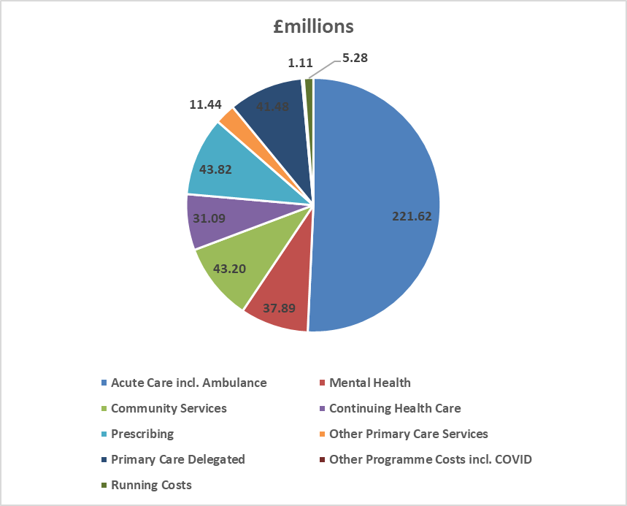

In 2021/22 the CCG spent £6.9m on Covid related expenditure.  The main areas of expenditure were £4.8m on Patient Transport as lead Commissioner on behalf of the System and £0.6m on the hospital discharge programme.

The CCG did not incur additional costs or receive additional funding in relation to EU exit.

**Capital spending**

The CCG did not require a capital allocation for 2021/22, but the Mid and South Essex Health and Care Partnership footprint was awarded Estates and Technology Transformation Funding (ETTF) towards primary care estates projects and GP IT.

**Paying our suppliers and providers**

National rules mean the CCG must aim to pay all valid invoices by the due date or within 30 days of receiving them, whichever is later. The NHS aims to pay at least 95% of invoices within 30 days of receipt, or within agreed contract terms. In 2021/22 the CCG met all four targets (based on invoice numbers and value of expenditure) for NHS and non-NHS invoices – see Note 6 of the Financial Statements for details.

The CCG is also an [approved signatory (hyperlinks)](https://www.smallbusinesscommissioner.gov.uk/ppc/signatories/?signatory=n) of the Prompt Payment Code. The government designed this initiative with the [Chartered Institute of Credit Management (hyperlinks)](https://www.cicm.com/) to tackle the crucial issue of late payment and to help small businesses. Suppliers can have confidence that any organisation signed up to the code will pay them within clearly defined terms and that proper processes are in place to deal with any disputed payments. Approved signatories have committed to:

* Paying suppliers on time
* Giving clear guidance to suppliers and resolving disputes as quickly as possible
* Encouraging suppliers and customers to sign up to the code.

The national measures for payment performance do not include any delays in payment during the time that an invoice is on hold.

**2022/23 financial plans and looking to the future**

The unprecedented impact of the Covid pandemic has inevitably delayed the return to normal financial arrangements. CCGs will cease to exist on 30 June 2022 and on 1 July 2022 they will be replaced by the Mid & South Essex Integrated Care Board (ICB). The Mid and South Essex Health and Care Partnership becomes the Mid & South Essex Integrated Care System (ICS). Allocations for 2022/23 have been given on a system level and it is expected that CCGs will balance for the first quarter with any risks falling on the new organisation. The CCG will continue to work with system partners over the coming months to prioritise programmes of work towards achieving a financially sustainable health and social care system.

### Risks

The CCG’s risk profile as a 31 March 2022 is detailed in the table below:

| **Workstream** | **RAG Rating** | | | **Total No of Risks** |
| --- | --- | --- | --- | --- |
| **Green** | **Amber** | **Red** |
| Cancer and End of Life | 0 | 1 | 1 | 2 |
| Children and Young People | 0 | 6 | 0 | 6 |
| Community | 2 | 4 | 0 | 6 |
| Digital and Business Intelligence | 1 | 3 | 0 | 4 |
| Estates | 0 | 2 | 0 | 2 |
| Finance | 1 | 3 | 1 | 5 |
| Health Inequalities | 0 | 1 | 0 | 1 |
| Integrated Care System | 2 | 3 | 0 | 5 |
| Maternity | 0 | 2 | 1 | 3 |
| Medicines Optimisation | 1 | 1 | 0 | 2 |
| Mental Health and Learning Disability | 0 | 4 | 2 | 6 |
| People | 1 | 1 | 1 | 3 |
| Planned Care | 1 | 2 | 2 | 5 |
| Population Health Management | 0 | 3 | 0 | 3 |
| Primary Care | 2 | 5 | 0 | 7 |
| Stewardship | 0 | 0 | 0 | 0 |
| Urgent Emergency Care | 2 | 5 | 0 | 7 |
| Vaccination | 0 | 1 | 0 | 1 |
| **Total as at 31 March 2022** | **13** | **47** | **8** | **68** |
|  |  | | |  |
|  |  |  |

During 2021/22 the MSE CCG’s risk profile has seen the number of red rated risks decrease. As of 31 March 2022, there were 8 red-rated risks, which related to the following 5 areas of the CCG’s business:

**Referral to Treatment (RTT) standard, cancer, access to service and capacity**

The CCGs continue to work with the Mid and South Essex NHS Foundation Trust (MSEFT) to address Licence Undertakings. Arrangements are in place to ensure oversight of the required actions to address RTT poor performance. There has been a significant impact on performance as a direct result of the Covid-19 pandemic. In partnership with NHS England, plans, oversight groups and reporting processes have been established to oversee restoration.

The System Quality section above provides an overview of action taken by MSE Quality teams to support MSEFT to undertake deep dive harm reviews on all patients whose care pathways breached cancer and RTT standards.

**Maternity services**

Arrangements are in place (as part of the MSEFT Licence Undertakings) to address significant concerns relating to maternity services, particularly those identified in the Care Quality Commission report for Basildon Hospital. The Mid and South Essex Local Maternity and Neonatal System (LMNS) are working with MSEFT to support workforce recruitment and retention measures and the Maternity Improvement Plan, including a review of the findings set out Donna Ockenden’s reports following her independent review of maternity services to assure the system and identify any further action required. Further information on maternity services is provided under the Care Quality Commission section of this report.

**Mental health services**

The Essex Mental Health Independent Inquiry is investigating matters surrounding the deaths of mental health inpatients across NHS Trusts in Essex between 2000 and 2020. The Inquiry will hear evidence from families, carers, and friends of those who died; others with experience of mental health inpatient care in Essex during the 21 year period; as well as staff, former-staff, relevant professionals, and organisations. The Inquiry is independent of government and the health care system.

**Workforce**

Workforce vacancy levels persist across MSE particularly in nursing and midwifery areas. Ongoing international and domestic recruitment initiatives are in place with a targeted retention strategy running in parallel. The MSE system has recently trialled a large in-person recruitment event for entry level roles, which resulted in 170 plus offers being made in one day. Similar initiatives will be rolled out across the system during 2022/2023.

**Financial Impact of Elective Recovery**

The submitted plans for Half 2 (H2) 2021/22 did not include additional Elective Recovery Fund income (ERF) within the system. This led to an income shortfall which has been mitigated by a mixture of additional efficiency savings within the system and some additional non-recurrent funding.

### Sustainable Development

**Introduction**

As an NHS organisation, and as a spender of public funds, we have an obligation to work in a way that has a positive effect on the communities for which we commission and procure healthcare services. Sustainability means spending public money well, the smart and efficient use of natural resources and building healthy, resilient communities. By making the most of social, environmental, and economic assets we can improve health both in the immediate and long term even in the context of rising cost of natural resources. Spending money well and considering the social and environmental impacts is enshrined in the Public Services (Social Value) Act (2012).

We acknowledge this responsibility to our patients, local communities, and the environment by working hard to minimise our carbon footprint.

In October 2020, the Greener NHS National Programme published its new strategy, Delivering a Net Zero National Health Service. This report highlighted that left unabated climate change will disrupt care, with poor environmental health contributing to major diseases, including cardiac problems, asthma and cancer. The report set out trajectories and actions for the entire NHS to reach net zero carbon emissions by 2040 for the emissions it controls directly, and 2045 for those it can influence (such as the supply chain). As part of the NHS, public health and social care system, it is our duty to contribute towards the targets set out in this document.

As a commissioner of services, the CCG sets out a commitment to sustainable procurement in its Procurement Policy. The CCG has taken measures to encourage greater awareness among staff. In November 2019 the Governance Committee recommended adoption of the NHS England pledge to eliminate single use plastics. In December 2019 the Staff Engagement Group supported an initiative for staff to make a “Green Pledge” for the start of the New Year.

An ICS Green Plan has been development and sets out actions to achieve Net Zero Carbon across the ICS. The CCG is fundamental to the delivery of this plan. Sustainability will become business as usual across all service areas.

**Modelled Carbon Footprint**

In England, the NHS is estimated to account for 5.4% of the country’s greenhouse gas emissions. The health and social care system reduced its carbon footprint by an estimated 62% between 1990-2020, however, drastic action is now required.

Figures 2 and 3 below illustrate the key areas of focus that the NHS must deliver on to reduce its carbon footprint and meet the Greener NHS targets of being a net carbon zero health care service by 2045.

Figure 2: Greenhouse Gas Protocol (GHGP) scopes in the context of the NHS

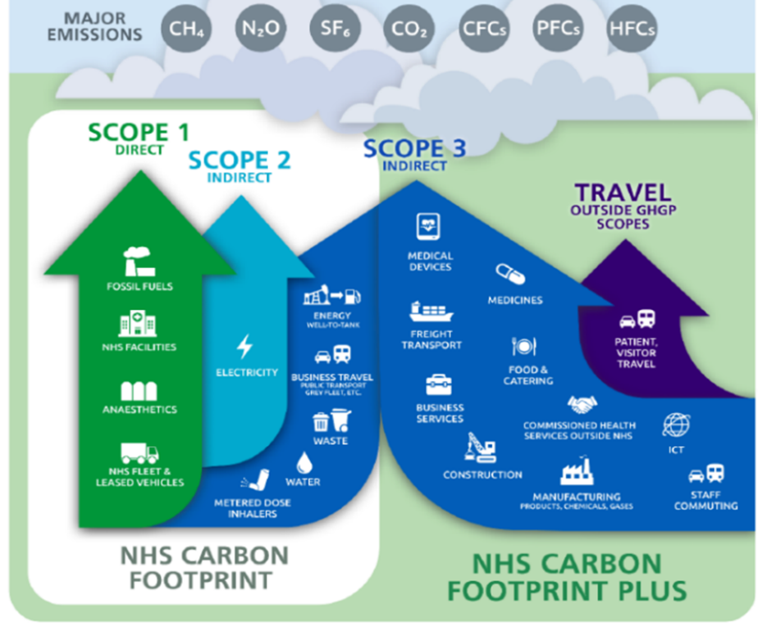

Figure 3: Sources of carbon emissions by proportion of NHS Carbon Footprint Plus

Diagram
Pie chart showing sources of carbon emissions

# ACCOUNTABILITY REPORT

## Corporate Governance Report

## Members Report

### Members Profiles

CCGs are clinically-led membership organisations made up of general practices. As of 31 March 2022 the following 35 practices are members of Basildon and Brentwood CCG:

|  |  |
| --- | --- |
| **Arterial Locality**  Ballards Walk Surgery  Dipple Medical Centre, East Wing (Dr Arayomi)  Western Road Surgery  The Billericay Medical Practice  Dr Sims and Partners  Queens Park Surgery  The New Surgery (Billericay)  Chapel Street Surgery  South Green Surgery  Knights Surgery  Dipple Medical Centre, South Wing (Dr Nasah) | **Partnership BIC Locality**  Felmores Medical Centre  Fryerns Medical Centre  Noak Bridge Medical Centre  Aryan Medical Centre  Rosevilla Surgery  Matching Green Surgery  The Knares Medical Practice  The Murree Medical Centre  Kingswood Medical Centre  Laindon Medical Group |
| **Brentwood Locality**  Rockleigh Court Surgery  Deal Tree Health Centre  New Folly Surgery  Tile House Surgery  The Highwood Surgery  Beechwood Surgery  The New Surgery (Brentwood)  Mount Avenue Surgery | **SEMC Locality**  Langdon Hills Medical Practice  Clayhill Medical Practice  The Robert Frew Medical Centre  Swanwood Partnership  The London Road Surgery  Aegis Medical Centre |

### Composition of Governing Body

The composition of the board’s voting and non-voting members who had authority or responsibility for directing or controlling the major activities of the CCG during the year are listed below:

**Voting members**

| Name | Role, locality (where applicable) and tenure (where the full financial year was not covered) |
| --- | --- |
| Dr Adegboyega (Boye) Tayo | Chair, GP member, SEMC Locality |
| Dr Kenneth Wrixon | GP member, Brentwood Locality |
| Dr Sri-Aravinder Guniyangodage | GP member, Brentwood Locality |
| Dr Sooraj Natarajan | GP member, Brentwood Locality |
| Dr Babafemi Salako | GP member, SEMC Locality |
| Dr Nimit Dabas | GP member, Arterial Locality |
| Dr Olugbenga Odutola | GP member, Arterial Locality |
| Dr Anita Pereira | GP member, Partnership BIC |
| Dr Vishal Sharma | GP member, Partnership BIC |
| Anthony McKeever | Joint Accountable Officer |
| Mark Barker | Chief Finance Officer |
| William Guy | Alliance Director |
| Dr Julia Hale | Secondary Care Consultant |
| Gillian Meriel Jones | Lay member, Patient & Public Involvement |
| Rachel Hearn | Executive Director of Quality and Nursing |
| Katherine Kirk MBE | Lay Member, Governance and Deputy Chair |
| Nicolas Spenceley | Lay Member and Audit Chair |

##### **Non-voting members with speaking rights**

| Name | Role, locality and tenure (where the full financial year was not covered) |
| --- | --- |
| Maggie Pacini | Public Health Representative, Essex County Council |
| Cllr Luke Mackenzie | Elected member of Essex County Council |

The following people have been CCG Board Members during 2021/22:

* **Dr Adegboyega Tayo, Chair and SEMC Elected Member**

**Appointment:** Chair from 1 April 2019

**Committee Memberships:**

The Chair has a standard invitation to attend all Board Committees (with the exception of Audit Committee)

**Profile:** Dr Tayo has been a GP in Wickford for 19 years.

He graduated from The University of Ibadan, Nigeria in 1985 and completed postgraduate training in the UK. As well as training in General Practice, he is a qualified Ophthalmologist and worked as a Trust Specialist in Ophthalmology at Southend Hospital before becoming a GP. For the CCG Dr Tayo leads on Integrated Care (Aligned Teams) and Chairs the local Alliance Forum.

**Declared interests and conflicts:**

GP Robert Frew Medical Centre

GP with special interest in Ophthalmology

Chair of SEMC Ltd – APMS Provider

Director of Mavens Medical Ltd – Healthcare Consultancy

Member of BB Healthcare Solutions

Member of Wickford Primary Care Network

* **Anthony McKeever (Mac), Joint Accountable Officer**

**Appointment:**  Joint Accountable Officer, mid and south Essex CCGs since 1 March 2020 and also Executive Lead, Mid and South Essex Health and Care Partnership from the same date.

**Committee Memberships:**

The JAO has a standard invitation to attend all Board Committees (with the exception of Audit Committee).

**Profile:** Anthony, known to all as Mac, has more than 40 years’ experience in the NHS and other healthcare organisations.  Before joining the mid and south Essex CCGs he served as Director General for Health and Community Services for the States of Jersey. Originally a “fast stream” civil servant, Mac joined the NHS in 1987, operating for 25 years as a CEO, helping to turn around performance at several hospitals and commissioning organisations. Having established his own business, he served on the Future Forum in 2010, and returned to work in the NHS in 2015.

**Declared interests and conflicts:**

Director of Macs Et al Ltd – wholly owned company through which he contracts with the NHS for Interim and other services.

Accountable Officer for Mid Essex, Thurrock, Castle Point & Rochford (CP&R) and Southend CCGs.

* **William Guy, Alliance Director**

**Appointment:** Alliance Director from October 2020

**Committee Memberships:**

Finance and Performance Committee

Clinical Executive Group

Primary Care Commissioning Committee (PCCC)

**Profile:** William has worked as a health service commissioner within South West Essex for 18 years with experience across primary, community and acute sectors.

**Declared interests and conflicts:** None

* **Rachel Hearn, Executive Director of Nursing & Quality**

#### Appointment:  Executive Director of Nursing and Quality from November 2020.

**Committee Memberships:**

Patient Safety and Quality Committee

Finance and Performance Committee

PCCC

**Profile:** Rachel is a Registered Nurse and Executive Director of Nursing and Quality across the five Mid and South Essex CCGs. Rachel has over 20 years’ clinical experience as a nurse within the NHS. Having worked predominantly in emergency and general medicine, Rachel has clinically led work on the changing face of emergency care. Rachel’s role in commissioning focuses on quality improvement, safeguarding adults and children and Continuing Health Care provision.

**Declared interests and conflicts:**

Executive Director of Nursing & Quality for Mid Essex, Thurrock, CP&R and Southend CCGs.

* **Mark Barker, Chief Finance Officer**

#### Appointment:  Joint Chief Finance Officer from 1 January 2021.

**Committee Memberships:**

Finance and Performance Committee

Clinical Executive Group

PCCC

**Profile:** Mark was appointed Chief Finance Officer for Mid and South Essex Clinical Commissioning Groups (CCGs) from 1 January 2021.

Mark is a Chartered Accountant with over 30 years Public sector experience within the NHS in commissioning and provider settings, Housing and Transport for London (TfL). He was previously the Chief Finance Officer for Southend and Castle Point and Rochford CCGs.

**Declared interests and conflicts:**

Chief Finance Officer for Mid Essex, Thurrock, CP&R and Southend CCGs.

* **Dr Sridhara Aravinda Guniyangodage, Brentwood Elected Member**

**Appointment:** From 1 April 2013

**Committee Memberships:**

Clinical Executive Group

**Profile:** Dr Guniyangodage is a GP in Brentwood, having worked there since 2007. He was Chair of the CCG for the three years to March 2019.

**Declared interests and conflicts:**

GP at The New Surgery Brentwood

Director & Board Member Accountable Care Enterprise Ltd

Clinical Director of Brentwood Primary Care Network

Teaching role for postgraduate education of GP trainees at King Georges – GP vocational training in London for Health Education England (HEE)

* **Dr Sooraj Natarajan, Brentwood Elected Member**

**Appointment:** From 1 April 2013

**Committee Memberships:**

Clinical Executive Group

Patient Safety & Quality Committee (PSQC and Acting Chair

**Profile:** Dr Natarajan has been a GP at the Tile House Surgery in Brentwood since 2005. Before becoming a GP, he worked in Paediatrics.   He has been involved in commissioning services as a GP member in the local practice-based Commissioning Group and as a Clinical Executive member in South West Essex CCG. Dr Natarajan leads on Children and Children’s Mental Health at the CCG and is acting Chair of PSQC.

**Declared interests and conflicts:**

GP Partner Tile House Surgery & GP from Brentwood Locality

Tile House Surgery is engaged in primary care research

Tile House Surgery is a member of ACE (Accountable Care Enterprise Limited)

Member of Brentwood Primary Care Network (PCN)

* **Dr Ken Wrixon, Brentwood Elected Member**

**Appointment:** From 1 April 2013

**Committee Memberships:**

Finance & Performance Committee (Chair)

Clinical Executive Group

**Profile:** Dr Wrixon has practised in Essex since 2002, initially as junior doctor at Broomfield Hospital, and more recently as a partner at Deal Tree Surgery since 2007. With a Masters in Public Health, he has always had an interest in population health. He leads on mental health and Improving Access to Psychological Therapies (IAPT) and is the sustainability champion for the CCG.  He is currently the Chair of the Brentwood locality. Dr Wrixon leads on the IAPT re-procurement and wider support of the mental health agenda.

**Declared interests and conflicts:**

GP Partner Deal Tree Health Centre

ACE (Accountable Care Enterprise Limited) – Shareholder

Wife is School Health Adviser for Virgin Healthcare.

Member of Brentwood Primary Care Network

* **Dr Nimit Dabas, Arterial Elected Member**

**Appointment:** From 1 December 2015

**Committee Memberships:**

Clinical Executive Group

**Profile:** Dr Dabas is an elected representative of Billericay and Basildon GPs on the Governing Body.  He is a full time GP in Billericay. For the CCG Dr Dabas leads on the Transfer of Care from Secondary to Out of Hospitals, NELFT contract and Urology.

**Declared interests and conflicts:**

GP Principal Queens Park Surgery and The New Surgery Billericay

Director of BB Healthcare Solutions Limited

Clinical Director for Billericay PCN

Wife is a Director and Shareholder of GP Support Limited

* **Dr Olugbenga Odutola, Arterial Elected Member**

**Appointment:** From 1 December 2018

**Committee Memberships:**

Clinical Executive Group, Patient Safety and Quality Committee

**Profile:** Dr Odutola is an elected representative of Billericay & Basildon GPs on the Governing Body.He is a full time GP.

**Declared interests and conflicts:**

Director of BB Healthcare Solutions

GP Partner at Knights Surgery and GP Partner at Fryerns Medical Centre

Puffie Limited - Director

Member of Central Basildon Primary Care Network

Member of Clinical & Multi Professional Group

* **Dr Babafemi Salako, SEMC Elected Member**

**A****ppointment:** From 1 April 2013

**Committee Memberships:**

Finance & Performance Committee

Clinical Executive Group (Chair)

**Profile:** Dr Salako has been a GP in Basildon since 2001 and works at Great Berry Surgery. He is a GP trainer and appraiser. For the CCG Dr Salako leads on Diabetes and is the CCG Research Champion. Former Chairman of Essex Faculty of RCGP

**Declared interests and conflicts:**

Senior Partner & GP Principal Langdon Hills Medical Centre

GP Southview Park Surgery

Director and Governance Lead at Basildon & Billericay Healthcare Solutions Ltd (BBHCS)

Director SEMC Ltd – APMS Provider

GP Registrar Tutor East of England Deanery

Chair of Central Basildon Primary Care Network

Director Andsons Solutions Ltd.

Member of East of England Cardiac Network

Director Community Healthcare Partnerships Ltd Community Medical Services provider

Member of Clinical & Multi Professional Group

* **Dr Anita Pereira, Partnership BIC elected member**

**Appointment:** From 1 January 2017

**Committee Memberships:** Clinical Executive Group, Patient Safety and Quality Committee

**Profile:** Dr Pereira is a GP Partner at Laindon Medical Group.

She is an Educational Supervisor for GP Trainees under Eastern Deanery GP Training Scheme.

Having worked in Public Health and in Obstetrics and Gynaecology in the past, she is passionate about tackling health inequalities and improving women’s health. For the CCG she has led on Acute Home Visiting Service, Self-Care and Elective Care Board.

**Declared interests and conflicts:**

GP Partner Laindon Medical Group

Laindon Medical Group is a member of BB Healthcare Solutions

Educational Supervisor with East of England Deanery

Member of West Basildon Primary Care Network

Care Homes Lead for West Basildon Primary Care Network

One son works as a junior doctor in London Trusts and is affiliated to supervising medical students at Cambridge University

Another son is a medical student rotating through London Trusts

Director of Basildon First Ltd, provider for West Basildon PCN

RCGP-Essex Faculty-Board member

* **Dr Vishal Sharma, Partnership BIC elected member**

**Appointment:** From 1 October 2019

**Committee Memberships:**

Clinical Executive Group

**Profile:**

GP Partner at Noak Bridge Medical Centre since 2009. He is also an external examiner for St. George’s school of medicine. His previous roles locally have included medicine management clinical lead for BBCCG. He was also the medical director for SEEDS OOH service. Prior to this he was a GP trainee in South London as part of the Guys and at Thomas’ VTS.

**Declared interests and conflicts:**

Director of Noak Bridge Medical Centre;

Director of BB Healthcare Solutions;

External Examiner - St Georges Hospital;

Member of West Basildon PCN;

Partner is Director of Noak Bridge Medical Centre;

Director of Basildon First Limited - Company provider for West Basildon Primary Care Network

* **Dr Julia Hale, Secondary Care Specialist**

**Appointment:** From 1September 2014

**Committee Memberships:**

Clinical Executive Group

Audit Committee

Remuneration Committee

PCCC

**Profile:** Dr Hale has been a consultant paediatrician for 21 years, specialising in neurodisability, safeguarding and adoption. She has an MSc in Community Child Health and was a member of the CoramBAAF Health Advisory Committee for 7 years. She has experience in clinical governance, patient experience and service reconfiguration in community services.

**Declared interests and conflicts:**

Bank Consultant Paediatric work at provider Trusts in Surrey

Locum Consultant for paediatric work at provider Trust in West London

Close family member employed by KPMG

Secondary Care Specialist for NHS Mid Essex CCG

* **Katherine Kirk MBE, Lay Member (Governance)**

**Appointment:** From 1September 2014

**Committee Memberships:**

Remuneration Committee (Chair)

PCCC

**Profile:** Katherine has chaired NHS Boards over a period of 15 years, concluding with chairing NHS South Essex until 2013. Her prior experience as a Chief Officer of a Community Health Council, championing and representing the needs of patients, has underpinned her subsequent roles. She also has experience as a local government officer. She was awarded an MBE in the 2013 Queen's Birthdays Honours for services to public health. In 2019 she was appointed as Deputy Chair of the Board.

**Declared interests and conflicts:**

None

* **Maggie Pacini, Non- voting attendee representing Public Health**

**Appointment:** From 13 May 2020

**Committee Memberships:** Clinical Executive Group

**Profile:** Maggie is employed in the Public Health Department for Essex County Council (ECC) and is the public health lead for NHS Basildon and Brentwood CCG.

**Declared interests and conflicts:**

Maggie is an employee of Essex County Council and is also public health lead for NHS Mid Essex CCG and NHS West Essex CCG.

* **Cllr Luke Mackenzie, Non-voting attendee representing Essex County Council**

**Appointment:** From July 2021

**Committee Memberships:** None

**Profile:** Chairman of the Council’s Scrutiny Committee and sits on the Audit and Risk Committee.  Deputy Mayor of Basildon Council and has been a borough councillor for Pitsea South-East Ward since 2018 and a county councillor for the Pitsea Division since May 2021. He was previously a borough councillor from May 2008 to May 2012, representing the ward of Vange.

**Declared interests and conflicts:**

Elected member of Essex County Council including member of Audit/ Governance and Standards Committee

Member of Health Overview Policy and Scrutiny Committee

Member of Basildon Council – Deputy Mayor

Employee, Conservative Group, London Assembly

* **Gillian Meriel Jones, Lay Member PPI**

**Appointment:** From February 2020

**Committee Memberships**

Patient and Community Reference Group

Patient, Safety and Quality Committee

Audit Committee

Remuneration Committee

PCCC

**Profile:**

Originally from Liverpool, Gillian has lived in Brentwood for more than 30 years. Gillian has worked in the public sector for 26 years in a number of roles, she is a specialist in the creation and maintenance of addresses and has worked with numerous countries and the United Nations to create and maintain national address databases. These address databases support the delivery of key services to the population. Most recently Gillian has worked on the introduction of postcodes to Ireland. Gillian has a longstanding interest in mental health care and has been a trustee and Vice Chair of HBBS counselling for over 10 years. The charity based in Brentwood provides counselling to people in Havering and Brentwood and works in local schools and with vulnerable groups as well as providing general counselling. HBBS Counselling was awarded the Queens award for voluntary service last year which is the highest award which can be awarded to a charity

**Declared interests and conflicts:**

Trustee and Vice Chair of Havering & Brentwood Bereavement Service (HBBS)

Director of GM Jones Ltd (dormant company)

* **Nicolas Spenceley, Lay Member and Audit Chair**

**Appointment:** From June 2019

**Committee Memberships**

Audit Committee (Chair)

Remuneration Committee

PCCC

**Profile:**

Nicolasworked for 36 years in Further Education colleges as an English Lecturer, ending up as Principal and Chief Executive of South East Essex Sixth Form College.

He retired from full-time work in 2016 and continues to be involved with colleges as an external moderator for Access to Higher Education courses which enable adults without A-Levels to enter degree programmes.

He is passionate about workforce development, the long-term sustainability of recruitment, and encouraging young people  from disadvantaged backgrounds to aspire to serve in the health professions.

**Declared interests and conflicts:**

Chair of Personnel and Resources at Writtle University College

### Member practices

#### Locality achievements

The member practices in the CCG are grouped into six Primary Care Networks (PCNs) as follows:

##### **West Basildon PCN – Clinical Director Dr Olutunde Macaulay**

* Ballards Walk Surgery
* Noak Bridge Medical Centre
* Kingswood Medical Centre
* Laindon Medical Group
* The Knares Medical Practice

**Central Basildon PCN – Dr Francesca Ogunbiyi**

* Dipple Medical Centre, East Wing (Dr Arayomi)
* Clayhill Medical Practice
* Knights Surgery
* The Murree Medical Centre
* Dipple Medical Centre, South Wing (Dr Nasah)
* Fryerns Medical Centre
* Langdon Hills Medical Practice
* Rosevilla Surgery
* Aegis Medical Centre

**East Basildon PCN – Dr Ayub Khan**

* Dr Sims and Partners
* Felmores Medical Centre
* Aryan Medical Centre
* Matching Green Surgery

**Brentwood PCN – Dr Sridhara Aravinda Guniyangodage**

* Rockleigh Court Surgery
* Deal Tree Health Centre
* New Folly Surgery
* Tile House Surgery
* The Highwood Surgery
* Beechwood Surgery
* The New Surgery (Brentwood)
* Mount Avenue Surgery

**Billericay PCN – Dr Nimit Dabas**

* Western Road Surgery
* The Billericay Medical Practice
* Queens Park Surgery
* The New Surgery (Billericay)
* Chapel Street Surgery
* South Green Surgery

**Wickford PCN – Clinical Director Dr Margaret Odufuye**

* The Robert Frew Medical Centre
* Swanwood Partnership
* The London Road Surgery

This year has continued to be a challenging year for primary care with the ongoing national lockdown/restrictions which has led primary care to continue working in a whole new way, including telephone and video consultation services alongside face to face appointments. All practices continue to offer online consultation services.

The flu campaign which was delivered from each practice achieved above the target of 75% of patients over the age of 65.

**Websites**

This year has seen the development of the Primary Care Websites. Offering links to local support and advice on health and care as follows:

[East Basildon PCN (hyperlinks)](https://www.eastbasildonpcn.nhs.uk/)

[West Basildon PCN (hyperlinks)](https://www.westbasildonpcn.nhs.uk/)

[Central Basildon PCN (hyperlinks)](https://www.centralbasildonpcn.nhs.uk/)

[Brentwood PCN (hyperlinks)](https://www.brentwoodpcn.nhs.uk/)

[Billericay PCN (hyperlinks)](https://www.billericaypcn.nhs.uk/)

**Shared Admin Hubs across PCNs**

The introduction of SystmOne Hubs this year provided one login for all PCN related work. For example a PCN clinical pharmacist, that previously had to log into each individual practice to access patient records, would only need to log into the hub to enable the clinical pharmacist access to read and update all patient records from member practices.  Reporting can also be run at PCN level. PCN role rotas can be shared with all practices, either by sharing the PCN unit rota to all practice units or remote booking.  This is possible by each member practice sharing with the PCN unit.

**Population Health Management**

East Basildon PCN have signed up to support changes to integrated care delivery, advance the system’s infrastructure and build sustainable capability across all tiers of the system. Patient letters are going out inviting an initial dialogue with social prescribers. West Basildon PCT are on the cusp of agreeing cohort.

**Covid-19 vaccinations**

The Primary Care Networks working alongside providers BB Healthcare and ACE Ltd have continued to offer the covid vaccination programme to all eligible patients. This has been challenging with regard to maintaining workforce who are also working in General Practice. Weekend and evening clinics have been opened to enable primary care staff to do both. In the first quarter 2022/23 the vaccination centres are focusing on the 5 – 11 at risk age group and for any patients who have yet to receive a vaccine or want a booster. Uptake currently stands at approximately 80% across the CCG with a lower uptake in more deprived areas of Basildon.

**Investment and Impact Fund (IIF)**

All PCNs and their member practices are signed up to IIF and continue to work on:

* Prevention and tackling health inequalities – vaccinations remain top priority
* Enhanced health in care homes
* Access – all practices have mapped all appointments
* Providing high quality care

**Partnership working**

The member practices within each PCN have continued to work together in identifying opportunities for greater collaboration, both between themselves and with other key local providers – e.g. community health and care teams. They have also expanded both the size of their PCN teams, and the range of professionals that make up these teams, through utilisation of the Additional Roles Reimbursement Scheme.

Whilst it is recognised that there remains considerable scope for the PCNs to further develop their models of collaborative partnership working and effective expansion in shared workforce, the work undertaken by PCNs over the previous year will provide a strong basis for maximising the available opportunities.

### Committees, including Audit Committee

To support the board (the governing body) in carrying out its duties effectively, committees reporting to the board are formally established. The remit and terms of reference of these committees have been reviewed during the year to ensure robust governance and assurance. All main committees are meeting ‘in common’ with partner MSE CCGs with the one exception being the Clinical Executive Group. Each committee reports its minutes to the board.

**Committee terms of reference**

The terms of reference for the committees of the CCG can be found on the CCG website [Terms of Reference (hyperlinks)](https://basildonandbrentwoodccg.nhs.uk/about-us/constitution-and-terms-of-reference)

**Governing Board (the Board)**

The CCG’s constitution sets out the governance arrangements, roles and responsibilities of the Board and its membership.

Publicly held Board meetings are held on a bi-monthly basis. The CCG meeting due to be held in January was cancelled as part of business continuity arrangements implemented from mid-December to the end of February 2022 as detailed above. However, appropriate arrangements were implemented to ensure that any key decisions were taken forward. Any decisions taken by the Central Incident Management Team (CIMT) were logged on the CIMT decisions log which was then reported to the Board.

In February 2022 the CCG Board met in common with the other MSE CCG Boards and agreed that they would continue to meet in common until the MSE Integrated Care Board (ICB) is established.

Board meetings are broadcast via ‘MS Teams’ which enables members of the public to listen to discussions held and submit questions.

Board meetings were quorate on the majority of occasions. If a Board meeting was inquorate due to one or more members being unavailable, their support for recommendations made was sought following the meeting to ensure that decisions were quorate. There are also arrangements in place to maintain a quorum where conflicts of interest require voting members of the Board to recuse themselves from a relevant vote.

As at 31 March 2022, the Board membership comprised of the following voting members:

The Chair (a GP member), Joint Accountable Officer, Alliance Director, Executive Chief Finance Officer, Executive Director of Nursing and Quality (Registered Nurse), eight other GP members, Secondary Care Specialist and three Lay Members.

Anthony McKeever was appointed Interim Joint Accountable Officer for the Mid and South Essex CCGs from 1 March 2020 and was subsequently appointed to this role on a permanent basis from 3 October 2020. Mr McKeever has since been appointed to the role of Chief Executive Officer Designate for the Mid and South Essex Integrated Care System.

Board representation also includes two non-voting appointees: a) a Public Health Consultant from Essex County Council (ECC); and b) an elected ECC councillor.

The Board undertakes regular reviews of its effectiveness and has determined that it fulfils its role effectively either all or most of the time and that there is good engagement of members. Appraisals of Board members are undertaken to evaluate individuals’ contributions and performance.

To support the Board in carrying out its duties effectively, committees reporting to the Board are formally established. The current committee structure can be found on the [CCG Web Site (hyperlinks)](https://basildonandbrentwoodccg.nhs.uk/about-us/) . This was updated from 1 April 2021 with the addition of the Primary Care Commissioning Committee. In line with NHS guidance to reduce the burden on NHS staff during the pandemic, some formal committee meetings were stood down during April 2021 and again from mid-December 2021 to February 2022, with any urgent business being conducted virtually.

From Quarter 1 of 2020/21, the five MSE CCGs held their Remuneration Committee, Patient Safety & Quality Committee (or equivalent) and Finance & Performance Committee meetings in common.

From Quarter 1 of 2021/22, meetings in common arrangements were extended to include the five MSE CCGs Audit Committees and Primary Care Commissioning Committees.

The Mid and South Essex Health and Care Partnership Board, which includes representation from the CCG, local authorities, Healthwatch Essex, the voluntary sector, Anglian Ruskin University and the CCG’s main providers, met in private throughout 2021/22. The minutes of these meetings were submitted to the CCG’s Part II Board meetings.

Each committee submits a summary of discussions, decisions and key issues to Board meetings. The main committees providing assurance to the Board are set out below.

**Audit Committee**

This Committee provides the CCG Board with an independent and objective view of the CCG’s financial systems, financial information and compliance with laws, regulations and directions governing the CCG insofar as they relate to finance, good corporate governance, information governance, cyber-security, emergency planning, response and resilience (EPRR), business continuity management (BCM) and the CCG’s responsibility to act effectively, efficiently and economically.

The Audit Committee is chaired by the Lay Member (Audit ), Nicholas Spenceley. As at 31 March 2022, the Committee’s other members were Gillian Meriel Jones, Lay Member (Patient and Public Engagement) and Julia Hale, Secondary Care Specialist

From the Quarter 1 of 2021/22, the Committee met in common with the other MSE CCG Audit Committees on 5 occasions, plus 2 extraordinary meetings to review draft policies developed for the MSE ICB. Attendance has been quorate in line with its Terms of Reference (minimum of two core members) on all occasions.

During 2021/22 the Audit Committee continued to focus upon ensuring the development and review of the systems, policies, procedures and processes fundamental to the governance of the organisation. During Quarter 4, the committee undertook a review of policies being developed for the MSE ICB relating to areas within the committee’s remit.

The Committee has received assurance from internal audit of key systems and processes and, in addition to routine reporting, has received updates on counter-fraud initiatives and investigations and implementation of audit recommendations. The Committee reviewed the CCG’s draft accounts and approved the final accounts and management response to the auditor on behalf of the Board.

The Committee also reviews the CCG’s risk register/Board Assurance Framework (BAF) and associated risk management processes and procedures. The Committee supported an aligned MSE CCG Risk Management Policy which was adopted by the CCG Boards in November 2021.

During the Level 4 incident from mid-December to February 2022, the committee received a copy of the Central Incident Management Team (CIMT) Risk Register which focussed on key risks whilst normal risk register reporting arrangements were paused. During this period, the committee also received a copy of the CIMT Decisions Log recording all decisions taken by CIMT.

The Committee also received the minutes of other main CCG committees namely: the Primary Care Commissioning Committee; the Patient Safety and Quality Committee and the Finance & Performance Committee meetings which were held in common with the other MSE CCG committees.

In line with NHS England guidance on the management of Conflicts of Interest, the Chair of the Audit Committee acts as the CCG’s Conflicts of Interest Guardian.

The Committee and Board approved an extension of the expiry date of relevant CCG policies, including the Conflicts of Interest, Gifts and Hospitality and Standards of Business Conduct Policies, to March 2022 to enable the MSE CCGs to focus on developing new aligned policies in preparation for the formation of a new Integrated Care System (ICS) NHS Body. In March 2022, these policies were subsequently extended by the Board until 30 June 2022 as a result of the national decision to delay the establishment of ICBs by three months.

The Audit Committee Chair received assurance that the CCG was adhering to NHS England mandatory guidance on the management of conflicts of interest via the annual internal audit of conflicts of interest which identified ‘reasonable’ assurance. The requirement to submit quarterly returns to NHS England regarding the CCG’s adherence to the mandatory guidance was suspended during 2021/22.

**Remuneration Committee**

The Remuneration Committee is a committee of the CCG Board with delegated responsibility for making recommendations to the Board on all aspects of remuneration and terms of service of employees, including the Accountable Officer, Directors and Lay Members.

In addition, the Committee is responsible for making recommendations to the Board concerning the remuneration and terms of service for Elected GP members and other people who provide services to the CCG (all of whom are not employees of the CCG), taking in to account any national or local guidance as appropriate, so as to ensure that individuals are fairly rewarded for their contribution to the CCG.

The membership of the Remuneration Committee as at 31 March 2022 is two lay members. The committee is chaired by the Lay Member (Governance).

The Remuneration Committee met in common with the other MSE CCG Remuneration Committees 10 times, either via MS Teams or by conducting business ‘virtually’ by email, during 2021/22.

**Clinical Executive Group (CEG)**

The CEG is a committee of the Board and provides a forum for the clinical leaders and senior officers to plan the clinical direction of the CCG and make recommendations to the Board. This was achieved through the review and evaluation of innovations, commissioning and decommissioning proposals and other schemes, projects and initiatives.

**Finance and Performance Committee**

This Committee scrutinises and provides the CCG Board with assurance on the delivery of the CCG’s remit in respect of the CCG’s overall financial position (including running costs) and for service performance for commissioned services not delegated to the Joint Committee (JC).

The Committee also maintains local oversight of information management and technology, estates developments, and a role in the scrutiny and challenge to ensure delivery of the CCG’s programme of financial savings. The Committee acts as a point of approval for major changes to existing projects and plans, where these are based on considerations related to the achievement of financial or other benefits. The Committee also assesses whether there is continued business justification for existing projects and programmes where the financial or other benefits have changed.

The Committee was chaired by a GP representative with the membership comprising a further GP Representative, the Lay Member (Audit Chair), Executive Chief Finance Officer and Alliance Director .

Since May 2020, the Committee has met in common with the other four MSE CCGs’ Finance and Performance Committees. During 2021/22 it met on 8 occasions to review finance and performance issues across all health care services, including those ordinarily within the remit of the Mid and South Essex STP CCG Joint Commissioning Committee (JC). All meetings were quorate.

During 2021/22 the Committee particularly focused upon review of finance & performance risks, receipt of monthly finance reports, Joint Committee finance reports, Elective Recovery Framework updates, Hospital Discharge Programme 2021/22, contract planning, awards and procurement decisions, performance reports from System Oversight and Assurance Group (SOAG), Adult Mental Health Transformation Plan contracts, system financial sustainability, 2021/22 Business Plan and CCG budgets, approval of terms of reference/frequency of meetings, receipt of System Finance Leaders Group (SFLG) minutes.

**Patient Safety and Quality Committee**

This Committee provides assurance regarding the safety and quality of services directly commissioned by the CCG, i.e. acute, community, learning disability and mental health services, as well as the quality of services within primary care and the care home sector.

The committee also maintains oversight of safeguarding (adults and children) and medicines optimisation.

At the start of the year the Committee was chaired by a GP Board Member, and its core decision making membership comprised a further GP Board Member, the Lay Member for Patient and Public Engagement and the Executive Director of Nursing and Quality. Committee meetings were also attended by other senior managers with specific responsibility for areas within the remit of the committee.

In May 2020 the Committee commenced meeting in common with the other four MSE CCGs’ Patient Safety and Quality (or equivalent) Committees to review the safety and quality of all health care services across mid and south Essex.

The Committee meeting in common focused on arrangements to provide care for patients diagnosed with COVID-19 within acute, community and care home settings, the safety of staff and workforce capacity issues, and the effect that the pandemic was having on patients requiring routine and elective care.

Other key areas discussed included arrangements for monitoring the quality of provider contracts; review of NHS Patient Safety Updates; review of the Quality Accounts 2020/21 from Mid and South Essex Hospital NHS Foundation Trust, Essex Partnership University NHS Foundation Trust (EPUT); North East London NHS Foundation Trust; Barking, Havering and Redbridge NHS Foundation Trust; Provide Community Interest Company and Farleigh Hospice; and agreeing the CCGs’ responses to the Quality Accounts; serious incidents and never events; review of arrangements for the implementation of the Patient Safety Incident Response Framework; update on Special Educational Needs and Disabilities services; updates on Learning Disabilities Mortality Review (LeDeR) Programme; System Quality Strategy; Infection Prevention and Control Strategy; approval of policies; all age continuing care; personal health budgets; review of patient safety and quality risks; quality and equality impact assessments; complaints and a review of any virtual decisions taken since the last committee meeting.

These meetings were attended by the minimum number of members required for each CCG committee to be considered quorate. Attendance was generally quorate in line with the Committees’ Terms of Reference. If a committee was inquorate due to one or more members being unavailable, their support for any decisions made was sought following the meeting.

Three ‘virtual’ meetings were held by email with update reports being circulated to members for information.

**Patient and Community Reference Group (PCRG)**

This PCRG provides the board with its view on a range of CCG activities and the views of the group are taken into account when considering commissioning proposals. Members are drawn from the population of the CCG, various patient and community groups and organisations representing local interest.

The work plan of PCRG is aligned to the CCG’s priorities and in order to ensure enough time is given to key issues, workshops focussing on a single topic are held. See the section on public and patient involvement for full details of engagement activities on page 24.

**Basildon and Brentwood Alliance**

The aim of the Basildon and Brentwood Alliance is to bring together stakeholders from across Basildon and Brentwood who have a shared interest in improving the wellbeing of our local population. The Alliance partners work collaboratively to enable transformational change that improves outcomes for the population we serve.

The membership comprises of representation from the CCG, PCN Clinical Directors, the CCG Chair, representation from Essex County Council and Basildon and Brentwood Councils, Essex Partnership University NHSFT, North East London NHSFT, Mid and South Essex Foundation Trust, St Luke’s Hospice and Virgin Healthcare

With the exception of January 2022, the Alliance has met monthly through 2021/22 with high levels of attendance and engagement from all stakeholders. The Alliance focussed on the delivery of the Basildon and Brentwood Alliance Plan. In addition, the Alliance has engaged an Organisation Development Agency called Collaborate to support the Alliance to consider its future function and form as we transition to the ICS.

**Primary Care Commissioning Committee**

The Committee is attended by both the CCG and NHS England/NHS Improvement. The committee is chaired by the Lay Member for Governance.

From June 2021 the Committee met in common with the other MSE CCGs Primary Care Commissioning Committees. There were five meetings held, with three further virtual meetings held to conduct urgent business that could not wait until the next scheduled meeting. A review of committee effectiveness confirmed that the committee was generally quorate in line with the Committee’s Terms of Reference.

During 2021/22 the Committee focused on, Contractual updates, breaches or requests for contractual changes from general practices; local contract decisions, e.g. Designated Enhanced Services; GP primary care quality and safety reports; budget reports; information technology and digital updates; estates issues; primary care workforce; review of Primary Care Risk Group minutes; review of primary care risks; and GP Business Continuity and resilience arrangements.

**Better Care Fund (including Improved Better Care Fund) Governance**

A Better Care Fund (BCF) Partnership Board meets to fulfil the governance requirements with Essex County Council.

In line with the terms of the Section 75 Better Care Fund Agreement, decision-making relating to the BCF is delegated to two nominated representatives of the CCG and two representatives of Essex County Council. Utilisation of the BCF funds was agreed in the Section 75 Agreement and in-year reporting focused upon expenditure on the approved services and monitoring against agreed performance targets.

**Mid and South Essex STP CCG Joint Commissioning Committee**

As outlined in the introduction, the five mid and south Essex CCGs formally established a CCG Joint Committee (JC) to act collectively in the planning, securing and monitoring of services to meet the needs of their 1.2million population. The JC was established as a committee of each CCG, not of the CCG’s governing bodies, and therefore sits alongside the CCG governing bodies, rather than being accountable to them.

During 2021/22 the committee meet three times to consider: risks within the remit of the committee; planning guidance; the Vanguard Theatre contract; MSEFT Legal Undertakings; Adult Mental Health Transformation Plan; review of Medicines Optimisation Terms of Reference; patient safety, finance and performance reports; receipt of minutes from Patient Safety & Quality Committees in common and Finance & Performance Committees in common; provider Quality Accounts and the CCGs’ responses to these; non-emergency patient transport procurement; and review of community beds.

The JC did not meet during December to February as a result of the implementation of pandemic business continuity arrangements and, following a decision by the MSE CCGs to meet in common from February until the establishment of the MSE ICB, the JC will no longer meet.

### Register of Interests

The CCG maintains a register of interests for all members of staff and board members.

The CCG’s most up to date register of interests for decision makers is available on the CCG website [Register of Interests (hyperlinks)](https://basildonandbrentwoodccg.nhs.uk/about-us/ccg-register-of-interests-gifts-and-hospitality-and-procurement-decisions)

Personal data related incidents(Information Governance)

The NHS Information Governance (IG) Framework sets the processes and procedures by which the NHS handles information about patients and employees, in particular personal identifiable information. The NHS Information Governance Framework is supported by a data security and protection toolkit and the annual submission process provides assurances to the CCG, other organisations and to individuals that personal information is dealt with legally, securely, efficiently and effectively.

We place high importance on ensuring there are robust information governance systems and processes in place to help protect patient and corporate information. We have established an information governance management framework and have developed information governance processes and procedures in line with the Data Security and Protection Toolkit. We have ensured all staff undertake annual information governance training and have implemented a staff information governance handbook to ensure members of staff are aware of their information governance roles and responsibilities, and how to access information or assistance.

There are processes in place for incident reporting and investigation of serious incidents. No serious incidents requiring investigation involving personal data were reported to the Information Commissioner in 2021/22.

The CCG has nominated information asset owners who have completed the new data flow mapping and information asset registers to ensure compliance with the General Data Protection Regulations (GDPR). This was undertaken with support from the IG Team to ensure consistency of approach.

As at 31 March 2022 the CCG has meet all mandatory assertions in relation to the requirements of the Data Security and Protection Toolkit.

### Statement of Disclosure to Auditors

Each individual who is a member of the CCG at the time the Members’ Report is approved confirms:

* So far as the member is aware, there is no relevant audit information of which the CCG’s auditor is unaware that would be relevant for the purposes of their audit report.
* The member has taken all the steps that they ought to have taken in order to make him or herself aware of any relevant audit information and to establish that the CCG’s auditor is aware of it.

### Donations to political parties and charitable organisations

The CCG does not make donations to political parties.

The CCG has made payments to a number of charitable organisations. The majority of these payments are in relation to Service Level Agreements (particularly to local hospices) or as a result of successful grant applications.

### Modern Slavery Act

**NHS Basildon and Brentwood Clinical Commissioning Group’s Response to the Requirements of the Modern Slavery Act 2015**

This statement comprises the [slavery and human trafficking statement (hyperlinks)](https://basildonandbrentwoodccg.nhs.uk/about-us/publications/publications-public/safeguarding-publications-public/5873-modern-slavery-statement-2022-1/file) of Basildon and Brentwood Clinical Commissioning Group for the financial year ending 31 March 2022 in accordance with Section 54, Part 6 of the Modern Slavery Act 2015. The organisation recognises that it has a responsibility to take a robust approach to slavery and human trafficking and is absolutely committed to preventing slavery and human trafficking in its corporate activities.

**Definition of Offences**

Slavery, servitude and forced or compulsory labour.

A person commits an offence if:

1. The person holds another person in slavery or servitude and the circumstances are such that the person knows or ought to know that the other person is held in slavery or servitude, or;
2. The person requires another person to perform forced or compulsory labour and the circumstances are such that the person knows or ought to know that the other person is being required to perform forced or compulsory labour.

**Human Trafficking**

A person commits an offence if:

1. The person arranges or facilitates the travel of another person (victim) with a view to being exploited;
2. It is irrelevant whether the victim consents to travel and whether or not the victim is an adult or a child.

**Exploitation**

A person is exploited if one or more of the following issues are identified in relation to the victim:

1. Slavery, servitude, forced or compulsory labour;
2. Sexual exploitation;
3. Removal of organs;
4. Securing services by force, threats and deception;
5. Securing services from children, young people and vulnerable persons.

**Organisational Structure**

As an authorised statutory body, the CCG is the lead commissioner for health care services (including acute, community, mental health and primary care) in Basildon and Brentwood, Essex. The Membership, Governing Body, Executive Team and all employees are committed to ensuring that there is no modern slavery or human trafficking in any part of our business activity and in so far as is possible to holding our suppliers to account to do likewise.

**Our approach**

Our overall approach is governed by compliance with legislative and regulatory requirements and the maintenance and development of best practice in the fields of contracting and employment. The CCG recognises safeguarding as a high priority for the organisation. In order to achieve this, we ensure that we have arrangements in place to provide strong leadership, vision and direction for safeguarding. We make sure we have clear accessible policies and procedures in line with relevant legislation, statutory guidance and best practice.

**The organisational structure, business and supply chain**

We have a clear line of accountability for safeguarding within the CCG. The CCG’s Accountable Officer has ultimate accountability for ensuring that the health contribution to safeguarding and promoting the welfare of children and adults is discharged effectively across the whole health economy through commissioning arrangements. The Executive Director of Nursing and Quality is the Governing Body executive lead for safeguarding and has responsibility for providing leadership and gaining assurance in relation to safeguarding issues within the CCG and locality. The CCG employs the expertise of designated professionals for both children and adults. These roles are an integral part of the CCG’s activity and support the delivery of the safeguarding adult and children agenda.

**Procurement**

The CCG ensures that organisations commissioned to provide services have appropriate systems that safeguard children in line with section 11 of the Children Act (2004), and adults in line The Mental Capacity Act 2005, The Care Act 2014 and The Modern Slavery Act 2015. With regards specifically to the Modern Slavery Act 2015, there is a specific question in our standard set in the pre-qualification questionnaire so that we can be assured of the approach of potential providers at the outset of procurement. In addition, the CCG’s contractual agreements (Standard NHS Contract) contain an obligation within clause SC1.2.2 for providers of services to ‘*perform all of its obligations under the Contract in accordance with*’:

1.1.1 the terms of this Contract; and

1.1.2 the Law; and

1.1.3 Good Practice’

Further, under SC32 Safety and Safeguarding there is a requirement upon all of our providers to have in place programmes for safeguarding and to co-operate with the Commissioner in pursuance of these.

**The policies in relation to Modern Slavery and Human Trafficking**

Across Essex there are multi-agency policy and procedures for the protection of adults and children; all organisations will report any concerns direct to the police or via the referral procedures identified in local policy.

**The due diligence processes in relation to Slavery and Human Trafficking in its business and supply chains**

The CCG is committed to ensuring that there is no Modern Slavery or Human Trafficking in our supply chains or in any part of our business. Safe recruitment principles are adhered to which includes strict requirements in respect of identity checks, work permits and criminal records. The pay structure is derived from national collective agreements and is based on equal pay principles with rates of pay that are nationally determined. Systems are in place to encourage the reporting of concerns and the protection of whistle blowers.

With regards to providers and supply chains, we expect these entities to have suitable anti-slavery and human trafficking policies and processes in place. We will use our routine contract management meetings with major providers to hold them explicitly to account for compliance with the Act and we will implement any relevant clauses contained within the Standard NHS Contract for 2022/23.

**The parts of its business and supply chains where there is a risk of Modern Slavery and Human Trafficking taking place, and the steps it has taken to assess and manage that risk**

The CCG is committed to social and environmental responsibility and has zero tolerance for Modern Slavery and Human Trafficking. Any identified concerns regarding Modern Slavery and Human Trafficking would be escalated as part of the organisational safeguarding process and in conjunction with partner agencies; such as the Local Authority and Police.

**The effectiveness in ensuring that Slavery and Human Trafficking is not taking place in its business or supply chains, measured against such performance indicators as it considers appropriate**

The CCG aims to be as effective as possible in ensuring that modern slavery and Human Trafficking is not taking place in any part of our business or supply chains by:

1. Effective interagency working with local authorities, the police and third sector organisations which includes appropriate arrangements for preventing and responding to modern slavery and Human Trafficking;
2. Signing up to the Southend, Essex and Thurrock multi-agency policy and procedures for the safeguarding and protection of adults and children;
3. Undertaking robust NHS employment checks and payroll systems;
4. Ensuring good communication through contract management meetings, with our commissioned providers in the supply chain and their understanding of, and compliance with, our expectations in relation to the NHS terms and conditions. These conditions relate to issues including bribery, slavery and other ethical considerations.

**Training about Modern Slavery and Human Trafficking**

Modern Slavery and Human Trafficking is part of the organisation’s mandatory safeguarding children and adults training programme.

This statement is made pursuant to Section 54(1) of the Modern Slavery Act 2015 and constitutes our organisation’s modern slavery and human trafficking statement for the current financial year.

### Statement of Accountable Officer’s Responsibilities

The National Health Service Act 2006 (as amended) states that each Clinical Commissioning Group shall have an Accountable Officer and that Officer shall be appointed by the NHS Commissioning Board (NHS England). NHS England has appointed the [inset post holder title] to be the Accountable Officer of [Name of CCG].

The responsibilities of an Accountable Officer are set out under the National Health Service Act 2006 (as amended), Managing Public Money and in the Clinical Commissioning Group Accountable Officer Appointment Letter. They include responsibilities for:

* The propriety and regularity of the public finances for which the Accountable Officer is answerable.
* For keeping proper accounting records (which disclose with reasonable accuracy at any time the financial position of the Clinical Commissioning Group and enable them to ensure that the accounts comply with the requirements of the Accounts Direction).
* For safeguarding the Clinical Commissioning Group’s assets (and hence for taking reasonable steps for the prevention and detection of fraud and other irregularities).
* The relevant responsibilities of accounting officers under Managing Public Money.
* Ensuring the CCG exercises its functions effectively, efficiently and economically (in accordance with Section 14Q of the National Health Service Act 2006 as amended and with a view to securing continuous improvement in the quality of services (in accordance with Section14R of the National Health Service Act 2006 as amended).
* Ensuring that the CCG complies with its financial duties under Sections 223H to 223J of the National Health Service Act 2006 as amended.

Under the National Health Service Act 2006 as amended, NHS England has directed each Clinical Commissioning Group to prepare for each financial year a statement of accounts in the form and on the basis set out in the Accounts Direction. The accounts are prepared on an accruals basis and must give a true and fair view of the state of affairs of the Clinical Commissioning Group and of its income and expenditure, Statement of Financial Position and cash flows for the financial year.

In preparing the accounts, the Accountable Officer is required to comply with the requirements of the Government Financial Reporting Manual and in particular to:

* Observe the Accounts Direction issued by NHS England, including the relevant accounting and disclosure requirements, and apply suitable accounting policies on a consistent basis.
* Make judgements and estimates on a reasonable basis.
* State whether applicable accounting standards as set out in the Government Financial Reporting Manual have been followed and disclose and explain any material departures in the accounts.
* Prepare the accounts on a going concern basis.
* Confirm that the Annual Report and Accounts as a whole is fair, balanced and understandable and take personal responsibility for the Annual Report and Accounts and the judgements required for determining that it is fair, balanced and understandable.

As the Accountable Officer, I have taken all the steps that I ought to have taken to make myself aware of any relevant audit information and to establish that Basildon and Brentwood CCG’s auditors are aware of that information. So far as I am aware, there is no relevant audit information of which the auditors are unaware.

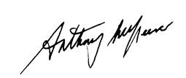

**Anthony McKeever**Executive Lead for the Mid and South Essex Health and Care Partnership and Joint Accountable Officer for its five CCGs

29 June 2022

# 

# Governance Statement

**Introduction and context**

Basildon and Brentwood CCG (the CCG) is a body corporate established by NHS England on 1 April 2013 under the National Health Service Act 2006 (as amended).

The CCG’s statutory functions are set out under the National Health Service Act 2006 (as amended). The CCG’s general function is arranging the provision of services for persons for the purposes of the health service in England. The CCG is, in particular, required to arrange for the provision of certain health services to such extent as it considers necessary to meet the reasonable requirements of its local population.

As at 31 March 2022, the CCG was not subject to any directions from NHS England issued under Section 14Z21 of the National Health Service Act 2006.

The CCG is part of the Mid and South Essex Health and Care Partnership (the HCP) covering the geographic areas of mid Essex, Basildon and Brentwood, Castle Point and Rochford, Southend, and Thurrock CCGs (the MSE CCGs). The HCP has been created to bring local health and care leaders together to plan for the long-term needs of local communities.

In July 2017 the five MSE CCGs formally established a CCG Joint Committee (JC) to act collectively in the planning, securing and monitoring of services to meet the needs of their 1.2 million population, as well as representing the HCP footprint for services commissioned over a larger area.

Specifically, the JC commissions and manages the contracts for acute hospital services (NHS and independent sector), NHS 111 and out-of-hours services, ambulance services, patient transport services, community services and mental health services. The JC also played a role in decision- making about Learning Disability services within the existing pan-Essex arrangements.

Due to business continuity arrangements implemented by the CCG from mid-December 2021 to the end of February 2022 as a result of the ongoing Covid-19 pandemic (Omicron variant) and the need to support the vaccination booster programme, the JC did not meet from December 2021 through to February 2022. From March 2022 alternative committee/Board decision making arrangements were implemented to deal with issues within the JC’s remit as detailed in the following paragraph and the individual committee headings below.

The five MSE CCG Boards met ‘in common’ on 24 February 2022 and agreed to hold all future CCG Board meetings ‘in common’ until the MSE Integrated Care Board (ICB) is established. During this transition period, the Boards meeting in common will conduct all business delegated to the JC. Consequently, the JC will not meet again.

All other decisions about healthcare continued to be taken locally by the relevant CCG.

**Scope of responsibility**

As Accountable Officer, I have responsibility for maintaining a sound system of internal control that supports the achievement of the clinical commissioning group’s policies, aims and objectives, whilst safeguarding the public funds and assets for which I am personally responsible, in accordance with the responsibilities assigned to me in Managing Public Money. I also acknowledge my responsibilities as set out under the National Health Service Act 2006 (as amended) and in my Clinical Commissioning Group Accountable Officer Appointment Letter.

I am responsible for ensuring that the CCG is administered prudently and economically and that resources are applied efficiently and effectively, safeguarding financial propriety and regularity. I also have responsibility for reviewing the effectiveness of the system of internal control within the clinical commissioning group as set out in this governance statement.

**Governance arrangements and effectiveness**

The main function of the governing body (the Board) is to ensure that the group has made appropriate arrangements for ensuring that it exercises its functions effectively, efficiently and economically and complies with such generally accepted principles of good governance as are relevant to it.

CCGs are clinically-led membership organisations made up of general practices. The members of the Basildon and Brentwood CCG have determined the governing arrangements for the CCG as set out in its constitution, which was based on the Model Constitution Framework for CCGs and originally approved in March 2013. The CCG undertook a thorough review of its constitution, in line with the NHS CCG New Model Constitution, to enable the CCG to take on fully delegated primary care commissioning with effect from 1 April 2021 and to align its constitution with the other mid and south Essex CCGs in preparation for the development of an Integrated Care System.

The revised constitution was approved by the Board at its meeting on 25 March 2021.

There are 35 member practices within the CCG, serving a registered population of 275,000 . The practices were formed into six Primary Care Networks (PCNs) across the Basildon and Brentwood footprint from 1 July 2019. Details of the six PCNs and their Clinical Directors are set out on pages 46 and 47 of this Annual Report

### UK Corporate Governance Code

The CCG is not required to comply with the UK Code of Corporate Governance. However, we have reported on our Corporate Governance arrangements by drawing upon best practice available, including those aspects of the UK Corporate Governance Code we consider to be relevant to the CCG and best practice.

As part of its annual review of effectiveness, the CCG Board undertook an assessment which encompassed the relevant principles of the UK Corporate Governance Code.

The Board concluded from this assessment that it was generally following best practice in relation to providing effective leadership, having an appropriate balance of skills, experience, independence and knowledge to enable Board members to discharge their duties and responsibilities effectively, presenting a balanced and understandable assessment of the CCG’s position in its financial and other reporting and ensuring that remuneration is set appropriately.

### Discharge of Statutory Functions

In light of recommendations of the 2013 Harris Review, the clinical commissioning group has reviewed all of the statutory duties and powers conferred on it by the National Health Service Act 2006 (as amended) and other associated legislative and regulations. As a result, I can confirm that the clinical commissioning group is clear about the legislative requirements associated with each of the statutory functions for which it is responsible, including any restrictions on delegation of those functions. The CCG’s current Scheme of Reservation and Delegation (SoRD) was approved by the Board in March 2021. The CCG is working with the other MSE CCGs to develop a new SoRD for the MSE ICB.

### Risk management arrangements and effectiveness

The CCG is committed to ensuring that risk management forms an integral part of its philosophy, practices and business plans, rather than viewed or practised as a separate programme, and that responsibility for implementation is accepted at all levels of the CCG.

An aligned MSE CCG Risk Management Policy, which encompasses both clinical and non-clinical risks and the CCGs’ agreed risk appetite statement, was approved by all MSE CCGs in November 2021. The Policy is based on the Australia/New Zealand risk management model and sets out the risk management system, supporting processes and reporting arrangements which aim to protect patients, the public, staff and the CCG’s assets and reputation.

In line with NHS guidance to reduce the burden on staff during the pandemic, the usual risk management processes were paused during April 2021 and again in December to February 2022. During these periods, the CIMT Risk Register was in use.

The overarching MSE Board Assurance Framework (BAF) originally implemented in June 2020, has been further developed. Risks are mapped against the MSE CCGs common strategic objectives and key workstreams, these being:

* Cancer and End of Life
* Children and Young People
* Community
* Digital and Business Intelligence
* Estates
* Finance
* Health Inequalities
* Integrated Care System
* Maternity
* Medicines Optimisation
* Mental Health and Learning Disability
* People
* Planned Care
* Population Health Management
* Primary Care
* Stewardship
* Urgent Emergency Care
* Vaccination

The risk appetite statement assists managers to identify when risk levels are tolerable or where further action is required to reduce risk ratings to an acceptable level. The Board reviews the BAF at each Part I Board meeting. During 2021/22 a review was undertaken to review risk descriptions and consolidate risks where possible to ensure that the BAF reflected risks facing the organisation as it emerged from the pandemic.

### Capacity to Handle Risk

During 2021/22 the CCG had the following arrangements in place.

* + - * Clear ownership of risks, with responsible Directors and lead officers identified, with escalation arrangements in place to the Board.
      * A Board Assurance Framework within which the latest updates from lead officers were recorded and reported to relevant committees and the Board.
      * Recording and investigation processes for incidents, including identification of learning.
      * Triangulation of learning from incidents, complaints and claims (should they arise) as a standing item on the agenda of the Patient, Safety and Quality Committee.
      * Monitoring of completion of Equality and Health Inequality Impact Assessments, Quality Impact Assessments and Privacy Impact Assessments
      * Regular review of anti-fraud, bribery and security arrangements by the Audit Committee.
      * Emergency Planning, Resilience and Response and Business Continuity Management Policies and Procedures.

The CCG’s Whistleblowing Policy, supported by the appointment of a Freedom To Speak Up Guardian, also supports risk management by providing a framework for employees to raise concerns, in line with the Public Interest Disclosure Act 1998, without the perception of being disloyal to colleagues, managers or the organisation. The Whistleblowing Policy was last updated in March 2020 and, as no amendments were required, its expiry date has been extended to June 2022.

The CCG is committed to identifying the underlying or root causes of incidents, claims and complaints and the principal objective is to identify ‘system failures’, rather than focusing on individual failures.

Stakeholders, including staff, patients and the public have been involved in the risk management process, for example by ensuring that relevant staff were identified to input into any risk assessments in their function or area of work; that CCG staff and contractors were made aware of agreed risk reporting procedures including risks associated with Covid-19; that contracts clearly stated the responsibilities of contracted personnel with regard to risk identification, reduction, mitigation and reporting; that feedback on risk issues was encouraged via the CCG’s complaints and enquiries services and through its public engagement and consultation mechanisms, e.g. patient stories at Board meetings, engagement with the public and other stakeholders on future plans for services.

The effectiveness of these risk management arrangements are summarised under the ‘Review of the Effectiveness of Governance, Risk Management and Internal Control’ section, which includes the monitoring, review and management of the Assurance Framework by the Audit Committee, and Board.

The annual audit of risk and governance was finalised by the CCG’s Internal Auditor in March 2021 and identified ‘reasonable’ assurance.

**Prevention of Risk**

The application of this framework enables the prevention of risk through:

* + - * Commitment to identifying the underlying or root causes of incidents, complaints and claims (should they arise)
      * Promoting an open, just and non-punitive culture
      * Driving an ongoing information and education programme which empowers and supports Board members and staff in the risk management process generally and in relation to specific areas of risk
      * All staff being familiar with the Anti-fraud, Anti-bribery and Security policies’ terms through promotion and training and the issuing of fraud alerts, with the help of counter-fraud services
      * All staff being familiar with the terms of the Conflicts of Interest, Gifts and Hospitality and Standards of Conduct Policies.
      * Registers of Interests being produced for Board and Committee meetings and those sub-committees with decision-making powers, or capacity to influence decisions made by the CCG, so that the relevant Chair can ensure that potential conflicts are managed appropriately.

### Risk Assessment

Risk assessments have been carried for each workstream identified in Section 2.2.3 above. Each risk recorded on the BAF is scored on the basis of inherent and residual risk. Continued efforts are made to strengthen controls where residual risk scores remain above the CCG Risk Appetite.

The CCG also undertakes other risk assessments, for example, health and safety/fire workplace risk assessment of its premises and Covid-19 risk assessment to ensure that its premises are Covid-19 secure. These risk assessments have associated action plans, policies and procedures to ensure that risks identified are managed on an ongoing basis.

### Other sources of assurance

### Internal Control Framework

A system of internal control is the set of processes and procedures in place in the CCG to ensure it delivers its policies, aims and objectives. It is designed to identify and prioritise the risks, to evaluate the likelihood of those risks being realised and the impact should they be realised, and to manage them efficiently, effectively and economically.

The system of internal control allows risk to be managed to a reasonable level rather than eliminating all risk; it can therefore only provide reasonable and not absolute assurance of effectiveness.

The system of control in place is set out within the Board, Committee and Risk Management sections of this statement.

**Financial arrangements**

The CCG’s key financial systems are operated by third party providers. The CCG Finance team oversee the operation of internal financial control arrangements and the dissemination of good financial management and professional standards. The CCG’s financial arrangements are assessed annually by external parties as part of the internal and external audit functions.

The Finance and Performance Committee, which met in common with the other MSE CCGs during 2021/22, exercises the Board’s functions in respect of the oversight of financial control.

### Annual audit of conflicts of interest management

The revised statutory guidance on managing conflicts of interest for CCGs (published June 2017) requires CCGs to undertake an annual internal audit of conflicts of interest management.

To support CCGs to undertake this task, NHS England has published a template audit framework. The annual internal audit of conflicts of interest 2021/22, which was undertaken as part of the wider audit of the CCG’s risk management and governance arrangements, identified ‘reasonable’ assurance.

### Data Quality

Due to the pandemic, NHS contracts were nationally suspended in 2021/22 and nationally calculated mandatory payments were made to NHS providers to ensure cashflow remained in place. As such, there was no requirement for detailed data quality monitoring during 2021/22.

Independent Sector Providers were contracted under national frameworks and guidance and so similarly there was no requirement for local data quality monitoring during 2021/22.

Non-NHS providers were contracted on a ‘light-touch’ basis to support the pandemic response as instructed under national contracting and payment guidance. As such, there was again no requirement for detailed data quality monitoring during 2021/22.

### Information Governance

The NHS Information Governance (IG) Framework sets the processes and procedures by which the NHS handles information about patients and employees, in particular personal identifiable information. The NHS Information Governance Framework is supported by a data security and protection toolkit and the annual submission process provides assurances to the CCG, other organisations and to individuals that personal information is dealt with legally, securely, efficiently and effectively.

We place high importance on ensuring there are robust information governance systems and processes in place to help protect patient and corporate information. We have established an information governance management framework and have developed information governance processes and procedures in line with the Data Security and Protection Toolkit. We have ensured all staff undertake annual information governance training and have implemented a staff information governance handbook to ensure members of staff are aware of their information governance roles and responsibilities, and how to access information or assistance.

There are processes in place for incident reporting and investigation of serious incidents. No serious incidents requiring investigation involving personal data were reported to the Information Commissioner in 2021/22.

The CCG has nominated information asset owners who have completed the new data flow mapping and information asset registers to ensure compliance with the General Data Protection Regulations (GDPR). This was undertaken with support from the IG Team to ensure consistency of approach.

The CCG achieved a “Standards Met” Data Security and Protection Toolkit in 2020/21, and, as at 31 March 2022, the CCG is on course to meet all mandatory assertions in relation to the requirements of the Toolkit by the deadline of 30 June 2022.

**Business Critical Models**

The CCG supports the principles of the Macpherson Report and is committed to embedding best practice in relation to quality assuring our prioritised business critical models and other functions.

The Essex CCGs each have a Business Continuity Plan supported by an overarching Essex-wide Business Continuity Policy, all of which have been approved by the CCGs' Audit Committee.  The documents are updated when a material change occurs, and usually a comprehensive annual review takes place each year, although during the last two years events have curtailed this process.

A memorandum of understanding has been signed by the Essex CCGs which sets out the intentions of the CCGs to provide mutual aid and assistance to each other during a business continuity incident which cannot be managed internally within each CCG’s own business continuity arrangements and which involves one or more of the following: critical loss of key staff, temporary loss of premises or loss of a significant amount of IT hardware.  The CCGs have worked jointly since March 2020 on the response to the Covid-19 pandemic.

Since March 2020, the CCGs have reviewed, tested and updated their internal business continuity arrangements as a result of the Covid-19 pandemic and continued to update these throughout 2021-22 in line with operational and Government requirements.

### Third party assurances

* + - * The CCG relies on a third party provider for payroll and pension services. This service is provided by Whittington Health NHS Trust which is based in North London. The CCG continues in a positive relationship with Whittington Health and regular virtual MS Teams meetings are held between Whittington and the HR Managers at the CCG.  The annual audit of payroll identified ‘substantial’ assurance.
      * In agreement with Arden & GEM, Human Resources transactional, recruitment and workforce services has been operating in house since 17December 2021. Occupational Health support was provided by Mid and South Essex Foundation Trust (MSEFT) and is now provided by East Coast Medical

**Control Issues**

The NHS declared Coronavirus (Omicron variant) as a ‘level 4 incident’ (the highest category of emergency) on 13 December 2021. Organising the local response to limit the spread of the virus and treat its effects, including providing support to the vaccination booster programme, therefore became a key focus for the CCG and partner organisations and the system-wide incident management structure that was set up during the first wave of the pandemic coordinated this work. In accordance with the CCG’s Business Continuity Plan, several of its functions were either paused or scaled down during mid-December to February 2022 to enable resources to be directed to the management of this latest outbreak.

The CCG implemented good practice guidance issued by organisations such as the Internal Audit Network and the Healthcare Financial Management Association to ensure that it continued to comply with its statutory duties and that its governance arrangements remained effective throughout the pandemic.

Essex Partnership University NHS Trust (EPUT) have developed a Quality Strategy ‘Safety First, Safety Always’ which aims to ensure that EPUT provide safe and high quality care. The Essex mental health system is one of the first areas in the country to roll out the new Patient Safety Incident Response Framework. The CCG continues to monitor safety via the CQRG mechanism. In September 2020 the CCGs began an independent review (known as the Mental Health Taskforce) of the systems and processes within CCGs covering the Essex footprint for the commissioning of mental health services as provided by EPUT. The Taskforce has completed its review and the final report has been produced. The ongoing work to fully deliver the taskforce recommendations is being mapped against the Mental Health Partnership Board governance to ensure that delivery and progress is maintained going forward.

As detailed within the Head of Internal Audit Opinion section below, the CCG received two Internal Audit reports during 2021/22 which identified ‘Requires Improvement’. There were no Internal Audit reports which identified ‘Insufficient’ assurance. The Audit Committee will maintain oversight of implementation of all recommendations made.

### Review of economy, efficiency & effectiveness of the use of resources

Many of the amendments made to the financial regime during 2021/22 remained in place during 2022/23 in response to the ongoing challenges of the Covid-19 pandemic. The CCG reported a breakeven position at the end of 2021/22.

The Finance and Performance Committee in Common and the Board have each after regular financial reporting and had the opportunity for detailed review of the CCG’s position.

The Finance and Performance Committee in Common has continued to monitor the CCG’s procurement and planning arrangements in order to ensure value for money from commissioned services.

The CCG’s 2021/22 running (management) costs were within the running cost allocation.

The Internal Auditor has reviewed the CCG’s financial systems and processes, including the arrangements for financial reporting and confirmed that the CCG has substantial arrangements in place. The external auditor’s comments on our arrangements for securing economy, efficiency and effectiveness in use of resources in 2021/22 are included in their report immediately preceding the Annual Accounts (see page 118).

### Delegation of functions

Acute services are commissioned by a central Mid and South Essex Acute Commissioning Team, which is hosted by Mid Essex CCG.

Acute adults and older adults mental health services are commissioned by a central mental health commissioning team hosted for Mid and South Essex by Thurrock CCG. The individual placements team, which commissions placements for individuals with Section 117 after-care rights as well as specialist placements for children and for adults requiring tertiary care, is hosted by North East Essex CCG, which provides this function on a pan-Essex basis.

Early intervention (Tier 2- Local Authority) and Specialist Community Mental Health Services ( Tier 3- CCGs) for Children is known as Southend, Essex and Thurrock Children and Adolescent Mental Health Services (SET CAMHS). This has been procured on a pan-Essex basis with a Commissioning Collaborative Agreement in place for all 10 partner organisations. West Essex CCG is the Host commissioner for this service. Children’s in-patient services continue to be commissioned by NHS England and managed through the establishment of the Provider Collaborative for Children’s Mental Health.

Learning Disability (LD) services are commissioned by Essex County Council, with Castle Point and Rochford and Southend CCGs leading on this for health for Mid and South Essex.

In common with other CCGs, the Executive Director of Nursing and Quality was a member of the Quality Surveillance Group which allows quality intelligence to be shared across Essex with other commissioners and with the CQC.

No adverse information has been received from third party assurance reports relating to West Essex’s host commissioner role for EWMHS or North East Essex CCG’s host commissioner role for section 117 services.

### Counter fraud arrangements

An accredited Local Counter Fraud Specialist (LCFS), who is an employee of the CCG’s internal auditors, is contracted to undertake counter fraud work proportionate to identified risks. The CCG Audit Committee receives an update from the LCFS regarding any counter-fraud initiatives or investigations at each meeting and reports progress and outcomes against each of the Counter Fraud Functional Standards.

There is executive support and direction from the Executive Chief Finance Officer for a proportionate proactive work plan to address identified risks. The Executive Chief Finance Officer is the identified member of the executive team named within the Anti-Fraud, Bribery and Corruption Policy who is proactively and demonstrably responsible for tackling fraud, bribery and corruption.

The CCG is committed to robustly investigating all reports of fraud, bribery and corruption and will seek to recover lost NHS funds where proportionate and necessary.

At the end of each financial year, the CCG submits a self-assessment to the NHSCFA against the Counter Fraud Functional Standards for Commissioners. The Executive Chief Finance Officer and Chair of the Audit Committee authorise the assessment which is part of the NHS Protect Standards for Commissioners prior to submission. The CCG has achieved a Green rating for the 2021/22 Counter Fraud Functional Standard Return.

### Head of Internal Audit Opinion

Following completion of the planned audit work for the financial year for the clinical commissioning group, the Head of Internal Audit issued an independent and objective opinion on the adequacy and effectiveness of the clinical commissioning group’s system of risk management, governance and internal control.

During 2021/22 Internal Audit issued the following audit reports:

| **Assignment** | **Assurance Opinion** |
| --- | --- |
| Cyber Security | Requires Improvement |
| Data Security and Protection Toolkit pt1 | Reasonable |
| Personal Health Budgets (PHB) | Requires Improvement |
| Key Financial Systems | Substantial |
| Primary Care Governance | Reasonable |
| Payroll | Substantial |
| Adult Safeguarding | Reasonable |
| BAF Risk Management and Conflicts of Interest | Reasonable |
| ICS Transition Part 1 | Reasonable |

The result of the audits on cyber security and Personal Health Budgets (PHBs) was ‘requires improvement’.

In relation to cyber security, there were 10 ‘high’ priority recommendations made. The Primary Care IT and Digital Board and Audit Committee monitored progress on implementation of recommendations made by internal audit. The MSE CCGs’ Associate Director of IT and Digital attended the Audit Committee on 11 March 2022 to present his comprehensive report on action being taken to address all outstanding recommendations. As of 31 March 2022, there were 7 high priority agreed management actions to be completed.

In relation to PHBs, there were 3 ‘high’ priority recommendations made in relation to Basildon and Brentwood CCG. The MSE Programme Lead for Personalised Care (which incorporates PHBs) attended the Audit Committee meeting in common on 15 October 2021 and the Patient Safety and Quality Committee meeting in common on 8 March 2022 to provide an update on implementation of internal audit recommendations. As of 31 March, 1 high priority management action remained to be completed.

Action plans have been established to address all recommendations made in the other internal audit reports. Regular updates on progress are submitted to Audit Committee.

### Review of the effectiveness of governance, risk management and internal control

My review of the effectiveness of the system of internal control is informed by the work of the internal auditors, executive managers and clinical leads within the clinical commissioning group who have responsibility for the development and maintenance of the internal control framework. I have drawn on performance information available to me. My review is also informed by comments made by the external auditors in their annual audit letter and other reports.

Our assurance framework provides me with evidence that the effectiveness of controls that manage risks to the clinical commissioning group achieving its principles objectives have been reviewed.

I have been advised on the implications of the result of this review by:

* The Board
* Audit Committee
* Remuneration Committee
* Patient Safety and Quality Committee
* Finance and Performance Committee
* Primary Care Commissioning Committee
* The Joint Committee
* Internal audit
* Other explicit review/assurance mechanisms.

### 

### Conclusion

I concur with the Head of Internal Audit Opinion that during the 2021/22 financial year there has been a generally sound system of internal control, designed to meet the organisation’s objectives, and that controls have been generally applied consistently.

Action plans to implement any outstanding recommendations from audits are in place and will continue to be monitored during the 2022/23 financial year.

I confirm that there are no risks which may affect the CCG’s Licence or serious lapses in control.



**Anthony McKeever**

Joint Accountable Officer, Mid and South Essex CCGs

Executive Lead, Mid and South Essex Health and Care Partnership

29 June 2022

# Remuneration and Staff Report

# Remuneration Report

### Remuneration Committee

For 2021/22 the membership of the remuneration committee was as follows:

| **Name** | **Role, locality and tenure (where the full financial year was not covered)** |
| --- | --- |
| Katherine Kirk | Lay Member for Governance |
| Nicolas Spenceley | Lay Member for Audit |
| Julia Hale | Secondary Care Specialist |

This committee met on 10 occasions during 2021/22, during which the Committee Chair was present and the meeting was quorate. The Accountable Officer withdrew at any time during discussion of their own remuneration.

HR and remuneration advice was provided by Victoria Robertson, Interim Director of Human Resources and the committee was informed by local and national guidance on remuneration matters.

### Policy on the remuneration of senior managers

Senior managers are subject to Agenda for Change terms and conditions, with the exception of those roles which are subject to the VSM (Very Senior Managers) framework. The salaries of governing body members are determined by remuneration committee with national and local guidance (provided by the Chief Finance Officer and Interim Director of Human Resources) being considered in all decisions.

### Senior managers’ performance-related pay

The performance of all staff (including the Accountable Officer, directors and senior managers) is monitored and assessed through the use of a robust appraisal system. A formal appraisal review is undertaken at least annually.

Agenda for Change contracts do not contain provision for performance-related remuneration beyond the element introduced in 2018 for bands 8c, 8d and 9. Specifically, in the year after an employee has reached the top of any of those bands, subject to performance the employee will retain their basic salary, or their salary will be reduced by five per cent or 10 per cent. The employee will be able to restore their salary at the end of the following year by achieving agreed levels of performance.

Under the VSM pay framework, there is the potential for performance-related pay under the terms and conditions of the contract. No proportion of remuneration for any staff member has been subject to performance conditions at the CCG during 2021/22.

The Accountable Officer/CEO salary is set within national salary boundaries for the AO/ CEO of a CCG/ICB.  The determination within this broad salary boundary is set with NHS England and the CCG Remuneration Committee.

### Policy on the duration of contracts, notice periods and termination payments

The duration of contracts is determined by the duration of the roles and responsibilities to be undertaken. The contracts of the Accountable Officer, directors and other CCG staff are permanent unless applicable to a time-limited project or funding, in which case contracts will be offered on a fixed term.

The notice period applying to the Joint Accountable Officer is six months. For directors and other senior managers, the notice period is three months. Any termination payments would be in accordance with relevant contractual, legislative and HMRC requirements.

### Salary and pension entitlements

The following tables set out information in relation to salaries, benefits in kind and pension entitlements of the decision makers of the organisation. There are no elements of remuneration outside the standard terms and conditions of the contracts of employment of senior managers.















**Cash equivalent transfer values**

A cash equivalent transfer value (CETV) is the actuarially assessed capital value of the pension scheme benefits accrued by a member at a particular point in time. The benefits valued are the member’s accrued benefits and any contingent spouse’s (or other allowable beneficiary’s) pension payable from the scheme.

A CETV is a payment made by a pension scheme or arrangement to secure pension benefits in another pension scheme or arrangement when the member leaves a scheme and chooses to transfer the benefits accrued in their former scheme. The pension figures shown relate to the benefits that the individual has accrued as a consequence of their total membership of the pension scheme, not just their service in a senior capacity to which disclosure applies.

The CETV figures and the other pension details include the value of any pension benefits in another scheme or arrangement which the individual has transferred to the NHS pension scheme. They also include any additional pension benefit accrued to the member as a result of their purchasing additional years of pension service in the scheme at their own cost. CETVs are calculated within the guidelines and framework prescribed by the Institute and Faculty of Actuaries.

**Real increase in CETV**

This reflects the increase in CETV that is funded by the employer. It does not include the increase in accrued pension due to inflation or contributions paid by the employee (including the value of any benefits transferred from another scheme or arrangement).

### Compensation on early retirement or for loss of office

There have been no payments for compensation on early retirement or for loss of office during the course of the year.

### Payments to past directors

There have been no payments to past directors during the course of the year.

|  |  |  |  |  |  |  |  |
| --- | --- | --- | --- | --- | --- | --- | --- |
| **Pay Ratio Information** | |  |  |  |  |  |  |
| Reporting bodies are required to disclose the relationship between the remuneration of the highest-paid director / member in their organisation against the 25th percentile, median and 75th percentile of remuneration of the organisation’s workforce. Total remuneration is further broken down to show the relationship between the highest paid director's salary component of their total remuneration against the 25th percentile, median and 75th percentile of salary components of the organisation’s workforce. | | | | | | | |
| The banded remuneration of the highest paid director/member in NHS Basildon & Brentwood CCG in the financial year 2021/22 was £125k - £130k (+9% against 2020/21: £115k - £120k) and the relationship to the remuneration of the organisation's workforce is disclosed in the below table. | | | | | | | |
| Pay Ratio information table: | |  |  |  |  |  |  |
|  |  |  |  |  |  |  |  |
| **2021-22** | | **25th percentile** | | **Median** | | **75th percentile** | |
| Total remuneration (£) | | £26,085 | | £40,383 | | £55,476 | |
| *Salary component of total remuneration (£) | | £26,085 | | £40,383 | | £55,476 | |
| Pay ratio information | | 4.9 : 1 | | 3.2 : 1 | | 2.3 : 1 | |
|  |  |  |  |  |  |  |  |
| **2020-21** | | **25th percentile** | | **Median** | | **75th percentile** | |
| Total remuneration (£) | | £25,365 | | £36,617 | | £51,291 | |
| *Salary component of total remuneration (£) | | £25,365 | | £36,617 | | £51,291 | |
| Pay ratio information | | 4.6 : 1 | | 3.2 : 1 | | 2.3 : 1 | |
|  |  |  |  |  |  |  |  |
| *No Performance Pay and Bonus Payments are paid by the CCG, therefore both Salary component and Total Remuneration are the same. | | | | | | | |
| In 2021/22, 0 (2020/21, 1) employee received remuneration in excess of the highest-paid director. | | | | | | | |
| As at 31 March 2022, remuneration ranged from £3k to £109k (+2% against 2020/21: £9k to 123k) based on annualised, full-time equivalent remuneration of all staff (including temporary and agency staff). Total remuneration includes salary, non-consolidated performance-related pay, benefits-in-kind, but not severance payments. It does not include employer pension contributions and the cash equivalent transfer value of pensions. | | | | | | | |

### Staff Report

**Number of senior managers**

|  |  |  |  |  |  |  |  |  |  |  |  |  |  |  |
| --- | --- | --- | --- | --- | --- | --- | --- | --- | --- | --- | --- | --- | --- | --- |
| Pay Band | 2 | 3 | 4 | 5 | 6 | 7 | 8a | 8b | 8c | 8d | 9 | Other | **Sub-total** | **Grand Total** |
|  |  |  |  |  |  |  |  |  | **Senior Managers** | | | | |  |
| Female | 0 | 0 | 8 | 9 | 8 | 14 | 4 | 4 | 1 | 4 | 2 | 1 | **8** | **55** |
| Male | 1 | 0 | 2 | 1 | 2 | 2 | 3 | 3 | 2 | 2 | 0 | 4 | **8** | **22** |
| **TOTAL** | **1** | **0** | **10** | **10** | **10** | **16** | **7** | **7** | **3** | **6** | **2** | **5** | **15** | **77** |

**Staff numbers and costs**

Staffing numbers, split by WTE and headcount are given below and are based on information recorded in the Electronic Staff Record (ESR) as of 31 March 2022.

|  |  |  |
| --- | --- | --- |
| EMPLOYED STAFF | | |
| Employee category | Headcount | WTE |
| Permanent | 64 | 58.37 |
| Fixed-term | 10 | 10.00 |
| TOTAL | 74 | 68.37 |
| AGENCY & INTERIM | | |
| TOTAL | 3 | 0.86 |
| **GRAND TOTAL** | **77** | **69.23** |

The number of staff employed by the CCG and related costs are disclosed in Notes 4.1.1 of the Annual Accounts on page 104.

### Staff composition

|  |  |  |  |
| --- | --- | --- | --- |
|  | Female | Male | **Grand Total** |
| Governing Body | 0 | 1 | **1** |
| All other staff | 55 | 21 | **76** |
| **TOTAL** | **55** | **22** | **77** |

### Sickness absence data

Details of the CCG’s sickness absence can be found at [NHS Digital publication series (Hyperlinks).](https://digital.nhs.uk/data-and-information/publications/statistical/nhs-sickness-absence-rates)

### Staff turnover percentages

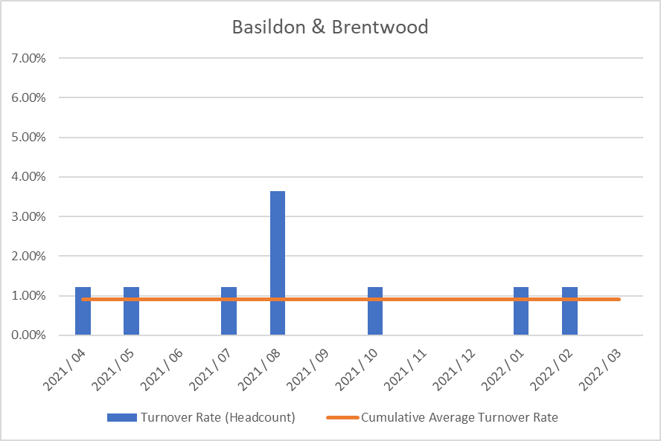

### Staff engagement

For the first year, all of the 5 CCGs in Mid and South Essex have participated in the NHS Staff Survey on a combined basis and the results have been presented across joint Directorates and teams. The CCGs chose Picker to run the survey and results were published nationally on 30th March.

The CCGs had an excellent response rate of 78%. Key themes have been shared with the CCGs Executive Team and they have been asked to work with their teams to write action plans in response to the staff survey results. In addition to this, the 5 CCGs formed a staff engagement group in January 2022 and this group is also developing an organisational action plan to look at key themes such as health and wellbeing and diversity and inclusion. This group has representation of staff from across the 5 CCGs and will be tasked with feeding into the organisational development work required as the CCGs transition into an ICB.

There are regular all-staff briefings across the 5 CCGs to communicate key messages around organisational change, as well as operational updates and regular updates on system priorities, for example Covid response updates.

There are also opportunities for staff to meet at a more local level through Alliance briefings as well as team briefings and regular one to one meetings with their manager.

### Staff policies

The CCG has given full and fair consideration to applications for employment made by disabled persons, having regard to their particular aptitudes and abilities.

The CCG has continued the employment of and arranged appropriate training for employees who have become disabled persons during their period of employment.

It is the policy of the CCG to ensure that any member of the CCG Board, its staff and its member practices are able to raise concerns about unlawful conduct, financial malpractice/fraud and risks to the environment and to patient care in line with legislation and good practice. This is covered under our whistleblowing policy.

**Health and Wellbeing**

The CCGs have benefitted from a comprehensive staff health and wellbeing offer through the Live Life Connected programme, which offers a vast array of health and wellbeing interventions, such as online talks around health topics, online exercise classes, mindfulness and gratitude practice.

In addition, there is also an employee assistance programme available to all staff which provides a telephone support line and counselling, as well as a comprehensive occupational health provision.

During the Covid pandemic, there have also been enhanced national, regional and local offers available to staff, including the regional mental health hubs and the Here For You service is available to all CCG employees.

The CCGs also have a trained network of mental health first aiders and have also provided bespoke Change and Resilience workshops for staff, as well as benefitting from ICS offers such as Kindness masterclasses.

The CCGs are committed to supporting disabled colleagues within the workplace through making reasonable adjustments as well as the use of regular risk assessments and also supporting colleagues’ mental health through the use of stress risk assessments and other support tools.

**Equality, Diversity and Inclusion**

The CCGs are committed to providing equal opportunities and to avoiding unlawful discrimination and the Recruitment and Selection Policy is designed to assist the CCGs in putting this commitment into practice. The policy is compliant with the Equality Act 2010 and sets out specific actions undertaken by the CCGs, in the context of employment and people management, in order to fulfil its Public Sector Equality Duty.

All CCG staff will be offered further equality, diversity and inclusion training as part of the transition into the ICB - the offering will include unconscious bias training, awareness of protected characteristics, allyship and also a complete review of policies, procedures and practices to eliminate bias. This will be offered in line with the recommendations of the No More Tick boxes report.

The CCGs will also be working with the Mid and South Essex Health and Care Partnership to develop an organisational and system response to the regional Anti Racism Strategy and this will be implemented through the Equality, Diversity and Inclusion Sub Group that is accountable to the Mid and South Essex People Board. In addition, an EDI dashboard is also in development for the MSE Partnerships, which the CCGs will feed into.

As the CCGs transition into an ICB, there will be single WRES and WDES reports and action plans that will be co-produced and regularly monitored to ensure progress against agreed objectives.

The CCGs will also participate in the MSE reciprocal mentoring programme through the NHS Leadership academy, a commitment that has been made by the Executive teams from across the system.

**Health and Safety**

The CCG’s Health and Safety Policy sets out our responsibilities and those of employees under the Health and Safety Work Act 1974. Health and safety, fire safety and manual handling are included in the mandatory training programme for all CCG staff.

Risk assessment and inspections identify health and safety issues to enable appropriate action to be taken to reduce risks to staff and other users of CCG premises. Although CCG staff have worked from home since the beginning of the pandemic, regular health and safety inspections, building system tests and maintenance continued throughout the year.

All CCG staff were asked to complete an individual risk assessment to identify their personal level of risk in relation to COVID-19. In addition, the CCG undertook a COVID-19 risk assessment of its premises and developed an associated procedure based on Government, NHS England and Health and Safety Executive guidance and advice from CCG Infection Prevention and Control staff, to ensure that the building was COVID-19 secure. These documents also received input from staff and union representatives. During the pandemic access to the CCG’s premises was restricted by application of a strict criteria and approval process. A number of CCG staff were redeployed to provider organisations to assist with the frontline response to COVID-19. Where this was the case, a formal cross-organisational agreement was in place to ensure that all health, safety and wellbeing needs of employees were met throughout their period of redeployment.

### Trade Union Facility Time Reporting Requirements

There was no Trade Union Facility Time in 2021/22.

### Expenditure on consultancy

The expenditure on consultancy was £124k during the course of the year.

### Off-payroll engagements

**Table 1: Off-payroll engagements longer than 6 months** see updated guidance Para 3.119 (k), and Chapter 3 Annex 4 – “Off-payroll” engagements Para 3.181 to 3.208  noting 3.194 to 3.200 and are *new*.

For all off-payroll engagements as at 31 March 2022 for more than £245* per day:

|  |  |
| --- | --- |
|  | Number |
| Number of existing engagements as of 31 March 2022 | 2 |
| Of which, the number that have existed: | |
| for less than one year at the time of reporting | 1 |
| for between one and two years at the time of reporting |  |
| for between 2 and 3 years at the time of reporting | 1 |
| for between 3 and 4 years at the time of reporting |  |
| for 4 or more years at the time of reporting |  |

*\*The £245 threshold is set to approximate the minimum point of the pay scale for a Senior Civil Servant.*

CCG to confirm that all existing off-payroll engagements have at some point been subject to a risk-based assessment as to whether assurance is required that the individual is paying the right amount of tax and, where necessary, that assurance has been sought.

**Table 2:** Off-payroll workers engaged at any point during the financial year

For all off-payroll engagements between 1 April 2021 and 31 March 2022, for more than £245(1) per day:

|  |  |
| --- | --- |
|  | Number |
| No. of temporary off-payroll workers engaged between 1 April 2021 and 31 March 2022 | 3 |
| Of which: | |
| No. not subject to off-payroll legislation(2) |  |
| No. subject to off-payroll legislation and determined as in-scope of IR35(2) |  |
| No. subject to off-payroll legislation and determined as out of scope of IR35(2) | 3 |
| the number of engagements reassessed for compliance or assurance purposes during the year |  |
| Of which: no. of engagements that saw a change to IR35 status following review |  |

*(1) The £245 threshold is set to approximate the minimum point of the pay scale for a Senior Civil Servant.*

*(2) A worker that provides their services through their own limited company or another type of intermediary to the client will be subject to off-payroll legislation and the Department must undertake an assessment to determine whether that worker is in-scope of Intermediaries legislation (IR35) or out-of-scope for tax purposes.*

**Table 3:** Off-payroll engagements / senior official engagements

For any off-payroll engagements of Board members and / or senior officials with significant financial responsibility, between 01 April 2021 and 31 March 2022:

|  |  |
| --- | --- |
| Number of off-payroll engagements of board members, and/or senior officers with significant financial responsibility, during the financial year (1) | 0 |
| Total no. of individuals on payroll and off-payroll that have been deemed “board members, and/or, senior officials with significant financial responsibility”, during the financial year. This figure should include both on payroll and off-payroll engagements. (2) | 24 |

*1There should only be a very small number of off-payroll engagements of board members and/or senior officials with significant financial responsibility, permitted only in exceptional circumstances and for no more than six months*

*2As both on payroll and off-payroll engagements are included in the total figure, no entries here should be blank or zero.*

In any cases where individuals are included within the first row of this table the CCG should set out:

* Details of the exceptional circumstances that led to each of these arrangements.
* Details of the length of time each of these exceptional engagements lasted.

### Exit packages, including special (non-contractual) payments

There have been no exit packages in 2021/22.

# Parliamentary Accountability and Audit Report

Basildon and Brentwood CCG is not required to produce a Parliamentary Accountability and Audit Report but has opted to include disclosures on remote contingent liabilities, losses and special payments, gifts, and fees and charges in this Accountability Report at page 117. An audit certificate and report is also included in this Annual Report at page 118.

# ANNUAL ACCOUNTS

I confirm that the annual accounts adhere to the reporting framework.



**Anthony McKeever**

Joint Accountable Officer, Mid and South Essex CCGs

Executive Lead, Mid and South Essex Health and Care Partnership

29 June 2022

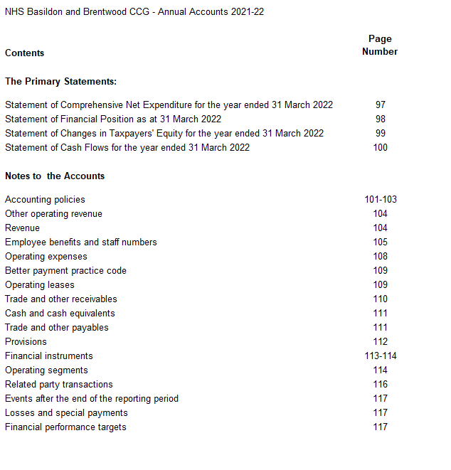

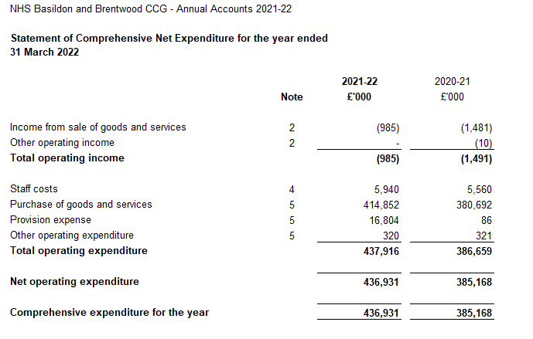

The notes on pages 101 to 117 form part of this statement

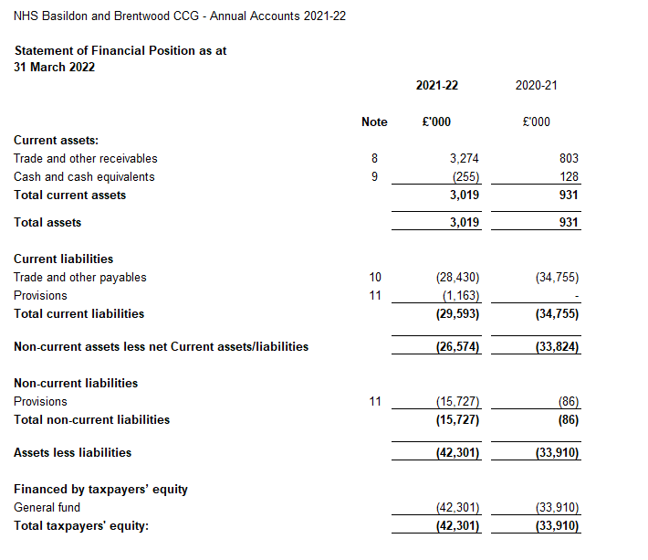

The notes on pages 101 to 117 form part of this statement.

The financial statements on pages 97 to 100 were approved by the Governing Body on 20 June

2022 and signed on its behalf by:



**Anthony McKeever**

Joint Accountable Officer, Mid and South Essex CCGs

Executive Lead, Mid and South Essex Health and Care Partnership

29 June 2022

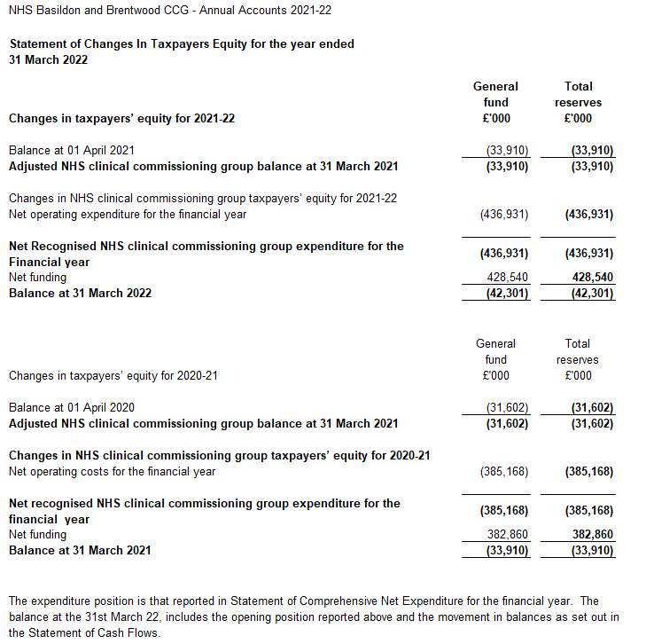

The notes on pages 101 to 117 form part of this statement

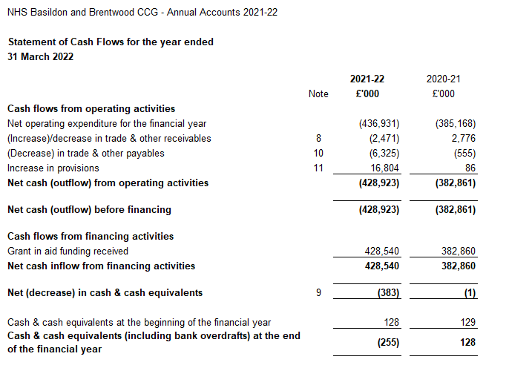

The notes on pages 101 to 117 form part of this statement

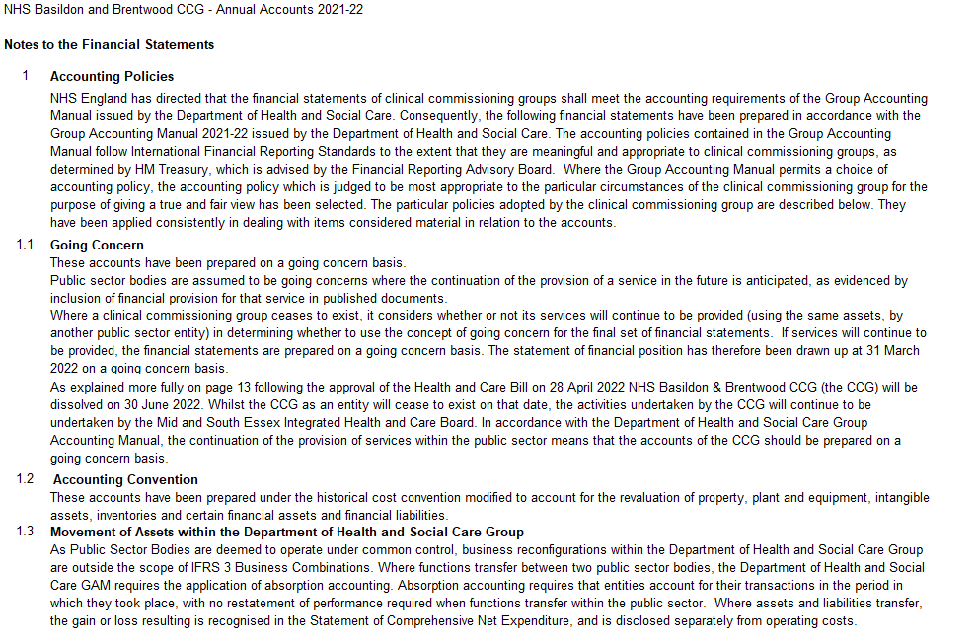 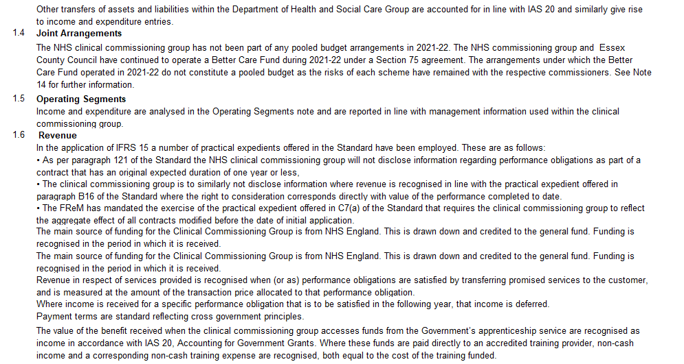 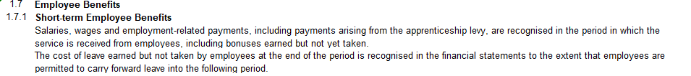 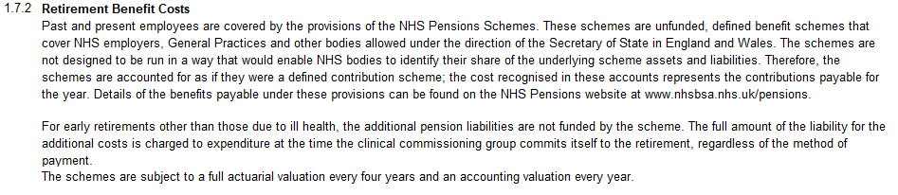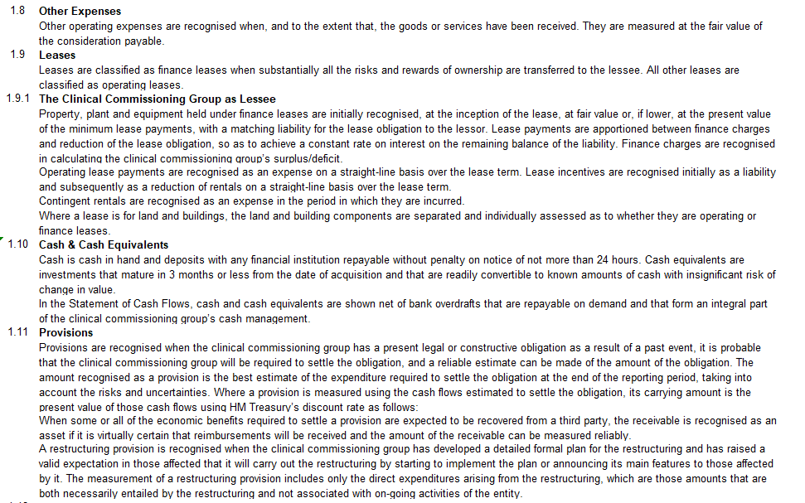 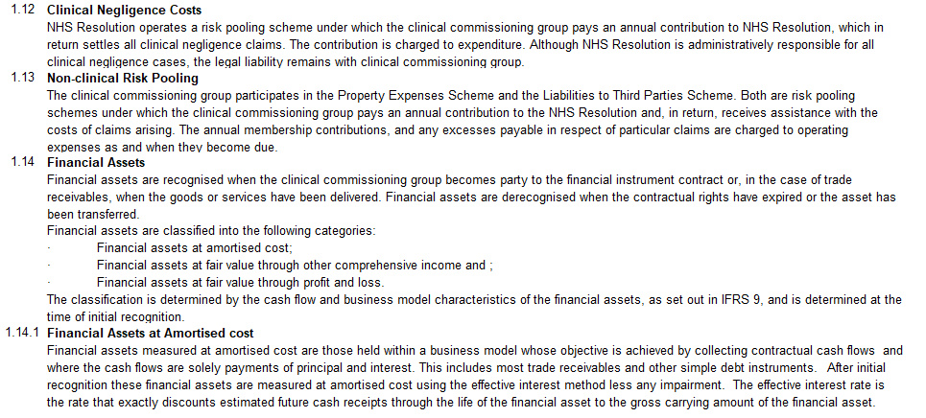 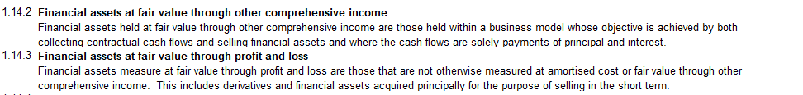

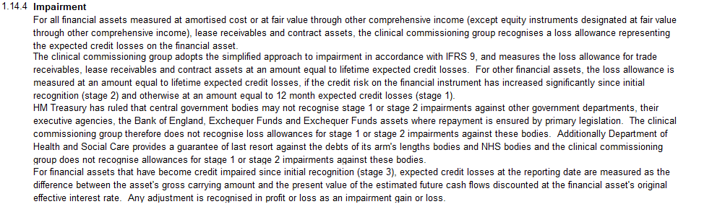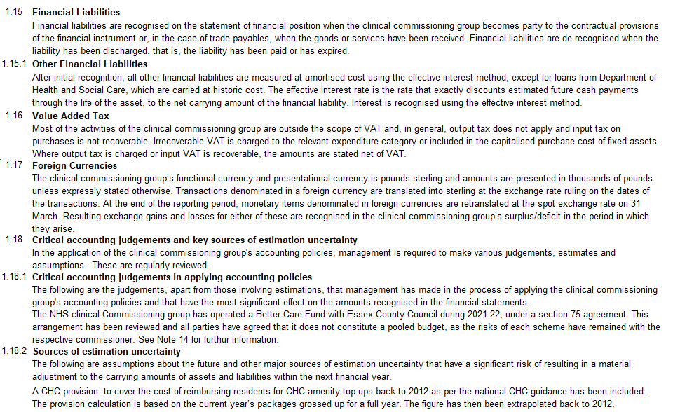 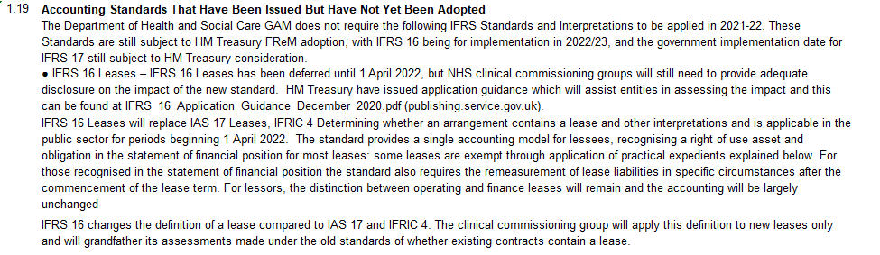 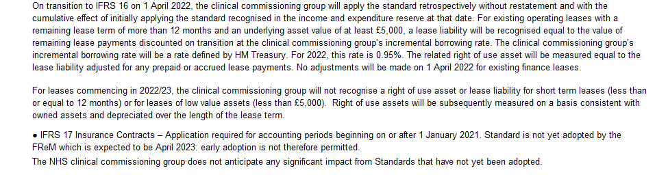

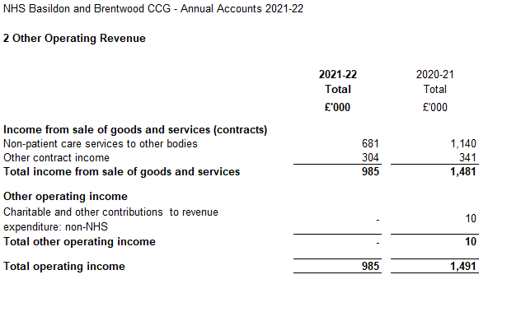 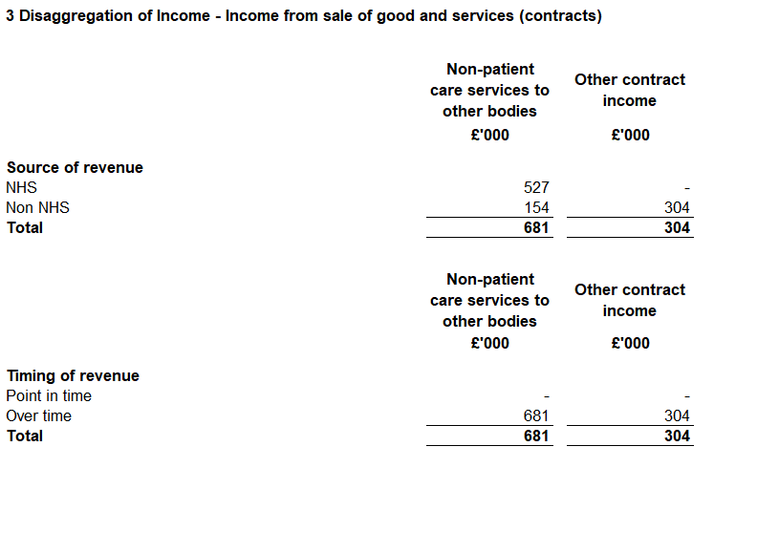

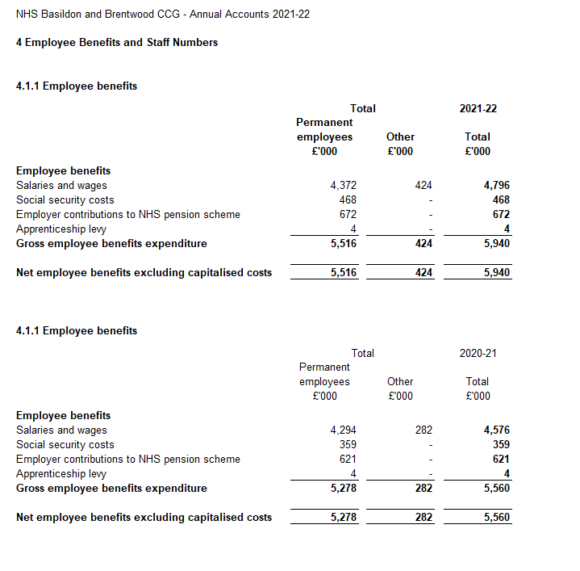

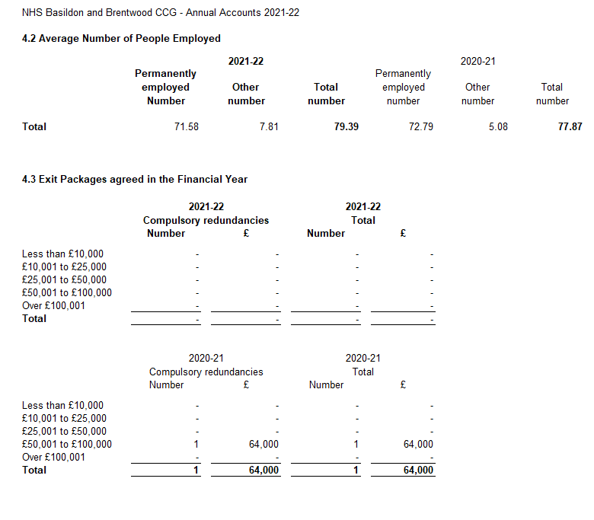

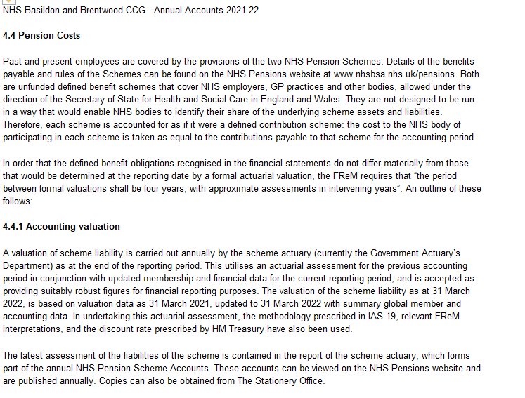 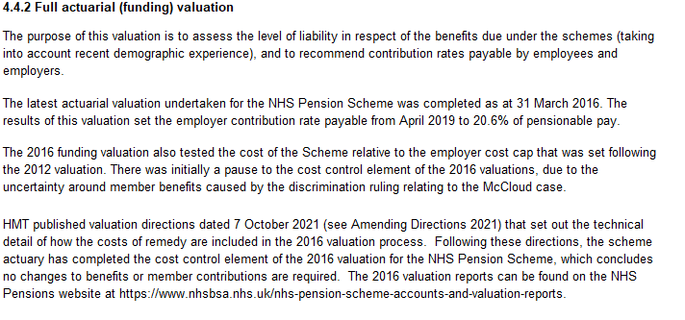

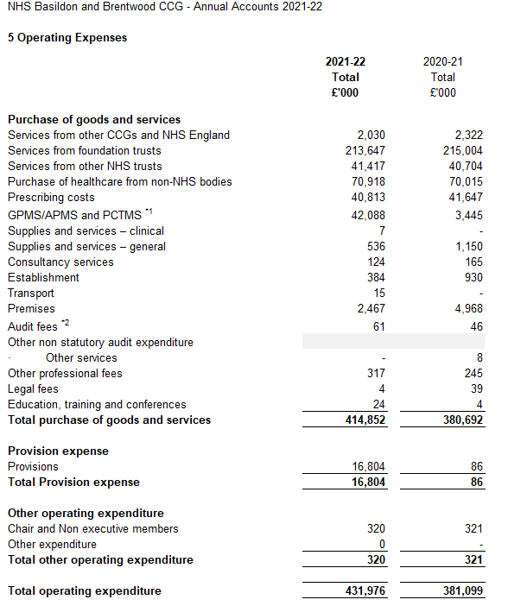

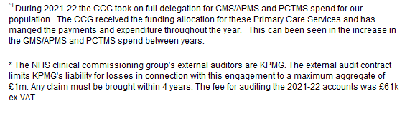

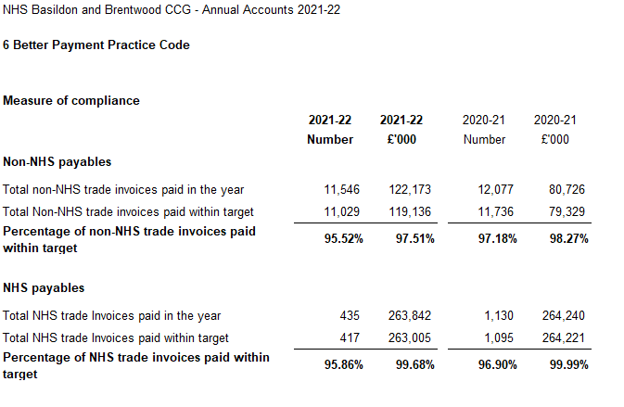 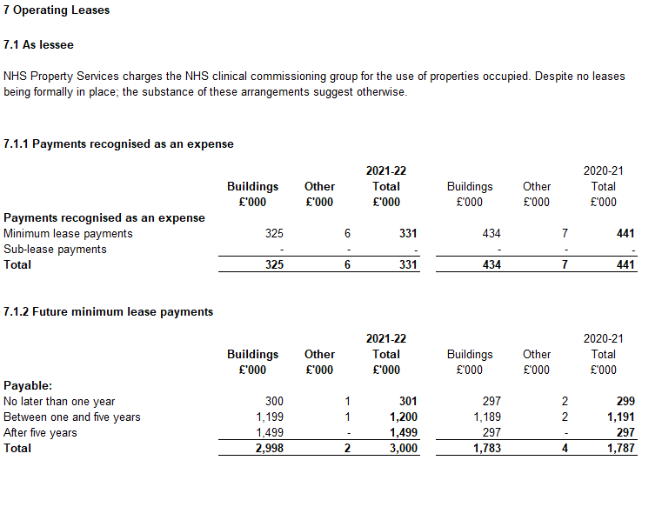

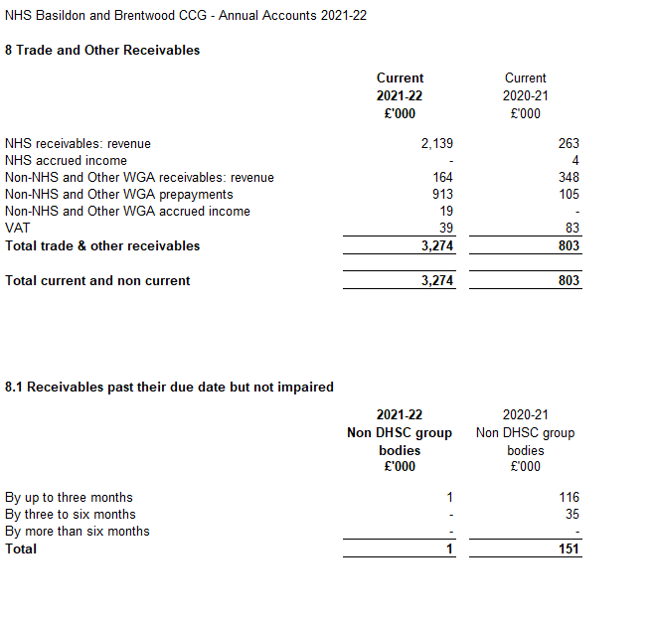

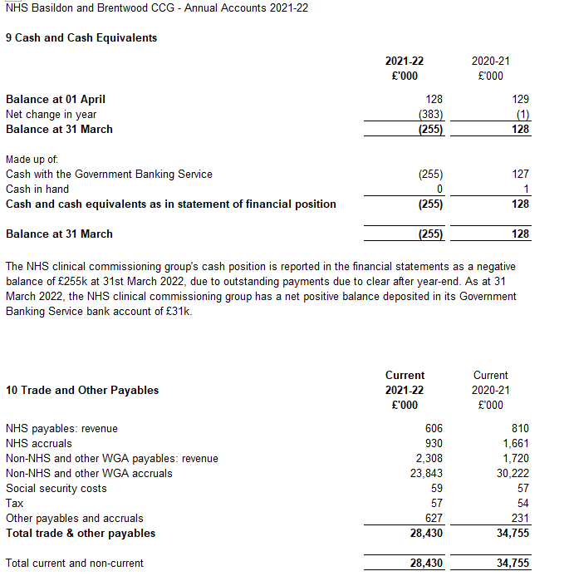 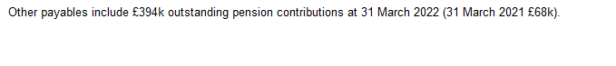

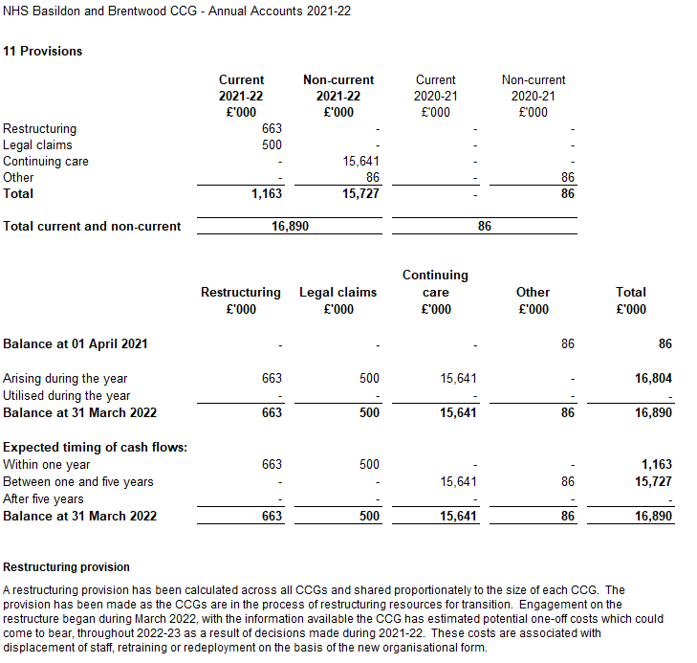 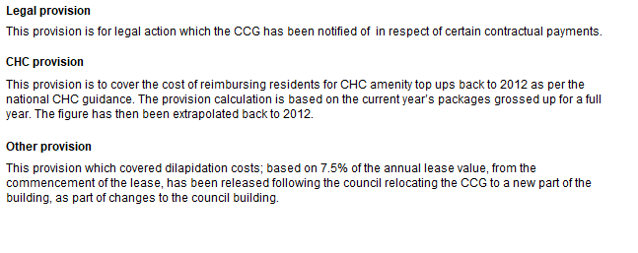

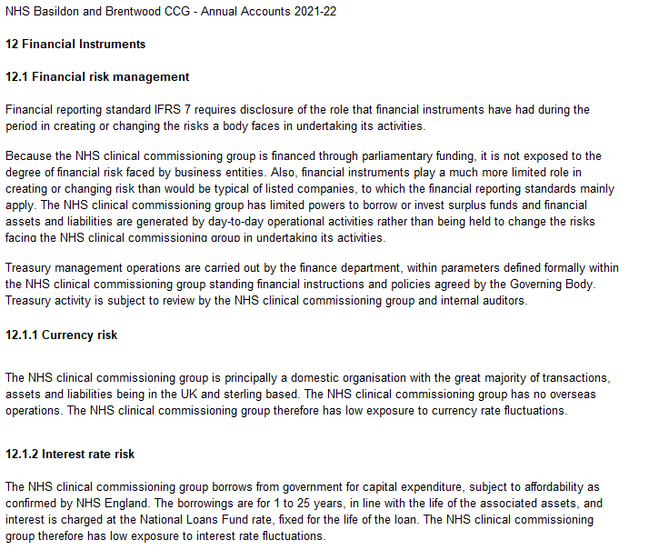 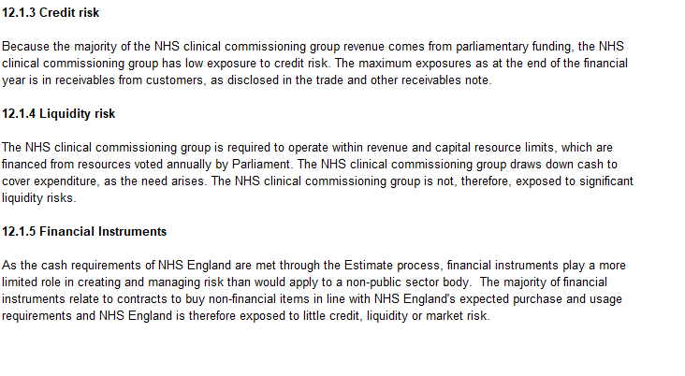

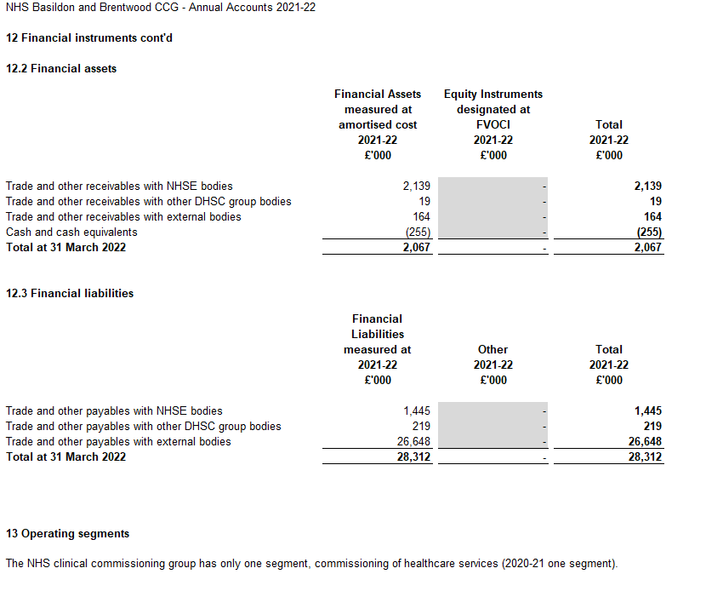

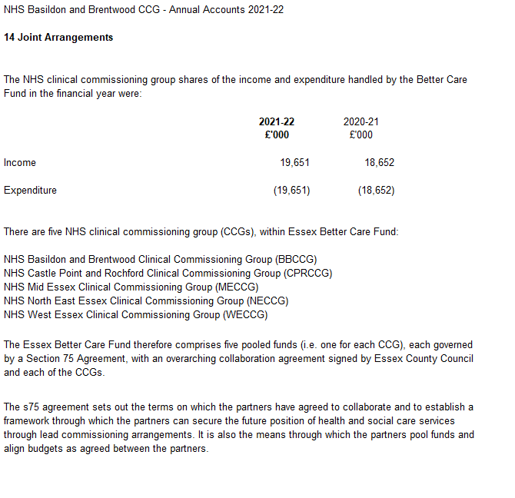

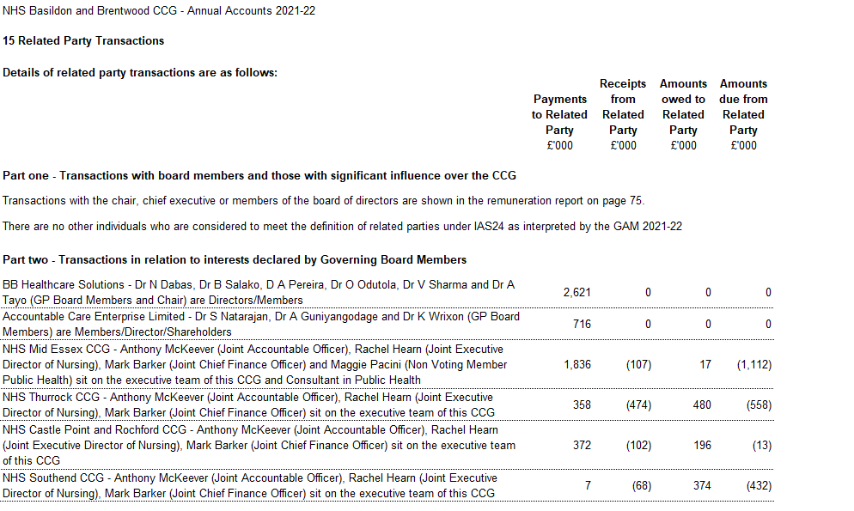 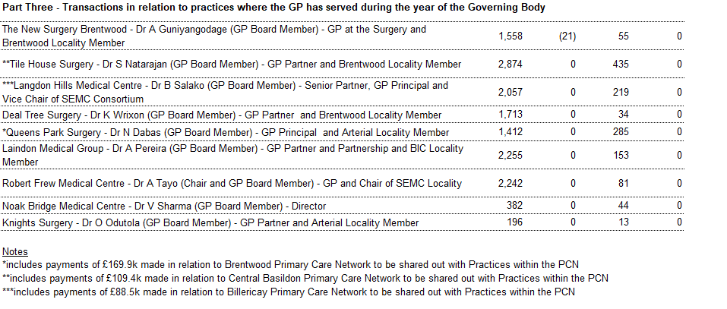 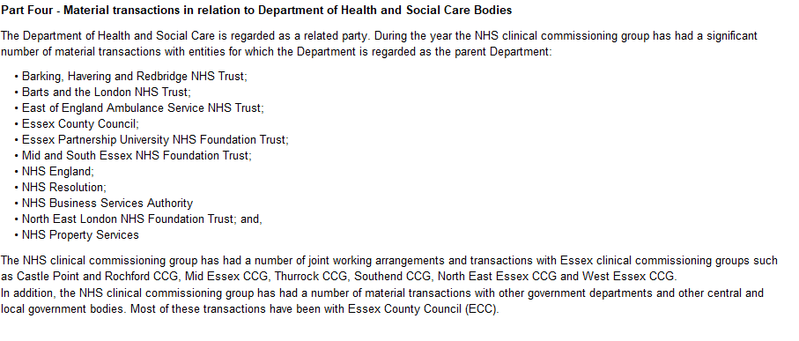

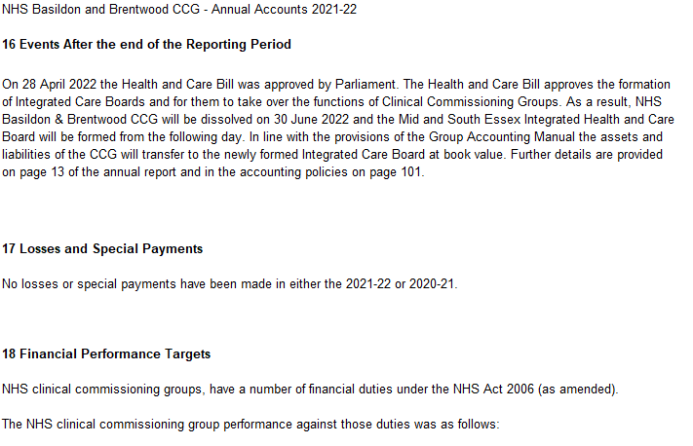 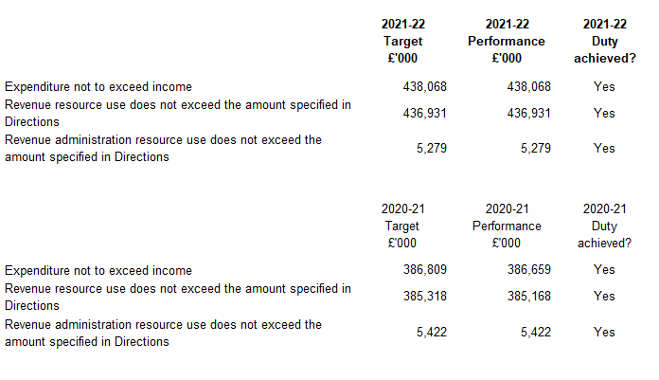

**INDEPENDENT AUDITOR’S REPORT TO THE MEMBERS OF THE GOVERNING BODY OF NHS BASILDON AND BRENTWOOD CLINICAL COMMISSIONING GROUP**

**REPORT ON THE AUDIT OF THE FINANCIAL STATEMENTS**

**Opinion**

We have audited the financial statements of NHS Basildon and Brentwood Clinical Commissioning Group (“the CCG”) for the year ended 31 March 2022 which comprise the Statement of Comprehensive Net Expenditure, Statement of Financial Position, Statement of Changes in Taxpayers’ Equity and Statement of Cash Flows, and the related notes, including the accounting policies in note 1.

In our opinion the financial statements:

* give a true and fair view of the state of the CCG’s affairs as at 31 March 2022 and of its income and expenditure for the year then ended; and
* have been properly prepared in accordance with the accounting policies directed by NHS England with the consent of the Secretary of State as being relevant to CCGs in England and included in the Department of Health and Social Care Group Accounting Manual 2021/22.

**Basis for opinion**

We conducted our audit in accordance with International Standards on Auditing (UK) (“ISAs (UK)”) and applicable law. Our responsibilities are described below. We have fulfilled our ethical responsibilities under, and are independent of the CCG in accordance with, UK ethical requirements including the FRC Ethical Standard. We believe that the audit evidence we have obtained is a sufficient and appropriate basis for our opinion.

**Emphasis of matter – going concern**

We draw attention to the disclosure made in note 1.1 to the financial statements which explains that on 1 July 2022, NHS Basildon and Brentwood CCG will be dissolved and its services transferred to Mid and South Essex Integrated Health and Care Board. Under the continuation of service principle, the financial statements of the CCG have been prepared on a going concern basis because its services will continue to be provided by the successor public sector entity. Our opinion is not modified in this respect.

**Going concern basis of preparation**

The Accountable Officer has prepared the financial statements on the going concern basis as they have not been informed by the relevant national body of the intention to dissolve the CCG without the transfer of its services to another public sector entity. They have also concluded that there are no material uncertainties that could have cast significant doubt over its ability to continue as a going concern for at least a year from the date of approval of the financial statements (“the going concern period”).

In our evaluation of the Accountable Officer’s conclusions, we considered the inherent risks to the CCG’s operating model and analysed how those risks might affect the CCG’s financial resources or ability to continue operations over the going concern period.

Our conclusions based on this work:

* we consider that the Accountable Officer’s use of the going concern basis of accounting in the preparation of the financial statements is appropriate;
* we have not identified, and concur with the Accountable Officer’s assessment that there is not, a material uncertainty related to events or conditions that, individually or collectively, may cast significant doubt on the CCG’s ability to continue as a going concern for the going concern period.

However, as we cannot predict all future events or conditions and as subsequent events may result in outcomes that are inconsistent with judgements that were reasonable at the time they were made, the above conclusions are not a guarantee that the CCG will continue in operation.

**Fraud and breaches of laws and regulations – ability to detect**

*Identifying and responding to risks of material misstatement due to fraud*

To identify risks of material misstatement due to fraud (“fraud risks”) we assessed events or conditions that could indicate an incentive or pressure to commit fraud or provide an opportunity to commit fraud. Our risk assessment procedures included:

* Enquiring of management, the Audit Committee and internal audit and inspection of policy documentation as to the CCG’s high-level policies and procedures to prevent and detect fraud, including the internal audit function, as well as whether they have knowledge of any actual, suspected or alleged fraud.
* Assessing the incentives for management to manipulate reported expenditure as a result of the need to achieve statutory targets delegated to the CCG by NHS England.
* Reading Governing Body and Audit Committee minutes.
* Using analytical procedures to identify any unusual or unexpected relationships.
* Reviewing the CCG’s accounting policies.

We communicated identified fraud risks throughout the audit team and remained alert to any indications of fraud throughout the audit.

As required by auditing standards, and taking into account possible pressures to meet delegated statutory resource limits, we performed procedures to address the risk of management override of controls, in particular the risk that CCG management may be in a position to make inappropriate accounting entries.

On this audit we did not identify a fraud risk related to revenue recognition because of the nature of funding provided to the CCG, which is transferred from NHS England and recognised through the Statement of Changes in Taxpayers’ Equity. However, in line with the guidance set out in Practice Note 10 Audit of Financial Statements of Public Sector Bodies in the United Kingdom we recognised a fraud risk related to expenditure recognition.

We did not identify any additional fraud risks.

We performed procedures including:

* Identifying journal entries to test based on risk criteria and comparing the identified entries to supporting documentation. These included journals where one side posts to cash and the other side posts to an unusual account, journals entries in period 12 where one side posts to expenditure and the other side posts to an unusual account, and Journals entries containing key words being: fraud, litigation, error
* Assessing the completeness of disclosed related party transactions and verifying they had been accurately recorded within the financial statements.
* Performing cut-off testing of expenditure in the period 1 March to 31 May 2022 to determine whether amounts had been recognised in the correct accounting period.

*Identifying and responding to risks of material misstatement related to non-compliance with laws and regulations*

We identified areas of laws and regulations that could reasonably be expected to have a material effect on the financial statements from our general sector experience and through discussion with the directors and other management (as required by auditing standards), and discussed with the directors and other management the policies and procedures regarding compliance with laws and regulations.

As the CCG is regulated, our assessment of risks involved gaining an understanding of the control environment including the entity’s procedures for complying with regulatory requirements.

We communicated identified laws and regulations throughout our team and remained alert to any indications of non-compliance throughout the audit.

The potential effect of these laws and regulations on the financial statements varies considerably.

The CCG is subject to laws and regulations that directly affect the financial statements including the National Health Service Act 2006 and financial reporting legislation. We assessed the extent of compliance with these laws and regulations as part of our procedures on the related financial statement items and our work on the regularity of expenditure incurred by the CCG in the year of account.

Whilst the CCG is subject to many other laws and regulations, we did not identify any others where the consequences of non-compliance alone could have a material effect on amounts or disclosures in the financial statements.

*Context of the ability of the audit to detect fraud or breaches of law or regulation*

Owing to the inherent limitations of an audit, there is an unavoidable risk that we may not have detected some material misstatements in the financial statements, even though we have properly planned and performed our audit in accordance with auditing standards. For example, the further removed non-compliance with laws and regulations is from the events and transactions reflected in the financial statements, the less likely the inherently limited procedures required by auditing standards would identify it.

In addition, as with any audit, there remained a higher risk of non-detection of fraud, as these may involve collusion, forgery, intentional omissions, misrepresentations, or the override of internal controls. Our audit procedures are designed to detect material misstatement. We are not responsible for preventing non-compliance or fraud and cannot be expected to detect non-compliance with all laws and regulations.

**Other information in the Annual Report**

The Accountable Officer is responsible for the other information presented in the Annual Report together with the financial statements. Our opinion on the financial statements does not cover the other information and, accordingly, we do not express an audit opinion or, except as explicitly stated below, any form of assurance conclusion thereon.

Our responsibility is to read the other information and, in doing so, consider whether, based on our financial statements audit work, the information therein is materially misstated or inconsistent with the financial statements or our audit knowledge. Based solely on that work:

* we have not identified material misstatements in the other information;
* in our opinion the other information included in the Annual Report for the financial year is consistent with the financial statements; and.
* in our opinion the other information has been prepared in accordance with the requirements of the Department of Health and Social Care Group Accounting Manual 2021/22.

***Annual Governance Statement***

We are required to report to you if the Annual Governance Statement has not been prepared in accordance with the requirements of the Department of Health and Social Care Group Accounting Manual 2021/22. We have nothing to report in this respect.

***Remuneration and Staff Reports***

In our opinion the parts of the Remuneration and Staff Reports subject to audit have been properly prepared in accordance with the Department of Health and Social Care Group Accounting Manual 2021/22.

**Accountable Officer’s responsibilities**

As explained more fully in the statement set out on page 61, the Accountable Officer is responsible for the preparation of financial statements that give a true and fair view. They are also responsible for such internal control as they determine is necessary to enable the preparation of financial statements that are free from material misstatement, whether due to fraud or error; assessing the CCG’s ability to continue as a going concern, disclosing, as applicable, matters related to going concern; and using the going concern basis of accounting unless they have been informed by the relevant national body of the intention to dissolve the CCG without the transfer of its services to another public sector entity.

**Auditor’s responsibilities**

Our objectives are to obtain reasonable assurance about whether the financial statements as a whole are free from material misstatement, whether due to fraud or error, and to issue our opinion in an auditor’s report. Reasonable assurance is a high level of assurance, but does not guarantee that an audit conducted in accordance with ISAs (UK) will always detect a material misstatement when it exists. Misstatements can arise from fraud or error and are considered material if, individually or in aggregate, they could reasonably be expected to influence the economic decisions of users taken on the basis of the financial statements.

A fuller description of our responsibilities is provided on the FRC’s website at [www.frc.org.uk/auditorsresponsibilities](http://www.frc.org.uk/auditorsresponsibilities)

**REPORT ON OTHER LEGAL AND REGULATORY MATTERS**

**Opinion on regularity**

We are required to report on the following matters under Section 25(1) of the Local Audit and Accountability Act 2014.

In our opinion, in all material respects, the expenditure and income recorded in the financial statements have been applied to the purposes intended by Parliament and the financial transactions conform to the authorities which govern them.

**Report on the CCG’s arrangements for securing economy, efficiency and effectiveness in its use of resources**

Under the Code of Audit Practice, we are required to report if we identify any significant weaknesses in the arrangements that have been made by the CCG to secure economy, efficiency and effectiveness in its use of resources.

We have nothing to report in this respect.

***Respective responsibilities in respect of our review of arrangements for securing economy, efficiency and effectiveness in the use of resources***

As explained more fully in the statement set out on page 61, the Accountable Officer is responsible for ensuring that the CCG exercises its functions effectively, efficiently and economically. We are required under section 21(1)(c) of the Local Audit and Accountability Act 2014 to be satisfied that the CCG has made proper arrangements for securing economy, efficiency and effectiveness in its use of resources.

We are not required to consider, nor have we considered, whether all aspects of the CCG’s arrangements for securing economy, efficiency and effectiveness in the use of resources are operating effectively.

We planned our work and undertook our review in accordance with the Code of Audit Practice and related statutory guidance, having regard to whether the CCG had proper arrangements in place to ensure financial sustainability, proper governance and to use information about costs and performance to improve the way it manages and delivers its services. Based on our risk assessment, we undertook such work as we considered necessary.

**Statutory reporting matters**

We are required by Schedule 2 to the Code of Audit Practice issued by the Comptroller and Auditor General (‘the Code of Audit Practice’) to report to you if we refer a matter to the Secretary of State and NHS England under section 30 of the Local Audit and Accountability Act 2014 because we have reason to believe that the CCG, or an officer of the CCG, is about to make, or has made, a decision which involves or would involve the body incurring unlawful expenditure, or is about to take, or has begun to take a course of action which, if followed to its conclusion, would be unlawful and likely to cause a loss or deficiency.

We have nothing to report in this respect.

**The purpose of our audit work and to whom we owe our responsibilities**

This report is made solely to the Members of the Governing Body of NHS Basildon and Brentwood CCG, as a body, in accordance with Part 5 of the Local Audit and Accountability Act 2014. Our audit work has been undertaken so that we might state to the Members of the Governing Body of the CCG, as a body, those matters we are required to state to them in an auditor’s report and for no other purpose. To the fullest extent permitted by law, we do not accept or assume responsibility to anyone other than the Members of the Governing Body, as a body, for our audit work, for this report or for the opinions we have formed.

**Certificate of completion of the audit**

We certify that we have completed the audit of the accounts of NHS Basildon and Brentwood CCG for the year ended 31 March 2022 in accordance with the requirements of the Local Audit and Accountability Act 2014 and the Code of Audit Practice.

Emma Larcombe

**for and on behalf of KPMG LLP,**

*Chartered Accountants*

Cambridge

30 June 2022