Thurrock Clinical Commissioning Group Annual Report 2021/22

Contents

Chair’s Foreword 4
PERFORMANCE REPORT 6
Accountable Officer’s Introduction 6
What Thurrock CCG does 8
Mid and South Essex Health and Care Partnership 10
Local Achievements 12
How we have performed 14
Performance analysis 16
Introduction 16
Performance summary 16
Improve Quality 19
Reducing Health Inequality 22
Engaging People and Communities 24
Health and Wellbeing Strategy 26
Financial Review 27
Risks 30
Sustainable Development 32
ACCOUNTABILITY REPORT 34
Corporate Governance Report 34
Members Report 34
Governance Statement 43
Thurrock Alliance 49
REMUNERATION AND STAFF REPORT 62
Remuneration Report 62
Staff Report 72
PARLIAMENTARY ACCOUNTABILITY AND AUDIT REPORT 79
ANNUAL ACCOUNTS 80

Chair’s Foreword
In what has been another challenging year for our teams right across the NHS I am proud that we have continued to provide safe and effective patient care. Working together for better lives, we have continued to build on collaborative working between our local authority, the CCG, community providers and voluntary organisations.

This foreword gives me an opportunity to say how proud I am of all my fellow health and care professionals in Thurrock and our wider colleagues who support us.

The ongoing vaccination programme continued to dominate our Covid response. I am pleased that the vast majority of people in our area have taken up the opportunity to receive their vaccine. it’s never too late to protect yourself if you haven’t yet had the jab
– there are plenty of opportunities to come forward, visit Essex Covid Vaccine (Hyperlinks)

I have been inspired by the work we have undertaken to support some of our seldom heard and more remote communities to receive their vaccine closer to home with the Essex Vax Van and mobile vaccination units. Working with public health and Essex Partnership University Trust, we were able to offer dozens of pop-up vaccine opportunities.

Every effort has also been made to continue providing routine healthcare to the population during the pandemic in a safe way. A robust plan is being developed and following national guidelines to significantly reduce the number people who are waiting for operations and treatments, as we move into the next year, the momentum on this will build. Working together, the Mid and South Essex Health and Care Partnership has also supported hundreds of people to receive timely care in their own home or care home. 2021/22 saw the launch of new virtual wards to reduce some of the pressure on our hospitals helping us continue some of our elective work.

During the last year we have seen a wider range of health and care professionals begin to work in our local GP practices. Professionals such as paramedics, physiotherapists, and mental health workers are now working within local Primary Care Networks to help meet the needs of our local communities.

We continue to utilise new technology in healthcare and our local residents were among the first as part of a national pilot to test out how people can improve their health outcomes through self-monitoring their blood pressure. To date across Essex, it is estimated that this has prevented 250 heart attacks and 375 strokes.

Place based acknowledgements

NHS Thurrock CCG has continued to improve and extend primary care services within our Primary Care Networks. This included providing extra face to face respiratory and spirometry provision within Thurrock Health Hubs, supporting people with Covid and other breathing problems to get the support they need. The winter access service supported Thurrock GP Practices with increasing demand among people presenting with respiratory, gastroenterology and any urgent on the day conditions, providing much

needed, same day face-to-face consultations for these conditions for patients in all age groups, including children.

In addition, the CCG was able to implement a new mental health pathway to support people with serious mental health within their local PCN, taking pressure off acute mental health services.

Thurrock’s Lung Health Check Programme has succeeded in inviting all 17,000 eligible cohorts and found 23 incidences of lung cancer. The programme will continue until 2024 and has had national recognition for the results it has achieved.

Work to on the Better Care Together Thurrock transformation programme did not stall, including the planning of the integrated medical centres for each locality in Thurrock. The first one will open in Corringham and Stanford Le Hope locality this coming financial year.

The Children’s Commissioner has worked tirelessly with Thurrock Council and partners to improve the quality of our special educational needs offer. The CQC has praised the team for the improvements made in the quality and stability of provision. The mental health in schools team continues to offer much needed support to children within a school environment and the neurodevelopment pathway has been strengthened to offer more care and support to children and families, read more about this in the report below.

As we move into the new financial year, I commend the teams working together to improve the lives of people in Thurrock and look forward to pushing forward together as an alliance with our local authority, trusts, community providers and wider community and voluntary sector.

Dr Anil Kallil

Chair, NHS Thurrock Clinical Commissioning Group 29 June 2022

PERFORMANCE REPORT

Performance Overview
The purpose of the performance report is to provide information on the CCG’s objectives for the 2021/22 financial year, the principal risks to their achievement and how the CCG performed against these objectives. This section provides a precis of the rest of the annual report and accounts.

Accountable Officer’s Introduction
It has been another extraordinary 12 months. Amid unprecedented world events, the NHS faced new COVID-19 variants and had to respond rapidly by expanding its vaccination programme. All aspects of the system continue to be under unprecedented pressure, whether in primary care, with both urgent demand and the support of patents with long term conditions, in our community services, who have stepped up to the challenge to deliver innovative ways of caring for more people in the community, our mental health services which are seeing a significant rise in demand and acuity of people accessing services, our acute hospitals, who are seeing rising demand on urgent and emergency care services which is affecting flow through the hospital and impacting on its ability to treat cancer and elective patients in a timely manner, our local authority partners, whose services are stretched in a challenging social care market and of course, our community and voluntary sector partners, without whom we could not have risen to the challenges that the Covid pandemic brought.

All this has made 2021/22 a very unsettling time.

Yet despite the pressures, our NHS and other institutions have generally succeeded in helping people get through these unique circumstances. When mid and south Essex residents looked for guidance or essential services, the NHS and its partners from the public and voluntary sectors stepped up, often in new and innovative ways. We were the trusted source of information and support.

Public services depend on trust. Every time the question of trusted professions comes up in Britain, doctors and nurses are near the top of the list. This shows the mutual confidence our residents and healthcare professionals have in one another and in the public services we all rely upon. During difficult times collaboration and confidence in one another can help us deal with difficulties and uncertain futures.

People have trusted the science behind new treatments and the support available from our institutions. In a similar way, our transition to an “integrated care system” – ICS for short – should also inspire confidence. As we restore more normal operations, the new ICS will build on the legacy of the five clinical commissioning groups to show that people’s best interests and improved health outcomes are at the heart of everything we do. Now and in the future.

As well as sharing what this CCG has achieved for [place name] residents through well- planned NHS services and partnership working, this document also reflects the seriousness with which we take our responsibilities as part of an ICS.

Strengthening relationships across the old CCG areas – what are now called “Alliances”
- is vital to better health outcomes and the reduction in health inequalities and just one example of the focus we are putting on that is the appointment of our first Head of Engagement. This role will focus on nurturing broadly based relationships with our public and partners, so we can design services, identify health outcomes and set standards together.

A part of this work, our “Moments that Matter” campaign, will showcase the best of what coordinated health and social care can do. It celebrates examples of professionalism and personalised care that have stood out for residents and colleagues. Anyone who has worked in or for one of our CCGs will understand how ‘little touches’ can sometimes make all the difference to those who look to the NHS for help.

As the passage of the Health Bill completes its final stages to create ICS’ on a statutory footing, we can all look to the exciting opportunities that this will bring for our residents. At the same time, it is right that we should mark the passing of a final and tumultuous full year for CCGs by noting the distinct contribution they have recently made in developing alliance-based services and Primary Care Networks of GP practices. That emphasis on delivering health and wellbeing services for and with residents at a local level will go from strength to strength.

So many people have contributed to the CCG’s success - to name them all here would be impossible. I would nevertheless like to pay tribute to CCG colleagues for the continued support they have shown one another and most importantly, to the 1.2m people we serve during these uniquely challenging times. CCG staff and Board members can be rightly proud of all that they have achieved and be assured that the lasting legacy of their work will be seen in the solid foundations they have laid for the ICS.

Anthony McKeever

Executive Lead for the Mid and South Essex Health and Care Partnership and Joint Accountable Officer for its five CCGs

29 June 2022

What Thurrock CCG does

Our Purpose

NHS Thurrock CCG, established on 1 April 2013, is responsible for commissioning (buying) healthcare services to meet the needs of residents in Thurrock (a GP registered population of circa 184k at 31 March 2022), which includes acute care, community services, mental health and some specialist services. NHS England (NHSE) commissioned the majority of primary care services throughout the year, but from 1 April 2021 NHS Thurrock CCG were delegated the authority to commission GP services on behalf of NHS England, who continue to commission services such as dentists, pharmacists and ophthalmology.

The CCG is a membership organisation formed of 27 GP member practices, who are grouped into four Primary Care Networks.

Services are commissioned through detailed analysis of health needs in conjunction with public health; defined within the Joint Strategic Needs Assessment (JSNA) that informs which services the CCG purchases within a defined financial framework.
Contracts are negotiated and agreed with providers by the CCG or by other CCGs, the acute/joint commissioning teams in the Mid and South Essex Health and Care Partnership, or appropriate bodies such as the local authority.

The commissioning process is clinically led through the CCG governing body and informed by engagement with key stakeholders, patients and the local community, which fulfils the CCG’s statutory duty to inform and involve patients. Once contracts have been established with providers, it is the responsibility of the CCG to ensure that the services delivered are ‘fit for purpose’ and meet adequate and appropriate quality and safety standards. This is delivered by monitoring and managing contracts.

The main acute provider for Thurrock residents is the Mid and South Essex NHS Foundation Trust (MSEFT) providing hospital services from Basildon, Southend and Broomfield Hospitals, which is commissioned by the mid and south Essex CCGs Joint Commissioning Committee acute commissioning team who are also responsible for managing contracts with the East of England Ambulance Service NHS Trust (EEAST).

Essex Partnership University NHS Foundation Trust (EPUT) are the main provider of mental health services and the CCG, from 1 February 2018, became the lead commissioner for these services on behalf of the five mid and south Essex CCGs.

Community services are provided by both EPUT and the North East London NHS Foundation Trust (NELFT).

The vision of the CCG is that the health and care experience for the people of Thurrock will be improved as a result of working together. To achieve this vision, the CCG designs services within available resources around the agreed needs of people and by working collaboratively with partner organisations.

Our governing body is made up of eight representatives of general practice (GPs) from across Thurrock along with a Joint Accountable Officer, Joint Chief Finance Officer,

Executive Director of Nursing, Thurrock NHS Alliance Director, secondary care (hospital) specialist, two Lay Members and Practice Manager.

NHS Thurrock CCG – facts and figures
CCG Headquarters | Civic Offices, 2nd floor, New Road, Grays RM17 6SL
Communities covered | Borough of Thurrock
Population (registered with a GP) at 1 April 2022 | 184,541 (as at 1 April 2022)
Number of member GP practices at 31 March 2022 | 27 (with approx. 68 WTE GPs)
Budget (2021/22) | £279.9m
Average number of employees | 58 staff, 53.75 whole time equivalent (WTE)

Our Strategy
The MSE Health & Care Partnership developed its five-year strategy in December 2019. The strategy outlines 4 key ambitions, with the underpinning aim to reduce health inequalities. The strategy outlines that we would achieve this through:

  - Creating opportunity for our residents – supporting education, employment and socio-economic improvements for our residents. We have developed this ambition further - for example, extending the successful work led by MSEFT on hospitals as Anchor institutions, and achieving agreement to a system-wide Anchor Charter in 2021.

  - Supporting health and wellbeing – including a focus on prevention, self-care, lifestyle support. We have undertaken much work in this area – particularly through the Covid pandemic, where we were able to use targeted engagement techniques to link with different communities, understanding their needs and barriers to accessing care, vaccinations and so on. We have also continued to work in partnership to target prevention opportunities and we have agreed with public health colleagues to focus particularly on obesity in the coming months.

  - Bringing Care Closer to Home – where this is safe and possible. Again, we have seen many examples of this, with our Covid vaccination van that has now been transformed to a “long-Covid van”, taking assessment and testing to our communities. We are progressing with the integrated medical centres in Thurrock, again as a new model of care to bring services closer to home.

  - Improving and Transforming our Services – we know that our services are under considerable pressure and we are not providing the level or quality of service that we would like. There are several transformation programmes progressing, underpinned by system working on workforce, digital, and finance to bring improvements in primary care, cancer care, elective recovery, urgent care,

community diagnostics, flow through the system and care arrangements. Our Stewardship programme will be key in our future approach to service improvement and transformation.

While the strategy was set in the pre-Covid era, we consider that the key ambitions have stood the test of time and have underpinned our partnership working during the pandemic.

We will therefore take the five-year strategy into the new ICS and use the early period of the Integrated Care Partnership (ICP) formation to begin work to develop the Integrated Care Strategy – taking our local authority Joint Strategic Needs Assessments (JSNAs) and health and wellbeing strategies to develop a single strategy for Mid & South Essex.

A joint strategic needs assessment (JSNA) looks at the current and future health and care needs of local populations to inform planning and commissioning of health, well- being and social care services. They are often, but not always, lead by the local authority(ies) of an area but do require participation from all appropriate partners to:

- Collect, analyse and interpret health and care needs information.
- Participate in engagement work between partners or with the population.
- Follow up and implement recommendations.

As a partner in the provision of health and care services to the population PCNs will be expected to fully participate and help shape, where appropriate, in the production of these needs assessments.

The plan for achieving this, by April 2023, will be agreed with the ICP once it is formed. We have been clear that we want the hallmarks of our ICS to be:
  - Evidence and data driven.
  - Have a true partnership with our communities and use their lived experience and insight to help us shape our work.

  - Ensure clinical and care professionals are leading strategy formation and supporting decision-making.

Mid and South Essex Health and Care Partnership

Key activities in 2021/22 and progress towards establishment of an ICB/ICP

During 2021/22 the system has progressed towards establishment of the ICS by:

  - Submitting a successful application to be formally designated as an Integrated Care System.

  - Refreshing our primary care strategy and established PCN support programmes.

  - Further establishing our population health management capacity and engaging with a national Population Health Management (PHM) programme to support turning data into intelligence to design interventions through our PCNs.

  - Our four Alliances have agreed their initial delivery plans to support their local populations, working in partnership with local authority, Healthwatch and community and voluntary sector organisations.

  - Developing a data and digital roadmap to transform our digital and data capacity and capability – and we have employed a Chief Digital Information Officer to enable the ICS to move forward on this important work that will underpin everything we do.

  - Agreeing an engagement strategy that defines how we will gain and use insight from our communities in the work that we do.

  - Launching the Citizens’ Panel, of 1500 residents, with whom we share ideas and obtain insights to help us design services appropriately.

  - Developing and agreeing a system wide quality strategy, bringing together all aspects of the health system.

  - Further developing our system finance approach through the System Finance Leaders Group.

  - Embedding joint accountability and assurance through our System Oversight and Assurance Group, co-chaired by the Accountable Officer and the Regional Director for Strategy and Transformation – and further developing our embedded assurance model with NHSE colleagues so as to reduce traditional transactional assurance processes between the system and NHSE.

  - Developing a new approach to clinical and professional leadership, including introducing a new clinical and professional congress to support the ICS to ensure the expertise of clinicians and care professionals is at the heart of our work.

  - Launching MSE Partners as a means to supporting innovation and improvement.

Establishing the ICS

In terms of preparing for forthcoming legislation to form the ICS on a statutory footing (which has a national target date of 1 July 2022), we have introduced an ICS Transition Programme Board with seven workstreams to manage and oversee the technical aspects for development of the ICS including the disestablishment of CCGs and the commencement of the new Integrated Care Board (ICB) as an organisation. The work streams are:

  - Quality and safety
  - Finance and resources
  - Governance and accountability

  - Data and digital
  - Communications and engagement
  - Workforce
  - Future system operating model

Integrated Care Board

The ICB will take on all of the functions of current CCGs and, over time, some commissioning functions from NHSE. It will be responsible for the system’s entire NHS finance allocation and will take responsibility for workforce, digital, data and engagement.

Anthony McKeever has been appointed as the Chief Executive Officer (CEO) designate of the new ICB and Professor Mike Thorne CBE, has been appointed as Chair designate of the ICB. Non-executive members for the new ICB Board have been appointed and remaining appointments to the executive team are being finalised.

The Transition Programme Board has overseen the due diligence requirements to establish the ICB and will complete a “Readiness to Operate” statement to enable NHSE to formally establish the new organisation.

Integrated Care Partnership

The ICP will be a joint and equal partnership between the NHS and our upper tier local authorities. Together, we have agreed that the ICP will be chaired by Professor Thorne so as to ensure consistency and coherence across the ICS, with the three health and wellbeing board chairs of our upper tier local authorities acting as vice chairs for the ICP. We have agreed membership of the ICP, and we are currently progressing discussions to agree its work programme. The first task of the ICP will be to develop a new Integrated Care Strategy for the ICS, and for the population of Mid & South Essex.

Local Achievements
Thurrock CCG has worked tirelessly through the ups and downs of the pandemic to ensure it meets its statutory duties and goes further in supporting residents with their health, mental health and wellbeing needs. Below are some of the highlights of the CCG’s work that has also included maturing the place-based Alliance conversation to a stage where we are now formalising governance structures to be business ready from 1st August 2022.

Primary Care Delegation

From April 2021, Thurrock CCG has taken on Primary Care delegation for its 27 practices and 4 Primary Care Networks. This will help us to plan, support and shape future primary care services in Thurrock in a way that will benefit patients. NHS England (NHSE) continues to commission services such as Dentists, Pharmacists and Ophthalmology.

Cloud based telephony

The CCG has supported an accelerated upgrade for telephony systems, piloting an innovative project incorporating a cloud-based telephony system on a PCN footprint - run by staff specialising in care navigation. This improves access to support for patients with minor health concerns and frees up individual practice phone lines. It is envisaged additional functionality such as direct booking for same day face to face appointments via community pharmacies could be added to this service during the pilot phase.

Serious Mental Illness Health Checks

Thurrock has historically had a low uptake for SMI Health Checks, during 2021/22 dedicated Mental Health practitioners were introduced into PCNs, this resulted in 58.9% of SMI health checks being completed against the national target of 60%. This is the highest rate of health checks completed for Thurrock over the last 3 years.

Learning Disability (LD) Health Checks

During 2021/22, Thurrock practices exceeded the national LD Health Check target of 80%, carrying out 83.6% of LD Health Checks for eligible patients. Thurrock has also been identified as achieving the highest LD Health Checks within mid and south Essex during this year.

COVID vaccinations

This continued to be a focus throughout 2021/2022 with first, second and booster doses offered via a variety of options, including through two local vaccination sites (GP led), through community outreach/mobile clinics, picking up the hard to reach, including minority ethnic and showman communities. Further work continues to improve uptake following Thurrock Council’s UK Health Security Agency’s Surge Rapid Response Team (SRRT) and the CCG is supporting their vaccine outreach to continue to increase vaccine uptake in specific areas and certain communities. A dedicated local vaccine website was set up to support better access to information across greater Essex at www.essexcovidvaccine.nhs.uk.

Thurrock Lung Health Checks

Thurrock and Luton CCGs were selected as part of a national programme to detect lung cancers at earlier stages, resulting in better outcomes for all involved. Targeted lung health checks are an important part of our overall strategy to reduce deaths from lung disease in Thurrock. The programme started in 2020 and was paused during COVID but restarted fully in April 2021 and will run until April 2024.

At the end of 2021/22, 5,7754 Lung Health Checks have been completed, 2,851 low dose CT scans carried out and 24 lung cancers found, 13 of which were either stage 1 or 2.

Long term conditions support via GP practices

BP@Home, Diabetes Three Treatment Improvement Targets (3TT) Project, ACR Testing at Home Programme, Skin Analytics, tele-dermatology pilot and community COPD Asthma Diagnostic Services were all launched in this financial year. These

programmes are designed to support people with common long-term conditions and pick up conditions early so treatment can start as soon as possible. They also avoid unnecessary admissions/attendances at hospital.

Many of these programmes of work involve the use of apps and technology and are replicated across practices in mid and south Essex, resulting in significant improvements in patient outcomes.

Funding has been made available for Thurrock to improve the management of patients with diabetes. The project (3TT) began in September 2021, with 90% of practices signed up. During this period, there has been an increase of 49% of the number of patients screened, equalling 842 additional patients screened. A significant improvement in patients has been recorded. 3TT will continue into 2022/23 with 100% practices signed up to the programme.

GP referrals for the National Diabetes Prevention Programme (NDPP) within Thurrock area at 153% of the profile target to date. During 2021/22 GPs have made 1,301 referrals against a target of 855. Thurrock has also achieved 95% uptake of patient sign up and engagement with the programme. Thurrock is the best performing CCG across Mid and South Essex for NDPP.

Aerosol Generating Procedures (AGP)
During the COVID-19 pandemic AGPs were suspended in line with guidelines. Dur to the gap in service provision and an unmet need, Thurrock commissioned Microsuction services through all 4 PCNs and a spirometry respiratory service through a Primary Care provider for the population of Thurrock during 2021/22.

Winter Access Service

Implemented in December 2021, this service provided extra capacity and appointments in general practice, supporting with pressures during the Omicron wave. 14,000 additional face to face appointments were created and delivered through the Winter Extended Health Hubs.

Self-Management Apps

The CCG has continued to fund tools for patients on the My mHealth platforms, including myDiabetes, myCOPD, myAsthma enabling greater monitoring for patients and health professionals. In Thurrock over 1000 licences have been activated for these apps.

How we have performed
The CCG monitors health outcomes against a range of NHS Constitutional Standards’ that are set nationally. Performance across the system has generally been below the set standards due to capacity pressures throughout the health and care system.

The CCG is working with local providers of services and NHS England/Improvement (which is the regulatory organisation for the CCG and providers of services) to agree the system transformation required to support improvements in care for patients.

As seen nationally, performance against the standards has been directly impacted by the Covid-19 pandemic. A key issue experienced nationally is the increase in patients waiting for planned elective care during the Covid-19 pandemic. As directed through national guidance whilst capacity was reduced, non-urgent diagnostic tests together with elective planned appointments and procedures were paused to prioritise emergency, urgent and cancer work.

A key risk that could affect the delivery of future performance and recovery is ensuring workforce is in place to meet the delivery of the increased capacity required to recover from the Covid-19 pandemic and meet demand. Key issues and risks

The Covid-19 pandemic had a significant impact upon the operation of NHS services across the country, which brought with it several associated risks, firstly in relation to the effects of the virus itself and secondly in relation to the effects that management of the pandemic has had on core services and the achievement of constitutional standards.

The former has been managed well during the year, which is reflected in the lowering of risk in relation to the effects of the virus as a result of the success of the Covid-19 vaccination programme and greater understanding of how to care for patients with the virus. The mid and south Essex CCGs continue to manage the impact of risks on core services, focusing on restoring performance back to pre-Covid levels.

Further information on the CCG’s key risks and risk profile is provided in the Risks section of the Performance Analysis report.

Performance analysis

Introduction
Measuring our performance against a range of indicators, including nationally agreed quality standards, is important for our patients and the public as they relate to key areas such as access, treatment times and quality of care. Performance against these targets, and the plans we have to improve them, is overseen by the Finance and Performance Committee.

2021/22 has, as outlined within this report, provided challenges to delivery and recovery of performance standards. The below summary shows the performance as reported in March 2022, this is the most up to date information at time of writing this report.

Mid and South Essex continues to work collaboratively with our provider partners to support recovery of performance standards and outcomes for our population. This work is ongoing and continues into 2022/23.

Performance summary
The following is an overview of how the system has performed against the constitutional standards.

NHS Constitution – Urgent and Emergency Care (UEC)

For UEC the NHS constitution includes standards for both Ambulance Response Times and Emergency Department (ED) waiting times.

Ambulance response times are significantly challenged as per following Mean and 90th centile summary by call category against the standards (format: hh:mm:ss) for 2021/22:

  - One calls - for life-threatening injuries and illness:
    - Mean: 00:10:57 (standard <=7min)
    - 90th Centile: 00:19:04 (standard <= 15min)
  - Two calls - for emergencies:
    - Mean: 01:00:43 (standard <= 18min)
    - 90th Centile: 02:10:50 (standard <= 40min)
  - Three calls - for urgent:
    - 90th Centile: 08:49:47 (standard <= 2 hours)
  - Four calls - for less urgent:
    - 90th Centile: 06:39:04 (standard <= 3 hours)
ED waiting times are also challenged. For Mid and South Essex NHS Foundation Trust (MSEFT), 77.6% of patients arriving within A&E were seen, treated, and discharged, or admitted to a ward with four hours of arrival (below standard of >= 95%) during 2021/22.

As a system the CCG are working with all partners including MSEFT, Community providers, Local Authorities and EEAST to improve response times and ED waiting times.

All partners are members of the Strategic Partnership Urgent and Emergency Care Board for oversight and input into the improvement of the system UEC performance. Daily operational calls (Daily Tactical Care call) are in place with system partners, ensuring plans are in place or reviewed to mitigate presenting pressures across the system.

Mid and South Essex system through collaborative working between partner organisations are working on several initiatives to improve ambulance offload times (for conveyed patients) and flow through ED.

Community providers are supporting for example, through the Urgent Community Response Team (UCRT) team working with EEAST to, where appropriate, provide an alternative to conveying patients to acute hospital. The Virtual Wards work is continuing to be developed to support admission and reduce the need for conveyance of frail elderly patients where more appropriate.

Another example of collaborative working between partner organisations is EEAST Hospital Ambulance Liaison Officer (HALO) work within MSEFT Emergency Departments (ED) to facilitate the triaging and handover of patients arriving via ambulance to release EEAST staff.

To facilitate optimal flow through the hospital, Local Authorities ensure continued support for timely discharges from the acute.

NHS Constitution – Diagnostics
As seen nationally during the COVID-19 pandemic, waiting times for diagnostic tests or procedures has increased significantly with a large increase in the number of patients waiting over six weeks and 13 weeks.
During 2021/22, 68% of patients waited less than six weeks (below standard of >= 99%)
with circa 14% of patients waiting over 13 weeks (below standard of zero) at MSEFT.

NHS Constitution – Cancer waiting times

As seen nationally during the COVID-19 pandemic, demand in terms of the number of two week wait (2WW) referrals decreased significantly and now, as expected demand on cancer services particularly the 2ww referrals is increasing as the country comes out of the pandemic.

For Mid and South Essex NHS Foundation Trust (MSEFT), during 2021/22:

  - 69.8% of patients were seen by a specialist within 2 weeks of being booked on a 2WW pathway (below standard of >= 93%).

  - 68.8% of patients were informed within 28 days whether they have cancer or not (below standard of >= 75%).

  - 85.7% of patients started first definitive treatment for a new primary cancer within 31 days of the decision to treat (below standard of >= 96%).

  - 55.3% of patients started first definitive treatment of cancer from receipt of urgent referral for suspected cancer within 62 days (below standard of >= 85%).

Delivery of the 62-day performance continues to be the most challenged cancer standard.

The CCG is working with MSEFT and Cancer Alliance through plans to transform the diagnosis, treatment, and care for cancer patients to recover performance for the local population.

NHS Constitution – Planned Care
As seen nationally during the COVID-19 pandemic, waiting times from referral to first definitive consultant led elective (non-urgent) treatment (RTT) has increased significantly with a large increase in the number of patients waiting over 18 and 52 weeks.
During 2021/22, 34.5% of patients waited less than 18 weeks (below standard of >= 92%) with circa 4% of patients waiting over 52 weeks (below standard of zero) at MSEFT.

Mid and South Essex system through collaborative working between partner organisations including MSEFT, Independent Sector Providers, Community Providers and primary care are working together to ease pressure at the acute trust, ensuring patients with 2ww or urgent referral are prioritised, and available capacity is maximised across the system.

Community providers are working with MSEFT to, where appropriate, provide an alternative place for treatment to waiting and being treated at MSEFT. Local Independent Sector providers are providing additional system capacity for patients waiting at MSEFT facilitated by commissioners and MSEFT. Primary care is supporting with demand management/referral diversion plans.

NHS Constitution – Improving Access to Psychological Therapies (IAPT) and waiting times

The number of people accessing psychological therapies is below target during
2021/22.

The waiting list for IAPT service is meeting the six and 18 week standards for receiving first treatment as follows:

  - 99% of patients received first treatment within six weeks (above standard of >=75%)
  - 99.8% of patients received first treatment within 18 weeks (above standard of >= 95%)

Of the people who complete treatment, 46% moved into recovery (above the standard of >= 50%).

NHS Constitution – Psychosis waiting times.
During 2021/22, 72% of people experiencing first episode psychosis started treatment, with NICE recommended package of care, within two weeks from referral (above the standard of >= 60%).

Severe Mental Illness (SMI) Health Checks.

Circa 1,300 people are living with Severe Mental Illness (SMI) within the CCG population. As at March 2022, 48.9% of people living with SMI have received their full physical health assessments (below standard of >= 60%).

The CCG is working closely with primary care GP Practices to increase coverage of people living with SMI receiving their health checks ensuring the 60% standard is met during 2022.

NHS Constitution – Children and Young People access to mental health services and eating disorders treatment waiting times.

The number of Children and Young People accessing Mental Health Services is above national trajectory of 35% at 38.1% (as at January 2022).

NHS Constitution – Dementia.

The standard is for the number of people on the dementia GP Practice register to be at least 66.7% of the estimated prevalence. The CCG register is at 67.6% (as at March 2022). The CCG is working closely with primary care GP practices to encourage GP referrals into the commissioned Memory Assessment Service to increase dementia diagnosis rate.

Improve Quality
2021/22 has continued to bring challenges and demands on our services, during which time colleagues from all sectors have done so much to ensure we continue to maintain quality care to thousands of patients across our system.

Mid and South Essex CCGs (MSE) have maintained core quality functions, such as serious incident monitoring and investigation, safeguarding, quality assurance and infection prevention and control, whilst recognising the challenges created by the pandemic. At times having to prioritise our work to flex with the needs of the system and continuing, where able, to work towards the transformation of services and processes in readiness for transition into an Integrated Care System (ICS).

Throughout 2021/22 the Quality team has adopted a continued response to the management of Covid-19 and associated workforce challenges, whilst continuing to influence the provision of safe, clinically effective healthcare locally.

Care Quality Commission (CQC)

The ratings of our main providers remain as ‘outstanding’ for Provide Community Interest Company, ‘good’ for Essex Partnership University Trust (EPUT) community services and ‘requires improvement’ for Mid and South Essex Foundation Trust

(MSEFT), EPUT Mental Health Services, North East London Foundation Trust community services and East of England Ambulance service.

As part of a new risk-based approach to inspections CQC undertook a formal reinspection of MSEFT Maternity services, and Emergency Departments. In terms of Maternity services, CQC gave an overall rating of ‘Requires Improvement’. This represents an improvement and acknowledges the hard work being undertaken as part of the MSE wide Maternity Improvement Programme. The CQC Section 31 notice for Maternity remains in place, as well as ongoing support as part of the NHSE/I Maternity Safety Support Programme. The Maternity Improvement Programme has been updated to reflect CQC’s most recent recommendations and strengthened to include learning from the Ockenden Report. Both will support and further improve the transformation of Maternity services across MSE.

CQC undertook a review in June 2021 of care for people with a learning disability during the Covid-19 pandemic. The report published looked at how providers worked collaboratively in a system in response to the Covid-19 pandemic and the experiences of people with a learning disability living independently within the community. The report showed positive aspects, that care was provided, and communication was good at the height of the pandemic. Advocacy was also seen as a positive aspect displayed at this time.

System Quality

In line with national NHSE guidance the MSE CCGs Executive Director of Nursing and Quality has successfully established the Mid and South Essex System Quality Group. This has significantly strengthened the quality surveyance, oversight and wider system learning from all key providers and partners. This group will be instrumental in developing system strategy leading into the Integrated Care Board and Partnership.

MSE CCGs have also initiated the Patient Safety Specialist meeting as one of the elements from the National Patient Safety Strategy. This meeting aims to share knowledge and learning across our system through the collaboration of all acute and community partners.

MSE Quality teams have also supported MSEFT to undertake deep dive harm reviews on all patients whose care pathways breached cancer standards and those breaching referral to treatment standards. This has enabled the Trust to identify where harm has occurred and for learning to be used to change pathways and processes moving forward.

For Mental Health service provision across the population of Mid and South Essex the Quality teams have been working closely with EPUT, the newly formed Mental Health Provider Collaborative and other local providers to ensure robust oversight of the quality and safety of care provided. During 2020/21 the CCGs have robustly reviewed their mental health commissioning arrangements through the CCG Mental Health Taskforce and supported the ongoing Parliamentary commissioned Essex Mental Health Independent Investigation.

Special Educational Needs and Disability (SEND)

Thurrock - Ofsted and CQC visited Thurrock in December 2021 to assess the levels of progress made by the Council in addressing areas identified as needing focus and development as highlighted through a joint local area SEND Ofsted inspection report in April 2019. The report found sufficient improvements on the storage of accurate records and oversight of the provision for children and young people. The rigorous quality assurance for services provided to 0- to 25-year-olds with SEND, and the quality and reviewing of Education, Health and Care (EHC) plans were also highlighted as key improvements.

Infection Prevention and Control

The Infection Prevention and Control team has been integral to the Covid-19 pandemic system response during 2021/22. They have maintained high levels of oversight and partnership working with local agents such as Public Health to ensure information, advice, and rapid learning has been robustly available.

The team have also maintained oversight of healthcare associated infections such as Meticillin resistant Staphylococcus aureus bacteraemia (MRSAB) and Clostridioides difficile infection (CDI) cases. In the year there were a total of 33 CCG and 9 Acute MRSAB cases and 382 CCG and 221 Acute CDI cases. Learning from these infections has been identified and we will be supporting providers moving forward to ensure this learning is embedded into practice.

With reference to the 2019 Group A Streptococcus (iGAS) outbreak in Mid and West Essex work has continued to ensure that all learning has been taken forward and disseminated regionally and national during 2021.

Patient Experience

During 2021/22 as part of the development of the Quality strategy, the Quality teams have strengthened the voice of the patient through ways such as a programme of patient stories which capture authentic lived experiences. This, in turn, is shared with commissioners and has directly influenced commissioning decisions. Furthermore, as part of stakeholder development of the MSE Quality strategy, a key priority highlighted going into 2022/23 is the call for ongoing focus to ensure robust coproduction with patients and services users.

Care Sector

The Quality team helped to progress the provision of Enhanced Care in Care Homes. Providing support to homes during the Covid-19 pandemic with training, new technology to support our patients remotely and daily hub calls to rapidly enable support to our homes in a timely way.

Reducing Health Inequality

Duty to reduce inequality

Health inequalities are the preventable, unfair, and unjust differences in health status between groups, populations or individuals that arise from the unequal distribution of social, environmental, and economic conditions within societies, which determine the risk of people getting ill, their ability to prevent sickness, or opportunities to act and access treatment when ill health occurs.

Addressing health inequalities is a core strategic ambition of the MSE Health & Care Partnership (HCP). The significant increase in collaborative working accelerated by the Covid pandemic has enabled us to tackle these issues across the HCP. The MSE ICS five-year HCP strategy outlines our commitment through working with our partners to reduce inequalities. We aim to achieve this by:

  - Creating opportunities through education, employment, housing and growth

  - Supporting health and wellbeing

  - Bringing care closer to home and

  - Transforming and improving health and care services.

The Health Inequalities Oversight Group (HIOG) was established to provide oversight, focus, and ensure the delivery of requirements to reduce inequalities. The HIOG group has cross organisational representation from NHS Providers, Local Authority Community and Voluntary Services, Public Health, Primary Care and other NHS organisations. This group reports into the System Leadership Executive and MSE Healthcare Partnership Board.

Dr Sunil Gupta, Chair of Castle Point and Rochford CCG, is the designated Senior Responsible Officer (SRO) for the HCP. Dr Gupta is supported by a Senior Executive Sponsor for Inequalities (Mark Tebbs, NHS Thurrock CCG Alliance Director) and by Senior Clinical Fellow. Dr Sophia Morris, Inequalities Programme Lead has also taken a lead in driving our work and is supported by a secondment role enabled by some non- recurrent seed funding to co-ordinate the work of the HIOG. The work to reduce health inequalities is driven by a maturing network of equity leadership. All system providers have a named Inequalities SRO, and each Alliance has named inequalities leads who will support the incoming Primary Care Network (PCN) Inequalities leads. Development of leadership within inequalities has been proactive and within MSE we have hosted a successful first cohort of five GP Trailblazer Deprivation Fellows with recruitment now open for cohort two.

Progress in health inequalities improvement is established through the use of the System Outcomes Framework which are health inequalities indicative metrics aligned to system ambitions. The system outcomes framework is being collated into an interactive system-wide dashboard. System and Place-based inequalities plans are focused on the amalgamation of Prevention, Population Health Management, Personalised Care, Self-Care and strengthening our community-based approach. A place-based approach to addressing inequalities is being delivered with our four Alliances which sees NHS

organisations, Primary Care, Health and Wellbeing Boards, Local Authority Public Health, Social Care and children’s services, voluntary sector organisations working collaboratively through a single, shared “place plan” to address agreed key priorities.

Addressing the wider determinants of inequalities, particularly in our most deprived areas, is crucial in reducing inequality gaps. With an explicit focus on the social determinants of health - at system and place level - partnership working is embedded in our approach to inequalities improvement. This can be seen in areas such as Better Start Southend, which delivers targeted provision to children aged 4 and under in the most deprived wards in Southend, and the Mid and South Essex Foundation Trust (MSEFT) Anchor Programme initiatives that are targeting employment opportunities to young people and adults in most deprived wards.

To realise our ambition to reduce inequalities, we have identified community asset engagement as a core principle within our engagement strategy - which is driven by our aim to ensure local voices are heard, improved local confidence and to be unified to creating changes. Embedding co-production into the equalities workstream has been a key part of the MSE equalities approach. Much co-production was seen within the Covid Inequalities Programme and this will continue as we learn and distill the good practice from this period. Following a co-design initiative for people with Learning Disabilities accessing hospital services in 2021-22, MSE FT will implement a detailed action plan in 2022-23 to improve access for people with Learning Disabilities across hospital sites. We are also working with providers in other parts of Essex to jointly take actions for the benefit of our population.

The latest planning guidance for NHS organisations outlines five priority areas for tackling health inequalities:

  - Priority 1: Restore NHS services inclusively
  - Priority 2: Mitigate against digital exclusion
  - Priority 3: Ensure datasets are complete and timely
  - Priority 4: Accelerate preventative programmes that proactively engage those at greatest risk of poor health outcomes

  - Priority 5: Strengthen leadership and accountability
The Core20PLUS5 approach to tackle health inequalities was also introduced in 2021. This approach outlines a framework to accelerate health inequalities improvement through focused approaches targeted at the Core20 (the most deprived 20% of the population) PLUS (other inclusion groups) and 5 (clinical areas of focus). This Core20PLUS5 framework has been adopted across the system and health inequalities improvement plans at system and place have been refined to reflect the Core20PLUS 5 approach.

Within Primary Care, the Tackling Neighborhood Inequalities Directed Enhanced Service (DES) has called for a coordinated approach to tackling inequalities within Primary Care. All PCNs are required to nominate a health inequalities lead will be to act as a focal point and champion for this work. PCNs will also work with commissioners

and PHM teams to design and deliver inequalities improvement intervention(s) for a selected population group experiencing inequality.

It is expected that an overarching ICS Health Inequalities Strategy will be deployed by July 2022.

Engaging People and Communities
We put patients and the public at the heart of our CCG. Working in partnership with patients, carers, families and local people within their own communities brings a different perspective to our understanding and can challenge our view of how we think services are received and should be delivered in the future. Service provision can be improved if we can learn more about the views, experiences and concerns of patients, service users, carers and our wider communities. We believe that better decisions are made when patients and professionals work together. In line with a system engagement framework (hyperlinks)we strive to make sure we get the community involved at the very beginning of a project and build things around local need rather than organisations.

The impact of the Covid-19 pandemic

The Covid-19 pandemic continued to pose challenges to how we went about meeting our usual duties to engage and communicate with our local communities and continued to postpone all face-to-face engagement. However, we recognised a critical need to engage and have constructive dialogue with local people and patients throughout this time.

Our legal duties and principles of engagement

The CCG has a duty, under Section 14Z2 of the NHS Act 2006, to involve the public in commissioning. Here we provide an overview of the consultation and engagement activities that have taken place over the past year (April 2021 – March 2022).

We know from experience that engagement with patients, carers and our local communities can result in:

  - Better outcomes and patient experience
  - Improved services
  - Reduced demand
  - Deliver change

Engagement in Thurrock CCG across the Mid and South Essex Health and Care System

Collectively the CCGs and partner organisations across mid and south Essex have benefitted from sharing best practice. So, we have been expanding the ways in which we work with local people and to join the conversation in a way that suits them:

  - Commissioning Reference Group – patient and community representative group that support commissioning decisions.

  - Attending the CCG’s public meetings, including its Annual General Meeting and Governing Body meetings in public.

  - Attending our virtual events
  - Join ad hoc meetings to inform our work. For example, we hosted a number of meetings with patient representative to inform our communications campaigns.

  - Being part of our Citizen Panel, called Virtual Views (hyperlinks). In 2021 we asked for their views on immunisation and changes to services re the pandemic response.

  - Following and interacting with the CCG on social media or visiting our website or subscribing to one of our newsletters.

  - Contacting the CCG with specific ideas, questions or concerns.
Details of all the groups and meetings, as well as the CCG’s contact details and social media, can be found on the CCG website Get involved - NHS Thurrock CCG (hyperlinks).

Partnerships across the health and care system

We actively work and collaborate with our local Healthwatch and voluntary, community and faith sector colleagues.

We partnered with Ford to develop the world’s first custom-built Covid-19 vaccination vehicle called the Essex Vax Van. This enabled a new model of outreach and ensured a culturally sensitive approach for communities not engaging in the national Covid-19 vaccination programme.

Having successfully increased the uptake of Covid-19 vaccinations in areas of low uptake, the team built on its success to bring much needed spirometry testing into the community. The initiative was a finalist for ‘Most impactful project addressing healthcare inequalities’ at the prestigious HSJ Partnership Awards 2022. For more information, please visit: Essex Vax Van (hyperlinks)

The CCG worked closely with Thurrock Council, and EPUT to reach out to the large showman community and meet the needs of the Women and Girls Empowerment Group in Tilbury, ensuring they were able to receive their vaccine and get blood pressure checks.

The CCG was also able to speak to wider community groups through attendance at Thurrock Diversity Group and Stronger Together Thurrock, providing opportunities to share information about COVID and the vaccine, as well as supporting with issues residents had around access to health and care services during the pandemic.

Improving accessibility to healthcare information

The CCGs have been improving accessibility to healthcare information with the support of the Council for Voluntary Services (CVS). This collaboration provided residents with resources such as: Easy Read, information in different languages or for learning disabilities and videos produced by the CCG with subtitles and where possible a British Sign Language interpreter on the screen.

My Health Matters: Deliver support to parents and carers of children aged 0-5 living in Thurrock to better manage childhood Illnesses, through a series of co-production workshops for health and care professionals, parents and carers of 0–5 year-olds. It provided an opportunity for them to influence local communications and behaviour interventions and support our campaign.

Social media and digital marketing

Collective planning, developing and delivering of social media and other online content for our communities. Posting regular messages offering information on COVID, self- care and other healthcare matters, the digital team produced a number of campaigns to support CCG priorities.

Our ambition

Our ambition is to place engagement at the forefront of all we do in Thurrock, creating healthier communities that people recognise and feel a part of.

Together we will aim to co-design and deliver new models of care and different ways of working that make a real difference to people and their local communities. We will work collaboratively across local authority, health, and voluntary sector to understand and build our communities, maximising the collective impact we can have on the health of our population.

Health and Wellbeing Strategy
The MSE Health & Care Partnership’s 5-year strategy is built upon the priorities agreed through the three upper tier Health and Wellbeing Boards and, as we move towards creating the statutory ICS, we have agreed the importance of continuing to ensure that the Health and Wellbeing strategies underpin the work we do together.

Through the ICS and our four Alliances we have been involved with and contributed to the development of refreshed joint Health and Well Being strategies, including the Thurrock Health and Wellbeing Strategy for 2022-26, and will continue to ensure our plans are supportive of delivering the aims of these strategies at system, alliance and PCN level.

Senior leaders from the CCGs have engaged with all three upper tier local authority health and wellbeing boards, as well as district, borough and city fora, throughout the year. CCG leaders are core members of the HWB Boards and have proactively participated in attending meetings, workshops and events, contributing to the refresh of joint health and wellbeing strategies and co-producing Alliance plans. Across the three

UTLA we have commenced work on a joint mental health strategy, as well as a children’s partnership plan.

The chairs of the three UTLA health and wellbeing boards sit on the MSE Health & Care Partnership Board, as do senior officers, including Directors of Adult Social Care and Directors of Public Health.

As we move into the formation of the statutory ICS, the Integrated Care Partnership will be an equal partnership arrangement between the NHS and upper tier local authorities. We have agreed that the ICB Chair (Professor Mike Thorne CBE) will chair
the Integrated Care Partnership and the three health and wellbeing board chairs will act as vice chairs. A wider range of local authority colleagues will play a role in the ICP – which may include, alongside the HWB chair, the Director of Adult Social Care, the Director of Children’s Social Care, the Director of Public Health. A representative from each district/borough/city council will also be on the ICP, broadening the range of local authority partners in this arrangement.

Financial Review

Financial overview

Our full statutory financial accounts are included in the final part of this report. This section provides a summary of our 2021/22 financial position. Our Head of Internal Audit offers an opinion on Financial Systems Key Controls and other matters which can be found on page 60. whilst our overall financial management arrangements and financial statements were subject to audit review and opinion by our external auditors, KPMG (hyperlinks), as part of their annual review of our accounts (see page 104 for their full audit opinion).

CCG funding

The financial regime and allocation methodology put in place by NHSE last financial year continued into the 2021/22 financial year due to the ongoing effects of Covid–19 and replaced the normal funding arrangements.

This financial year, however, the funding of the costs of our main independent acute services providers have reverted to CCGs and the status quo has remained for CCG payments to NHS providers being restricted to key NHS providers and the cost of services provided to the CCG from minor NHS funded via national arrangements.
There was additional income received relating to Elective Recovery Fund (ERF). The CCG was delegated the Primary Care co-commissioning budget of £26.5m which included additional funding for Additional Roles Reimbursements for PCNs (ARRS).

For the first half of the financial year (H1), CCGs were allocated a budget within which it had to live. The Hospital Discharge Programme (HDP) continued with reimbursement of care from April – June for the first six weeks of care with this tapering to 4 weeks of care till end of October with a system envelope of £11.9m.

For the second half of the financial year (H2), the payment flows to providers continued with each NHS system (local CCGs and NHS providers) allocated a resource funding envelope within which to manage expenditure. There was no major change in technical

approach in H2 except for the uplift for inflation, pay award (including back-pay relating to H1) and an increased efficiency request of 3 - 3.5% There has been some additional top-up funding for specified transformation and Covid priorities, but broadly, individual CCGs and the System were required to manage within the advised System envelope. The HDP continued the 4 weeks of care reimbursement basis with System allocation of
£11.5m.

Mid Essex CCG continued as the nominated lead CCG for receiving and managing the distribution of most non-organisational specific System allocations such as Covid and system growth funds. Some additional transformation funding was made available to CCGs on an individual basis or as system hosts with Thurrock CCG receiving Service Development Funds (SDF) and Service Review (SR) funds for Mental Health, Personalisation and Targeted Lung Health Checks.

In 2021/22 our in-year total healthcare funding was £276.5m and funding for running the CCG (called “running cost expenditure”) was £3.4m, resulting in total overall funding of £279.9m. CCG expenditure was £279.9m, including some expenditure incurred on behalf of the Mid & South Essex System, resulting in a break-even position for the year.

NHS planning guidance requires CCGs to meet the ‘Mental Health Investment Standard’ (MHIS). This requires CCGs to demonstrate that expenditure on mental health services has grown year on year. In 2021/22 the CCG has achieved the MHIS by increasing all Mental Health related expenditure by 4.5%.

As of 1 April 2021, the CCG had an accumulated surplus from previous years of
£3.57m. In 2021/22 the CCG (maintained the accumulated surplus from previous
years) and carried forward a remaining surplus of £3.57m.

How your money was spent

In 2021/22 we spent £276.5m on healthcare services and a further £3.4m on running costs, totalling £279.9m.

The following chart shows the major areas of expenditure for healthcare (including CCG running costs).

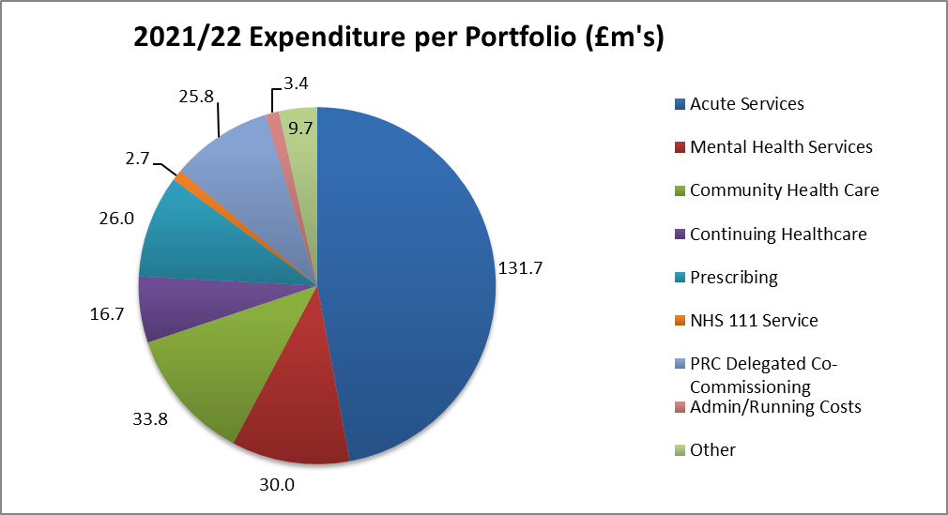

In 2021/22 the CCG spent £3.05m on Covid related expenditure. The main areas of expenditure were £2.47m on the hospital discharge programme – of which £1.11m on CHC and £1.36m with Thurrock Borough Council and £0.58m on other cost pressures. Additional funding was made available to address these costs.

The CCG did not incur additional costs or receive additional funding in relation to EU exit.

Capital spending

We did not require a CCG capital allocation for 2021/22, but the Mid and South Essex Health and Care Partnership footprint was awarded Estates and Technology Transformation Funding (ETTF) towards primary care estates projects and GP IT. ETTF expenditure is accounted for by NHSEI.

Paying our suppliers and providers

National rules mean we must aim to pay all valid invoices by the due date or within 30 days of receiving them, whichever is later. The NHS aims to pay at least 95% of invoices within 30 days of receipt, or within agreed contract terms. In 2021/22 we met all four targets (based on invoice numbers and value of expenditure) for NHS and non- NHS invoices – see Note 6 of the Financial Statements for details.

We are also an approved signatory (hyperlinks) of the Prompt Payment Code. The government designed this initiative with the Chartered Institute of Credit Management (hyperlinks) to tackle the crucial issue of late payment and to help small businesses. Suppliers can have confidence that any organisation signed up to the code will pay them within clearly defined terms and that proper processes are in place to deal with any disputed payments. Approved signatories have committed to:

  - Paying suppliers on time

  - Giving clear guidance to suppliers and resolving disputes as quickly as possible
  - Encouraging suppliers and customers to sign up to the code.
The national measures for payment performance do not include any delays in payment during the time that an invoice is on hold.

2022/23 Financial plans and looking to the future

The unprecedented impact of the Covid pandemic has inevitably delayed the return to normal financial arrangements. CCGs will cease to exist on 30 June 2022 and on 1 July 2022 be replaced by the Mid & South Essex Integrated Care Board (ICB). The Mid and South Essex Health and Care Partnership becomes the Mid & South Essex Integrated Care System (ICS).

Allocations for 2022/23 have been given on a system level and it is expected that CCGs will balance for the first quarter with any risks falling on the new organisation. We will continue to work with system partners over the coming months to prioritise programmes of work towards achieving a financially sustainable health and social care system.

Risks
The CCG’s risk profile as at 31 March 2022 is detailed in the table below:

Workstream | RAG Rating |  |  | Total No of Risks
 | Green | Amber | Red
Cancer and End of Life | 0 | 1 | 1 | 2
Children and Young People | 0 | 6 | 0 | 6
Community | 2 | 4 | 0 | 6
Digital and Business Intelligence | 1 | 3 | 0 | 4
Estates | 0 | 2 | 0 | 2
Finance | 1 | 3 | 1 | 5
Health Inequalities | 0 | 1 | 0 | 1
Integrated Care System | 2 | 3 | 0 | 5
Maternity | 0 | 2 | 1 | 3
Medicines Optimisation | 1 | 1 | 0 | 2
Mental Health and Learning Disability | 0 | 4 | 2 | 6
People | 1 | 1 | 1 | 3
Planned Care | 1 | 2 | 2 | 5
Population Health Management | 0 | 3 | 0 | 3
Primary Care | 2 | 5 | 0 | 7
Stewardship | 0 | 0 | 0 | 0
Urgent Emergency Care | 2 | 5 | 0 | 7
Vaccination | 0 | 1 | 0 | 1
Total as at 31 March 2022 | 13 | 47 | 8 | 68

During 2021/22 the MSE CCG’s risk profile has seen the number of red rated risks decrease. As of 31 March 2022, there were 8 red-rated risks, which related to the following 5 areas of the CCG’s business:

Referral to Treatment (RTT) standard, cancer, access to service and capacity
The CCGs continue to work with the Mid and South Essex NHS Foundation Trust (MSEFT) to address Licence Undertakings. Arrangements are in place to ensure oversight of the required actions to address RTT poor performance. There has been a significant impact on performance as a direct result of the Covid-19 pandemic. In partnership with NHS England, plans, oversight groups and reporting processes have been established to oversee restoration.

The System Quality section above provides an overview of action taken by MSE Quality teams to support MSEFT to undertake deep dive harm reviews on all patients whose care pathways breached cancer and RTT standards.

Maternity services
Arrangements are in place (as part of the MSEFT Licence Undertakings) to address significant concerns relating to maternity services, particularly those identified in the Care Quality Commission report for Basildon Hospital. The Mid and South Essex Local Maternity and Neonatal System (LMNS) are working with MSEFT to support workforce recruitment and retention measures and the Maternity Improvement Plan, including a review of the findings set out Donna Ockenden’s reports following her independent review of maternity services to assure the system and identify any further action required. Further information on maternity services is provided under the Care Quality Commission section of this report.

Mental health services

The Essex Mental Health Independent Inquiry is investigating matters surrounding the deaths of mental health inpatients across NHS Trusts in Essex between 2000 and 2020. The Inquiry will hear evidence from families, carers, and friends of those who died; others with experience of mental health inpatient care in Essex during the 21 year period; as well as staff, former-staff, relevant professionals, and organisations. The Inquiry is independent of government and the health care system.

Workforce
Workforce vacancy levels persist across MSE particularly in nursing and midwifery areas. Ongoing international and domestic recruitment initiatives are in place with a targeted retention strategy running in parallel. The MSE system has recently trialled a large in-person recruitment event for entry level roles, which resulted in 170 plus offers being made in one day. Similar initiatives will be rolled out across the system during 2022/2023.

Financial Impact of Elective Recovery

The submitted plans for Half 2 (H2) 2021/22 did not include additional Elective Recovery Fund income (ERF) within the system. This led to an income shortfall which has been mitigated by a mixture of additional efficiency savings within the system and some additional non-recurrent funding.

Sustainable Development
As an NHS organisation, and as a spender of public funds, we have an obligation to work in a way that has a positive effect on the communities for which we commission and procure healthcare services. Sustainability means spending public money well, the smart and efficient use of natural resources and building healthy, resilient communities. By making the most of social, environmental, and economic assets we can improve health both in the immediate and long term even in the context of rising cost of natural resources. Spending money well and considering the social and environmental impacts is enshrined in the Public Services (Social Value) Act (2012).

We acknowledge this responsibility to our patients, local communities, and the environment by working hard to minimise our carbon footprint.

In October 2020, the Greener NHS National Programme published its new strategy, Delivering a Net Zero National Health Service. This report highlighted that left unabated climate change will disrupt care, with poor environmental health contributing to major diseases, including cardiac problems, asthma and cancer. The report set out trajectories and actions for the entire NHS to reach net zero carbon emissions by 2040 for the emissions it controls directly, and 2045 for those it can influence (such as the supply chain). As part of the NHS, public health and social care system, it is our duty to contribute towards the targets set out in this document.

As a commissioner of services, the CCG sets out a commitment to sustainable procurement in its Procurement Policy. The CCG has taken measures to encourage greater awareness among staff. In November 2019 the Governance Committee recommended adoption of the NHS England pledge to eliminate single use plastics. In December 2019 the Staff Engagement Group supported an initiative for staff to make a “Green Pledge” for the start of the New Year.

An ICS Green Plan has been development and sets out actions to achieve Net Zero Carbon across the ICS. The CCG is fundamental to the delivery of this plan.
Sustainability will become business as usual across all service areas.

Modelled Carbon Footprint

In England, the NHS is estimated to account for 5.4% of the country’s greenhouse gas emissions. The health and social care system reduced its carbon footprint by an estimated 62% between 1990-2020, however, drastic action is now required.

Figures 2 and 3 below illustrate the key areas of focus that the NHS must deliver on to reduce its carbon footprint and meet the Greener NHS targets of being a net carbon zero health care service by 2045.

Figure 1: Greenhouse Gas Protocol (GHGP) scopes in the context of the NHS

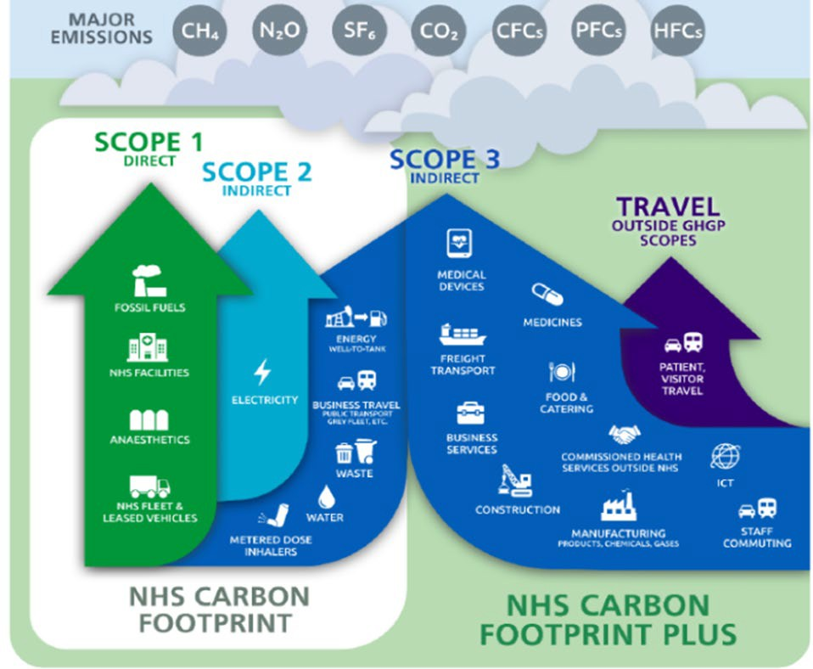

Figure 2: Sources of carbon emissions by proportion of NHS Carbon Footprint Plus
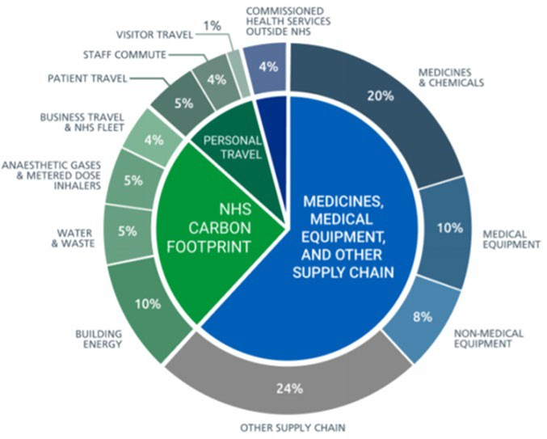

ACCOUNTABILITY REPORT

Corporate Governance Report

Members Report

Member profiles

The CCG is a clinically-led membership organisation established on 1 April 2013, consisting of the 27 practices (plus eleven branch surgeries) within Thurrock listed below in Primary Care Network (PCN) groups to reflect the new way of working.

Member Name | Practice Address
PCN - Corringham and Stanford
Hassengate Medical Centre | Southend Road, Stanford-le-Hope, Essex, SS17 0PH
Neera Medical Centre | 2 Wharf Road, Stanford-le-Hope, Essex, SS17 0BY
Orsett Surgery | 63 Rowley Road, Orsett, Essex, RM16 3ET
The Surgery, Horndon-on-the-Hill | High Road, Horndon-on-the-Hill, Essex, SS17 8LB
The Sorrells Surgery | 7 The Sorrells, Stanford-le-Hope, Essex, SS17 7DZ
Southend Road Surgery | 271A Southend Road, Stanford-le-Hope, Essex, SS17 8HD
PCN - Grays
Balfour Medical Centre | 2 Balfour Road, Grays, Essex, RM17 5NS
Chafford Hundred Medical Centre | Drake Road, Chafford Hundred, Essex, RM16 6RS
The Dell Medical Centre | 111 Orsett Road, Grays, Essex, RM17 5HA
East Thurrock Road Medical Centre | 34 East Thurrock Rd, Grays, Essex, RM17 6SP
The Grays Surgery | 78 High Street, Grays, RM17 6HU
Milton Road Surgery | 12 Milton Road, Grays, Essex, RM17 5EZ
Oddfellows Hall Health Centre | Odd Fellows Hall, Dell Road, Grays, Essex, RM17 5JY
Primecare Medical Centre | 167 Bridge Road, Grays, Essex, RM17 6DB
Stifford Clays Medical Practice | Crammavill Street, Stifford Clays, Grays, Essex, RM16 2AP
Thurrock Health Centre | 55-57 High Street, Grays, Essex, RM17 6NB PCN

PCN - Aveley, South Ockendon and Purfleet
Aveley Medical Centre | 22 High Street, Aveley, Essex, RM15 4AD
Derry Court Medical Centre | Derry Court, Derry Ave, South Ockendon, Essex, RM15 5GN
Pear Tree Surgery | Pear Tree Close, South Ockendon, Essex, RM15 6PR
Purfleet Care Centre | Tank Hill Road, Purfleet, Essex, RM19 1SX
The Sancta Maria Centre | Daiglen Drive, South Ockendon, Essex, RM15 5SZ
Dr Yasin Surgery | Darenth Lane, South Ockendon, Essex, RM15 5LP
PCN - Tibury & Chawell
Commonwealth Health Centre | Quebec Road, Tilbury, Essex, RM18 7RB
Medic House | Ottawa Road, Tilbury, Essex, RM18 7RJ
The Rigg Milner Medical Centre | 2 Bata Avenue, East Tilbury, Essex, RM18 8SD
Sai Medical Centre | 105 Calcutta Road, Tilbury, Essex, RM18 7QA
Tilbury Health Centre | London Road, Tilbury, Essex RM18 8EB

Composition of Governing Body

The CCGs Governing Body is the accountable body for the performance of the CCG. It has eight GP members and a Practice Manager elected by their peers to lead the organisation alongside the executive membership. One of the elected GPs chairs the Governing Body meeting.

The Governing Body also has three lay members and a secondary care member. The role of lay members includes ensuring views and suggestions from patients and the public are properly considered by the CCG, providing independent judgement and sound commercial knowledge, and helping to ensure the CCG is well run and uses public funds properly.

The role of the secondary care member ensures that the views of secondary care providers, which includes acute and mental health services, are considered by the Board.

The Governing Body also comprises the Joint Accountable Officer, Joint Chief Finance Officer, Executive Director of Nursing and NHS Alliance Director.

As of 31 March 2022, the board consisted of 16 members with one vacancy. Of these, four members are female and twelve are male.

The main function of the Governing Body is to ensure that the group has appropriate arrangements in place to exercise its functions effectively, efficiently and economically and in accordance with the group’s principles of good governance. The other key functions are outlined within the CCG’s constitution. During 2021/22, due to Covid-19,

the Governing Body suspended some of the public meetings due to system pressures, however, confidential meetings continued to take place.

Board meetings are held in public on a bi-monthly basis and Board papers are published on the CCG website in advance of each meeting. Details of these meetings are available on our website: https://www.thurrockccg.nhs.uk/about-us/ccg-board- meetings/gb-board-papers.

In February 2022 the Basildon and Brentwood, Castle Point and Rochford, Mid Essex, Southend and Thurrock CCG Boards, collectively referred to as Mid and South Essex (MSE) CCG Boards, agreed to ‘meet in common’ until establishment of the MSE Integrated Care Board. This means that each Board will meet in the same place (currently virtually via MS Teams), at the same time, although they still act and make decisions as separate Boards. These arrangements will enable decisions affecting the whole MSE population to be made collectively.

The following people have been CCG Board Members during 2021/22:

Dr Anil Kallil, CCG Chair
Dr Kallil has been working as a GP in Orsett for 14 years. Before this he worked in Hospital Medicine. Dr Kallil is one of the clinical leads for the Thurrock Health Hubs and on 26 February 2020 was selected by the governing body to become the CCG Chair. Dr Kallil has been a former Board Member and interim Medical Director for a former out-of-hours primary care provider. Dr Kallil was also a board member for Thurrock Primary Care Trust before it was officially granted the legal status as a Clinical Commissioning Group.

Anthony (Mac) McKeever, Joint Accountable Officer, Mid and South Essex CCGs and Executive Lead, Mid and South Essex Health and Care Partnership

Anthony, known to all as Mac, has more than 40 years’ experience in the NHS and other healthcare organisations. Before joining the mid and south Essex CCGs he served as Director General for Health and Community Services for the States of Jersey.

Originally a “fast stream” civil servant, Mac joined the NHS in 1987, operating for 25 years as a CEO, helping to turn around performance at several hospitals and commissioning organisations. Having established his own business, he served on the Future Forum in 2010, and returned to work in the NHS in 2015.

Mac has been appointed Chief Executive Officer Designate for the Mid and South Essex Integrated Care Board and System.

Mark Barker, Chief Finance Officer
Prior to joining the NHS over 20 years ago, Mark was a Senior Manager at KPMG, Director of Finance in various housing associations and business controller at Transport for London. Mark has worked in a number of NHS organisations, most recently as the Chief Finance Officer for Castle Point and

Rochford and Southend CCGs and, from 1 January 2021, he was appointed as Joint Chief Finance Officer for the five mid and south Essex CCGs.

Rachel Hearn, Executive Director Nursing and Quality
Rachel is a Registered Nurse and Executive Director of Nursing and Quality across the five Mid and South Essex CCGs. Rachel has over 20 years’ clinical experience as a nurse within the NHS. Having worked predominantly in emergency and general medicine, Rachel has clinically led work on the changing face of emergency care. Rachel’s role in commissioning focuses on quality improvement, safeguarding adults and children and continuing health care provision.

Mark Tebbs, NHS Alliance Director
Mark joined Thurrock CCG in 2013 and has been a member of the board for the last five years, driving work on integrated care within the CCG as well as undertaking the role of senior responsible officer for mental health across the Mid and South Essex Health and Care Partnership. In March 2020, Mark became the Deputy Accountable Officer for the CCG and from November 2020 Mark’s primary responsibilities are as the NHS Alliance Director for Thurrock. This enables him to continue developing effective working relationships, with our partners and a culture of delivery across the Thurrock Alliance, supporting Primary Care Network development and ensuring the effective operation of the local urgent care system

Lesley Buckland, Deputy CCG Chair, Lay Member (Governance) and Chair of Audit Committee

Lesley’s professional background is in Human Resource Management. Lesley has held senior management roles in Industry and within the NHS. The latter part of her career as Head of an Academic Department and the Director of the Institute of Vocational Learning, based in London Southbank University. Lesley has also held non-executive roles in the NHS for over nineteen years. Lesley chairs the Audit Committee and is a member of several other committees in her role as Lay Member Governance. Lesley also chairs the Mid and South Essex Joint Committee Finance and Performance Committee which met in common across Mid and south Essex during the pandemic. Lesley was Chair and continues as a Trustee of a Charity /Social Enterprise , focussing on the Care of the Elderly with an emphasis on supporting clients with Dementia.

Alan Hudson, Lay Member, Patient and Public Involvement
Alan Hudson was the Lay Member for Patient and Public Involvement on the board and Chair of the Primary Care Commissioning Committee until December 2021. Prior to this he was a long-standing major voice in Thurrock relating to health and care and served as the Chair of the Thurrock Commissioning Reference Group (CRG) providing local insights and feedback on CCG commissioning decisions. Alan was a strong supporter of the Lung Health Checks programme coming to Thurrock and was key in guiding the communication and patient involvement in this. Alan sadly passed away whilst

still a serving member of the board and continued to be a passionate advocate for Thurrock residents to the end.

Pauline Stratford, 3rd Lay Member
Prior to joining the NHS Pauline was a senior commissioner for social care mental health services and previously to that a human resources and change manager with a lead in equalities in central government. Pauline also serves as the Lay Member for Primary Care for the Castle Point and Rochford and Southend CCGs and the third Lay Member for Mid Essex CCG.

Dr Rachael Liebmann, Secondary Care Consultant
Dr Rachael Liebmann is a secondary care clinician and board member for NHS Thurrock Clinical Commissioning Group (CCG). Rachael is a past vice president of the Royal College of Pathologists and has over 20 years’ experience as an NHS consultant. Dr Liebmann has also been shortlisted for the National Patient Safety Awards and Health Service Journal ‘Clinical Leader of the Year’ and was awarded the College Medal for Distinguished Service. In 2020 Dr Liebmann was awarded an OBE for her service to pathology.

Dr Anjan Bose, GP Governing Body Member and Clinical Tutor Lead
Dr Bose is the Clinical Lead and Educational Tutor in NHS Thurrock CCG. He has been a GP since 1992 and specialises in pulmonology and diabetes (GPwSI). Dr Bose is an active participant in the Diabetes Network, is a member of the Foot Care Network and has been actively running educational courses since 1999 and champions Medicines Optimisation. Dr Bose facilitated the Primary Care Time to Learn sessions and continues to do so having be re- elected as a GP Board Member in February 2020.

Dr Anand Deshpande, GP Governing Body Member

Dr Deshpande has sat on the CCG’s governing body since 2013, serving as the Chair between April 2013 and February 2020. Before becoming Chair of NHS Thurrock CCG, he has been a board member of previous Thurrock NHS organisations related to primary care, holding various portfolios. He has also been Executive Board Member of the South Essex Primary Care Trust and chaired the South Essex Local Medical committee for three years. Dr Deshpande has represented GPs from the whole of Essex in the British Medical Association (BMA) GP Committee in London for six years. He has been instrumental in leading on primary care transformation and supported the bid to fund Thurrock’s four health hubs. Dr Deshpande has been practising as a GP since 1991 in Thurrock and practices with a partner as a GP at Neera Medical Centre, Stanford-Le-Hope. His ambition is to work with NHS England to develop services in the community nearer to the patients in Thurrock.

Dr Luis Leighton, GP Governing Body Member and Respiratory Lead

Dr Leighton, re-elected as a GP Board Member in February 2020, trained at The Middlesex Hospital Medical School in London qualifying in 1979 and completed

his GP training in Chesterfield. He has over 33 years’ experience as a GP in Thurrock and is also an occupational health specialist in the locality. He also works for the local Hub. Dr Leighton is the Respiratory Lead for the CCG.

Dr Sanjeev Maskara, GP Governing Body Member and Chair of the Clinical Engagement Group

Dr Maskara joined NHS Thurrock CCG as a Governing Body member in November 2017 and is chair of the Clinical Engagement Group, continuing this role into 2020/21 having being elected as a GP Board Member in February 2020. Dr Maskara is a GP partner, trainer, NHS GP appraiser and GP Specialist Adviser (GP SpA) for the Care Quality Commission (CQC). Dr Maskara’s areas of expertise are elderly care, chronic disease management, and he is passionate about teaching and training especially medical education.

Dr Rajan Mohile, GP Governing Body Member and Mental Health Lead
Dr Mohile has been a member of the CCG governing body since April 2013, having been re-elected in February 2020. He is Mental Health Lead for the CCG and works as a GP in Grays. Dr Mohile trained at St Bartholomew’s Hospital before receiving his GP training in Maidenhead. He has over 35 years’ experience as a GP and was a founding Chairman of an out of hours service. He is also the former Chairman of South West Essex Diabetes Network and a member of the Grays Thurrock Rotary Club.

Dr Thamotherampillat Nimal-Raj, GP Governing Body Member and Cancer Lead

Dr Nimal-Raj has been a long-standing Member of NHS Thurrock CCG, he has been a GP Governing Body Member, having been re-elected in February 2020. Dr Nimal-Raj works as a GP at surgeries in Purfleet and East Tilbury. Dr Nimal- Raj was a senior GP in Purfleet Care Centre from when it was established in 2003 until 2016. Dr Nimal-Raj is the lead for unplanned care and cancer care.

Dr Henry Okoi, GP Governing Body Member, Medicines Optimisation Lead
Dr Okoi has been working in Thurrock as a GP since October 2006. He became a CCG board member in January 2017 when he was also appointed as Medicines Management lead and continues this role having been re-elected in February 2020. As a governing body member, Dr Okoi has provided independent robust scrutiny to the work of the CCG, specifically in chairing the CCG Quality and Patient Safety Committee, supporting the CCG to improve the health of residents of Thurrock. As Medicines Management lead, Dr Okoi has worked closely with his team to enhance the safety of prescribing in Thurrock. Dr Okoi is also a GP Trainer, preparing the next generation of GPs for the NHS.

Ahmed Yasin, Practice Manager Governing Body Member
Ahmed is a retired pharmacist having spent the majority of his working life in the pharmaceutical industry and leaving GSK in 2015 as the Head of Formulation Development for macromolecules. He spent one year as a CMC director at

Novaliq in Germany before joining his GP wife at her surgery in South Ockendon as a non-clinical partner. He is also the non-clinical lead for the Aveley, South Ockendon and Purfleet (ASOP) PCN and he joined the board having been elected as the Practice Manager Board Member in February 2020

Committees, including Audit Committee

A full list of the committees supporting the Board, including the Audit Committee, and membership of those committees is provided within the Governance Statement at page 43.

Register of Interests

At all formal meetings of the board and its committees, members must declare if they have an interest in any agenda items under discussion.

The CCG maintains a register of interests declared by board members, a copy of which is provided at all board meetings. The full register of board members’ interests is on our website: Register of Interests - Thurrock CCG Board Members (hyperlink)

Freedom of Information Requests

The Freedom of Information (FoI) Act 2000 gives a general right of access to recorded information held by public authorities, subject to certain conditions and exemptions. The CCG received 168 FoI requests during 2020/21. The CCG responded to 97.6X% of these within the statutory timescale of 20 working days.

We certify that we have complied with HM Treasury’s guidance on setting charges for information.

Statement of Disclosure to Auditors

Each individual who is a member of the CCG at the time the Members’ Report is approved confirms:

  - So far as the member is aware, there is no relevant audit information of which the CCG’s auditor is unaware that would be relevant for the purposes of their audit report.

  - The member has taken all the steps that they ought to have taken in order to make him or herself aware of any relevant audit information and to establish that the CCG’s auditor is aware of it.

Donations to political parties and charitable organisations

The CCG does not make donations to political parties.

The CCG has made payments to a number of charitable organisations. The majority of these payments are in relation to Service Level Agreements (particularly to local hospices) or as a result of successful grant applications.

Modern Slavery Act

NHS Thurrock CCG fully supports the Government’s objectives to eradicate modern slavery and human trafficking. Our Slavery and Human Trafficking Statement for the financial year ending 31 March 2022 is published on our website at Modern Slavery Statement (hyperlinks).

Complaints to Parliamentary and Health Service Ombudsman

There were no complaints investigated by the Parliamentary & Health Service Ombudsman (PHSO) in 2021/22.

Concerns and complaints provide the CCG with valuable information about the experiences of patients to enable the CCG to improve its own services and those it commissions.

During 2021/22 the CCG’s Complaints team received 15 formal complaints and 229 enquiries primarily in relation to commissioned services. In each case, the team worked with the complainant and the provider (where applicable) to achieve resolution in the majority of cases and to identify service improvements and learning outcomes.

The CCG’s Compliments, Concerns and Complaints Policy reflects the best practice principles for complaints handling advocated by the Parliamentary & Health Service Ombudsman (Principles for Remedy, Principles of Good Complaint Handling and Principles of Good Administration). In accordance with the Principles for Remedy, the CCG places a strong emphasis upon putting things right and ensuring continuous improvement and learning from complaints.

Statement of Accountable Officer’s Responsibilities
The National Health Service Act 2006 (as amended) states that each Clinical Commissioning Group shall have an Accountable Officer and that Officer shall be appointed by the NHS Commissioning Board (NHS England). NHS England has appointed the [inset post holder title] to be the Accountable Officer of [Name of CCG].

The responsibilities of an Accountable Officer are set out under the National Health Service Act 2006 (as amended), Managing Public Money and in the Clinical Commissioning Group Accountable Officer Appointment Letter. They include responsibilities for:

  - The propriety and regularity of the public finances for which the Accountable Officer is answerable.
  - For keeping proper accounting records (which disclose with reasonable accuracy at any time the financial position of the Clinical Commissioning Group and enable them to ensure that the accounts comply with the requirements of the Accounts Direction).
  - For safeguarding the Clinical Commissioning Group’s assets (and hence for taking reasonable steps for the prevention and detection of fraud and other irregularities).
  - The relevant responsibilities of accounting officers under Managing Public Money.

  - Ensuring the CCG exercises its functions effectively, efficiently and economically (in accordance with Section 14Q of the National Health Service Act 2006 as amended and with a view to securing continuous improvement in the quality of services (in accordance with Section14R of the National Health Service Act 2006 as amended).
  - Ensuring that the CCG complies with its financial duties under Sections 223H to 223J of the National Health Service Act 2006 as amended.

Under the National Health Service Act 2006 as amended, NHS England has directed each Clinical Commissioning Group to prepare for each financial year a statement of accounts in the form and on the basis set out in the Accounts Direction. The accounts are prepared on an accruals basis and must give a true and fair view of the state of affairs of the Clinical Commissioning Group and of its income and expenditure, Statement of Financial Position and cash flows for the financial year.

In preparing the accounts, the Accountable Officer is required to comply with the requirements of the Government Financial Reporting Manual and in particular to:

  - Observe the Accounts Direction issued by NHS England, including the relevant accounting and disclosure requirements, and apply suitable accounting policies on a consistent basis.
  - Make judgements and estimates on a reasonable basis.
  - State whether applicable accounting standards as set out in the Government Financial Reporting Manual have been followed and disclose and explain any material departures in the accounts.
  - Prepare the accounts on a going concern basis.
  - Confirm that the Annual Report and Accounts as a whole is fair, balanced and understandable and take personal responsibility for the Annual Report and Accounts and the judgements required for determining that it is fair, balanced and understandable.

As the Accountable Officer, I have taken all the steps that I ought to have taken to make myself aware of any relevant audit information and to establish that Thurrock CCG’s auditors are aware of that information. So far as I am aware, there is no relevant audit information of which the auditors are unaware.

Anthony McKeever
Executive Lead for the Mid and South Essex Health and Care Partnership and Joint Accountable Officer for its five CCGs

29 June 2022

Governance Statement

Introduction and context

Thurrock CCG (the CCG) is a body corporate established by NHS England on 1 April 2013 under the National Health Service Act 2006 (as amended).

The CCG’s statutory functions are set out under the National Health Service Act 2006 (as amended). The CCG’s general function is arranging the provision of services for persons for the purposes of the health service in England. The CCG is, in particular, required to arrange for the provision of certain health services to such extent as it considers necessary to meet the reasonable requirements of its local population.

As at 31 March 2022, the CCG was not subject to any directions from NHS England issued under Section 14Z21 of the National Health Service Act 2006.

The CCG is part of the Mid and South Essex Health and Care Partnership (the HCP) covering the geographic areas of mid Essex, Basildon and Brentwood, Castle Point and Rochford, Southend, and Thurrock CCGs (the MSE CCGs). The HCP has been created to bring local health and care leaders together to plan for the long-term needs of local communities.

In July 2017 the five MSE CCGs formally established a CCG Joint Committee (JC) to act collectively in the planning, securing and monitoring of services to meet the needs of their 1.2 million population, as well as representing the HCP footprint for services commissioned over a larger area.

Specifically, the JC commissions and manages the contracts for acute hospital services (NHS and independent sector), NHS 111 and out-of-hours services, ambulance services, patient transport services, community services and mental health services.
The JC also played a role in decision-making about Learning Disability services within the existing pan-Essex arrangements.

Due to business continuity arrangements implemented by the CCG from mid-December 2021 to the end of February 2022 as a result of the ongoing COVID-19 pandemic (Omicron variant) and the need support the vaccination booster programme, the JC did not meet from December 2021. Alternative committee/Board meeting arrangements were implemented to deal with issues within the JC’s remit as detailed in the following paragraph and the individual committee headings below.

The five MSE CCG Boards met in common on 24 February 2022 and agreed to hold all future CCG Board meetings in common until the MSE Integrated Care Board (ICB) is established. During this transition period, the Boards meeting in common will conduct all business delegated to the JC. Consequently, the JC will not meet again.

All other decisions about healthcare continued to be taken locally by the relevant CCG.

Scope of responsibility

As Accountable Officer, I have responsibility for maintaining a sound system of internal control that supports the achievement of the clinical commissioning group’s policies, aims and objectives, whilst safeguarding the public funds and assets for which I am

personally responsible, in accordance with the responsibilities assigned to me in Managing Public Money. I also acknowledge my responsibilities as set out under the National Health Service Act 2006 (as amended) and in my Clinical Commissioning Group Accountable Officer Appointment Letter.

I am responsible for ensuring that the CCG is administered prudently and economically and that resources are applied efficiently and effectively, safeguarding financial propriety and regularity. I also have responsibility for reviewing the effectiveness of the system of internal control within the clinical commissioning group as set out in this governance statement.

Governance arrangements and effectiveness

The main function of the governing body (the Board) is to ensure that the group has made appropriate arrangements for ensuring that it exercises its functions effectively, efficiently and economically and complies with such generally accepted principles of good governance as are relevant to it.

CCGs are clinically led membership organisations made up of general practices. The members of the Thurrock CCG have determined the governing arrangements for the CCG as set out in its constitution, which was based on the Model Constitution Framework for CCGs and originally approved in 2013. The CCG undertook a thorough review of its constitution, in line with the NHS CCG New Model Constitution, to enable the CCG to take on fully delegated primary care commissioning with effect from 1 April 2021 and to align its constitution with the other mid and south Essex CCGs in preparation for the development of an Integrated Care System.

The revised constitution was approved by the Board at its meeting on 24 March 2021.

There are 27 member practices within Thurrock CCG, serving a registered population of 184,541 patients as of March 2022. The practices were formed into four Primary Care Networks (PCNs) across Thurrock from June 2019. Details of these PCNs are shown in the table below:

Primary Care Network | Number of Practices | Registered Patient Population as at 31 March  2022
Stanford-le-Hope and Corringham | 6 | 32,744
Grays | 10 | 73,519
Aveley, South Ockendon & Purfleet | 6 | 40,372
Tilbury & Chadwell | 5 | 37,906

Practices work together within their PCNs to collaborate on the effective provision of primary care in their local areas and to engage in the commissioning of services on behalf of their populations.

In some PCNs these working together arrangements are facilitated through the sharing of workforce, sharing back-office functions, and collaborative working in certain

chosen clinical areas. Practices are gradually working towards developing standardised policies, processes and agreed governance structures.

Governing Body (the Board)

The CCG’s constitution sets out the governance arrangements, roles and responsibilities of the Board and its membership.

Publicly held Board meetings are held on a bi-monthly basis. The CCG meeting due to be held in January was cancelled as part of business continuity arrangements implemented from mid-December to the end of February 2022 as detailed above.
However, appropriate arrangements were implemented to ensure that any key decisions were taken forward. Any decisions taken by the Central Incident Management Team (CIMT) were logged on the CIMT decisions log which was then reported to the Board.

In February 2022 the CCG Board met in common with the other MSE CCG Boards and agreed that they would continue to meet in common until the MSE Integrated Care Board (ICB) is established.

Board meetings are broadcast via ‘MS Teams’ which enables members of the public to listen to discussions held and submit questions.

Board meetings were quorate on the majority of occasions. If a Board meeting was inquorate due to one or more members being unavailable, their support for recommendations made was sought following the meeting to ensure that decisions were quorate. There are also arrangements in place to maintain a clinical majority and manage conflicts of interest to achieve quorum where voting members of the Board recuse themselves from a relevant vote.

As at 31 March 2022, the Board membership comprised of the following voting members:

The Chair (a GP member), Joint Accountable Officer, NHS Alliance Director for Thurrock, Executive Chief Finance Officer, Executive Director of Nursing and Quality (Registered Nurse), seven other GP members, Secondary Care Board member, two Lay Members (plus one vacancy) and a Practice Manager member.

Anthony McKeever was appointed Interim Joint Accountable Officer for the Mid and South Essex CCGs from 1 March 2020 and was subsequently appointed to this role on a permanent basis from 3 October 2020. Mr McKeever has since been appointed to the role of Chief Executive Officer Designate for the Mid and South Essex Integrated Care System.

Board representation also includes the Director of Primary Care, Director of Public Health (Thurrock Council), Director of Adult Services (Thurrock Council) and Chief Operating Officer, Healthwatch.

The Board undertakes an annual review of its effectiveness and has determined that it fulfils its role effectively either all or most of the time and that there is good engagement of members.

To support the Board in carrying out its duties effectively, committees reporting to the Board are formally established. In line with NHS guidance to reduce the burden on NHS staff during the pandemic, some formal committee meetings were stood down during April 2021 and again from mid-December 2021 to February 2022, with any urgent business being conducted virtually.

From Quarter 1 of 2020/21, the five MSE CCGs held their Remuneration Committee, Patient Safety & Quality Committee (or equivalent) and Finance & Performance Committee meetings in common.

From Quarter 1 of 2021/22, meetings in common arrangements were extended to include the five MSE CCGs Audit Committees and Primary Care Commissioning Committees.

The Mid and South Essex Health and Care Partnership Board, which includes representation from the CCG, local authorities, Healthwatch Essex, the voluntary sector, Anglian Ruskin University and the CCG’s main providers, met in private throughout 2021/22.The minutes of these meetings were submitted to the CCG’s Part II Board meetings.

Each committee submits its minutes to Board meetings. The main committees providing assurance to the Board are set out below.

Audit Committee
This Committee provides the CCG Board with an independent and objective view of the CCG’s financial systems, financial information and compliance with laws, regulations and directions governing the CCG insofar as they relate to finance, good corporate governance, information governance, cyber-security, emergency planning, response and resilience (EPRR), business continuity management (BCM) and the CCG’s responsibility to act effectively, efficiently and economically.

The Audit Committee is chaired by the Lay Member (Governance) and Deputy Chair of the CCG, Lesley Buckland. As at 31 March 2022, the Committee’s other members were Pauline Stratford, Lay Member (Primary Care) and Dr Rachael Liebmann, Secondary Care Consultant.

From the Quarter 1 of 2021/22, the Committee met in common with the other MSE CCG Audit Committees on 5 occasions, plus 2 extraordinary meetings to review draft policies developed for the MSE ICB. Attendance has been quorate in line with its Terms of Reference (minimum of two core members) on all but one occasion where arrangements were made for the Lay Member to virtually review and approve minutes in advance of the meeting. There were no other items on the agenda for approval.

During 2021/22 the Audit Committee continued to focus upon ensuring the development and review of the systems, policies, procedures and processes fundamental to the governance of the organisation. During Quarter 4, the committee undertook a review of policies being developed for the MSE ICB relating to areas within the committee’s remit.

The Committee has received assurance from internal audit of key systems and processes and, in addition to routine reporting, has received updates on counter- fraud initiatives and investigations and implementation of audit recommendations. The Committee reviewed the CCG’s draft accounts and approved the final accounts and management response to the auditor on behalf of the Board.

The Committee also reviews the CCG’s risk register/Board Assurance Framework (BAF) and associated risk management processes and procedures. The Committee supported an aligned MSE CCG Risk Management Policy which was adopted by the CCG Boards in November 2021.

During the Level 4 incident from mid-December to February 2022, the committee received a copy of the CIMT Risk Register which focussed on key risks whilst normal risk register reporting arrangements were paused. During this period, the committee also received a copy of the CIMT Decisions Log recording all decisions taken by CIMT.

The Committee also received the minutes of other main CCG committees namely: the minutes of the Primary Care Commissioning Committee (operating in partnership between the CCG and NHS England/NHS Improvement as noted below to reflect the joint commissioning of primary care); the minutes of the Patient Safety and Quality and the Finance & Performance Committee meetings held in common with the other M&SE CCG committees.

In line with NHS England guidance on the management of Conflicts of Interest, the Chair of the Audit Committee acts as the CCG’s Conflicts of Interest Guardian.

The Committee and Board approved an extension of the expiry date of relevant CCG policies, including the Conflicts of Interest, Gifts and Hospitality and Standards of Business Conduct Policies, to March 2022 to enable the M&SE CCGs to focus on developing new aligned policies in preparation for the formation of a new Integrated Care System (ICS) NHS Body. In March 2022, these policies were subsequently extended by the Board until 30 June 2022 as a result of the national decision to delay the establishment of ICBs by three months.

The Audit Committee Chair received assurance that the CCG was adhering to NHS England mandatory guidance on the management of conflicts of interest via the annual internal audit of conflicts of interest which identified ‘reasonable’ assurance. The requirement to submit quarterly returns to NHS England regarding the CCG’s adherence to the mandatory guidance was suspended during 2021/22.

Remuneration Committee

The Remuneration and Terms of Service Committee is a committee of the CCG Board with delegated responsibility for making recommendations to the Board on all aspects of remuneration and terms of service of employees, including the Accountable Officer, Directors and Lay Members.

In addition, the Committee is responsible for making recommendations to the Board concerning the remuneration and terms of service for Elected GP members and other people who provide services to the CCG (all of whom are not employees of the CCG),

taking in to account any national or local guidance as appropriate, so as to ensure that individuals are fairly rewarded for their contribution to the CCG.

The membership of the Remuneration Committee as at 31 March 2022 is two lay Board members and the Board Secondary Care Specialist. The committee is chaired by a Lay Board Member.

The Remuneration Committee met in common with the other M&SE CCG Remuneration Committees 10 times, either via MS Teams or by conducting business ‘virtually’ by email, during 2021/22.

Patient Safety and Quality Committee

This Committee provides assurance regarding the safety and quality of services directly commissioned by the CCG, i.e. acute, community, learning disability and mental health services, as well as the quality of services within primary care and the care home sector. The committee also maintains oversight of safeguarding (adults and children) and medicines optimisation.

At the start of the year, the Committee was chaired by a GP Board Member and its core decision making membership comprised the Executive Director of Nursing & Quality, two GP Board Members and Lay Member. The committee was also attended by other senior managers with specific responsibility for areas within the remit of the committee.

Since May 2020, the Committee met in common with the other four MSE CCGs’ Patient Safety and Quality (or equivalent) Committees to review the safety and quality of all health care services.

The Committees meeting in common focused on arrangements to provide care for patients diagnosed with COVID-19 within acute, community and care home settings, the safety of staff and workforce capacity issues, and the effect that the pandemic was having on patients requiring routine and elective care.

Other key areas discussed included arrangements for monitoring the quality of provider contracts; review of NHS Patient Safety Updates; review of the Quality Accounts 2020/21 from Mid and South Essex Hospital NHS Foundation Trust, Essex Partnership University NHS Foundation Trust (EPUT); North East London NHS Foundation Trust; Barking, Havering and Redbridge NHS Foundation Trust; Provide Community Interest Company and Farleigh Hospice; and agreeing the CCGs’ responses to the Quality Accounts; serious incidents and never events; review of arrangements for the implementation of the Patient Safety Incident Response Framework; update on Special Educational Needs and Disabilities services; updates on Learning Disabilities Mortality Review (LeDeR) Programme; System Quality Strategy; Infection Prevention and Control Strategy; approval of policies; all age continuing care; personal health budgets; review of patient safety and quality risks; quality and equality impact assessments; complaints and a review of any virtual decisions taken since the last committee meeting.

These meetings were attended by the minimum number of members required for each CCG committee to be considered quorate. Attendance was generally quorate in line with the Committees’ Terms of Reference. If a committee was inquorate due to one or

more members being unavailable, their support for any decisions made was sought following the meeting.

There were three ‘virtual’ meetings held by email with update reports being circulated to members for information.

Finance and Performance Committee

This Committee scrutinises and provides the CCG Board with assurance on the delivery of the CCG’s remit in respect of the CCG’s overall financial position (including running costs) and for service performance for commissioned services not delegated to the JC.

The Committee also maintains local oversight of information management and technology, estates developments and the Savings Programme Board’s scrutiny and challenge role to ensure the delivery of the CCG’s programme of financial savings. The Committee acts as a point of approval for major changes to existing projects and plans, where these are based on considerations related to the achievement of financial or other benefits. The Committee also assesses whether there is continued business justification for existing projects and programmes where the financial or other benefits have changed.

At the start of the year the Committee was chaired by the Lay Member (Governance) and its core membership comprised of the Joint Chief Finance Officer, GP Board Member and Lay Member.

Since May 2020, the Committee met in common with the other four M&SE CCGs’ Finance and Performance (or equivalent) Committees. During 2021/22 it met on 8 occasions to review finance and performance issues across all health care services, including those ordinarily within the remit of the Mid and South Essex STP CCG Joint Commissioning Committee (JC).

The quoracy arrangements for meetings held in common with the other CCG committees, mirrored those described under the ‘Quality and Governance Committee’ section.

During 2021/22 the Committee particularly focused upon review of finance & performance risks, receipt of monthly finance reports, Joint Committee finance reports, Elective Recovery Framework updates, Hospital Discharge Programme 2021/22, contract planning, awards and procurement decisions, performance reports from System Oversight and Assurance Group (SOAG), Adult Mental Health Transformation Plan contracts, system financial sustainability, 2021/22 Business Plan and CCG budgets, approval of terms of reference/frequency of meetings, receipt of System Finance Leaders Group (SFLG) minutes.

Thurrock Alliance
The aim of the Thurrock Alliance (Thurrock Integrated Care Partnership (TICP)) is to bring all key partners from across Thurrock together to provide the localism needed within the mid and south Essex system to create opportunities for people to live well in Thurrock.

Its membership comprises Director level representation from the CCG, PCN Clinical Directors, the CCG Chair, representation from Thurrock Council, EPUT, NELFT, MSEFT, Thurrock CVS and Healthwatch.

The Alliance meets monthly with good representation from all partners. An Alliance plan was developed with all Thurrock partners for 2021/22 which determined the priorities, vision, outcomes and measures for improving health and wellbeing of the population, grouped into the following key areas:

  - Health inequalities
  - Primary Care
  - Governance & Leadership
  - Transformation, and
  - Place-based prevention schemes.

Conflicts of Interest Committee

The Conflicts of Interest Committee is chaired by a Lay Member of the governing body and met once during the year. It has delegated authority as an independent committee responsible for making decisions on behalf of the governing body where the governing body (or sub-committee) is considered to be conflicted in such a way that they are unable to take a decision because that committee would no longer be quorate having excluded conflicted members. Membership of the COIC includes Lay Members and Executive Officers; a clinical advisor is also co-opted to the committee to ensure adequate scrutiny of any clinically related decisions.

Primary Care Commissioning Committee

This Committee was established from 1 April 2021 following the CCG being approved for fully delegated Primary Care commissioning and is chaired by a Lay Board Member.

From June 2021 the Committee met in common with the other MSE CCGs Primary Care Commissioning Committees.

There were five meetings held, with three further virtual meetings held to conduct urgent business that could not wait until the next scheduled meeting.

A review of committee effectiveness confirmed that the committee was generally quorate line with the Committee’s Terms of Reference on all occasions.

During 2021/22 the Committee focused on contractual updates/breaches/requests for contractual changes from general practices; local contract decisions, e.g. Designated Enhanced Services; GP primary care quality and safety reports; budget reports; information technology and digital updates; estates issues; primary care workforce; review of Primary Care Risk Group minutes; review of primary care risks; and GP Business Continuity and resilience arrangements.

Better Care Fund (including Improved Better Care Fund) Governance

A Better Care Fund (BCF) Finance and Performance Delivery Group, a working group of the Thurrock Integrated Care Partnership, meets to fulfil the governance requirements with Thurrock Council.

In line with the terms of the Section 75 Better Care Fund Agreement, decision-making relating to the BCF requires joint agreement of nominated representatives of the CCG and of Thurrock Council. Utilisation of the BCF funds was agreed in the Section 75 Agreement and in-year reporting focused upon expenditure on the approved services and monitoring against agreed performance targets.

Mid and South Essex CCG Joint Commissioning Committee

As outlined in the introduction, the five mid and south Essex CCGs formally established a CCG Joint Committee (JC) to act collectively in the planning, securing and monitoring of services to meet the needs of their 1.2million population. The JC was established as a committee of each CCG, not of the CCG’s governing bodies, and therefore sits alongside the CCG governing bodies, rather than being accountable to them.

During 2021/22 the committee meet three times to consider: risks within the remit of the committee; planning guidance; the Vanguard Theatre contract; MSEFT Legal Undertakings; Adult Mental Health Transformation Plan; review of Medicines Optimisation Terms of Reference; patient safety, finance and performance reports; receipt of minutes from Patient Safety & Quality Committees in common and Finance & Performance Committees in common; provider Quality Accounts and the CCGs’ responses to these; non-emergency patient transport procurement; and review of community beds.

The JC did not meet during December to February as a result of the implementation of pandemic business continuity arrangements and, following a decision by the MSE CCGs to meet in common from February until the establishment of the MSE ICB, it is anticipated that the JC will no longer meet.

UK Corporate Governance Code

The CCG is not required to comply with the UK Code of Corporate Governance. However, we have reported on our Corporate Governance arrangements by drawing upon best practice available, including those aspects of the UK Corporate Governance Code we consider to be relevant to the CCG and best practice.

As part of its annual review of effectiveness, the CCG Board undertook an assessment which encompassed the relevant principles of the UK Corporate Governance Code.

The Board concluded from this assessment that it was generally following best practice in relation to providing effective leadership, having an appropriate balance of skills, experience, independence and knowledge to enable Board members to discharge their duties and responsibilities effectively, presenting a balanced and understandable assessment of the CCG’s position in its financial and other reporting and ensuring that remuneration is set appropriately.

Discharge of Statutory Functions

In light of recommendations of the 2013 Harris Review, the clinical commissioning group has reviewed all of the statutory duties and powers conferred on it by the National Health Service Act 2006 (as amended) and other associated legislative and regulations. As a result, I can confirm that the clinical commissioning group is clear about the legislative requirements associated with each of the statutory functions for which it is responsible, including any restrictions on delegation of those functions. The CCG’s current Scheme of Reservation and Delegation (SoRD) was approved by the Board in March 2021. The CCG is working with the other MSE CCGs to develop a new SoRD for the MSE ICB.

Risk management arrangements and effectiveness

The CCG is committed to ensuring that risk management forms an integral part of its philosophy, practices and business plans, rather than viewed or practised as a separate programme, and that responsibility for implementation is accepted at all levels of the CCG.

An aligned MSE CCG Risk Management Policy, which encompasses both clinical and non-clinical risks and the CCGs’ agreed risk appetite statement, was approved by all MSE CCGs in November 2021. The Policy is based on the Australia/New Zealand risk management model and sets out the risk management system, supporting processes and reporting arrangements which aim to protect patients, the public, staff and the CCG’s assets and reputation.

In line with NHS guidance to reduce the burden on staff during the pandemic, the usual risk management processes were paused during April 2021 and again in December to February 2022. During these periods, the CIMT Risk Register was in use.

The overarching M&SE Board Assurance Framework (BAF) originally implemented in June 2020, has been further developed. Risks are mapped against the MSE CCGs common strategic objectives and key workstreams, these being:

- Cancer and End of Life
- Children and Young People
- Community
- Digital and Business Intelligence
- Estates
- Finance
- Health Inequalities
- Integrated Care System
- Maternity
- Medicines Optimisation
- Mental Health and Learning Disability
- People
- Planned Care
- Population Health Management
- Primary Care
- Stewardship

- Urgent Emergency Care
- Vaccination
The risk appetite statement assists managers to identify when risk levels are tolerable or where further action is required to reduce risk ratings to an acceptable level. The Board reviews the BAF at each Part I Board meeting. During 2021/22 a review was undertaken to review risk descriptions and consolidate risks where possible to ensure that the BAF reflected risks facing the organisation as it emerged from the pandemic.

Capacity to Handle Risk

During 2021/22 the CCG had the following arrangements in place.

- Clear ownership of risks, with responsible Directors and lead officers identified, with escalation arrangements in place to the Board.
- A Board Assurance Framework within which the latest updates from lead officers were recorded and reported to relevant committees and the Board.
- Recording and investigation processes for incidents, including identification of learning.
- Triangulation of learning from incidents, complaints and claims (should they arise) as a standing item on the agenda of the Quality and Governance Committee.
- Monitoring of completion of Equality and Health Inequality Impact Assessments, Quality Impact Assessments and Privacy Impact Assessments
- Regular review of anti-fraud, bribery and security arrangements by the Audit Committee.
- Emergency Planning, Resilience and Response and Business Continuity Management Policies and Procedures.

The CCG’s Whistleblowing Policy, supported by the appointment of a Freedom To Speak Up Guardian, also supports risk management by providing a framework for employees to raise concerns, in line with the Public Interest Disclosure Act 1998, without the perception of being disloyal to colleagues, managers or the organisation. The Whistleblowing Policy was last updated in March 2020 and, as no amendments were required, its expiry date has been extended to June 2022.

The CCG is committed to identifying the underlying or root causes of incidents, claims and complaints, and the principal objective is to identify ‘system failures’, rather than focusing on individual failures.

Stakeholders, including staff, patients and the public have been involved in the risk management process, for example by ensuring that relevant staff were identified to input into any risk assessments in their function or area of work; that CCG staff and contractors were made aware of agreed risk reporting procedures including risks associated with COVID-19; that contracts clearly stated the responsibilities of contracted personnel with regard to risk identification, reduction, mitigation and reporting; that feedback on risk issues was encouraged via the CCG’s complaints and enquiries services and through its public engagement and consultation mechanisms,

e.g. patient stories at Board meetings, engagement with the public and other stakeholders on future plans for services.

The effectiveness of these risk management arrangements are summarised under the ‘Review of the Effectiveness of Governance, Risk Management and Internal Control’ section, which includes the monitoring, review and management of the Assurance Framework by the Audit Committee, and Board.

The annual audit of risk and governance was finalised by the CCG’s Internal Auditor in March 2021 and identified ‘reasonable’ assurance.

Prevention of Risk
The application of this framework enables the prevention of risk through:

- Commitment to identifying the underlying or root causes of incidents, complaints and claims (should they arise)
- Promoting an open, just and non-punitive culture
- Driving an ongoing information and education programme which empowers and supports Board members and staff in the risk management process generally and in relation to specific areas of risk
- All staff being familiar with the Anti-fraud, Anti-bribery and Security policies’ terms through promotion and training and the issuing of fraud alerts, with the help of counter-fraud services
- All staff being familiar with the terms of the Conflicts of Interest, Gifts and Hospitality and Standards of Conduct Policies.
- Registers of Interests being produced for Board and Committee meetings and those
Sub-committees with decision-making powers, or capacity to influence decisions made by the CCG, so that the relevant Chair can ensure that potential conflicts are managed appropriately.

Other sources of assurance Internal Control Framework
A system of internal control is the set of processes and procedures in place in the CCG to ensure it delivers its policies, aims and objectives. It is designed to identify and prioritise the risks, to evaluate the likelihood of those risks being realised and the impact should they be realised, and to manage them efficiently, effectively and economically.

The system of internal control allows risk to be managed to a reasonable level rather than eliminating all risk; it can therefore only provide reasonable and not absolute assurance of effectiveness.

The system of control in place is set out within the Board, Committee and Risk Management sections of this statement.

Financial arrangements

The CCG’s key financial systems are operated by third party providers. The CCG Finance team oversee the operation of internal financial control arrangements and the dissemination of good financial management and professional standards. The CCG’s financial arrangements are assessed annually by external parties as part of the internal and external audit functions.

The Finance and Performance Committee, which held local meetings and also met in common with the other M&SE CCGs during 2021/22, exercises the Board’s functions in respect of the oversight of financial control.

Risk Assessment

Risk assessments have been carried for each workstream identified on page 52 above. Each risk recorded on the BAF is scored on the basis of inherent and residual risk.
Continued efforts are made to strengthen controls where residual risk scores remain above the CCG Risk Appetite.

The CCG also undertakes other risk assessments, for example, health and safety/fire workplace risk assessment of its premises and Covid-19 risk assessment to ensure that its premises are Covid-19 secure. These risk assessments have associated action plans, policies and procedures to ensure that risks identified are managed on an ongoing basis.

Annual Audit of Conflicts of Interest Management

The revised statutory guidance on managing conflicts of interest for CCGs (published June 2017) requires CCGs to undertake an annual internal audit of conflicts of interest management.

To support CCGs to undertake this task, NHS England has published a template audit framework. The annual internal audit of conflicts of interest 2022/22, which was undertaken as part of the wider audit of the CCG’s risk management and governance arrangements, identified ‘reasonable’ assurance.

Data quality

Due to the pandemic, NHS contracts were nationally suspended in 2021/22 and nationally calculated mandatory payments were made to NHS providers to ensure cashflow remained in place. As such, there was no requirement for detailed data quality monitoring during 2021/22.

Independent Sector Providers were contracted under national frameworks and guidance and so similarly there was no requirement for local data quality monitoring during 2021/22.

Non-NHS providers were contracted on a ‘light-touch’ basis to support the pandemic response as instructed under national contracting and payment guidance. As such, there was again no requirement for detailed data quality monitoring during 2021/22.

Information Governance

The NHS Information Governance (IG) Framework sets the processes and procedures by which the NHS handles information about patients and employees, in particular personal identifiable information. The NHS Information Governance Framework is supported by a data security and protection toolkit and the annual submission process provides assurances to the CCG, other organisations and to individuals that personal information is dealt with legally, securely, efficiently and effectively.

We place high importance on ensuring there are robust information governance systems and processes in place to help protect patient and corporate information. We have established an information governance management framework and have developed information governance processes and procedures in line with the Data Security and Protection Toolkit. We have ensured all staff undertake annual information governance training and have implemented a staff information governance handbook to ensure members of staff are aware of their information governance roles and responsibilities, and how to access information or assistance.

There are processes in place for incident reporting and investigation of serious incidents. No serious incidents requiring investigation involving personal data were reported to the Information Commissioner in 2021/22.

The CCG has nominated information asset owners who have completed the new data flow mapping and information asset registers to ensure compliance with the General Data Protection Regulations (GDPR). This was undertaken with support from the IG Team to ensure consistency of approach.

The CCG achieved a “Standards Met” Data Security and Protection Toolkit in 2020/21, and, as at 31 March 2022, the CCG is on course to meet all mandatory assertions in relation to the requirements of the Toolkit by the deadline of 30th June 2022.

Business-critical models

The CCG supports the principles of the Macpherson Report and is committed to embedding best practice in relation to quality assuring our prioritised business critical models and other functions.

The Essex CCGs each have a Business Continuity Plan supported by an overarching Essex-wide Business Continuity Policy, all of which have been approved by the CCGs' Audit Committee. The documents are updated when a material change occurs, and usually a comprehensive annual review takes place each year, although during the last two years events have curtailed this process.

A memorandum of understanding has been signed by the Essex CCGs which sets out the intentions of the CCGs to provide mutual aid and assistance to each other during a business continuity incident which cannot be managed internally within each CCG’s own business continuity arrangements and which involves one or more of the following: critical loss of key staff, temporary loss of premises or loss of a significant amount of IT hardware. The CCGs have worked jointly since March 2020 on the response to the Covid-19 pandemic.

Since March 2020, the CCGs have reviewed, tested and updated their internal business continuity arrangements as a result of the COVID-19 pandemic and continued to update these throughout 2021-22 in line with operational and Government requirements.

Third-party assurances
The CCG relies on a number of third-party providers which are listed below, together with information on how assurance is received from each provider, the effectiveness of these arrangements and whether any improvements are planned in the future.

- The CCG relies on a third-party provider for payroll and pension services. This service is provided by Whittington Health NHS Trust which is based in North London. The CCG continues in a positive relationship with Whittington Health and regular virtual MS Teams meetings are held between Whittington and the HR Managers at the CCG. The annual audit of payroll identified ‘substantial’ assurance.
- In agreement with Arden & GEM, Human Resources transactional, recruitment and workforce services has been operating in house since 17th December 2021. Occupational Health support was provided by Mid and South Essex Foundation Trust (MSEFT) and is now provided by East Coast Medical.
- The CCG retains the services of a procurement expert company (Attain) to ensure probity during procurement processes. The Finance & Performance Committee receives procurement reports at each meeting and a register of procurement decisions, which is published on the CCG’s public-facing website, is reviewed by the Audit Committee to ensure rigour is being applied.
- As from 1 July 2018, Arden and GEM CSU became the CCG’s provider for Information Technology (IT) services as well as its Business Intelligence service. Regular IT update meetings are held to discuss performance and any ongoing concerns. At these meetings, assurances have been received regarding the robustness of back-up procedures. Similar assurances have also been sought and received by the CCG’s Head of Emergency Planning in relation to business continuity management arrangements.

Control Issues

The NHS declared Coronavirus (Omicron variant) as a ‘level 4 incident’ (the highest category of emergency) on 13 December 2021. Organising the local response to limit the spread of the virus and treat its effects, including providing support to the vaccination booster programme, therefore became a key focus for the CCG and partner organisations and the system-wide incident management structure that was set up during the first wave of the pandemic coordinated this work. In accordance with the CCG’s Business Continuity Plan, several of its functions were either paused or scaled down during mid-December to February 2022 to enable resources to be directed to the management of this latest outbreak.

The CCG implemented good practice guidance issued by organisations such as the Internal Audit Network and the Healthcare Financial Management Association to ensure that it continued to comply with its statutory duties and that its governance arrangements remained effective throughout the pandemic

Essex Partnership University NHS Trust (EPUT) have developed a Quality Strategy ‘Safety First, Safety Always’ which aims to ensure that EPUT provide safe and high- quality care. The Essex mental health system is one of the first areas in the country to roll out the new Patient Safety Incident Response Framework. The CCG continues to monitor safety via the CQRG mechanism. In September 2020 the CCGs began an independent review (known as the Mental Health Taskforce) of the systems and processes within CCGs covering the Essex footprint for the commissioning of mental health services as provided by EPUT. The Taskforce has completed its review and the final report has been produced. The ongoing work to fully deliver the taskforce recommendations is being mapped against the Mental Health Partnership Board governance to ensure that delivery and progress is maintained going forward.

As detailed within the Head of Internal Audit Opinion section below, Thurrock CCG received two Internal Audit reports during 2021/22 which identified ‘Requires Improvement’. There were no Internal Audit reports which identified ‘Insufficient’ assurance. The Audit Committee will maintain oversight of implementation of all recommendations made.

Review of economy, efficiency and effectiveness of the use of resources

As set out in the ‘Financial Review’ Section, many of the amendments made to the financial regime during 2021/22 remained in place during 2022/23 in response to the ongoing challenges of the COVD-19 pandemic. The CCG reported a break-even position at the end of 2021/22.

The Finance and Performance Committee in Common and the Board have each received regular financial reporting and had the opportunity for detailed review of the CCG’s position.

The Finance and Performance Committee in Common has continued to monitor the CCG’s procurement and planning arrangements in order to ensure value for money from commissioned services.

The CCG’s 2021/22 running (management) costs were on target.

The Internal Auditor has reviewed the CCG’s financial systems and processes, including the arrangements for financial reporting and confirmed that the CCG has reasonable arrangements in place. The external auditor’s comments on our arrangements for securing economy, efficiency and effectiveness in use of resources in 2021/22 are included in their report that follows the Annual Accounts (see page 108).

Delegation of functions

Acute services are commissioned by a central Mid and South Essex Acute Commissioning Team, which is hosted by Mid Essex CCG.

Acute adult and older adult mental health services are commissioned by a central mental health commissioning team hosted for Mid and South Essex by Thurrock CCG. The individual placements team, which commissions placements for individuals with Section 117 after-care rights as well as specialist placements for children and for adults

requiring tertiary care, is hosted by North East Essex CCG, which provides this function on a pan-Essex basis.

Early intervention (Tier 2- Local Authority) and Specialist Community Mental Health Services (Tier 3- CCGs) for Children is known as Southend, Essex and Thurrock Children and Adolescent Mental Health Services (SET CAMHS). This has been procured on a pan-Essex basis with a Commissioning Collaborative Agreement in place for all 10 partner organisations. West Essex CCG is the Host commissioner for this service. Children’s in-patient services continue to be commissioned by NHS England and managed through the establishment of the Provider Collaborative for Childrens Mental Health.

Learning Disability (LD) services are commissioned by Essex County Council, with Castle Point and Rochford and Southend CCGs leading on this for health for Mid and South Essex.

In common with other CCGs, the Executive Director of Nursing and Quality was a member of the Quality Surveillance Group which allows quality intelligence to be shared across Essex with other commissioners and with the CQC.

No adverse information has been received from third party assurance reports relating to West Essex’s host commissioner role for EWMHS or North East Essex CCG’s host commissioner role for section 117 services.

Counter fraud arrangements

An accredited Local Counter Fraud Specialist (LCFS), who is an employee of the CCG’s internal auditors, is contracted to undertake counter fraud work proportionate to identified risks. The CCG Audit Committee receives an update from the LCFS regarding any counter-fraud initiatives or investigations at each meeting and reports progress and outcomes against each of the Counter Fraud Functional Standards.

There is executive support and direction from the Executive Chief Finance Officer for a proportionate proactive work plan to address identified risks. The Executive Chief Finance Officer is the identified member of the executive team named within the Anti- Fraud, Bribery and Corruption Policy who is proactively and demonstrably responsible for tackling fraud, bribery and corruption.

The CCG is committed to robustly investigating all reports of fraud, bribery and corruption and will seek to recover lost NHS funds where proportionate and necessary.

At the end of each financial year, the CCG submits a self-assessment to the NHSCFA against the Counter Fraud Functional Standards for Commissioners. The Executive Chief Finance Officer and Chair of the Audit Committee authorise the assessment which is part of the NHS Protect Standards for Commissioners prior to submission. The CCG has achieved a Green rating for the 2021/22 Counter Fraud Functional Standard Return.

Head of Internal Audit Opinion

Following completion of the planned audit work for the financial year for the clinical commissioning group, the Head of Internal Audit issued an independent and objective

opinion on the adequacy and effectiveness of the clinical commissioning group’s system of risk management, governance and internal control.

During 2021/22 Internal Audit issued the following audit reports:

Assignment | Assurance Opinion
Cyber Security | Requires Improvement
Data Security and Protection Toolkit pt1 | Reasonable
Personal Health Budgets | Requires Improvement
Key Financial Systems | Substantial
Primary Care Governance | Reasonable
Payroll | Substantial
Adult Safeguarding | Reasonable
BAF Risk Management and Conflicts of Interest | Reasonable
Transformation Due Diligence Assurance | Reasonable

The result of the audits on cyber security and Personal Health Budgets (PHBs) was ‘requires improvement’.

In relation to cyber security, there were 10 ‘high’ priority recommendations made. The Primary Care IT and Digital Board and Audit Committee monitored progress on implementation of recommendations made by internal audit. The MSE CCGs’ Associate Director of IT and Digital attended the Audit Committee on 11 March 2022 to present his comprehensive report on action being taken to address all outstanding recommendations. As of 31 March 2022, there were 7 high priority agreed management actions to be completed.

In relation to PHBs, there were 3 ‘high’ priority recommendations made in relation to Thurrock CCG. The MSE Programme Lead for Personalised Care (which incorporates PHBs) attended the Audit Committees meeting in common on 15 October 2021 and the Patient Safety and Quality Committees meeting in common on 8 March 2022 to provide an update on implementation of internal audit recommendations. As of 31 March, 1 high priority management action remained to be completed.

Action plans have been established to address all recommendations made in the other internal audit reports. Regular updates on progress are submitted to Audit Committee.

Review of the effectiveness of governance, risk management and internal control

My review of the effectiveness of the system of internal control is informed by the work of the internal auditors, executive managers and clinical leads within the clinical commissioning group and the Acute Commissioning Team who have responsibility for the development and maintenance of the internal control framework. I have drawn on

performance information available to me. My review is also informed by comments made by the external auditors in their annual audit letter and other reports.

Our assurance framework provides me with evidence that the effectiveness of controls that manage risks to the clinical commissioning group achieving its principal objectives have been reviewed.

I have been advised on the implications of the result of this review by:

- The Board
- Audit Committee
- Remuneration Committee
- Quality and Governance Committee
- Finance and Performance Committee
- Primary Care Commissioning Committee
- The Joint Committee
- Internal audit
- Other explicit review/assurance mechanisms.

Conclusion

I concur with the Head of Internal Audit Opinion that during the 2021/22 financial year there has been a generally sound system of internal control, designed to meet the organisation’s objectives, and that controls have been generally applied consistently.

Action plans to implement any outstanding recommendations from audits are in place
and will continue to be monitored during the 2022/23 financial year.

I confirm that there are no risks which may affect the CCG’s Licence or serious lapses in control.

Anthony McKeever
Executive Lead for the Mid and South Essex Health and Care Partnership and Joint Accountable Officer for its five CCGs

29 June 2022

Remuneration and Staff Report

Remuneration Report

Remuneration Committee

During 2021/22 the membership of the remuneration committee was as follows:

- 2 Lay Board members
- Board Secondary Care Specialist
This committee met on 10 occasions during 2021/22, during which the Committee Chair (or deputy) was present and the meeting was quorate. The Accountable Officer withdrew at any time during discussion of their own remuneration.

HR and remuneration advice was provided by Victoria Robertson, Interim Director of Human Resources, and the committee was informed by local and national guidance on remuneration matters.

Policy on the remuneration of senior managers

Senior managers are subject to Agenda for Change terms and conditions, with the exception of those roles that are subject to the VSM (Very Senior Managers) framework. The salaries of governing body members are determined by Remuneration Committee with national and local guidance (provided by the Chief Finance Officer and Interim Director of Human Resources) being considered in all decisions.

Remuneration of Very Senior Managers

The Accountable Officer/CEO salary is set within national salary boundaries for the AO/CEO of a CCG/ICB. The determination within this broad salary boundary is set with NHS England and the CCG Remuneration Committee.

Senior Manager’s Performance Related Pay

The performance of all staff (including the Accountable Officer, directors and senior managers) is monitored and assessed through the use of a robust appraisal system. A formal appraisal review is undertaken at least annually.

Agenda for Change contracts do not contain provision for performance-related remuneration beyond the element introduced in 2018 for bands 8c, 8d and 9. Specifically, in the year after an employee has reached the top of any of those bands, subject to performance the employee will retain their basic salary, or their salary will be reduced by five per cent or 10 per cent. The employee will be able to restore their salary at the end of the following year by achieving agreed levels of performance.

Under the VSM pay framework, there is the potential for performance-related pay under the terms and conditions of the contract. No proportion of remuneration for any staff member has been subject to performance conditions at the CCG during 2020/21.

Senior manager remuneration (including salary and pension entitlements) (2021- 22 (Subject to Audit)

CCG Remuneration Reports 2021/22

This CCG Remuneration Report for 2021/22 is shown in three sections, representing the senior leadership structure of the five CCGs within the Mid & South Essex Health & Care Partnership. These show the following information:

Salaries and Allowances table:

The information for salaries, benefits in kind and pension entitlements is required to be
detailed in the Annual Report in respect of CCG senior managers in 2021/22.

Joint Committee Table:

During 2017, the five CCGs in mid and south Essex formed a Joint Committee to enable commissioners to act collectively in the planning, commissioning and monitoring of services to meet the needs of the whole population of the area they cover between them. To enable the Joint Committee to discharge its functions, and following a staff consultation process, relevant staff across the five CCGs have now formed combined teams such as the Acute Commissioning team.

The Joint Committee comprises the Chairs and Joint Accountable Officer of the five CCGs, with the Executive Director of Nursing, Joint Chief Finance Officer, Medical Director and Director of Commissioning for the Joint Commissioning Team in attendance. The committee is chaired by one of the CCG Chairs on a 6-monthly rotation.

The Joint Committee table shows those staff employed to discharge these commissioning functions across the five CCGs. From the 1st October 2020, some of these staff have transferred to the new Joint Executive Team (see below)

Joint Executive Committee Table:

From 1st October 2020, the Joint Executive Team was established across the five CCGs. This replaces the executive structure of the existing CCG Governing Bodies. The GP representation remains on a CCG specific basis and there are no other members therefore included in the Joint Executive Team table.

The NHS Alliance Director roles are specific to Place and as such continue to be shown in the Remuneration Report table specific to the CCG that they support. The other executive roles are included in the Joint Executive Table.

NHS Thurrock CCG - Remuneration Report 2021-22
Salaries and allowances of Senior Managers

2021-22 |  |  |  |  |  |  |  | Dates served
Name | Title | Salary  (bands of | Expense payments (Taxable)  (to the | Other Remuneration  (bands of | All pension-  related benefits ¹  (bands of | Total  (bands of |  | Commenced | Ceased
 |  | £5,000)  £000 | nearest £100)  £ | £5,000)  £000 | £2,500)  £000 | £5,000)  £000
Executive Directors
Anthony McKeever 2 | Joint Accountable Officer | 20 - 25 | 0 | 0 | 2.5 - 5 7 | 25 - 30 |  | 03-Mar-20 | -
Mark Barker 2 | Joint Chief Finance Officer | 15 - 20 | 0 | 0 | 0 8 | 15 - 20 |  | 01-Jan-21 | -
Rachel Hearn 2 | Executive Director of Nursing & Quality | 15 - 20 | 0 | 0 | 0 8 | 15 - 20 |  | 02-Nov-20 | -
Mark Tebbs 3 | NHS Alliance Director, Thurrock | 125 - 130 | 0 | 0 | 60- 62.5 | 190 - 195 |  | 02-Nov-20 | -
Governing Body Members
Dr Anil Kallil 4 | GP Board Member and CCG Chair | 80 - 85 | 0 | 0 | 0 | 80 - 85 |  | 01-Jan-17 | -
Lesley Buckland | Lay Member Governance & Deputy CCG Chair | 20 - 25 | 0 | 0 | 0 | 20 - 25 |  | 01-May-13 | -
Alan Hudson | Lay Member | 5 - 10 | 0 | 0 | 0 | 5 - 10 |  | 26-Feb-20 | 15-Dec-21
Pauline Stratford 5 | Lay Member | 0 - 5 | 0 | 0 | 0 | 0 - 5 |  | 01-Aug-21 | -
Dr Anand Deshpande | GP Board Member | 5 - 10 | 0 | 0 | 0 | 5 - 10 |  | 01-Apr-13 | -
Dr Anjan Bose | GP Board Member | 0 - 5 | 0 | 0 | 0 | 0 - 5 |  | 01-Apr-13 | -
Dr Henry Okoi 4 | GP Board Member | 10 - 15 | 0 | 0 | 0 | 10 - 15 |  | 01-Jan-17 | -
Dr Luis Leighton | GP Board Member | 5 - 10 | 0 | 0 | 0 | 5 - 10 |  | 01-Jan-17 | -
Dr Rajan Mohile | GP Board Member | 5 - 10 | 0 | 0 | 0 | 5 - 10 |  | 01-Apr-13 | -
Dr Sanjeev Maskara 4 | GP Board Member | 30 - 35 | 0 | 0 | 0 | 30 - 35 |  | 01-Nov-17 | -
Dr Thamotherampillat Nimal-Raj | GP Board Member | 15 - 20 | 0 | 0 | 0 | 15 - 20 |  | 01-Jul-17 | -
Dr Rachael Liebmann 6 | Secondary Care Consultant | 0 - 5 | 0 | 0 | 0 | 0 - 5 |  | 01-Aug-21 | -
Non-Voting Members
Ahmed Yasin | Practice Manager Board Member | 0 - 5 | 0 | 0 | 0 | 0 - 5 |  | 26-Feb-20 | -
1 The pension-related benefit figures do not represent cash payments made to an individual's pension provider. The quoted figures provided by NHS Pensions Agency are an estimate of the increase in the accrued pension over their estimated pensionable life.
2 Anthony McKeever, employed by Basildon and Brentwood CCG, Mark Barker, employed by Castle Point & Rochford CCG, and Rachel Hearn, employed by Mid Essex CCG are members of the Joint
Executive Team, a single executive body covering the five CCGs in mid and south Essex. Their remuneration is shared across the five CCGs, and our share is shown in the table above. The total remuneration (inclusive of pension benefits and taxable expense payments) for Rachel Hearn, was in the range £185k-£190k, for Mark Barker in the range £165k-£170k, and for Anthony McKeever in the range £185k-£190k.
3 Mark Tebbs is a member of the Joint Executive Team, as a NHS Alliance Director supporting the mid Essex locality and leading on Mental Health across the five CCGs in mid and south Essex. Mark Tebbs total remuneration is shown in the Salaries and Allowances table above.
4 The Salary disclosure includes Employers Pension contributions to the GP SOLO Pension scheme.
5 Pauline Stratford, Lay Member is also a member of NHS Castle Point & Rochford CCG, NHS Southend CCG and NHS Mid Essex CCG Boards. The agreed remuneration as shown in the table above relates to NHS Thurrock CCG. The total remuneration for Pauline Stratford, was in the range £15k-£20k.
6 Dr Rachael Liebmann, Secondary Care Consultant, is also member of NHS Castle Point & Rochford CCG Board. The agreed remuneration as shown in the table above relates to NHS Thurrock CCG. The total remuneration for Dr Rachael Liebmann, was in the range £15k-£20k.
⁷ The Employers contribution to stakeholder pension has been show in line with the proportion funded by each CCG.
⁸ The pension figures for staff who are also included in CCG remuneration reports are shown in full in that CCG's remuneration report and have not been apportioned to more than one organisation.
Dr Jo Broadbent, Director for Public Health, Thurrock Council, attends the board in a non-voting capacity as the Thurrock Council representative. No remuneration is paid to Thurrock Council and they are therefore not included in the above table.

Joint Committee and Joint Executive Team 2021-22
Joint Committee
Note Joint Committee Members
The members of the Joint Committee comprise the Joint Accountable Officer and Chairs of the five Mid & South Essex CCGs (Basildon & Brentwood CCG, Castle Point & Rochford CCG, Mid Essex CCG,
- Southend CCG and Thurrock CCG).
- No remuneration is paid to Joint Committee members as a result of them being a CCG Chair or Joint Accountable Officer above the remuneration paid to them by that CCG
- The Chair role is not a pensionable role.
- The Chair role is fulfilled by existing CCG Chairs on a rotational basis. No additional remuneration is paid for this role above that paid directly by the CCGs.

All pension-
Expense related
Salary payments benefits Total
Whole time (bands of (taxable) (bands of (bands of Commenced Ceased
Name Title equivalent £5,000) to nearest £100 £2,500) £5,000) (if during year) (if during year)
Rotational role (note 4) Chair (note 3, 4) 0.0 0 0 0 0 - -
Anthony McKeever Joint Accountable Officer 0.0 0, (note 2) 0, (note 2) 0, (note 2) 0, (note 2) - -
Dr José Garcia Lobera Chair - Southend CCG 0.0 0, (note 2) 0, (note 2) 0, (note 2) 0, (note 2) - -
Dr Sunil Gupta Chair - Castle Point & Rochford CCG 0.0 0, (note 2) 0, (note 2) 0, (note 2) 0, (note 2) - -
Dr Anil Kallil Chair - Thurrock CCG 0.0 0, (note 2) 0, (note 2) 0, (note 2) 0, (note 2) - -
Dr Anna Davey Chair - Mid Essex CCG 0.0 0, (note 2) 0, (note 2) 0, (note 2) 0, (note 2) - -
Dr Boye Tayo Chair - Basildon & Brentwood CCG 0.0 0, (note 2) 0, (note 2) 0, (note 2) 0, (note 2) - -

Note Joint Committee Executive
Payments include salaries, expenses and bonus payments made to staff, and do not include employer's NI or pension contributions. Pension related benefits reflect the increase in the theoretical value of the
- pension fund for the relevant staff member calculated in line with NHS guidance for the purposes of the remuneration report and do not reflect payments actually made in-year to the member of staff.

- Andy Ray is on secondment to the Finance Director Purchase of Healthcare & Contracting role. The costs included under salary payments reflect the payment made to his employing NHS organisation.

- The pension figures have not been apportioned to more than one organisation.

All pension-
Expense related
Salary payments benefits Total
Whole time (bands of (taxable) (bands of (bands of Commenced Ceased
Name Title equivalent £5,000) to nearest £100 £2,500) £5,000) (if during year) (if during year)
Director of Commissioning, Performance &
Karen Wesson EPRR 1.0 125 - 130 0 125 - 127.5 250 - 255 - -
Finance Director, Purchase of Healthcare &
Andy Ray Contracting 1.0 140 - 145 0 42.5 - 45 185 - 190 - -
Donald McGeachy Joint Committee Medical Director 0.6 20 - 25 0 0 20 - 25 - 02-Jul-21

Salary | Expenses | Pension | Totals
NHS Thurrock CCG share
 |  | All pension-
 | Expense | related
salary | payments | benefits | Total
(bands of | (bands of | (bands of | (bands of
£5,000) | £100) | £2,500) | £5,000)
0 | 0 | 0 | 0
0 | 0 | 0 | 0
0 | 0 | 0 | 0
0 | 0 | 0 | 0
0 | 0 | 0 | 0
0 | 0 | 0 | 0
0 | 0 | 0 | 0
 |  | All pension-
 | Expense | related
salary | payments | benefits | Total
(bands of | (bands of | (bands of | (bands of
£5,000) | £100) | £2,500) | £5,000)
15 - 20 | 0 | 0, (note 7) | 15 - 20
20 - 25 | 0 | 0, (note 7) | 20 - 25
0 - 5 | 0 | 0 | 0 - 5

 |  | Total  (bands of  £5,000)  20 - 25  15 - 20  15 - 20  0  0  0  0 | Expense payments (bands of  £100)  0  0  0  0  0  0  0 | Total  (bands of  £5,000)  2.5 - 5  (note 9)  0, (note 10)  0, (note 10)  0  0  0  0 | Total  (bands of  £5,000)  25 - 30  15 - 20  15 - 20  0  0  0  0
Joint Executive Team
Note Joint Executive Team, Members
- There are currently no Joint Executive Team appointed GP or Chair roles. The existing five CCG Governing Body members and Chairs remain in place for the 2021-22 financial year

Note Joint Executive Team, Executives
- 0.8 wte of this role is funded by the CCGs as the Joint Accountable Officer of all five CCGs. The Employers contribution to stakeholder pension has been show in line with the proportion funded by each CCG.
- The pension figures for staff who are also included in CCG remuneration reports are shown in full in that CCG's remuneration report and have not been apportioned to more than one organisation.
The NHS Alliance Director roles are part of the Joint Executive Team. The costs for these roles are paid directly by the CCGs that their geographic roles cover - Daniel Doherty, Mid Essex CCG; Patricia D'Orsi,
- Castle Point & Rochford and Southend CCGs; William Guy, Basildon & Brentwood CCG; Mark Tebbs, Thurrock CCG.
All pension-
Expense related
Salary payments benefits Total
Whole time (bands of (taxable) (bands of (bands of Commenced Ceased
Name Title equivalent £5,000) to nearest £100 £2,500) £5,000) (if during year) (if during year)
Anthony McKeever Joint Accountable Officer (note 9) 0.8 155 - 160 0 30 - 32.5 185 - 190 - -
Mark Barker Joint Chief Finance Officer 1.0 135 - 140 0 30 - 32.5 165 - 170 - -
Rachel Hearn Executive Director of Nursing & Quality 1.0 125 - 130 0 62.5 - 65 185 - 190 - -
Daniel Doherty NHS Alliance Director, Mid Essex 1.0 0, (note 11) 0, (note 11) 0, (note 11) 0, (note 11) - -
Tricia D'Orsi NHS Alliance Director, SE Essex 1.0 0, (note 11) 0, (note 11) 0, (note 11) 0, (note 11) - -
William Guy NHS Alliance Director, Basildon & Brentwood 1.0 0, (note 11) 0, (note 11) 0, (note 11) 0, (note 11) - -
Mark Tebbs NHS Alliance Director, Thurrock 1.0 0, (note 11) 0, (note 11) 0, (note 11) 0, (note 11) - -
**Note: Taxable expenses and benefits in kind are expressed to the nearest £100.

NHS Thurrock CCG - Remuneration Report 2020-21
Salaries and allowances of Senior Managers

2020-21 |  |  |  | Dates served
Name | Title |  | Salary Expense*1 Other All pension- Total payments Remuneration related  (Taxable) ^{benefits}  (bands of (to the (bands of (bands of (bands of  £5,000) nearest £100) £5,000) £2,500) £5,000)  £000 £ £000 £000 £000 | Commenced | Ceased
Executive Directors
Anthony McKeever^{*2} | Accountable Officer |  | 20 - 25 600 0 0 20 - 25 | 03-Mar-20
Maria Wheeler ^{*3} | Chief Finance Officer |  | 95 - 100 0 0 45 - 47.5 140 - 145 * | 01-Aug-18 | 14-Feb-21
Mark Barker | Chief Finance Officer |  | 5 - 10 0 0 0 - 2.5 5 - 10 | 01-Jan-21
Mark Tebbs | Interim Deputy Accountable Officer  NHS Alliance Director |  | 115 - 120 200 0 32.5 - 35 145 - 150 | - Apr-20  - Nov-20 | 01-Nov-20
Jane Foster-Taylor ^{*4} | Executive Nurse |  | 85 - 90 0 0 0 70 - 75 | 01-Apr-13 | 15-Jan-21
Rachel Hearn | Executive Director Nursing and Quality |  | 5 - 10 0 0 0 5 - 10 | 02-Nov-20
Governing Body Members
Dr Anil Kallil | GP Board Member and CCG Chair (Chair from 26-Feb-20) |  | 65 - 70 0 0 0 65 - 70 | 01-Jan-17
Lesley Buckland | Lay Member Governance & Deputy CCG Chair |  | 25 - 30 0 0 0 25 - 30 | 01-May-13
Alan Hudson | Lay Member |  | 5 - 10 0 0 0 5 - 10 | 26-Feb-20
Dr Anand Deshpande | GP Board Member |  | 0 - 5 0 0 0 0 - 5 | 01-Apr-13
Dr Anjan Bose | GP Board Member |  | 0 - 5 0 0 0 0 - 5 | 01-Apr-13
Dr Henry Okoi | GP Board Member |  | 15 - 20 0 0 0 15 - 20 | 01-Jan-17
Dr Luis Leighton | GP Board Member |  | 5 - 10 0 0 0 5 - 10 | 01-Jan-17
Dr Protichi Mallik | GP Board Member |  | 0 - 5 0 0 0 0 - 5 | 26-Feb-20 | 08-Jun-20
Dr Rajan Mohile | GP Board Member |  | 10 - 15 0 0 0 10 - 15 | 01-Apr-13
Dr Sanjeev Maskara | GP Board Member |  | 20 - 25 0 0 0 20 - 25 | 01-Nov-17
Dr Thamotherampillat Nimal-Raj^{*5} | GP Board Member |  | 10 - 15 0 0 0 10 - 15 | 01-Jul-17
Non-Voting Members
Ahmed Yasin | Practice Manager Board Member |  | 0 - 5 0 0 0 0 - 5 | 26-Feb-20

*¹ The expenses relate to the taxable element of mileage reclaims in relation to business mileage.
*² Anthony McKeever became the Accountable officer on 03/10/20 and was the Interim Accountable officer from 03/03/20 to 02/10/20.
^{*3} The pension-related benefit figures do not represent cash payments made to an individual's pension provider. The quoted figures provided by NHS Pensions Agency are an estimate of the increase in the accrued pension over their estimated pensionable life. *Where an individual joins the pension fund, or after a significant gap, this can result in a higher estimate than would normally be expected. However, the pension benefit figures are expected to return to normal levels in the future years of disclosure.
^{*4} The pension-related benefit figures do not represent cash payments made to an individual's pension provider. The quoted figures provided by NHS Pensions Agency are an estimate of the increase in the accrued pension over their estimated pensionable life. Member has retired.
*² Dr Nimal-Raj received an redundancy payment following a High Court Order in the financial year, see Exit packages note in the Statutory Accounts.

Joint Committeee and Joint Executive Team 2020-21
Note | Joint Committee Members
The members of the Joint Committee comprise the Accountable Officer and Chairs of the five Mid & South Essex CCGs (Basildon & Brentwood CCG, Castle Point & Rochford CCG, Mid Essex CCG, Southend CCG and
- Thurrock CCG).
- No remuneration is paid to Joint Committee members as a result of them being a CCG Chair or Accountable Officer above the remuneration paid to them by that CCG.
- The Chair role is not a pensionable role.
- The Chair role is fulfilled by existing CCG Chairs on a rotational basis. No additional remuneration is paid for this role above that paid directly by the CCGs.

Payments include salaries, expenses and bonus payments made to staff, and do not include employer's NI or pension contributions. Pension related benefits reflect the increase in the theoretical value of the
- pension fund for the relevant staff member calculated in line with NHS guidance for the purposes of the remuneration report and do not reflect payments actually made in-year to the member of staff.

Salary Expense payments All pension- Total
Whole time (bands of (taxable) related benefits (bands of Commenced Ceased
Name Title equivalent £5,000) to nearest £100 (bands of £2,500) £5,000) (if during year) (if during year)
Rotational role (note 4) Chair (note 3, 4) 0.0 0 0 0, note 3 0
Anthony McKeever Joint Accountable Officer 0.0 0, note 2 0, note 2 0, note 2 0, note 2
Dr José Garcia Lobera Chair - Southend CCG 0.0 0, note 2 0, note 2 0, note 2 0, note 2
Dr Sunil Gupta Chair - Castle Point & Rochford CCG 0.0 0, note 2 0, note 2 0, note 2 0, note 2
Dr Anil Kallil Chair - Thurrock CCG 0.0 0, note 2 0, note 2 0, note 2 0, note 2
Dr Anna Davey Chair - Mid Essex CCG 0.0 0, note 2 0, note 2 0, note 2 0, note 2
Dr Adegboyega Tayo Chair - Basildon & Brentwood CCG 0.0 0, note 2 0, note 2 0, note 2 0, note 2
Note | Joint Committee Executive
- Andy Ray is on secondment to the Chief Finance Officer, Acute Commisioning Team role. The costs included under salary payments reflect the payment made to his employing NHS organisation.
Rachel Hearn was the Chief Nurse for Mid Essex CCG (0.5 wte) and the Chief Nurse for the Acute Commissioning Team (0.5 wte) from 1/4/20 to 1/11/20. On 2/11/20 she was appointed to the Joint Executive
- Team. Costs for Rachel Hearn are shown in the Joint Executive Team table from 2/11/20 (1.0 wte).
The pension figures for staff who are also CCG directors are shown in full in that CCG's remuneration report and have not been apportioned to more than one organisation. . Donald McGeachy is not a CCG
- Director and does not contribute to the NHS pension scheme.

Salary Expense payments All pension- Total
Whole time (bands of (taxable) related benefits (bands of Commenced Ceased
Name Title equivalent £5,000) to nearest £100 (bands of £2,500) £5,000) (if during year) (if during year)
Karen Wesson Director of Commissioning, Performance 1.0 110-115 0 0, note 8 110-115
and EPRR
Andy Ray Chief Finance Officer, Acute 1.0 135-140 0 15-17.5 155-160
Commisioning Team
Rachel Hearn Chief Nurse 0.5 30-35 0 0, note 8 30-35 1/11/20, note 7
Donald McGeachy Medical Director 0.6 90-95 0 0, note 8 90-95

Salary | Expenses | Pension | Totals
Thurrock CCG | Thurrock CCG |  | Thurrock CCG
share | share | Thurrock CCG share | share
salary | Expense | All pension-related | Total
(bands of | payments | benefits | (bands of
£5,000) | (bands of £100) | (bands of £2,500) | £5,000)
0 | 0 | 0 | 0
0 | 0 | 0 | 0
0 | 0 | 0 | 0
0 | 0 | 0 | 0
0 | 0 | 0 | 0
0 | 0 | 0 | 0
0 | 0 | 0 | 0
salary | Expense | All pension-related | Total
(bands of | payments | benefits | (bands of
£5,000) | (bands of £100) | (bands of £2,500) | £5,000)
15-20 | 0 | 0 | 15-20
20-25 | 0 | 0-2.5 | 20-25
0-5 | 0 | 0 | 0-5
10-15 | 0 | 0 | 10-15

Note | Mid and South Essex CCGs Executive Team
- 0.8 wte of this role is funded by the CCGs as the Accountable Officer. No NHS pension payments are made in respect of this appointment. Contributions are made to a NEST pension scheme.

Anthony McKeever was the Interim Accountable Officer of all 5 CCGs from 3/3/20 to 2/10/20. For this period, the costs included under salary payments reflect the payment made as invoiced excluding VAT. On
- 3/10/20 the Joint Executive Team of the five CCGs was created. Costs for Anthony McKeever are shown in the Joint Executive Team table from 3/10/20.
The NHS Alliance Director roles are part of the Joint Executive Team. The costs for these roles are paid directly by the CCGs that their geographic roles cover - Daniel Doherty, Mid Essex CCG; Patricia D'Orsi, Castle
- Point & Rochford and Southend CCGs; William Guy, Basildon & Brentwood CCG; Mark Tebbs, Thurrock CCG.
Mark Barker was the Chief Finance Officer for Castle Point & Rochford and Southend CCGs from 1/4/20 to 31/12/20. On 1/1/21 Mark Barker was appointed to the role of Chief Finance Officer for the five CCGs.
- Costs for Mark Barker are shown in the Joint Executive Team table from 1/1/21. Mark Barker joined the NHS Pension scheme on 1/1/21.

Salary Expense payments All pension- Total
Whole time (bands of (taxable) related benefits (bands of Commenced Ceased
Name Title equivalent £5,000) to nearest £100 (bands of £2,500) £5,000) (if during year) (if during year)
Anthony McKeever Joint Accountable Officer 0.8, note 9 165-170 4,200 note 8 170-175 note 10
Mark Barker Joint Chief Finance Officer 1.0 30-35 0 5-7.5 40-45 1/1/21, note 12
Rachel Hearn Executive Director Nursing and Quality 1.0 50-55 0 note 8 50-55 2/11/20, note 7
Daniel Doherty NHS Alliance Director 1.0 0, note 11 0, note 11 0, note 11 0, note 11 2/11/20, note 11
Tricia D'Orsi NHS Alliance Director 1.0 0, note 11 0, note 11 0, note 11 0, note 11 2/11/20, note 11
William Guy NHS Alliance Director 1.0 0, note 11 0, note 11 0, note 11 0, note 11 2/11/20, note 11
Mark Tebbs NHS Alliance Director 1.0 0, note 11 0, note 11 0, note 11 0, note 11 2/11/20, note 11

Total | Expense |  | Total
(bands of | payments | Total | (bands of
£5,000) | (bands of £100) | (bands of £5,000) | £5,000)
20 - 25 | 600 | 0 | 20 - 25
5 - 10 | 0 | 0 - 2.5 | 5 - 10
5 - 10 | 0 | 0 | 5 - 10
0 | 0 | 0 | 0
0 | 0 | 0 | 0
0 | 0 | 0 | 0
0 | 0 | 0 | 0

**Note: Taxable expenses and benefits in kind are expressed to the nearest £100.

Pension benefits as at 31 March 2022

Pension entitlements of Directors and Senior Managers 2021-22

Name | Title | Real increase in pension at pension age (bands of £2,500)  £000 | Real increase in pension lump sum at pension age (bands of £2,500)  £000 | Total accrued pension at pension age at 31st March  2022  (bands of £5,000)  £000 | Lump sum at pension age related to accrued pension at 31st March 2022 (bands of £5,000)  £000 | Cash equivalent transfer value at 1st April  2021  £000 | Real increase  in cash equivalent transfer value  £000 | Cash equivalent transfer value at 31st March  2022  £000 | Employers contribution to stakeholder  pension  £000
Executive Directors
Mark Tebbs | NHS Alliance Director, Thurrock | 2.5 - 5 | 2.5 - 5 | 30 - 35 | 50 - 55 | 454 | 46 | 521 | 0
Joint Executive Team, Executive Directors
Anthony McKeever | Joint Accountable Officer | 0 | 0 | 0 | 0 | 0 | 0 | 0 | 30
Mark Barker | Joint Chief Finance Officer | 2.5 - 5 | 0 | 0 - 5 | 0 | 9 | 19 | 48 | 0
Rachel Hearn | Executive Director of Nursing & Quality | 2.5 - 5 | 2.5 - 5 | 35 - 40 | 65 - 70 | 484 | 48 | 553 | 0
Joint Committee, Executive
Andy Ray | Finance Director, Purchase of Healthcare & Contracting | 2.5 - 5 | 0 - 2.5 | 50 - 55 | 105 - 110 | 929 | 49 | 998 | 0
Karen Wesson | Director of Commissioning, Performance & EPRR | 5 - 7.5 | 10 - 12.5 | 45 - 50 | 95 - 100 | 680 | 108 | 808 | 0
Certain Members do not receive pensionable remuneration therefore there will be no entries in respect to pensions for certain Members.
The pension-related benefit figures quoted do not represent cash payments made to an individual's pension provider. The quoted figures provided by NHS Pensions Agency are an estimation of the increase in the accrued pension over their estimated pensionable life. Where an individual joins the pension fund after a significant gap, this can result in a higher estimate than would normally be expected. However, the pension benefit figures are expected to return to normal levels in the second year of disclosure.
GP Board Menbers are classified as Off payroll worker and no pension disclosure is therefore required.
NHS Pensions are using pension and lump sum data from their systems without any adjustment for a potential future legal remedy required as a result of the McCloud judgement. (This is a legal case concerning age discrimination over the manner in which UK public service pension schemes introduced a CARE benefit design in 2015 for all but the oldest members who retained a Final Salary design). We believe this approach is appropriate given that there is still considerable uncertainty on how the affected benefits within the new NHS 2015 Scheme would be adjusted in future once legal proceedings are completed.

Pension entitlements of directors and senior managers 2020-21

Name and Title |  | Real increase in  pension at pension age (bands of £2,500)  £000 | Real increase in pension lump sum at pension  age  (bands of £2,500)  £000 | Total accrued pension at pension age at 31st March 2021 (bands of £5,000)  £000 | Lump sum at pension age related to accrued pension at 31st March 2021 (bands of £5,000)  £000 | Cash equivalent transfer value at 1st April 2020  £000 | Real increase in cash equivalent transfer value  £000 | Cash equivalent transfer value at 31st March 2021  £000 | Employers contribution to stakeholder  pension  £00
Executive Directors
Maria Wheeler | Chief Finance Officer | 2.5 - 5 | 0 | 25 - 30 | 55 - 60 | 462 | 36 | 526 | 0
Mark Tebbs | NHS Alliance Director | 0 - 2.5 | 0 - 2.5 | 25 - 30 | 50 - 55 | 410 | 20 | 454 | 0
Jane Foster - Taylor | Chief Nurse | 0 | 0 - 2.5 | 40 - 45 | 125 - 130 | 988 | *1 n/a | *1 n/a | 0
Joint Executive Team
Anthony McKeever | Joint Accountable Officer | 0 | 0 | 0 | 0 | 0 | 0 | 0 | 7
Mark Barker | Joint Chief Finance Officer | 0 - 2.5 | 0 | 0 - 5 | 0 | 0 | 4 | 9 | 0
Rachel Hearn | Executive Director Nursing and Quality | 2.5 - 5 | 5 - 7.5 | 30 - 35 | 60 - 65 | 401 | 60 | 484 | 0
Acute Commissioning Team
Andy Ray | Chief Finance Officer, Acute Commisioning Team | 0 - 2.5 | 0 | 45 - 50 | 100 - 105 | 826 | 23 | 877 | 0
Karen Wesson | Director of Commissioning, Performance and EPRR | 0 | 0 | 15 - 20 | 30 - 35 | 246 | 0 | 244 | 0
* ¹ Member has retired – therefore a CETV calculation is not applicable

Certain Members do not receive pensionable remuneration therefore there will be no entries in respect to pensions for certain Members.
Cash Equivalent Transfer Values
A Cash Equivalent Transfer Value (CETV) is the actuarially assessed capital value of the pension scheme benefits accrued by a member at a particular point in time. The benefits valued are the member’s accrued benefits and any contingent spouse’s (or other allowable beneficiary’s) pension payable from the scheme.

A CETV is a payment made by a pension scheme or arrangement to secure pension benefits in another pension scheme or arrangement when the member leaves the scheme and chooses to transfer the benefits accrued in their former scheme. The pension figures shown relate to the benefits that the individual has accrued as a consequence of their total membership of the pension scheme, not just their service in a senior capacity to which disclosure is required.

The CETV figures and the other pension details include the value of any pension benefits in another scheme or arrangement which the individual has transferred to the NHS pension scheme. They also include any additional pension benefit accrued to the member as a result of their purchasing additional years of pension service in the scheme at their own cost. CETVs are calculated within the guidelines and framework prescribed by the Institute and Faculty of Actuaries.

Real Increase in CETV
This reflects the increase in CETV effectively funded by the employer. It takes account of the increase in accrued pension due to inflation, contributions paid by the employee (including the value of any benefits transferred from another scheme or arrangement) and uses common market valuation factors for the start and end of the period.
The pension-related benefit figures quoted do not represent cash payments made to an individual's pension provider. The quoted figures provided by NHS Pensions Agency are an estimation of the increase in the accrued pension over their estimated pensionable life. Where an individual joins the pension fund after a significant gap, this can result in a higher estimate than would normally be expected. However, the pension benefit figures are expected to return to normal levels in the second year of disclosure.
NHS Pensions are using pension and lump sum data from their systems without any adjustment for a potential future legal remedy required as a result of the McCloud judgement. (This is a legal case concerning age discrimination over the manner in which UK public service pension schemes introduced a CARE benefit design in 2015 for all but the oldest members who retained a Final Salary design). We believe this approach is appropriate given that there is still
considerable uncertainty on how the affected benefits within the new NHS 2015 Scheme would be adjusted in future once legal proceedings are completed.

Policy on the duration of contracts, notice periods and termination payments

The duration of contracts is determined by the duration of the roles and responsibilities to be undertaken. The contracts of the Accountable Officer, directors and other CCG staff are permanent unless applicable to a time-limited project or funding, in which case contracts will be offered on a fixed term.

The notice period applying to the Joint Accountable Officer is six months. For directors and other senior managers, the notice period is three months. Any termination payments would be in accordance with relevant contractual, legislative and HMRC requirements.

Salary and Pension Entitlements – Subject to Audit

The following tables set out information in relation to salaries, benefits in kind and pension entitlements of the decision makers of the organisation. There are no elements of remuneration outside the standard terms and conditions of the contracts of employment of senior managers.

Pay ratio information

Reporting bodies are required to disclose the relationship between the remuneration of the highest-paid director / member in their organisation against the 25th percentile, median and 75th percentile of remuneration of the organisation’s workforce. Total remuneration is further broken down to show the relationship between the highest paid director's salary component of their total remuneration against the 25th percentile, median and 75th percentile of salary components of the organisation’s workforce

The banded remuneration of the highest paid director/member in NHS Thurrock CCG in the financial year 2021/22 was £125k - £130k (+9% against 2020/21: £115k - £120k) and the relationship to the remuneration of the organisation's workforce is disclosed in the below table.

Remuneration of Thurrock CCG staff is shown in the table below:

2021-22 | 25th percentile | Median | 75th percentile
Total remuneration (£) | £23,319 | £40,972 | £57,606
*Salary component of total  remuneration (£) | £23,319 | £40,972 | £57,606
Pay ratio information | 5.5 : 1 | 3.1 : 1 | 2.2 : 1

2020-21 | 25th percentile | Median | 75th percentile
Total remuneration (£) | £26,153 | £42,806 | £58,984
*Salary component of total  remuneration (£) | £26,153 | £42,806 | £58,984
Pay ratio information | 4.5 : 1 | 2.7 : 1 | 2:0 : 1

*No Performance Pay and Bonus Payments are paid by the CCG, therefore both Salary component and Total Remuneration are the same.

In 2021/22, 2 (2020/21, 1) employees received remuneration in excess of the highest-
paid director/member.

As at 31 March 2022, remuneration ranged from £1k to £143k (+0.2% against 2020/21:
£2k to £125k) based on annualised, full-time equivalent remuneration of all staff (including temporary and agency staff). Total remuneration includes salary, non- consolidated performance-related pay, benefits-in-kind, but not severance payments. It does not include employer pension contributions and the cash equivalent transfer value of pensions.

Staff Report

Number of senior managers

Pay Band | 2 | 3 | 4 | 5 | 6 | 7 | 8a | 8b | 8c | 8d | 9 | Other | Sub- total | Grand Total
 |  |  |  |  |  |  |  |  | Senior Managers
Female | 1 | 1 | 3 | 3 | 7 | 12 | 5 | 4 | 5 | 2 | 1 | 2 | 10 | 46
Male | 0 | 0 | 1 | 0 | 3 | 1 | 2 | 1 | 1 | 1 | 1 | 1 | 4 | 12
TOTAL | 1 | 1 | 4 | 3 | 10 | 13 | 7 | 5 | 6 | 3 | 2 | 3 | 14 | 58
Staff numbers and costs

The total staffing allocation for 2021/22 was £2.899m (2020-21;£2.858m) (salaries and wages for permanent staff within the CCG.

EMPLOYED STAFF @ 31 March 2022
Employee category | Headcount | WTE
Permanent | 43 | 41.28
Fixed-term | 14 | 12.27
ACT team | 9 | 8.82
TOTAL | 66 | 62.37
AGENCY & INTERIM
TOTAL | 3 | 2.40
GRAND TOTAL | 69 | 64.77

Staff composition

Pay Band | 2 | 3 | 4 | 5 | 6 | 7 | 8a | 8b | 8c | 8d | 9 | Other | Sub- total | Grand Total
 |  |  |  |  |  |  |  |  | Senior Managers
Female | 1 | 1 | 3 | 3 | 7 | 12 | 5 | 4 | 5 | 2 | 1 | 2 | 10 | 46
Male | 0 | 0 | 1 | 0 | 3 | 1 | 2 | 1 | 1 | 1 | 1 | 1 | 4 | 12
TOTAL | 1 | 1 | 4 | 3 | 10 | 13 | 7 | 5 | 6 | 3 | 2 | 3 | 14 | 58

Sickness absence data
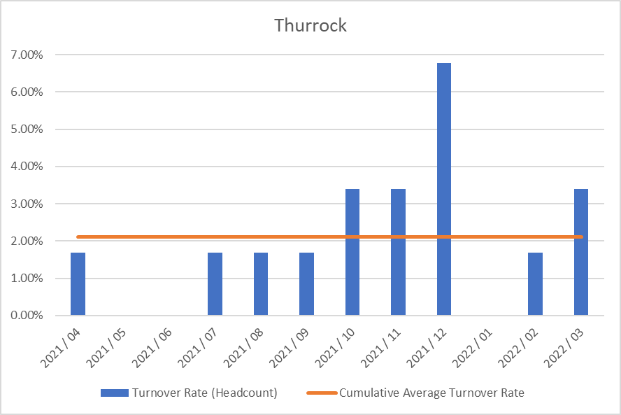

Sickness absence data can be found here: https://digital.nhs.uk/data-and- information/publications/statistical/nhs-sickness-absence-rates

Staff engagement

All of the 5 CCGs in Mid and South Essex have participated in the NHS Staff Survey on a combined basis and the results have been presented across joint Directorates and teams. The CCGs chose Picker to run the survey and the results were published nationally on 30 March 2022.

For the first year, all of the 5 CCGs in Mid and South Essex have participated in the NHS Staff Survey on a combined basis and the results have been presented across joint Directorates and teams. The CCGs chose Picker to run the survey and results were published nationally on 30th March.
The CCGs had an excellent response rate of 78%. Key themes have been shared with the CCGs Executive Team and they have been asked to work with their teams to write action plans in response to the staff survey results. In addition to this, the 5 CCGs formed a staff engagement group in January 2022 and this group is also developing an organisational action plan to look at key themes such as health and wellbeing and diversity and inclusion. This group has representation of staff from across the 5 CCGs and will be tasked with feeding into the organisational development work required as the CCGs transition into an ICB.

There are regular all-staff briefings across the 5 CCGs to communicate key messages around organisational change, as well as operational updates and regular updates on system priorities, for example Covid response updates.

There are also opportunities for staff to meet at a more local level through Alliance briefings as well as team briefings and regular one to one meetings with their manager.

Key themes have been shared with the CCGs’ Executive Team and they have been asked to work with their teams to produce action plans in response to the staff survey results. In addition, the joint staff engagement group formed by the 5 CCGs in January 2022 is developing an organisational action plan to address key areas such as health and wellbeing. This group has representation of staff from across the 5 CCGs and will be tasked with feeding into organisational development work as the CCGs transition into an ICB.

There are regular all-staff briefings across the 5 CCGs to communicate key messages around organisational change, as well as operational updates and regular updates on system priorities, for example Covid response updates.

There are also opportunities for staff to meet at a more local level through Alliance briefings as well as team briefings and regular one to one meetings with their manager.

Staff policies

The CCG has given full and fair consideration to applications for employment made by disabled persons, having regard to their particular aptitudes and abilities.

The CCG has continued the employment of and arranged appropriate training for employees who have become disabled persons during their period of employment.

It is the policy of the CCG to ensure that any member of the CCG Board, its staff and its member practices are able to raise concerns about unlawful conduct, financial malpractice/fraud and risks to the environment and to patient care in line with legislation and good practice. This is covered under our whistleblowing policy.

Equality, Diversity and Inclusion

The CCGs are committed to providing equal opportunities and to avoiding unlawful discrimination and their equality policies are designed to assist the CCGs in putting this commitment into practice. The policy is compliant with the Equality Act 2010 and sets out specific actions undertaken by the CCGs, in the context of employment and people management, in order to fulfil its Public Sector Equality Duty.

All CCG staff will be offered further equality, diversity and inclusion training as part of the transition into the ICB. The offering will include unconscious bias training, awareness of protected characteristics and allyship. A complete review of policies, procedures and practices will also be undertaken to eliminate bias. This will be offered in line with the recommendations of the No More Tick boxes report.

The CCGs will also be working with the Mid and South Essex Health and Care Partnership to develop an organisational and system response to the regional Anti- Racism Strategy and this will be implemented through the Equality, Diversity and Inclusion Sub Group that is accountable to the Mid and South Essex People Board. In addition, an Equality, Diversity and Inclusion dashboard is in development for the MSE Partnerships, which the CCGs will feed into.

As the CCGs transition into an ICB, single Workforce Race Equality Standard and Workforce Disability Equality Standard reports and action plans will be co-produced and regularly monitored to ensure progress against agreed objectives.

The CCGs will also participate in the MSE reciprocal mentoring programme through the NHS Leadership academy - a commitment that has been made by the Executive teams from across the system.

Trade Union Facility Time Reporting Requirements

There was no Trade Union Facility Time in 2021/22.

Health and Wellbeing

The CCGs have benefitted from a comprehensive staff health and wellbeing offer through the Live Life Connected programme, which offers a vast array of health and wellbeing interventions, such as online talks around health topics, online exercise classes, mindfulness and gratitude practice.

In addition, there is also an employee assistance programme available to all staff which provides a telephone support line and counselling, as well as a comprehensive occupational health provision.

During the Covid pandemic, there have also been enhanced national, regional and local offers available to staff, including the regional mental health hubs and the Here For You service is available to all CCG employees.

The CCGs also have a trained network of mental health first aiders and have also provided bespoke Change and Resilience workshops for staff, as well as benefitting from ICS offers such as Kindness masterclasses.

The CCGs are committed to supporting disabled colleagues within the workplace through making reasonable adjustments as well as the use of regular risk assessments and also supporting colleagues’ mental health through the use of stress risk assessments and other support tools.

Health and Safety

The CCG’s Health and Safety Policy sets out our responsibilities and those of employees under the Health and Safety Work Act 1974. Health and safety, fire safety and manual handling are included in the mandatory training programme for all CCG staff.

Risk assessment and inspections identify health and safety issues to enable appropriate action to be taken to reduce risks to staff and other users of CCG premises. Although CCG staff have worked from home since the beginning of the pandemic, regular health and safety inspections, building system tests and maintenance continued throughout the year.

All CCG staff were asked to complete an individual risk assessment to identify their personal level of risk in relation to Covid-19. In addition, the CCG undertook a Covid-19 risk assessment of its premises and developed an associated procedure based on Government, NHS England and Health and Safety Executive guidance, and advice from CCG Infection Prevention and Control staff to ensure that office premises were Covid-19 secure. These documents also received input from staff and union representatives. During the pandemic access to the CCG’s premises was restricted by application of a strict criteria and approval process.

A number of CCG staff were redeployed to provider organisations to assist with the frontline response to Covid-19. Where this was the case, a formal cross-organisational agreement was in place to ensure that all health, safety and wellbeing needs of employees were met throughout their period of redeployment.

Expenditure on consultancy

The CCG spend £253k on consultancy during 2021/22 (2020/21 - £113K).

Off payroll engagements

Table 1: Length of all highly paid off-payroll engagements

For all off-payroll engagements as of 31 March 2021, for more than £245 per day

Numbers of existing engagements as of 31 March 2021 | 2
Of which, the number that have existed:
For less than one year at the time of reporting | 2

For between one and two years at the time of reporting | 0
For between two and three years at the time of reporting | 0
For between three and four years at the time of reporting | 0
For four or more years at the time of reporting | 0

Table 2: Off-Payroll workers engaged at any point during the financial year
For all off-payroll engagements between 1 April 2021 and 31 March 2022, for more than
£245 per day.

Number of temporary off-payroll workers engaged between 1 April 2021 and 31 March 2022 | 4
Of which…
No. not subject to off-payroll legislation | 0
No. subject to off-payroll legislation and determined as in-scope of IR35 | 4
No. subject to off-payroll legislation and determined as out of scope of IR35 | 0
No. of engagements reassessed for compliance or assurance purposes during the year | 0
Of which: no of engagements that saw a change to IR35 status following review | 0

Table 3: Off-Payroll board members/senior official engagements
For any off-payroll engagements of board members, and/or senior officials with significant
financial responsibility, between 1 April 2021 and 31 March 2022:

Number of off-payroll engagements of Governing Body members and/or senior officials with significant financial responsibility during the financial year | 0
Total number of individuals on payroll and off-payroll deemed to be “board members and/or senior officials with significant financial responsibility” during the financial year. | 14

Exit packages

There have been zero Exit Packages.

Payments for loss of office

There has been no payment for Loss of Office in 2021/22.

Compensation on early retirement of for loss of office

Liabilities of £0, due in future years under arrangements to buy out the liability for early retirement over 5 years (31 March 2021: £0).

Payments to past directors

There was no payment made to past senior members in 2021/22.

Parliamentary Accountability and Audit Report
Thurrock CCG is not required to produce a Parliamentary Accountability and Audit Report but has opted to include disclosures on remote contingent liabilities, losses and special payments, gifts, and fees and charges in this Accountability Report at page 103. An audit certificate and report is also included in this Annual Report.

ANNUAL ACCOUNTS

I confirm that the annual accounts adhere to the reporting framework.

Anthony McKeever
Executive Lead for the Mid and South Essex Health and Care Partnership and Joint Accountable Officer for its five CCGs

29 June 2022

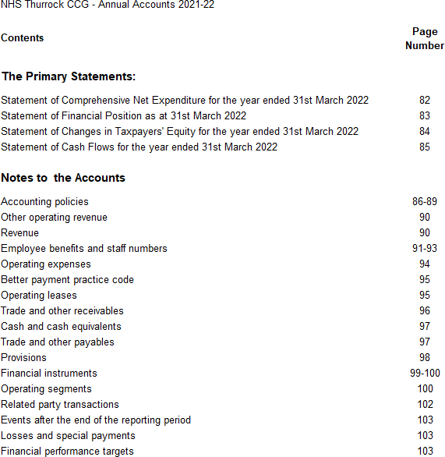

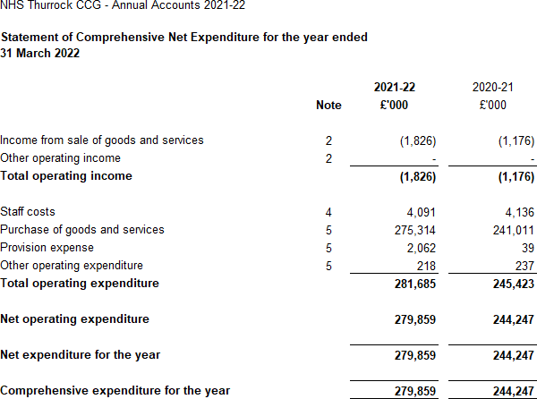

The notes on pages 86 to 103 form part of this statement

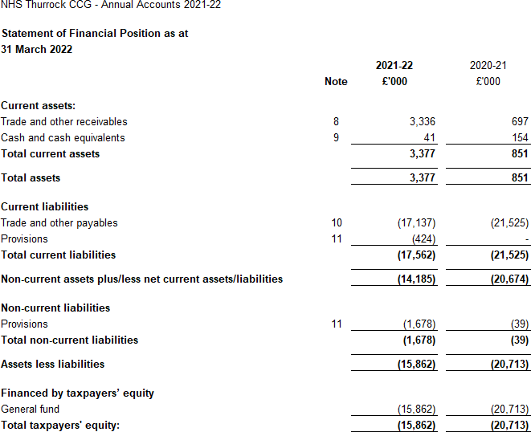

The notes on pages 86 to 103 form part of this statement

The financial statements on pages 82 to 85 were approved by the Governing Body on 20 June 2022 and signed on its behalf by:

Chief Accountable Officer Anthony McKeever

29 June 2022

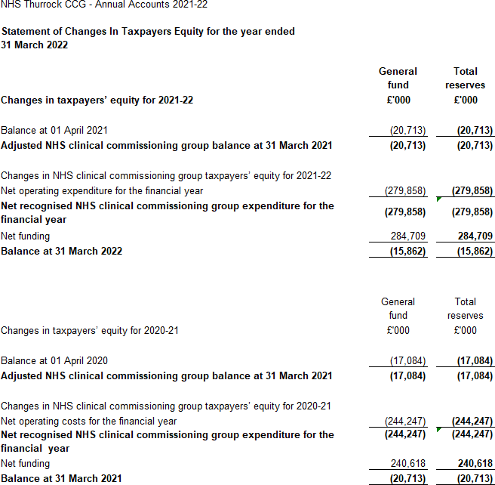

The notes on pages 86 to 103 form part of this statement

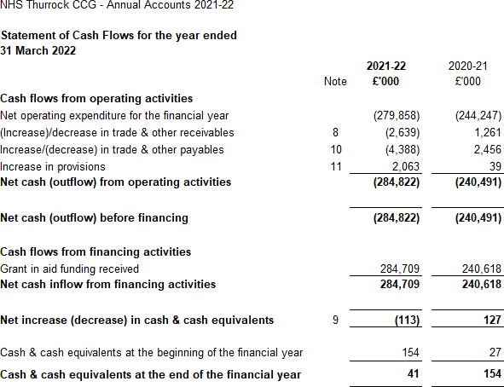

The notes on pages 86 to 103 form part of this statement

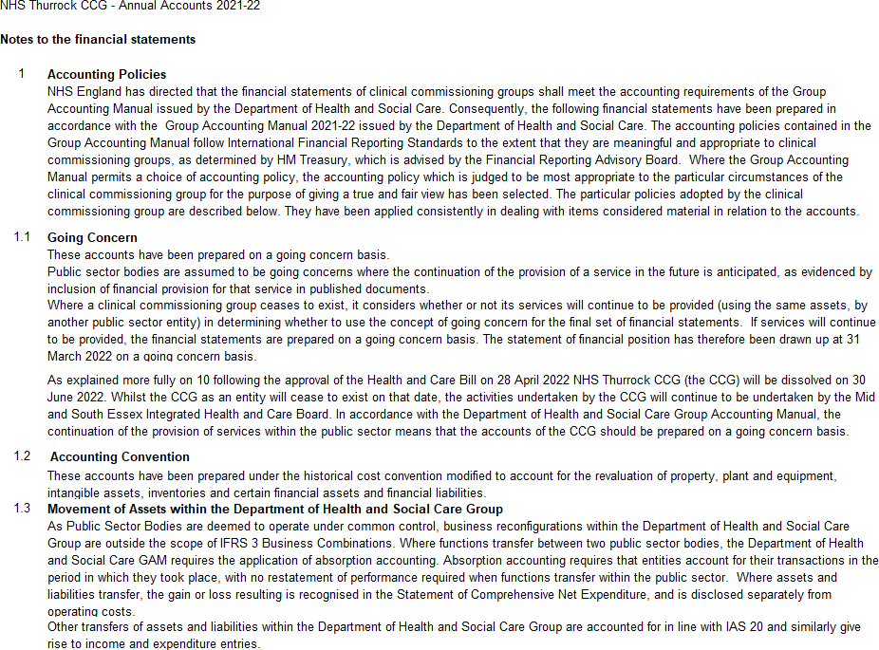
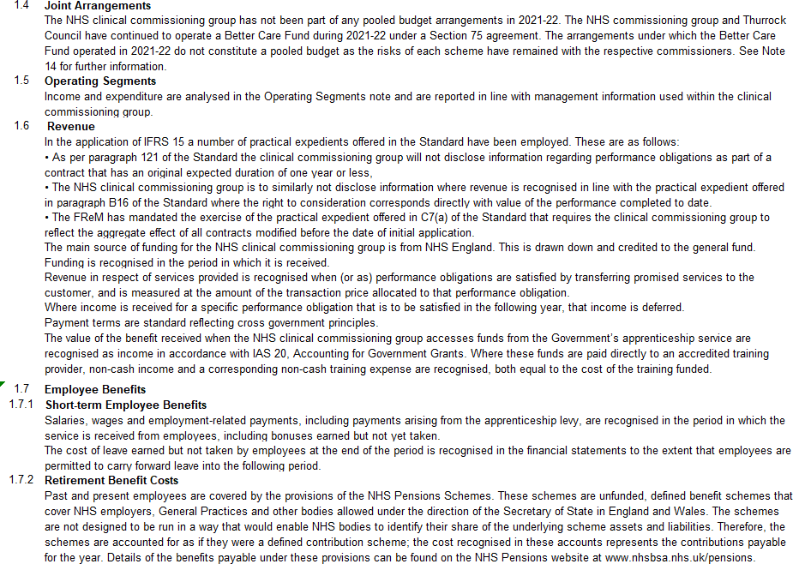

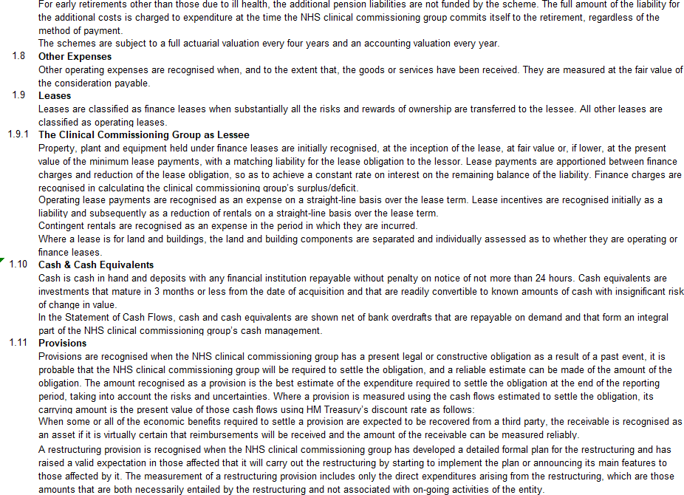
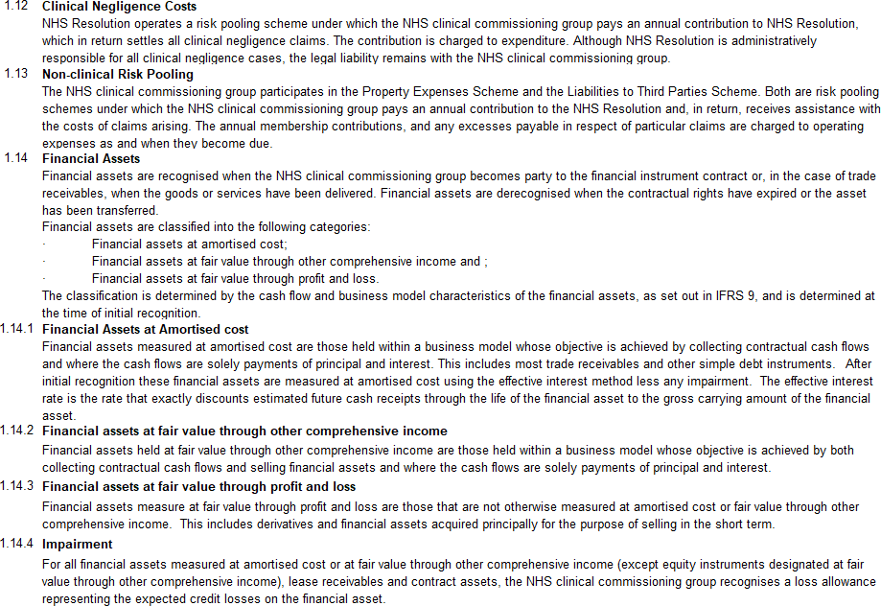

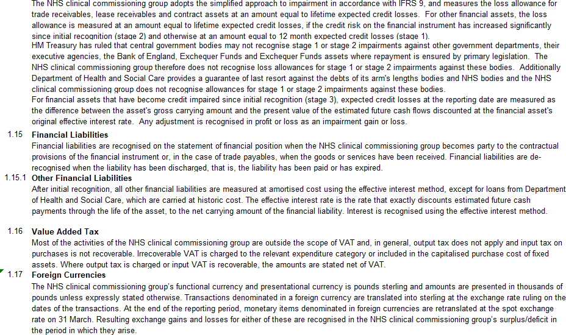
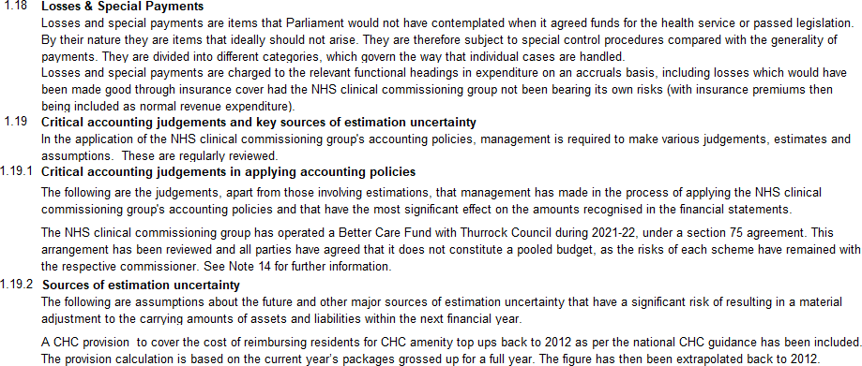

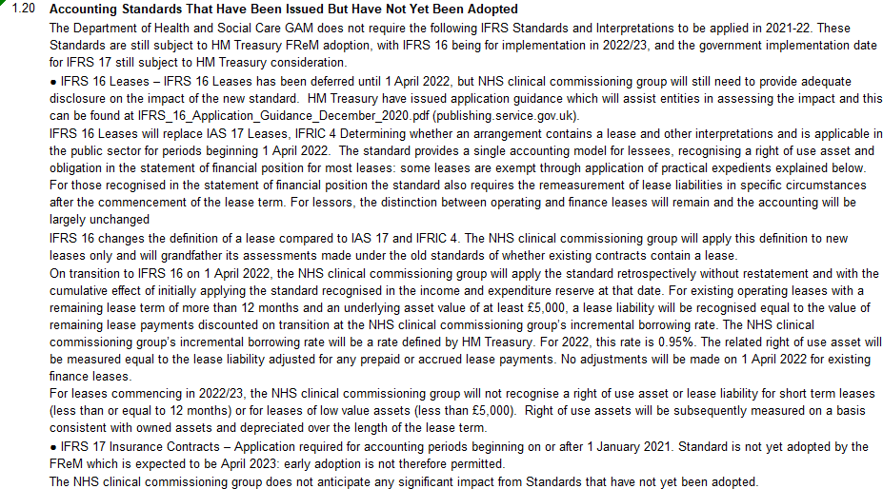

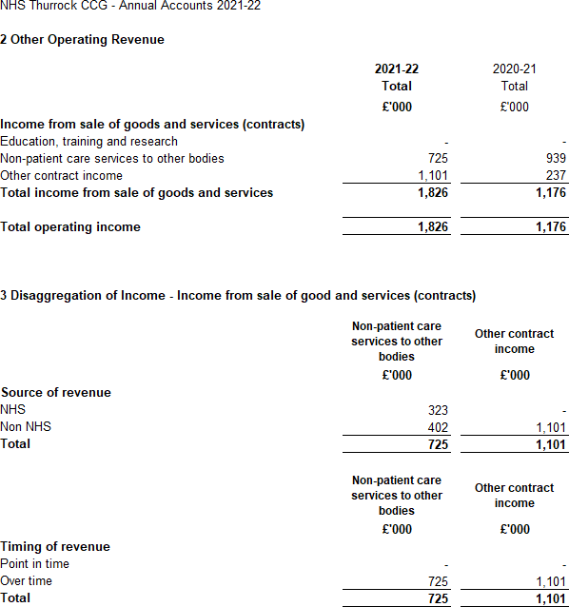

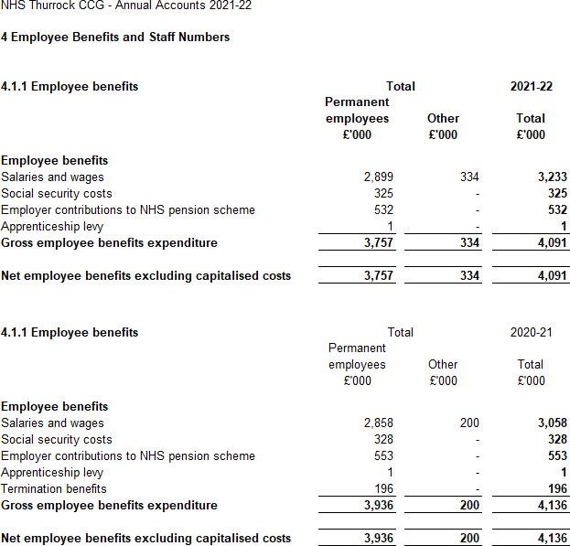

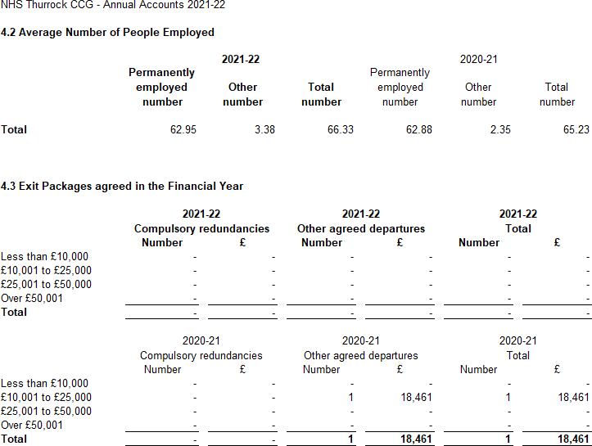

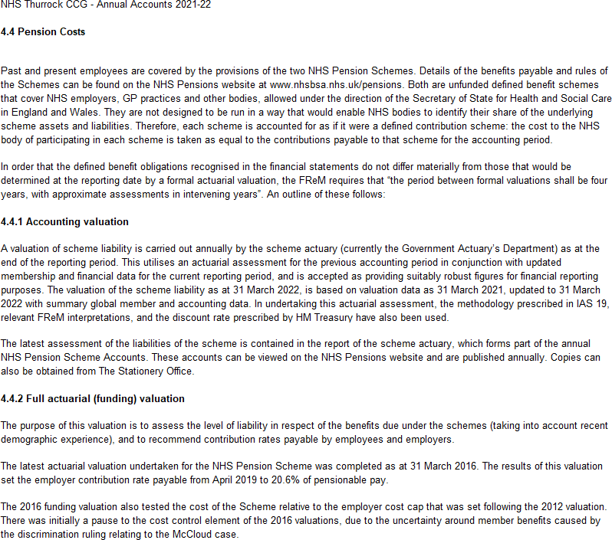
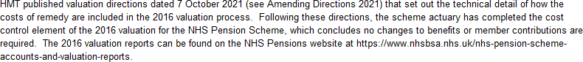

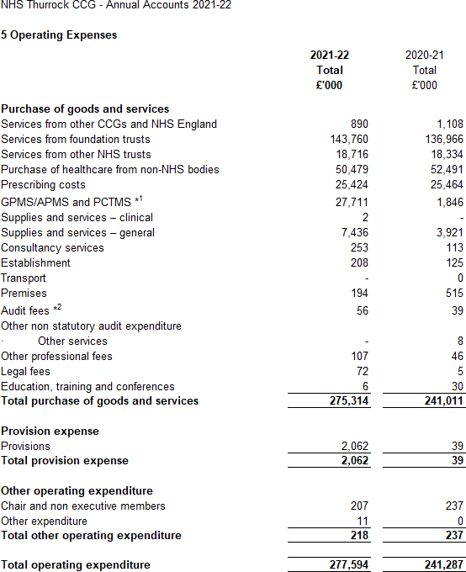
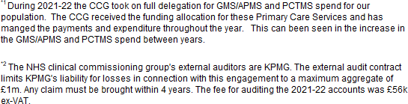

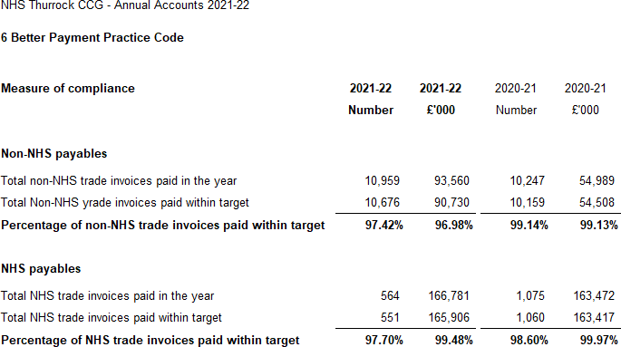

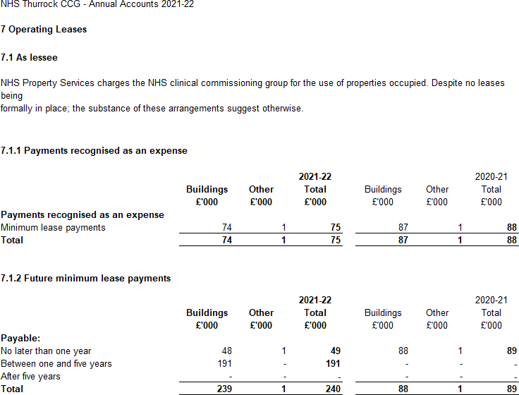

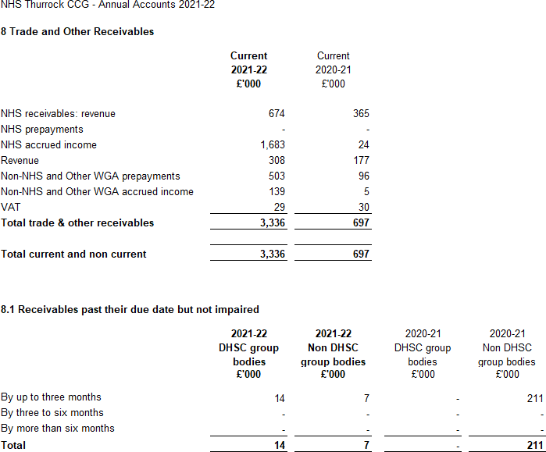

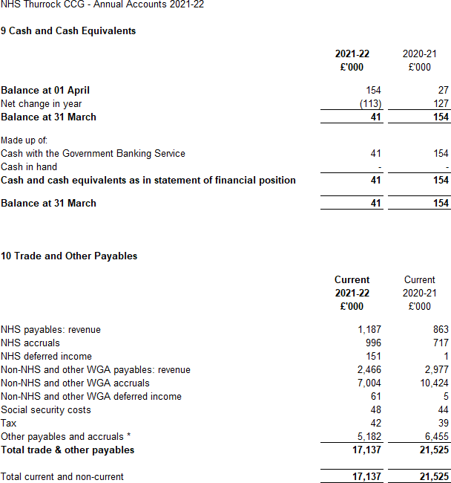

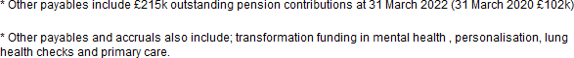

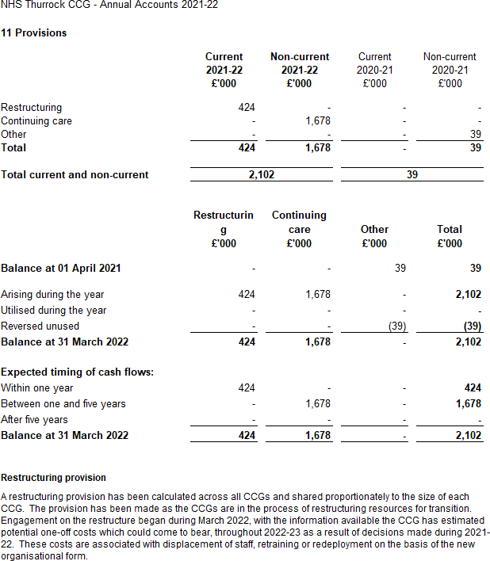
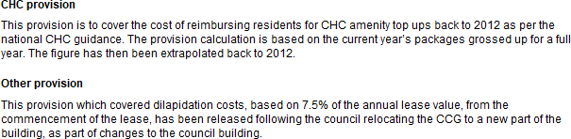

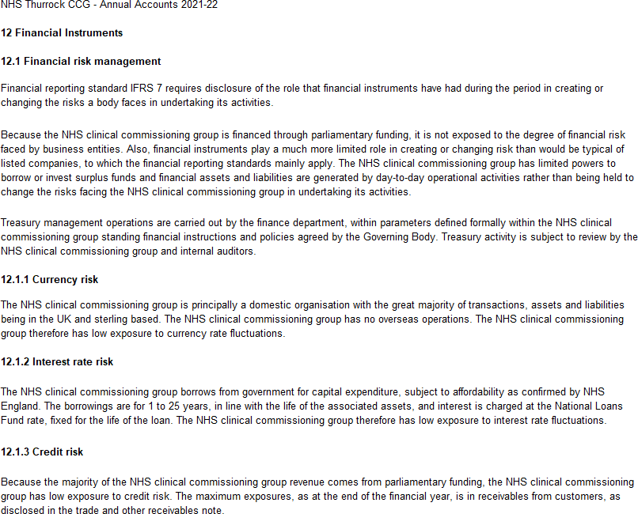
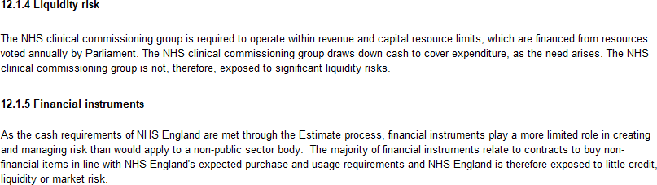

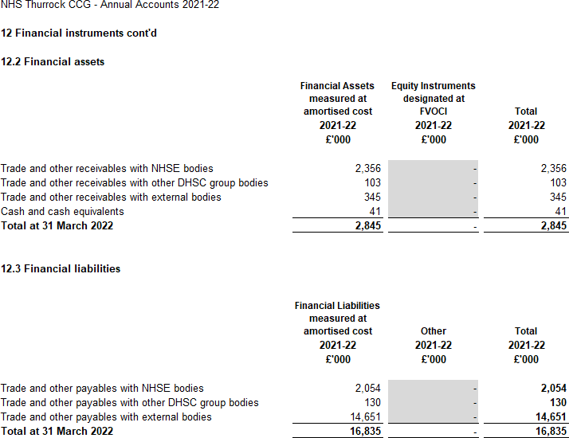

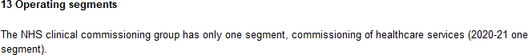

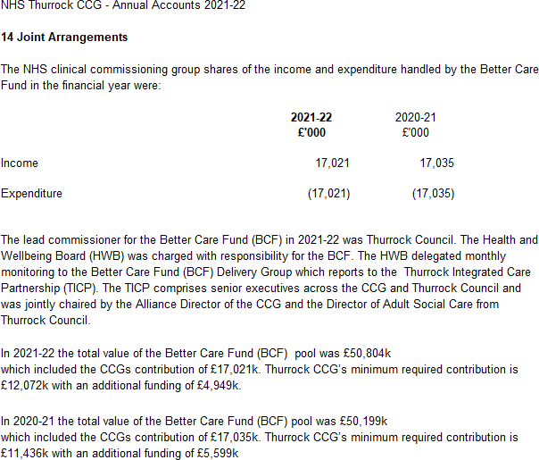

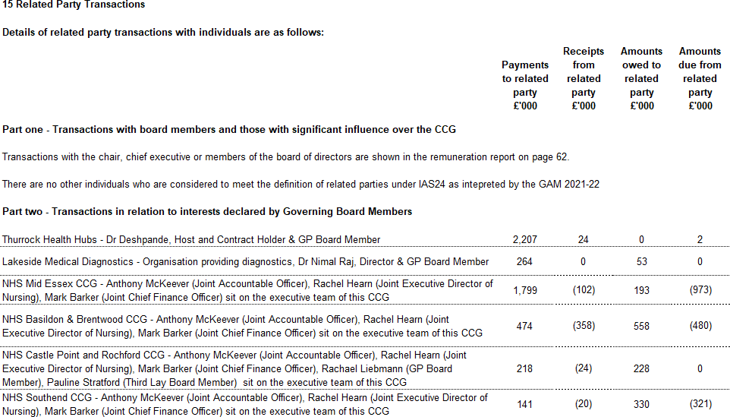
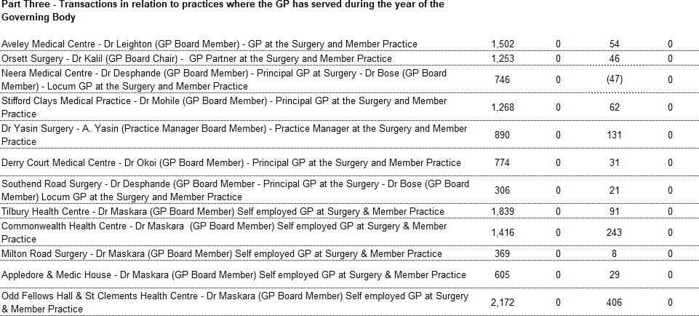
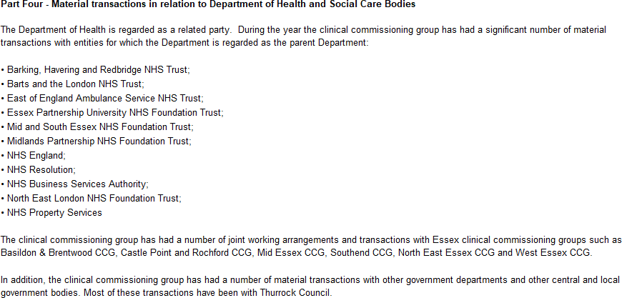

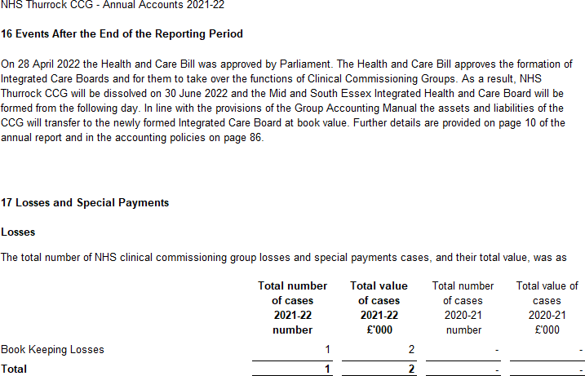

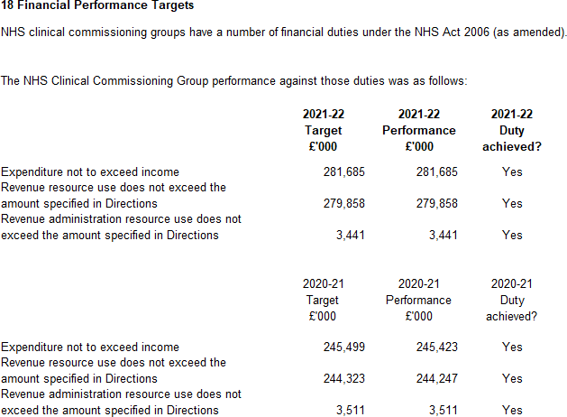

INDEPENDENT AUDITOR’S REPORT TO THE MEMBERS OF THE GOVERNING BODY OF NHS THURROCK CLINICAL COMMISSIONING GROUP

REPORT ON THE AUDIT OF THE FINANCIAL STATEMENTS

Opinion

We have audited the financial statements of NHS Thurrock Clinical Commissioning Group (“the CCG”) for the year ended 31 March 2022 which comprise the Statement of Comprehensive Net Expenditure, Statement of Financial Position, Statement of Changes in Taxpayers’ Equity and Statement of Cash Flows, and the related notes, including the accounting policies in note 1.

In our opinion the financial statements:
- give a true and fair view of the state of the CCG’s affairs as at 31 March 2022 and of its income and expenditure for the year then ended; and
- have been properly prepared in accordance with the accounting policies directed by NHS England with the consent of the Secretary of State as being relevant to CCGs in England and included in the Department of Health and Social Care Group Accounting Manual 2021/22.

Basis for opinion

We conducted our audit in accordance with International Standards on Auditing (UK) (“ISAs (UK)”) and applicable law. Our responsibilities are described below. We have fulfilled our ethical responsibilities under, and are independent of the CCG in accordance with, UK ethical requirements including the FRC Ethical Standard. We believe that the audit evidence we have obtained is a sufficient and appropriate basis for our opinion.

Emphasis of matter – going concern

We draw attention to the disclosure made in note 1.1 to the financial statements which explains that on 1 July 2022, NHS Thurrock CCG will be dissolved and its services transferred to Mid and South Essex Integrated Health and Care Board. Under the continuation of service principle, the financial statements of the CCG have been prepared on a going concern basis because its services will continue to be provided by the successor public sector entity. Our opinion is not modified in this respect.

Going concern basis of preparation

The Accountable Officer has prepared the financial statements on the going concern basis as they have not been informed by the relevant national body of the intention to dissolve the CCG without the transfer of its services to another public sector entity.
They have also concluded that there are no material uncertainties that could have cast significant doubt over its ability to continue as a going concern for at least a year from the date of approval of the financial statements (“the going concern period”).

In our evaluation of the Accountable Officer’s conclusions, we considered the inherent risks to the CCG’s operating model and analysed how those risks might affect the CCG’s financial resources or ability to continue operations over the going concern period.

Our conclusions based on this work:
- we consider that the Accountable Officer’s use of the going concern basis of accounting in the preparation of the financial statements is appropriate;
- we have not identified, and concur with the Accountable Officer’s assessment that there is not, a material uncertainty related to events or conditions that, individually or collectively, may cast significant doubt on the CCG’s ability to continue as a going concern for the going concern period.

However, as we cannot predict all future events or conditions and as subsequent events may result in outcomes that are inconsistent with judgements that were reasonable at the time they were made, the above conclusions are not a guarantee that the CCG will continue in operation.

Fraud and breaches of laws and regulations – ability to detect

Identifying and responding to risks of material misstatement due to fraud

To identify risks of material misstatement due to fraud (“fraud risks”) we assessed events or conditions that could indicate an incentive or pressure to commit fraud or provide an opportunity to commit fraud. Our risk assessment procedures included:

- Enquiring of management, the Audit Committee and internal audit and inspection of policy documentation as to the CCG’s high-level policies and procedures to prevent and detect fraud, including the internal audit function, as well as whether they have knowledge of any actual, suspected or alleged fraud.
- Assessing the incentives for management to manipulate reported expenditure as a result of the need to achieve statutory targets delegated to the CCG by NHS England.
- Reading Governing Body and Audit Committee minutes.
- Using analytical procedures to identify any unusual or unexpected relationships.
- Reviewing the CCG’s accounting policies.
We communicated identified fraud risks throughout the audit team and remained alert to any indications of fraud throughout the audit.

As required by auditing standards, and taking into account possible pressures to meet delegated statutory resource limits, we performed procedures to address the risk of management override of controls, in particular the risk that CCG management may be in a position to make inappropriate accounting entries.

On this audit we did not identify a fraud risk related to revenue recognition because of the nature of funding provided to the CCG, which is transferred from NHS England and recognised through the Statement of Changes in Taxpayers’ Equity. However, in line with the guidance set out in Practice Note 10 Audit of Financial Statements of Public

Sector Bodies in the United Kingdom we recognised a fraud risk related to expenditure recognition.
We did not identify any additional fraud risks. We performed procedures including:
- Identifying journal entries to test based on risk criteria and comparing the identified entries to supporting documentation. These included journals where one side posts to cash and the other side posts to an unusual account, journals entries in period 12 where one side posts to expenditure and the other side posts to an unusual account, and Journals entries containing key words being: fraud, litigation, error
- Assessing the completeness of disclosed related party transactions and verifying they had been accurately recorded within the financial statements.
- Performing cut-off testing of expenditure in the period 1 March to 31 May 2022 to determine whether amounts had been recognised in the correct accounting period.

Identifying and responding to risks of material misstatement related to non-compliance with laws and regulations

We identified areas of laws and regulations that could reasonably be expected to have a material effect on the financial statements from our general sector experience and through discussion with the directors and other management (as required by auditing standards), and discussed with the directors and other management the policies and procedures regarding compliance with laws and regulations.

As the CCG is regulated, our assessment of risks involved gaining an understanding of the control environment including the entity’s procedures for complying with regulatory requirements.

We communicated identified laws and regulations throughout our team and remained alert to any indications of non-compliance throughout the audit.

The potential effect of these laws and regulations on the financial statements varies considerably.

The CCG is subject to laws and regulations that directly affect the financial statements including the National Health Service Act 2006 and financial reporting legislation. We assessed the extent of compliance with these laws and regulations as part of our procedures on the related financial statement items and our work on the regularity of expenditure incurred by the CCG in the year of account.

Whilst the CCG is subject to many other laws and regulations, we did not identify any others where the consequences of non-compliance alone could have a material effect on amounts or disclosures in the financial statements.

Context of the ability of the audit to detect fraud or breaches of law or regulation

Owing to the inherent limitations of an audit, there is an unavoidable risk that we may not have detected some material misstatements in the financial statements, even though we have properly planned and performed our audit in accordance with auditing

standards. For example, the further removed non-compliance with laws and regulations is from the events and transactions reflected in the financial statements, the less likely the inherently limited procedures required by auditing standards would identify it.

In addition, as with any audit, there remained a higher risk of non-detection of fraud, as these may involve collusion, forgery, intentional omissions, misrepresentations, or the override of internal controls. Our audit procedures are designed to detect material misstatement. We are not responsible for preventing non-compliance or fraud and cannot be expected to detect non-compliance with all laws and regulations.

Other information in the Annual Report

The Accountable Officer is responsible for the other information presented in the Annual Report together with the financial statements. Our opinion on the financial statements does not cover the other information and, accordingly, we do not express an audit opinion or, except as explicitly stated below, any form of assurance conclusion thereon.

Our responsibility is to read the other information and, in doing so, consider whether, based on our financial statements audit work, the information therein is materially misstated or inconsistent with the financial statements or our audit knowledge. Based solely on that work:
- we have not identified material misstatements in the other information;
- in our opinion the other information included in the Annual Report for the financial year is consistent with the financial statements; and.
- in our opinion the other information has been prepared in accordance with the requirements of the Department of Health and Social Care Group Accounting Manual 2021/22.

Annual Governance Statement

We are required to report to you if the Annual Governance Statement has not been prepared in accordance with the requirements of the Department of Health and Social Care Group Accounting Manual 2021/22. We have nothing to report in this respect.

Remuneration and Staff Reports

In our opinion the parts of the Remuneration and Staff Reports subject to audit have been properly prepared in accordance with the Department of Health and Social Care Group Accounting Manual 2021/22.

Accountable Officer’s responsibilities

As explained more fully in the statement set out on page 41, the Accountable Officer is responsible for the preparation of financial statements that give a true and fair view.
They are also responsible for such internal control as they determine is necessary to enable the preparation of financial statements that are free from material misstatement, whether due to fraud or error; assessing the CCG’s ability to continue as a going concern, disclosing, as applicable, matters related to going concern; and using the going concern basis of accounting unless they have been informed by the relevant national body of the intention to dissolve the CCG without the transfer of its services to another public sector entity.

Auditor’s responsibilities

Our objectives are to obtain reasonable assurance about whether the financial statements as a whole are free from material misstatement, whether due to fraud or error, and to issue our opinion in an auditor’s report. Reasonable assurance is a high level of assurance, but does not guarantee that an audit conducted in accordance with ISAs (UK) will always detect a material misstatement when it exists. Misstatements can arise from fraud or error and are considered material if, individually or in aggregate, they could reasonably be expected to influence the economic decisions of users taken on the basis of the financial statements.

A fuller description of our responsibilities is provided on the FRC’s website at
www.frc.org.uk/auditorsresponsibilities

REPORT ON OTHER LEGAL AND REGULATORY MATTERS

Opinion on regularity

We are required to report on the following matters under Section 25(1) of the Local Audit and Accountability Act 2014.

In our opinion, in all material respects, the expenditure and income recorded in the financial statements have been applied to the purposes intended by Parliament and the financial transactions conform to the authorities which govern them.

Report on the CCG’s arrangements for securing economy, efficiency and effectiveness in its use of resources

Under the Code of Audit Practice, we are required to report if we identify any significant weaknesses in the arrangements that have been made by the CCG to secure economy, efficiency and effectiveness in its use of resources.

We have nothing to report in this respect.

Respective responsibilities in respect of our review of arrangements for securing economy, efficiency and effectiveness in the use of resources

As explained more fully in the statement set out on page 41, the Accountable Officer is responsible for ensuring that the CCG exercises its functions effectively, efficiently and economically. We are required under section 21(1)(c) of the Local Audit and Accountability Act 2014 to be satisfied that the CCG has made proper arrangements for securing economy, efficiency and effectiveness in its use of resources.

We are not required to consider, nor have we considered, whether all aspects of the CCG’s arrangements for securing economy, efficiency and effectiveness in the use of resources are operating effectively.

We planned our work and undertook our review in accordance with the Code of Audit Practice and related statutory guidance, having regard to whether the CCG had proper arrangements in place to ensure financial sustainability, proper governance and to use information about costs and performance to improve the way it manages and delivers its services. Based on our risk assessment, we undertook such work as we considered necessary.

Statutory reporting matters

We are required by Schedule 2 to the Code of Audit Practice issued by the Comptroller and Auditor General (‘the Code of Audit Practice’) to report to you if we refer a matter to the Secretary of State and NHS England under section 30 of the Local Audit and Accountability Act 2014 because we have reason to believe that the CCG, or an officer of the CCG, is about to make, or has made, a decision which involves or would involve the body incurring unlawful expenditure, or is about to take, or has begun to take a course of action which, if followed to its conclusion, would be unlawful and likely to cause a loss or deficiency.

We have nothing to report in this respect.

THE PURPOSE OF OUR AUDIT WORK AND TO WHOM WE OWE OUR RESPONSIBILITIES

This report is made solely to the Members of the Governing Body of NHS Thurrock CCG, as a body, in accordance with Part 5 of the Local Audit and Accountability Act 2014. Our audit work has been undertaken so that we might state to the Members of the Governing Body of the CCG, as a body, those matters we are required to state to them in an auditor’s report and for no other purpose. To the fullest extent permitted by law, we do not accept or assume responsibility to anyone other than the Members of the Governing Body, as a body, for our audit work, for this report or for the opinions we have formed.

CERTIFICATE OF COMPLETION OF THE AUDIT

We certify that we have completed the audit of the accounts of NHS Thurrock CCG for the year ended 31 March 2022 in accordance with the requirements of the Local Audit and Accountability Act 2014 and the Code of Audit Practice.

Emma Larcombe
for and on behalf of KPMG LLP, Chartered Accountants Cambridge

30 June 2022

