Mid and South Essex Finance Strategy

# Document Control:

Date: 22/06/2022  
Version: v12

# Contents

1. Vision 5

2. Ambition 6

3. System Overview 8

4. Financial Sustainability Overview 10

5. Future Financial Outlook 13

6. Financial Leadership 15

7. System Allocation 17

8. Financial Sustainability Strategy 18

9. Stewardship supported by the System Financial Framework 20

10. System Reporting and Accountability 23

11. System Capital and Investment 25

12. Risks and Opportunities 27

13. Approaching managing funding across sectors 29

14. Approach to Efficiency 30

15. Approach to Costing 32

16. Approach to Financial Risk Management 34

17. Approach to Cash Management and System Contracting 35

18. Skills and Capability to deliver the transition 36

# Introduction

The legislative proposals expected to be formally implemented from 2022 present our Mid and South Essex Integrated Care System (ICS) with an opportunity that is once in a generation. The System grew in its collective resilience to the demands of COVID-19, and, together with new System thinking and funding flows, local organisations are collectively looking to rebalance how funds are committed to achieve long term financial sustainability.

Our Mid and South Essex (“MSE”) System receives in excess of £3.2bn of funding to deliver health and care across our System. System funding of £2.2bn relates directly to the delivery of health care and £1bn of Council income associated with the provision of adult social care, children & young people, and public health services. The system is financially and operationally challenged.

The figure below sets out some of the challenges we are facing now but also over the next 5 years but operationally and financially.

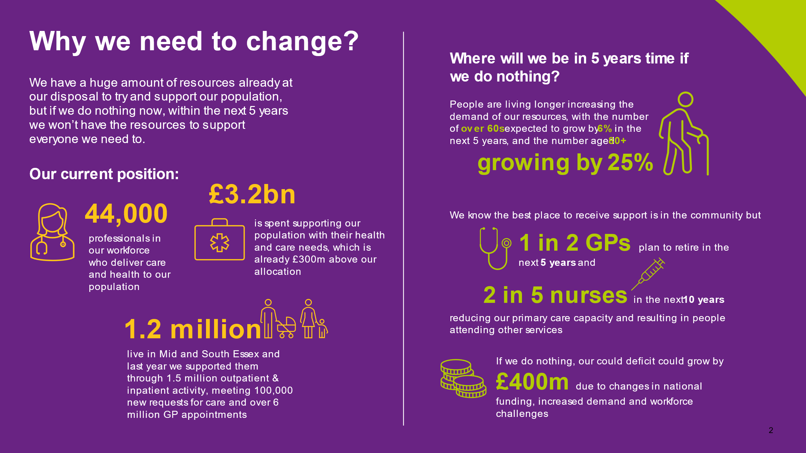

Creating the flexibility for investment into our population living well is key as evidence demonstrates 80% of the determinants of healthcare needs are due to factors not directly related to care provided.

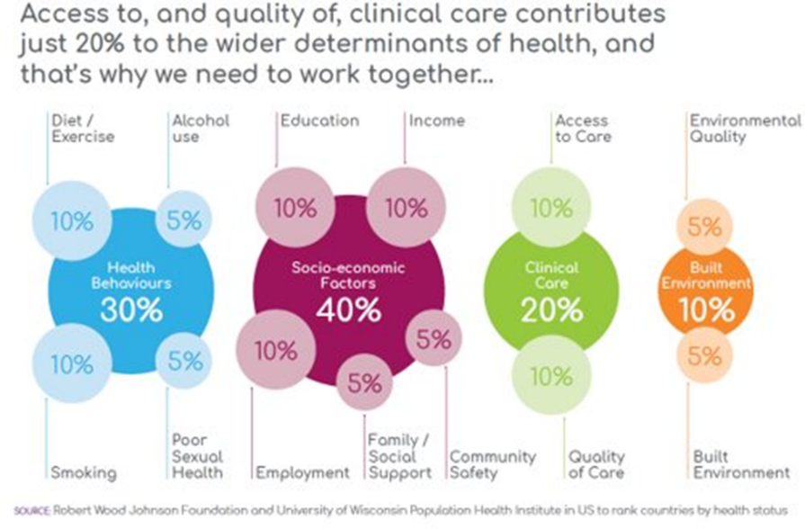

The formation of the Integrated Care System (“ICS”) facilitates a new way of collaborative working, enabling operational and financial challenges to be managed more effectively as a collective partnership, driving improvements at scale. This was hugely beneficial during the pandemic and the system took significant steps towards working better together taking a whole-system approach. We must build on the core principles we are committed to:

* to operate fairly and transparently,
* to operate both collectively and individually,
* that our shared focus is on the benefits for our residents and patients.

Underpinning the principles, we recognise the need to manage risk effectively as a system. However, there is still some way to go towards partners working as a joined-up entity.

The funding envelope for MSE presents the ICS with an opportunity to transform services, reduce health inequalities and improve the wellbeing of its local population. However, to achieve this effectively we must plan to deliver recurrent and sustainable efficiencies as a system to mitigate an enduring financial deficit and avoid impending financial challenges following funding announcements and more importantly create the headroom to resource change through transformation and innovation.

This document sets out the MSE ICS Financial Strategy in four parts:

* Our vision and ambition (‘The why’)
* Defining the potential (‘What’)
* Framework for aligning future resources (‘The how’)
* Managing the transition (‘The when’)

# Our Vision and Ambition

## Vision

As the MSE system we are committed to achieving the triple aim:

* Better population health;
* Better quality of care; and
* Financially sustainable services.

To achieve the best possible outcomes for our population we need to think differently to prevent avoidable ill health and as partners act as one through transparency and collaboration.

The finance strategy is a key enabler for the way we use our money to deliver our system ambitions.

## Ambition

The triple aim is our commitment, but our ambition for Mid and South Essex is set out below:

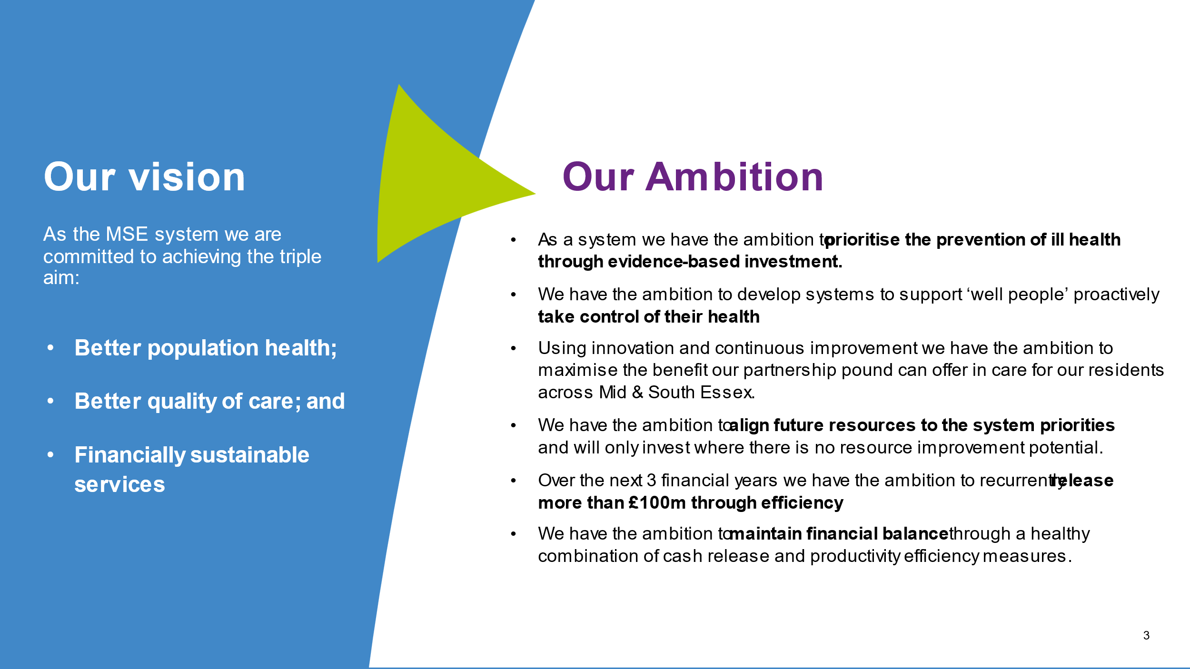

Historically our system has delivered an ‘acute centric’ model of care which is not sustainable and not always the best model to improve population health outcomes. The emergency pathway often results in a higher long term care dependency and unnecessary patient experiences. **As a system we have the ambition to prioritise the prevention of ill health through evidence-based investment.**

The consequence of decades of care being built around ill health results in infrastructure geared towards the unwell. **We have the ambition to develop systems to support ‘well people’ proactively take control of their health.** Our Alliances, supporting our Primary Care Networks are critical to engage with our residents so we can achieve this significant shift in the way we use our resources.

We have the potential with the partners and the skills in our system to change the way we are working, through programmes such as Stewardship. **Using innovation and continuous improvement we have the ambition to maximise the benefit our partnership pound can offer in care for our residents across Mid & South Essex.**

The system financial framework is functioning with a system operating budget and a risk management approach which enables a stable planning footing. **We have the ambition to align future resources to the business priorities and will only invest where there is no resource improvement potential.**

The financial sustainability review highlighted the opportunities we have as a system to optimise resource improvements. **Over the next 3 financial years we have the ambition to recurrently release more than £100m through efficiency.** Delivering these improvements involves the ambition to reduce avoidable demand for acute services, reduce our reliance on bank and agency staffing and as a system support the downsizing of acute capacity through productivity measures which can only be achieved through the stabilisation of legacy activity and transforming the ways of working.

The reset of national financial allocations has enabled the system to plan for a breakeven position. **We have the ambition to maintain financial balance through a healthy combination of cash release and productivity efficiency measures.**

As a system we are committed to achieve financial sustainability with the ambitious goal of achieving recurrent balance and improved financial resilience by the end of 2024/25. We have a vibrant, experienced, and skilled finance community working across partners to maximise the MSE partnership pound.

## System Overview

The Mid and South Essex Health and Care Partnership (HCP) serves a population of 1.2m people.

We comprise:

* 1 upper tier Local Authority (Essex County Council) working with 7 district authorities;
* 2 unitary Local Authorities (Southend-on-Sea Borough Council and Thurrock Council);
* 1 Acute Hospital Trust (Mid & South Essex NHS Foundation Trust (MSEFT));
* 3 Community and Mental Health providers (Essex Partnership University Foundation Trust (EPUT); North East London NHS Foundation Trust (NELFT); and Provide Community Interest Company (Provide);
* 1 Ambulance Trust (East of England Ambulance Services Trust (EEAST);
* Pre-establishment of Integrated Care Body (ICB) 5 Clinical Commissioning Groups (CCGs);
* 3 Healthwatch Organisations; and
* 9 Community and Voluntary Sector Organisations.

Our 4 Alliances (Basildon & Brentwood, Mid-Essex, South East Essex and Thurrock) and 27 Primary Care Networks (covering 149 GP practices) are critical to our work.

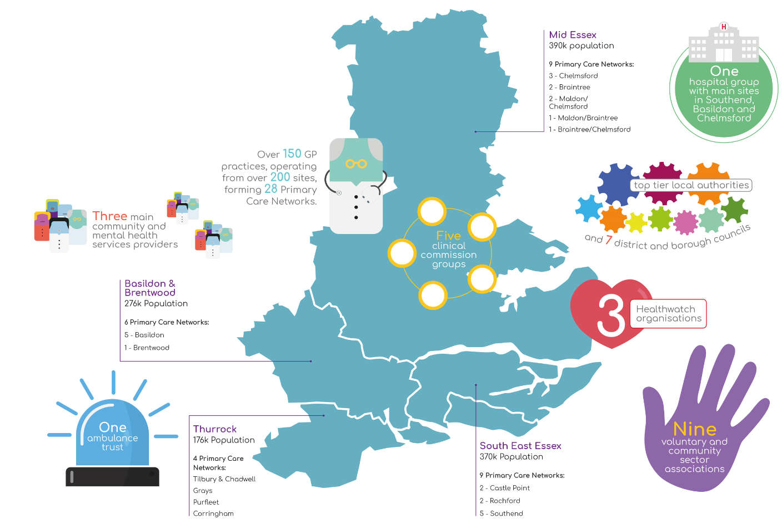

The Partnership Board has an independent, non-executive chair (Professor Michael Thorne CBE).

Our Partnership has a single Executive Lead and Accountable Officer (Anthony McKeever).

Executive leads from statutory partner organisations across MSE come together into the System Leadership Executive Group.

Joint Accountability for quality and safety, performance and system transformation are overseen by a System Oversight and Assurance Group, attended by partner organisations including NHSEI local director, and chaired, alternately, by the Joint Accountable Officer/Partnership Executive Lead and the NHSEI Director of Strategy and Transformation.

A key part of our system governance is the established System Finance Leadership Group which is pivotal in enabling system collaboration. An annual work plan is agreed by the Health & Care Partnership Board which sets out a number of the key priorities, including the development of an ambitious financial framework for our system.

Another key forum is the Finance & Investment Committee, which is a formal committee of the ICB, whose purpose is to provide oversight and assurance to the Board in the development and delivery of a robust, viable and sustainable financial plans and associated financial performance in relation to services commissioned by the ICB, mitigating risk as appropriate in the context of system working.

# Defining the potential

## Financial Sustainability Overview

Many partners within the System have had a long standing recurrent underlying financial challenge for many years. In April 2021 partners collectively commenced a financial sustainability review. This review considered the scale of the financial challenge across the system, the drivers of high cost at operational, strategic, and structural levels, and designing interventions required to address these challenges.

Using the 2019/20 funding flows and baseline the review concluded five drivers behind high cost.

A similar detailed drivers of deficit review needs to be progressed in local authority partners to ensure a full understanding of the system financial challenges and increased clarity on how we can work most effectively together to address these. These reviews need to continue to happen to refresh our understanding and ensure we are working collectively together on the priority areas.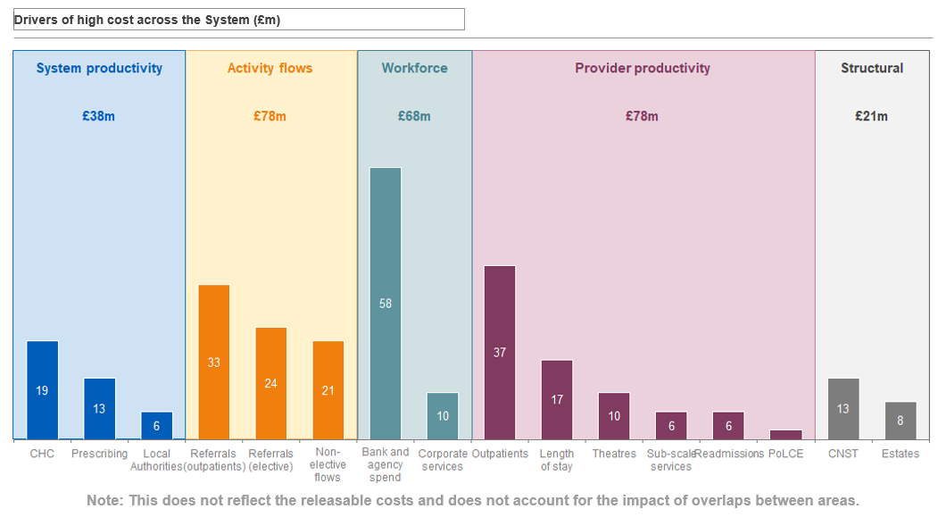

The identified £6m local authority saving is not a directly realisable health saving, however, to achieve this requires system partner collaboration.

Interventions were developed on the basis of extensive hypothesis put forward by system partners and tested with relevant benchmarking comparisons and best practice. Five intervention themes were identified that address the underlying drivers of deficit and move the System towards financial sustainability. Themes are as follows:

1. Delivering the right care at the right time to improve pathway efficiency;
2. Effectively supporting the management of population health in lower cost settings;
3. Improving productivity to deliver activity at a lower cost;
4. Moving towards system-wide corporate services to remove duplication; and
5. Embedding financial and operational performance management.

Each intervention has been designed to address the financial challenges identified. At the time of undertaking the work across all of the intervention’s releasable costs of c£141m have been identified, and £29m of estimated replacement costs potentially required to set up/expand services to release these savings. The net benefit of transformation savings expected through system collaboration is assessed as c£112m, [which includes £6m of identified long term residential opportunities which would support LA partners with improvement against their underlying deficit].

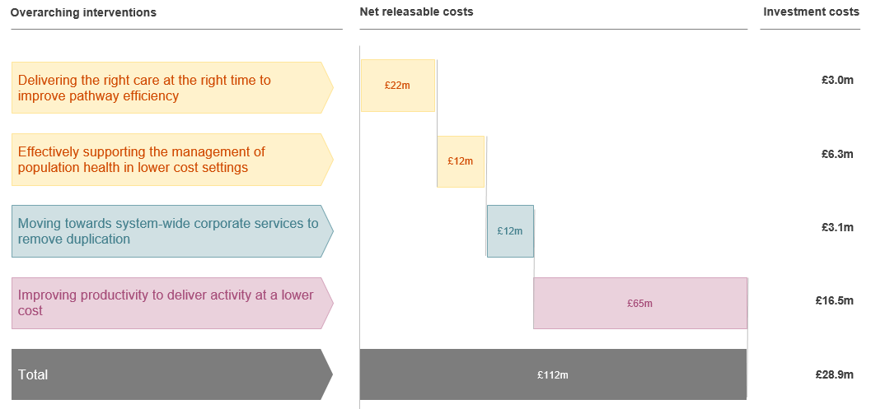

In summary, the review shows that:

* A concerted and collaborative effort is required to address the number of referrals made, both into and within the acute system. It is acknowledged that our implementation of GP triage and Advice and Guidance has been sub-optimal in the past therefore there is confidence that this presents us with opportunity.
* It shows that once patients are in the acute system there is scope for improved efficiencies with regards to elective pathways (Outpatients and Theatres). This has potential to reduce time spent in hospital ((elective and non-elective length of stays, and number of outpatient follow-ups). Additionally, improving productivity of community services will impact on outpatient follow-up.
* The above findings, alongside the higher-than-average staff-vacancy levels, increase the requirement to utilise temporary staffing via bank and agency. Except for Agenda for Change bank staff, agency staff come at a premium cost to substantive staff, thus contributing to the workforce driver of our high costs.
* In the community, the review has confirmed we have varied provision of Continuing Health Care (CHC) services, and differing costs of packages. Applying a standardised approach and collating our purchasing power as one ICS will realise savings in this area.
* Our prescribing costs are higher than the national average (adjusted for demography) and variations in practice have been highlighted. Prescribing costs in relation to Opioids has been identified as having significant opportunity to realise efficiencies.

It is key we work collaboratively as a system to make sure that where costs are moving between organisations so that they are in the correct place, we work together to address any financial impact this has on the system as a whole.

## Future Financial Outlook

There is an underlying deficit in the system now, and if we do nothing this position is expected to deteriorate in the coming years. However, based on actions the system is taking, by the end of the strategy horizon the system expects to manage and mitigate risks that would result in this position deteriorating and using innovation and transformation expect the position to improve.

People are living longer increasing the demand of our resources, with our overall population expected to grow by 2.5% over the next 5 years, the number of over 60s expected to grow by 6%, and the number aged 80+ growing by 25%.

With this growing demand, the question of how we continue to deliver everything that we have for our population becomes increasingly important.

The increase in demand coupled with changes to funding and increased cost pressures will see our expenditure grow far quicker and greater than the income for the system. If we take no actions to deal with these factors, then in the “do nothing” scenario, the underlying deficit in the system is expected to grow by an additional £300m over the next 4 years.

Health and care partners are required to balance their budget each year and so savings will need to continue to be identified to balance budgets.

We have a huge amount of resources already at our disposal to try and support our population, but if we do nothing now, within the next 5 years we won’t have the resources to support everyone we need to. We need to change our approach now.

# Framework for Aligning Future Resources

## Financial Leadership

The finance leaders across system partners are uniquely placed to model behaviours essential to these core principles and support clinical leaders in developing their own skills so together we can achieve the shared ambition.

We are committed to work together as equal partners. At the start of our Integrated Care Partnership journey local government’s regulatory and statutory arrangements are separate from those of the NHS and therefore financial control and risk managed independently. As our partnership develops and we gain further understanding of how to unlock the benefits of collaboration for our population, we aspire to manage the partnership pound as one, maturing from these separate arrangements.

Whilst financial arrangements are independent, partners across Mid & South Essex have agreed to align relevant planning, investment, and performance improvement to reflect our ICS design principles to benefit our local population most effectively.

Covering areas such as:

* Revenue
* Capital
* Asset Management
* Digital
* Costing to ensure value for money in the purchase of healthcare

We will develop the skills across our workforce to increase understanding of each of our roles in achieving the ‘triple aim’ ensuring appropriate stewardship in the management of, and accountability for, our system resources. This will be achieved through the development of a thriving community of skilled specialists from across the system, with expert in areas such as finance, analytics, digital, legal, commercial and estate, who will support the capabilities of our stewards, with a shared goal to improve our population health.

Our vision can be summarised into some financial principles which we are committed to displaying across our system:

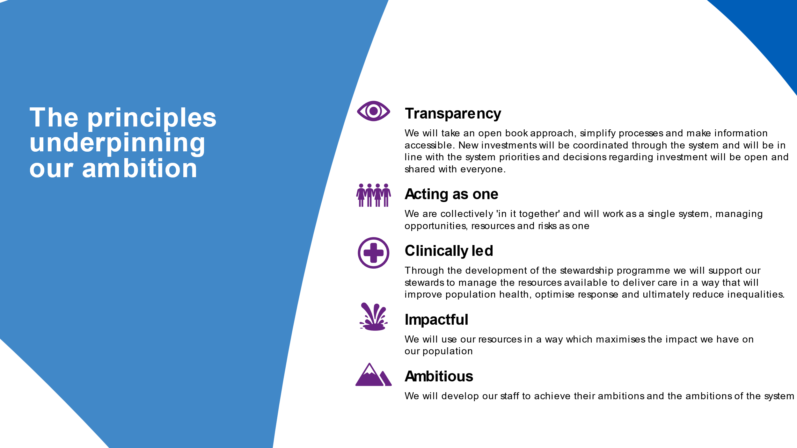

## System Allocation

Through the ICB, MSE are allocated a healthcare resource to secure the provision of healthcare services for the local population. The ambition is for this resource to be used in a way that achieves the best outcomes for patients, securing the maximum amount of care within the available resources.

At the time of drafting the System Finance Strategy the allocations for ICS for 2022/23 have been published, although acknowledged that there will be allocation changes during the financial year especially for additional transformational programmes. For 2022/23 the total recurrent allocation is £2,123bn and the non-recurrent allocation is £109bn. In addition to this allocation, there are other income streams received into MSE through NHS provider partners where care is provided beyond the system envelope which generates a revenue. This is currently planned for 2022/23 to be £0.6bn. In addition to this local authority income relating to the residents of MSE is a further c£1bn.

Included within the responsibilities of an Integrated Care System is the management of resource across the system. The system reviewed a paper in January 2021 considering the approach of healthcare resource allocation. This concluded that whilst MSE maintains an underlying deficit the ability to create a pace of change for investment to target improvements in population health would be challenging. The system operating budget and financial framework was endorsed as the direction of travel. The basis of the financial framework is that system budgets for services are based on primary cost incurred to provide care, effectively managing delivery on the basis of ‘open book’ accounting. The financial sustainability review has identified areas where costs could be reduced within the system and the principle of budgeting for cost means that the system will effectively be moving budgets in a way that is in a transparent and risk shared way. It will also facilitate the ability for new resources to be directed to priority areas on the basis that primary cost of delivery care has been budgeted for transparently across the system.

The considerations of a system allocation approach also highlighted the need for a clearer picture of what the optimum resources should be if it was to achieve a targeted level of resource to optimize population health by disease (service) area. Operating through a stewardship model will enable insights to be gained and actions to be taken to improve this understanding.

## Financial Sustainability Strategy

Finance transformation alone will not address the underlying deficit across health partners. In order to successfully address the financial challenge across the System, the delivery of substantial transformational savings is required. There are three strands to the strategy:

* Transformation delivery from opportunities identified within the Financial Sustainability review (£106m excluding the £6m relating to residential long-term placements)
* ‘Business as usual’ (BAU) efficiency requirements through productivity realisation against baseline budgets from 2021/22;
* Council resource allocation plans being realised to ensure system wide resilience; and
* Continued receipt of national Sustainability Funding (c£100m) aligned to MSE.

#### Transformation

The financial sustainability review has highlighted a number of opportunities. The delivery of this transformation will be a multi-year programme and requires transparency and collaboration of system partners. A System Efficiency Programme Board co-ordinate the delivery of the financial sustainability programmes, including targeted transformational productivity and is accountable to the System Oversight Assurance Group.

The expectation is that the delivery through transformation will be achieved over the 3 years by the end of 2024/25 with an ambition of releasing health net costs of between £100m - £106m.

On the basis that clinically led stewardship groups across the system manage budgets within the approved envelope, it is expected that budgets will roll forward to deliver, as a minimum, the same levels of service with a continued drive for improvement. This approach would expect budget reductions from the delivery of the transformational finance sustainability work to be transacted transparently.

From a cross council and health perspective, opportunities to explore collaborative working and joint savings initiatives will be progressed, particularly in areas where there are clear dependencies or where a change to a more integrated approach would deliver system wide benefits.

#### In year ‘Business as Usual’

The system will co-ordinate the planning of resources on the basis of a System Operating Budget. This approach will facilitate partners to operate in a transparent way and to understand and manage the financial risks of delivery. This methodology relies on the collaboration of partners to affect the means to achieve this, but also requires system partners to manage the resources in line with the approved plan. This is essential to avoid undermining the ability to manage system financial risk.

In-year efficiency requirements will take the form of improvement in general productivity and sound financial management to mitigate the need for continued unplanned growth in investments which, as a system that holds an underlying deficit, cannot be sustained. It is planned to move away from the traditional ‘salami slice’ approach to savings and consolidate our delivery into a single system transformation, whilst at the same time individual partners deliver improvements in responsiveness through local productivity and sound financial management. Service changes will be impact assessed as a system.

Beyond reductions from finance transformation programme delivery, system partner budgets will only be adjusted for material stepped changes in activity in a planned way, for example procurement savings, or decommissioning/varying of services. Investments will require a business case to be signed off through system governance. This approach is on the basis that partner budgets will equal contract values budgets being set as part of the system planning phase. Reductions will result in a budget movement across the system in line with the principles of the System Operating Budget. Budgets will be reviewed annually according to Budget Setting Principles, which will increasingly be aligned across system partners.

The ambition is that marginal budget reductions will no longer be applied generically across services in the future. Efficiency programmes will be targeted and managed on a service line basis through a Stewardship programme approach, led by clinical stewards across the system.

#### Sustainability Funding

Prior to COVID the system was advised that £89m of Financial Recovery funding and £10.7m of Marginal Rate Elective Threshold (MRET) funding would be available totalling c£100m. This resource is an essential part of the sustainability plan. As demonstrated from the independent financial sustainability review, even with the maximum benefits identified through transformation and the system managing in year growth, there remains a gap of c£100m.

The 2022/23 Financial Framework has supported the system in addressing this strand of the sustainability strategy. As part of the system allocation the ‘Top up’ funding (previously MRET and Financial recovery funding) has now been baked into the allocations. Over time systems are expected to move into spending against a redefined target allocation for each system nationally. For 2022/23 Mid & South Essex has been determined to be 5.5% above target for core allocations and 0.7% above target for Primary Medical Care services. As a result, a ‘convergence’ reduction of 1.0% and 0.2% respectively has been deducted from 2022/23 allocations. This adjustment will continue annually until the system funding is aligned to target allocations.

## Stewardship supported by the System Financial Framework

Stewardship is a model being initiated across MSE which focussed on multi-professional, cross-organisational frontline teams, working together to get the best out of health and care resources.

It was initiated through learning that occurred during COVID, bringing together partners to deliver care for residents without the barriers of organisational boundaries. The concept initially started by looking at how we could consider joining up resources and changing accountability structure to remove barriers and inefficiencies. This sparked a programme to engage with clinical leaders across organisations to consider how we could adopt the concepts set out in in an article “Developing a culture of stewardship: how to prevent the Tragedy of the Commons in universal health systems”

The aim is for stewards to take on collective responsibility, on behalf of all Partnership organisations, for stewarding resources within their care area e.g., Stroke, Ageing Well, Cancer etc. The goal is to deliver on the Triple Aim.



**Intelligence**

* Population health management – using integrated data to improve health and wellbeing
* Evidence based practice

**Responsibility**

Sharing responsibility for health and care through:

* Coal-face staff leading and accountable for their Care Areas
* Multi-organisational, multidisciplinary team members
* Host organisation model
* Patient and resident involvement in defining value

**Resources**

* Pooling partnership resources
* Care area operating budgets

Stewardship



The narrative that we set out with stewards reflects that Health and Care Partnership resources are like that ‘Common Land’, underpinning the way in which our population can lead healthy lives. Together as a Health and Care Partnership, we will adopt a culture of Stewardship, taking collective responsibility for how that common resource ((e.g., funding, workforce, and infrastructure) is used and applied in a fair and transparent way to the maximum benefit of our population.

From experience the shared resource is often fragmented, divided and sub-divided into smaller plots, down to departmental or sub-specialty level. The sense of shared, wider responsibility and potential to flexibly align and/or re-align resources with evolving population needs are lost in the competition for plots – the ‘Tragedy of the Commons’.

A culture of Stewardship, sharing responsibility for ensuring that our Partnership’s common resource is used for the common good, is required to release its potential and to re-focus resource use on addressing our residents’ greatest needs.

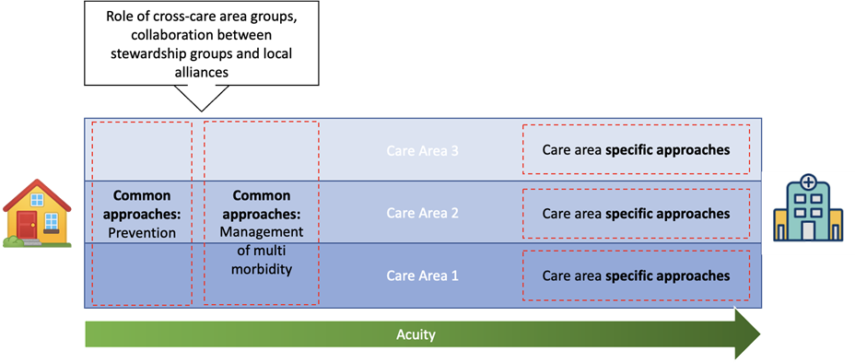There is commitment to ensure that Stewardship Teams can identify opportunities to improve how resources are used, including specifying common clinical standards and policies across the system. This commitment requires our system to connect information, not just financial related, but all information relating to the delivery of the service areas, in a transparent way, so that we can collectively optimise the delivery and improve outcomes for our residents.

In July 2021 we published the first edition of our system budget book, which has set out by service line indicative budgets and other key metrics. Reporting arrangements are maturing to facilitate this information being shared regularly to provide necessary insights to inform, influence and impact change behaviours.

Work is actively underway with the six pilot areas to ensure accurate alignment of costs to the most appropriate stewardship area, as well as developmental work for stewards to understand the breadth of resources that would be at their disposal under new ways of working.

All six areas are identifying specific pathways within their care areas – i.e. Early Supported Discharge for Stroke and Asthma within Respiratory – to focus on improvements across the triple aim during this development period.

We will be developing this work through the support of host organisations from within Mid & South Essex to move to practical implementation with an ambition to have 25 care areas operational by 2025.

## System Reporting and Accountability

Governance includes regular collective oversight and assurance via the System Oversight & Assurance Group (SOAG) enabling areas of rising risk to be identified, agree necessary recovery actions required and, where necessary, to redirect or secure additional resources to enable course correction.

Detailed accountability and assurance will happen through specific subject-matter groups (including, but not limited to, the Mental Health Partnership Board, Elective Care Board, People Board, Cancer Board, Urgent and Emergency Care Board, Primary Care Transformation Board, our Alliance Boards, System Quality Group and System Finance Leadership Group), enabling SOAG to take a risk-based and proportionate governance approach to oversight and assurance. Senior finance officers from across the system will support these subject matter groups to ensure consistent alignment and understanding regarding resource implications.

The principles supporting joint accountability arrangements are underpinned by effective collaboration, transparency, and trust between all partners, and between the ICS and its residents. Each part of the ICS (system, alliance, and neighbourhood) and each statutory organisation will have its own arrangements for gaining assurance regarding the management of resources as approved through the ICS planning process. As a system we are committed to managing risks across the system, either rising risks from within partner organisations or emerging system wide risks both requiring collective management as a system.

Transparent reporting will be undertaken at a system level, recognising accountability to the public. The use of resources and the financial implications of decisions will be a core part of expected reporting.

Aside from the System role of resource allocator, there are two other roles that will operate in the system; Resource Consumer or Resource Manager.

The distinction between the two roles has been made as follows:

* Resource consumer: will be measured on the level of resources consumed of services provided by others. Management reporting for resource consumption will provide a view of the level of resource that has been used – it is not the transfer of cash, and the aim of reporting will be to understand the variation of resources use to improve population health.
* Resource manager is the direct manager of a budget for resources, incurring the costs for the delivery of care and is linked with cash transactions. Management reporting will provide insight into the performance against budget and is a hard measure for the financial success of the ICS against the System financial envelope

As consumers of resource Alliances neighbourhoods will both be supported to understand the resources consumed by their populations and how this links to the services which are provided.

As the stewardship programme matures, accountability for delivery across a service area, underpinned by a data driven evidence base will be overseen by SOAG.

The relationship between the new Integrated Care Partnership and the Health & Well Being Board and continuing joint forums will be critical to ensure consistency of reporting and accountability against system priorities.

## System Capital and Investment

Operating as a system in deficit will require choices to be made, at both care area and system level. We will identify where resources are being used sub-optimally and redirect or refocus this into areas that deliver greater value. These choices will need to be reflected in how the system utilises any future growth funding, ensuring this is targeted either at service deficits or identifiable needs. Such decisions will be based upon evidence where available, using tools such as Model Hospital and GIRFT, as well as population health projections, to identify where best investments will be made.

We are committed to prioritising capital & investments to reflect the needs of our population in line with our ICS strategy. We are at the start of the journey to leverage the collective benefits of operating as a system, particularly exploiting the opportunities of local authority partners regarding housing and planning as one of the wider determinants of health.

The first priority on funding is to equalise national expected inflation pressures on the basis that productivity will be the key to mitigating the need for growth investment. Any excess growth funding we are committed to prioritise within the system to maximise population health improvement and gain the best benefits from the partnership pound through an ambition to achieve a positive return on investment on all future investments.

The capital funding arrangements in health are evolving and we expect greater autonomy within the ICS to manage, utilise and direct capital funding within the limitations of CDEL.

Our financial planning submission includes a 3-year capital programme although our local investment plans will be considered over longer time horizons (5-10yrs) than current operational planning. We have developed draft System pipeline schemes linked to Estates and Digital strategies and are mindful these plans will need to balance the requirements of System and single partners.

Our Estates investments are underpinned by a single Estates strategy reflective of jointly agreed principles for transformation of the estate and supporting new models of care. We are already recognising Estate rationalisation opportunities and our ambition will be to maximise and accelerate these opportunities, including consideration of asset ownership transfers to optimise the benefits for our population.

Our investment decisions will follow a capital prioritisation process which will ensure a consistent risk-based approach to investment proposals. Early on the System Finance Leadership Group recommended an investment matrix (below) to the HCP Board to support the considerations and prioritisation of investment. Due to the over subscription in available capital and long pipeline of legacy commitments limited new investments have proceeded unless they are linked with national capital investment programmes. We will continue to ensure plans are clinical and operationally led and as clinical strategies develop our plans will adapt.

We will widen the scope of our capital reporting arrangements to be inclusive of all partners beyond local NHS partners. We will continue to work with our commercial partners.

We recognise the importance of continued strong relationships with all NHS departments to ensure all Capital resource opportunities are identified and, where applicable submit appropriate bids to maximise capital resources. This will include obtaining resources to support the Elective Recovery Programme and restoration agenda at a quick pace.

|  |  |  |  |  |  |
| --- | --- | --- | --- | --- | --- |
| **Factor** | **Detail** | **Scale** | | | **Weighting**  **%** |
| **Low (0-3)** | **Mid (4-7)** | **High (8-10)** |
| **Strategic Fit** | Supports delivery of STP Board agreed priorities | Does not address the objectives of the STP Board priorities. Low risk to reputation or other imperative if not delivered. | Partially addresses one or more of the objectives of the STP Board priorities. Some risk to reputation or other imperatives if not delivered. | Fully supports one or more of the objectives of the STP Board priorities. High risk to reputation of other imperatives is not delivered | **25** |
| **Addressing health Inequalities** | Reduces identified health inequalities. | Little contribution towards reducing health inequalities. | Some contribution towards reducing health inequalities. | Significant contribution towards addressing health inequalities. | **15** |
| **Quality and Outcomes** | Clinical Evidence base, patient experience, measurable outcome on health and well-being, life expectancy or other population health outcomes | Limited benefit to patients is demonstrated | Some benefits demonstrated; and/or significant benefits, but difficult to measure/evidence | Significant and measurable benefit. | **20** |
| **Deliverability** | Deliverability within resource, time, workforce, or other constraints | Significant unmitigated risks to deliverability. | Some unmitigated risks to deliverability. | Clear evidence that risks to deliverability have been adequately mitigated. | **20** |
| **Cost Effectiveness** | Return on investment expected (quantitative or qualitative assessment can be used) | Limited evidence of return on investment, or significant risks that claimed returns will not be delivered | Some evidence of return on investment. Some questions re value for money. Some risk that claimed returns will not be delivered | Clear evidence of return on investment. Clear benefits and value for money. | **20** |
|  | | | | | **100** |

## Risks and Opportunities

We recognise that to achieve this vision, there will be a number of risks and opportunities along the journey. We will need to prioritise and make the best use of existing resources and prioritising any investment into future resources.

#### Workforce

The frontline workforce who delivers heath and care to our citizens has been stretched and fatigued over the past 2 years. We know that we need to attract and retain our staff, provide excellent development, and career pathways matching the ambition of our workforce to ensure we have a stable, motivated, and highly skilled workforce.

We have a huge, talented, and motivated volunteering community that we need to recognise and utilise alongside our frontline workforce, supporting and complimenting each other’s skillsets to support out population.

#### COVID Impact on the delivery of our services

It’s harder to work effectively and efficiently across and within service areas due to the pandemic and our limited resources now must be more targeted than ever. The gap between health inequalities has grown and we know that we must implement our stewardship model and review how we deliver all our services immediately to ensure we are using our resources now and, in the future, as effectively as possible for our citizens. This will free up the capital needed to invest now for the future.

#### Infrastructure and Estates

Our infrastructure and estates are old, and investment is required to consolidate modernise our estate. We know the older the estate the greater the financial burden, and so we must innovate and work with third parties to find the resources and solutions needed to invest now for the future whilst balancing the need to prioritise investments across the system.

#### Market constrains and cost of living impact

The Ukrainian conflict alongside national inflationary pressures have seen the cost of care rise rapidly over the past 18 months. The provider care market and workforce who support our population, are stretched with capacity but also financially. We need to work with the market to find solutions to deliver the right care at the right time that is sustainable for everyone.

#### Capacity in the right settings

Expansion of Primary care capacity has been limited with growth in population and demand. Capacity in the right setting is essential as well as development greater opportunities to facilitate self-care, reducing the demand downstream in more resource heavy settings.

#### Social Care Funding Announcement

In September 2021 the Prime Minister announced proposals to tackle NHS backlogs, reform adult social care and bring the health and social care system closer together. This was set out in “Build Back Better: Our Plan for Health and Social Care”.

The main announcement highlighted:

* There will be a cap on care costs from October 2023, which local authority partners will need to administer and fund individuals’ costs once the cap is exceeded;
* There will be a more generous means-test, resulting in an increase in people being eligible for council funding support (including those who currently fund the entirety of their care);
* Self-funders will be able to ask local authority partners to arrange their care for them with a view to doing so at better rates for the individual.

Whilst the 2021 funding announcement promoting greater integration between Health and Social Care was welcomed, local government partners are still unclear how this will impact the system financially. LAs currently rely on income from client contributions, which will reduce after the new arrangements are introduced. Care home providers will be required to increase their charges following the announcement to lift National Insurance by 1.25%. It is anticipated that Central Government expect local authority partners to bridge the additional funding gap caused by these proposals, through increasing the social care precept and council tax. Unless there is greater flexibility in the rules on the level of uplift allowed, no additional income can be generated. This poses a significant risk to our system in an already volatile market.

# Managing the Transition

## Approaching managing funding across sectors

As we move towards new ways of working, and adopting a stewardship approach, we do not want to destabilise any of the partner organisations within the system. As such transition to new models, which will likely require the movement of funding, or resource, across organisations and sectors will require careful management.

It is essential however that processes exist to enable this to occur, particularly to enable the implementation of a stewardship approach and to empower front-line staff to make best use of available resource.

Through this finance strategy it is the aim to:

* Improve outcomes for residents;
* Achieve sustainable management of resources;
* Focus resource on delivering service line and system priorities;
* Allow clinical SROs / provider’s flexibility to reconfigure services; and
* Seek joint solutions to issues that arise.

For this to occur we will adopt the following behaviours:

* Act with openness and transparency;
* Adopt regular collective reporting and an open book approach to problem solving to enable:
  + Clinically led solutions which generate best outcomes for the population and the system as a whole
  + reduction or elimination of stranded costs where possible
  + an approach that ensures no single organisation incurs a cost pressure as a result of an overall system gain

We will achieve change in the management of funding across sectors through phases:

* Phase 1:
  + Align budgets and reporting and establish a single operating budget to avoid destabilising any one part of the system
  + Proof of concept Stewardship
* Phase 2
  + Target investment into priority areas and drive cost reduction through transformational changes in the areas that have identified opportunities – instead of blanket/ generic cost reductions across all partners
  + Shadow Stewardship
* Phase 3:
  + Using stewardship as a vehicle, alignment of accountability with the resources available through provider led models so that accountability for the end to end clinical and financial governance

## Approach to Efficiency

Significant focus was given to undertake the Financial Sustainability review across MSE in 2021, providing a transparent understanding of the opportunities.

The approach to system operating budgets provides a framework for organisations to transparently manage the potential destabilising risk of historic adjustments which bear no resemblance to the true cost of delivering care to the population (primary cost of delivery).

Sustainable delivery for our system requires a relentless focus on managing the primary costs, which makes the approach to delivering efficiency in MSE ICS ambitious and stand out in comparison to other ICS.

A System Efficiency Programme Board has been established which draws together partners to oversee the delivery of the Financial Sustainability review. This approach drives a programme structure, aligning finance partner support from across the system, to support the Senior Responsible Officers for the programmes set out in the review. The financial sustainability programme is expected to deliver stepped changes in finance transformation across the following work streams over a 3-year period 2022 – 2025.

Table 2



Table 3



To ensure we have the right programme delivery the following governance has been established to realise the multi-year financial improvement plan.

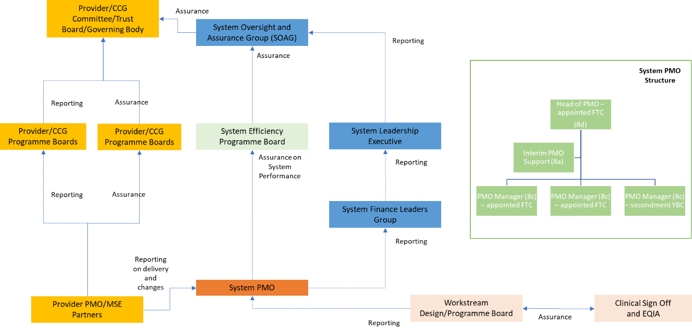

## Approach to Costing

The NHS in England has invested substantially in costing to implement the National Costing Transformation Programme, though locally this has not been the case with all local providers. The reality is that while NHS trusts are putting some funding into supporting costing, local health systems are not reaping the potential huge benefits. The majority of Costing teams time is spent on the annual National Cost Collection NCC). As a result, there is little time to support clinical and operational teams to use the cost data to improve value. The potential for costing is substantial particularly supporting the stewardship process, but unlocking the potential requires a fundamental reset of the approach to costing locally.

In order to have a clear understanding of the costs, and cost drivers, of care within our system we will open up a wealth of opportunities for partners to better harness and manage the resources available.

The expertise of costing experience and capability locally currently rests within MSEFT, primarily driven by the mandatory annual requirements of cost collections and reporting to support model hospital. Other partners also have some costing capabilities, however the resilience and maturity in the development of these functions reflects the relative focus that nationally has been on services outside the acute sector.

An ambition within our ICS is to take the costing capabilities and strength of the team to build capacity and capability to stretch across the system, facilitating the development of world class costing knowledge to improve the understanding and accessibility of information for our stewards.

The costing strategy ambition is to have a single costing hub, centred around the expertise and experience based at MSEFT, with a single costing system to support this.

The costing strategy will provide a structured training plan for developing the technical skills of costing staff, to support the recruitment and retention of highly skilled costing professionals.

The strategy will embed costing and benchmarking into stewardship, clinical leadership, and operational meetings and in the long term should not be limited to health services.

The medium-term costing strategy will develop a structured clinical engagement programme which educates and supports clinicians and service managers to understand costing information, reduce clinical variation, support business cases, drive cost efficiencies and help to develop efficient patient pathways, working alongside all partners.

Along with the key challenge of retention on highly skilled and ‘niche’ costing expertise within the system are the significant challenges regarding both Business Intelligence (BI) and Information Technology (IT) requirements and support. A single costing ‘hub’ servicing the system would need an investment in the short-term to increase the bandwidth of the current team, but also in IT and BI around this.

System Information Governance is an important factor as the single hub will need access to data over several organisations.

The key measures of success based on health costing requirements are as follows:

* Local system cost information is regularly used in decision-making to drive improvements in value;
* There is a single version of cost data that can be used both locally;
* Compliant annual National Cost Collections ‘NCC’ to NHSEI by all required to submit;
* Model hospital costing data provided to suitable quality from all partners;
* Outcome of National Cost Collections reviewed and discussed at Finance & Performance and System Financial Leaders Group;
* Retention of experienced staff;
* Dedicated IT and Business Improvement resource;
* Cloud based costing system;
* Single costing system implemented across Mid and South Essex;
* Use of patient level costing within financial management reporting;
* Costing information influencing clinical decision making; and
* Costing and related finance/activity training programme in place (primarily group training/on-line).

Our longer-term ambition is to be one of the leading ICSs in the country helping to shape the future direction of costing and benchmarking practices in the NHS.

## Approach to Financial Risk Management

The system needs to develop and agree a financial risk management framework, which then underpins this financial strategy.

System partners understand the need to manage risk and the financial consequences. Through the memorandum of understanding partners are committed to robust financial risk management including:

* Commitment to operating on the basis of a “System operating Budget” as the basis of the ICS Finance Framework, which will include a system budget structure to co-ordinate resources across and on behalf of the system according to approved plans;
* Reporting routinely and on a timely basis to meet the financial reporting needs and expectations of the ICS;
* Providing well-formed and open insights into financial performance and risks to facilitate an open approach to delivering the financial commitments of the ICS;
* Commitment to the delivery of the Financial Sustainability Programme, following the approval of the Financial Sustainability Review in August 2021. This forms the basis of the system financial strategy which is to address the underlying financial deficit;
* Prioritisation of future discretionary system resources to improve the benefit of population health;
* Agreeing to support system-based recovery plans where necessary in year. From time to time, this will also require partners to risk share; and
* Commitment to collate all partner and organisation risks.

Acknowledging the risk in volatility relating to demand for services across Health & Care, the ambition is to mature our predictive capabilities to proactively manage risk and associated financial consequences.

## Approach to Cash Management and System Contracting

Whilst each provider within the system has a contract which sets out the minimum delivery and quality requirements, this has not been the basis of relationship between providers in Mid and South Essex. The relationship between providers has always been to work collectively together to support our population in the best way. This approach will continue going forwards, but we recognise the importance and responsibility of managing cashflow in the system:

* We need to manage cash effectively across the system to ensure reduced interest payments, and not create transaction inefficiencies

Will need to respond to external ICS contracts and transactions/challenge to ensure value for money and governance and transparency are maintained.

* Best practice standards such as Public Sector Payment Policy (pay within 30 days) and minimising loans and interest are adopted by all partners

## Skills and Capability to deliver the transition

As a finance community we recognise the importance on investing in our finance community to ensure we develop strong skills and opportunities for succession planning. As a System Finance Leadership, we are committed to the development of a Finance Staff Development plan to support the growth of integration across our system.

The use of the following tools, networks and principles will be considered in the development of this plan.

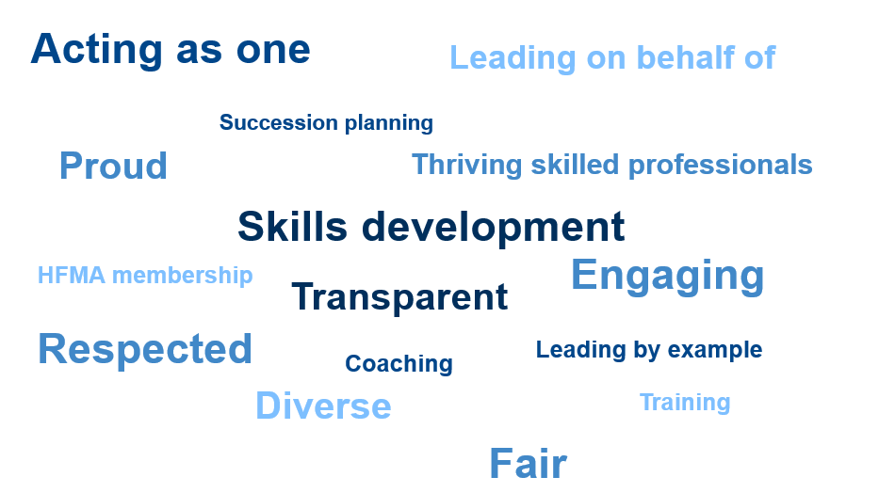

Finance Teams across the system will be instrumental in delivering our ambition as part of the wider Integrated Care System. We want to be able to provide our population and our staff with the confidence that resources are being used transparently, supporting the benefit of population health improvement, and fulfilling our statutory obligations and duties.

By establishing clear and transparent funding arrangements within our system we aim to support the collective understanding of how resources are allocated across the system for both revenue and capital.

We want to ensure value for money across the whole system by supporting our Integrated Care Partnership in the establishment and management of integrated fund arrangements, (such as the Better Care Fund) at place and across Health and Wellbeing Boards.

We will further support our places to understand the resource consumption of their populations and how to utilise available funding in accordance with ICB priorities and national policies.

The implementation of a model of Finance Business Partnering will enable expert leadership on all aspects of financial management and reporting for a specific spend area within the ICB. Becoming the financial expert for their area they will work openly and supportively with clinical and operational managers as required supporting and upskilling the capabilities of teams outside of finance.

Adopting a consistent model of financial management, and an ethos of collaboration at all levels, across partner organisations will enable development opportunities across sectors for finance professionals

Working beyond professional boundaries is pivotal in delivering our vision of financial transparency and sustainability for our population.

# Conclusion

As the MSE system we are committed to achieving the triple aim. As a system we have the ambition to prioritise the prevention of ill health through evidence-based investment and to develop systems to support ‘well people’ proactively take control of their health.

This finance strategy will underpin how we innovate and continuously improve over the coming years so we can maximise the benefit our partnership pound can offer to improve health and care for our residents across Mid & South Essex.