Management of Serious Incidents (SI) Policy

Document Control:
Document Control Information | Details
Policy Name | Management of Serious Incident (SI) Process
Policy Number | MSEICB067
Version | 1.1
Status | Final
Author / Lead | Joanna Bunton, Patient Safety and Quality Manager, Mid and South Essex (MSE) Integrated Care Board (ICB)
Responsible Executive Director | Executive Director of Nursing & Quality
Responsible Committee | Quality Committee
Date Ratified by Responsible Committee | 8 March 2022
Date Approved by Board/Effective Date | 1 July 2022
Next Review Date | 31 December 2023 (review date extended by Audit Committee, 20 June 2023)
Target Audience | - MSE ICB staff (including temporary/bank/agency staff/ individuals on work experience/volunteers).  - Providers and Contractors engaged by the Integrated Care System (ICS) Body.  - Staff from other MSE ICS Partnership organisations (including those working within ICS Body facilities).  - Patients and members of the public (visitors).
Stakeholders engaged in development of Policy (internal and external) | - Eleanor Sherwen, Interim Head of Nursing, Basildon and Brentwood ICB.  - Karen Flitton, Senior Patient Safety and Quality Manager, Mid and South Essex ICBs.  - Sue Cleall, Patient Safety and Quality Manager, Thurrock ICB.  - Ross Keily-Cracknell, Lead Nurse - Mental Health (Interim), Thurrock ICB.  - Vicky Cline, Lead Nurse Primary Care, Mid and South Essex ICB.  - Tracy Williams Senior Quality Support Officer, Mid and South Essex ICB.  - Matt Gillam, Interim Head of Nursing Thurrock/CP&R/Southend.  - Jackie Barrett, Interim Head of Nursing, Mid Essex.  - Iain Gear Information Governance.
Impact Assessments Undertaken  (Delete if non-applicable) | - Equality and Health Inequalities Impact Assessment.

Version History
Version | Date | Author (Name and Title) | Summary of amendments made
0.1 | 08.12.2021 | Joanna Bunton, Patient Safety and Quality Manager | Initial draft.
0.2 | 26.01.2022 | Steve McEwen, Patient Safety and Quality Manager | Updated with comments from stakeholders engaged in development / review of Policy.
0.3 | 05.04.2022 | Viv Barnes, Governance Lead | Update of policy format and identification of areas requiring further review.
0.4 | 20.06.2022 | Matt Gillam | Update job and committee titles, following Structure release. Header/footer update. Addition of Patient Safety training expectations from NHSE/I  EIA.
1.0 | 06.07.2022 | Charlotte Tannett | Final review of version 1.0.
1.1 | 20/06/2023 | Governance Officer | Review date amended to 31 December 2023 as agreed by Audit Committee (20 June 2023)

Contents
1. Introduction 5
2. Purpose / Policy Statement 5
3. Scope ______________________________________________________6
4. Definitions 6
5. Roles and Responsibilities 7
5.1. Integrated Care Board 7
5.2. Quality Committee (QC) 7
5.3. Chief Executive 8
5.4. Director of Nursing for Patient Safety 8
5.5. Patient Safety and Quality Team 8
5.6. Caldicott Guardian 9
5.7. Mid and South Essex SINE Panel 9
5.8. Policy Authors 10
5.9. Line Managers 10
5.10. All Staff 10
6. Policy Detail – SI Management Process 10
6.1. Overview 10
6.2. What constitutes an SI 11
6.3. Duty of Candour 11
6.4. Multiple Incidents/Victims 12
6.5. Providers including Primary Care 12
6.6. Incidents occurring within the ICB 13
6.7. De-escalation of SIs 13
6.8. Types of Investigation 13
6.9. Final report requirements 14
6.10. RCA Report Templates 15
6.11. Report Quality Standards 15
6.12. Monitoring and Closure of Incidents 17
6.13. Action Plan Templates 17
6.14. Action Plan Quality Standards 17
6.15. Aggregated Action Plans 18
6.16. Report Review/Quality Assurance 18
6.17. SINE Panel Review 19
6.18. Supporting Learning to Prevent Recurrence 19
7. Monitoring Compliance 20
8. Staff Training 20
9. Arrangements For Review 21
10. Associated Policies, Guidance And Documents 21
11. References 21
12. Equality Impact Assessment 22
Appendix A - Equality Impact Assessment 23
Appendix B – References 26
Appendix C – SI Review & Assurance Process for Mid and South Essex 27
Appendix D – Serious Incident (SI) Quality Admin Hub (QAH) Flow Chart 28
Appendix D continued 29
Appendix E – Primary Care Incident/SI Flow Chart 30
Appendix F – Guidance 31
Appendix G – Serious Incident Forms 33
Appendix H – Terms of Reference – Serious Incidents and Never Events Panel (Mid and South Essex ICB) 34

Introduction

Responding appropriately when things go wrong in healthcare is a key part of the way that the NHS can continually improve the safety of the services we provide to our patients.

Serious Incidents in healthcare are adverse events, where the consequence to patients, families and carers or organisation are so significant, or the potential is so great that a heightened level of response is justified.

The National Framework for Serious Incidents does not allow for a list of local definitions to be created, due to concerns that this approach would lead to ‘inconsistent or inappropriate management of incidents’ (NHS England, 2015; p12) and ‘debilitating processes which do not effectively support learning’ (NHS England, 2015; p16).

Purpose / Policy Statement

The purpose of this policy is to implement a framework and process for managing SIs to ensure that they are investigated appropriately, and learning is shared in accordance with the National Framework for Serious Incidents published in March 2015. Upon release of the Patient Safety Incident Response Framework (PSIRF) which will replace the SI Framework this policy will be reviewed (due April 2021).

The ICB will adopt the criteria for defining a serious incident from the NHS England Serious Incident Framework (2015).

The ICB will clearly identify the accountability, roles and responsibilities for the management of SIs.

The ICB will implement a clear accountability framework for the governance of SI management.

The ICB will comply with national and local guidance and governance arrangements regarding the maintenance of records associated with SI and policy review.

All staff working within the ICB must follow the policy.

All commissioned providers will be expected to have local policies and procedures in place to manage and report incidents and SIs and the ICB Policy will be included in the contract. Compliance with the requirements for reporting and managing incidents and SIs will be included within the monitoring of quality contracts.

For Independent Contractors, e.g., GPs, the ICB would encourage the reporting of all SIs in line with best practice and regulatory requirements. Primary care have direct access to report incident to the Learning From Patient Safety Events (LFPSE) platform on line.

Scope

This policy applies to:
- MSE ICB staff (including temporary/bank/agency staff/ individuals on work experience/volunteers).
- Providers and Contractors engaged by the ICS Body.
- Staff from other MSE ICS Partnership organisations (including those working within ICS Body facilities).
- Patients and members of the public (visitors).

Definitions
- Serious Incident - the NHS England Serious Incident Framework published in March 2015 defines that serious incidents are events in health care where the potential for learning is so great, or the consequence to patients, families and carers, staff or organisations are so significant that they warrant using additional resources to undertake a comprehensive response. It is emphasised that serious incidents can extend beyond incidents which affect patients directly and can include incidents that may indirectly impact patient safety or an organisation’s ability to deliver on-going healthcare e.g., electrical failure.
Whilst there is no definitive list of events/incidents that constitute a serious incident, this would include acts or omissions in care that result in; unexpected or avoidable death, unexpected of avoidable injury resulting in serious harm, abuse, never events, incidents that prevent an organisation’s ability to continue to deliver an acceptable quality of healthcare services and incidents that may cause widespread public concern.
- Serious Harm - the SI framework defines serious harm as:
  - Severe harm (patient safety incident that appears to have resulted in permanent harm to one or more persons receiving NHS funded care).
  - Chronic pain (continuous long-term pain of more than 12 weeks or after the time that healing would have been thought to have occurred in pain after trauma or surgery).
  - Psychological harm, impairment to sensory, motor, or intellectual function or impairment to normal working or personal life which is likely to be temporary (i.e., has lasted, or is likely to last for a continuous period of at least 28 days).
- Never Events - Never Events are patient safety incidents that are wholly preventable where guidance or safety recommendations that provide strong systemic protective barriers are available at a national level and have been implemented by healthcare providers.
See https://www.england.nhs.uk/publication/never-events/ for a list of defined never events.
- Near Miss - a near miss can be classed an SI if there is the potential for the incident to occur again. Therefore, deciding whether or not a near miss incident should be classified as an SI should therefore be based on an assessment of risk that considers:
  - The likelihood of the incident occurring again if current systems /processes remain unchanged and
  - The potential for harm to staff, patients and the organisation should the incident occur again.
- Duty of Candour - regulation sets out duty of candour with definitions of openness, transparency and candour used by Robert Francis in his report.
- Openness – enabling concerns and complaints to be raised freely without fear and questions asked to be answered.
- Transparency – allowing information about the truth about performance and outcomes to be shared with staff, patients, the public and regulators.
- Candour – any patient harmed by the provision of a healthcare service is informed of the fact and an appropriate remedy offered, regardless of whether a complaint has been made or a question asked about it.

Roles and Responsibilities

Integrated Care Board
    - The ICB Board has overall responsibility for ensuring that the organisation has a robust system in place for the management, investigation and monitoring of Serious Incidents.

Quality Committee (QC)
    - The QC is responsible for monitoring outcomes from serious incident investigations declared by providers for which the ICBs are the lead commissioner and escalating any concerns to the ICB.
    - The QC is also responsible for monitoring compliance with this policy.

Chief Executive
    - The Chief Executive of the ICB has overall accountability for implementing this policy.

Director of Nursing for Patient Safety
    - The Director of Nursing (DoN), Patient Safety leads the Clinical Quality Team and holds accountability for the SI management process and the Serious Incident and Never Event Panel (SINE). The DoN will:
- Liaise with the team and senior management in the provider organisation, to establish if an incident should be declared a SI and the level of investigation required.
- Facilitate decision-making where multiple providers are involved in an SI, in terms of determining the lead organisation to be responsible for co-ordination of the multiple strands of the investigation and for providing a single aggregated investigation report.
- Have shared responsibility for coordinating and monitoring the SI management progress in the ICB and commissioned services.
- Delegate responsibility to (or undertake in the absence of) their deputies and/or relevant specialist leads, the review of all SI investigation reports and action plans, ensuring that they are robust and meet the terms of reference set.
- The DoN (or ICB On-Call Manager out of hours) has responsibility for any required liaison with NHS England (NHSE) or other external body (i.e. Monitor, Care Quality Commission (CQC), media, police) as required in relation to declaration and closure of SIs.
- Share intelligence/escalate as determined necessary to NHS England/Improvement (NHSE/I), regulatory bodies, and partner organisations.
- Lead the SINE panel for closure of SI investigations.

Patient Safety and Quality Team
    - The Patient Safety and Quality Team is part of the Nursing and Quality Directorate and assumes responsibility for the overall management of SIs and for reporting to the relevant committees.
    - On receipt of notification of an SI, the Team will:
- Record the notification on the Serious Incident and Never Event (SINE) panel record sheet.
- Notify the relevant personnel on a weekly basis (locally specified internal distribution list), e.g., Directors of Nursing and Safeguarding Leads within the ICB and any relevant specialist practitioner of the SIs that have been declared in the preceding week.
- Ensure that, where a provider does not have access to the national Strategic Executive Information System (StEIS), that the incident is recorded on that system on the provider’s behalf.
- Maintain a robust electronic documentary audit trail for every SI investigation.
- Be responsible for liaison with the provider organisation to co-ordinate and monitor the progress of the SI, ensuring that all investigation and reporting is undertaken within the agreed reporting timescales.
- Ensure that, if appropriate, the incident is added to the relevant risk register.
- Review and assure initial, update and final reports, in association with the relevant specialist lead(s).
- Present the investigation report to the SINE panel for closure of the SI investigation.
    - It should be noted that the Patient Safety and Quality Team can assist in and advise on the investigation of individual SIs, but the primary responsibility for resolution rests with the provider organisation or department/individual responsible for the area/service where the SI occurred.

Caldicott Guardian
    - This sits with the Executive Director of Nursing and Quality ICB Chief Nurse who is responsible for ensuring that the protection and use of patient identifiable information is used appropriately, which may be used during the serious incident reporting process.

Mid and South Essex SINE Panel
    - The SINE Panel (Terms of Reference including functions of the Panel can be found at Appendix G) acts with delegated authority from the ICB, as a second line of assurance and specialist resource in supporting the ICB to discharge their responsibilities for the management of SIs.
    - The Panel will:
- Meet weekly (face-to-face or via teleconference) to scrutinise all new SIs reported by the providers within the ICB; to determine that investigations are suitably robust, and that learning has been identified and implemented in order to agree closure of SIs; and to determine categorisation of SIs where there is doubt.
- Use the NHSE Serious Incident Framework (2015), NHS Improvement Revised Never Events Policy and Framework (2018) and other relevant best practice guidance and resources to determine and agree whether an incident constitutes a Serious Incident or a Never Event.
- Have delegated authority from the ICB to make the final decision, in accordance with the NHS England Serious incident Framework (2015), and NHS Improvement Revised Never Events Policy and Framework (2018) of the status of an SI as a Never Event. Provider organisations have recourse to attend the SINE Panel to present their case, where the categorisation of an SI as a Never Event is disputed.
- Make arrangements for the sharing of learning across the local and wider health system and partners.

Policy Authors
    - The policy author will have responsibility for reviewing and updating the policy in line with Section 8.

Line Managers
    - Line managers are responsible for upholding and promoting high standards in relation to the management of Serious Incident processes, ensuring staff reporting to them adhere to the requirements of this policy and for providing adequate, appropriate and transparent reporting to the ICB Board and its committees, stakeholders and the public.

All Staff
    - All members of staff have a responsibility to familiarise themselves with the content of the Policy for the Management of the Serious Incidents Process.
    - All members of staff have a duty to work within the standards and guidelines as specified in this Policy.
    - All members of staff have a duty to ensure colleagues, patients, their relatives, and carers are not discriminated against or treated in any way less favourably when SIs are reported and investigated.
    - All members of staff will review their practice as a result of any learning identified from SI investigations.

Policy Detail – SI Management Process

Overview
    - The over-arching process for SI management is specified in Part Three of the NHSE SI Framework (2015). The local process is demonstrated in a flow-chart in Appendix C of this policy.
    - Specific elements of the SI process requiring further local clarification are defined below.

What constitutes an SI
    - In accordance with the SI Framework (2015), there is no definitive list of events/incidents that constitute a SI and lists should not be created. Every incident must be considered on a case by-case basis using the description below and reported to the ICB:
- Acts and/or omissions occurring as part of NHS-funded healthcare (including in the community) that result in:
  - Unexpected or avoidable death of one or more people. This includes suicide/self-inflicted death and homicide by a person in receipt of mental health care within the recent past.
  - Unexpected or avoidable injury to one or more people that has resulted in serious harm.
  - Unexpected or avoidable injury to one or more people that has required further treatment by a healthcare professional to prevent death or serious harm.
- Safeguarding concerns such as: actual or alleged abuse; sexual abuse, physical or psychological ill-treatment, or acts of omission which constitute neglect, exploitation, financial or material abuse, discriminative and organisational abuse, self-neglect, domestic abuse, human trafficking, and modern-day slavery where healthcare did not take appropriate action/intervention to safeguard against such abuse occurring or where abuse occurred during the provision of NHS-funded care, may be raised as an SI but consideration should be given to the value of duplication of investigation if a safeguard has already been raised.
- A Never Event – all Never Events are defined as SIs although not all Never Events result in serious harm or death.
- An incident (or series of incidents) that prevents, or threatens to prevent, an organisation’s ability to continue to deliver an acceptable quality of healthcare.
- Major loss of confidence in the service, including prolonged adverse media coverage or public concern about the quality of healthcare or an organisation.

Duty of Candour
    - The CQC introduced a new regulation in March 2015 as a direct response to recommendation 181 of the Francis Inquiry report into Mid Staffordshire NHS Foundation Trust 1, which recommended that a statutory duty of candour be introduced for health and care providers. This is further to the contractual requirement for candour for NHS bodies in the standard contract, and professional requirements for candour in the practice of a regulated activity. In interpreting the regulation on the duty of candour the CQC used the definitions of openness, transparency and candour used by Robert Francis in his report.
- Openness – enabling concerns and complaints to be raised freely without fear and questions asked to be answered.
- Transparency – allowing information about the truth about performance and outcomes to be shared with staff, patients, the public and regulators.
- Candour – any patient harmed by the provision of a healthcare service is informed of the fact and an appropriate remedy offered, regardless of whether a complaint has been made or a question asked about it.
    - The aim of this regulation is to ensure that providers are open and transparent with people who use services and other ‘relevant persons’ (people acting lawfully on their behalf) in relation to care and treatment.
    - It also sets out some specific requirements that providers must follow when things go wrong with care and treatment, including informing people about the incident, providing reasonable support, providing truthful information and an apology.
    - Providers must promote a culture that encourages candour, openness, and honesty at all levels. This should be an integral part of a culture of safety that supports organisational and personal learning.
    - Formal duty of candour (verbal and followed up in writing) must be completed for all incidents and SIs graded as moderate harm and above.
    - If the provider has rationale for not undertaking Duty of Candour then a conversation between the ICB DON and provider DON should take place to agree this.

Multiple Incidents/Victims
    - The purposes of clarity, the ICB defines an SI relating to a single occurrence, but affecting multiple patients, staff, or members of the public as comprising one SI.
    - Similar or identical incidents occurring on more than one occasion and affecting one or more persons are classified as multiple SIs. In these cases, the provider should notify the ICB of one SI per occurrence. The provider and ICB will jointly determine whether a multi-incident methodology (NHSE, 2015, Part 1; 1.4.2) will be applied to such ‘clusters’ of similar incidents

Providers including Primary Care
    - All providers are required to enter SIs on STEIS (Strategic Executive Information System) within two working days of the incident being identified. Once the SI has been reported on STEIS an automated email will be sent to the relevant Commissioner to notify and provide a unique identifier number.
    - For providers without access to StEIS the administrative team within the Patient Safety and Quality Team will enter this on their behalf.
    - The NHS England SI framework indicates that an update should be sent to the relevant commissioning ICB within 3 working days of reporting the incident. This is to provide more detail to the ICB with regards to immediate action taken and Duty of Candour.

Incidents occurring within the ICB
    - When an SI occurs within the ICB in the first instance, immediate action must be taken to minimise and prevent further harm. The incident should be reported to the Director of Nursing, Patient Safety or if out of hours the Executive on Call. Further information can be found within the Incident Reporting Policy.
    - If the incident meets the SI criteria an investigating officer will be identified who must then follow the reporting schedule outlined in section 5.7.
    - Relevant reporting templates for can be found at within the appendices. All reports must be completed by the deadline and sent to meICB.msejc.si@nhs.net

De-escalation of SIs
    - If, after initial investigation, it is evidenced that the incident does not meet the criteria for an SI, then a formal withdrawal request must be sent to the meICB.msejc.si@nhs.net for consideration. SINE panel will consider the rationale for the retraction and if considered appropriate the SI will be retracted from STEIS.

Types of Investigation
    - All SIs will vary in nature, severity and complexity and therefore vary on a case-by case basis. The level of response should be dependent on and proportionate to the circumstances of each specific incident. Levels of response are as follows:
Level | Type | Detail
1 | Concise internal investigation | Suited to less complex incidents which can be  managed at a local level
2 | Internal investigation | Suited to complex issues which should be managed by a multidisciplinary team involving  experts and/or specialist investigators
3 | Independent investigation | Required when the integrity of the investigation is  likely to be challenged or if a number of  organisations are involved.

Final report requirements
    - Staff conducting investigations should be trained in RCA methodology and final reports should describe causative factors and recommendations to prevent recurrence.
    - The investigation should be completed, and a final report and action plan submitted within 60 working days of the incident being reported.
    - If there is likelihood that the report will not be completed within the 60-day timeframe, an extension request must be submitted to the ICB. All requests for extensions must be made in writing via the meccg.msejc.si@nhs.net and are considered on a case-by-case basis.
    - Extensions will only be granted for justifiable circumstances. Any request should be made prior to the original date the 60-day report was due, a template is available upon request from meccg.msejc.si@nhs.net
    - Level 1 and 2 investigations (concise and comprehensive) must be completed within 60 working dates and Level 3 investigations (independent) completed within 6 months from the date the investigation is commissioned.
    - Timescales for report submission and review will be in accordance with the NHSE SI Framework (2015) and will be monitored by the ICB.
    - In certain circumstances, trusts may find it difficult to complete a final report within these timescales. This might be due to:
- Enforced compliance with the timetable of an external agency, such as police, Coroner, Health and Safety Executive or Local Children Safeguarding Board or Safeguarding Adult Board
- Investigation of highly specialised and multi-organisation incidents, such as those involving a national screening programme; or
- Incidents of significant complexity.
    - In such circumstances the commissioner and investigations team can agree an alternative timeframe. This should be clearly recorded within the SI management system and included in the SI incident report.
    - In certain circumstances providers may request a ‘stop the clock’ (STC) to suspend the investigation. This must be requested in writing. The date for completion will be reviewed and agreed again once the investigation can commence.
    - STC may also be used for SIs which are being investigated by an independent body (eg Health Service Investigation Branch (HSIB) whereby timescales will reflect external agency process. Upon receipt of the report from the independent organisation the provider must review the report and develop an action plan to submit to the commissioners and request closure
    - Action plans must be submitted with the final report. Actions must be Specific, Measurable, Attainable, Relevant and Timebound (SMART); clear, with responsible persons, timeframes and plans to monitor and review, including follow-up audits to gain assurance that the learning has been implemented and changes embedded into practice.

Root Cause Analysis (RCA) Report Templates
    - The NHSE SI Framework (2015) recommends use of national reporting templates.
    - The ICB has determined that the following variations to the NHSE SI Framework (2015) will apply to templates used for local SI management process:
    - The ICB has previously worked with providers to develop bespoke RCA templates for specific types of incident investigation (for example pressure ulcers and falls). The SINE Panel (see 3.5) have agreed that such templates, provided they incorporate all of the essential elements of a full investigation and thus remain consistent with the NHSE SI Framework (2015), can continue to be used and further developed over time for joint agreement, where these have been found to facilitate RCA.
    - There will be no mandatory local requirement for an executive summary for an SI investigation, where the length of the report makes this requirement unnecessary. Investigators should determine the need for an executive summary to provide an ‘at-a- glance’ overview of the investigation, dependent on the extent of the report. Where utilised, section headings within the Executive Summary should be the same as within the full report.

Report Quality Standards
    - The ICB will further enhance the expected minimum standards for report quality as follows (incorporating the requirements in Part Three of the NHSE SI Framework (2015).
    - The SI investigation reports submitted to the ICB must:
- Be in clear language and easy to read.
- Be non-accusatory and avoid the use of judgemental language.
- Contain a glossary for explaining medical or complex terminology.
- Define all acronyms in full with the acronym in brackets on first use.
- Have an executive summary where appropriate, index and contents page and clear headings.
- Include the title of the document and state whether it is a draft or the final version.
- Include the version number, date, reference initials, document name, computer file path and page number (in ‘Page X of Y’ format) in the footer.
- Use paragraph and sub-paragraph numbering, according to the numbered section of the report (i.e., 4.1, 4.2, 4.2.1, etc).
- Use the 24-hour clock only to indicate time within the 24-hour period.
- Only use date format dd/mm/yyyy (never ‘the next day’ or ‘day 5’) and clearly state the day of the week.
- Disclose only relevant confidential personal information for which consent has been obtained, or if patient confidentiality should be overridden in the public interest. This should however be considered by the Caldicott Guardian and where required confirmed by legal advice.
- Include evidence and details of the methodology used for the investigation
- Refer to any relevant national or local guidelines, policies and procedures that should be followed in relation to the case being investigated.
- Include a description of how patients/victims and families have been engaged in the investigation process.
- Include a description of the support provided to patients/victims/families and staff following the incident.
- Identify root causes and recommendations.
- Ensure that conclusions are evidenced and reasoned, and that recommendations are SMART.
- Be reviewed internally by the provider for quality assurance prior to submission and have approval for submission to the commissioner noted on the front of the report, with date and approval body clearly recorded.
- Have all amendments made following ICB request ‘tracked’ or in some way clearly highlighted, in order that they can be rapidly reviewed.
    - An SI investigation final report will not be accepted for ICB review in the absence of an action plan. The provider investigation timescale ‘clock’ will not be stopped until both final report and an accompanying action plan are submitted for review.

Monitoring and Closure of Incidents
    - It is expected that each provider organisation has a formal committee accountable to its Board that had responsibility for monitoring and managing SIs.
    - Final reports for SIs will be reviewed by designated members of the Quality & Patient Team to determine if all aspects of the incident have been adequately investigated.
    - The ICB will feedback to the provider within 20 working days. The ICB may request additional information or evidence that actions have taken place as additional assurance.
    - Once the ICB is assured that the investigation and action plan are robust the SI will be closed on STEIS. However, identified actions will be monitored through local monitoring systems until all actions have been implemented and appropriate evidence, where appropriate, has been received.
    - The initial SI notification and report completion timescales are monitored by the ICB and reported to the Quality Committee.

Action Plan Templates
    - The NHSE SI Framework (2015) recommends use of a specific action plan template.
    - The ICB has previously worked with some providers to agree the use of bespoke action plan templates that mirror those used within each organisation. The SINE Panel (see 4.6) have agreed that such templates are acceptable, provided they incorporate all of the essential elements of a complete action plan as specified within the template recommended by the NHSE SI Framework (2015).

Action Plan Quality Standards
    - The ICB will further enhance the expected minimum standards for action plan quality as follows (incorporating the requirements in Part Three of the NHSE SI Framework (2015):
- Action plans must be formulated by those who have responsibility for implementation, delivery, and financial aspects of any actions (not an investigator who has nothing to do with the service although clearly their recommendations must inform the action plan).
- Every recommendation must have a clearly articulated and numbered action that follows logically from the findings of the investigation.
- Actions should be designed and targeted to significantly reduce the risk of recurrence of the incident. It must target the weaknesses in the system (i.e., the ‘root causes’ /most significant influencing factors) which resulted in the lapses/acts/omissions in care and treatment identified as causing or contributing towards the incident.
- A responsible person (job title only) must be identified for implementation of each action point (in the event of personnel change, this facilitates identification of the new action owner).
- There are clear deadlines for completion of actions.
- There must be a description of the form of evidence that will be available to confirm completion and also to demonstrate the impact implementation has had on reducing the risk of recurrence.
- A SMART approach to action planning is essential. That is, the actions should be: Specific, Measurable, Attainable, Relevant and Time-bound. To ensure that the most.
- Effective actions/solutions are taken forward, it is recommended that an option appraisal of the potential actions/solutions is undertaken before the final action plan is developed and agreed.
- Actions must be achievable within 3 months of the date of the final investigation report.
- All exceptions to this maximum timescale must be agreed with the ICB prior to initial submission of the action plan.

Aggregated Action Plans
    - Where a series of incidents has occurred that are linked in terms of themes and learning, an aggregated action plan may be the best method of combining similar actions. This approach must be agreed with the ICB. All actions in an aggregated action plan must be clearly cross-referenced to the relevant SI cases, in order that individual SI cases that fall under the single action plan can be closed as all actions pertinent to each case are completed.

Report Review/Quality Assurance
    - The ICB Nursing and Quality Directorate are responsible for reviewing all SI investigation reports for the providers aligned to the ICB and their commissioned providers, against the minimum reporting standards, and in accordance with the expected timescales specified in Part 3 of the NHSE SI Framework (2015).
    - Report reviews will always be undertaken by a clinician and/or subject-matter specialist. This may require reviews of reports to be undertaken by external experts, where that area of expertise is not available in-house. The Nursing and Quality Directorate will undertake review of SI investigations within 20 days of receipt. For SIs where there is severe harm or death and for Never Events the review will be undertaken by a minimum of two members of the team.
    - The Closure Checklist may be used to support assurance of the report quality.
    - Where the reviewers feel there is inadequate information to support the presentation for closure, additional questions may be asked of the provider. Questions must be submitted on a Query Form. Questions must be peer reviewed with a colleague before sending to the provider organisation to ensure that they are relevant and clear.
    - Once the reviewing team have all the information required to allow for presentation at SINE panel then a closure form must be completed.
    - Upon completion of SI investigations, the provider may of the opinion that the incident no longer meets the criteria of a SI (see 5.6). Upon receipt of the de-escalation request the reviewer will determine if they have sufficient information to request de-escalation by the SINE panel. To request closure, a de-escalation form must be completed and presented to SINE panel. This will be completed within 20 days of the request.

SINE Panel Review
    - Following review of an SI investigation report, the group responsible for agreeing closure of SI investigations is the SINE Panel (section 4.6). This panel will consist of senior members of staff from the ICB Nursing and Quality Directorate and staff representing the JC to ensure that robust peer review is in place.
    - SIs will be closed by the SINE Panel on presentation of a closure form (presented by the ICB representative recommending closure) when the members of the panel are satisfied that the incident has been fully investigated, and an appropriate action plan is in place to address the findings and recommendations.

Supporting Learning to Prevent Recurrence
    - Following closure agreement, the relevant fields will be completed on StEIS by the Quality Administration Hub of the Nursing and Quality Directorate, to close the case and the relevant provider informed of closure.
    - The ICB reserves the right to request assurance that actions have been completed for SI action plans via submission of documentary evidence. The action plan, where documentary evidence of implementation is deemed necessary, will be monitored by the ICB until that evidence is submitted and agreed to provide appropriate assurance of implementation, this will then be closed.
    - For additional assurance and triangulation, a purposive sample of actions from SI action plans will be selected by the commissioner, and assurance of implementation will be sought during the commissioner’s quality assurance visits to relevant clinical areas.

Monitoring Compliance
    - This policy will be monitored by the ICB Quality Committee.
    - The Executive Director of Nursing & Quality will have overall responsibility for monitoring the policy.
    - To ensure a robust audit trail, all communications in relation to SIs must be made to the generic SI email addresses of providers and commissioners, and not sent separately to individuals in these organisations. Where any other communications occur, i.e. telephone calls, face to face conversations, escalation to executives, etc. a confirmation email must be sent to the generic address to confirm the content of the communication that has taken place. All communications should start with the locally agreed reference and StEIS reference number in the subject line.

Staff Training
    - It is an expectation from NHSE/I that all staff, up to and including Board Level will complete online Patient Safety Awareness Training level 1.
    - Levels 2-5 will be considered appropriate for staff who have a patient-facing function.
    - Those staff with responsibility for providing advice and support regarding the management of Serious Incident processes will be required to undertake appropriate additional training relating to the management of conflicts of interest available on Electronic Staff Record (ESR) or e-Learning for Health (eLfH).
    - Completion of mandatory training will be monitored and action taken to address completion rates where necessary. Staff will be expected to maintain mandated training and local recommended training, where indicated.

Arrangements For Review

This policy will be reviewed no less frequently than every two years. An earlier review will be carried out in the event of any relevant changes in legislation, national or local policy/guidance, organisational change or other circumstances which mean the policy needs to be reviewed.

If only minor changes are required, the sponsoring Committee has authority to make these changes without referral to the Integrated Care Board. If more significant or substantial changes are required, the policy will need to be ratified by the relevant committee before final approval by the Integrated Care Board.

Associated Policies, Guidance And Documents

Associated Policies
- Incident Reporting Policy.
- Safeguarding Adults Policy.
- Safeguarding Children’s Policy.
- Freedom of Information Policy.
- Health & Safety Policy.
- Complaints Policy.
- Disciplinary Policy.
- Information Governance Policy.

References
- NHS England (2015) Serious Incident Framework: Supporting learning to prevent recurrence.
- NHS England (2015) Serious Incident Framework 2015/16 – Frequently Asked Questions.
- NHS England (2015) Serious Incident Framework – Frequently Asked Questions (March 2016).
- NHS Improvement (2018) Revised Never Events Policy and Framework.
- NHS Improvement (2018) Never Events List 2018.
- NHS England (2019) Patient Safety Strategy.

Equality Impact Assessment
    - The EIA has identified no equality issues with this policy.
    - The EIA has been included as Appendix A.

Appendix A - Equality Impact Assessment

INITIAL INFORMATION
Name of policy:  Management of Serious Incident Processes  Version number (if relevant):  1.0 | Directorate/Service:  Nursing & Quality
Assessor’s Name and Job Title:  Matt Gillam, Interim Head of Nursing | Date:  June 22

OUTCOMES
Briefly describe the aim of the policy and state the intended outcomes for staff
This policy is designed to set out how the Nursing & Quality directorate will monitor and manage Serious Incidents reported by provider services.
This provides staff involved with the process to understand the required steps and for staff not directly involved to understand how the process works.
EVIDENCE
What data / information have you used to assess how this policy might impact on protected groups?
The ICB monitors the composition of its workforce under the nine protected equality characteristics and reports on this annually. This information helps the ICB to assess the potential impact of its policies upon staff.
Who have you consulted with to assess possible impact on protected groups? If you have not consulted other people, please explain why?
The policy is based on the NHS England/Improvement Policy guidance for managing Serious Incidents. The Staff Engagement Group have been consulted on the policy and their feedback was considered before the policy was finalised.

ANALYSIS OF IMPACT ON EQUALITY
The Public Sector Equality Duty requires us to eliminate discrimination, advance equality of opportunity and foster good relations with protected groups. Consider how this policy / service will achieve these aims.

N.B. In some cases it is legal to treat people differently (objective justification).

- Positive outcome – the policy/service eliminates discrimination, advances equality of opportunity and fosters good relations with protected groups.
- Negative outcome – protected group(s) could be disadvantaged or discriminated against.
- Neutral outcome – there is no effect currently on protected groups.
Please tick to show if outcome is likely to be positive, negative or neutral. Consider direct and indirect discrimination, harassment and victimisation.
Protected  Group | Positive  outcome | Negative  outcome | Neutral  outcome | Reason(s) for outcome
Age |  |  | X | The management of the investigation of Serious incidents is not influenced by protected characteristics
Disability  (Physical and Mental/Learning) |  |  | X | As above
Religion or belief |  |  | X | As above
Sex (Gender) |  |  | X | As above
Sexual  Orientation |  |  | X | As above
Transgender / Gender Reassignment |  |  | X | As above
Race and ethnicity |  |  | X | As above
Pregnancy and maternity (including breastfeeding mothers) |  |  | X | As above
Marriage or Civil Partnership |  |  | X | As above

MONITORING OUTCOMES
Monitoring is an ongoing process to check outcomes. It is different from a formal review which takes place at pre-agreed intervals.
What methods will you use to monitor outcomes on protected groups?
SINE Panel currently meets weekly to monitor progress of SI’s across the system.

REVIEW
How often will you review this policy / service?
Due to organisational transformation processes and imminent National guidance around moving away from SI in favour of Patient Safety Incidence Report Framework (PSIRF), this will require review in 12 month to ensure changes are appropriately reflected.
If a review process is not in place, what plans do you have to establish one?
N/A

Appendix B – References

NHS England (2015) Serious Incident Framework: Supporting learning to prevent recurrence
https://www.england.nhs.uk/patientsafety/wp-content/uploads/sites/32/2015/04/serious- incidnt-framwrk-upd2.pdf

NHS England Serious Incident Framework 2015-16 – Frequently Asked Questions
https://www.england.nhs.uk/wp-content/uploads/2015/03/serious-incident-framwrk-15-16- faqs-fin.pdf

NHS England Serious Incident Framework – Frequently Asked Questions (March 2016)
https://www.england.nhs.uk/patientsafety/wp-content/uploads/sites/32/2016/03/serious- incdnt-framwrk-faqs-mar16.pdf

NHS Improvement (2018) Revised Never Events Policy and Framework and List
https://www.england.nhs.uk/publication/never-events/

Appendix C – SI Review & Assurance Process for Mid and South Essex

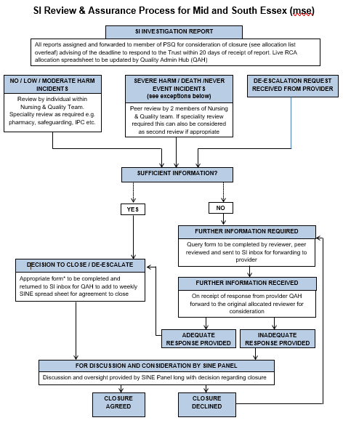

Appendix D – Serious Incident (SI) Quality Admin Hub (QAH) Flow Chart
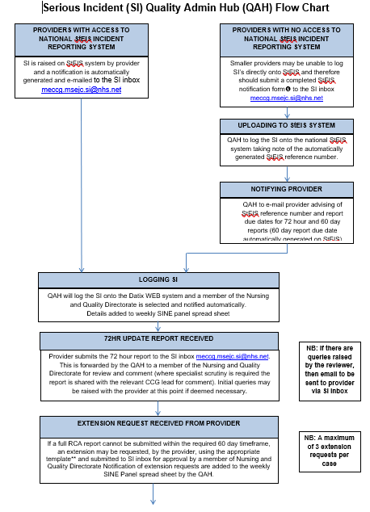

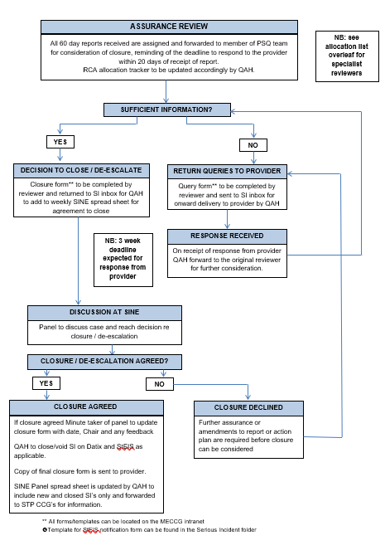
Appendix D continued

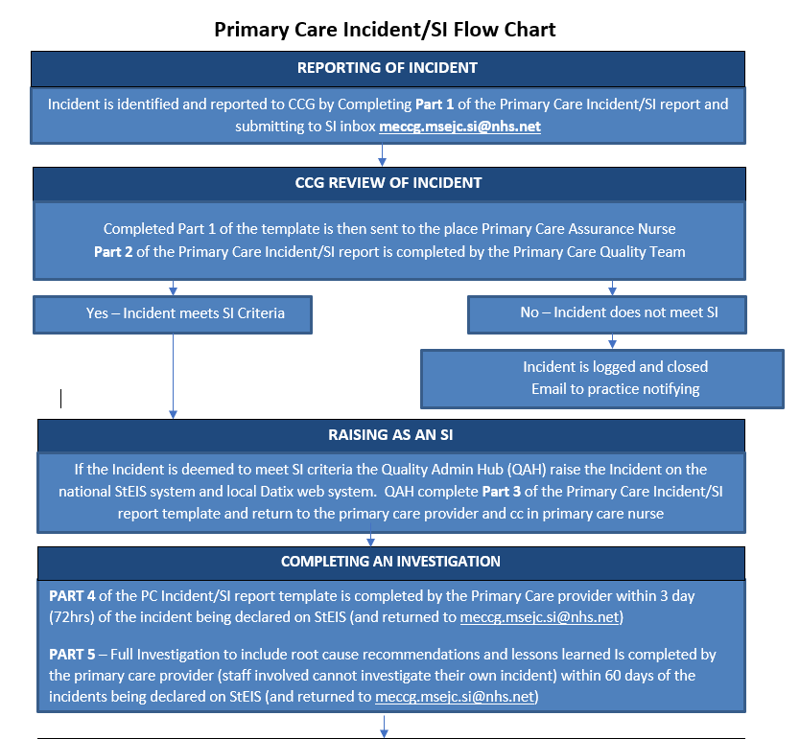
Appendix E – Primary Care Incident/SI Flow Chart
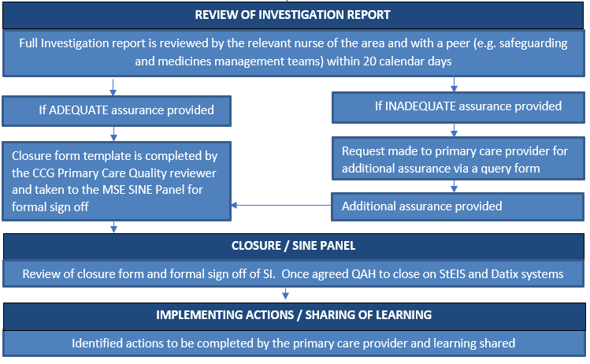

Appendix F – Guidance
Guidance for Reporting, Managing and Investigating Information Governance and Cyber Security Serious Incidents Requiring Investigation
The purpose for an incident investigation is to determine the facts concerning the incident and:
- To identify whether any deficiencies in the application of the ICBs policies or procedures and/or the organisation’s arrangements for confidentiality and data protection contributed to the incident or:
- Determine whether a human error has occurred, but not to allocate blame
- Establish what actually happened and what actions need to be taken to prevent reoccurrence.
- Carry out root cause analysis in order to ascertain the cause and to make recommendations.
As part of an initial assessment of an incident, the IG Lead will liaise with service area/team’s IAO/s (Information Asset Owner/s) and the organisation’s SIRO (Senior Information Risk Owner) to ensure incidents are correctly graded and reviewed.
The IG Lead and responsible IAO/s will establish a process so that all facts are looked at and the investigation will be based on establishing what actually happened and what actions need to be taken to prevent reoccurrence, but not to allocate blame. However, in some cases the investigation may identify whether any disciplinary processes may need to be invoked.
The decision to notify a data subject will be made by the SIRO and the Caldicott Guardian on the ground of disclosure, including transparency and the ability to protect against harm. This may include theft or blackmail: weighed against the potential harm that may be caused to subject if notified of the incidents and organisational Duty of Candour.
Where an incident occurs out of business hours, the designated on-call officer will ensure that action is taken to inform the appropriate contacts within 24-hour of becoming aware of the incident.
Staff Guideline on Identifying and Reporting an Information Incident
This guideline applies to all staff including permanent, temporary and contract staff. All incidents mobs be reported to your line manager, IAO with 24 hours of becoming aware of the incident
Where a breach involves a risk to the rights and freedoms of individuals, this must be reported to the Information Commissioner’s Office within 72 hours of becoming aware of the breach. In order to determine whether a breach is reportable, please provide as much information as possible to the Information Governance team (using EssexICB.IG@nhs.net ) as early as possible. The team, in conjunction with the ICB’s SIRO, will review the breach and make a decision as to whether to report or not.
What should you report?
Here are some examples of information incidents that should be reported:

- Finding a computer printout of Personal Identifiable Data (PID) details laying around
- Identifying that a fax that was thought to have been sent to a recipient had been received by an unknown recipient or organisation
- Finding confidential waste in a “normal” waste bin;
- Losing a mobile computing device with personal information on it;
- Giving information to someone who should not have access to it – verbally, in writing or electronically;
- Accessing a computer database using someone else’s authorisations for example someone else’s user id and password;
- Finding your PC and/or programmes are not working correctly – potentially because you may have a virus;
- Sending a sensitive e-mail to an unintended recipient or “all staff” by mistake
- Finding a colleague’s password written down on a “post-it” note;
- Discovering a “break in” to the organisation
What happens next?
Your manager or the IG Lead will investigate the incident and may wish to speak to you directly as things progress.

Appendix G – Serious Incident Forms
Serious Incident Forms

The following forms are used within the SI process:

Ref | Form
a) | Initial notification for NHS providers without access to StEIS
b) | 72-hour Update Report
c) | 60-Day SI Investigation (Root Cause Analysis) report template
d) | Action Plan template
e) | Closure Checklist
f) | Closure Form
g) | uery form
g) | De-escalation Form
h) | Extension Request Form

The most up to date copies of the forms can be obtained upon request please email:

meICB.msejc.si@nhs.net

Appendix H – Terms of Reference – Serious Incidents and Never Events Panel (Mid and South Essex ICB)
TERMS OF REFERENCE – Serious Incidents and Never Events Panel (Mid and South Essex ICBs)
These terms of reference have been approved by the Patient Safety & Quality Committee in Common.
These terms of reference will be reviewed annually, or in year if required.
MEMBERSHIP
Deputy Directors of Nursing & Quality, Mid Essex ICB’s
Heads of Nursing & Quality MSE ICBs
Infection Prevention & Control Lead Nurse covering Mid and South Essex (MSE) ad hoc
Any member of the MSE ICB’s Quality Teams as deemed appropriate
System wide Quality & Safety Representation as required
QUORACY
- The meeting will be deemed quorate with the minimum attendance of;
- Deputy Director of Nursing or Senior Clinician graded 8c.
- 2 members of the Acute Commissioning Team.
- 2 members of the non-acute Nursing and Quality Team.
- Safeguarding representative, minimum of one designate of attendance.
NB: When closures are being submitted for non MEICB hosted contracts, quality representation presentation will be required from the respective team.
The meeting will be chaired on a rotational basis.
AIMS AND OBJECTIVES
To review all Mid and South Essex ICB’s Serious Incidents (SI’s) and Never Events (NE)
To review all SI’s and NE raised via our commissioned providers
As required under the ICBs constitution this panel will provide clinical assurance, with expert oversight of the quality of investigations and management of SIs across the Mid and South Essex ICB’s and commissioned services. The panel will share any learning identified from SIs, providing peer review assurance to the Mid and South Essex ICBs. The Panel will ensure that SI’s, where appropriate will closed in a timely manner. It is also the role of this panel to ensure that Duty of Candour has been undertaken in line with regulation and policy.
The Serious Incidents and Never Events (SINE) Panel is a Clinical professionals sub-committee of the Mid Essex ICB Quality Committee and Mid and South Essex Patient Safety and Quality Committee, with delegated authority to fulfil function as stated above.
To fully scrutinise such incidents and determine classification in accordance with the categories of the Strategic Executive Information System (StEIS).
Review Root Cause Analysis (RCA) findings from all SI investigations, ensuring that opportunities for learning and prevention of recurrence are identified, and to recommend closure where criteria for closure is met and to raise queries where criteria is not met.
To confirm closure or de-escalation of SIs.
To ensure sharing of learning from serious incidents in healthcare across the local health system and relevant partners.
The panel will:
- Receive weekly reports from the respective ICB’s relating to all newly declared SIs for Mid and South Essex ICB’s and commissioned providers
- Use the NHS England Serious Incident Framework (2015); NHS England Revised Never Events Policy and Framework (2018) and supporting guidance in the execution of their functions;
- Meet ‘virtually’ by tele/video conference if not able to meet face to face, attendance at panel will require the panel member to have reviewed all cases for discussion.
- Determine where an incident initially declared as a serious incident does not meet the criteria and requires de-escalation and removal from StEIS;
- Note SIs that have been considered as suitable for closure by member peer review outside of full panel;
- Call upon expert advice as required following the raising of a potential Never Event, to facilitate review of the decision;
- Raise concerns to Executive Director of Nursing for onward notification to contract monitoring group as necessary;
- Cases for closure will require the lessons learnt to be identified to the SINE panel, and confirmation that there is a clear action plan that reflects the learning and recommendations from the investigation is in place, before a decision will be agreed;
- Inform relevant reporting provider(s) of the outcomes of all decisions made by the panel;
- Inform the wider health system and relevant partners of learning where it is relevant to do so to prevent recurrence in similar settings.
FREQUENCY OF MEETINGS

Weekly - Panel may determine, with approval of ICB Deputy Director of Nursing, to reduce or increase the frequency of meetings in response to number of SIs reported/ready for closure. The panel will consider a maximum of ten cases per meeting.
REPORTING

Numbers of SI and NE, inclusive of thematic’s and learning will be reported to Place and System Committees by their respective leads.
ADMINISTRATION

To be provided by MEICB/MSE Nursing and Quality administration team.

