Legal Services Policy

Document Control:
Policy Name | Legal Services Policy
Policy Number | MSEICB 022
Version | 1.0
Status | Final ICB Policy
Author / Lead | David Triggs, Governance Lead
Responsible Executive Director | The Chief Executive has delegated responsibility for legal services to the Chief of Staff
Responsible Committee | Audit Committee
Date Ratified by Responsible Committee | N/A
Date Approved by Board/Effective Date | 1 July 2022
Next Review Date | 1 July 2025
Target Audience | - Mid and South Essex (MSE) Integrated Care Board (ICB) members and staff (including temporary/bank/agency/work experience staff)  - Contractors engaged by the ICB  - Staff from other MSE Integrated Care Partnership (ICP) organisations who are members of ICB Committees/Sub-Committees and other groups
Stakeholders engaged in development of Policy (internal and external) | - Mid and South Essex CCG Governance Leads  - Human Resources  - Information Governance Lead  - CCG Director of Finance  - MSE CCGs Audit Committees meeting in common
Impact Assessments Undertaken | - Equality and Health Inequalities Impact Assessment

Version History
Version | Date | Author (Name and Title) | Summary of amendments made
0.1 | 12/04/2022 | David Triggs  Governance Lead | First draft of new Policy for Integrated Care Board
0.2 | 30/05/22 | Viv Barnes, Governance Lead | Review of policy prior to submission to Audit Committees in common
1.0 | 01/07/2022 | Viv Barnes, Governance Lead | Final approved ICB policy

Contents
1. Introduction 3
2. Purpose 3
3. Definitions 3
4. Roles and Responsibilities 3
4.1. ICB Board 3
4.2. Audit Committee 3
4.3. Chief Executive 4
4.4. Chief of Staff 4
4.5. Director of Resources 4
4.6. Policy Author 4
4.7. Line Managers 4
4.8. All Staff 4
5. Policy Detail 5
5.1. Reasons for seeking legal advice 5
5.3. Contacting legal firms 5
6. Reporting of Legal Cases 6
7. Monitoring Compliance 6
8. Staff Training 6
9. Arrangements For Review 6
10. Associated Policies, Guidance and Documents 6
11. References 7
12. Equality Impact Assessment 7
Appendix A - Equality Impact Assessment 8
Appendix B – Flowchart for Accessing Legal Advice 10
Appendix C – Sources of Advice 11

Introduction

As a public body, the Mid and South Essex Integrated Care Board (the ICB) from time to time may require a professional or formal opinion regarding the substance or procedure of the law in relation to a particular factual situation.

This policy explains the circumstances when legal advice may be required and the process for obtaining such advice, both from within the ICB and, if appropriate, from a law firm or other external legal advisors.

Purpose

The purpose of this policy is to set out the framework for the provision of legal support and advice to the ICB in order to ensure that:
- Staff are aware of the process that must be followed when they need legal support and advice.
- The ICB receives high quality advice at a reasonable cost.
- Expenditure is kept within budgetary restraints.
- Advice received is held centrally to avoid unnecessary duplication and ensure access and benefit to the ICG as a whole.
- Requests are appropriate and the advice is not already available from another source.
- There is an opportunity to review the performance and quality of legal advice provided by legal firms engaged by the ICB.

Definitions
- Legal advice – professional advice obtained from an independent lawyer or legal firm.

Roles and Responsibilities

ICB Board
    - The ICB Board is accountable for ensuring that the ICB has effective processes for handling requests for legal support and advice.

Audit Committee
    - The Audit Committee will have responsibility for monitoring compliance with this policy.

Chief Executive
    - The ICB Chief Executive has overall responsibility for the management of legal advice and has delegated day-to day responsibility to the Chief of Staff.

Chief of Staff
    - The Chief of Staff, assisted by the Deputy Director of Governance, is responsible for:
- Ensuring that appropriate arrangements are in place to effectively manage requests for legal support and advice.
- Advising officers and staff on the necessity and appropriateness of seeking legal advice.
- Advising whether a particular legal firm is best suited to provide advice on a particular matter.
- Authorising requests for legal advice.
- Maintaining a record of legal advice obtained by the ICB and associated costs.
- Liaising with finance and Executive Directors on budget management issues.
- Reviewing the timeliness, value for money and quality of legal advice provided by firms instructed by the ICB at periodic intervals.

Director of Resources
    - The Director of Resources may authorise legal advice in the absence of the Chief of Staff and Deputy Director of Governance.

Policy Author
    - The policy author is responsible for reviewing and updating this policy on a three-yearly basis or sooner if required by legislation, guidance, organisational change or other circumstances.

Line Managers
    - Line managers are responsible for being aware of the policy and seeking guidance and approval before procuring legal advice.

All Staff
    - Staff and other individuals covered by the scope of this policy are responsible for making themselves aware of the policy, seeking advice and acting in accordance with the policy.

Policy Detail

Reasons for seeking legal advice
    - Situations will occur where it is necessary and / or appropriate for the ICB and its representatives to seek legal advice. It may be a routine issue relating to the management of the ICB (e.g. constitutional or matters of contract law) or it may relate to potential litigation. In such cases, early intervention may prevent situations escalating.
    - Reasons to seek legal advice may include:
- A situation that has not been encountered before and is beyond the technical knowledge of any internal subject expert.
- Confirmation that a proposed or intended action is correct and lawful.
- Disputes that may lead to legal action if not resolved at an early stage, e.g. contractual challenges and disputes.
- Where another party has involved solicitors.

Accessing Legal Advice
    - If you need legal advice, then refer to the flow chart (Appendix B) noting that only those officers listed in 4.5 and 4.6 are authorised to seek legal advice.

Contacting legal firms
    - If legal advice is to be effective, it is important that clear, accurate information regarding the situation in question is provided.
    - It may be helpful to consider the following prior to seeking legal advice:
- Does the matter relate to a clinical negligence or personal injury allegation, claim or potential claim? If yes, then refer to the ICB Governance Lead.
- Have you contacted the internal subject expert? See Appendix C for sources of potential advice. Depending on the nature of the advice required, help may be available in-house or from partner organisations. For example, the Human Resources Team for employment issues, and NHS Property Services for estates and facilities issues.
    - If authorisation is given to seek external legal advice, it is important to:
- Ensure that you are clear about the issue you need advice on and the sequence/chronology of events (it may be helpful to write this down in advance if you are seeking verbal advice).
- Ensure that you have any relevant documents/information to hand and can email or upload them if required.
- Ensure that any verbal request for advice is followed up in writing as soon as possible (e.g. by email) confirming the scope of advice that is required.
- Request an estimate of costs before engaging a legal advisor, except in urgent cases where an estimate must be sought and agreed as soon as possible.
- Copy the written request for advice to the Deputy Director of Governance and ask for the advice provided and any changes in the estimated costs to be shared with the Deputy Director of Governance.
- Copy the estimate of costs to the Deputy Director of Governance.
- Provide regular updates to the Deputy Director of Governance if a legal case is ongoing.

Reporting of Legal Cases

The Board will be made aware of situations, recommendations or activities that could have significant legal consequences via the relevant Executive Director or via the Chief Executive raising the matter directly with the Board.

Monitoring Compliance

Compliance with this policy will be monitored as part of the routine monitoring undertaken by the Governance team

Staff operating outside of this policy may be subject to disciplinary proceedings in accordance with ICB Human Resources policies

Staff Training

All new staff and managers will be made aware of the ICB’s policies and procedures as part of the induction process.

Arrangements For Review

This policy will be reviewed on a three yearly cycle or sooner in the event of any relevant changes in legislation, national or local policy/guidance.

If only minor changes are required, the sponsoring Committee has authority to make these changes without referral to the Integrated Care Board. If more significant or substantial changes are required, the policy will need to be ratified by the relevant committee before final approval by the Integrated Care Board.

Associated Policies, Guidance and Documents
Associated ICB documents:
    - Standing Orders/ Scheme of Delegation /Standing Financial Instructions.
    - Risk Management Strategy.
    - Complaints and Concerns Policy.
    - Information Governance Policy.
    - Freedom of Information Policy.

References
- For claims, refer to NHS Resolution website at https://resolution.nhs.uk/.

Equality Impact Assessment

The EIA has identified a neutral impact and is included at Appendix A.

Appendix A - Equality Impact Assessment

INITIAL INFORMATION
Name of policy: Legal Advice Policy  Version number (if relevant): 1.0 | Directorate/Service: Corporate Office / Governance
Assessor’s Name and Job Title: David Triggs, Governance Lead | Date: May 2022

OUTCOMES
Briefly describe the aim of the policy and state the intended outcomes for staff
The policy is intended to ensure that staff are aware of the process that must be followed when they need legal support and advice and that the ICB receives high quality advice at a reasonable cost.
EVIDENCE
What data / information have you used to assess how this policy might impact on protected groups?
The policy has been shared with Governance staff whose experience of handling legal cases enables them to help identify and minimise any possible impact on protected groups,
Who have you consulted with to assess possible impact on protected groups? If you have not consulted other people, please explain why?
- Mid and South Essex CCG Governance Leads
- Human Resources
- Information Governance Lead
- CCG Director of Finance
- MSE CCGs Audit Committees meeting in common

ANALYSIS OF IMPACT ON EQUALITY
The Public Sector Equality Duty requires us to eliminate discrimination, advance equality of opportunity and foster good relations with protected groups. Consider how this policy / service will achieve these aims.
N.B. In some cases it is legal to treat people differently (objective justification).
- Positive outcome – the policy/service eliminates discrimination, advances equality of opportunity and fosters good relations with protected groups
- Negative outcome – protected group(s) could be disadvantaged or discriminated against
- Neutral outcome – there is no effect currently on protected groups
Please tick to show if outcome is likely to be positive, negative or neutral. Consider direct and indirect discrimination, harassment and victimisation.
Protected  Group | Positive  outcome | Negative  outcome | Neutral  outcome | Reason(s) for outcome
Age |  |  | X | No impact identified
Disability  (Physical and Mental/Learning) |  |  | X | As above.
Religion or belief |  |  | X | As above
Sex (Gender) |  |  | X | As above
Sexual  Orientation |  |  | X | As above
Transgender/Gender Reassignment |  |  | X | As above
Race and ethnicity |  |  | X | As above.
Pregnancy and maternity (including breastfeeding mothers) |  |  | X | As above
Marriage or Civil Partnership |  |  | X | As above

MONITORING OUTCOMES
Monitoring is an ongoing process to check outcomes. It is different from a formal review which takes place at pre-agreed intervals.
What methods will you use to monitor outcomes on protected groups?
Any breaches of this policy will be reported to the Audit Committee and triangulated with other information held by the ICB in relation to incidents, complaints or disciplinary action involving individuals who believe they have been mis-treated due to their protected groups status.

REVIEW
How often will you review this policy / service?
Every 3 years as a minimum and earlier if there are any significant changes in legislation, policy or good practice.
If a review process is not in place, what plans do you have to establish one?
N/A

Appendix B – Flowchart for Accessing Legal Advice

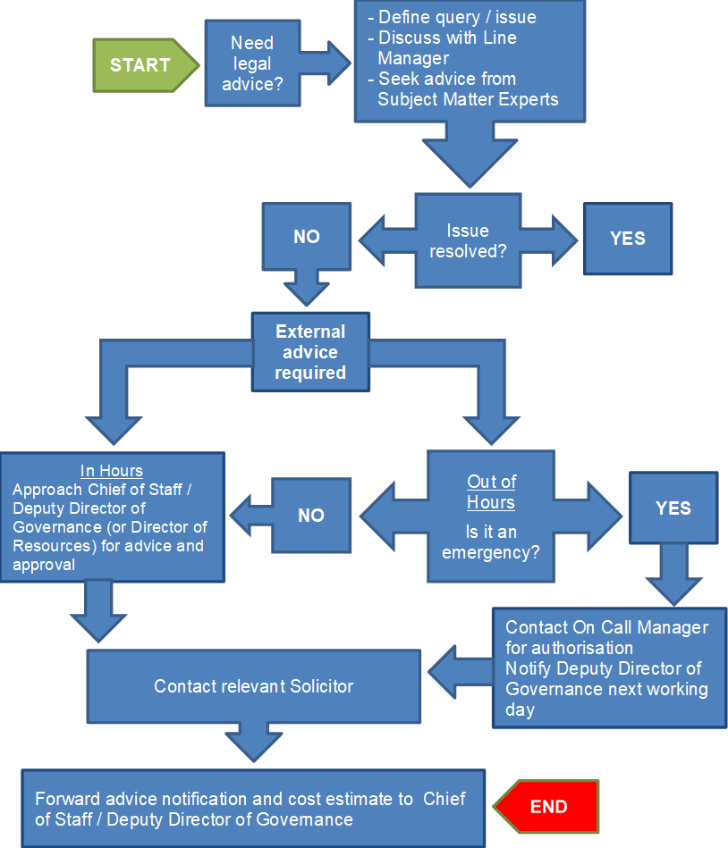

Appendix C – Sources of Advice
Internal subject matter experts
Issue | Designation
Clinical Issues | Chief Nurse
Clinical Service Contracts | Director of Resources
Complaints / Claims / Potential Litigation | Chief of Staff / Chief Nurse
Health Records / Data Protection | Head of Information Governance
Corporate Governance / Constitutional / Compliance Issues | Chief of Staff/ Governance team
Freedom of Information | Head of Information Governance/ Chief of Staff/ Governance team
Employee / Public Liability | Chief of Staff / Governance team
Human Resources | Human Resources team
Mental Health Act Issues | Chief Nurse / Quality team
Safeguarding Issues | Chief Nurse / Adults and Children Safeguarding Leads
Patient Information & Confidentiality | Head of Information Governance / Chief Nurse (as Caldicott Guardian) / Director of Resources (as SIRO)
Property | NHS Property Services / Director of Estates

Crown Commercial Service Legal services for the wider public sector
The ICB does not have a legal services agreement with any particular firm. Advice may therefore be sought from any provider on the Crown Commercial Service Legal services for the wider public sector framework.
See https://www.crowncommercial.gov.uk/agreements/RM3788 for more information.
Use of any other legal services provider must be agreed in advance with the Chief of Staff/Deputy Director of Governance, or in their absence the Director of Resources, and will be subject to the usual procurement requirements in the Standing Financial Instructions.
N.B. Before seeking legal advice in respect of contractual and commercial disputes, it is recommended that support is sought from the Centre for Effective Dispute Resolution (CEDR). CEDR provide mediation, adjudication and arbitration services to healthcare and other sectors.
Tel: 020 7536 6000
Email: info@cedr.com
NHS Resolution Legal Panel Solicitors
- Bevan Brittan
- Browne Jacobson
- Capsticks
- Clyde and Co
- DAC Beachcroft
- DWF Law
- Hempsons
- Hill Dickinson
- Kennedys
- Weightman

