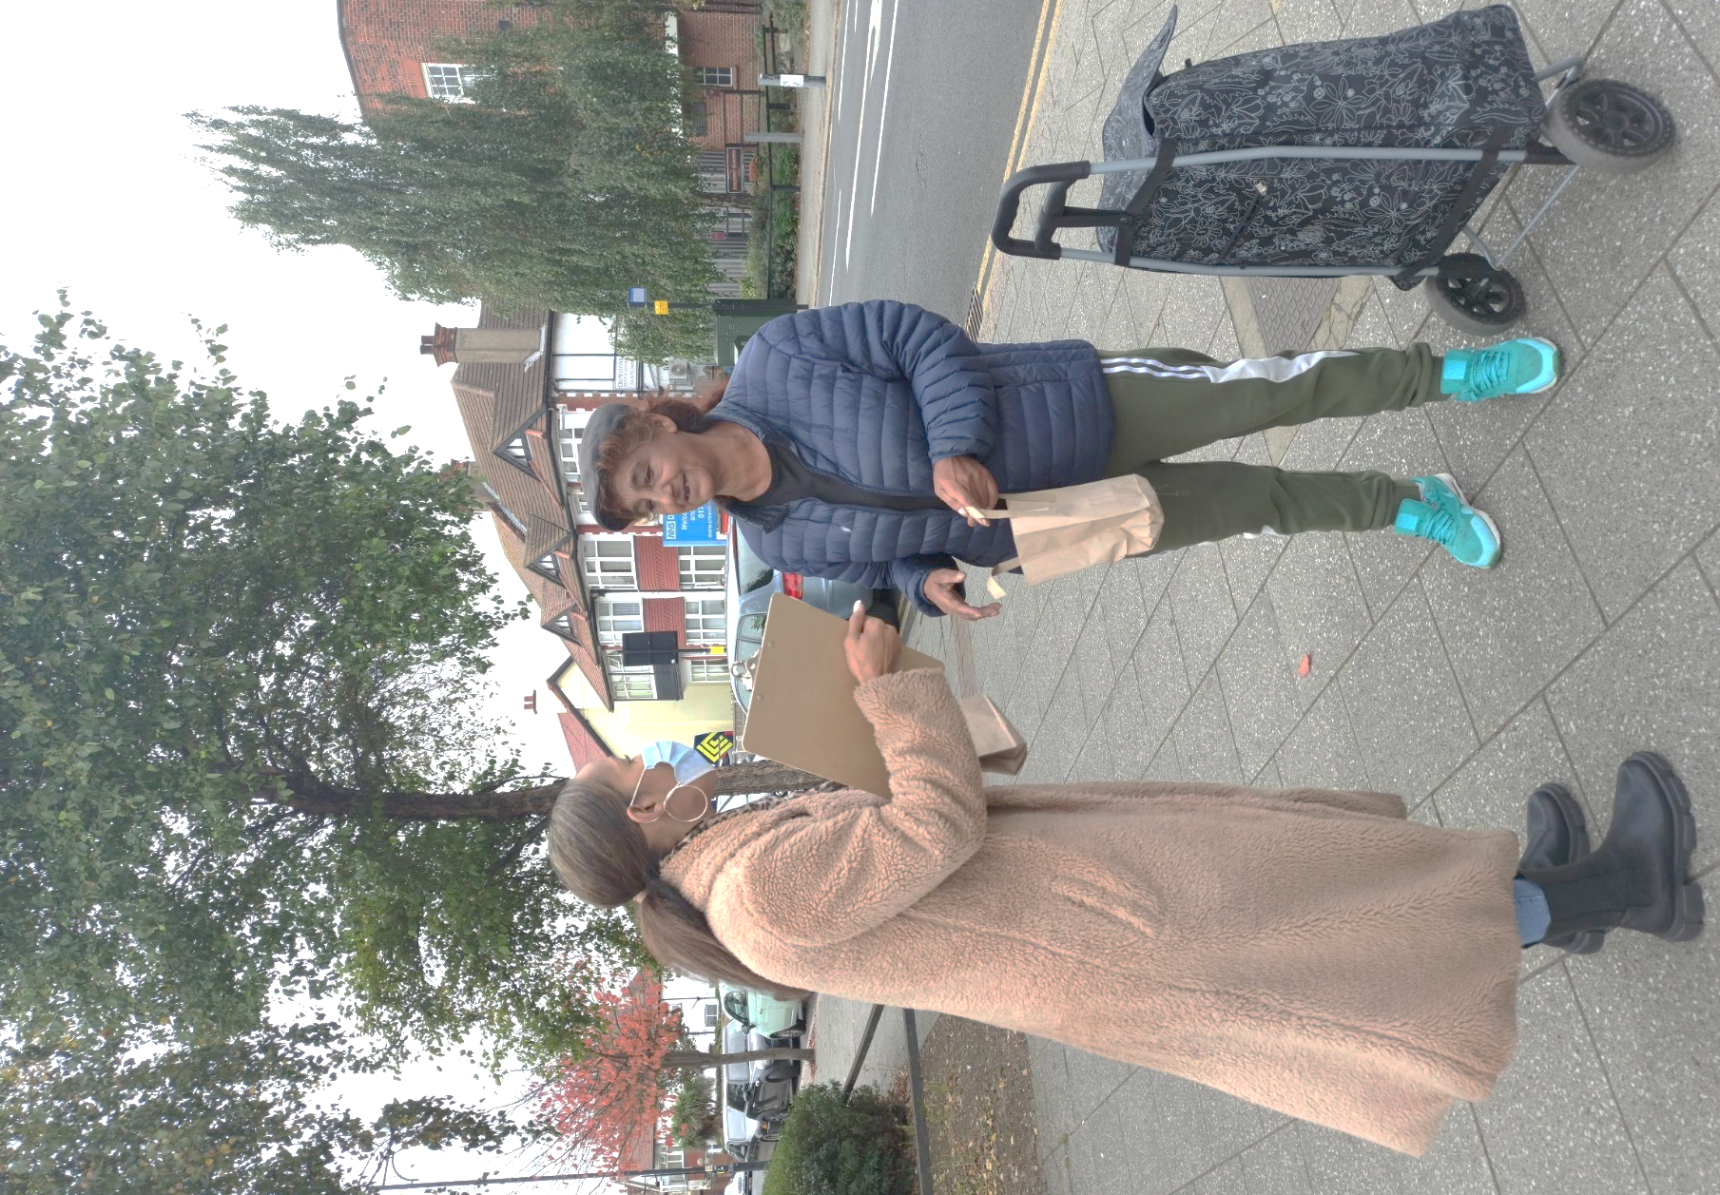
Mental Health Outreach
for Ethnic Minority Communities

Completion Report
Prepared for the Mental Health
Integrated Commissioning Team
NHS Southend Clinical Commissioning Group

8 February 2022

By Peter Merrifield, Chief Executive
Support When It Matters (SWIM) Enterprise CIC
email: peter.m@swimenterprises.com
phone: 07557 260174
Table of Contents
Executive Summary 4
Approach 5
Engagement with citizens, community groups and local mental health services 5
Findings 7
1 Has the COVID-19 lockdown impacted how you think about your mental health? 7
2 If yes, how have you been affected? 7
3 Are you aware of the local mental health services available to you? 7
4 Do you feel that the current local mental health services work for you? 8
5 If no, what would encourage you to access the local services? 9
6 What issues would prevent you from accessing local mental health services if you ever felt the need for it? 9
7 Do you think current services are mindful of people’s religious and cultural backgrounds? 9
8 Do you consent to being contacted by us for any future events or initiatives? 10
9 Your name 10
10 Contact number 11
11 Email address 11
12 Post code 11
13 Gender 12
14 Age bracket 12
15 Ethnicity 13
Outcomes and conclusions 14
Next steps 15

Executive Summary
Between 8 October and 26 November 2021, SWIM conducted Assertive Outreach & Engagement to:
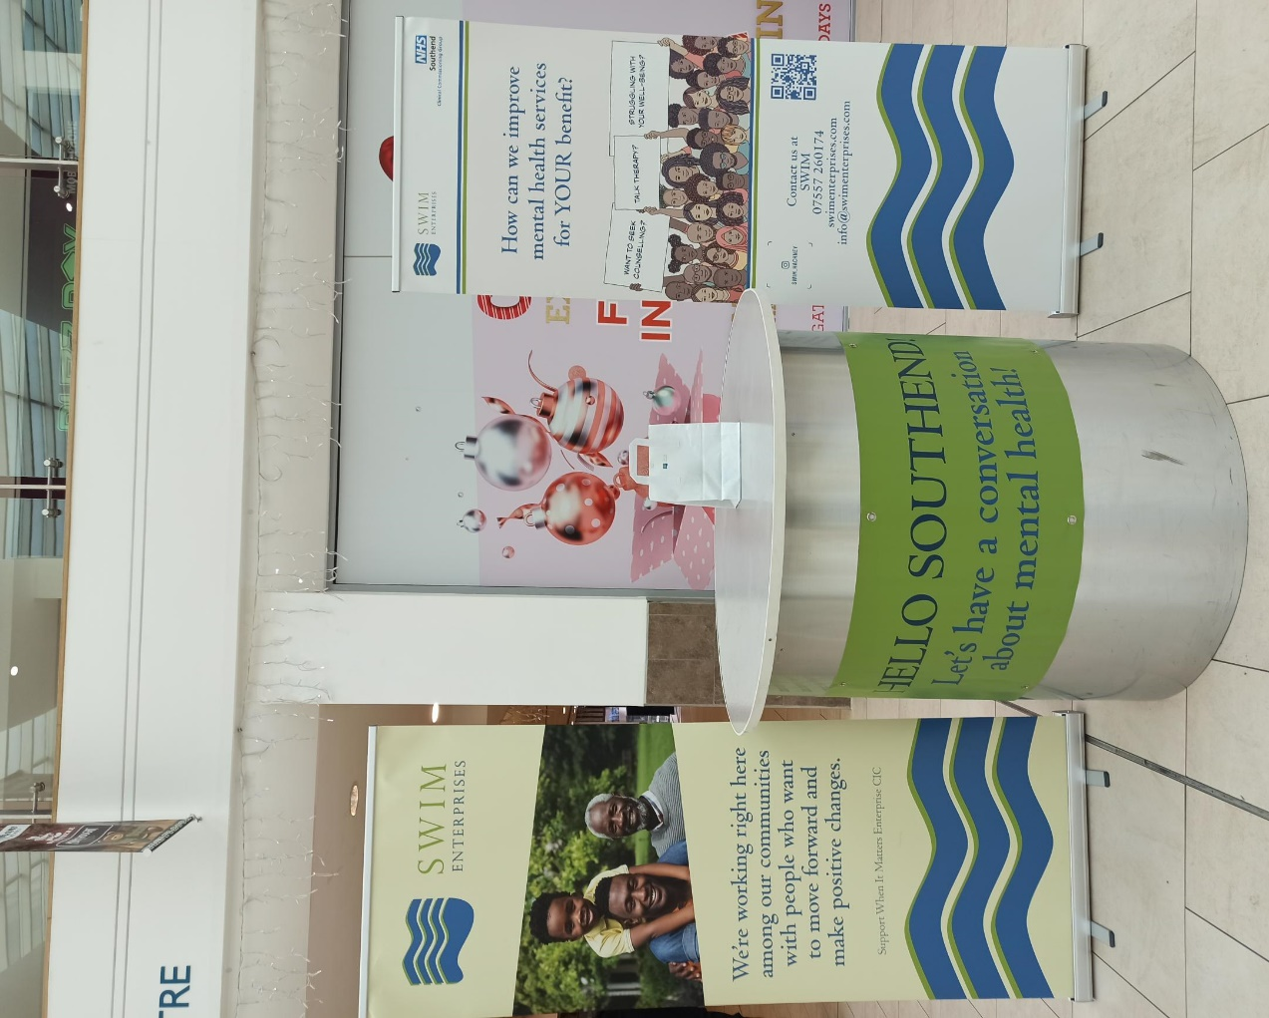
- Engage seldom heard ethnic minority (EM) community groups and raise awareness of mental health services among the people they represent;
- Listen to communities to discover how COVID-19 has impacted them;
- Collate first-hand evidence of the mental health impact of COVID-19 on individuals and families in these communities;
- Provide detailed feedback on experiences of COVID-19 and of accessing local mental health services; and
- Determine what kind of mental health services Black Asian & Minority Ethnic citizens would like in Southend and Castle Point & Rochford.
This Completion Report collates and analyses the information we gathered, capturing the experiences of EM communities in Southend, and their feelings towards engaging in services, including IAPT, in a culturally sensitive, non-clinical setting. It identifies health and demographic trends as well as service pathway recommendations that arise from our interviews.
Our work has provided NHS Southend Clinical Commissioning Group (CCG) with qualitative feedback to guide refinements to clinical pathways and service culture to support EM citizens. SWIM has also captured quantitative data that the CCG can use for scaling and targeting services.

Figure 1 SWIM stand at Victoria Shopping Centre, Chartwell Square, Southend

Approach

Engagement with citizens, community groups
and local mental health services
To raise engagement in mental health services among your African, Caribbean and Asian communities, SWIM hosted outreach events to converse with citizens about COVID-19 and its impact on health and well-being. We built a rapport with local community groups such as the Milton Community Partnership and Rethink Mental Illness.
We also interacted with IAPT services and counselling services in Southend such as Southend Treatment And Recovery Service (STARS) and Therapy for You for partnership work on the outreach events. We held meetings on Microsoft Teams to introduce SWIM and explain our project, after which we invited them to partner on the outreach. Members of the Therapy for You clinical staff were scheduled to join us on the 4th outreach but other priorities took precedence. Even so, a therapist from Therapy for You still came to the shopping centre to meet us.
We held four outreach events to engage with local people and elicit their views on mental health services:
- 1st outreach – outside the Palace Theatre, London Road, Southend
- 2nd and 3rd outreach – outside Victoria Shopping Centre
- 4th outreach – inside the Victoria Shopping Centre.
All four events consisted of us setting up a table with multiple banners and flyers designed for this project, along with curated goody bags that contained hand sanitisers, stress balls and flyers.

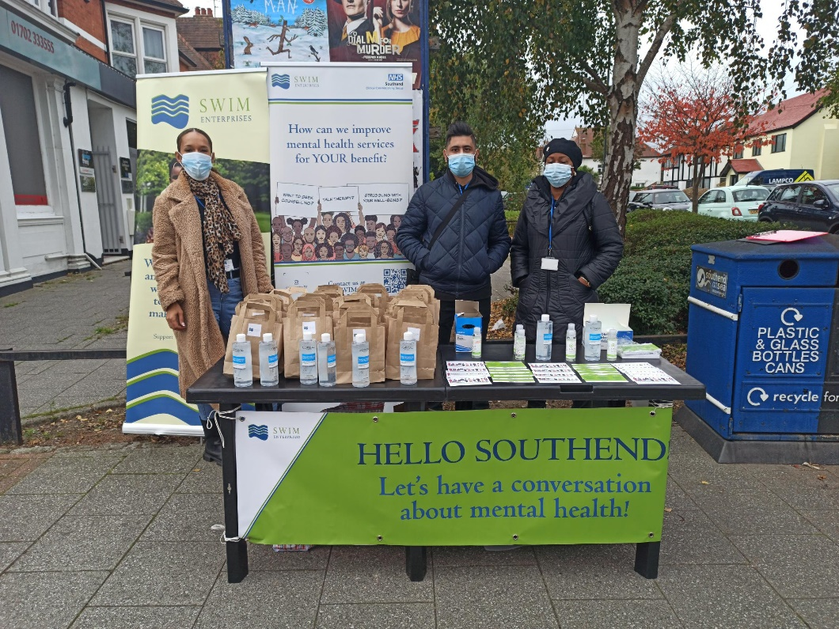
Figure 2 SWIM outreach in Southend
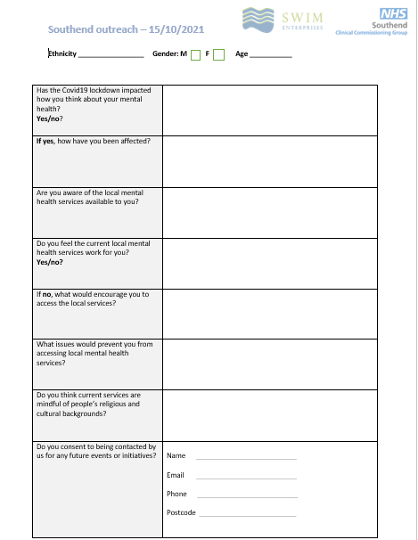
We interacted by approaching members of the public to ask them survey questions. They were each given a goody bag. We interviewed citizens using an agreed question set (see Figure 3) with follow-up engagements to gather information on:
- Age and gender
- Ethnicity and languages
- Postcode
- The impact of the lockdown on their mental health
- Their awareness and perception of local mental health services
- Barriers and motivators to accessing mental health services
- Perceived level of cultural competence in mental health services
- Impact of COVID-19 on mental health
- Awareness and perception of local mental health services.
We also asked for permission to contact interviewees about future events and initiatives.
Figure 3 Southend Outreach Interview Capture Form

Findings
Across the four events, we spoke to 487 people in Southend. Their responses to our questions are summarised in words, tables and graphics.

1 Has the COVID-19 lockdown impacted how you think about your mental health?
Response | Yes | No
Number | 255 | 212
% of total | 58% | 42%
Well over half of the people we spoke to Southend said that the COVID-19 lockdown had affected their mental health.

2 If yes, how have you been affected?
The word cloud below depicts the range of responses we received from interviewers about how they have been affected by the COVID-19 lockdown.

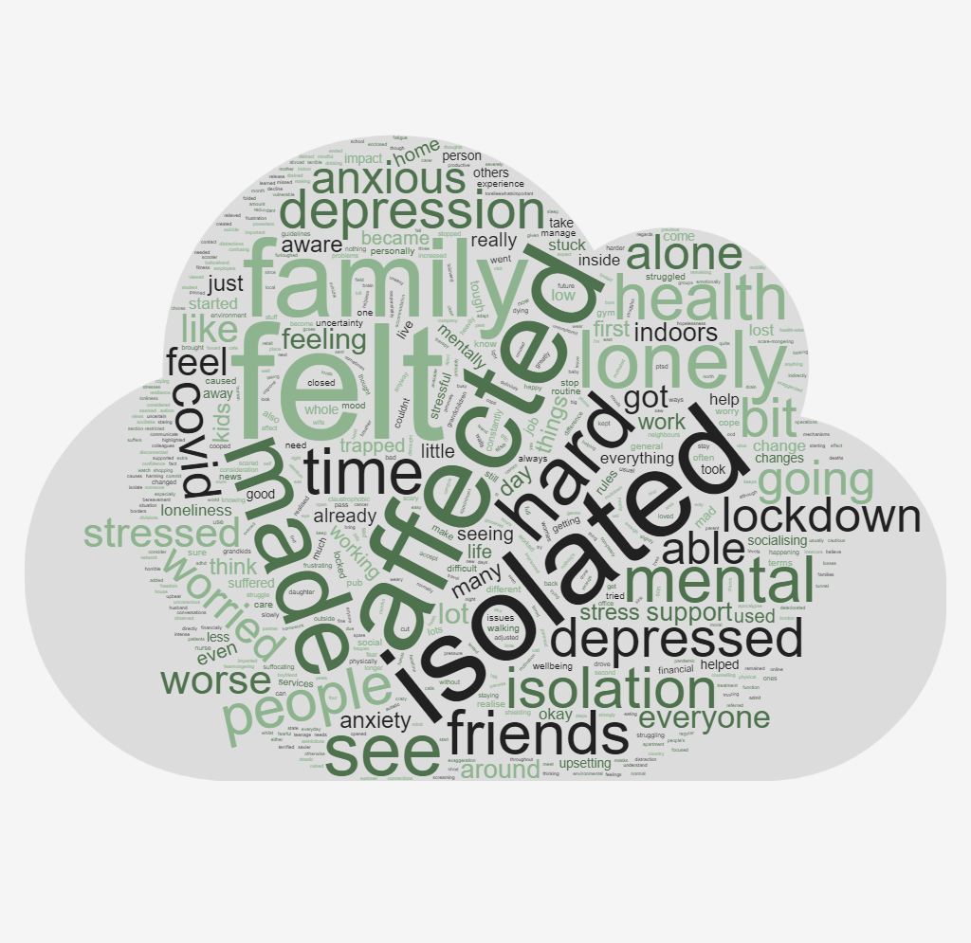
3 Are you aware of the local mental health services available to you?
Response | Yes | Some /  A little | No
Number | 39 | 145 | 282
% of total | 8% | 31% | 61%
Awareness of local mental health services was low: over half were unaware of local provision. Knowledge among all but a small number of the remainder was patchy.

4 Do you feel that the current local mental health services work for you?
Response | Yes | No | Don’t know
Number | 89 | 138 | 240
% of total | 19% | 30% | 52%
Over half of our interviewees were unsure whether mental health services were working for them. added to the 30% who felt they weren’t working, our survey indicated a lack of confidence in mental health provision.

5 If no, what would encourage you to access the local services?
Many respondents said they would be more likely to access the services if they knew where the services were and how to reach them and who to contact. They focused on quicker appointments, more information and awareness, improved accessibility, readily available groups and sessions, help if they felt very unwell, direct recommendation, encouragement, GP referrals. The word cloud below depicts the range of responses we received from interviewers about the factors that would encourage them to access local services.

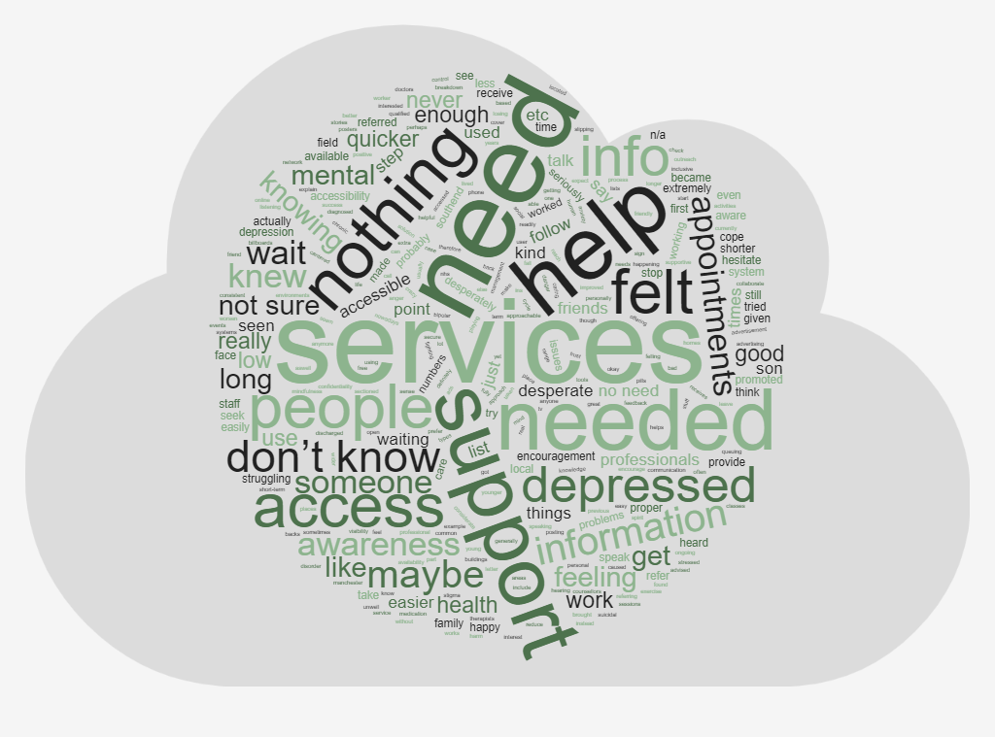
6 What issues would prevent you from accessing local mental health services if you ever felt the need for it?
Encouragingly, many respondents said nothing would stop them accessing services if needed. However, other said that not knowing who to talk to about seeking professional help deterred them. Fear of stigma and judgement were also factors, along with wait times, not being aware of services, travel costs, bad reviews, lack of confidentiality, societal fears, difficult of online access for elderly people, mistrust and availability of time. The word cloud below depicts the range of responses we received from interviewers about the barriers they perceived to accessing local mental health services.

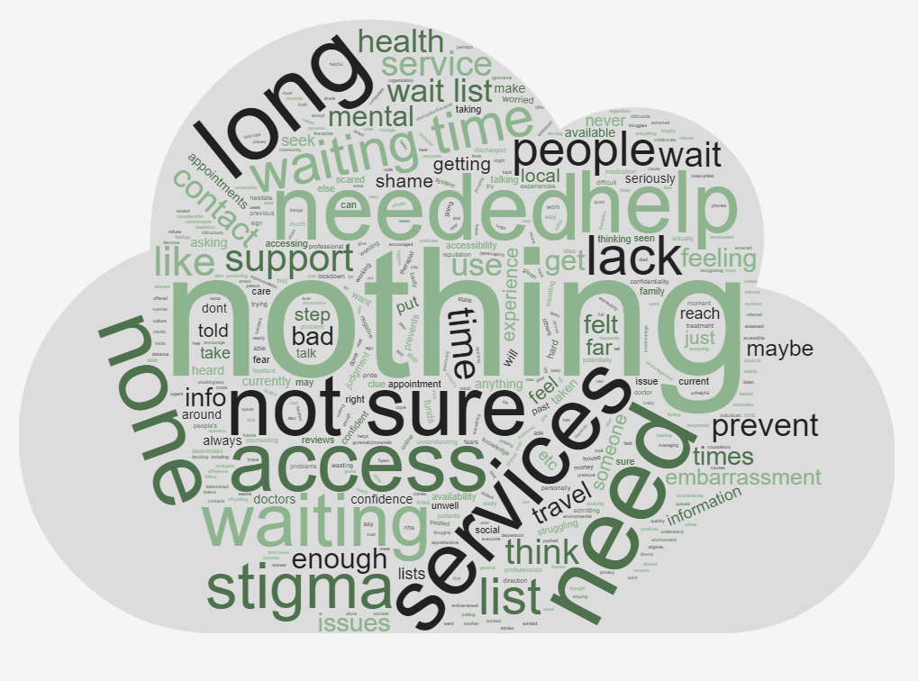
7 Do you think current services are mindful of people’s religious and cultural backgrounds?
Response | Yes | No | Don’t know
Number | 83 | 124 | 260
% of total | 18% | 27% | 56%
Responses to this question were varied. Over half were unsure and around a quarter felt that services were not mindful of religious and cultural backgrounds. An interesting note was that almost all the respondents who said services were mindful of people’s backgrounds came from those who identified as White British or British.

8 Do you consent to being contacted by us for any future events or initiatives?
Around four out of five respondents were unwilling to share personal data. On other surveys on different topics, SWIM typically secures consent to record details from around two out of three respondents. There is a suggestion that the stigma associated with mental health services accounts for the overwhelming reticence to share information.
Response | Yes | No
Number | 144 | 323
% of total | 31% | 69%
Most respondents did not consent to being contacted for future events.

9 Your name
Response | Yes | No
Number | 365 | 102
% of total | 78% | 22%
Most respondents did not consent to their name being recorded.

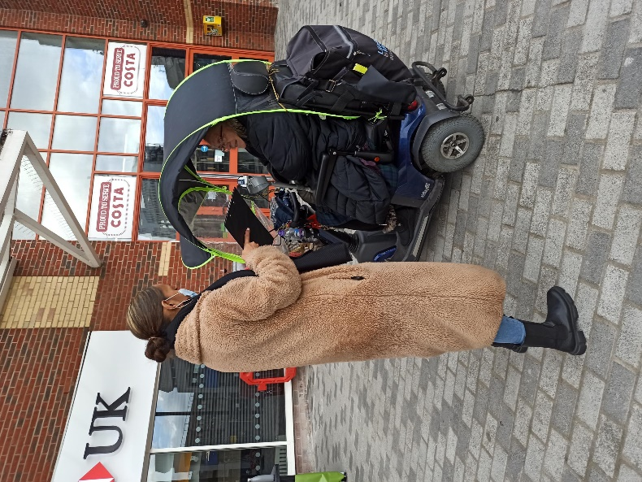
10 Contact number
Response | Yes | No
Number | 89 | 378
% of total | 19% | 81%
Most did not consent to their contact number being recorded.

11 Email address
Response | Yes | No
Number | 88 | 379
% of total | 19% | 81%
Most did not consent to their contact number being recorded.

12 Post code
Response | SS1-SS9 | Other | Not provided
Number | 158 | 108 | 201
% of total | 34% | 23% | 43%
Of the people interviewed around a third were from Southend postcodes. Unfortunately over 40% of respondents declined to provide their postcode so it is difficult to say with certainty whether the majority of respondents were from the targeted geography.

13 Gender
Response | Male | Female | Non-binary | No response
Number | 88 | 250 | 3 | 126
% of total | 19% | 54% | 1% | 27%
Over half of the respondent who provided a response identified themselves as women, while less than 20% identified as men. The significant proportion of respondents who did not answer this question is puzzling, but we still infer from the data that men are less inclined to talk about mental health challenges than women.

14 Age bracket
People came froward in broadly equal proportion in the 18-25, 26-35 and 46-55 age brackets. We saw a smaller proportion of older respondents, which may indicate a reluctance among older EM generations to talk about mental health.

15 Ethnicity
Response | Number | % of total
African | 23 | 4.8%
Asian | 57 | 11.9%
Caribbean | 23 | 4.8%
Mediterranean | 4 | 0.8%
South American | 2 | 0.4%
East European | 3 | 0.6%
White British/British | 303 | 63.5%
Dual Heritage | 18 | 3.8%
Total who responded | 433 | 9.2%
The large proportion of respondents who identified as White British or British reflects their interest in the opportunity to talk about their mental health compared with EM communities, who seemed more reluctant to engage. This finding corresponds to the general sense of reticence we found among EM people to be interviewed in detail, even when they were invited to speak to people of similar backgrounds. To overcome this barrier, we would consider using less public and more culturally congruent setting for the outreach work so that people from the target cohort feel more inclined to discuss their mental health with us.

Outcomes and conclusions
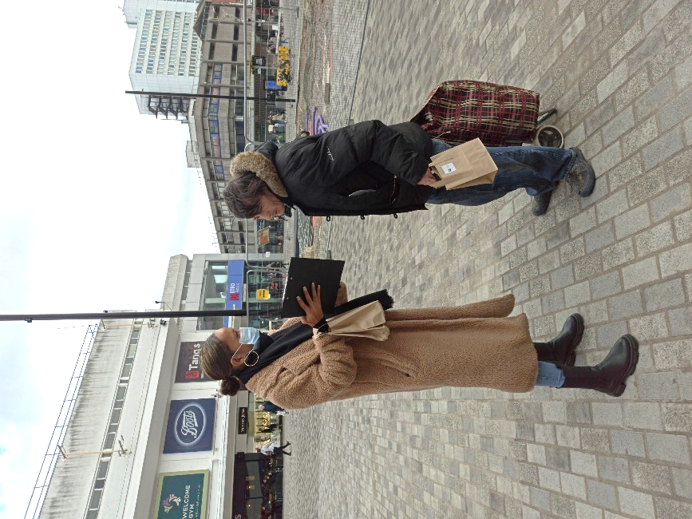
On the evidence of our four outreach events, people in Southend seemed a lot easier to interact with than London. They were open to talking about mental health and their own experiences with it, even if they were reluctant to leave their details for further contact with us. The group most willing to talk about mental health were White British.
Many of the people we spoke to want to seek help with mental health but have no information on how to get help, when to get help and what services are available to them. We also noticed that there was very little knowledge around the local mental health services available. The majority hadn’t heard of any of the local services and didn’t know where to look for them either. They mentioned that the services were very disjointed and need to be more collaborative.
Out of the two locations we chose for outreach, Victoria Shopping Centre) was more of a success than outside the Palace Theatre on London Road, Southend. The exterior of the shopping centre has a higher flow of people walking past, which meant that we completed more surveys.
Just by observation and from talking to the public, a greater proportion of people presented with learning difficulties and/or autism than we would find in London boroughs.

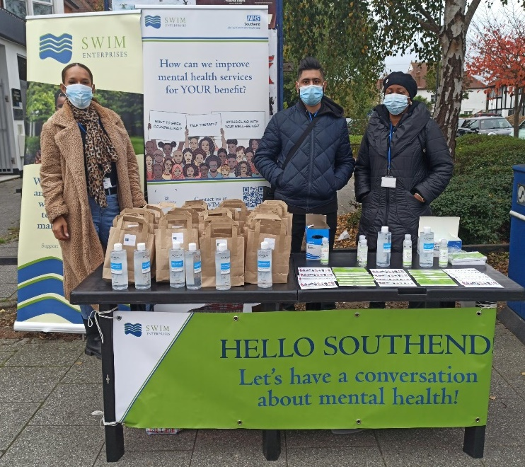
Next steps
Based on our survey responses, the local community in Southend are not well informed on services available to them. A suggestion would be to make the public more aware on the services around them and what kind of support is provided. One way to do this could be by displaying posters and flyers at GP surgeries, hospitals, clinics and pharmacies.
Some respondents also noted that there is a lack of follow-up appointments after patient treatments have ended. They wanted some type of follow-up session to check on how they are doing.
As concerns were raised about services a lack of liaison and disjointed services. A suggestion would be for services to communicate with each other more effectively when patients are being discharged and referred to another service so that better patient care can be provided.

