Application Form
The application form was designed to test the applicants’ suitability against the person specification. It was written by the fellows and signed off by Andy Griffiths.

Mid and South Essex Clinical Fellowship Programme Application Form

Important Information
Please complete sections 1-4
Send your completed application, with a copy of your CV, to:
mseicb-bb.clinicalfellows@nhs.net
You will receive an email confirming receipt of your application within 24 hours.

Application deadline: 16^{h} April 202 23 :59
Interviews are expected to be held on the May 1st and 4th 2023 via MS Teams (dates subject to change)
An opportunity will be offered to candidates who get offered an interview to meet virtually with current senior clinical fellows.
Candidates will be notified ASAP after interview (1-2 weeks) to allow standardisation

SECTION ONE: Personal Information
Title: | First Name: | Surname:
Professional Body: | Professional Body Number:
Previous/current FMLM Scheme: | Email Address:
Contact Number: | Location (current region):
Applying for Full-Time or Part-Time position:
SECTION TWO: Please complete the following questions
- What is your motivation for applying to this fellowship programme in Mid and South Essex and how do you think the fellowship will contribute to your own leadership development? (max 200 words)

- What skills and qualities will you bring to MSE to help meet local and national objectives? (max 200 words)

SECTION THREE: Please complete a personal statement to support your application outlining what particular attributes and achievements make you a strong candidate for the fellowship?
(please do not repeat information already mentioned above, max 300 words)
SECTION FOUR: References
Please include 2 references. References will be taken following interview and prior to the post-start date.
Reference 1

Title:
Name:
Job title:
Organisation:
Professional Relationship with candidate:
Email Address:
Telephone Number:

Reference 2

Title:
Name:
Job title:
Organisation:
Professional Relationship with candidate:
Email Address:
Telephone Number:

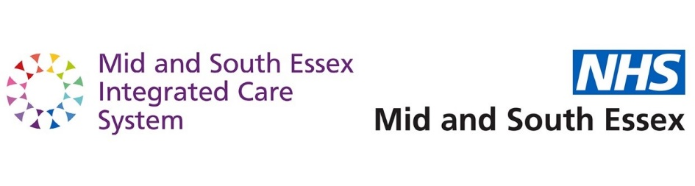

Interviews
- Interviews will last 30 minutes.
- Panel and interview times will be sent out to candidates as early as possible to allow for availability.
- Interviews will be held over MS Teams.
- Each candidate will be sent an individual Teams link to a separate meeting.
- The panel will have access to candidate applications, job description, person specification and an interview pack (with details of the interview times and suggested questions) in advance. In addition the panel are informed of the application score and the candidate suitability for the post based on the application and pre interview discussions with the current fellows.
- The panel will decide which member will ask which question and in what order on the day of the interview
- The questions are designed to test areas of the person specification that were not addressed in the application, or would have added to the information provided in the application.
- A formal interview scoring system maybe employed
- Following the interviews candidates will be informed of the outcome in one week
- Those who are not offered a post will be offered feedback
- Formal job offers will be sent out.

