Southend Clinical Commissioning Group Annual Report 2021/22

# Contents

Chair’s Foreword 4

PERFORMANCE REPORT 6

Accountable Officer’s Introduction 6

What Southend CCG does 8

Mid and South Essex Health and Care Partnership 11

Local Achievements 12

How we have performed 15

Key issues and risks 15

Performance analysis 16

Introduction 16

Performance summary 16

Improve Quality 19

Reducing Health Inequality 22

Engaging People and Communities 24

Health and Wellbeing Strategy 26

Financial Review 27

Risks 30

Sustainable Development 32

ACCOUNTABILITY REPORT 34

Corporate Governance Report 34

Members Report 34

Governance Statement 42

REMUNERATION AND STAFF REPORT 61

Remuneration Report 61

Staff Report 71

PARLIAMENTARY ACCOUNTABILITY AND AUDIT REPORT 78

ANNUAL ACCOUNTS 79

# Chair’s Foreword

In what has been another challenging year for our teams right across the NHS I am proud that we have continued to provide safe and effective patient care. Working together for better lives, we have continued to build on collaborative working between our local authority, the CCG, community providers and voluntary organisations.

This foreword gives me an opportunity to say how proud I am of all my fellow health and care professionals in Southend, and our wider colleagues who support us.

The ongoing vaccination programme continued to dominate our Covid response. I am pleased that the vast majority of people in our area have taken up the opportunity to receive their vaccine. It’s never too late to protect yourself if you haven’t yet had the jab – there are plenty of opportunities to come forward, visit [Essex Covid Vaccine (Hyperlinks)](http://www.essexcovidvaccine.nhs.uk)

I have been inspired by the work we have undertaken to support some of our seldom heard and more remote communities to receive their vaccine closer to home with the Essex Vax Van and mobile vaccination units. Working with public health and Essex Partnership University Trust, we were able to offer dozens of pop-up vaccine opportunities.

Every effort has also been made to continue providing routine healthcare to the population during the pandemic in a safe way. A robust plan is being developed (following national guidelines) to significantly reduce the number of people who are waiting for operations and treatments, as we move into the next year, the momentum on this will build.  Working together, the Mid and South Essex Health and Care Partnership has also supported hundreds of people to receive timely care in their own home or care home. 2021/22 saw the launch of new virtual wards to reduce some of the pressure on our hospitals helping us continue some of our elective work.

During the last year we have seen a wider range of health and care professionals begin to work in our local GP practices. Professionals such as paramedics, physiotherapists, pharmacists, social prescribers, and mental health workers are now working within local Primary Care Networks to help meet the needs of our local communities.

We continue to utilise new technology in healthcare and our local residents were among the first as part of a national pilot to test out how people can improve their health outcomes through self-monitoring their blood pressure. To date across Essex, it is estimated that this has prevented 250 heart attacks and 375 strokes.

While every patient concern is unique, we acknowledge there is one concern that many share – and it affects staff working in GP practices, every day. It’s the challenge faced when calling for an appointment and all that goes on behind the scenes to respond to that call. A challenge that increased dramatically during the pandemic to help to keep everyone safe. Rest assured we are looking to tackle this head on to improve and expand the ways people can access our services such as the NHS App.

We continue to work hard to challenge health inequalities through initiatives such as the Integrated Healthcare for Homeless initiative in Southend working with Southend City Council, Essex Partnership University NHS Foundation Trust and primary care and shortlisted for a 2021 Health Service Journal Award. Our Essex Vax Van is also a finalist in the HSJ Partnership Awards 2022 as we continue to work with partners to make a real difference in the lives of some of society’s most vulnerable people, such as local support for Afghan refugees, for better health outcomes locally.

A report from an Ofsted and CQC revisit to the services provided to children and young people with special educational needs and disabilities (SEND) in Southend-on-Sea, has found sufficient progress has been made in three out of four areas of significant weakness identified in a December 2018 inspection.

As we move into the new financial year, I commend the teams working together to improve the lives of people in Southend and look forward to pushing forward together as an alliance with our local authority, trusts, community providers and wider community and voluntary sector.

We have huge challenges in front of us and our values – working together, facing the future, and delivering excellence - will really help us to meet these challenges head on. I have no doubt that with the help and support of our partners in the system, we will continue to work together to deliver excellence for all the people we serve.

Dr Jose Garcia

Chair

29 June 2022

# PERFORMANCE REPORT

# Performance Overview

The purpose of the performance report is to provide information on the CCG’s objectives for the 2021/22 financial year, the principal risks to their achievement and how the CCG performed against these objectives. This section provides a precis of the rest of the annual report and accounts.

## Accountable Officer’s Introduction

It has been another extraordinary 12 months. Amid unprecedented world events, the NHS faced new COVID-19 variants and had to respond rapidly by expanding its vaccination programme. All aspects of the system continue to be under unprecedented pressure, whether in primary care, with both urgent demand and the support of patents with long term conditions, in our community services, who have stepped up to the challenge to deliver innovative ways of caring for more people in the community, our mental health services which are seeing a significant rise in demand and acuity of people accessing services, our acute hospitals, who are seeing rising demand on urgent and emergency care services which is affecting flow through the hospital and impacting on its ability to treat cancer and elective patients in a timely manner, our local authority partners, whose services are stretched in a challenging social care market and of course, our community and voluntary sector partners, without whom we could not have risen to the challenges that the Covid pandemic brought.

All this has made 2021/22 a very unsettling time.

Yet despite the pressures, our NHS and other institutions have generally succeeded in helping people get through these unique circumstances. When mid and south Essex residents looked for guidance or essential services, the NHS and its partners from the public and voluntary sectors stepped up, often in new and innovative ways. We were the trusted source of information and support.

Public services depend on trust. Every time the question of trusted professions comes up in Britain, doctors and nurses are near the top of the list. This shows the mutual confidence our residents and healthcare professionals have in one another and in the public services we all rely upon. During difficult times collaboration and confidence in one another can help us deal with difficulties and uncertain futures.

People have trusted the science behind new treatments and the support available from our institutions. In a similar way, our transition to an “integrated care system” – ICS for short – should also inspire confidence. As we restore more normal operations, the new ICS will build on the legacy of the five clinical commissioning groups to show that people’s best interests and improved health outcomes are at the heart of everything we do. Now and in the future.

As well as sharing what this CCG has achieved for [place name] residents through well-planned NHS services and partnership working, this document also reflects the seriousness with which we take our responsibilities as part of an ICS.

Strengthening relationships across the old CCG areas – what are now called “Alliances” – is vital to better health outcomes and the reduction in health inequalities and just one example of the focus we are putting on that is the appointment of our first Head of Engagement. This role will focus on nurturing broadly based relationships with our public and partners, so we can design services, identify health outcomes and set standards together.

A part of this work, our “Moments that Matter” campaign, will showcase the best of what coordinated health and social care can do. It celebrates examples of professionalism and personalised care that have stood out for residents and colleagues. Anyone who has worked in or for one of our CCGs will understand how ‘little touches’ can sometimes make all the difference to those who look to the NHS for help.

As the passage of the Health Bill completes its final stages to create ICS’ on a statutory footing, we can all look to the exciting opportunities that this will bring for our residents. At the same time, it is right that we should mark the passing of a final and tumultuous full year for CCGs by noting the distinct contribution they have recently made in developing alliance-based services and Primary Care Networks of GP practices. That emphasis on delivering health and wellbeing services for and with residents at a local level will go from strength to strength.

So many people have contributed to the CCG’s success - to name them all here would be impossible. I would nevertheless like to pay tribute to CCG colleagues for the continued support they have shown one another and most importantly, to the 1.2m people we serve during these uniquely challenging times. CCG staff and Board members can be rightly proud of all that they have achieved and be assured that the lasting legacy of their work will be seen in the solid foundations they have laid for the ICS.

**Anthony McKeever**Executive Lead for the Mid and South Essex Health and Care Partnership and Joint Accountable Officer for its five CCGs

29 June 2022

## What Southend CCG does

### Our Purpose

NHS Southend CCG is a clinically-led organisation, established on 1 April 2013, that decides how to spend the NHS budget on the majority of health services for 190,000 people living in Southend.

This includes the care and treatment you receive in hospital, maternity services, community, and mental health services. NHS Southend CCG also assumes full responsibility for co-commissioning of GP services (since April 2015).

Our role is to specify outcomes that we want to achieve for our population, and then contract with Providers to provide care to achieve those outcomes. We are committed to ensuring the provision of local, high quality services that meet the specific needs of our population.

We have a statutory obligation to achieve our financial targets and ensure that we live within our means, whilst assuring all centrally set performance targets are met.

Established under the Health and Social Care Act 2012 as a statutory body, every GP from the 24 GP practices is a member of NHS Southend CCG. As a CCG, we work hard to understand the needs of people living in Southend to commission the right services for the those that live in the borough.

To do this, the vast majority of decisions about how we use public money is made by local clinicians who are closest to the people they look after. We work in partnership with health and social care partners (e.g. local hospitals, local authorities, the community, and voluntary sector). Our governing body is made up of eight representatives of general practice (GPs) from across Southend along with a Joint Accountable Officer, Joint Chief Finance Officer, Executive Director of Nursing, NHS Alliance Director, secondary care (hospital) specialist and three Lay Members that are part of a joint management team across mid and south Essex.

The key providers from which the CCG buys health services for the residents of Southend are:

* Mid and South Essex NHS Foundation Trust (MSEFT) is the main provider of acute hospital services from its sites at Basildon, Southend, and Broomfield.
* Essex Partnership University NHS Foundation Trust (EPUT) is the main provider of mental health services.
* EPUT and the North East London NHS Foundation Trust (NELFT) are our main providers of community services.
* Emergency health services and transport are provided by the East of England Ambulance Service NHS Trust and urgent care services by IC24.

In addition, the CCG has a range of contracts with other providers of services such as palliative care and end of life services, specialist health services for fertility and termination of pregnancy and community elective care services. We also buy services from a number of Independent Sector providers.

A formal document, called a constitution, sets out the arrangements the CCG has made to ensure it meets its responsibilities for commissioning high quality services for the people of Southend.

It describes the governing principles, rules and procedures which will ensure integrity, honesty, and accountability. Also, it commits the CCG to taking decisions in an open and transparent way and places the interests of patients and public at its heart. We last refreshed our constitution during 2020/21 to reflect joint working arrangements with mid and south Essex CCGs.

Our constitution can be downloaded from <https://southendccg.nhs.uk/about-us/key-documents/constitution>.

#### NHS Southend CCG – facts and figures

|  |  |
| --- | --- |
| NHS Southend CCG – facts and figures | |
| Office Location | NHS Southend CCG, Floor 6, Southend on Sea  Borough Council, Civic Centre, Victoria Avenue,  Southend on Sea, Essex, SS2 6ER |
| Communities covered | Southend is covered by the unitary authority -  Southend-on-Sea Borough Council |
| Population (registered with a GP) on 1 April 2022 | Approx. 190,000 |
| Number of member GP practices on 31 March 2022 | 25 |
| In year revenue resource limit (2021/22) | £313.8m |
| Average number of employees | 33.29 WTE |

### Our Strategy

The MSE Health & Care Partnership developed its five-year strategy in December 2019. The strategy outlines 4 key ambitions, with the underpinning aim to **reduce health inequalities.** The strategy outlines that we would achieve this through:

* **Creating opportunity for our residents** – supporting education, employment, and socio-economic improvements for our residents. We have developed this ambition further - for example, extending the successful work led by MSEFT on hospitals as Anchor institutions, and achieving agreement to a system-wide Anchor Charter in 2021.
* **Supporting health and wellbeing** – including a focus on prevention, self-care, lifestyle support.  We have undertaken much work in this area – particularly through the Covid pandemic, where we were able to use targeted engagement techniques to link with different communities, understanding their needs and barriers to accessing care, vaccinations and so on.  We have also continued to work in partnership to target prevention opportunities and we have agreed with public health colleagues to focus particularly on obesity and continued work on vaccine hesitancy in the coming months
* **Bringing Care Closer to Home** – where this is safe and possible.  Again, we have seen many examples of this, with our Covid vaccination van that has now been transformed to a “long-Covid van”, taking assessment and testing to our communities.  We are progressing with the integrated medical centres in Thurrock, again as a new model of care to bring services closer to home.
* **Improving and Transforming our Services** – we know that our services are under considerable pressure and we are not providing the level or quality of service that we would like. There are several transformation programmes progressing, underpinned by system working on workforce, digital, and finance to bring improvements in primary care, cancer care, elective recovery, urgent care, community diagnostics, flow through the system and care arrangements.   Our Stewardship programme will be key in our future approach to service improvement and transformation.

While the strategy was set in the pre-Covid era, we consider that the key ambitions have stood the test of time and have underpinned our partnership working during the pandemic.

We will therefore take the five-year strategy into the new ICS and use the early period of the Integrated Care Partnership (ICP) formation to begin work to develop the Integrated Care Strategy – taking our local authority Joint Strategic Needs Assessments (JSNAs) and health and wellbeing strategies to develop a single strategy for Mid & South Essex.

A joint strategic needs assessment (JSNA) looks at the current and future health and care needs of local populations to inform planning and commissioning of health, well-being and social care services.  They are often, but not always, led by the local authority(ies) of an area but do require participation from all appropriate partners to:

1. Collect, analyse and interpret health and care needs information.
2. Participate in engagement work between partners or with the population.
3. Follow up and implement recommendations.

As a partner in the provision of health and care services to the population PCNs will be expected to fully participate and help shape, where appropriate, in the production of these needs assessments.

The plan for achieving this, by April 2023, will be agreed with the ICP once it is formed.

We have been clear that we want the hallmarks of our ICS to be:

* Evidence and data driven.
* Have a true partnership with our communities and use their lived experience and insight to help us shape our work.
* Ensure clinical and care professionals are leading strategy formation and supporting decision-making.

## Mid and South Essex Health and Care Partnership

**Key activities in 2021/22 and progress towards establishment of an ICB/ICP**

During 2021/22 the system has progressed towards establishment of the ICS by:

* Submitting a successful application to be formally designated as an Integrated Care System.
* Refreshing our primary care strategy and established PCN support programmes.
* Further establishing our population health management capacity and engaging with a national Population Health Management (PHM) programme to support turning data into intelligence to design interventions through our PCNs.
* Our four Alliances have agreed their initial delivery plans to support their local populations, working in partnership with local authority, Healthwatch and community and voluntary sector organisations
* Developing a data and digital roadmap to transform our digital and data capacity and capability – and we have employed a Chief Digital Information Officer to enable the ICS to move forward on this important work that will underpin everything we do.
* Agreeing an engagement strategy that defines how we will gain and use insight from our communities in the work that we do.
* Launching the Citizens’ Panel, of 1500 residents, with whom we share ideas and obtain insights to help us design services appropriately.
* Developing and agreeing a system wide quality strategy, bringing together all aspects of the health system.
* Further developing our system finance approach through the System Finance Leaders Group.
* Embedding joint accountability and assurance through our System Oversight and Assurance Group, co-chaired by the Accountable Officer and the NHSE Regional Director for Strategy and Transformation – and further developing our embedded assurance model with NHSE colleagues so as to reduce traditional transactional assurance processes between the system and NHSE.
* Developing a new approach to clinical and professional leadership, including introducing a new clinical and professional congress to support the ICS to ensure the expertise of clinicians and care professionals is at the heart of our work.
* Launching MSE Partners as a means to supporting innovation and improvement.

### Establishing the ICS

In terms of preparing for forthcoming legislation to form the ICS on a statutory footing (which has a national target date of 1 July 2022), we have introduced an ICS Transition Programme Board with seven workstreams to manage and oversee the technical aspects for development of the ICS including the disestablishment of CCGs and the commencement of the new Integrated Care Board (ICB) as an organisation. The work streams are:

* Quality and safety
* Finance and resources
* Governance and accountability
* Data and digital
* Communications and engagement
* Workforce
* Future system operating model

### Integrated Care Board

The ICB will take on all of the functions of current CCGs and, over time, some commissioning functions from NHSE. It will be responsible for the system’s entire NHS finance allocation and will take responsibility for workforce, digital, data and engagement.

Anthony McKeever has been appointed as the Chief Executive Officer (CEO) designate of the new ICB and Professor Mike Thorne CBE, has been appointed as Chair designate of the ICB. Non-executive members for the new ICB Board have been appointed and remaining appointments to the executive team are being finalised.

The Transition Programme Board has overseen the due diligence requirements to establish the ICB and will complete a “Readiness to Operate” statement to enable NHSE to formally establish the new organisation.

Integrated Care Partnership

The ICP will be a joint and equal partnership between the NHS and our upper tier local authorities. Together, we have agreed that the ICP will be chaired by Professor Thorne so as to ensure consistency and coherence across the ICS, with the three health and wellbeing board chairs of our upper tier local authorities acting as vice chairs for the ICP. We have agreed membership of the ICP, and we are currently progressing discussions to agree its work programme. The first task of the ICP will be to develop a new Integrated Care Strategy for the ICS, and for the population of Mid & South Essex.

## Local Achievements

**PCN Aligned Community Team – PACT**

SS9 successfully bid for Accelerator status to support the development and implementation of a PCN Aligned Community Team (PACT) model. Benfleet PCN took this forward initially with SS9 PCN becoming a fast-follower and adopting the PACT model.

PACT integrates the delivery of health and care to people with complex frailty needs, so services and support are coordinated and aligned in ways which make sense to the local population. Workflow is united at locality level to deliver real-time multi-agency working between primary care, community nursing, mental health dementia teams, palliative care, adult social care, care providers and voluntary sector assets to provide efficient proactive care. Digital and IT solutions are enabling this live day to day working across multiple professionals who are creating a ‘one team’ identity in the Benfleet locality. In turn, this is reducing repeated, reactive, urgent demand on teams and services as capacity becomes united and efficiently coordinated ensuring local residents get the right support, by the right team, at the right place and time for them.

**Children & Young People**

In September 2021, Mid and South Essex was chosen as one of 12 sites across England to test National Integrated Models of Care. Southend and Castle Point and Rochford CCGs were chosen as the testing site for implementing a model of integrated care for Childhood Asthma.  Work is underway with EPUT, primary care, Southend Hospital and the local authorities to develop the model and test the concept, with the aim of bringing services closer together, addressing the new National Bundle of Care programme, improving education and training and ultimately improving the quality of care our children and young people receive.

In 2021/22, Southend and Castle Point & Rochford CCGs commissioned a community feeding and swallowing service for children and young people.  Prior to this, practitioners did not have access to the key skills and competencies required to support children and families effectively.  Following a very successful pilot, Southend and Castle Point and Rochford CCGs officially began commissioning this vital service in February 2022.  EPUT are delivering the service as part of their Speech and Language Therapy service and are already evidencing a positive impact on children, young people and their families.

**Physical Health Checks for individuals with Serious Mental Illness (SMI)**

Southend and Castle Point & Rochford CCGs developed a blended model for delivering SMI physical health checks, receiving acclaim by achieving 95% of 21/22 target at Q3 and highlighted at National level as an exemplar in tackling health inequalities for people with Serious Mental Illness. Recovering from a very poor position pre-pandemic, both Southend and Castle Point & Rochford CCGs have consistently been in the top 5 performing areas in the country for SMI Physical Health checks. MSE has been cited in national webinars for areas of good practice relating to SMI physical health checks in Southend and Castle Point & Rochford.

**Anchor Programme**

The Anchoring Southend 2050 Ambition project focuses on moving people living in the most disadvantaged wards in Southend who are unemployed or economically inactive, towards work at either Southend Hospital or its Health and Care sector. The pilot wraps around existing work and skills programmes and provides dedicated individual, in person, support. That support enables participants to make high quality and ultimately successful applications to work in the NHS or healthcare sectors. Performance to date is encouraging and offers the potential to realise Anchor ambitions and principles, in terms of; activating communities, bringing people toward quality work with the NHS and helping, long term, to reduce health inequality.

**Partnership Working - Operation Union**

Southend CCG worked closely with Southend City Council and Essex Police in the standing-up of Operation Union in response to the easing of COVID-19 lockdown restrictions in June 2021. This saw additional police presence to combat antisocial behaviour and also increasing first aid presence in the high tourist footfall areas of the Borough of Southend to ensure that visitors and local residents were being kept safe. 2022 has seen this focus continue – the summer season is effectively being considered an extended event with additional police and community safety resources being applied.

**Learning Disabilities**

The Diabetes Champion Network for Learning Disabilities was established in September 2021 following a successful bid to NHSE&I for funding. Southend and Castle Point & Rochford CCGs are hosting the network on behalf of all CCGs within Mid and South Essex, the aim of the Network is to reduce health inequalities for those with learning disabilities and diabetes by providing support, resources and education to individuals, their families and carers. In addition, the Network provides a forum to raise awareness and discuss routes to positive health outcomes. 12 volunteer Diabetes champions have been recruited, 5 virtual meetings held with different focus points, a face-to-face education day with 30 participants was held in March 2022 collaboratively with Diabetes UK and Essex County Council.

**Learning Disability Health Checks**

Greater numbers of individuals with a learning disability are taking part in Annual Health Checks. People with a learning disability can sometimes find it hard to know when they are unwell, or to tell someone about it, an annual health check can improve people’s health by spotting problems earlier. Anyone over the age of 14 with a learning disability can have an annual health check. 78% of patients registered as having a learning disability accessed annual health checks in 2021/22, this continues to build on the 70% achievement last year.

**Southend Integrated Healthcare for Homeless**

The Southend Integrated Healthcare for Homeless initiative in Southend provided better joined-up care for those affected by homelessness. Championed by Dr Haroon Siddique and his team the initiative supported the health and care needs of some of Southend’s most vulnerable people. Since the initiative launched in January 2020, multiple homeless people have had health interventions which they normally wouldn’t have had access to reducing health inequalities in Southend. The initiative was selected as a finalist in the prestigious [HSJ Awards 2021](https://awards.hsj.co.uk/) recognising the outstanding contribution to healthcare in what has been an exceptional and challenging period across the sector.

## How we have performed

The CCG monitors health outcomes against a range of NHS Constitutional Standards’ that are set nationally. Performance across the system has generally been below the set standards due to capacity pressures throughout the health and care system.

The CCG is working with local providers of services and NHS England/Improvement (which is the regulatory organisation for the CCG and providers of services) to agree the system transformation required to support improvements in care for patients.

As seen nationally, performance against the standards has been directly impacted by the Covid-19 pandemic. A key issue experienced nationally is the increase in patients waiting for planned elective care during the Covid-19 pandemic. As directed through national guidance whilst capacity was reduced, non-urgent diagnostic tests together with elective planned appointments and procedures were paused to prioritise emergency, urgent and cancer work.

A key risk that could affect the delivery of future performance and recovery is ensuring workforce is in place to meet the delivery of the increased capacity required to recover from the Covid-19 pandemic and meet demand.

## Key issues and risks

The Covid-19 pandemic had a significant impact upon the operation of NHS services across the country, which brought with it several associated risks, firstly in relation to the effects of the virus itself and secondly in relation to the effects that management of the pandemic has had on core services and the achievement of constitutional standards.

The former has been managed well during the year, which is reflected in the lowering of risk in relation to the effects of the virus as a result of the success of the Covid-19 vaccination programme and greater understanding of how to care for patients with the virus. The Mid and South Essex CCGs continue to manage the impact of risks on core services, focusing on restoring performance back to pre-Covid levels.

Further information on the CCG’s key risks and risk profile is provided in the Risks section of the Performance Analysis report.

# Performance analysis

## Introduction

Measuring our performance against a range of indicators, including nationally agreed quality standards, is important for our patients and the public as they relate to key areas such as access, treatment times and quality of care. Performance against these targets, and the plans we have to improve them, is overseen by the Finance and Performance Committee.

2021/22 has, as outlined within this report, provided challenges to delivery and recovery of performance standards. The below summary shows the performance as reported in March 2022, this is the most up to date information at time of writing this report.

Mid and South Essex continues to work collaboratively with our provider partners to support recovery of performance standards and outcomes for our population. This work is ongoing and continues into 2022/23.

## Performance summary

The following is an overview of how the system has performed against the constitutional standards.

#### NHS Constitution – Urgent and Emergency Care (UEC)

#### For UEC the NHS constitution includes standards for both Ambulance Response Times and Emergency Department (ED) waiting times.

#### Ambulance response times are significantly challenged as per following Mean and 90th centile summary by call category against the standards (format: hh:mm:ss) for 2021/22:

* One calls - for life-threatening injuries and illness:
  + Mean: 00:08:06 (standard <=7min)
  + 90th Centile: 00:14:11 (standard <= 15min)
* Two calls - for emergencies:
  + Mean: 00:56:47 (standard <= 18min)
  + 90th Centile: 02:09:08 (standard <= 40min)
* Three calls - for urgent:
  + 90th Centile: 08:16:05 (standard <= 2 hours)
* Four calls - for less urgent:
  + 90th Centile: 09:12:27 (standard <= 3 hours)

ED waiting times are also challenged. For Mid and South Essex NHS Foundation Trust (MSEFT), 77.6% of patients arriving within A&E were seen, treated, and discharged, or admitted to a ward with four hours of arrival (below standard of >= 95%) during 2021/22.

As a system the CCG are working with all partners including MSEFT, Community providers, Local Authorities and EEAST to improve response times and ED waiting times.

All partners are members of the Strategic Partnership Urgent and Emergency Care Board for oversight and input into the improvement of the system UEC performance. Daily operational calls (Daily Tactical Care call) are in place with system partners, ensuring plans are in place or reviewed to mitigate presenting pressures across the system.

Mid and South Essex system through collaborative working between partner organisations are working on several initiatives to improve ambulance offload times (for conveyed patients) and flow through ED.

Community providers are supporting for example, through the Urgent Community Response Team (UCRT) team working with EEAST to, where appropriate, provide an alternative to conveying patients to acute hospital. The Virtual Wards work is continuing to be developed to support admission and reduce the need for conveyance of frail elderly patients where more appropriate.

Another example of collaborative working between partner organisations is EEAST Hospital Ambulance Liaison Officer (HALO) work within MSEFT Emergency Departments (ED) to facilitate the triaging and handover of patients arriving via ambulance to release EEAST staff.

To facilitate optimal flow through the hospital, Local Authorities ensure continued support for timely discharges from the acute.

#### NHS Constitution – Diagnostics

#### As seen nationally during the COVID-19 pandemic, waiting times for diagnostic tests or procedures has increased significantly with a large increase in the number of patients waiting over six weeks and 13 weeks.

#### During 2021/22, 68% of patients waited less than six weeks (below standard of >= 99%) with circa 14% of patients waiting over 13 weeks (below standard of zero) at MSEFT.

#### NHS Constitution – Cancer waiting times

As seen nationally during the COVID-19 pandemic, demand in terms of the number of two week wait (2WW) referrals decreased significantly and now, as expected demand on cancer services particularly the 2ww referrals is increasing as the country comes out of the pandemic.

For Mid and South Essex NHS Foundation Trust (MSEFT), during 2021/22:

* 69.8% of patients were seen by a specialist within 2 weeks of being booked on a 2WW pathway (below standard of >= 93%).
* 68.8% of patients were informed within 28 days whether they have cancer or not (below standard of >= 75%).
* 85.7% of patients started first definitive treatment for a new primary cancer within 31 days of the decision to treat (below standard of >= 96%).
* 55.3% of patients started first definitive treatment of cancer from receipt of urgent referral for suspected cancer within 62 days (below standard of >= 85%).

Delivery of the 62-day performance continues to be the most challenged cancer standard.

The CCG is working with MSEFT and Cancer Alliance through plans to transform the diagnosis, treatment, and care for cancer patients to recover performance for the local population.

#### NHS Constitution – Planned Care

#### As seen nationally during the COVID-19 pandemic, waiting times from referral to first definitive consultant led elective (non-urgent) treatment (RTT) has increased significantly with a large increase in the number of patients waiting over 18 and 52 weeks.

#### During 2021/22, 34.5% of patients waited less than 18 weeks (below standard of >= 92%) with circa 4% of patients waiting over 52 weeks (below standard of zero) at MSEFT.

Mid and South Essex system through collaborative working between partner organisations including MSEFT, Independent Sector Providers, Community Providers and primary care are working together to ease pressure at the acute trust, ensuring patients with 2ww or urgent referral are prioritised, and available capacity is maximised across the system.

Community providers are working with MSEFT to, where appropriate, provide an alternative place for treatment to waiting and being treated at MSEFT. Local Independent Sector providers are providing additional system capacity for patients waiting at MSEFT facilitated by commissioners and MSEFT. Primary care is supporting with demand management/referral diversion plans.

#### NHS Constitution – Improving Access to Psychological Therapies (IAPT) and waiting times

The number of people accessing psychological therapies is below target during 2021/22.

The waiting list for IAPT service is meeting the six and 18 week standards for receiving first treatment as follows:

* 99% of patients received first treatment within six weeks

(above standard of >=75%)

* 100% of patients received first treatment within 18 weeks

(above standard of >= 95%)

Of the people who complete treatment, 51% moved into recovery (above the standard of >= 50%).

#### NHS Constitution – Psychosis waiting times.

#### During 2021/22, 79.9% of people experiencing first episode psychosis started treatment, with NICE recommended package of care, within two weeks from referral (above the standard of >= 60%).

#### Severe Mental Illness (SMI) Health Checks

Circa 2,300 people are living with Severe Mental Illness (SMI) within the CCG population. As at March 2022, 68.2% of people living with SMI have received their full physical health assessments (above standard of >= 60%).

**NHS Constitution – Children and Young People access to mental health services and eating disorders treatment waiting times.**

The number of Children and Young People accessing Mental Health Services is above national trajectory of 35% at 42.6% (as at January 2022).

#### NHS Constitution – Dementia

The standard is for the number of people on the dementia GP Practice register to be at least 66.7% of the estimated prevalence. The CCG register is at 70.1% (as at January 2022), above the standard.

## Improve Quality

2021/22 has continued to bring challenges and demands on our services, during which time colleagues from all sectors have done so much to ensure we continue to maintain quality care to thousands of patients across our system.

Mid and South Essex CCGs (MSE) have maintained core quality functions, such as serious incident monitoring and investigation, safeguarding, quality assurance and infection prevention and control, whilst recognising the challenges created by the pandemic. At times having to prioritise our work to flex with the needs of the system and continuing, where able, to work towards the transformation of services and processes in readiness for transition into an Integrated Care System (ICS).

Throughout 2021/22 the Quality team has adopted a continued response to the management of Covid-19 and associated workforce challenges, whilst continuing to influence the provision of safe, clinically effective healthcare locally.

#### Care Quality Commission (CQC)

The ratings of our main providers remain as ‘outstanding’ for Provide Community Interest Company, ‘good’ for Essex Partnership University Trust (EPUT) community services and ‘requires improvement’ for Mid and South Essex Foundation Trust (MSEFT), EPUT Mental Health Services, North East London Foundation Trust community services and East of England Ambulance service.

As part of a new risk-based approach to inspections CQC undertook a formal reinspection of MSEFT Maternity services, and Emergency Departments. In terms of Maternity services, CQC gave an overall rating of ‘Requires Improvement’. This represents an improvement and acknowledges the hard work being undertaken as part of the MSE wide Maternity Improvement Programme. The CQC Section 31 notice for Maternity remains in place, as well as ongoing support as part of the NHSE/I Maternity Safety Support Programme. The Maternity Improvement Programme has been updated to reflect CQC’s most recent recommendations and strengthened to include learning from the Ockenden Report. Both will support and further improve the transformation of Maternity services across MSE.

CQC undertook a review in June 2021 of care for people with a learning disability during the Covid-19 pandemic. The report published looked at how providers worked collaboratively in a system in response to the Covid-19 pandemic and the experiences of people with a learning disability living independently within the community. The report showed positive aspects, that care was provided, and communication was good at the height of the pandemic. Advocacy was also seen as a positive aspect displayed at this time.

#### System Quality

In line with national NHSE guidance the MSE CCGs Executive Director of Nursing and Quality has successfully established the Mid and South Essex System Quality Group. This has significantly strengthened the quality surveyance, oversight and wider system learning from all key providers and partners. This group will be instrumental in developing system strategy leading into the Integrated Care Board and Partnership.

MSE CCGs have also initiated the Patient Safety Specialist meeting as one of the elements from the National Patient Safety Strategy. This meeting aims to share knowledge and learning across our system through the collaboration of all acute and community partners.

MSE Quality teams have also supported MSEFT to undertake deep dive harm reviews on all patients whose care pathways breached cancer standards and those breaching referral to treatment standards. This has enabled the Trust to identify where harm has occurred and for learning to be used to change pathways and processes moving forward.

For Mental Health service provision across the population of Mid and South Essex the Quality teams have been working closely with Essex Partnership University NHS Foundation Trust (EPUT), the newly formed Mental Health Provider Collaborative and other local providers to ensure robust oversight of the quality and safety of care provided. During 2020/21 the CCGs have robustly reviewed their mental health commissioning arrangements through the CCG Mental Health Taskforce and supported the ongoing Parliamentary commissioned Essex Mental Health Independent Investigation.

#### Special Educational Needs and Disability (SEND)

Southend - An Ofsted and CQC revisit to special education needs and disabilities (SEND) services in Southend-on-Sea in November 2021 found sufficient progress made in three out of four areas of significant weakness as identified through the 2018 SEND Inspection. The report highlighted improvements to the Local Offer, the multi-agency approach to Education Health and Care (EHC) plans and better evaluation of education needs, as well as commenting on the ‘palpable’ change in culture and greater commitment to joint working for the best outcomes for children and young people with SEND in Southend.

#### Infection Prevention and Control

The Infection Prevention and Control team has been integral to the Covid-19 pandemic system response during 2021/22. They have maintained high levels of oversight and partnership working with local agents such as Public Health to ensure information, advice, and rapid learning has been robustly available.

The team have also maintained oversight of healthcare associated infections such as Methicillin resistant Staphylococcus aureus bacteraemia (MRSAB) and Clostridioides difficile infection (CDI) cases. In the year there were a total of 33 CCG and 9 Acute MRSAB cases and 382 CCG and 221 Acute CDI cases.  Learning from these infections has been identified and we will be supporting providers moving forward to ensure this learning is embedded into practice.

With reference to the 2019 Group A Streptococcus (iGAS) outbreak in Mid and West Essex work has continued to ensure that all learning has been taken forward and disseminated regionally and national during 2021.

#### Patient Experience

During 2021/22 as part of the development of the Quality strategy, the Quality teams have strengthened the voice of the patient through ways such as a programme of patient stories which capture authentic lived experiences. This, in turn, is shared with commissioners and has directly influenced commissioning decisions. Furthermore, as part of stakeholder development of the MSE Quality strategy, a key priority highlighted going into 2022/23 is the call for ongoing focus to ensure robust coproduction with patients and services users.

#### Care Sector

The Quality team helped to progress the provision of Enhanced Care in Care Homes. Providing support to homes during the Covid-19 pandemic with training, new technology to support our patients remotely and daily hub calls to rapidly enable support to our homes in a timely way.

## Reducing Health Inequality

#### Duty to reduce inequality

Health inequalities are the preventable, unfair, and unjust differences in health status between groups, populations or individuals that arise from the unequal distribution of social, environmental, and economic conditions within societies, which determine the risk of people getting ill, their ability to prevent sickness, or opportunities to act and access treatment when ill health occurs.

Addressing health inequalities is a core strategic ambition of the MSE Health & Care Partnership (HCP). The significant increase in collaborative working accelerated by the Covid pandemic has enabled us to tackle these issues across the HCP. The MSE ICS five-year HCP strategy outlines our commitment through working with our partners to reduce inequalities. We aim to achieve this by:

(1) Creating opportunities through education, employment, housing, and growth

(2) Supporting health and wellbeing

(3) Bringing care closer to home and

(4) Transforming and improving health and care services.

The Health Inequalities Oversight Group (HIOG) was established to provide oversight, focus, and ensure the delivery of requirements to reduce inequalities. The HIOG group has cross organisational representation from NHS Providers, Local Authority Community and Voluntary Services, Public Health, Primary Care, and other NHS organisations. This group reports into the System Leadership Executive and MSE Healthcare Partnership Board.

Dr Sunil Gupta, Chair of Castle Point and Rochford CCG, is the designated Senior Responsible Officer (SRO) for the HCP. Dr Gupta is supported by a Senior Executive Sponsor for Inequalities (Mark Tebbs, Thurrock Alliance Director) and by a Senior Clinical Fellow. Dr Sophia Morris, Inequalities Programme Lead, has also taken a lead in driving our work and is supported by a secondment role enabled by some non-recurrent seed funding to co-ordinate the work of the HIOG. The work to reduce health inequalities is driven by a maturing network of equity leadership. All system providers have a named Inequalities SRO, and each Alliance has named inequalities leads who will support the incoming Primary Care Network (PCN) Inequalities leads. Development of leadership within inequalities has been proactive and within MSE we have hosted a successful first cohort of five GP Trailblazer Deprivation Fellows with recruitment now open for cohort two.

Progress in health inequalities improvement is established through the use of the System Outcomes Framework which are health inequalities indicative metrics aligned to system ambitions. The system outcomes framework is being collated into an interactive system-wide dashboard. System and Place-based inequalities plans are focused on the amalgamation of Prevention, Population Health Management, Personalised Care, Self-Care and strengthening our community-based approach. A place-based approach to addressing inequalities is being delivered with our four Alliances which sees NHS organisations, Primary Care, Health and Wellbeing Boards, Local Authority Public Health, Social Care and children’s services, voluntary sector organisations working collaboratively through a single, shared “place plan” to address agreed key priorities.

Addressing the wider determinants of inequalities, particularly in our most deprived areas, is crucial in reducing inequality gaps. With an explicit focus on the social determinants of health - at system and place level - partnership working is embedded in our approach to inequalities improvement. This can be seen in areas such as Better Start Southend, which delivers targeted provision to children aged 4 and under in the most deprived wards in Southend, and the Mid and South Essex Foundation Trust (MSEFT) Anchor Programme initiatives that are targeting employment opportunities to young people and adults in the most deprived wards.

To realise our ambition to reduce inequalities, we have identified community asset engagement as a core principle within our engagement strategy - which is driven by our aim to ensure local voices are heard, improved local confidence and to be unified to creating changes. Embedding co-production into the equalities workstream has been a key part of the MSE equalities approach. Much co-production was seen within the Covid Inequalities Programme and this will continue as we learn and distill the good practice from this period. Following a co-design initiative for people with Learning Disabilities accessing hospital services in 2021-22, MSE FT will implement a detailed action plan in 2022-23 to improve access for people with Learning Disabilities across hospital sites. We are also working with providers in other parts of Essex to jointly take actions for the benefit of our population.

The latest planning guidance for NHS organisations outlines five priority areas for tackling health inequalities:

* Priority 1: Restore NHS services inclusively
* Priority 2: Mitigate against digital exclusion
* Priority 3: Ensure datasets are complete and timely
* Priority 4: Accelerate preventative programmes that proactively engage those at greatest risk of poor health outcomes
* Priority 5: Strengthen leadership and accountability

The Core20PLUS5 approach to tackle health inequalities was also introduced in 2021. This approach outlines a framework to accelerate health inequalities improvement through focused approaches targeted at the Core20 (the most deprived 20% of the population) PLUS (other inclusion groups) and 5 (clinical areas of focus). This Core20PLUS5 framework has been adopted across the system and health inequalities improvement plans at system and place have been refined to reflect the Core20PLUS 5 approach.

Within Primary Care, the Tackling Neighborhood Inequalities Directed Enhanced Service (DES) has called for a coordinated approach to tackling inequalities within Primary Care. All PCNs are required to nominate a health inequalities lead will be to act as a focal point and champion for this work. PCNs will also work with commissioners and PHM teams to design and deliver inequalities improvement intervention(s) for a selected population group experiencing inequality.

It is expected that an overarching ICS Health Inequalities Strategy will be deployed by July 2022.

## Engaging People and Communities

We put patients and the public at the heart of our CCG. Working in partnership with patients, carers, families, and local people within their own communities brings a different perspective to our understanding and can challenge our view of how we think services are received and should be delivered in the future. Service provision can be improved if we can learn more about the views, experiences and concerns of patients, service users, carers, and our wider communities. We believe that better decisions are made when patients and professionals work together. In line with a [system engagement framework (hyperlinks)](https://www.msehealthandcarepartnership.co.uk/become-involved/introduction/) we strive to make sure we get the community involved at the very beginning of a project and build things around local need rather than organisations.

#### The impact of the Covid-19 pandemic

The Covid-19 pandemic continued to pose challenges to how we went about meeting our usual duties to engage and communicate with our local communities and continued to postpone all face-to-face engagement. However, we recognised a critical need to engage and have constructive dialogue with local people and patients throughout this time.

#### Our legal duties and principles of engagement

The CCG has a duty, under Section 14Z2 of the NHS Act 2006, to involve the public in commissioning. Here we provide an overview of the consultation and engagement activities that have taken place over the past year (April 2021 – March 2022).

We know from experience that engagement with patients, carers and our local communities can result in:

* Better outcomes and patient experience
* Improved services
* Reduced demand
* Deliver change

#### Engagement in Southend CCG across the Mid and South Essex Health and Care System

Collectively the CCGs and partner organisations across mid and south Essex have benefitted from sharing best practice. So, we have been expanding the ways in which we work with local people and to join the conversation in a way that suits them:

* Patient and Community Reference Groups - Southend CCG continued to hold bimonthly Patient and Community Reference meetings online.
* Attending the CCG’s public meetings, including its Annual General Meeting and Governing Body meetings in public.
* Attending our virtual events – our Southend Community Covid-19 listening events, provided an opportunity to hear from the Director of Public health and the Deputy Alliance Director for Southend CCG on national and local Covid-19 information and provided opportunities for attendees to ask questions; give comment and opinion; share lived experience and provide feedback to the Council and the NHS.
* Two formats were adopted, general ‘Community Conversation’ events and events targeting specific residents and community groups. Attendees were able to join either online or by telephone. Upon request a BSL interpreter was in attendance to make sessions as accessible as possible. There has been a total of 23 conversations which saw an average of fifty residents attending each event which equated to over 500 unique contacts.
* Join ad hoc meetings to inform our work. For example, we hosted a number of meetings with patient representatives to inform our communications campaigns.
* Being part of our Citizen Panel, called [Virtual Views (hyperlinks)](https://www.msehealthandcarepartnership.co.uk/become-involved/citizens-panel/). In 2021 we asked for their views on immunisation and changes to services re the pandemic response.
* Following and interacting with the CCG on social media or visiting our website or subscribing to one of our newsletters.
* Contacting the CCG with specific ideas, questions, or concerns.

Details of all the groups and meetings, as well as the CCG’s contact details and social media, can be found on the CCG website [Get Involved - NHS Southend CCG](https://southendccg.nhs.uk/get-involved) (hyperlinks).

#### Partnerships across the health and care system

We actively work and collaborate with our local Healthwatch and voluntary, community and faith sector colleagues.

We partnered with Ford to develop the world’s first custom-built Covid-19 vaccination vehicle called the Essex Vax Van. This enabled a new model of outreach and ensured a culturally sensitive approach for communities not engaging in the national Covid-19 vaccination programme.

Having successfully increased the uptake of Covid-19 vaccinations in areas of low uptake, the team built on its success to bring much needed spirometry testing into the community. The initiative was a finalist for ‘Most impactful project addressing healthcare inequalities’ at the prestigious HSJ Partnership Awards 2022. For more information, please visit: [Essex Vax Van](http://www.essexcovidvaccine.nhs.uk/coronavirus-vaccine/essex-vax-van/) (hyperlinks)

### Improving accessibility to healthcare information

The CCG have been improving accessibility to healthcare information with the support of the Council for Voluntary Services (CVS). This collaboration provided residents with resources such as Easy Read, information in different languages or for learning disabilities and videos produced by the CCG with subtitles and where possible a British Sign Language interpreter on the screen.

NHS Vaccine Inequalities Funding was offered to support individuals to Access Covid vaccines in areas where vaccine confidence, complacency and accessibility was low. We worked with communities to understand some of the barriers and support individuals to come forward for their vaccination. We were able to offer these communities funding which was to be used specifically to increase vaccine uptake amongst groups and residents living in areas where it is lowest.

My Health Matters**:** Deliver support to parents and carers of children aged 0-5 living in Southend to better manage childhood Illnesses, through a series of co-production workshops for health and care professionals, parents, and carers of 0-5 year olds. It provided an opportunity for them to influence local communications and behaviour interventions and support our campaign.

#### Social media and digital marketing

Collective planning, developing, and delivering of social media and other online content for our communities. Posting regular messages offering information on COVID, self-care and other healthcare matters, the digital team produced a number of campaigns to support CCG priorities.

#### Our ambition

Our ambition is to place engagement at the forefront of all we do in Southend, creating healthier communities that people recognise and feel a part of.

Together we will aim to co-design and deliver new models of care and different ways of working that make a real difference to people and their local communities. We will work collaboratively across local authority, health, and voluntary sector to understand and build our communities, maximising the collective impact we can have on the health of our population.

## Health and Wellbeing Strategy

The MSE Health & Care Partnership’s 5-year strategy is built upon the priorities agreed through the three upper tier Health and Wellbeing Boards and, as we move towards creating the statutory ICS, we have agreed the importance of continuing to ensure that the Health and Wellbeing strategies underpin the work we do together.

Through the ICS and our four Alliances we have been involved with and contributed to the development of refreshed joint Health and Well Being strategies, including the Southend Health and Wellbeing Strategy for 2021-24, and will continue to ensure our plans are supportive of delivering the aims of these strategies at system, alliance and PCN level.

Senior leaders from the CCGs have engaged with all three upper tier local authority health and wellbeing boards, as well as district, borough and city fora, throughout the year.  CCG leaders are core members of the HWB Boards and have proactively participated in attending meetings, workshops and events, contributing to the refresh of joint health and wellbeing strategies and co-producing Alliance plans. Across the three UTLA we have commenced work on a joint mental health strategy, as well as a children’s partnership plan.

The chairs of the three UTLA health and wellbeing boards sit on the MSE Health & Care Partnership Board, as do senior officers, including Directors of Adult Social Care and Directors of Public Health.

As we move into the formation of the statutory ICS, the Integrated Care Partnership will be an equal partnership arrangement between the NHS and upper tier local authorities.  We have agreed that the ICB Chair (Professor Mike Thorne CBE) will chair the Integrated Care Partnership and the three health and wellbeing board chairs will act as vice chairs.  A wider range of local authority colleagues will play a role in the ICP – which may include, alongside the HWB chair, the Director of Adult Social Care, the Director of Children’s Social Care, the Director of Public Health.  A representative from each district/borough/city council will also be on the ICP, broadening the range of local authority partners in this arrangement.

## Financial Review

Financial overview

Our full statutory financial accounts are included in the final part of this report. This section provides a summary of our 2021/22 financial position. Our Head of Internal Audit offers an opinion on Financial Systems Key Controls and other matters which can be found on page 59, whilst our overall financial management arrangements and financial statements were subject to audit review and opinion by our external auditors, [KPMG (hyperlinks)](https://home.kpmg/uk/en/home.html), as part of their annual review of our accounts (see page 101 for their full audit opinion).

**CCG funding**

The financial regime and allocation methodology which NHSE put in place in the last financial year has continued into the 2021/22 financial year due to ongoing effects of Covid – 19.

This financial year, however, the funding of the costs of our main independent acute services providers have reverted to CCGs and the status quo has remained for CCG payments to NHS providers. Furthermore, there was additional income received relating to Elective Recovery Fund (ERF) and the Additional Roles Reimbursements for PCNs (ARRS).

For the first half of the financial year (H1), CCGs were issued allocations within which they had to remain. The Hospital Discharge Programme (HDP), however, continued, with reimbursement of care from April – June for the first six weeks of care, tapering to 4 weeks of care until the end of October, with a system-wide (Mid & South Essex) envelope of up to £11.9m being made available.

For the second half of the financial year (H2), the payment flows to providers continued, with each NHS system (local CCGs and NHS providers) allocated a resource funding envelope within which to manage expenditure. There was no major change in technical approach in H2, other than uplifts being granted for inflation, pay awards (including back-pay relating to H1) and an increased efficiency challenge of 3 - 3.5% There has been some additional top-up funding for specified transformation and Covid priorities, but broadly, individual CCGs and the System were required to manage within the advised System envelope. The HDP continued, with 4 weeks of care being reimbursed, with a system-wide allocation of up to £11.5m being made available.

Mid Essex CCG has broadly continued as the nominated lead CCG for receiving and managing the distribution of most non-organisational specific System allocations such as Covid and system growth funds. Furthermore, some additional transformation funding was made available to CCGs either on an individual basis or as system hosts.

In 2021/22 our in–year total healthcare funding was £310.2m and funding for running the CCG (called “running cost expenditure”) was £3.6m, resulting in total overall funding of £313.8m.  CCG expenditure was £313.7m, including some expenditure incurred on behalf of the Mid & South Essex System, and resulting in a £0.1m surplus position for the year.

NHS planning guidance requires CCGs to meet the ‘Mental Health Investment Standard’ (MHIS).  This requires CCGs to demonstrate that expenditure on mental health services has grown year on year.  In 2021/22 the CCG has achieved the MHIS by increasing all Mental Health related expenditure by 4.46%.

As of 1 April 2021, the CCG had an accumulated surplus from previous years of £2.9m.  In 2021/22 the CCG maintained the accumulated surplus from previous years. This surplus, coupled with the in-year surplus in 2021/22, results in the surplus brought forward into 2022/23 standing at £3.0m.

#### How your money was spent

In 2021/22 we spent £310.1m on healthcare services and a further £3.6m on running costs, totalling £313.7m.

The following chart shows the major areas of expenditure for healthcare (including CCG running costs).

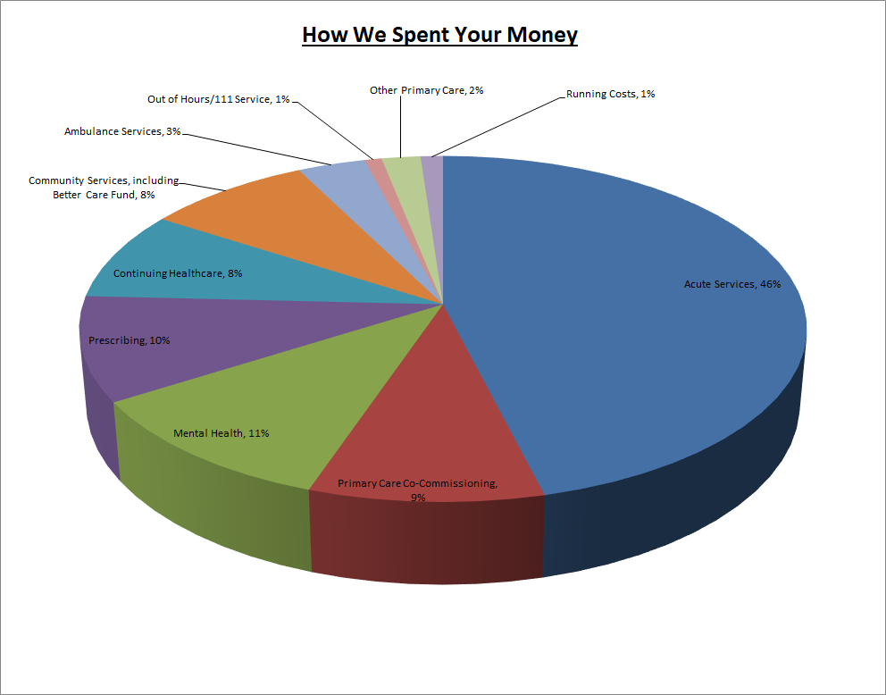

In 2020/21 the CCG spent £2.8m on Covid related expenditure. The main areas of expenditure were £2.7m on the hospital discharge programme – of which £0.4m was spent on CHC, and a further £2.3m was incurred via Southend City Council.

Additional funding was made available to address these costs.

The CCG did not incur additional costs or receive additional funding in relation to EU exit.

#### Capital spending

We did not receive a CCG capital allocation for 2021/22, but the Mid and South Essex Health and Care Partnership footprint was awarded Estates and Technology Transformation Funding (ETTF) towards primary care estates projects and GP IT. ETTF expenditure is accounted for by NHSEI.

#### Paying our suppliers and providers

National rules mean we must aim to pay all valid invoices by the due date or within 30 days of receiving them, whichever is later. The NHS aims to pay at least 95% of invoices within 30 days of receipt, or within agreed contract terms. In 2021/22 we met all four targets (based on invoice numbers and value of expenditure) for NHS and non-NHS invoices – see Note 6 of the Financial Statements for details.

We are also an [approved signatory (hyperlinks)](https://www.smallbusinesscommissioner.gov.uk/ppc/signatories/?signatory=n) of the Prompt Payment Code. The government designed this initiative with the [Chartered Institute of Credit Management (hyperlinks)](https://www.cicm.com/) to tackle the crucial issue of late payment and to help small businesses. Suppliers can have confidence that any organisation signed up to the code will pay them within clearly defined terms and that proper processes are in place to deal with any disputed payments. Approved signatories have committed to:

* Paying suppliers on time
* Giving clear guidance to suppliers and resolving disputes as quickly as possible
* Encouraging suppliers and customers to sign up to the code.

The national measures for payment performance do not include any delays in payment during the time that an invoice is on hold.

### 2022/23 Financial plans and looking to the future

#### The unprecedented impact of the Covid pandemic has inevitably delayed the return to normal financial arrangements.  CCGs will cease to exist on 30 June 2022 and on 1 July 2022 be replaced by the Mid & South Essex Integrated Care Board (ICB). The Mid and South Essex Health and Care Partnership becomes the Mid & South Essex Integrated Care System (ICS).  Allocations for 2022/23 have been issued on a system level and it is expected that CCGs allocation and expenditure will be balanced for the first quarter, with any risks falling to the new organisation. We will continue to work with system partners over the coming months to prioritise programmes of work towards achieving a financially sustainable health and social care system.

## Risks

The CCG’s risk profile as a 31 March 2022 is detailed in the table below:

| **Workstream** | **RAG Rating** | | | **Total No of Risks** |
| --- | --- | --- | --- | --- |
| **Green** | **Amber** | **Red** |
| Cancer and End of Life | 0 | 1 | 1 | 2 |
| Children and Young People | 0 | 6 | 0 | 6 |
| Community | 2 | 4 | 0 | 6 |
| Digital and Business Intelligence | 1 | 3 | 0 | 4 |
| Estates | 0 | 2 | 0 | 2 |
| Finance | 1 | 3 | 1 | 5 |
| Health Inequalities | 0 | 1 | 0 | 1 |
| Integrated Care System | 2 | 3 | 0 | 5 |
| Maternity | 0 | 2 | 1 | 3 |
| Medicines Optimisation | 1 | 1 | 0 | 2 |
| Mental Health and Learning Disability | 0 | 4 | 2 | 6 |
| People | 1 | 1 | 1 | 3 |
| Planned Care | 1 | 2 | 2 | 5 |
| Population Health Management | 0 | 3 | 0 | 3 |
| Primary Care | 2 | 5 | 0 | 7 |
| Stewardship | 0 | 0 | 0 | 0 |
| Urgent Emergency Care | 2 | 5 | 0 | 7 |
| Vaccination | 0 | 1 | 0 | 1 |
| **Total as at 31 March 2022** | **13** | **47** | **8** | **68** |

During 2021/22 the MSE CCG’s risk profile has seen the number of red rated risks decrease. As of 31 March 2022 there were 8 red-rated risks, which related to the following 5 areas of the CCG’s business:

#### Referral to Treatment (RTT) standard, cancer, access to service and capacity

The CCGs continue to work with the Mid and South Essex NHS Foundation Trust (MSEFT) to address Licence Undertakings. Arrangements are in place to ensure oversight of the required actions to address RTT poor performance. There has been a significant impact on performance as a direct result of the COVID-19 pandemic. In partnership with NHS England, plans, oversight groups and reporting processes have been established to oversee restoration.

The System Quality section above provides an overview of action taken by MSE Quality teams to support MSEFT to undertake deep dive harm reviews on all patients whose care pathways breached cancer and RTT standards.

#### Maternity services

Arrangements are in place (as part of the MSEFT Licence Undertakings) to address significant concerns relating to maternity services, particularly those identified in the Care Quality Commission report for Basildon Hospital. The Mid and South Essex Local Maternity and Neonatal System (LMNS) are working with MSEFT to support workforce recruitment and retention measures and the Maternity Improvement Plan, including a review of the findings set out Donna Ockenden’s reports following her independent review of maternity services to assure the system and identify any further action required. Further information on maternity services is provided under the Care Quality Commission section of this report.

#### Mental health services

The Essex Mental Health Independent Inquiry is investigating matters surrounding the deaths of mental health inpatients across NHS Trusts in Essex between 2000 and 2020. The Inquiry will hear evidence from families, carers, and friends of those who died; others with experience of mental health inpatient care in Essex during the 21-year period; as well as staff, former-staff, relevant professionals, and organisations. The Inquiry is independent of government and the health care system.

#### Workforce

Workforce vacancy levels persist across MSE particularly in nursing and midwifery areas. Ongoing international and domestic recruitment initiatives are in place with a targeted retention strategy running in parallel. The MSE system has recently trialled a large in-person recruitment event for entry level roles, which resulted in 170 plus offers being made in one day. Similar initiatives will be rolled out across the system during 2022/2023.

#### Financial Impact of Elective Recovery

The submitted plans for Half 2 (H2) 2021/22 did not include additional Elective Recovery Fund income (ERF) within the system. This led to an income shortfall which has been mitigated by a mixture of additional efficiency savings within the system and some additional non-recurrent funding.

## Sustainable Development

As an NHS organisation, and as a spender of public funds, we have an obligation to work in a way that has a positive effect on the communities for which we commission and procure healthcare services. Sustainability means spending public money well, the smart and efficient use of natural resources and building healthy, resilient communities. By making the most of social, environmental, and economic assets we can improve health both in the immediate and long term even in the context of rising cost of natural resources. Spending money well and considering the social and environmental impacts is enshrined in the Public Services (Social Value) Act (2012).

We acknowledge this responsibility to our patients, local communities, and the environment by working hard to minimise our carbon footprint.

In October 2020, the Greener NHS National Programme published its new strategy, Delivering a Net Zero National Health Service. This report highlighted that left unabated climate change will disrupt care, with poor environmental health contributing to major diseases, including cardiac problems, asthma, and cancer. The report set out trajectories and actions for the entire NHS to reach net zero carbon emissions by 2040 for the emissions it controls directly, and 2045 for those it can influence (such as the supply chain). As part of the NHS, public health, and social care system, it is our duty to contribute towards the targets set out in this document.

As a commissioner of services, the CCG sets out a commitment to sustainable procurement in its Procurement Policy. The CCG has taken measures to encourage greater awareness among staff. In November 2019, the Governance Committee recommended adoption of the NHS England pledge to eliminate single use plastics. In December 2019, the Staff Engagement Group supported an initiative for staff to make a “Green Pledge” for the start of the New Year.

An ICS Green Plan has been development and sets out actions to achieve Net Zero Carbon across the ICS. The CCG is fundamental to the delivery of this plan. Sustainability will become business as usual across all service areas.

#### Modelled Carbon Footprint

In England, the NHS is estimated to account for 5.4% of the country’s greenhouse gas emissions. The health and social care system reduced its carbon footprint by an estimated 62% between 1990-2020, however, drastic action is now required.

Figures 1 and 2 below illustrate the key areas of focus that the NHS must deliver on to reduce its carbon footprint and meet the Greener NHS targets of being a net carbon zero health care service by 2045.

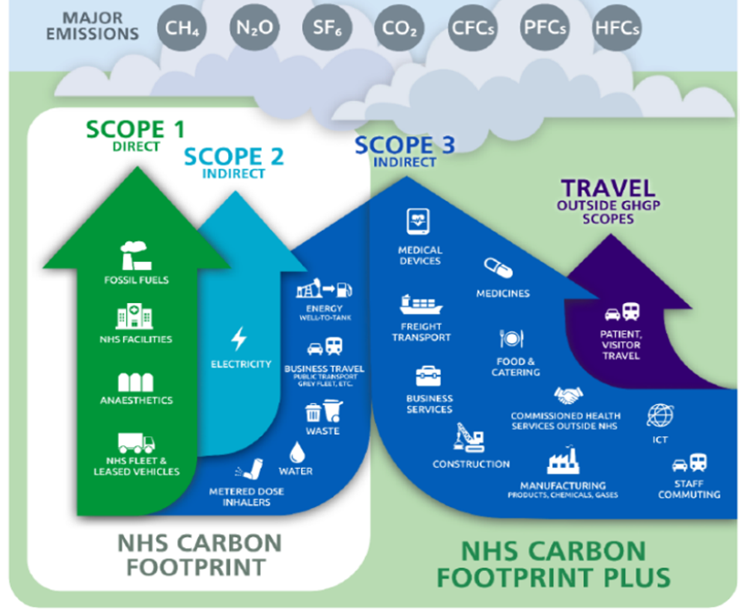

Figure 1: Greenhouse Gas Protocol (GHGP) scopes in the context of the NHS

Figure 2: Sources of carbon emissions by proportion of NHS Carbon Footprint Plus

# ACCOUNTABILITY REPORT

# Corporate Governance Report

## Members Report

### Member profiles

CCGs are clinically-led membership organisations made up of general practices. As of 31 March 2022, the following 25 NHS practices are members of Southend CCG:

|  |  |
| --- | --- |
| Member Name | F Code and Practice Address |
| Drs Agha and Siddique | F81121, The Thorpe Bay Surgery, 99 Tyrone Road, Thorpe Bay, SS1 3HD |
| Dr B Bekas | F81207, 48 Argyll Road, Westcliff on Sea, SS0 7HN |
| Dr H Siddique | F81209, Shaftsbury Avenue Practice, 119 Shaftesbury Ave, Southend on Sea, SS1 3AN |
| Dr S M Callaghan and Partners | F81097, Valkyrie Surgery, Valkyrie Road PCC, 50 Valkyrie Road, Westcliff on Sea, SS0 8BU |
| Dr B R M Houston and Partners | F81112, Highlands Surgery, 1643 London Road, Leigh on Sea, SS9 2SQ  Branch site: 1446 London Road |
| Dr A C Irlam and Partner | F81086, Central Surgery, 27 Southchurch Blvd, Southend on Sea, SS2 4UB |
| Dr A Sivaprasad and Partners | F81081, Queensway Medical Centre,75 Queensway, Southend on Sea, SS1 2AB  Branch: 508 Sutton Rd, Southend, SS2 5PN |
| Dr G K Jayatilaka and Partner | F81696, The Leigh Surgery, 194 Elmsleigh Drive, Leigh on Sea, SS9 4JQ |
| Dr F Khan | F81003, Carnarvon Medical Centre, North Road Primary Care Centre, 183-195 North Road, Westcliff on Sea, SS0 7AF |
| Dr A C Krishnan and Partner | F81046, Kent Elms Health Centre, 1 Rayleigh Road, Leigh on Sea, SS9 5UU |
| Dr Navin Kumar | F81147, Central Surgery, 1st Floor, North Road Primary Care Centre, 183-195 North Road, Westcliff on Sea, SS0 7AF  Branch: 38 Acacia Dr, Thorpe Bay, SS1 3JX |
| Dr N Kumar and Partner | F81613, Shoebury Health Centre, Campfield Road, Shoebury, SS3 9BX |
| Dr S A Malik | F81223, Kent Elms Health Centre, 1 Rayleigh Road, Leigh on Sea, SS9 5UU |
| Dr H Siddique | F81684, North Shoebury Surgery, Frobisher Way, Shoebury, SS3 8UT |
| Dr L Nagle and Partners | F81144, The Pall Mall Surgery, 1st Floor, Leigh Primary Care Centre, 918 London Road, Leigh on Sea, SS9 3NG |
| Dr H W Ng | F81744, Scott Park Surgery, 205 Western App. Southend on Sea, SS2 6XY |
| Dr J Palacin | F81649, Shoebury Health Centre, Campfield Road, Shoebury, SS3 9BX |
| Dr N K Shah and Partner | F81176, North Avenue Surgery, 332 North Avenue, Southend on Sea, SS2 4EQ |
| Dr H Siddique and Agha | F81159, Southend Medical Centre, 50-52 London Road, Southend on Sea, SS1 1NX |
| Dr V Sooriakumaran and Partner | F81092, 3 Prince Avenue, Southend on Sea, SS2 6RL Branch: 38 Leigh Road, Leigh on Sea, SS9 1LF |
| HCRG | Y02707 St Luke's Health Centre, Pantile Avenue, Southend on Sea, SS2 4BD |
| The Practice | Y02177, 32 Northumberland Avenue, Southend on Sea, SS1 2TH |
| Dr S L Vashisht | F81656, 61 Warrior Square, Southend on Sea, SS1 2JJ |
| Dr S H Zaidi (two Practices) | F81128, Eastwood Group Practice, 335 Eastwood Road North, Leigh on Sea, SS9 4LT Branch: Kent Elms Health Centre, 1 Rayleigh Road, Leigh on Sea, SS9 5UU  Branch: 348 Rayleigh Road, Eastwood, SS9 5PU |

### Composition of Governing Body

The CCGs Governing Body is the accountable body for the performance of the CCG. It has seven GP members elected by their fellow GPs to lead the organisation alongside the executive membership. One of these elected GPs chairs the Governing Body meeting.

The Governing Body also has three lay members. Their roles include ensuring views and suggestions from patients and the public are properly considered by the CCG, providing independent judgement and sound commercial knowledge, and helping to ensure the CCG is well run and uses public funds properly. The CCGs constitution makes provision for secondary care representation on the Governing Body.

The Governing Body also comprises of Joint Accountable Officer, Joint Chief Finance Officer, Executive Director of Nursing, NHS Alliance Director. Representatives from Essex County Council and other CCG executive directors are regular attendees.

As of 31 March 2022, the board consisted of 15 members. Of these, six are female, nine are male.

The Governing Body has the following functions conferred on it by sections 14L (2) and (3) of the 2006 Act, inserted by section 25 the 2012 Act, together with any other functions connected with its main functions as may be specified in its constitution.

The main function of the Governing Body is to ensure that the group has appropriate arrangements in place to exercise its functions effectively, efficiently, and economically and in accordance with the group’s principles of good governance. The other key functions are outlined in section five of the CCGs constitution. During 2021/22, due to Covid-19, the Governing Body suspended some of the public meetings due to system pressures, however, confidential meetings continued to take place. NHS Castle Point and Rochford CCG and NHS Southend CCG governing bodies met in common during 2021/22. Details of these meetings are available on our website: <https://southendccg.nhs.uk/about-us/our-governing-body/governing-body-dates>.

In February 2022, the Basildon and Brentwood, Castle Point and Rochford, Mid Essex, Southend and Thurrock CCG Boards, collectively referred to as Mid and South Essex (MSE) CCG Boards, agreed to ‘meet in common’ until establishment of the MSE Integrated Care Board. This means that each Board will meet in the same place (currently virtually via MS Teams), at the same time, although they still act and make decisions as separate Boards. These arrangements will enable decisions affecting the whole MSE population to be made collectively.

The following people have been CCG Board Members during 2021/22:

* **Dr Jose Garcia-Lobera, Chair & Elected GP** – Dr José Garcia-Lobera moved from Spain in 2003 and has worked as qualified GP in Southend for the last 18 years at the Pall Mall Surgery in Leigh–on-sea. José is the Chairman for NHS Southend CCG and clinical lead for prescribing, mental health, and primary care.
* Anthony (Mac) McKeever, Joint Accountable Officer and Executive Lead, Mid and South Essex Health and Care Partnership – Anthony, known to all as Mac, has more than 40 years’ experience in the NHS and other healthcare organisations.  Before joining the mid and south Essex CCGs he served as Director General for Health and Community Services for the States of Jersey.

Originally a “fast stream” civil servant, Mac joined the NHS in 1987, operating for 25 years as a CEO, helping to turn around performance at several hospitals and commissioning organisations. Having established his own business, he served on the Future Forum in 2010, and returned to work in the NHS in 2015.

Mac has been appointed Chief Executive Officer Designate for the Mid and South Essex Integrated Care Board and System.

* **Mark Barker, Joint Chief Finance Officer** – Prior to joining the NHS over 20 years ago, Mark was a Senior Manager at KPMG, Director of Finance in various Housing Associations and Business Controller at Transport for London. Mark has worked in a number of NHS organisations, most recently as the Chief Finance Officer for Castle Point and Rochford and Southend CCGs and, from 1 January 2021, he was appointed as Joint Chief Finance Officer for the five mid and south Essex CCGs
* **Rachel Hearn, Executive Director of Nursing & Quality** – Rachel is a Registered Nurse and Executive Director of Nursing and Quality across the five Mid and South Essex CCGs. Rachel has over 20 years’ clinical experience as a nurse within the NHS. Having worked predominantly in emergency and general medicine, Rachel has clinically-led work on the changing face of emergency care. Rachel’s role in commissioning focuses on quality improvement, safeguarding adults and children and Continuing Health Care provision.
* **Tricia D’Orsi, NHS Alliance Director** – Tricia is the NHS Alliance Director for South East Essex and has led both Castle Point & Rochford and Southend CCGs over recent years. Prior to the NHS Alliance Director role, Tricia was the Deputy Accountable Officer for both organisations and prior to that, since 2012, was the Chief Nurse for both CCGs. Tricia has over thirty years’ experience of working in the NHS at a very senior manager level and has used her career to promote quality, integration and choice always championing the voice of patients and staff alike.
* **Tracey Freeman, Lay Member for Governance** – Tracey is a chartered certified accountant with over 30 years’ experience in both the private and public sectors. Tracey has been the governance lay member for NHS Castle Point and Rochford and NHS Southend CCGs since October 2019. As the Conflict of Interest Guardian and the Freedom to Speak Up Guardian, Tracey has a passion for supporting and challenging colleagues, but also promoting and driving empowerment, equality, diversity, opportunity, and change.
* **Janis Gibson, Lay Member for Patient & Public Involvement** – Janis is the governing body member with oversight for patient and public involvement and Chair of the Remuneration Committee. She also attends the primary care, audit, finance and quality and performance committee meetings in Common. During her career and prior to joining the NHS, Janis held global executive roles in the corporate financial services sector, overseeing communications, marketing and involvement with corporate mergers, acquisitions and change management.  Janis has been a non-executive director of an acute hospital NHS trust and is currently CEO of a charity and non-executive director of a social housing trust.
* **Pauline Stratford, Lay Member for Primary Care** – Prior to joining the NHS Pauline was a senior commissioner for social care mental health services and previously to that human resources and change manager with a lead in equalities in central government. Pauline also serves as the Lay Member for Primary Care of the Castle Point and Rochford and Southend CCGs and the third Lay Member for Mid and Thurrock CCG’s.
* **Dr Sreeman Andole, Secondary Care Consultant** – Dr Sreeman Andole is a Stroke Consultant and also Assistant Medical Director for NHSE/I and has been interim Medical Director for East of England Ambulance NHS Trust as a part of Improvement Director for the National Improvement Team for challenged Systems. He is currently and executive medical director of Manx care and a specialist advisor for CQC. He was HSJ Clinical Leader of the Year finalist in 2013 and HSJ BME Pioneer of the Year in 2013 and winner of professional excellence award from stroke UK 2018. He is a member of clinical reference group, Neurosciences UK and also part of NICE committee for stroke and TIA.  He has been awarded Senior fellowship to faculty of medical management and leadership in 2021.
* **Dr Irfan Akram, Elected GP** – Dr Akram is a GP locally in Southend. He is also currently the Clinical Director for West Central Primary Care Network.
* **Dr Kate Barusya, Elected GP** – Dr Barusya is a practicing GP with an interest in women and children, quality improvement and prevention. She has been a governing body member since 2015, but previous to that had been and still is Clinical Lead for Children and Maternity and DMO for SEND since 2013 and recently since January 2021 is DMO for Castle Point and Rochford. She is a Quality Improvement Fellow with UCL Partners, NHS GP Appraiser and Clinical Supervisor for ARU Medical Students. Her work and interests bring her in contact with different agencies, with a focus on making a difference.
* **Dr Krishna Chaturvedi, Elected GP** – Dr Krishna Chaturvedi practiced at Southbourne Grove Surgery in Westcliff for a number of years and is well known locally.
* **Dr Brian Houston, Elected GP** – Dr Houston has been practicing at Highlands Surgery Leigh-on-Sea for a number of years. He has a special interest in cardiac care and stroke management and prevention and is clinical lead for MSK. Dr Houston also Chairs the Drug & Therapeutics Committee.
* **Dr Hon Ng, Elected GP** – Dr Ng qualified as a specialist in General Medicine and Clinical Pharmacology and Therapeutics in Liverpool and joined general practice in Southend over 25 years ago. He has been Clinical Lead for Prescribing for Southend since 2002, and Governing Body Member for NHS Southend CCG since 2012.
* **Dr Taz Syed, Elected GP** – Dr Syed has been a governing body member for the last seven years and has been the lead GP for safeguarding children in Southend and Castle Point and Rochford for the last four years and the Lead GP for safeguarding adults for the last three years, and digital primary care lead for mid and south Essex Health and Care Partnership. Dr Syed is a GP principal in Southend currently offering training for primary care in safeguarding and learning disability. He is also Chief clinical Information Officer in primary care for MSE HCP, and in the stewardship group for Urgent and Emergency Care in MSE HCP.

### Committees, including Audit Committee

A full list of the committees supporting the Board, including the Audit Committee, and membership of those committees is provided within the Governance Statement at page 44.

Register of Interests  
At all formal meetings of the board and its committees, members must declare if they have an interest in any agenda items under discussion.

The CCG maintains a register of interests declared by board members.  The register of board members’ interests is regularly updated and included within the papers for publicly held board meetings available on the [CCGs website](https://southendccg.nhs.uk/about-us/key-documents/3847-governing-body-register-of-interests-2021-22/file).

### Freedom of Information Requests

The Freedom of Information (FoI) Act 2000 gives a general right of access to recorded information held by public authorities, subject to certain conditions and exemptions. The CCG received 159 FoI requests during 2020/21. The CCG responded to 98.7% of these within the statutory timescale of 20 working days.

We certify that we have complied with HM Treasury’s guidance on setting charges for information.

### Statement of Disclosure to Auditors

Each individual who is a member of the CCG at the time the Members’ Report is approved confirms:

* So far as the member is aware, there is no relevant audit information of which the CCG’s auditor is unaware that would be relevant for the purposes of their audit report.
* The member has taken all the steps that they ought to have taken in order to make him or herself aware of any relevant audit information and to establish that the CCG’s auditor is aware of it.

### Donations to political parties and charitable organisations

The CCG does not make donations to political parties.

The CCG has made payments to a number of charitable organisations. The majority of these payments are in relation to Service Level Agreements (particularly to local hospices) or as a result of successful grant applications.

### Modern Slavery Act

Southend CCG fully supports the Government’s objectives to eradicate modern slavery and human trafficking. Our Slavery and Human Trafficking Statement for the financial year ending 31 March 2022 is published on our website at [Modern Slavery Statement](https://southendccg.nhs.uk/news-events/governing-body-papers/2013-archive/key-documents/safeguarding/4085-modern-slavery-statement-2022-southend-ccg/file) (hyperlinks).

### Complaints to Parliamentary and Health Service Ombudsman

There were no Parliamentary and Health Service Ombudsman (PHSO) complaints raised in 2021/22.

Southend CCG receives complaints from patients, carers, family members and Members of Parliament. Where the complaint relates directly to a provider the permission of the individual is sought to refer to the relevant provider. The CCG will analyse any trends and themes arising from complaints and works with providers to address these. Complaints relating to primary care services are managed by NHS England.

During 2021/22, there were 6 complaints opened and 6 complaints closed, meaning there are currently no complaints under investigation.

### Statement of Accountable Officer’s Responsibilities

The National Health Service Act 2006 (as amended) states that each Clinical Commissioning Group shall have an Accountable Officer and that Officer shall be appointed by the NHS Commissioning Board (NHS England). NHS England has appointed the [inset post holder title] to be the Accountable Officer of [Name of CCG].

The responsibilities of an Accountable Officer are set out under the National Health Service Act 2006 (as amended), Managing Public Money and in the Clinical Commissioning Group Accountable Officer Appointment Letter. They include responsibilities for:

* The propriety and regularity of the public finances for which the Accountable Officer is answerable.
* For keeping proper accounting records (which disclose with reasonable accuracy at any time the financial position of the Clinical Commissioning Group and enable them to ensure that the accounts comply with the requirements of the Accounts Direction).
* For safeguarding the Clinical Commissioning Group’s assets (and hence for taking reasonable steps for the prevention and detection of fraud and other irregularities).
* The relevant responsibilities of accounting officers under Managing Public Money.
* Ensuring the CCG exercises its functions effectively, efficiently, and economically (in accordance with Section 14Q of the National Health Service Act 2006 as amended and with a view to securing continuous improvement in the quality of services (in accordance with Section14R of the National Health Service Act 2006 as amended).
* Ensuring that the CCG complies with its financial duties under Sections 223H to 223J of the National Health Service Act 2006 as amended.

Under the National Health Service Act 2006 as amended, NHS England has directed each Clinical Commissioning Group to prepare for each financial year a statement of accounts in the form and on the basis set out in the Accounts Direction. The accounts are prepared on an accruals basis and must give a true and fair view of the state of affairs of the Clinical Commissioning Group and of its income and expenditure, Statement of Financial Position, and cash flows for the financial year.

In preparing the accounts, the Accountable Officer is required to comply with the requirements of the Government Financial Reporting Manual and in particular to:

* Observe the Accounts Direction issued by NHS England, including the relevant accounting and disclosure requirements, and apply suitable accounting policies on a consistent basis.
* Make judgements and estimates on a reasonable basis.
* State whether applicable accounting standards as set out in the Government Financial Reporting Manual have been followed and disclose and explain any material departures in the accounts.
* Prepare the accounts on a going concern basis.
* Confirm that the Annual Report and Accounts as a whole is fair, balanced, and understandable and take personal responsibility for the Annual Report and Accounts and the judgements required for determining that it is fair, balanced, and understandable.

As the Accountable Officer, I have taken all the steps that I ought to have taken to make myself aware of any relevant audit information and to establish that Southend CCG’s auditors are aware of that information. So far as I am aware, there is no relevant audit information of which the auditors are unaware.

I also confirm that as far as I am aware, there is no relevant audit information of which the CCG’s auditors are unaware, and that as Accountable Officer, I have taken all the steps that I ought to have taken to make myself aware of any relevant audit information and to establish that the CCG’s auditors are aware of that information.

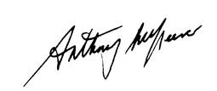

**Anthony McKeever**Executive Lead for the Mid and South Essex Health and Care Partnership and Joint Accountable Officer for its five CCGs

29 June 2022

## Governance Statement

### Introduction and context

Southend CCG (the CCG) is a body corporate established by NHS England on 1 April 2013 under the National Health Service Act 2006 (as amended).

The CCG’s statutory functions are set out under the National Health Service Act 2006 (as amended). The CCG’s general function is arranging the provision of services for persons for the purposes of the health service in England. The CCG is, in particular, required to arrange for the provision of certain health services to such extent as it considers necessary to meet the reasonable requirements of its local population.

As at 31 March 2022, the CCG was not subject to any directions from NHS England issued under Section 14Z21 of the National Health Service Act 2006.

The CCG is part of the Mid and South Essex Health and Care Partnership (the HCP) covering the geographic areas of mid Essex, Basildon and Brentwood, Castle Point and Rochford, Southend, and Thurrock CCGs (the MSE CCGs). The HCP has been created to bring local health and care leaders together to plan for the long-term needs of local communities.

In July 2017, the five MSE CCGs formally established a CCG Joint Committee (JC) to act collectively in the planning, securing and monitoring of services to meet the needs of their 1.2 million population, as well as representing the HCP footprint for services commissioned over a larger area.

Specifically, the JC commissions and manages the contracts for acute hospital services (NHS and independent sector), NHS 111 and out-of-hours services, ambulance services, patient transport services, community services and mental health services. The JC also played a role in decision- making about Learning Disability services within the existing pan-Essex arrangements.

Due to business continuity arrangements implemented by the CCG from mid-December 2021 to the end of February 2022 as a result of the ongoing COVID-19 pandemic (Omicron variant) and the need support the vaccination booster programme, the JC did not meet from December 2021. Alternative committee/Board meeting arrangements were implemented to deal with issues within the JC’s remit as detailed in the following paragraph and the individual committee headings below.

The five MSE CCG Boards met in common on 24 February 2022 and agreed to hold all future CCG Board meetings in common until the MSE Integrated Care Board (ICB) is established. During this transition period, the Boards meeting in common will conduct all business delegated to the JC. Consequently, it is anticipated that the JC will not meet again.

All other decisions about healthcare continued to be taken locally by the relevant CCG.

#### Scope of responsibility

As Accountable Officer, I have responsibility for maintaining a sound system of internal control that supports the achievement of the clinical commissioning group’s policies, aims and objectives, whilst safeguarding the public funds and assets for which I am personally responsible, in accordance with the responsibilities assigned to me in Managing Public Money. I also acknowledge my responsibilities as set out under the National Health Service Act 2006 (as amended) and in my Clinical Commissioning Group Accountable Officer Appointment Letter.

I am responsible for ensuring that the CCG is administered prudently and economically and that resources are applied efficiently and effectively, safeguarding financial propriety and regularity. I also have responsibility for reviewing the effectiveness of the system of internal control within the clinical commissioning group as set out in this governance statement.

#### Governance arrangements and effectiveness

The main function of the governing body (the Board) is to ensure that the group has made appropriate arrangements for ensuring that it exercises its functions effectively, efficiently and economically and complies with such generally accepted principles of good governance as are relevant to it.

CCGs are clinically-led membership organisations made up of general practices. The members of the Southend CCG have determined the governing arrangements for the CCG as set out in its constitution, which was based on the Model Constitution Framework for CCGs. In 2019/20, the CCG undertook a thorough review of its constitution, in line with the NHS CCG New Model Constitution and to align its constitution with the other mid and south Essex CCGs in preparation for the development of an Integrated Care System.

The revised constitution was approved by the Board at its meeting on 25 March 2021.

There are 24 member practices within Southend CCG, serving a registered population of approximately 190,000 patients. The practices were formed into four Primary Care Networks (PCNs) across Southend from 1 July 2019. Details of the four PCNs are shown in the table below:

|  |  |  |
| --- | --- | --- |
| Primary Care Network | Number of Practices | Registered Patient Population as at 1 January 2022 |
| Southend East | 6 | 37,205 |
| Southend Victoria | 8 | 59,505 |
| SS9 | 5 | 57,023 |
| West Central | 6 | 36,753 |

Practices work together within their PCNs to collaborate on the effective provision of primary care in their local areas and to engage in the commissioning of services on behalf of their populations.

In some PCNs these working together arrangements are facilitated through the sharing of workforce, sharing back-office functions, and collaborative working in certain chosen clinical areas. Practices are gradually working towards developing standardised policies, processes and agreed governance structures.

### Governing Body (the Board)

The CCG’s constitution sets out the governance arrangements, roles and responsibilities of the Board and its membership.

Publicly held Board meetings are held on a bi-monthly basis. The CCG meeting due to be held in January was cancelled as part of business continuity arrangements implemented from mid-December to the end of February 2022 as detailed above. However, appropriate arrangements were implemented to ensure that any key decisions were taken forward. Any decisions taken by the Central Incident Management Team (CIMT) were logged on the CIMT decisions log which was then reported to the Board.

In February 2022, the CCG Board met in common with the other MSE CCG Boards and agreed that they would continue to meet in common until the MSE Integrated Care Board (ICB) is established.

Board meetings are broadcast via ‘MS Teams’ which enables members of the public to listen to discussions held and submit questions.

Board meetings were quorate on the majority of occasions. If a Board meeting was inquorate, their support for recommendations made was sought following the meeting to ensure that decisions were quorate. There are also step-down/co-opting arrangements in place to maintain a clinical majority or in cases of conflict of interest where voting members of the board recuse themselves from a relevant vote.

As at 31 March 2022, the Board membership comprised of the following voting members:

The Chair (a GP member), Joint Accountable Officer, NHS Alliance Director for South East Essex, Executive Chief Finance Officer, Executive Director of Nursing and Quality (Registered Nurse), six other GP members, Secondary Care Board member and three Lay Members.

Anthony McKeever was appointed Interim Joint Accountable Officer for the Mid and South Essex CCGs from 1 March 2020 and was subsequently appointed to this role on a permanent basis from 3 October 2020. Mr McKeever has since been appointed to the role of Chief Executive Officer Designate for the Mid and South Essex Integrated Care System.

Board representation also includes a Public Health Consultant from Southend City Council (SBC).

The Board undertakes an annual review of its effectiveness and has determined that it fulfils its role effectively either all or most of the time and that there is good engagement of members.

To support the Board in carrying out its duties effectively, committees reporting to the Board are formally established. In line with NHS guidance to reduce the burden on NHS staff during the pandemic, some formal committee meetings were stood down during April 2021 and again from mid-December 2021 to February 2022, with any urgent business being conducted virtually.

From Quarter 1 of 2020/21, the five MSE CCGs held their Remuneration Committee, Patient Safety & Quality Committee (or equivalent) and Finance & Performance Committee meetings in common.

From Quarter 1 of 2021/22, meetings in common arrangements were extended to include the five MSE CCGs Audit Committees and Primary Care Commissioning Committees.

The Mid and South Essex Health and Care Partnership Board, which includes representation from the CCG, local authorities, Healthwatch Essex, the voluntary sector, Anglian Ruskin University and the CCG’s main providers, met in private throughout 2021/22. The minutes of these meetings were submitted to the CCG’s Part II Board meetings.

Each committee submits its minutes to Board meetings. The main committees providing assurance to the Board are set out below.

### Audit Committee

This Committee provides the CCG Board with an independent and objective view of the CCG’s financial systems, financial information and compliance with laws, regulations and directions governing the CCG insofar as they relate to finance, good corporate governance, information governance, cyber-security, emergency planning, response and resilience (EPRR), business continuity management (BCM) and the CCG’s responsibility to act effectively, efficiently and economically.

The Audit Committee is chaired by the Lay Member (Governance).

From the Quarter 1 of 2021/22, the Committee met in common with the other MSE CCG Audit Committees on 5 occasions, plus 2 extraordinary meetings to review draft policies developed for the MSE ICB. Attendance has been quorate in line with its Terms of Reference (minimum of Chair and two core members) on all occasions.

During 2021/22 the Audit Committee continued to focus upon ensuring the development and review of the systems, policies, procedures and processes fundamental to the governance of the organisation. During Quarter 4, the committee undertook a review of policies being developed for the MSE ICB relating to areas within the committee’s remit.

The Committee has received assurance from internal audit of key systems and processes and, in addition to routine reporting, has received updates on counter-fraud initiatives and investigations and implementation of audit recommendations. The Committee reviewed the CCG’s draft accounts and approved the final accounts and management response to the auditor on behalf of the Board.

The Committee also reviews the CCG’s risk register/Board Assurance Framework (BAF) and associated risk management processes and procedures. The Committee supported an aligned MSE CCG Risk Management Policy which was adopted by the CCG Boards in November 2021.

During the Level 4 incident from mid-December to February 2022, the committee received a copy of the CIMT Risk Register which focussed on key risks whilst normal risk register reporting arrangements were paused. During this period, the committee also received a copy of the CIMT Decisions Log recording all decisions taken by CIMT.

The Committee also received the minutes of other main CCG committees, namely the Primary Care Commissioning Committee, Patient Safety and Quality and the Finance & Performance Committee meetings held in common with the other M&SE CCG committees.

In line with NHS England guidance on the management of Conflicts of Interest, the Chair of the Audit Committee acts as the CCG’s Conflicts of Interest Guardian.

The Committee and Board approved an extension of the expiry date of relevant CCG policies, including the Conflicts of Interest, Gifts and Hospitality and Standards of Business Conduct Policies, to March 2022 to enable the M&SE CCGs to focus on developing new aligned policies in preparation for the formation of a new Integrated Care System (ICS) NHS Body. In March 2022, these policies were subsequently extended by the Board until 30 June 2022 as a result of the national decision to delay the establishment of ICBs by three months.

The Audit Committee Chair received assurance that the CCG was adhering to NHS England mandatory guidance on the management of conflicts of interest via the annual internal audit of conflicts of interest which identified ‘reasonable’ assurance. The requirement to submit quarterly returns to NHS England regarding the CCG’s adherence to the mandatory guidance was suspended during 2021/22.

### Remuneration Committee

The Remuneration and Terms of Service Committee is a committee of the CCG Board with delegated responsibility for making recommendations to the Board on all aspects of remuneration and terms of service of employees, including the Accountable Officer, Directors and Lay Members.

In addition, the Committee is responsible for making recommendations to the Board concerning the remuneration and terms of service for Elected GP members and other people who provide services to the CCG (all of whom are not employees of the CCG), taking in to account any national or local guidance as appropriate, so as to ensure that individuals are fairly rewarded for their contribution to the CCG.

The membership of the Remuneration Committee as at 31 March 2022 is three lay members and a secondary care consultant. The committee is chaired by the Lay Member (Patient and Public Engagement).

The Remuneration Committee met in common with the other M&SE CCG Remuneration Committees 10 times, either via MS Teams or by conducting business ‘virtually’ by email, during 2021/22.

### Patient Safety and Quality Committee

This Committee provides assurance regarding the safety and quality of services directly commissioned by the CCG, i.e. acute, community, learning disability and mental health services, as well as the quality of services within primary care and the care home sector. The committee also maintains oversight of safeguarding (adults and children) and medicines optimisation.

At the start of the year the Committee was chaired by the Lay Member for Patient and Public Engagement and its core decision making membership comprised a GP Representative (Vice Chair), Director of Nursing and Quality and the Alliance Director for South East Essex. The committee was also attended by other senior managers with specific responsibility for areas within the remit of the committee.

In May 2020, the Committee commenced meetings in common with the other four MSE CCGs’ Patient Safety and Quality (or equivalent) Committees to review the safety and quality of all health care services.

The Committees meeting in common focused on arrangements to provide care for patients diagnosed with COVID-19 within acute, community and care home settings, the safety of staff and workforce capacity issues, and the effect that the pandemic was having on patients requiring routine and elective care.

Other key areas discussed included arrangements for monitoring the quality of provider contracts; review of NHS Patient Safety Updates; review of the Quality Accounts 2020/21 from Mid and South Essex Hospital NHS Foundation Trust, Essex Partnership University NHS Foundation Trust (EPUT); North East London NHS Foundation Trust; Barking, Havering and Redbridge NHS Foundation Trust; Provide Community Interest Company and Farleigh Hospice; and agreeing the CCGs’ responses to the Quality Accounts; serious incidents and never events; review of arrangements for the implementation of the Patient Safety Incident Response Framework; update on Special Educational Needs and Disabilities services; updates on Learning Disabilities Mortality Review (LeDeR) Programme; System Quality Strategy; Infection Prevention and Control Strategy; approval of policies; all age continuing care; personal health budgets; review of patient safety and quality risks; quality and equality impact assessments; complaints and a review of any virtual decisions taken since the last committee meeting.

These meetings were attended by the minimum number of members required for each CCG committee to be considered quorate. Attendance was generally quorate in line with the Committees’ Terms of Reference. If a committee was inquorate due to one or more members’ being unavailable, their support for any decisions made was sought following the meeting.

There were three ‘virtual’ meetings held by email with update reports being circulated to members for information.

### Finance and Performance Committee

This Committee scrutinises and provides the CCG Board with assurance on the delivery of the CCG’s remit in respect of the CCG’s overall financial position (including running costs) and for service performance for commissioned services not delegated to the JC.

The Committee also maintains local oversight of information management and technology, estates developments and the Savings Programme Board’s scrutiny and challenge role to ensure the delivery of the CCG’s programme of financial savings. The Committee acts as a point of approval for major changes to existing projects and plans, where these are based on considerations related to the achievement of financial or other benefits. The Committee also assesses whether there is continued business justification for existing projects and programmes where the financial or other benefits have changed.

The Committee was chaired by the Lay Member (Governance) and its core membership comprised a GP Representative (Vice Chair), Executive Chief Finance Officer, Alliance Director for South East Essex (or nominated deputy), and Executive Director of Nursing and Quality (or nominated deputy nurse).

In May 2020, the Committee commenced meetings in common with the other four M&SE CCGs’ Finance and Performance (or equivalent) Committees. During 2021/22 it met on 8 occasions to review finance and performance issues across all health care services, including those ordinarily within the remit of the Mid and South Essex CCG Joint Commissioning Committee (JC).

The quoracy arrangements for meetings held in common with the other CCG committees, mirrored those described under the ‘Quality and Governance Committee’ section.

During 2021/22 the Committee particularly focused upon review of finance and performance risks, receipt of monthly finance reports, Joint Committee finance reports, Elective Recovery Framework updates, Hospital Discharge Programme 2021/22, contract planning, awards and procurement decisions, performance reports from System Oversight and Assurance Group (SOAG), Adult Mental Health Transformation Plan contracts, system financial sustainability, 2021/22 Business Plan and CCG budgets, approval of terms of reference/frequency of meetings, receipt of System Finance Leaders Group (SFLG) minutes.

### South East Essex Alliance

The aim of the South East Essex Alliance is to bring all key partners from across South East Essex together to provide the localism needed within the Mid & South Essex system to create opportunities for people to live well in South East Essex.

Its membership comprises Director level representation from the CCG, PCN Clinical Directors, the CCG Chair, representation from Essex County Council, Southend City Council, Rochford District Council and Castle Point Borough Council, Essex Partnership University NHSFT, North East London NHSFT, Mid and South Essex Foundation Trust, Havens Hospice, Southend, Castle Point and Rochford CVS’, Essex Police, Southend Healthwatch and Essex Healthwatch.

The Alliance meets monthly with good representation from all partners. An Alliance plan was developed with all South East Essex system partners for 2021/22 which determined the priorities, vision, outcomes and measures for improving health and wellbeing of the population.

The Alliance is about to embark on a six-month Development Programme led by an external facilitator to support the development of priorities, plans and governance for 2022/23 and beyond.

### 

### Primary Care Commissioning Committee

From June 2021 the Committee met in common with the other MSE CCGs Primary Care Commissioning Committees.

There were five meetings held, with three further virtual meetings held to conduct urgent business that could not wait until the next scheduled meeting.

A review of committee effectiveness confirmed that the committee was generally quorate line with the Committee’s Terms of Reference on all occasions.

During 2021/22 the Committee focused on contractual updates/breaches/requests for contractual changes from general practices; local contract decisions, e.g. Designated Enhanced Services; GP primary care quality and safety reports; budget reports; information technology and digital updates; estates issues; primary care workforce; review of Primary Care Risk Group minutes; review of primary care risks; and GP Business Continuity and resilience arrangements.

### Better Care Fund (including Improved Better Care Fund) Governance

A Better Care Fund (BCF) Management Group meets to fulfil the governance requirements with Southend City Council.

In line with the terms of the Section 75 Better Care Fund Agreement, decision-making relating to the BCF is delegated to three nominated representatives of the CCG and three representatives of Southend City Council. Utilisation of the BCF funds was agreed in the Section 75 Agreement and in-year reporting focused upon expenditure on the approved services and monitoring against agreed performance targets.

### Mid and South Essex CCG Joint Commissioning Committee

As outlined in the introduction, the five mid and south Essex CCGs formally established a CCG Joint Committee (JC) to act collectively in the planning, securing and monitoring of services to meet the needs of their 1.2million population. The JC was established as a committee of each CCG, not of the CCG’s governing bodies, and therefore sits alongside the CCG governing bodies, rather than being accountable to them.

During 2021/22 the committee meet three times to consider: risks within the remit of the committee; planning guidance; the Vanguard Theatre contract; MSEFT Legal Undertakings; Adult Mental Health Transformation Plan; review of Medicines Optimisation Terms of Reference; patient safety, finance and performance reports; receipt of minutes from Patient Safety & Quality Committees in common and Finance & Performance Committees in common; provider Quality Accounts and the CCGs’ responses to these; non-emergency patient transport procurement; and review of community beds.

The JC did not meet during December to February as a result of the implementation of pandemic business continuity arrangements and, following a decision by the MSE CCGs to meet in common from February until the establishment of the MSE ICB, it is anticipated that the JC will no longer meet.

### 

### UK Corporate Governance Code

The CCG is not required to comply with the UK Code of Corporate Governance. However, we have reported on our Corporate Governance arrangements by drawing upon best practice available, including those aspects of the UK Corporate Governance Code we consider to be relevant to the CCG and best practice.

As part of its annual review of effectiveness, the CCG Board undertook an assessment which encompassed the relevant principles of the UK Corporate Governance Code.

The Board concluded from this assessment that it was generally following best practice in relation to providing effective leadership, having an appropriate balance of skills, experience, independence and knowledge to enable Board members to discharge their duties and responsibilities effectively, presenting a balanced and understandable assessment of the CCG’s position in its financial and other reporting and ensuring that remuneration is set appropriately.

### Discharge of Statutory Functions

In light of recommendations of the 2013 Harris Review, the clinical commissioning group has reviewed all of the statutory duties and powers conferred on it by the National Health Service Act 2006 (as amended) and other associated legislative and regulations. As a result, I can confirm that the clinical commissioning group is clear about the legislative requirements associated with each of the statutory functions for which it is responsible, including any restrictions on delegation of those functions. The CCG’s current Scheme of Reservation and Delegation (SoRD) was approved by the Board in March 2021. The CCG is working with the other MSE CCGs to develop a new SoRD for the MSE ICB.

### Risk management arrangements and effectiveness

The CCG is committed to ensuring that risk management forms an integral part of its philosophy, practices and business plans, rather than viewed or practised as a separate programme, and that responsibility for implementation is accepted at all levels of the CCG.

An aligned MSE CCG Risk Management Policy, which encompasses both clinical and non-clinical risks and the CCGs’ agreed risk appetite statement, was approved by all MSE CCGs in November 2021. The Policy is based on the Australia/New Zealand risk management model and sets out the risk management system, supporting processes and reporting arrangements which aim to protect patients, the public, staff and the CCG’s assets and reputation.

In line with NHS guidance to reduce the burden on staff during the pandemic, the usual risk management processes were paused during April 2021 and again in December to February 2022. During these periods, the CIMT Risk Register was in use.

The overarching M&SE Board Assurance Framework (BAF) originally implemented in June 2020, has been further developed. Risks are mapped against the MSE CCGs common strategic objectives and key workstreams, these being:

* Cancer and End of Life
* Children and Young People
* Community
* Digital and Business Intelligence
* Estates
* Finance
* Health Inequalities
* Integrated Care System
* Maternity
* Medicines Optimisation
* Mental Health and Learning Disability
* People
* Planned Care
* Population Health Management
* Primary Care
* Stewardship
* Urgent Emergency Care
* Vaccination

The risk appetite statement assists managers to identify when risk levels are tolerable or where further action is required to reduce risk ratings to an acceptable level. The Board reviews the BAF at each Part I Board meeting. During 2021/22 a review was undertaken to review risk descriptions and consolidate risks where possible to ensure that the BAF reflected risks facing the organisation as it emerged from the pandemic.

### Capacity to Handle Risk

During 2021/22 the CCG had the following arrangements in place.

* Clear ownership of risks, with responsible Directors and lead officers identified, with escalation arrangements in place to the Board.
* A Board Assurance Framework within which the latest updates from lead officers were recorded and reported to relevant committees and the Board.
* Recording and investigation processes for incidents, including identification of learning.
* Triangulation of learning from incidents, complaints and claims (should they arise) as a standing item on the agenda of the Quality and Governance Committee.
* Monitoring of completion of Equality and Health Inequality Impact Assessments, Quality Impact Assessments and Privacy Impact Assessments
* Regular review of anti-fraud, bribery and security arrangements by the Audit Committee.
* Emergency Planning, Resilience and Response and Business Continuity Management Policies and Procedures.

The CCG’s Whistleblowing Policy, alongside the appointment of a Freedom to Speak Up Guardian, also supports risk management by providing a framework for employees to raise concerns, in line with the Public Interest Disclosure Act 1998, without the perception of being disloyal to colleagues, managers or the organisation. The Whistleblowing Policy was last updated in March 2020 and, as no amendments were required, its expiry date has been extended to June 2022.

The CCG is committed to identifying the underlying or root causes of incidents, claims and complaints, and the principal objective is to identify ‘system failures’, rather than focusing on individual failures.

Stakeholders, including staff, patients and the public have been involved in the risk management process, for example by ensuring that relevant staff were identified to input into any risk assessments in their function or area of work; that CCG staff and contractors were made aware of agreed risk reporting procedures including risks associated with COVID-19; that contracts clearly stated the responsibilities of contracted personnel with regard to risk identification, reduction, mitigation and reporting; that feedback on risk issues was encouraged via the CCG’s complaints and enquiries services and through its public engagement and consultation mechanisms, e.g. patient stories at Board meetings, engagement with the public and other stakeholders on future plans for services.

The effectiveness of these risk management arrangements is summarised under the ‘Review of the Effectiveness of Governance, Risk Management and Internal Control’ section, which includes the monitoring, review and management of the Assurance Framework by the Audit Committee, and Board.

The annual audit of risk and governance was finalised by the CCG’s Internal Auditor in March 2022 and identified ‘reasonable’ assurance.

### Prevention of Risk

The application of this framework enables the prevention of risk through:

* + - * Commitment to identifying the underlying or root causes of incidents, complaints and claims (should they arise)
      * Promoting an open, just and non-punitive culture
      * Driving an ongoing information and education programme which empowers and supports Board members and staff in the risk management process generally and in relation to specific areas of risk
      * All staff being familiar with the Anti-fraud, Anti-bribery and Security policies’ terms through promotion and training and the issuing of fraud alerts, with the help of counter-fraud services
      * All staff being familiar with the terms of the Conflicts of Interest, Gifts and Hospitality and Standards of Conduct Policies.
      * Registers of Interests being produced for Board and Committee meetings and those Sub-committees with decision-making powers, or capacity to influence decisions made by the CCG, so that the relevant Chair can ensure that potential conflicts are managed appropriately.

### Other sources of assurance

### Internal Control Framework

A system of internal control is the set of processes and procedures in place in the CCG to ensure it delivers its policies, aims and objectives. It is designed to identify and prioritise the risks, to evaluate the likelihood of those risks being realised and the impact should they be realised, and to manage them efficiently, effectively and economically.

The system of internal control allows risk to be managed to a reasonable level rather than eliminating all risk; it can therefore only provide reasonable and not absolute assurance of effectiveness.

The system of control in place is set out within the Board, Committee and Risk Management sections of this statement.

### Financial arrangements

The CCG’s key financial systems are operated by third party providers. The CCG Finance team oversee the operation of internal financial control arrangements and the dissemination of good financial management and professional standards. The CCG’s financial arrangements are assessed annually by external parties as part of the internal and external audit functions.

The Finance and Performance Committee, which held local meetings and also met in common with the other M&SE CCGs during 2021/22, exercises the Board’s functions in respect of the oversight of financial control.

### Risk Assessment

Risk assessments have been carried for each workstream identified on page 51 above. Each risk recorded on the BAF is scored on the basis of inherent and residual risk. Continued efforts are made to strengthen controls where residual risk scores remain above the CCG Risk Appetite.

The CCG also undertakes other risk assessments, for example, health and safety/fire workplace risk assessment of its premises and COVID-19 risk assessment to ensure that its premises are COVID-19 secure. These risk assessments have associated action plans, policies and procedures to ensure that risks identified are managed on an ongoing basis.

### Annual audit of conflicts of interest management

The revised statutory guidance on managing conflicts of interest for CCGs (published June 2017) requires CCGs to undertake an annual internal audit of conflicts of interest management.

To support CCGs to undertake this task, NHS England has published a template audit framework. The annual internal audit of conflicts of interest 2022/22, which was undertaken as part of the wider audit of the CCG’s risk management and governance arrangements, identified ‘reasonable’ assurance.

### Data Quality

Due to the pandemic, NHS contracts were nationally suspended in 2021/22 and nationally calculated mandatory payments were made to NHS providers to ensure cashflow remained in place. As such, there was no requirement for detailed data quality monitoring during 2021/22.

Independent Sector Providers were contracted under national frameworks and guidance and so similarly there was no requirement for local data quality monitoring during 2021/22.

Non-NHS providers were contracted on a ‘light-touch’ basis to support the pandemic response as instructed under national contracting and payment guidance. As such, there was again no requirement for detailed data quality monitoring during 2021/22

### Information Governance

The NHS Information Governance (IG) Framework sets the processes and procedures by which the NHS handles information about patients and employees, in particular personal identifiable information. The NHS Information Governance Framework is supported by a data security and protection toolkit and the annual submission process provides assurances to the CCG, other organisations and to individuals that personal information is dealt with legally, securely, efficiently, and effectively.

We place high importance on ensuring there are robust information governance systems and processes in place to help protect patient and corporate information. We have established an information governance management framework and have developed information governance processes and procedures in line with the Data Security and Protection Toolkit. We have ensured all staff undertake annual information governance training and have implemented a staff information governance handbook to ensure members of staff are aware of their information governance roles and responsibilities, and how to access information or assistance.

There are processes in place for incident reporting and investigation of serious incidents. No serious incidents requiring investigation involving personal data were reported to the Information Commissioner in 2021/22.

The CCG has nominated information asset owners who have completed the new data flow mapping and information asset registers to ensure compliance with the General Data Protection Regulations (GDPR). This was undertaken with support from the IG Team to ensure consistency of approach.

The CCG achieved a “Standards Met” Data Security and Protection Toolkit in 2020/21, and, as of 31 March 2022, the CCG is on course to meet all mandatory assertions in relation to the requirements of the Toolkit by the deadline of 30th June 2022.

#### Business Critical Models

The CCG supports the principles of the Macpherson Report and is committed to embedding best practice in relation to quality assuring our prioritised business critical models and other functions.

The Essex CCGs each have a Business Continuity Plan supported by an overarching Essex-wide Business Continuity Policy, all of which have been approved by the CCGs' Audit Committee.  The documents are updated when a material change occurs, and usually a comprehensive annual review takes place each year, although during the last two years events have curtailed this process.

A memorandum of understanding has been signed by the Essex CCGs which sets out the intentions of the CCGs to provide mutual aid and assistance to each other during a business continuity incident which cannot be managed internally within each CCG’s own business continuity arrangements and which involves one or more of the following: critical loss of key staff, temporary loss of premises or loss of a significant amount of IT hardware.  The CCGs have worked jointly since March 2020 on the response to the Covid-19 pandemic.

Since March 2020, the CCGs have reviewed, tested and updated their internal business continuity arrangements as a result of the COVID-19 pandemic and continued to update these throughout 2021-22 in line with operational and Government requirements.

**Third party assurances**

The CCG relies on a number of third-party providers which are listed below, together with information on how assurance is received from each provider, the effectiveness of these arrangements and whether any improvements are planned in the future.

* + - * Human Resources transactional, recruitment and workforce services and occupational health advice are provided by Anglian Community Enterprise (ACE). This arrangement has been in place since October 2014, and the relationship between the two organisations continues to be very positive. Both the CCG and Anglian Community Enterprise (ACE) have received good internal and external audit reviews of their HR/recruitment functions. The CCG receives regular KPI data regarding the performance of the ACE service and monthly client/provider meetings are held; prior to COVID-19, these were held in person, but have since moved to a virtual model via MS Teams.
      * Payroll and pension services are provided to MECCG by Whittington Health NHS Trust. This arrangement came into force on 1 March 2018, with support provided to the CCG from the Whittington Health Head Office in north London. The CCG continues in a positive relationship with Whittington Health. The Employment Services Lead (ACE) leads the monthly client ‘conference call’ with Whittington, involving the HR Operations Manager and the Head of HR at the CCG where necessary. Prior to the COVID-19 pandemic, face to face meetings with Whittington occurred at the CCG’s headquarters on a quarterly basis. However, since the pandemic all meetings have been virtual via MS Teams. In addition, the Employment Services Lead (ACE) will liaise with the Whittington team on behalf of the CCG to address payroll and Electronic Staff Record issues as and when they arise. The annual audit of payroll identified ‘substantial’ assurance.
      * The CCG retains the services of a procurement expert company (Attain) to ensure probity during procurement processes. The Finance & Performance Committee receives procurement reports at each meeting and a register of procurement decisions, which is published on the CCG’s public-facing website, is reviewed by the Audit Committee to ensure rigour is being applied.
      * As from 1 July 2018, Arden and GEM CSU became the CCG’s provider for Information Technology (IT) services as well as its Business Intelligence service. Regular IT update meetings are held to discuss performance and any ongoing concerns. At these meetings, assurances have been received regarding the robustness of back-up procedures. Similar assurances have also been sought and received by the CCG’s Head of Emergency Planning in relation to business continuity management arrangements.

### Control Issues

The NHS declared Coronavirus (Omicron variant) as a ‘level 4 incident’ (the highest category of emergency) on 13 December 2021. Organising the local response to limit the spread of the virus and treat its effects, including providing support to the vaccination booster programme, therefore became a key focus for the CCG and partner organisations and the system-wide incident management structure that was set up during the first wave of the pandemic coordinated this work. In accordance with the CCG’s Business Continuity Plan, several of its functions were either paused or scaled down during mid-December to February 2022 to enable resources to be directed to the management of this latest outbreak.

The CCG implemented good practice guidance issued by organisations such as the Internal Audit Network and the Healthcare Financial Management Association to ensure that it continued to comply with its statutory duties and that its governance arrangements remained effective throughout the pandemic.

Essex Partnership University NHS Trust (EPUT) have developed a Quality Strategy ‘Safety First, Safety Always’ which aims to ensure that EPUT provide safe and high quality care. The Essex mental health system is one of the first areas in the country to roll out the new Patient Safety Incident Response Framework. The CCG continues to monitor the safety the care via the CQRG mechanism. In September 2020, the CCGs began an independent review (known as the Mental Health Taskforce) of the systems and processes within CCGs covering the Essex footprint for the commissioning of mental health services as provided by EPUT. The Taskforce has completed its review and the final report has been produced. The ongoing work to fully deliver the taskforce recommendations is being mapped against the Mental Health Partnership Board governance to ensure that delivery and progress is maintained going forward.

As detailed within the Head of Internal Audit Opinion section below, Southend CCG received two Internal Audit reports during 2021/22 which identified ‘Requires Improvement’. There were no Internal Audit reports which identified ‘Insufficient’ assurance. The Audit Committee will maintain oversight of implementation of all recommendations made.

### Review of economy, efficiency & effectiveness of the use of resources

As set out in the ‘Financial Review’ Section, many of the amendments made to the financial regime during 2021/22 remained in place during 2022/23 in response to the ongoing challenges of the Covid-19 pandemic. The CCG has reported a £77k in-year surplus at the end of 2021/22 which, when coupled with the brought forward surplus accumulated in previous years, will give rise to a surplus being brought forward into 2022/23 of £3.0m

The Finance and Performance Committee in Common and the Board have each received regular financial reporting and had the opportunity for detailed review of the CCG’s position.

The Finance and Performance Committee in Common has continued to monitor the CCG’s procurement and planning arrangements in order to ensure value for money from commissioned services.

The CCG’s 2021/22 running (management) costs were marginally below permitted expenditure.

The Internal Auditor has reviewed the CCG’s financial systems and processes, including the arrangements for financial reporting and confirmed that the CCG has reasonable arrangements in place. The external auditor’s comments on our arrangements for securing economy, efficiency and effectiveness in use of resources in 2021/22 are included in their report immediately preceding the Annual Accounts (see page 101).

**Delegation of functions**

Acute services are commissioned by a central Mid and South Essex Acute Commissioning Team, which is hosted by Mid Essex CCG.

Acute adult and older adult mental health services are commissioned by a central mental health commissioning team hosted for Mid and South Essex by Thurrock CCG. The individual placements team, which commissions placements for individuals with Section 117 after-care rights as well as specialist placements for children and for adults requiring tertiary care, is hosted by North East Essex CCG, which provides this function on a pan-Essex basis.

Early intervention (Tier 2- Local Authority) and Specialist Community Mental Health Services (Tier 3- CCGs) for Children is known as Southend, Essex and Thurrock Children and Adolescent Mental Health Services (SET CAMHS). This has been procured on a pan-Essex basis with a Commissioning Collaborative Agreement in place for all 10 partner organisations. West Essex CCG is the Host commissioner for this service. Children’s in-patient services continue to be commissioned by NHS England and managed through the establishment of the Provider Collaborative for Children’s Mental Health.

Learning Disability (LD) services are commissioned by Essex County Council, with Castle Point and Rochford and Southend CCGs leading on this for health for Mid and South Essex.

In common with other CCGs, the Executive Director of Nursing and Quality was a member of the Quality Surveillance Group which allows quality intelligence to be shared across Essex with other commissioners and with the CQC.

No adverse information has been received from third party assurance reports relating to West Essex’s host commissioner role for EWMHS or North East Essex CCG’s host commissioner role for section 117 services.

### Counter fraud arrangements

An accredited Local Counter Fraud Specialist (LCFS), who is an employee of the CCG’s internal auditors, is contracted to undertake counter fraud work proportionate to identified risks. The CCG Audit Committee receives an update from the LCFS regarding any counter-fraud initiatives or investigations at each meeting and reports progress and outcomes against each of the Counter Fraud Functional Standards.

There is executive support and direction from the Executive Chief Finance Officer for a proportionate proactive work plan to address identified risks. The Executive Chief Finance Officer is the identified member of the executive team named within the Anti-Fraud, Bribery and Corruption Policy who is proactively and demonstrably responsible for tackling fraud, bribery and corruption.

The CCG is committed to robustly investigating all reports of fraud, bribery and corruption and will seek to recover lost NHS funds where proportionate and necessary.

At the end of each financial year, the CCG submits a self-assessment to the NHSCFA against the Counter Fraud Functional Standards for Commissioners. The Executive Chief Finance Officer and Chair of the Audit Committee authorise the assessment which is part of the NHS Protect Standards for Commissioners prior to submission. The CCG has achieved a Green rating for the 2021/22 Counter Fraud Functional Standard Return.

### Head of Internal Audit Opinion

Following completion of the planned audit work for the financial year for the clinical commissioning group, the Head of Internal Audit issued an independent and objective opinion on the adequacy and effectiveness of the clinical commissioning group’s system of risk management, governance and internal control.

During 2021/22 Internal Audit issued the following audit reports:

| **Assignment** | **Assurance Opinion** |
| --- | --- |
|
|  |
| Cyber Security | Requires Improvement |
| Data Security and Protection Toolkit pt1 | Reasonable |
| Personal Health Budgets | Requires Improvement |
| Key Financial Systems | Substantial |
| Primary Care Governance | Reasonable |
| Payroll | Substantial |
| Adult Safeguarding | Reasonable |
| BAF Risk Management and Conflicts of Interest | Reasonable |
| Transformation Due Diligence Assurance | Reasonable |

The result of the audits on cyber security and Personal Health Budgets (PHBs) was ‘requires improvement’.

In relation to cyber security, there were 10 ‘high’ priority recommendations made. The Primary Care IT and Digital Board and Audit Committee monitored progress on implementation of recommendations made by internal audit. The MSE CCGs’ Associate Director of IT and Digital attended the Audit Committee on 11 March 2022 to present his comprehensive report on action being taken to address all outstanding recommendations. As of 31 March 2022, there were 7 high priority agreed management actions to be completed.

In relation to PHBs, there were 2 ‘high’ priority recommendations made in relation to Southend CCG. The MSE Programme Lead for Personalised Care (which incorporates PHBs) attended the Audit Committees meeting in common on 15 October 2021 and the Patient Safety and Quality Committees meeting in common on 8 March 2022 to provide an update on implementation of internal audit recommendations. As of 31 March, 1 high priority management action remained to be completed.

Action plans have been established to address all recommendations made in the other internal audit reports. Regular updates on progress are submitted to Audit Committee.

### Review of the effectiveness of governance, risk management and internal control

My review of the effectiveness of the system of internal control is informed by the work of the internal auditors, executive managers and clinical leads within the clinical commissioning group and the Acute Commissioning Team who have responsibility for the development and maintenance of the internal control framework. I have drawn on performance information available to me. My review is also informed by comments made by the external auditors in their annual audit letter and other reports.

Our assurance framework provides me with evidence that the effectiveness of controls that manage risks to the clinical commissioning group achieving its principal objectives have been reviewed.

I have been advised on the implications of the result of this review by:

* The Board
* Audit Committee
* Remuneration Committee
* Quality and Governance Committee
* Finance and Performance Committee
* Primary Care Commissioning Committee
* The Joint Committee
* Internal audit
* Other explicit review/assurance mechanisms.

### Conclusion

I concur with the Head of Internal Audit Opinion that during the 2021/22 financial year there has been a generally sound system of internal control, designed to meet the organisation’s objectives, and that controls have been generally applied consistently.

Action plans to implement any outstanding recommendations from audits are in place and will continue to be monitored during the 2022/23 financial year.

I confirm that there are no risks which may affect the CCG’s Licence or serious lapses in control.



**Anthony McKeever**Executive Lead for the Mid and South Essex Health and Care Partnership and Joint Accountable Officer for its five CCGs

29 June 2022

# REMUNERATION AND STAFF REPORT

## Remuneration Report

#### Remuneration Committee

For 2021/22 the membership of the Remuneration committee was as follows:

* Janis Gibson, Lay Member (Patient and Public Engagement) – Chair
* Tracey Freeman, Lay Member (Governance)
* Pauline Stratford, Lay Member (Primary Care)
* Sreeman Andole, Secondary Care Consultant

This committee met on 10 occasions during 2021/22, during which the Committee Chair was present, and the meeting was quorate. The Accountable Officer withdrew at any time during discussion of their own remuneration.

HR and remuneration advice was provided by Victoria Robertson, Interim Director of Human Resources and the committee was informed by local and national guidance on remuneration matters.

### Policy on the remuneration of senior managers

Senior managers are subject to Agenda for Change terms and conditions, with the exception of those roles which are subject to the VSM (Very Senior Managers) framework. The salaries of governing body members are determined by remuneration committee with national and local guidance (provided by the Chief Finance Officer and Interim Director of Human Resources) being considered in all decisions.

### Remuneration of Very Senior Managers

The Accountable Officer/CEO salary is set within national salary boundaries for the AO/CEO of a CCG/ICB.  The determination within this broad salary boundary is set with NHS England and the CCG Remuneration Committee.

### Senior Manager’s Performance Related Pay

The performance of all staff (including the Accountable Officer, directors and senior managers) is monitored and assessed through the use of a robust appraisal system. A formal appraisal review is undertaken at least annually.

Agenda for Change contracts do not contain provision for performance-related remuneration beyond the element introduced in 2018 for bands 8c, 8d and 9. Specifically, in the year after an employee has reached the top of any of those bands, subject to performance the employee will retain their basic salary, or their salary will be reduced by five per cent or 10 per cent. The employee will be able to restore their salary at the end of the following year by achieving agreed levels of performance.

Under the VSM pay framework, there is the potential for performance-related pay under the terms and conditions of the contract. No proportion of remuneration for any staff member has been subject to performance conditions at the CCG during 2020/21.

**Senior manager remuneration (including salary and pension entitlements)**

**CCG Remuneration Reports 2021/22**

This CCG Remuneration Report for 2021/22 is shown in three sections, representing the senior leadership structure of the five CCGs within the Mid & South Essex Health & Care Partnership. These show the following information:

Salaries and Allowances table:

The information for salaries, benefits in kind and pension entitlements is required to be detailed in the Annual Report in respect of CCG senior managers in 2021/22.

Joint Committee Table:

During 2017, the five CCGs in mid and south Essex formed a Joint Committee to enable commissioners to act collectively in the planning, commissioning and monitoring of services to meet the needs of the whole population of the area they cover between them. To enable the Joint Committee to discharge its functions, and following a staff consultation process, relevant staff across the five CCGs have now formed combined teams such as the Acute Commissioning team.

The Joint Committee comprises the Chairs and Joint Accountable Officer of the five CCGs, with the Executive Director of Nursing, Joint Chief Finance Officer, Medical Director and Director of Commissioning for the Joint Commissioning Team in attendance. The committee is chaired by one of the CCG Chairs on a 6-monthly rotation.

The Joint Committee table shows those staff employed to discharge these commissioning functions across the five CCGs.

From the 1st October 2020, some of these staff transferred to the new Joint Executive Team (see below).

Joint Executive Team Table:

From 1st October 2020, the Joint Executive Team was established across the five CCGs. This replaces the executive structure of the existing CCG Governing Bodies. The GP representation remains on a CCG specific basis and there are no other members therefore included in the Joint Executive Team table.

The NHS Alliance Director roles are specific to Place and as such continue to be shown in the Remuneration Report table specific to the CCG that they support.

The other executive roles are included in the Joint Executive Table.





Taxable expenses and benefits in kind are expressed to the nearest £100.

### 

### 

### Pension benefits as at 31 March 2022

### 



### 

### Policy on the duration of contracts, notice periods and termination payments

The duration of contracts is determined by the duration of the roles and responsibilities to be undertaken. The contracts of the Accountable Officer, directors and other CCG staff are permanent unless applicable to a time-limited project or funding, in which case contracts will be offered on a fixed-term.

The notice period applying to the Joint Accountable Officer is six months. For directors and other senior managers, the notice period is three months. Any termination payments would be in accordance with relevant contractual, legislative and HMRC requirements.

### Salary and Pension Entitlements

The following tables set out information in relation to salaries, benefits in kind and pension entitlements of the decision makers of the organisation. There are no elements of remuneration outside the standard terms and conditions of the contracts of employment of senior managers.

### Pay ratio information

Reporting bodies are required to disclose the relationship between the remuneration of the highest-paid director / member in their organisation against the 25th percentile, median and 75th percentile of remuneration of the organisation’s workforce. Total remuneration is further broken down to show the relationship between the highest paid director's salary component of their total remuneration against the 25th percentile, median and 75th percentile of salary components of the organisation’s workforce.

The banded remuneration of the highest paid director/member in NHS Castle Point & Rochford CCG and NHS Southend CCG in the financial year 2021/22 was £145k - £150k (+10% against 2020/21: £130k - £135k) and the relationship to the remuneration of the organisation's workforce is disclosed in the below table.



In 2021/22, 0 (2020/21, 0) employees received remuneration in excess of the highest-paid director/member.

As at 31 March 2022, remuneration ranged from £7k to £148k (+9% against 2020/21: £7k to 135k) based on annualised, full-time equivalent remuneration of all staff (including temporary and agency staff). Total remuneration includes salary, non-consolidated performance-related pay, benefits-in-kind, but not severance payments. It does not include employer pension contributions and the cash equivalent transfer value of pensions.

## Staff Report

### Number of senior managers

In 2021/22, the CCG had 12 senior managers.

### Staff numbers and costs

|  |  |  |
| --- | --- | --- |
| **EMPLOYED STAFF** | | |
| **Employee category** | **Headcount** | **WTE** |
| Permanent | 33 | 29.29 |
| Fixed-term | 4 | 4.00 |
| **TOTAL** | **37** | **33.29** |
| **AGENCY & INTERIM** | | |
| **TOTAL** | **8** | **1.55** |
| **GRAND TOTAL** | **45** | **34.84** |

|  |  |  |  |  |  |  |  |  |  |  |  |  |  |  |
| --- | --- | --- | --- | --- | --- | --- | --- | --- | --- | --- | --- | --- | --- | --- |
| Pay Band | 2 | 3 | 4 | 5 | 6 | 7 | 8a | 8b | 8c | 8d | 9 | Other | *Sub-total* | **Grand Total** |
|  |  |  |  |  |  |  |  |  | Senior Managers | | | | |  |
| Female | 0 | 0 | 2 | 4 | 4 | 2 | 10 | 7 | 1 | 2 | 0 | 2 | *5* | **34** |
| Male | 1 | 0 | 0 | 0 | 0 | 0 | 2 | 1 | 0 | 1 | 0 | 6 | *7* | **11** |
| **TOTAL** | **1** | **0** | **2** | **4** | **4** | **2** | **12** | **8** | **1** | **3** | **0** | **8** | ***12*** | **45** |

### 

### Staff composition

|  |  |  |  |
| --- | --- | --- | --- |
|  | Female | Male | **Grand Total** |
| Governing Body | 0 | 0 | **0** |
| All other staff | 34 | 11 | **45** |
| **TOTAL** | **34** | **11** | **45** |

### 

### Employee Benefits and Staff Numbers



### Sickness absence data

Sickness absence data can be found here: <https://digital.nhs.uk/data-and-information/publications/statistical/nhs-sickness-absence-rates>

### Staff turnover percentages

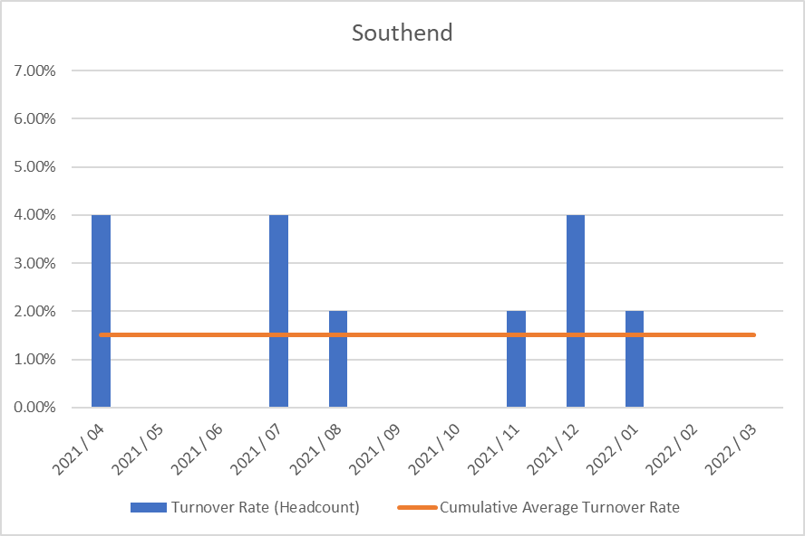

### Staff Engagement

For the first year, all of the 5 CCGs in Mid and South Essex have participated in the NHS Staff Survey on a combined basis and the results have been presented across joint Directorates and teams. The CCGs chose Picker to run the survey and results were published nationally on 30th March.

The CCGs had an excellent response rate of 78%. Key themes have been shared with the CCGs Executive Team and they have been asked to work with their teams to write action plans in response to the staff survey results. In addition to this, the 5 CCGs formed a staff engagement group in January 2022 and this group is also developing an organisational action plan to look at key themes such as health and wellbeing, and diversity and inclusion. This group has representation of staff from across the 5 CCGs and will be tasked with feeding into the organisational development work required as the CCGs transition into an ICB.

There are regular all-staff briefings across the 5 CCGs to communicate key messages around organisational change, as well as operational updates and regular updates on system priorities, for example Covid response updates.

There are also opportunities for staff to meet at a more local level through Alliance briefings as well as team briefings and regular one to one meetings with their manager.

### Staff policies

The CCG has given full and fair consideration to applications for employment made by disabled persons, having regard to their particular aptitudes and abilities.

The CCG has continued the employment of and arranged appropriate training for employees who have become disabled persons during their period of employment.

It is the policy of the CCG to ensure that any member of the CCG Board, its staff and its member practices are able to raise concerns about unlawful conduct, financial malpractice/fraud and risks to the environment and to patient care in line with legislation and good practice. This is covered under our whistleblowing policy.

### Equality, Diversity, and Inclusion

The CCGs are committed to providing equal opportunities and to avoiding unlawful discrimination and the Recruitment and Selection Policy is designed to assist the CCGs in putting this commitment into practice. The policy is compliant with the Equality Act 2010 and sets out specific actions undertaken by the CCGs, in the context of employment and people management, in order to fulfil its Public Sector Equality Duty.

All CCG staff will be offered further equality, diversity and inclusion training as part of the transition into the ICB - the offering will include unconscious bias training, awareness of protected characteristics, allyship and also a complete review of policies, procedures and practices to eliminate bias. This will be offered in line with the recommendations of the No More Tick boxes report.

The CCGs will also be working with the Mid and South Essex Health and Care Partnership to develop an organisational and system response to the regional Anti-Racism Strategy, and this will be implemented through the Equality, Diversity and Inclusion Subgroup that is accountable to the Mid and South Essex People Board. In addition, an EDI dashboard is also in development for the MSE Partnerships, which the CCGs will feed into.

As the CCGs transition into an ICB, there will be single WRES and WDES reports and action plans that will be co-produced and regularly monitored to ensure progress against agreed objectives.

The CCGs will also participate in the MSE reciprocal mentoring programme through the NHS Leadership academy, a commitment that has been made by the Executive teams from across the system.

### Trade Union Facility Time Reporting Requirements

There was no Trade Union Facility Time in 2021/22.

### Health and Wellbeing

The CCGs have benefitted from a comprehensive staff health and wellbeing offer through the Live Life Connected programme, which offers a vast array of health and wellbeing interventions, such as online talks around health topics, online exercise classes, mindfulness and gratitude practice.

In addition, there is also an employee assistance programme available to all staff which provides a telephone support line and counselling, as well as a comprehensive occupational health provision.

During the Covid pandemic, there have also been enhanced national, regional and local offers available to staff, including the regional mental health hubs and the Here For You service is available to all CCG employees.

The CCGs also have a trained network of mental health first aiders and have also provided bespoke Change and Resilience workshops for staff, as well as benefitting from ICS offers such as Kindness masterclasses.

The CCGs are committed to supporting disabled colleagues within the workplace through making reasonable adjustments as well as the use of regular risk assessments and also supporting colleagues’ mental health through the use of stress risk assessments and other support tools.

### Health and Safety

The CCG’s Health and Safety Policy sets out our responsibilities and those of employees under the Health and Safety Work Act 1974. Health and safety, fire safety and manual handling are included in the mandatory training programme for all CCG staff.

Risk assessment and inspections identify health and safety issues to enable appropriate action to be taken to reduce risks to staff and other users of CCG premises. Although CCG staff have worked from home since the beginning of the pandemic, regular health and safety inspections, building system tests and maintenance continued throughout the year.

All CCG staff were asked to complete an individual risk assessment to identify their personal level of risk in relation to COVID-19. In addition, the CCG undertook a COVID-19 risk assessment of its premises and developed an associated procedure based on Government, NHS England and Health and Safety Executive guidance and advice from CCG Infection Prevention and Control staff, to ensure that the building was COVID-19 secure. These documents also received input from staff and union representatives. During the pandemic access to the CCG’s premises was restricted by application of a strict criteria and approval process.

A number of CCG staff were redeployed to provider organisations to assist with the frontline response to COVID-19. Where this was the case, a formal cross-organisational agreement was in place to ensure that all health, safety and wellbeing needs of employees were met throughout their period of redeployment.

### Expenditure on consultancy

|  |  |  |
| --- | --- | --- |
| **Year** | **Administrative** | **Programme** |
| 2021/22 | £ 0 | £ 11,637 |
| 2020/21 | £ 43,100 | £ 102,399 |
| 2019/20 | £ 110,851 | £ 102,722 |

### Off-payroll engagements

**Table 1: Off-payroll engagements longer than 6 months**

For all off-payroll engagements as at 31 March 2022 for more than £245 per day and that last longer than six months:

|  |  |
| --- | --- |
|  | Number |
| Number of existing engagements as of 31 March 2022 | 0 |
| Of which, the number that have existed: | |
| for less than one year at the time of reporting | 0 |
| for between one and two years at the time of reporting | 0 |
| for between 2 and 3 years at the time of reporting | 0 |
| for between 3 and 4 years at the time of reporting | 0 |
| for 4 or more years at the time of reporting | 0 |

**Table 2: Off-payroll workers engaged at any point during the financial year**

For all off-payroll engagements between 1 April 2021 and 31 March 2022, for more than £245 per day:

|  |  |
| --- | --- |
|  | Number |
| No. of temporary off-payroll workers engaged between 1 April 2021 and 31 March 2022 | 0 |
| Of which: | |
| No. not subject to off-payroll legislation | 0 |
| No. subject to off-payroll legislation and determined as in-scope of IR35 | 0 |
| No. subject to off-payroll legislation and determined as out of scope of IR35 | 0 |
| the number of engagements reassessed for compliance or assurance purposes during the year | 0 |
| Of which: no. of engagements that saw a change to IR35 status following review | 0 |

**Table 3:** **Off-payroll engagements / senior official engagements**

For any off-payroll engagements of Board members and / or senior officials with significant financial responsibility, between 01 April 2021 and 31 March 2022:

|  |  |
| --- | --- |
| Number of off-payroll engagements of board members, and/or senior officers with significant financial responsibility, during the financial year (1) | 0 |
| Total no. of individuals on payroll and off-payroll that have been deemed “board members, and/or, senior officials with significant financial responsibility”, during the financial year. This figure should include both on payroll and off-payroll engagements. (2) | 26 |

### Losses and Special Payments

In 2021/22, the total number of NHS clinical commissioning group losses and special payments cases were nil (2020/21: nil).

### Exit packages, including special (non-contractual) payments

In 2021/22 the total number of NHS clinical commissioning group exit packages were nil (2020/21: nil)

# PARLIAMENTARY ACCOUNTABILITY AND AUDIT REPORT

Southend CCG is not required to produce a Parliamentary Accountability and Audit Report but has opted to include disclosures on remote contingent liabilities, losses and special payments, gifts, and fees and charges in this Accountability Report at page 100. An audit certificate and report are also included in this Annual Report.

# ANNUAL ACCOUNTS

I confirm that the annual accounts adhere to the reporting framework.



**Anthony McKeever**Executive Lead for the Mid and South Essex Health and Care Partnership and Joint Accountable Officer for its five CCGs

29 June 2022

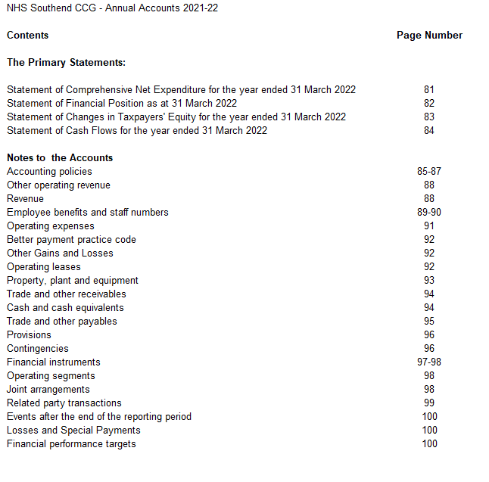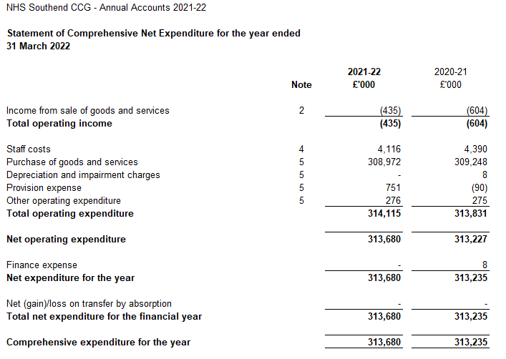

The notes on pages 85 to 100 form part of this statement

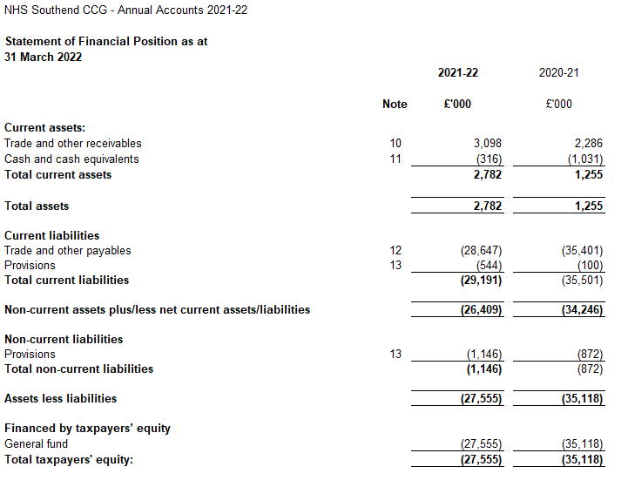

The notes on pages 85 to 100 form part of this statement.

The financial statements on pages 81 to 84 were approved by the Governing Body on 28 June 2022

and signed on its behalf by:



Chief Accountable Officer

Anthony McKeever

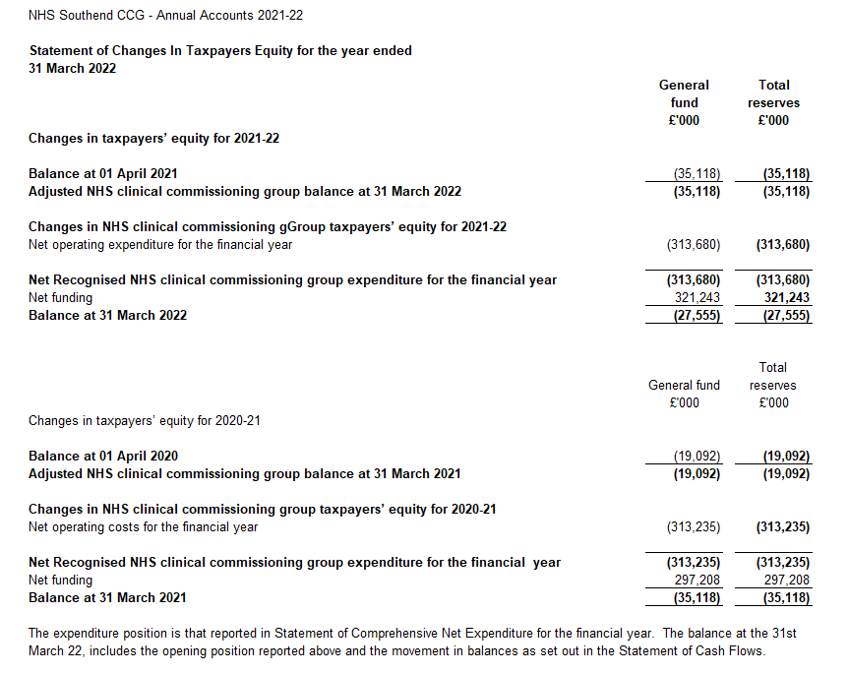

The notes on pages 85 to 100 form part of this statement.

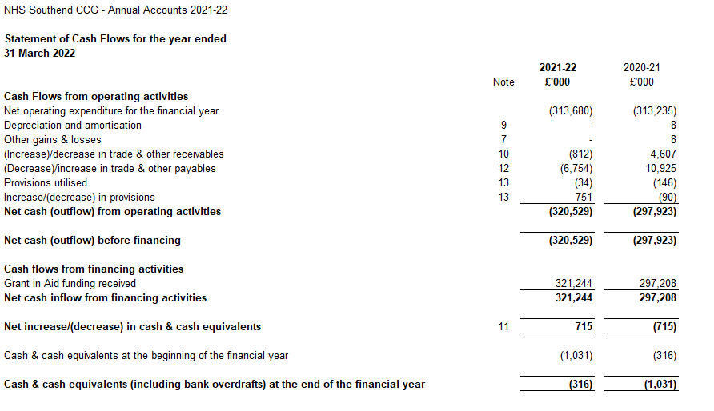

The notes on pages 85 to 100 form part of this statement.

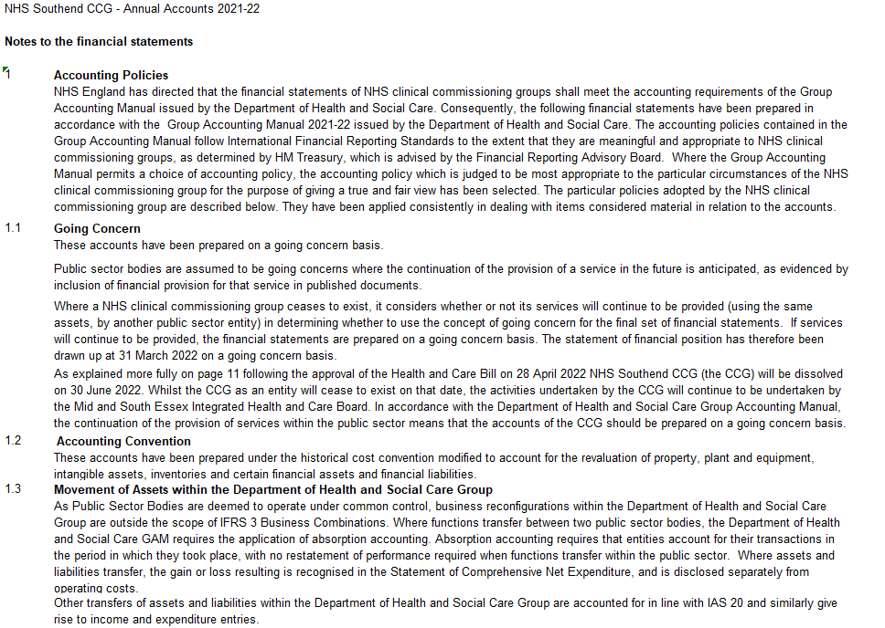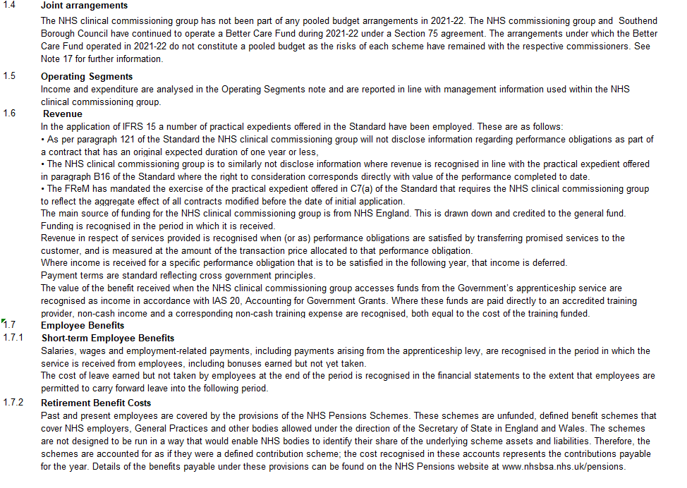

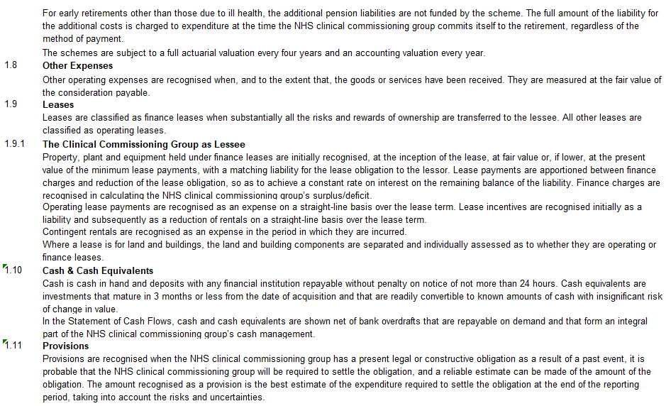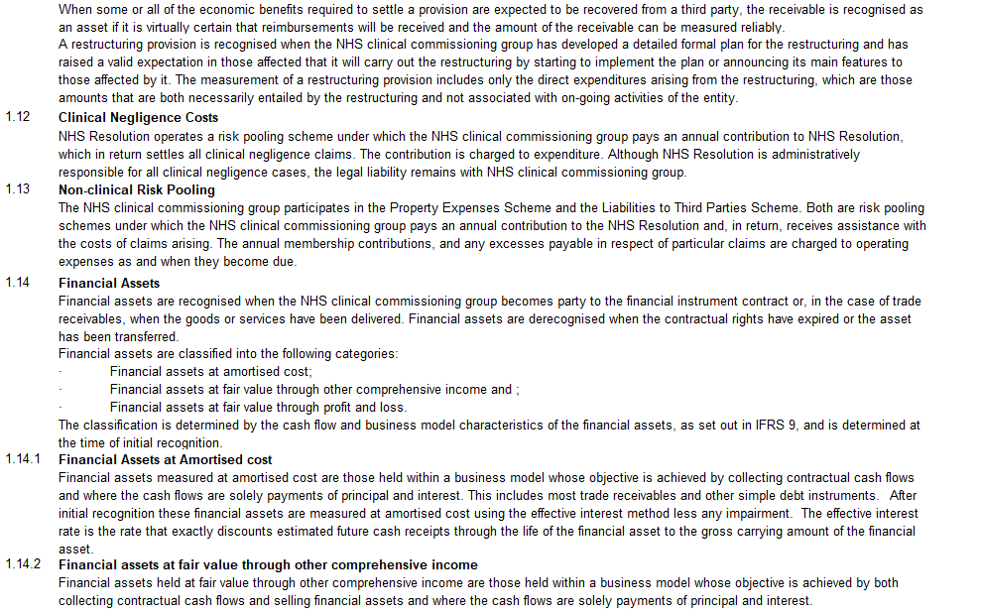

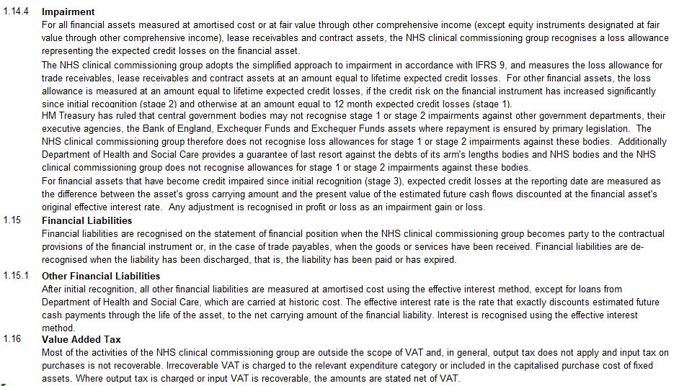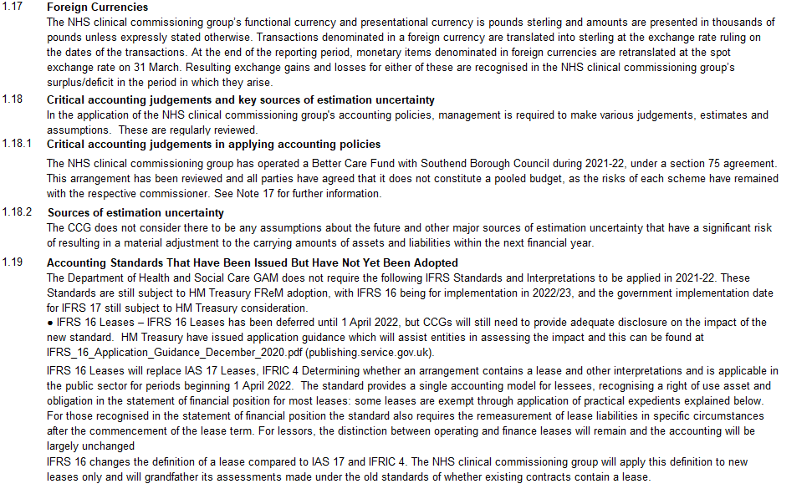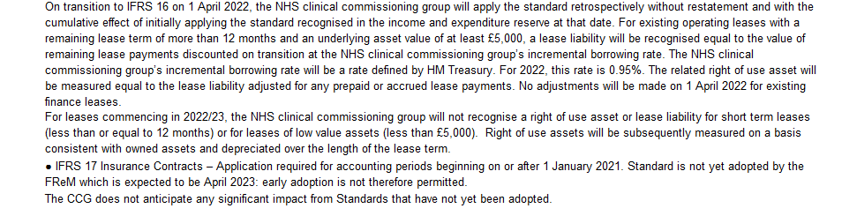

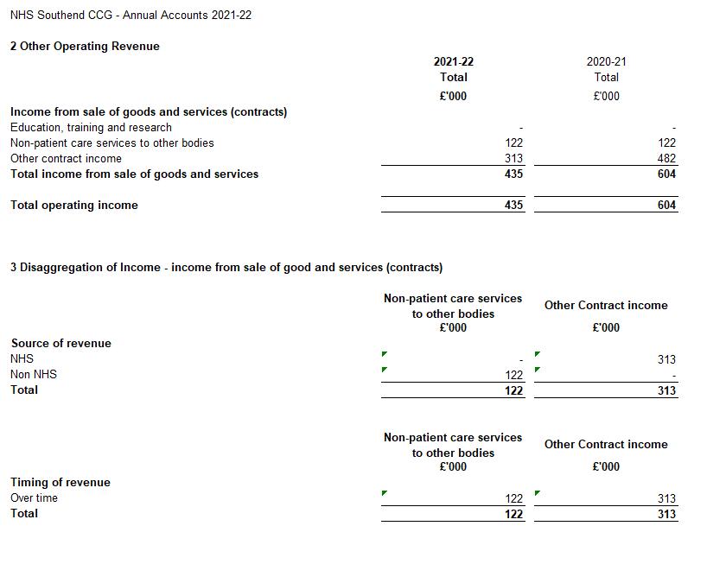

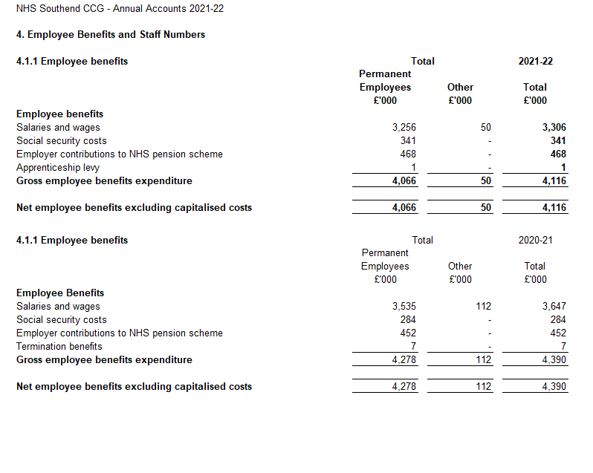 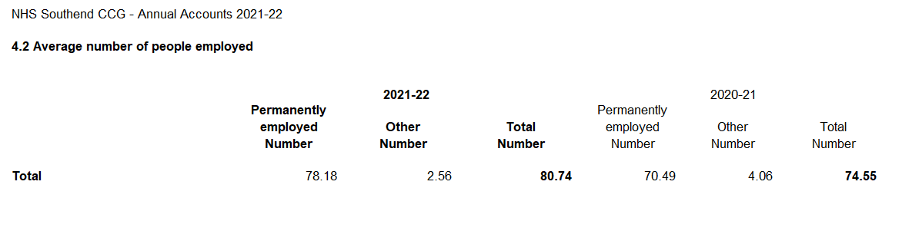

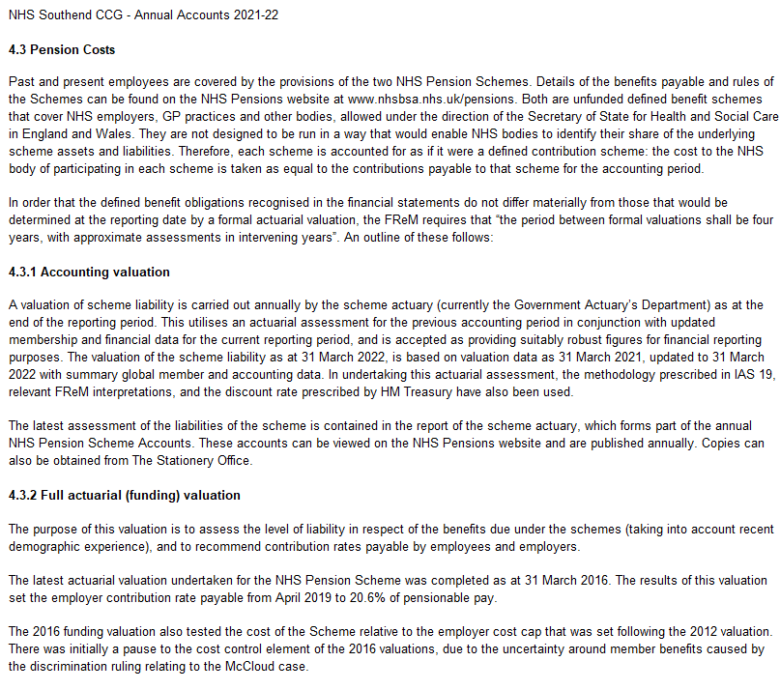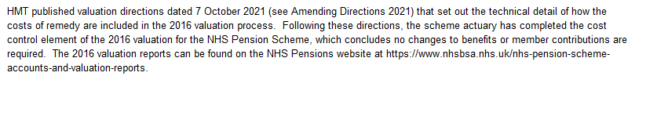

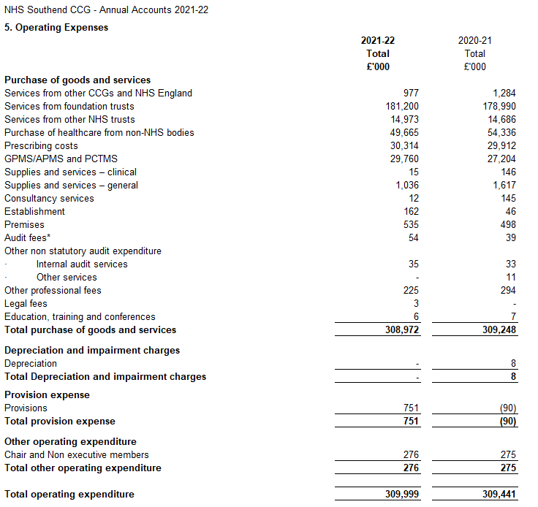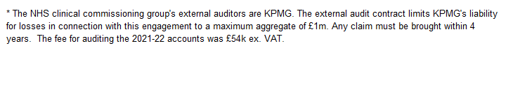

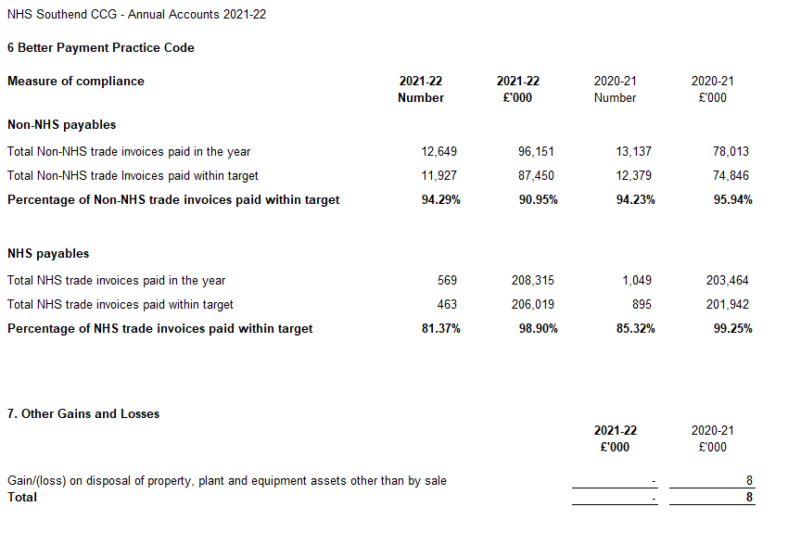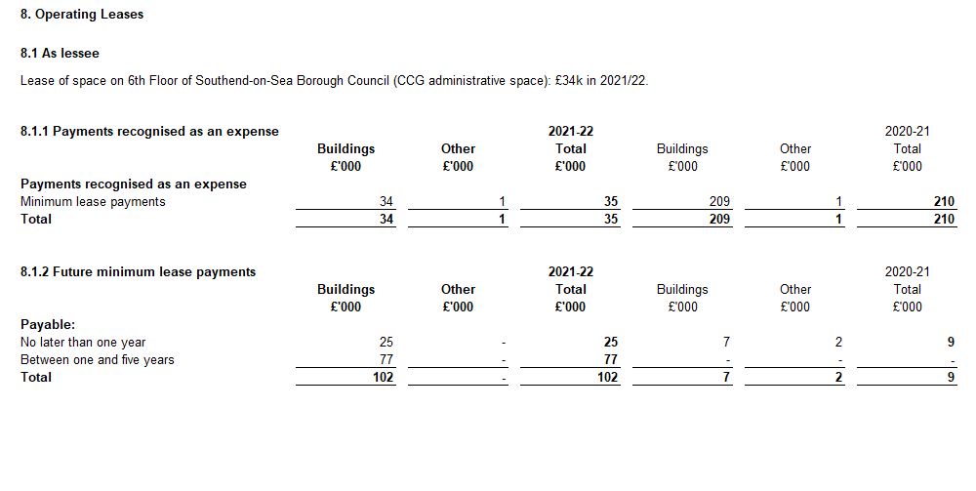

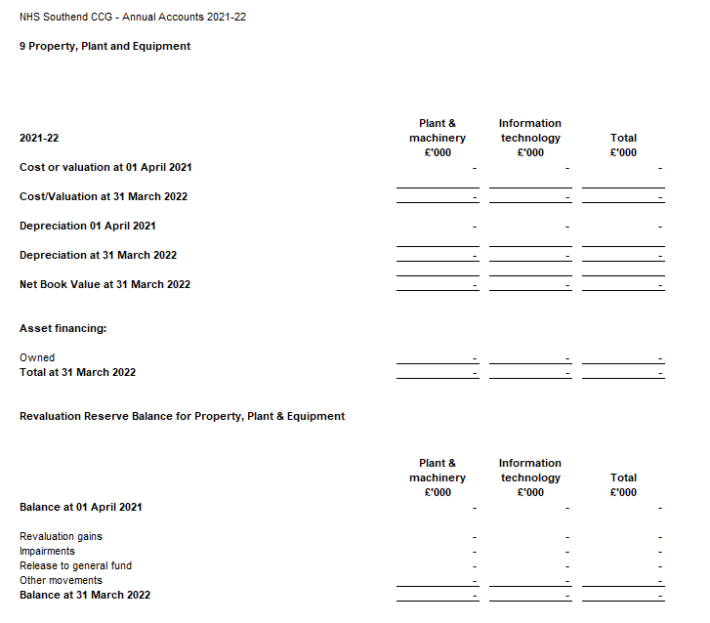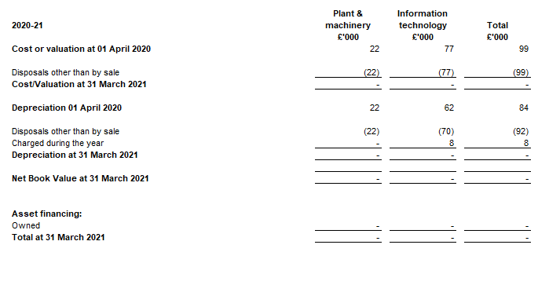

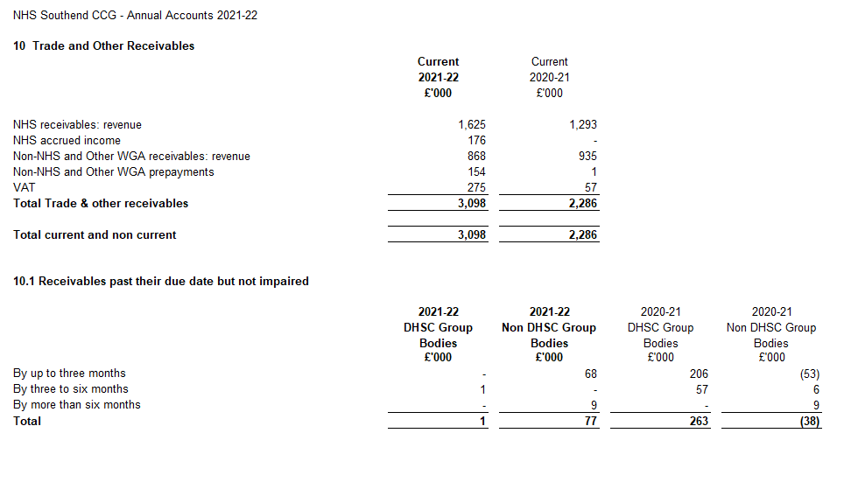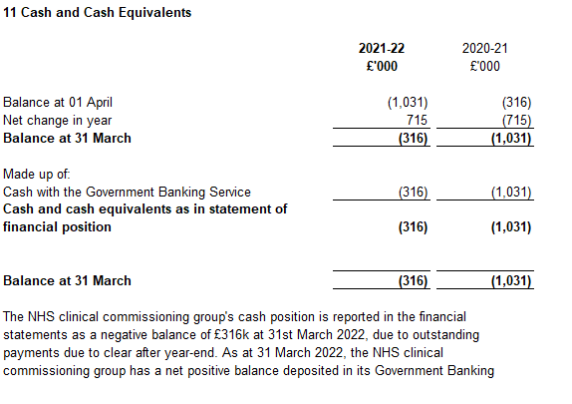

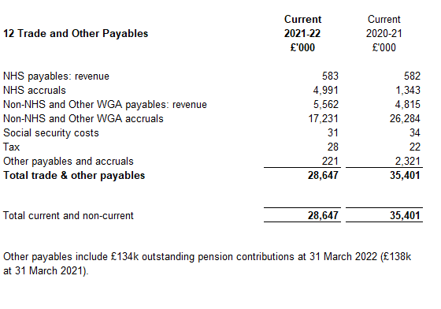

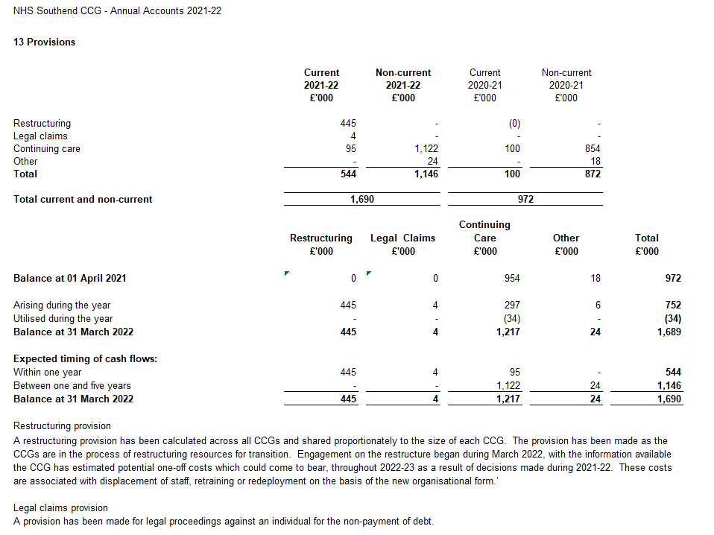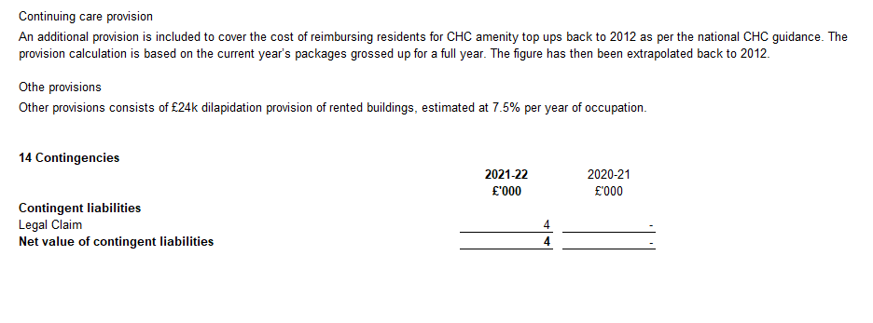

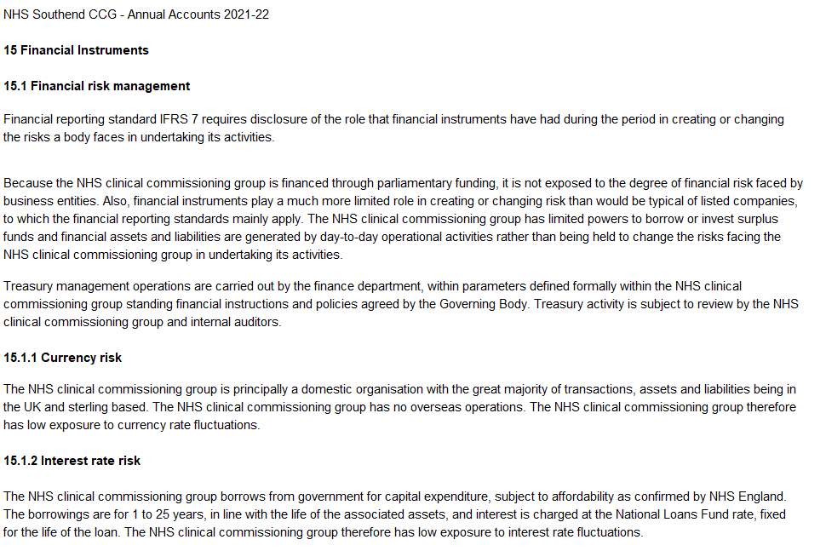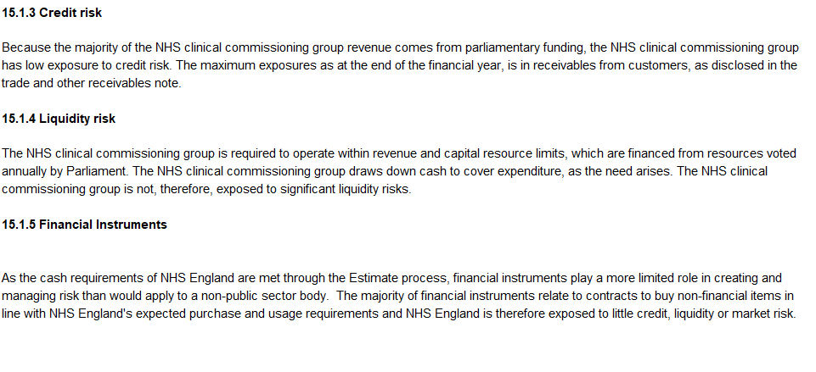

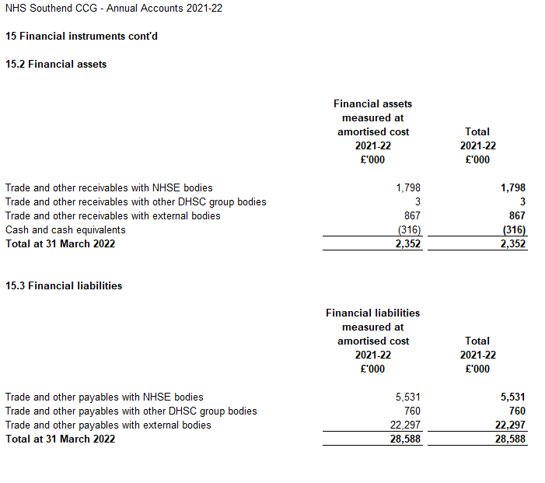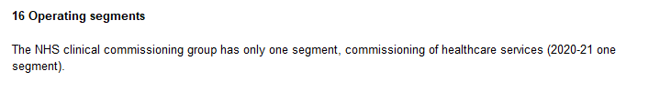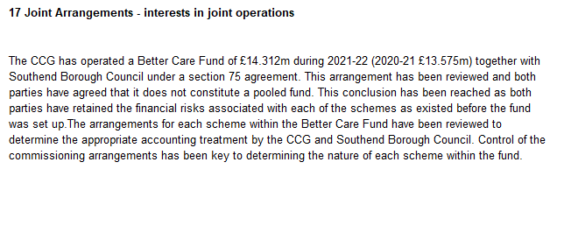

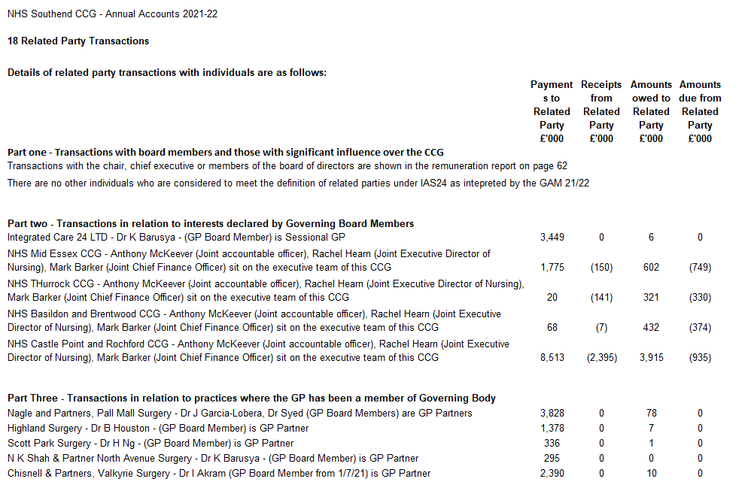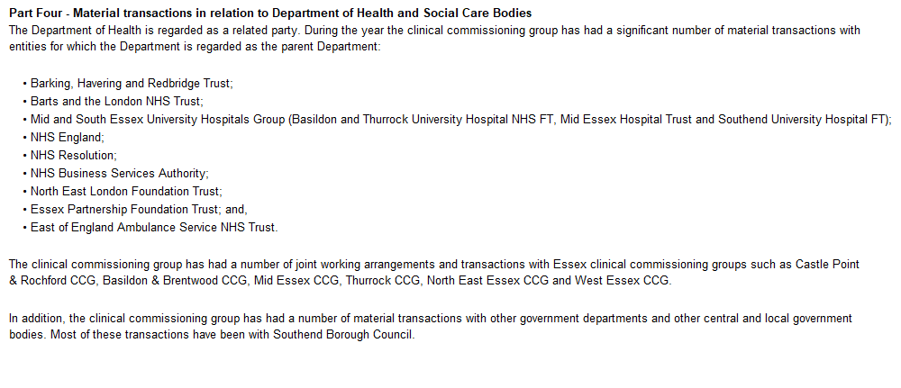

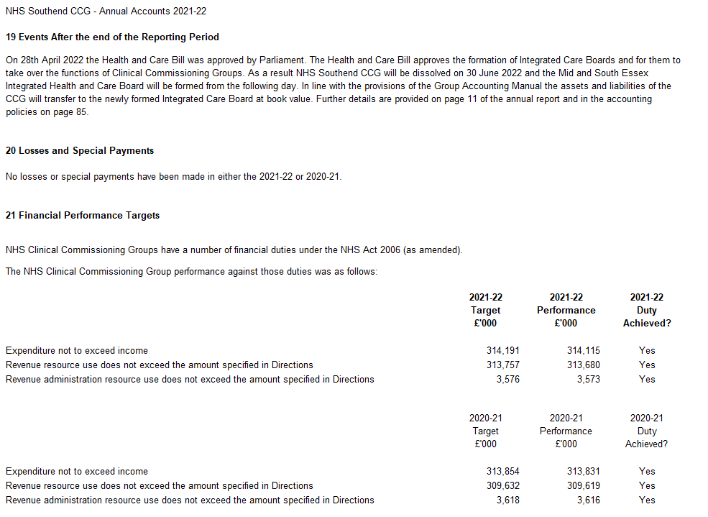

**INDEPENDENT AUDITOR’S REPORT TO THE MEMBERS OF THE GOVERNING BODY OF NHS SOUTHEND CLINICAL COMMISSIONING GROUP**

**REPORT ON THE AUDIT OF THE FINANCIAL STATEMENTS**

**Opinion**

We have audited the financial statements of NHS Southend Clinical Commissioning Group (“the CCG”) for the year ended 31 March 2022 which comprise the Statement of Comprehensive Net Expenditure, Statement of Financial Position, Statement of Changes in Taxpayers’ Equity and Statement of Cash Flows, and the related notes, including the accounting policies in note 1.

In our opinion the financial statements:

* give a true and fair view of the state of the CCG’s affairs as at 31 March 2022 and of its income and expenditure for the year then ended; and
* have been properly prepared in accordance with the accounting policies directed by NHS England with the consent of the Secretary of State as being relevant to CCGs in England and included in the Department of Health and Social Care Group Accounting Manual 2021/22.

**Basis for opinion**

We conducted our audit in accordance with International Standards on Auditing (UK) (“ISAs (UK)”) and applicable law. Our responsibilities are described below. We have fulfilled our ethical responsibilities under, and are independent of the CCG in accordance with, UK ethical requirements including the FRC Ethical Standard. We believe that the audit evidence we have obtained is a sufficient and appropriate basis for our opinion.

**Emphasis of matter – going concern**

We draw attention to the disclosure made in note 1.1 to the financial statements which explains that on 1 July 2022, NHS Southend CCG will be dissolved and its services transferred to Mid and South Essex Integrated Health and Care Board. Under the continuation of service principle, the financial statements of the CCG have been prepared on a going concern basis because its services will continue to be provided by the successor public sector entity. Our opinion is not modified in this respect.

**Going concern basis of preparation**

The Accountable Officer has prepared the financial statements on the going concern basis as they have not been informed by the relevant national body of the intention to dissolve the CCG without the transfer of its services to another public sector entity. They have also concluded that there are no material uncertainties that could have cast significant doubt over its ability to continue as a going concern for at least a year from the date of approval of the financial statements (“the going concern period”).

In our evaluation of the Accountable Officer’s conclusions, we considered the inherent risks to the CCG’s operating model and analysed how those risks might affect the CCG’s financial resources or ability to continue operations over the going concern period.

Our conclusions based on this work:

* we consider that the Accountable Officer’s use of the going concern basis of accounting in the preparation of the financial statements is appropriate;
* we have not identified, and concur with the Accountable Officer’s assessment that there is not, a material uncertainty related to events or conditions that, individually or collectively, may cast significant doubt on the CCG’s ability to continue as a going concern for the going concern period.

However, as we cannot predict all future events or conditions and as subsequent events may result in outcomes that are inconsistent with judgements that were reasonable at the time they were made, the above conclusions are not a guarantee that the CCG will continue in operation.

**Fraud and breaches of laws and regulations – ability to detect**

*Identifying and responding to risks of material misstatement due to fraud*

To identify risks of material misstatement due to fraud (“fraud risks”) we assessed events or conditions that could indicate an incentive or pressure to commit fraud or provide an opportunity to commit fraud. Our risk assessment procedures included:

* Enquiring of management, the Audit Committee and internal audit and inspection of policy documentation as to the CCG’s high-level policies and procedures to prevent and detect fraud, including the internal audit function, as well as whether they have knowledge of any actual, suspected or alleged fraud.
* Assessing the incentives for management to manipulate reported expenditure as a result of the need to achieve statutory targets delegated to the CCG by NHS England.
* Reading Governing Body and Audit Committee minutes.
* Using analytical procedures to identify any unusual or unexpected relationships.
* Reviewing the CCG’s accounting policies.

We communicated identified fraud risks throughout the audit team and remained alert to any indications of fraud throughout the audit.

As required by auditing standards, and taking into account possible pressures to meet delegated statutory resource limits, we performed procedures to address the risk of management override of controls, in particular the risk that CCG management may be in a position to make inappropriate accounting entries.

On this audit we did not identify a fraud risk related to revenue recognition because of the nature of funding provided to the CCG, which is transferred from NHS England and recognised through the Statement of Changes in Taxpayers’ Equity. However, in line with the guidance set out in Practice Note 10 Audit of Financial Statements of Public Sector Bodies in the United Kingdom we recognised a fraud risk related to expenditure recognition.

We did not identify any additional fraud risks.

We performed procedures including:

* Identifying journal entries to test based on risk criteria and comparing the identified entries to supporting documentation. These included journals where one side posts to cash and the other side posts to an unusual account, journals entries in period 12 where one side posts to expenditure and the other side posts to an unusual account, and Journals entries containing key words being: fraud, litigation, error
* Assessing the completeness of disclosed related party transactions and verifying they had been accurately recorded within the financial statements.
* Performing cut-off testing of expenditure in the period 1 March to 31 May 2022 to determine whether amounts had been recognised in the correct accounting period.

*Identifying and responding to risks of material misstatement related to non-compliance with laws and regulations*

We identified areas of laws and regulations that could reasonably be expected to have a material effect on the financial statements from our general sector experience and through discussion with the directors and other management (as required by auditing standards), and discussed with the directors and other management the policies and procedures regarding compliance with laws and regulations.

As the CCG is regulated, our assessment of risks involved gaining an understanding of the control environment including the entity’s procedures for complying with regulatory requirements.

We communicated identified laws and regulations throughout our team and remained alert to any indications of non-compliance throughout the audit.

The potential effect of these laws and regulations on the financial statements varies considerably.

The CCG is subject to laws and regulations that directly affect the financial statements including the National Health Service Act 2006 and financial reporting legislation. We assessed the extent of compliance with these laws and regulations as part of our procedures on the related financial statement items and our work on the regularity of expenditure incurred by the CCG in the year of account.

Whilst the CCG is subject to many other laws and regulations, we did not identify any others where the consequences of non-compliance alone could have a material effect on amounts or disclosures in the financial statements.

*Context of the ability of the audit to detect fraud or breaches of law or regulation*

Owing to the inherent limitations of an audit, there is an unavoidable risk that we may not have detected some material misstatements in the financial statements, even though we have properly planned and performed our audit in accordance with auditing standards. For example, the further removed non-compliance with laws and regulations is from the events and transactions reflected in the financial statements, the less likely the inherently limited procedures required by auditing standards would identify it.

In addition, as with any audit, there remained a higher risk of non-detection of fraud, as these may involve collusion, forgery, intentional omissions, misrepresentations, or the override of internal controls. Our audit procedures are designed to detect material misstatement. We are not responsible for preventing non-compliance or fraud and cannot be expected to detect non-compliance with all laws and regulations.

**Other information in the Annual Report**

The Accountable Officer is responsible for the other information presented in the Annual Report together with the financial statements. Our opinion on the financial statements does not cover the other information and, accordingly, we do not express an audit opinion or, except as explicitly stated below, any form of assurance conclusion thereon.

Our responsibility is to read the other information and, in doing so, consider whether, based on our financial statements audit work, the information therein is materially misstated or inconsistent with the financial statements or our audit knowledge. Based solely on that work:

* we have not identified material misstatements in the other information;
* in our opinion the other information included in the Annual Report for the financial year is consistent with the financial statements; and.
* in our opinion the other information has been prepared in accordance with the requirements of the Department of Health and Social Care Group Accounting Manual 2021/22.

***Annual Governance Statement***

We are required to report to you if the Annual Governance Statement has not been prepared in accordance with the requirements of the Department of Health and Social Care Group Accounting Manual 2021/22. We have nothing to report in this respect.

***Remuneration and Staff Reports***

In our opinion the parts of the Remuneration and Staff Reports subject to audit have been properly prepared in accordance with the Department of Health and Social Care Group Accounting Manual 2021/22.

**Accountable Officer’s responsibilities**

As explained more fully in the statement set out on page 39, the Accountable Officer is responsible for the preparation of financial statements that give a true and fair view. They are also responsible for such internal control as they determine is necessary to enable the preparation of financial statements that are free from material misstatement, whether due to fraud or error; assessing the CCG’s ability to continue as a going concern, disclosing, as applicable, matters related to going concern; and using the going concern basis of accounting unless they have been informed by the relevant national body of the intention to dissolve the CCG without the transfer of its services to another public sector entity.

**Auditor’s responsibilities**

Our objectives are to obtain reasonable assurance about whether the financial statements as a whole are free from material misstatement, whether due to fraud or error, and to issue our opinion in an auditor’s report. Reasonable assurance is a high level of assurance, but does not guarantee that an audit conducted in accordance with ISAs (UK) will always detect a material misstatement when it exists. Misstatements can arise from fraud or error and are considered material if, individually or in aggregate, they could reasonably be expected to influence the economic decisions of users taken on the basis of the financial statements.

A fuller description of our responsibilities is provided on the FRC’s website at [www.frc.org.uk/auditorsresponsibilities](http://www.frc.org.uk/auditorsresponsibilities)

**REPORT ON OTHER LEGAL AND REGULATORY MATTERS**

**Opinion on regularity**

We are required to report on the following matters under Section 25(1) of the Local Audit and Accountability Act 2014.

In our opinion, in all material respects, the expenditure and income recorded in the financial statements have been applied to the purposes intended by Parliament and the financial transactions conform to the authorities which govern them.

**Report on the CCG’s arrangements for securing economy, efficiency and effectiveness in its use of resources**

Under the Code of Audit Practice, we are required to report if we identify any significant weaknesses in the arrangements that have been made by the CCG to secure economy, efficiency and effectiveness in its use of resources.

We have nothing to report in this respect.

***Respective responsibilities in respect of our review of arrangements for securing economy, efficiency and effectiveness in the use of resources***

As explained more fully in the statement set out on page 39, the Accountable Officer is responsible for ensuring that the CCG exercises its functions effectively, efficiently and economically. We are required under section 21(1)(c) of the Local Audit and Accountability Act 2014 to be satisfied that the CCG has made proper arrangements for securing economy, efficiency and effectiveness in its use of resources.

We are not required to consider, nor have we considered, whether all aspects of the CCG’s arrangements for securing economy, efficiency and effectiveness in the use of resources are operating effectively.

We planned our work and undertook our review in accordance with the Code of Audit Practice and related statutory guidance, having regard to whether the CCG had proper arrangements in place to ensure financial sustainability, proper governance and to use information about costs and performance to improve the way it manages and delivers its services. Based on our risk assessment, we undertook such work as we considered necessary.

**Statutory reporting matters**

We are required by Schedule 2 to the Code of Audit Practice issued by the Comptroller and Auditor General (‘the Code of Audit Practice’) to report to you if we refer a matter to the Secretary of State and NHS England under section 30 of the Local Audit and Accountability Act 2014 because we have reason to believe that the CCG, or an officer of the CCG, is about to make, or has made, a decision which involves or would involve the body incurring unlawful expenditure, or is about to take, or has begun to take a course of action which, if followed to its conclusion, would be unlawful and likely to cause a loss or deficiency.

We have nothing to report in this respect.

**The purpose of our audit work and to whom we owe our responsibilities**

This report is made solely to the Members of the Governing Body of NHS Southend CCG, as a body, in accordance with Part 5 of the Local Audit and Accountability Act 2014. Our audit work has been undertaken so that we might state to the Members of the Governing Body of the CCG, as a body, those matters we are required to state to them in an auditor’s report and for no other purpose. To the fullest extent permitted by law, we do not accept or assume responsibility to anyone other than the Members of the Governing Body, as a body, for our audit work, for this report or for the opinions we have formed.

**Certificate of completion of the audit**

We certify that we have completed the audit of the accounts of NHS Southend CCG for the year ended 31 March 2022 in accordance with the requirements of the Local Audit and Accountability Act 2014 and the Code of Audit Practice.

Emma Larcombe

**for and on behalf of KPMG LLP,**

*Chartered Accountants*

Cambridge

30 June 2022